Mid-Term Project Progress Report

CS 766: Computer Vision

Daniel Huff

[dthuff@wisc.edu](mailto:dthuff@wisc.edu)

Summary of Current Progress

Outline of Current Workflow

After a quick literature search, I decided to base my approach to this problem somewhat on work published in 2016 (Nguyen et al.), with some simplifications and some extensions. Here, I’ll give a rundown of the steps in the workflow, and compare each step to the implementation in the literature publication.

The workflow begins with a patient PET and CT image which are coregistered. Both images are three dimensional, and of size 512 x 512 x 300-400. The range of third dimension sizes is due to varying patient heights and scanner axial resolutions. The first segmentation step encompasses the extraction of a full bone mask. This step makes a call to extract_bone_mask, which accepts a CT image and several tuning parameters and returns a binary mask of the same size as the CT image. Because bone is denser than soft tissue, it exhibits higher CT image values, and so can be roughly segmented with a simple threshold. My code currently uses a CT threshold of 150 to get an initial bone mask, then a series of opening, closing, and hole filling steps to remove small volumes outside the skeleton, and fill small holes in the skeleton. Nguyen et al uses a more sophisticated 3D graphcut approach with two CT threshold values.

Following whole bone segmentation, bone marrow segmentation proceeds in two steps. First, the marrow compartments in the vertebra of the spine are segmented by locating intervertebral disks. This is done by finding minima in the axial distribution of mean PET-image slice values in the function find_axial_minima. This technique works because the connective tissue of intervertebral disks is less physiologically active than neighboring parts of the spine, and so exhibits lower FDG PET values. Nguyen et al finds minima in the axial CT distribution, as intervertebral disks are also less dense than the adjacent vertebra, but I found this technique to results in many more false positive disk locations than using PET values. Nguyen et al also accounts for disks that may be tilted by searching for minima in a space parameterized by a tilt angle, but I have not implemented anything similar. Once the disk minima have been detected, I segment each vertebral body by eroding the section of bone mask between adjacent minima with a spherical structuring element.

Besides the spine, large bone volumes containing significant bone marrow proliferation which we are interested in segmenting include the pelvis, femurs, and humeri. Nguyen et al was only interested in the lumbar and thoracic spine, so this part of the workflow is an extension of their approach. To segment other parts of the skeleton, the spinal bone marrow segmentation from the previous step is subtracted from the whole bone mask to avoid double segmenting the spine. This difference mask is eroded with a spherical structuring element to separate skeletal segments as well as remove the surface cortical bone from the bone mask. Then, the largest connected components from the eroded difference mask are selected as the bone marrow compartments of large bones outside the spine. The union of these components and the final vertebra mask obtained from the vertebral segmentation process are taken to be the final complete bone marrow mask.

Current Results

I’ve run this workflow on a 30 patient cohort. For a typical image set, the segmentation process takes 120-140 seconds per patient. I’ve included one example of good performance, and then one example demonstrating each of the three difficulties I discuss in the following section. While all the results I show are 2D slices, the segmentation is actually 3D.

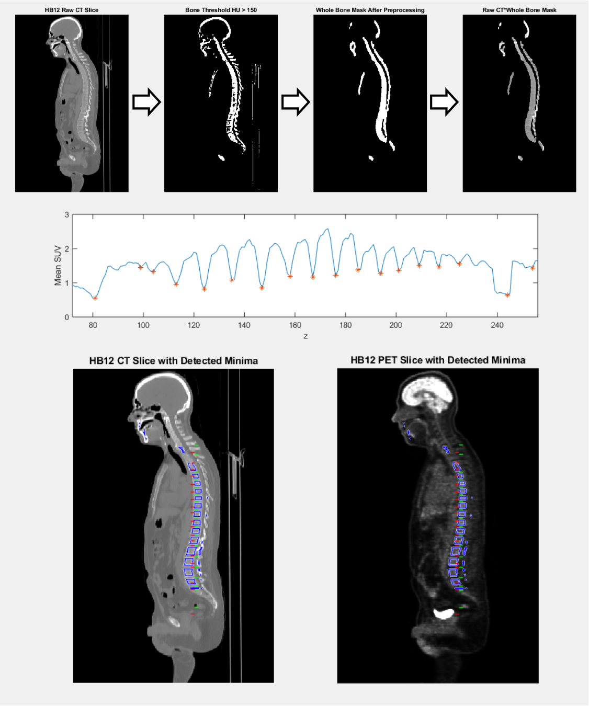

Figure 1: Example of good algorithm performance leading to successful marrow segmentation. Top portion of the figure shows the process of whole bone extraction, beginning with a raw patient CT image, and ending with a whole bone mask. The middle plot shows the axial distribution of mean PET SUV values inside the whole bone mask, with identified minima corresponding to intervertebral disk locations. The bottom portion of the figure shows sagittal CT and PET image slices overlaid with minima locations identified on PET (green) and CT (red), as well as final marrow segmentation (blue).

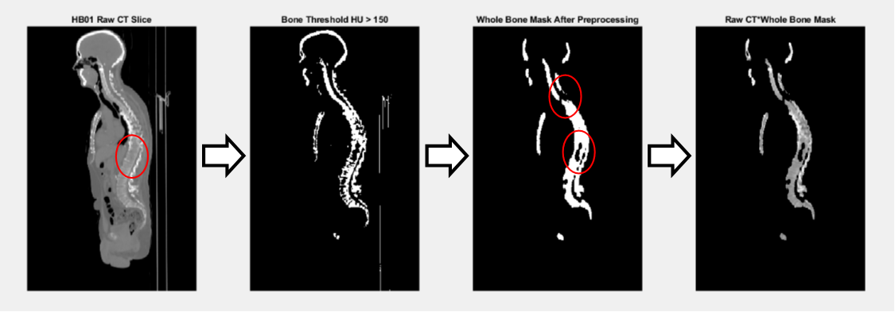

Figure 2: Example of incomplete whole bone segmentation. This patient exhibited lower than average bone density, as demonstrated in the second panel. The morphological closing and hole filling steps in the workflow are able to correctly fill some of the hyposdense bone volume, but some voids remain (red circles), leading to incomplete marrow segmentation in the following workflow steps.

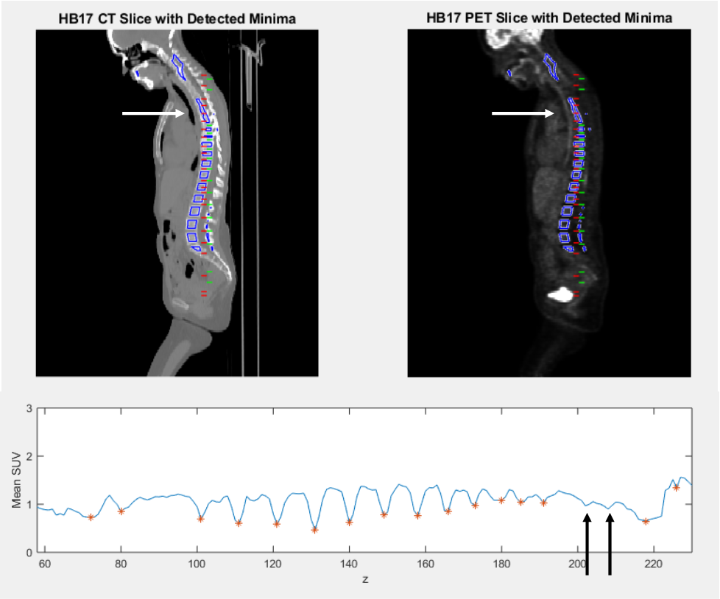

Figure 3: Missed intervertebral disk detection leading to fused vertebra segmentation. Location of missed disk locations are indicated by arrows. Missed disk locations are more common in the cervical spine, where vertebra and their intervertebral disks are smaller and may be tilted anteriorly.

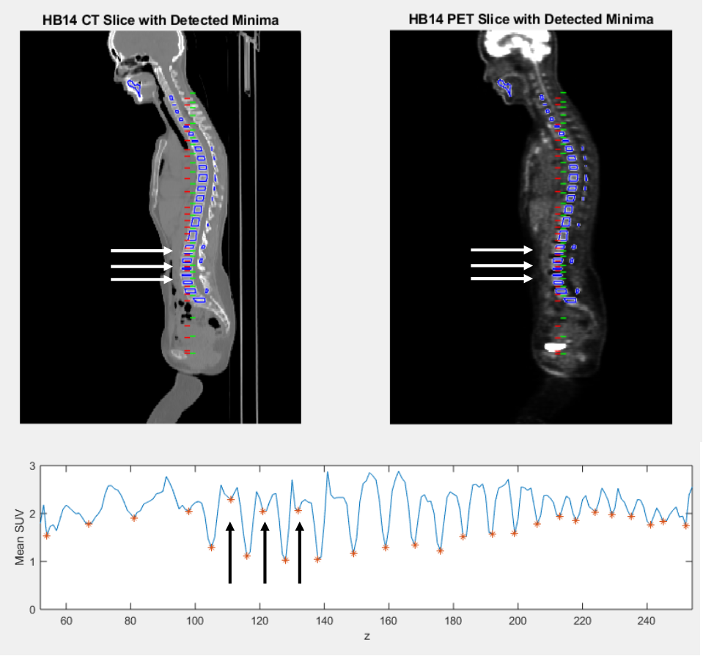

Figure 4: Example of false positive disk detection, leading to split vertebra segmentation. Locations of spurious disk detection are indicated with arrows. Vertebra splitting is most common in the lumbar spine, where vertebral bodies are tall, and can exhibit decreased FDG uptake inside their bulk.

Difficulties

There are several stages of the current workflow that can perform poorly and lead to poor results. Three of the biggest current issues are: incomplete whole bone segmentation, missed intervertebral disk detection due to tilted or irregular vertebra, and false positive disk detections due to spurious minima. I’ll briefly discuss how each of these three issues manifest in my current results, and what can be done to address them.

Incomplete whole bone segmentation can be caused by hypodense bone which may be present in older patients, or patients with degenerative skeletal diseases. Because the marrow segmentation step in my workflow expect to begin with a whole bone mask, incomplete bone segmentation leads to incomplete marrow segmentation. An example of this is shown in Figure XXXX. This problem may be better addressed with a lower CT bone threshold, a dynamic thresholding technique, or the implementation of a different segmentation technique, such as the 3D graphcut used by Nguyen et al.

Missed intervertebral disk detection is one of the two ways the minima finding technique can fail. Missed vertebra may be due to a tilt in the vertebral body, which washes out the minima along the axial direction, or just poor image contrast, resulting in a minima that does not meet the peak prominence threshold. Missed minima results in fused vertebra segmentations, as seen in Figure XXX. The problem of tilted vertebra can be addressed by implementing a search for minima over a range of tilt angles, but addressing the problem of poor image contrast would require the collection of new CT scans, which I think is outside the scope of this project.

False positive disk detection is the other failure mode of the minima finding technique. This failure arises from either a decrease or noise in the PET values inside the body of a vertebra strong enough to be selected by the minima finding function. It leads to splitting of vertebral volumes, as seen in Figure XX. This issue could be addressed by increasing the peak prominence threshold necessary for detecting minima, but at the expense of more missed disk detections.

A final overall limitation of the current workflow is it’s dependence on engineered parameters such as peak prominence thresholds, bone density CT thresholds, and small volume rejection thresholds. I have not attempted to do any rigorous optimization of these parameters because that would require a ground truth segmentation done by a physician.

How Proposal might have Changed

Original proposal said bone mask would be an input, current workflow starts with just raw PET, CT, computes bone mask.

References

Nguyen, C., et al. "An Automatic 3d Ct/Pet Segmentation Framework for Bone Marrow Proliferation Assessment." *Proc Int Conf Image Proc* 2016 (2016): 4126-30. Print.