**Chapter 3**

# CRU common firmware

The upgrade of the electronics allows one to increase the data to a value of about two orders of magnitude larger than the one that ALICE experienced during LHC RUN1 and RUN2. As mentioned above, one of the main goals of the new data campaign is the study of rare probes down to low transverse momenta, a region where the large background makes the triggering techniques very inefficient or even impossible in many situations. Such increase of data size, combined with the high collision and acquisition rates, makes standard approaches difficult to apply without enormous (technical and economical) efforts for the upgrade of computing capabilities. Since the required scaling of computing infrastructure cannot cope with the data throughput increase, a new acquisition and processing paradigm had to be developed.

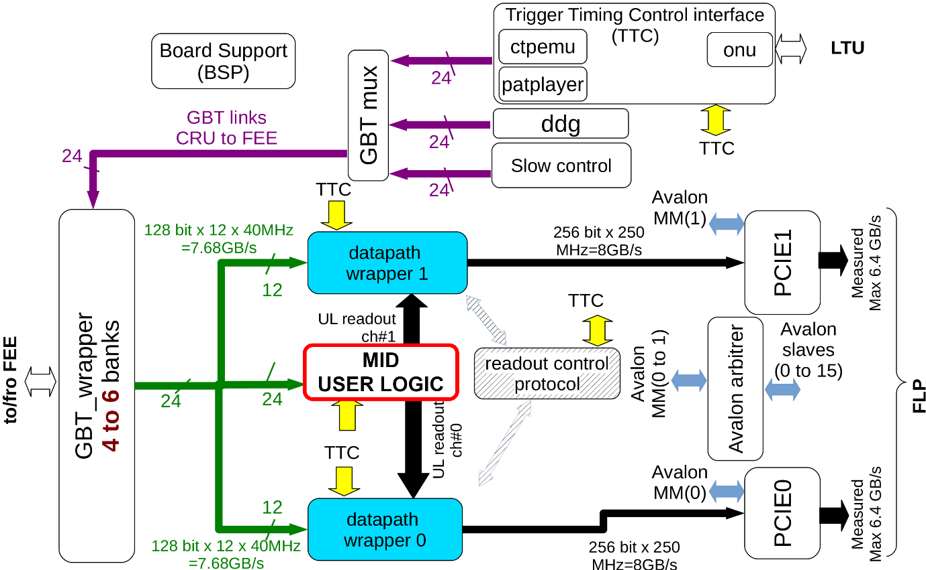

|  |  |
| --- | --- |
| 2 | MID readout chain |

**Data extraction**