
FREC 1.1 - Ethical compliance for engineering students
Student’s surname | THYS-DINGOU |  |  |  |  | Student no. | 214349721
First names | DIEUVEIL ORCEL
Phone  Cell phone: 0712004894 |  |  | E-mail: 214349721@mycput.ac.za
Gender: M |  |  | Ethnic group*  Black / White / Coloured / Indian

Nationality: Congolese
Prior qualifications: BTECH |  |  |  | Status (full-time / part-time):
Title of dissertation/thesis: Design and development of the ALICE CRU user logic firmware for the MID readout chain
Indicate whether a 50% dissertation or 100% thesis: |  |  |  | 50% dissertation |  |  | 100% thesis
Department |  | Engineering
Degree |  | Electrical
Principal supervisor |  | Dr A.RAJI
Position |  | Senior Lecturer |  |  | Qualifications DTech : Electrical

Name of Reviewer | Dr ML Adonis
It is recommended that the application for ethics approval be: Approved / Not approved
(Circle appropriate statement)

Comments:

No perceived ethical challenges with this work.

√
No data collection is required.

Data collection is required and permission letter was obtained.

ETHICAL COMPLIANCE AGREEMENT:

Explain the potential ethical issues that could arise from this research. | There are no ethical issues that could arise from this research.
How will the quality and integrity of the research be ensured? | To ensure the quality and integrity of the research, all sources and methods used to obtain and analyze data will be fully disclosed. The thesis produced by this research will be reviewed and will mention any issues and explain how they have been dealt with in the design and interpretation. Furthermore, the student will adhere to the CPUT’s Research Integrity, including procedures for investigating allegations of misconduct in research.
How will informed consent be obtained from participants | There are no ethical issues that could arise from this research.
How will the confidentiality and anonymity of the research respondents be ensured? | There are no ethical issues that could arise from this research.
How will voluntary participation be ensured | There are no ethical issues that could arise from this research.
How will harm to the participants be prevented | There are no ethical issues that could arise from this research.
How will harm to the environment be prevented | The aim of this research is to develop a user logic prototype capable of meeting the requirement of ALICE MID readout chain. This is done using intel ARRIA 10 FPGA. This FPGA causes no harm to the environment and complies to the Intel Environmental Health and Safety Policy found on intel website.
How is it ensured that the research will be independent and impartial? | To ensure that the research will be independent and impartial, the student will:  - Work closely with the supervisor throughout the project.  - Avoid confusing roles and relationships in a way that may give rise to reasonable doubt concerning conflicts of interest.  - Be fair and unbiased
Explain if there are any other organisations involved in the research, whether the ethics policy of the institution has been explained to them and whether written permission has been obtained from them to participate in the research. | Co-supervisors Ass. Prof. Zinhle Buthelezi and Dr Siegfried V Förtsch are Senior Scientists in the Department of Subatomic Physics at the NRF-iThemba LABS. They are Principal Investigators of the research topic and are well aware of the CPUT ethics policy.  The student through NRF iThemba LABS is part of a national program called SA CERN. This program gives South African students from different universities an opportunity to access to the largest research facility in the world, CERN, located in Geneva, Switzerland. As such the student has been granted full access to NRF iThemba LABS as well as CERN laboratories.
Explain any ethics requirements that are set by potential funders and how these will be dealt with. | No ethical issues are expected to arise from this research.
Explain what risk scenarios exist (individual, community, environment etc) and how these will be dealt with. | The potential risk scenarios that might happen during the hardware tests of the user logic prototype in the laboratory are:  - Integration the user logic firmware prototype in the common readout unit (CRU) if not properly designed, it may corrupt the entire system. To prevent this, the integration of the user logic prototype will only be done through conformance with well-established requirements and practice.  - Many pieces of the electronic equipment used in NRF iThemba LABS laboratory includes a power supply unit. Mains driven power supplies can be very dangerous to work with. They often contain large capacitors which can store dangerous voltages even after disconnecting the mains supply. To prevent the risk of electrocution, the student will have to follow the safety precautions established by the NRF iThemba LABS safety and Health Management System.
Explain how authorship issues will be dealt with when publications and conference papers are produced as a result of the research. Indicate what the roles and responsibilities will be and who will be the primary and secondary authors. | No authorship issues will be dealt.  The primary author will be the student and the supervisors and will also include co-author(s) [other authors will be included and positional arranged according to their contributions].  The supervisor Dr Raji will provide academic support and guidance to the student. He will be responsible for assuring that the student understands and complies with all CPUT policies and regulations.  The co-supervisors Prof Buthelezi and Dr Förtsch have great knowledge to the scientific area in question. They are principal investigators of the research topic. As such they are the main interface between South Africa and ALICE collaboration, particularly guiding the student during interactions with the muon identifier collaborators in France and CERN experts in Geneva.
Explain what will be done to prevent any form of plagiarism in the research publications. | To prevent plagiarism the student will keep track of the sources consulted during the research. Ideas or piece of information used from a source will be either paraphrased or quoted. Credit will be given to the original author in an in-text citation and reference list. Plagiarism checker will be used before submitting.
Explain if there may be any conflicts of interest relating to the supervisor and the student in the research, whether any other parties will benefit from the research and how this will be dealt with in a fair and transparent way. | There are no conflicts of interest relating to the supervisor and the student in the research.  The project is fully funded by the NRF iThemba LABS and, collaborator (France and CERN) support is facilitated through SA-CERN funding from the NRF. The infrastructure as well as the tools used are property of the NRF. The student conducting the research is registered and administered at CPUT.  CPUT and NRF iThemba LABS will both benefit from the research.
Explain what engineering aspects of the study will be subject to the codes of conduct of the engineering profession and its representative bodies and how these will be complied with. | The engineering aspects of this research are tinkering, design, analysis, problem solving, collaboration, and project management.  These aspects will be subject to the Engineering Council of South Africa (ECSA) code of conduct for engineers and technologists and will comply with the following principles:  - Hold paramount the safety, health, and welfare of the public.  - May only undertake work in which, their education, training and experience have rendered them competent to perform and its within the category of their registration.  - Must avoid situations that gives rise to conflict of interest or the potential for such conflict of interest.  - Must ensure that any work approved or certified by them, has been reviewed or inspected to the instinct necessary to confirm the correctness of the approval or certification.  - May not without satisfactory reasons destroy or dispose of, or knowingly allow any other person to destroy or dispose of, any information within a period of 10 years after completion of the work concerned.

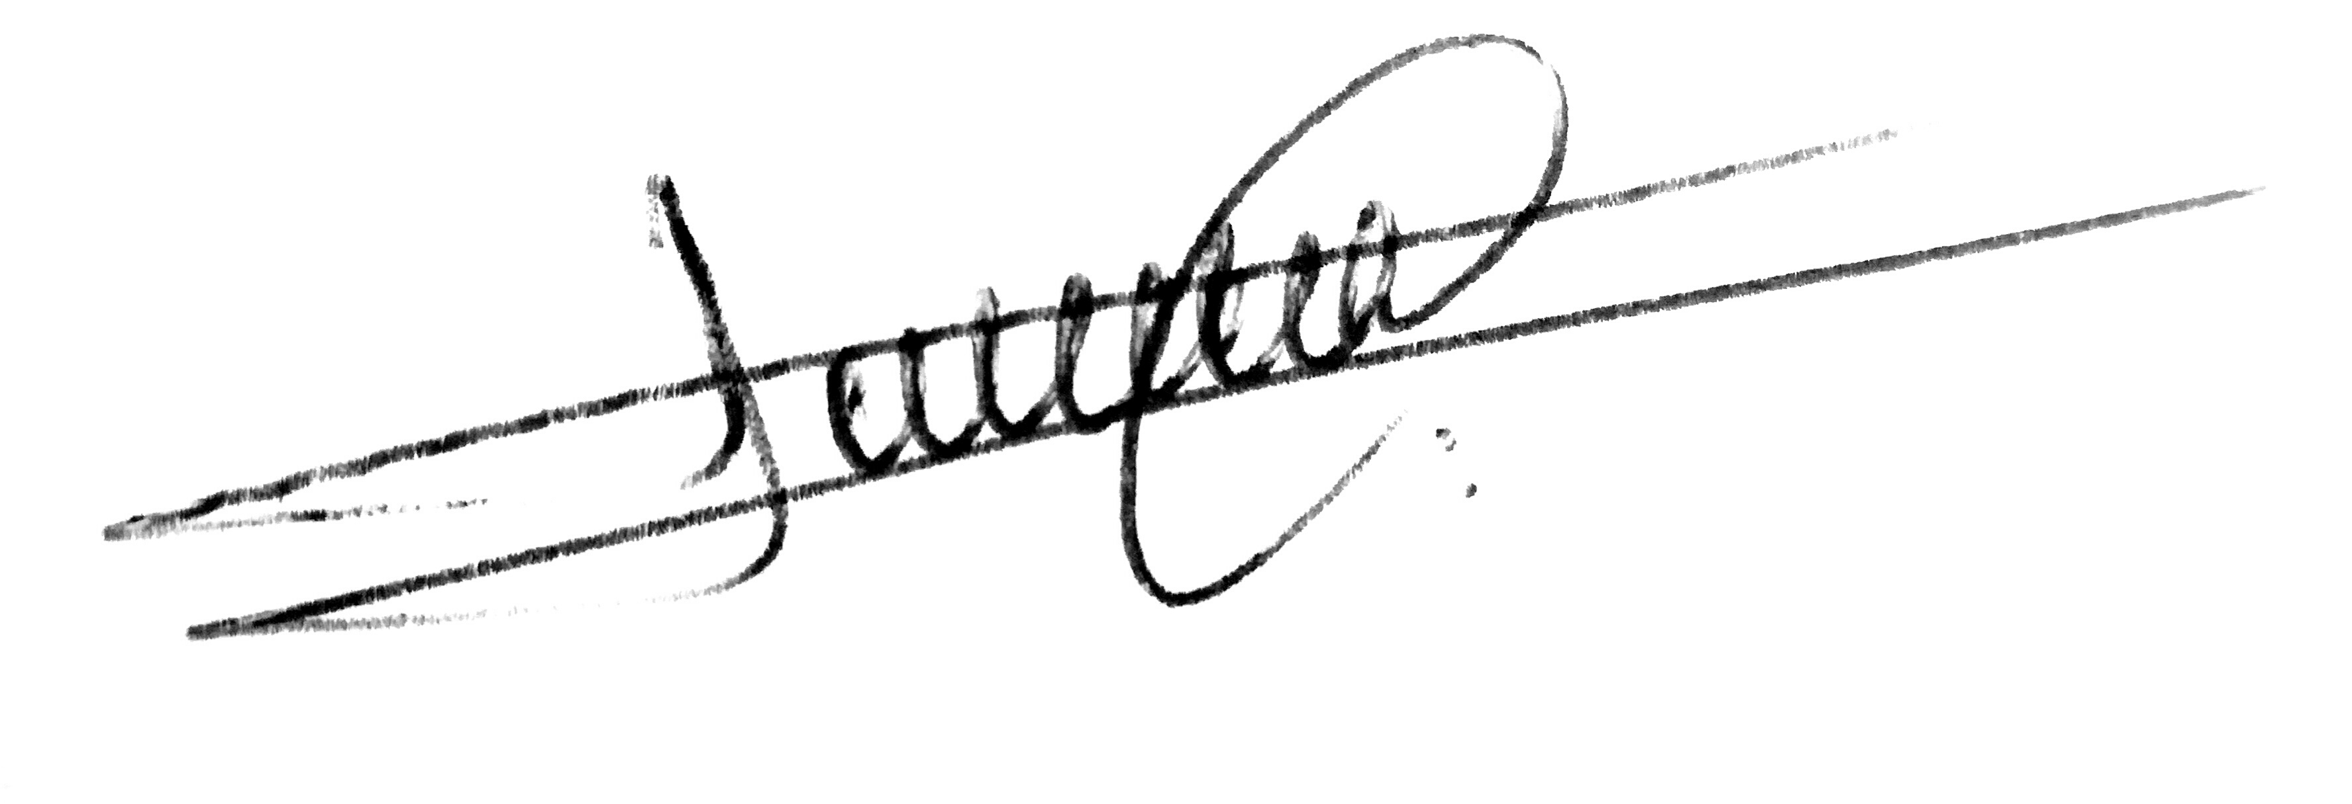

Signed

(Student) Date: 07/01/2021

Signed

(Supervisor) Date:

Signed (HOD) Date:

