# **Planning Document**

# Client Requirements

You are a part of a working group that develops digital resources for school students. Your team has been asked to develop a database and later implement it as a source of information to develop a mobile or web application.   
The database is to contain reference materials for students on three subjects: art, mathematics and technology. Each subject can have articles with biographies of the key people as well as articles on the major art objects, events and important concepts.

A sample data file is provided with this document (SampleData.xls).

The database can be accessed by administrators, tutors and students with various access levels.

The client would like the database to have the following functionality:

* Students should be able to:
  + Browse articles by category
  + Browse articles by a keyword in the title
* Tutors should be able to:
  + Add or modify articles
* Administrators should be able to:
  + Add, modify or remove articles

As a team, you have decided to use the Agile approach and perform development in iterations with client approval at the end of each iteration. After discussion with the client, the following iterations have been agreed on:

## Solution Design Decision

For the database we have decided as a group to use MySQL.

For the backend of the application, we have decided to use Python Django.

For the single page front end of the application, we decided to use Html and Python Html.

## Iteration 1: Developing System Design document

**14 November – 19 November 2021**

Analyse the data and create a Solution Design document outlining the architecture and database model. Also create appropriate User Access and UX Design documents to implement the database using a web application. For each part of the Solution Design document, provide reasons as to why you selected a particular technology or design.

|  |  |  |  |
| --- | --- | --- | --- |
| **Task:** | **Expected Completed Date:** | **Completed By:** | **Actual Completed Date:** |
| Analyse the data and create a Solution Design document | 17/11/2021 |  |  |
| Create appropriate User Access and UX Design documents | 19/11/2021 |  |  |

Screenshot of the Kanban board for iteration 1

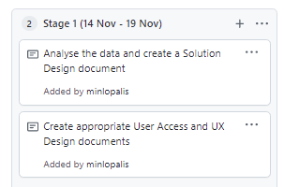

## Iteration 2: Developing the Database

**20 November – 25 November 2021**

Create the database in the approved database management system. Follow the approved database model to create the appropriate database structure. Enter the test data provided.

|  |  |  |  |
| --- | --- | --- | --- |
| **Task:** | **Expected Completed Date:** | **Completed By:** | **Actual Completed Date:** |
| Create the database in the approved database management system.  Follow the approved database model to create the appropriate database structure. | 23/11/2021 |  |  |
| Enter the test data provided | 25/11/2021 |  |  |

Screenshot of the Kanban board for iteration 2

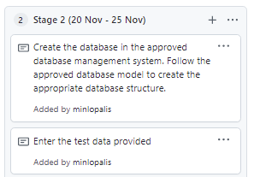

## Iteration 3: Developing Database Queries

**26 November – 30 November 2021**

Create and test the appropriate queries as per client requirements.

|  |  |  |  |
| --- | --- | --- | --- |
| **Task:** | **Expected Completed Date:** | **Completed By:** | **Actual Completed Date:** |
| Create and test the appropriate queries as per client requirements | 28/11/2021 |  |  |

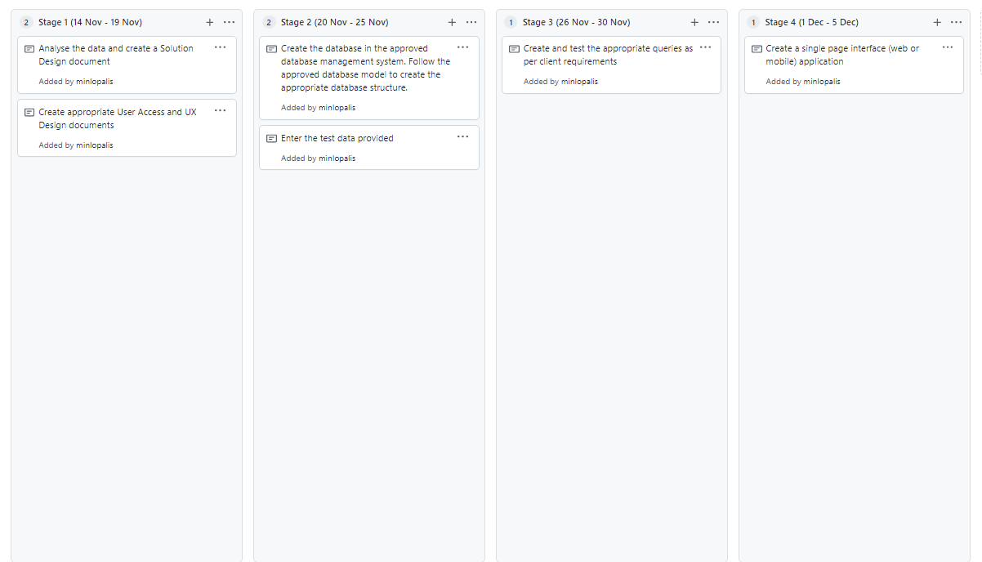

## Iteration 4: Implementing Database using Web Application

**1 December – 5 December 2021**

Create a single page interface (web or mobile) application to implement and test the client requirement for the database queries.

|  |  |  |  |
| --- | --- | --- | --- |
| **Task:** | **Expected Completed Date:** | **Completed By:** | **Actual Completed Date:** |
| Create a single page interface (web or mobile) application | 02/12/2021 |  |  |

