CS487 Project

GUI Deliverable

Group1

Kusuma Goli, Ange Veillon, Daniel Tiberi

Here is our submission for the GUI deliverable of the CS487 Project. You will find the html files of our application in the GetARide folder. Open them in your web browser to experience the GUI we developed for the app. Please note that most (if not all, except from the ones requesting the database for instance) of the buttons used to navigate between pages are fuctioning. To explain the architecture of the app, we also created a set of models using the draw.io website. This archi.drawio file contains them all and can be opened using the draw.io website. This Word document will also include screenshots of said models if you do not wish to open the archi file.

Do not forget to allow the webpage to see your location (you can also fake it in your browser console) so that the maps can display.

High level:

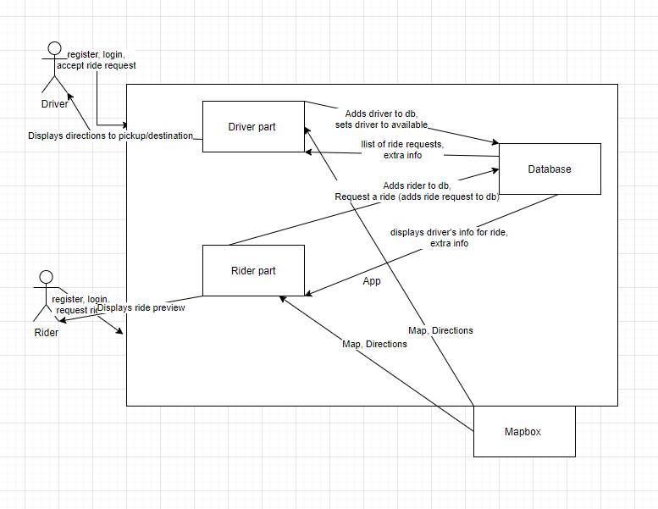

Main page:

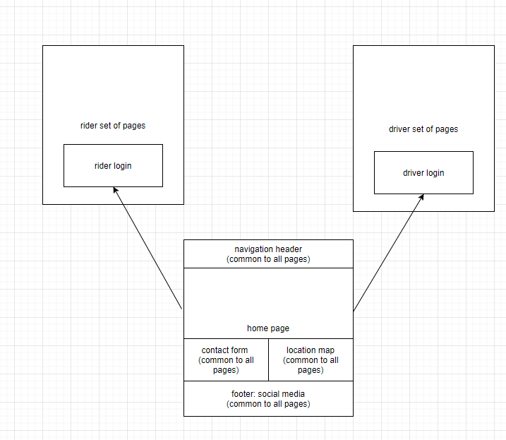

Rider:

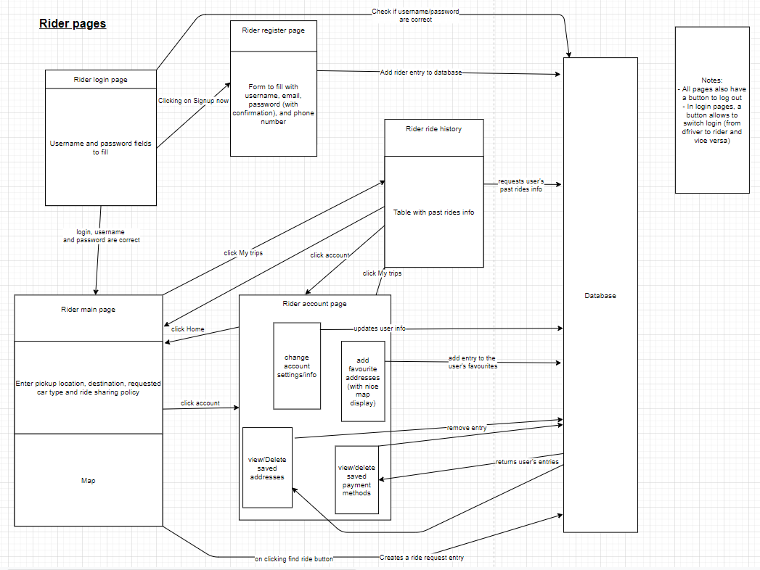

Driver:

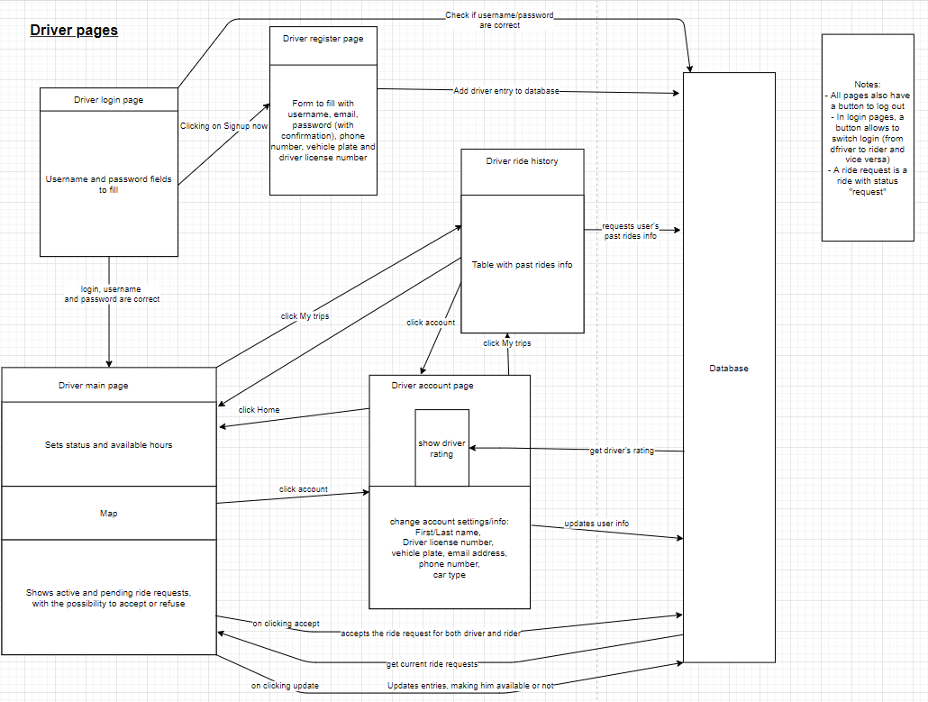

Ride request accepted:

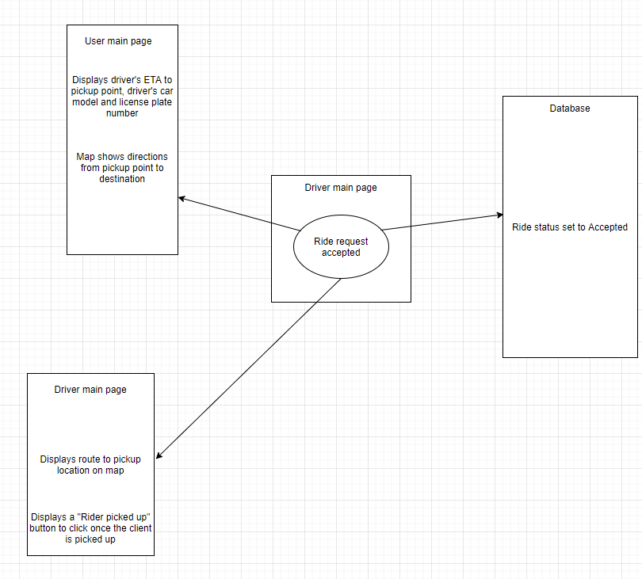

Client picked up:

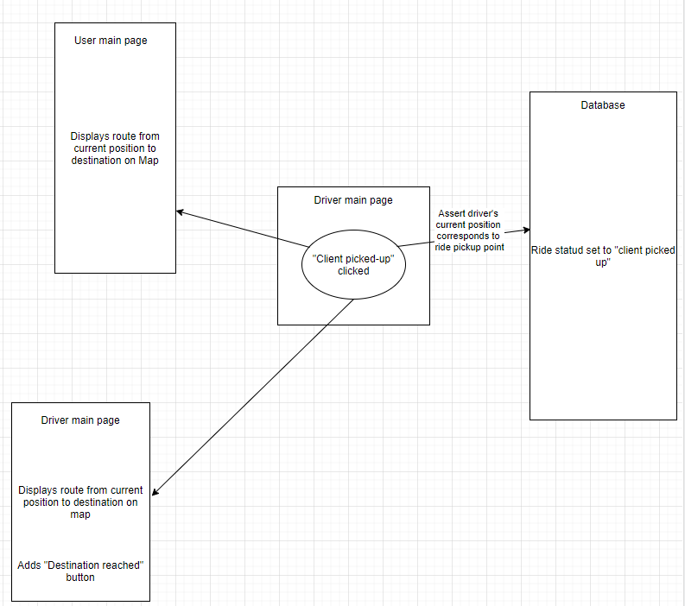

Ride completed:

