Solar Monitor
Developer Documentation
Architecture • Services • Data Model • API • Inverter Integration
dtitsolutions/solar-tracker — Version 1, June 2026

Contents

1. Introduction
Solar Monitor is a self-hosted, brand-agnostic dashboard for solar inverters. It polls one or more inverters on the local network, stores time-series readings, and serves a live web dashboard — with no dependency on the manufacturer's cloud. This document is for developers extending or operating the codebase; for plain installation see the Deployment & Operations Guide.

1.1 Design goals
- Local-first: read inverters directly over the LAN; the cloud is optional.
- Fault isolation: one OS process per inverter, so a single misbehaving device can't take down the fleet.
- Brand-agnostic core: inverter access sits behind a driver interface so new protocols slot in.
- Operable: Prometheus metrics, health endpoint, structured logs, and an in-app updater.

2. System Architecture
The system is a small set of containers orchestrated by Docker Compose. The browser only ever talks to the public web tier; the Python tier owns inverter access, persistence, and authentication.
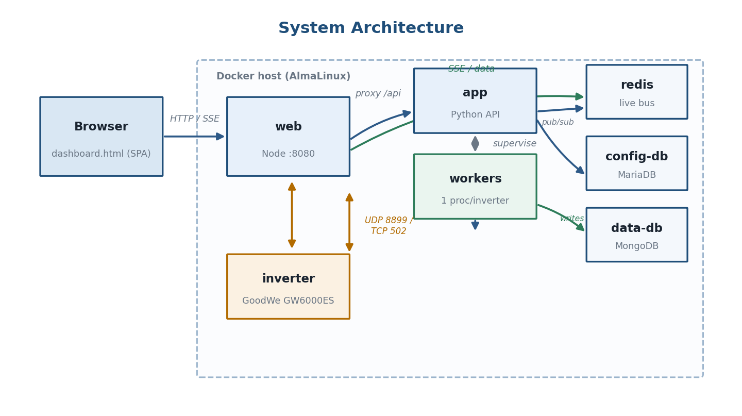
Figure 1 — Container topology and the connections between services.

2.1 Components
Service | Image / language | Responsibility
web | Node.js | Public HTTP :8080; serves dashboard.html, streams live data over SSE, proxies all other /api calls to the Python tier.
app | Python (stdlib http.server) | REST API, authentication, the inverter supervisor, and a mirror thread that pushes snapshots to Redis.
workers | Python (multiprocessing) | One child process per inverter: connect, poll, decode, persist, emit.
config-db | MariaDB | Users, roles, inverter definitions, settings.
data-db | MongoDB | Time-series readings.
redis | Redis | Low-latency live bus between the collector and the web tier.

2.2 Live data pipeline
Each poll cycle turns a raw inverter response into a normalized snapshot that is both stored (for history) and published (for live view).
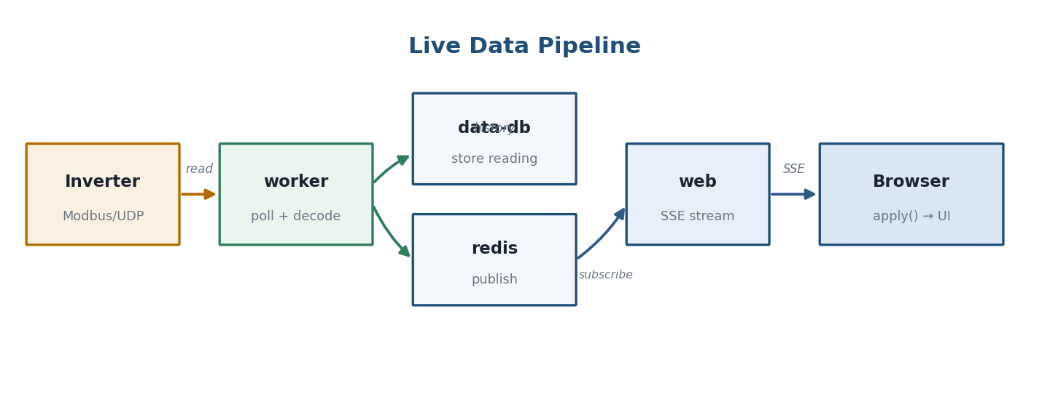
Figure 2 — From inverter read to browser render.
Path: a worker reads the inverter, decodes a snapshot, writes a reading document to MongoDB and publishes the snapshot to Redis; the web tier holds a Server-Sent-Events stream open to each browser and forwards new snapshots; the browser's apply() binds values to the UI.

2.3 Process & thread model (app container)
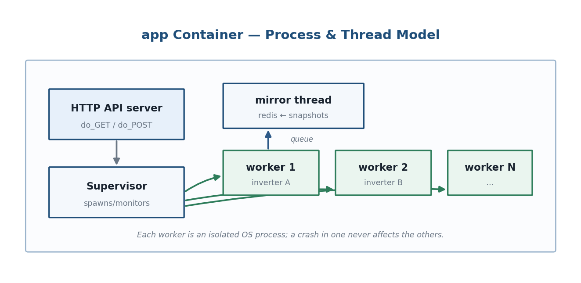
Figure 3 — The supervisor spawns isolated worker processes; the API server and mirror thread run alongside.
The supervisor (in solar_monitor.py) spawns and monitors one workers.py process per configured inverter. Workers hand snapshots back over a queue; a mirror thread relays the latest state to Redis. The HTTP API server runs in the main process. Because workers are separate OS processes, a crash or a wedged network read in one never blocks the others.

3. Technology Stack
Layer | Choice | Notes
Collector / API | Python 3 (stdlib) | http.server, multiprocessing, urllib — minimal dependencies
Inverter driver | goodwe (UDP) + Modbus TCP | pluggable per protocol
Web tier | Node.js | static serving + SSE + reverse proxy
Frontend | Vanilla JS + SVG | single dashboard.html, no build step
Config store | MariaDB | relational config/users
Data store | MongoDB | schema-light time series
Bus | Redis | pub/sub + last-state cache
Packaging | Docker Compose | one command up; image bakes the git SHA

4. Repository Layout
solar-tracker/
├─ solar_monitor.py # API, auth, supervisor, mirror, /metrics, /healthz
├─ workers.py # process-per-inverter: poll loop, daily() energy
├─ config_store.py # MariaDB: users, inverters, settings
├─ data_store.py # MongoDB: insert_reading, series()
├─ logsetup.py # structured logging + action/audit log
├─ dashboard.html # entire frontend (HTML/CSS/JS/SVG)
├─ cli.py # standalone single-inverter diagnostic/reader
├─ lib/
│ └─ inverter_goodwe.py # GoodWe driver: connect() + SUMMARY map
├─ web/server.js # Node web tier (SSE + proxy)
├─ docker-compose.yml # the stack
├─ docker-compose.hostnet.yml # host-network override (LAN edge cases)
├─ Dockerfile # app image; ARG GIT_SHA -> ENV SM_DEPLOYED_SHA
├─ scripts/ # install-docker.sh, build.sh, update.sh, units, probe.py
└─ docs/ # this documentation

5. Service Reference

5.1 web/server.js (Node)
A thin public tier. It serves the dashboard, exposes the live endpoints from Redis, and proxies everything else to the Python API (which enforces its own auth).
- GET / → dashboard.html.
- GET /api/stream → Server-Sent Events; emits the current snapshot then each update from Redis.
- GET /api/data → the latest snapshot as JSON (one-shot).
- Catch-all → reverse-proxy to app:8080; the Python tier handles auth and returns 401 when needed.

5.2 solar_monitor.py (API + supervisor)
The heart of the Python tier. Built on the standard-library HTTP server.

Request handling & auth
- do_GET / do_POST dispatch on path. /api/login is handled before the auth gate; all other routes require a valid session.
- self._authed() validates the session cookie; self._user() returns the username; config_store.is_admin(self._user()) gates admin-only routes.
- self._json(code, payload), self._read_json(), self._send(code, ctype, body) are the response helpers.

Supervisor & mirror
- On startup it loads inverters from config and spawns a worker per inverter; it restarts a worker that dies and reaps it on shutdown.
- A mirror thread reads the newest per-inverter snapshot and writes combined live state to Redis for the web tier.

Update endpoints
- check_for_update() calls the GitHub commits API (token-aware), compares to the deployed SHA; update_version() returns the deployed SHA only (no internet); request_update() writes the trigger file.

5.3 workers.py (per-inverter process)
Each worker owns exactly one inverter. Pseudocode of the loop:
driver = lib.get_driver(brand)
inverter = loop.run_until_complete(driver.connect(ip, retries=3))
while not stop.is_set():
raw = loop.run_until_complete(inverter.read_runtime_data())
snap = normalize(raw) # ppv, house_consumption, active_power, ...
data_store.insert_reading(inv_id, snap) # history
daily(snap) # today's energy + grid integration
emit(snap, meta) # -> supervisor queue -> redis
stop.wait(poll_interval)
- daily() maintains today's generation/consumption (native counters) and integrates measured grid power into import/export; it resets at local midnight.
- _seed_grid_today() runs once on (re)start: it integrates today's already-logged readings so a mid-day restart doesn't zero the day's grid totals.

5.4 config_store.py (MariaDB) & data_store.py (MongoDB)
- config_store: users (hashed passwords, role), inverters (id, nickname, brand, ip), and settings; helpers like is_admin(), set_password().
- data_store: insert_reading(inverter_id, snap) maps active_power → grid_power_w (+import/−export) and stores recorded_at in UTC; series(inverter_id, since, until, limit) returns rows oldest-first for history and seeding.

5.5 lib/inverter_goodwe.py (driver)
Exposes async connect(ip, retries) and a SUMMARY map of the sensor ids the dashboard cares about. The connect routine tries an explicit family hint (SM_GOODWE_FAMILY), then auto-detect, then a sweep of ES/ET/EH/DT/BP/EM — making GoodWe's flaky discovery reliable. See Section 7 for the Modbus-TCP path.

6. Data Model

6.1 Reading snapshot (normalized keys)
The canonical keys produced by a worker and consumed by the dashboard:
Key | Meaning | Sign / unit
ppv | PV / solar power | W
house_consumption | House load | W
active_power | Grid power | + import / − export, W
pbattery1 | Battery power | + charge / − discharge, W
battery_soc | Battery state of charge | %
e_day | Generation today | kWh
e_load_day | Consumption today | kWh
e_total | Lifetime generation | kWh
temperature | Inverter temperature | °C

6.2 MongoDB reading document
{ inverter_id: <id>,
recorded_at: <UTC ISO>, // indexed for range queries
grid_power_w: <+imp/-exp>, // derived from active_power
solar_power_w, load_power_w, battery_power_w, battery_soc, ... }

6.3 Redis live state
The mirror thread keeps the newest combined snapshot under a well-known key and publishes updates on a channel the web tier subscribes to. The web tier never reads the databases directly.

7. HTTP API Reference
All routes are served by the Python tier (proxied through the web tier). JSON in/out. Admin-only routes return 403 for non-admins; unauthenticated requests return 401.
Method & path | Auth | Purpose
POST /api/login | public | create a session
POST /api/logout | user | end the session
GET /api/me | user | current user + role
GET /api/data | user | latest snapshot
GET /api/stream | user | SSE live stream
GET /api/history | user | windowed time-series for the chart
GET /api/inverters | user | list inverters
POST /api/inverters | admin | add / edit / remove an inverter
GET/POST /api/users… | admin | user administration
GET /api/settings | user | server settings
GET /api/update/check | admin | compare deployed vs GitHub
GET /api/update/version | admin | deployed SHA (no internet)
POST /api/update/apply | admin | trigger a self-update
GET /metrics | open* | Prometheus metrics
GET /healthz | open* | health probe
* metrics/health are intended for an internal network; restrict at the reverse proxy if exposed.

8. Inverter Integration
The most important — and most device-specific — part of the system. GoodWe dongles speak one of two local protocols depending on generation.
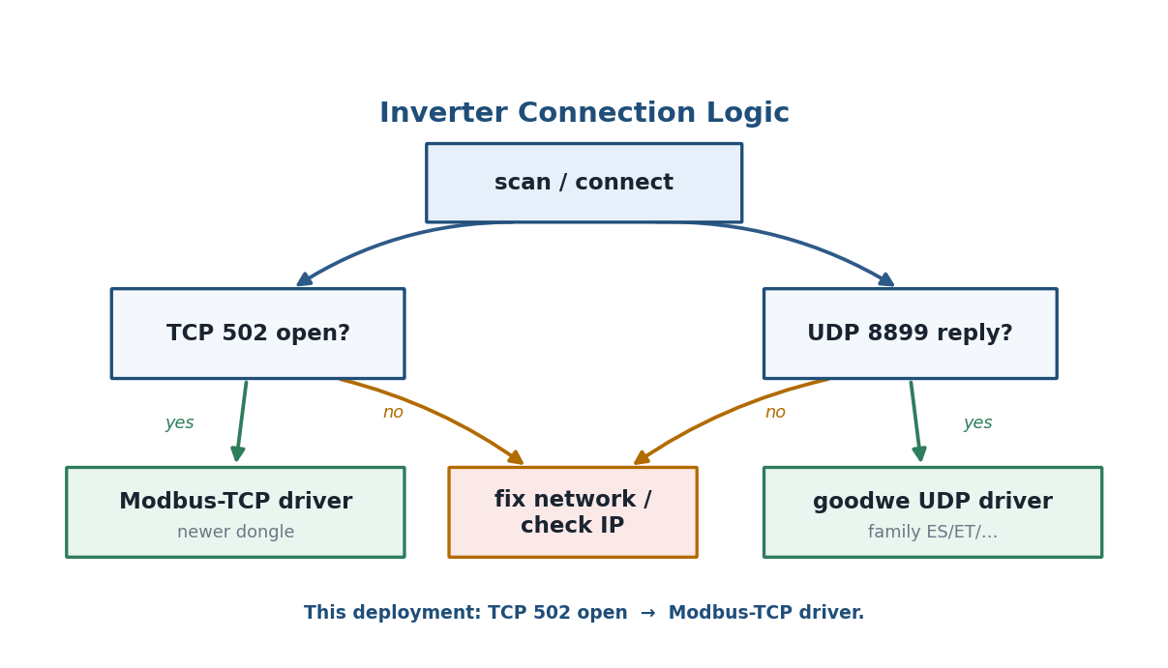
Figure 4 — Choosing the driver from what the dongle exposes.

8.1 Protocols
Protocol | Transport | Framing | Library / code
GoodWe UDP | UDP 8899 | AA55 (ES) or Modbus-RTU-over-UDP (ET) | goodwe package
Modbus TCP | TCP 502 | Modbus TCP (MBAP + PDU) | custom reader (cli.py / planned driver)

8.2 connect() strategy (UDP)
order = [hint] if hint else []
order += [None] # auto-discovery
order += ['ES','ET','EH','DT','BP','EM'] # ES first (GW####ES)
for fam in order:
try: return goodwe.connect(host, family=fam, timeout, retries)
except: keep trying

8.3 Modbus TCP (newer dongles)
Newer dongles — the kind the SEMS+ app connects to locally — answer on TCP 502 with Modbus. A read is an MBAP header + PDU (function 3). Device info lives at 0x88B8 (model, serial at byte offset 6, rated power); running data starts at 0x891C; battery SoC is in the BMS block (0x908F). The device-info serial provides a built-in decode check.
# Modbus-TCP read (function 3), no external deps
pdu = struct.pack('>BHH', 0x03, start, qty)
adu = struct.pack('>HHHB', 1, 0, len(pdu)+1, unit) + pdu # unit 0xF7
# response: MBAP(7) + func(1) + bytecount(1) + data

8.4 Adding a driver
Drivers live in lib/ and are resolved by lib.get_driver(brand). A driver provides an async connect(ip, retries) returning an object with read_runtime_data(), sensors(), model_name and serial_number. To add Modbus-TCP support, implement a driver that wraps the reads above and normalizes to the keys in Section 6.1.

9. Energy & Sign Conventions
- Grid active_power: positive = importing from grid, negative = exporting.
- Battery pbattery1: positive = charging, negative = discharging.
- Daily import/export are integrated from measured grid power (not the inverter's native daily counters, which are unreliable on this ES unit), and seeded from logged data on restart.
- Generation/consumption today use the inverter's native e_day / e_load_day counters.

10. Frontend Architecture
The whole UI is one dashboard.html — HTML, CSS and vanilla JS, no build step. It is a single-page app with an admin shell (sidebar + topbar + content).
- Pages: showPage(id) toggles .page.active (Dashboard, History, Fleet, Inverter Info, Settings).
- Live binding: apply(snapshot) updates KPI cards, the flow diagram, and the 3D house from one data object so the views never disagree.
- Flow views: a toggle switches the circles diagram and the isometric 3D house; the choice is remembered in localStorage.
- Updates UI: an admin-only Updates panel and a global banner call the update endpoints, with a browser-side GitHub fallback.
- Verification: the frontend is checked with node --check and a DOM-shim harness that loads the script and asserts no init errors.

11. Authentication & Roles
Sessions are cookie-based and validated on every request by the Python tier. Two roles: admin (full control, including users, inverters and updates) and user (read the dashboard). The default admin/admin must be changed on first login. Non-admin UI is hidden via a body.role-user CSS class and enforced server-side.

12. Build, Deploy & Self-Update
The image bakes the current commit via Dockerfile ARG GIT_SHA → ENV SM_DEPLOYED_SHA, so the running app knows its own version. build.sh passes GIT_SHA=$(git rev-parse HEAD).
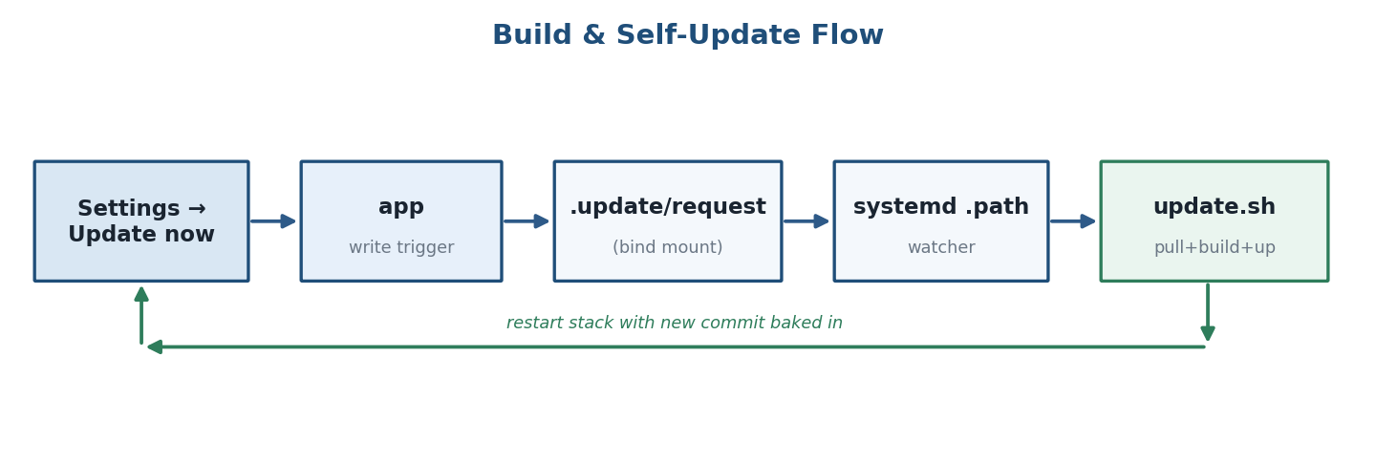
Figure 5 — A container can't rebuild itself, so the app signals a host-side watcher.
On "Update now", the app writes .update/request (a bind-mounted directory). A systemd .path unit watches that file and runs update.sh: git pull → docker compose build → up -d, then records the new SHA and clears the trigger. No Docker socket is exposed to the container.

13. Observability
- /metrics — Prometheus counters/gauges (poll success/failure, connection state, last-read age).
- /healthz — liveness/health for probes and uptime checks.
- Structured logs via logsetup.py, including an action/audit log for admin operations (logins, user changes, update requests).

14. Testing & Verification
The sandbox used to build this has no network, Docker or real databases, so verification leans on fast static and stand-in checks:
- python -m py_compile for every Python module.
- node --check on the extracted dashboard script.
- A DOM-shim harness that loads the dashboard JS against mock elements/fetch and asserts initialization runs without errors and dropdowns populate.
- In-memory stand-ins for config_store/data_store, and unit tests for the tricky logic (grid-seeding integration, SHA comparison, Modbus framing/decoding).

15. Extending the System
- New inverter brand/protocol: add a driver under lib/ and register it with lib.get_driver; normalize to the Section 6.1 keys.
- New dashboard view: add a .page, a nav item with data-page, and bind data in apply().
- New metric: emit it from the worker snapshot and expose it on /metrics.
- Run from source: use cli.py to validate inverter access before wiring a new driver into the stack.

16. Appendix — Environment Variables
Variable | Default | Purpose
SM_GOODWE_FAMILY | (empty) | Force a UDP protocol family (e.g. ES)
SM_GOODWE_TIMEOUT | 2 | Per-read timeout (s)
SM_GITHUB_REPO | dtitsolutions/solar-tracker | Repo the updater checks
SM_GITHUB_BRANCH | main | Branch tracked
SM_GITHUB_TOKEN | (empty) | Token for a private repo
SM_DEPLOYED_SHA | (build arg) | Commit baked into the image
SM_UPDATE_TRIGGER | /app/.update/request | Self-update trigger file
SM_OFFLINE_TIMEOUT_SECONDS | 120 | Mark an inverter offline after silence
— End of developer documentation —

