BeanDefinitionReader

BeanFactoryPostProcessor
default Object postProcessBeforeInitialization(Object bean, String beanName) throws BeansException {
return bean;
}
default Object postProcessAfterInitialization(Object bean, String beanName) throws BeansException {
return bean;
}

BeanFactoryProcessor

BeanFactory，FactoryBean
接口，都是用来生产对象
BeanFactory生产大量对象
生产一个固定的复杂的对象使用FactoryBean

Springboot启动原理
SpringApplication.run(BootApplication6990.class, args);

public static ConfigurableApplicationContext run(Class<?> primarySource, String... args) {
return run(new Class<?>[] { primarySource }, args);
}

public static ConfigurableApplicationContext run(Class<?>[] primarySources, String[] args) {
return new SpringApplication(primarySources).run(args);
}

public SpringApplication(ResourceLoader resourceLoader, Class<?>... primarySources) {
this.resourceLoader = resourceLoader;
Assert.notNull(primarySources, "PrimarySources must not be null");
this.primarySources = new LinkedHashSet<>(Arrays.asList(primarySources));
this.webApplicationType = WebApplicationType.deduceFromClasspath();
setInitializers((Collection) getSpringFactoriesInstances(ApplicationContextInitializer.class));
setListeners((Collection) getSpringFactoriesInstances(ApplicationListener.class));
this.mainApplicationClass = deduceMainApplicationClass();
}
setInitializers((Collection) getSpringFactoriesInstances(ApplicationContextInitializer.class));
setListeners((Collection) getSpringFactoriesInstances(ApplicationListener.class));
读取全部spring.factories文件，取出其中的ApplicationContextInitializer初始化器（7个）和ApplicationListener监听器（11个）。
以上只是创建了一个SpringApplication对象，new SpringApplication(primarySources).run(args);还没有执行run()

自动装配

springboot启动主函数注解
@SpringBootApplication包含注解@EnableAutoConfiguration开启自动配置

@EnableAutoConfiguration
@ComponentScan(excludeFilters = { @Filter(type = FilterType.CUSTOM, classes = TypeExcludeFilter.class),
@Filter(type = FilterType.CUSTOM, classes = AutoConfigurationExcludeFilter.class) })
public @interface SpringBootApplication

使用
@Import(AutoConfigurationImportSelector.class)
public @interface EnableAutoConfiguration

AutoConfigurationImportSelector类中方法：
@Override
public String[] selectImports(AnnotationMetadata annotationMetadata) {
if (!isEnabled(annotationMetadata)) {
return NO_IMPORTS;
}
AutoConfigurationMetadata autoConfigurationMetadata = AutoConfigurationMetadataLoader
.loadMetadata(this.beanClassLoader);
AutoConfigurationEntry autoConfigurationEntry = getAutoConfigurationEntry(autoConfigurationMetadata,
annotationMetadata);
return StringUtils.toStringArray(autoConfigurationEntry.getConfigurations());
}

方法getAutoConfigurationEntry：
protected AutoConfigurationEntry getAutoConfigurationEntry(AutoConfigurationMetadata autoConfigurationMetadata,
AnnotationMetadata annotationMetadata) {
if (!isEnabled(annotationMetadata)) {
return EMPTY_ENTRY;
}
AnnotationAttributes attributes = getAttributes(annotationMetadata);
List<String> configurations = getCandidateConfigurations(annotationMetadata, attributes);
configurations = removeDuplicates(configurations);
Set<String> exclusions = getExclusions(annotationMetadata, attributes);
checkExcludedClasses(configurations, exclusions);
configurations.removeAll(exclusions);
configurations = filter(configurations, autoConfigurationMetadata);
fireAutoConfigurationImportEvents(configurations, exclusions);
return new AutoConfigurationEntry(configurations, exclusions);
}
List<String> configurations = getCandidateConfigurations(annotationMetadata, attributes);
protected List<String> getCandidateConfigurations(AnnotationMetadata metadata, AnnotationAttributes attributes) {
List<String> configurations = SpringFactoriesLoader.loadFactoryNames(getSpringFactoriesLoaderFactoryClass(),
getBeanClassLoader()); //扫描所有类路径下的META-INF/spring.factories文件
Assert.notEmpty(configurations, "No auto configuration classes found in META-INF/spring.factories. If you "
+ "are using a custom packaging, make sure that file is correct.");
return configurations;
}
把扫描到的文件封装成Properties类，再从Properties类中获取到EnableAuto Configuration.class的值加入到容器中
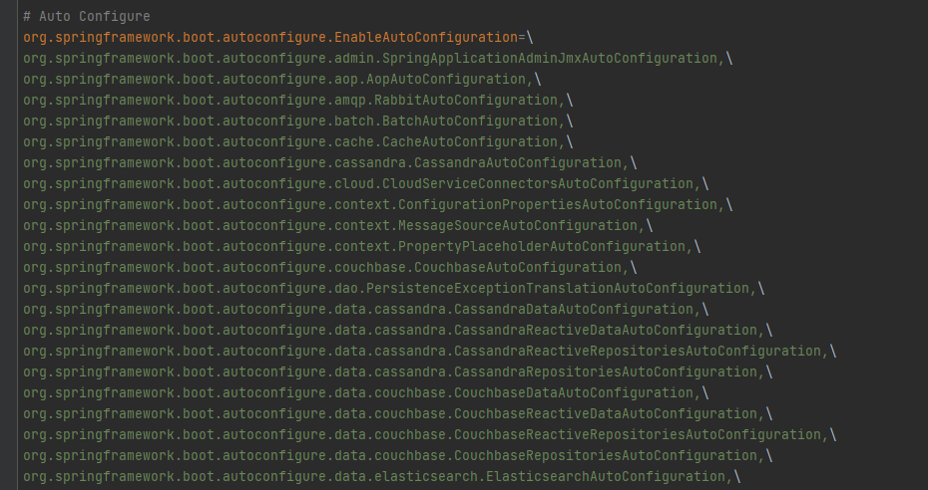
以HttpEncodingAutoConfiguration.class为例

@Configuration(proxyBeanMethods = false) 表示这是一个配置类，可以先容器中添加组件
@EnableConfigurationProperties(HttpProperties.class) 启用 指定类的ConfigurationProperties功能
@ConditionalOnWebApplication(type = ConditionalOnWebApplication.Type.SERVLET) 判断当前引用是否是WEB应用
@ConditionalOnClass(CharacterEncodingFilter.class) //判断当前项目有没有这个类，乱码过滤器
@ConditionalOnProperty(prefix = "spring.http.encoding", value = "enabled", matchIfMissing = true) 判断配置文件中是否存在某个属性，如果不存在也是成立的
public class HttpEncodingAutoConfiguration{
。。。
}
HttpProperties.class：
@ConfigurationProperties(prefix = "spring.http")
public class HttpProperties {
}

