Grab this script

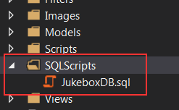

Connect to your SQL Server

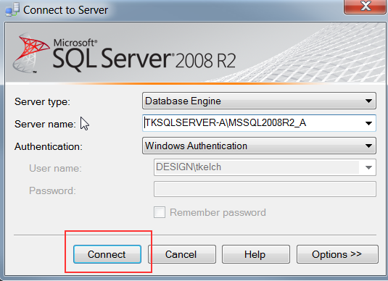

Make a new query

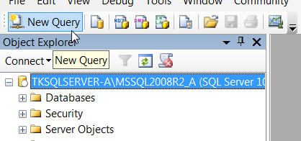

Open the script file in SSMS

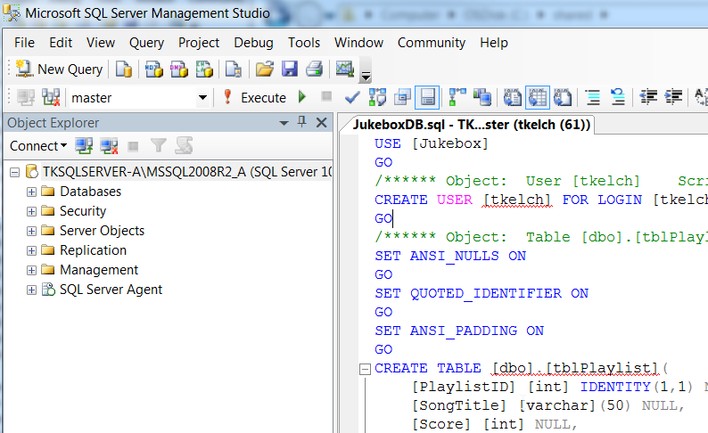

Then press the execute button

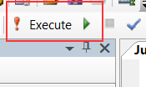

You can modify the script so you don’t use tkelch. Also, you’ll probably need to do some stuff to change the actual database. Google whatever errors you get.