Supplements

Supplementary methods

Trivial Filtering Taxa by Prevalence and Abundance
Removing trivial noise taxa in lab-specific longitudinal contaminant survey
# pseq is phyloseq object created from count table
require(phyloseq)
require(microViz)
pseq %>%
microViz::tax_filter(prev_detection_threshold = 2,
min_prevalence = 2,
min_total_abundance = 1e-6)

For true samples and NCT sampls in PDAC study:
# pseq_true: intratumor PDAC sample created from count table
pseq_true <- pseq_true %>%
microViz::tax_filter(min_prevalence = 1,
prev_detection_threshold = 2,
min_total_abundance = 1e-6)
# pseq_NCT: negative control corresponding for the study
pseq_NCT <- pseq_NCT %>%
microViz::tax_filter(min_prevalence = 1,
prev_detection_threshold = 2,
min_total_abundance = 5e-7)

Composite Score Calculation
Let be the putative contaminant set derived from the NCT survey, and be a set of taxa remained after a certain decontamination method. To be rigorous, we only consider taxa whose prevalence greater or equal 50% as putative true taxa in , denoted this set as 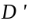. The formula for the metric yield and purity as follows:

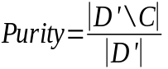
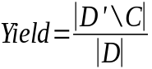

Thus, the composite score is:
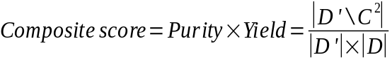

Supplementary figures
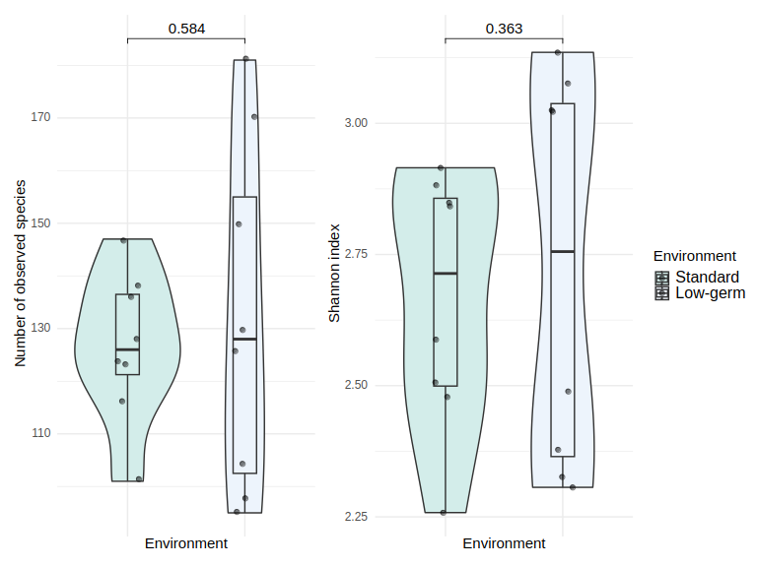
Fig. S1: Alpha diversity with respect to processing environment after adjusting effect of laboratory person. Low-germ environment includes sterile gloves, facial mask, working under the hood. Standard processing refers to working with standard gloves, no facial mask and at the bench. Multivariable negative binomial distribution for number of observed species and Gaussian distribution for Shannon index were applied.

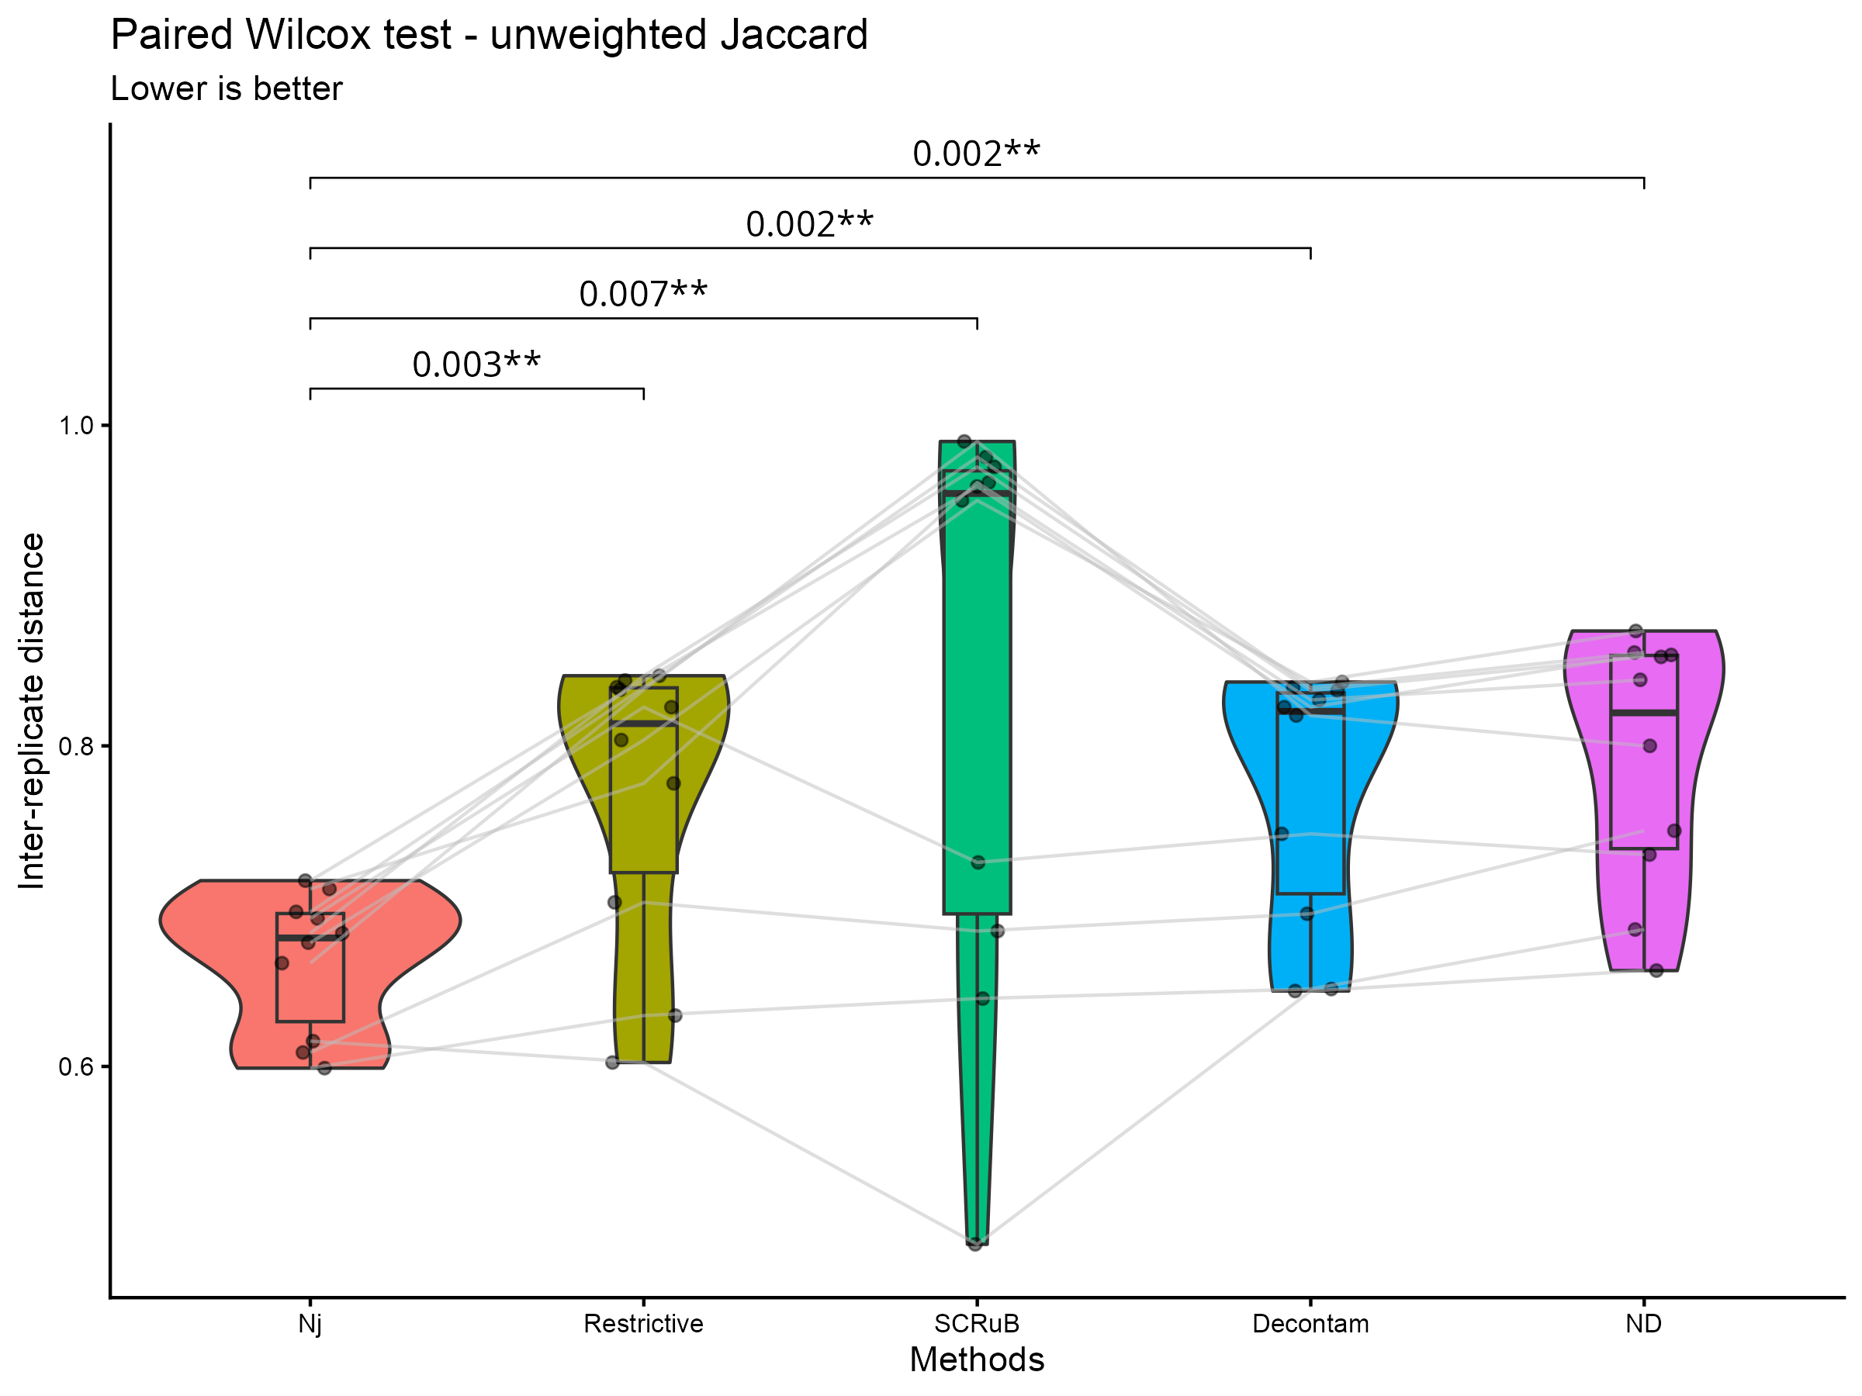
Fig. S2: Paired Wilcox-signed test of inter-replica distance using Jaccard distance of non-decontaminated samples (ND) and various decontamination methods. Nj – Nejman et al. approach

Fig. S3: Venn diagram showing the overlap of number of taxa in species level of paired formalin-fixed paraffin-embedded samples and two fresh frozen replicates. Rows are tumor samples and columns are decontamination methods.
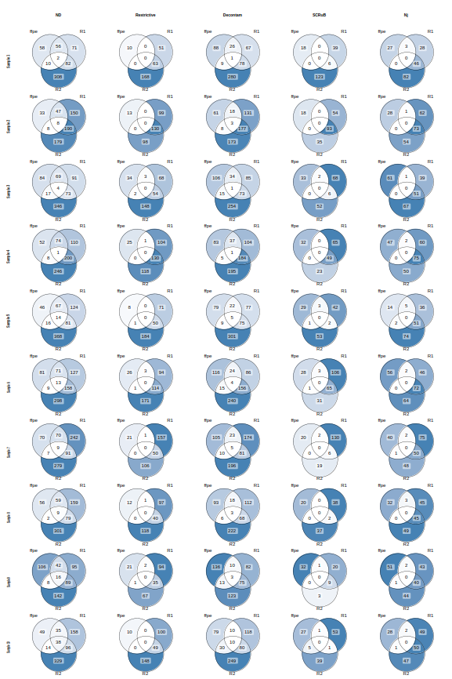

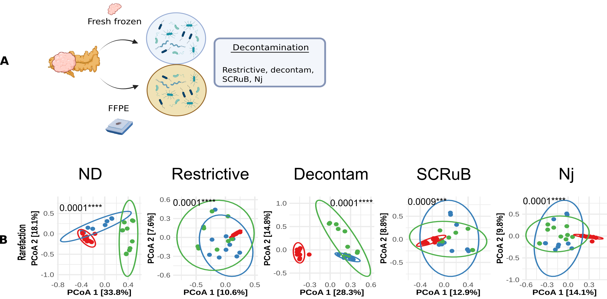Fig. S4: Experimental design and β diversity analyses from paired formalin-fixed paraffin embedded (FFPE) and fresh-frozen (FF) replicates of tumor samples. A) Schematic overview of the study design: Ten paired tumor from LSL-Kras^{G12D/+};LSL-Trp53^{R172H/+};Pdx-1-Cre (KPC) mice were profiled by whole 16S rRNA sequencing using both FF and FFPE samples from the sample tumors. Two independent sequencing runs were performed for the FF samples to generate technical replicates. B) Bray-Curtis dissimilarity of the two FF technical replicates and paired FFPE samples. Samples are colored and grouped by technical replicate. Analyses were performed using rarefaction as normalization. The plot is ordinated with Principal Coordinate Analysis (PCoA) and p-values were calculated by PERMANOVA.

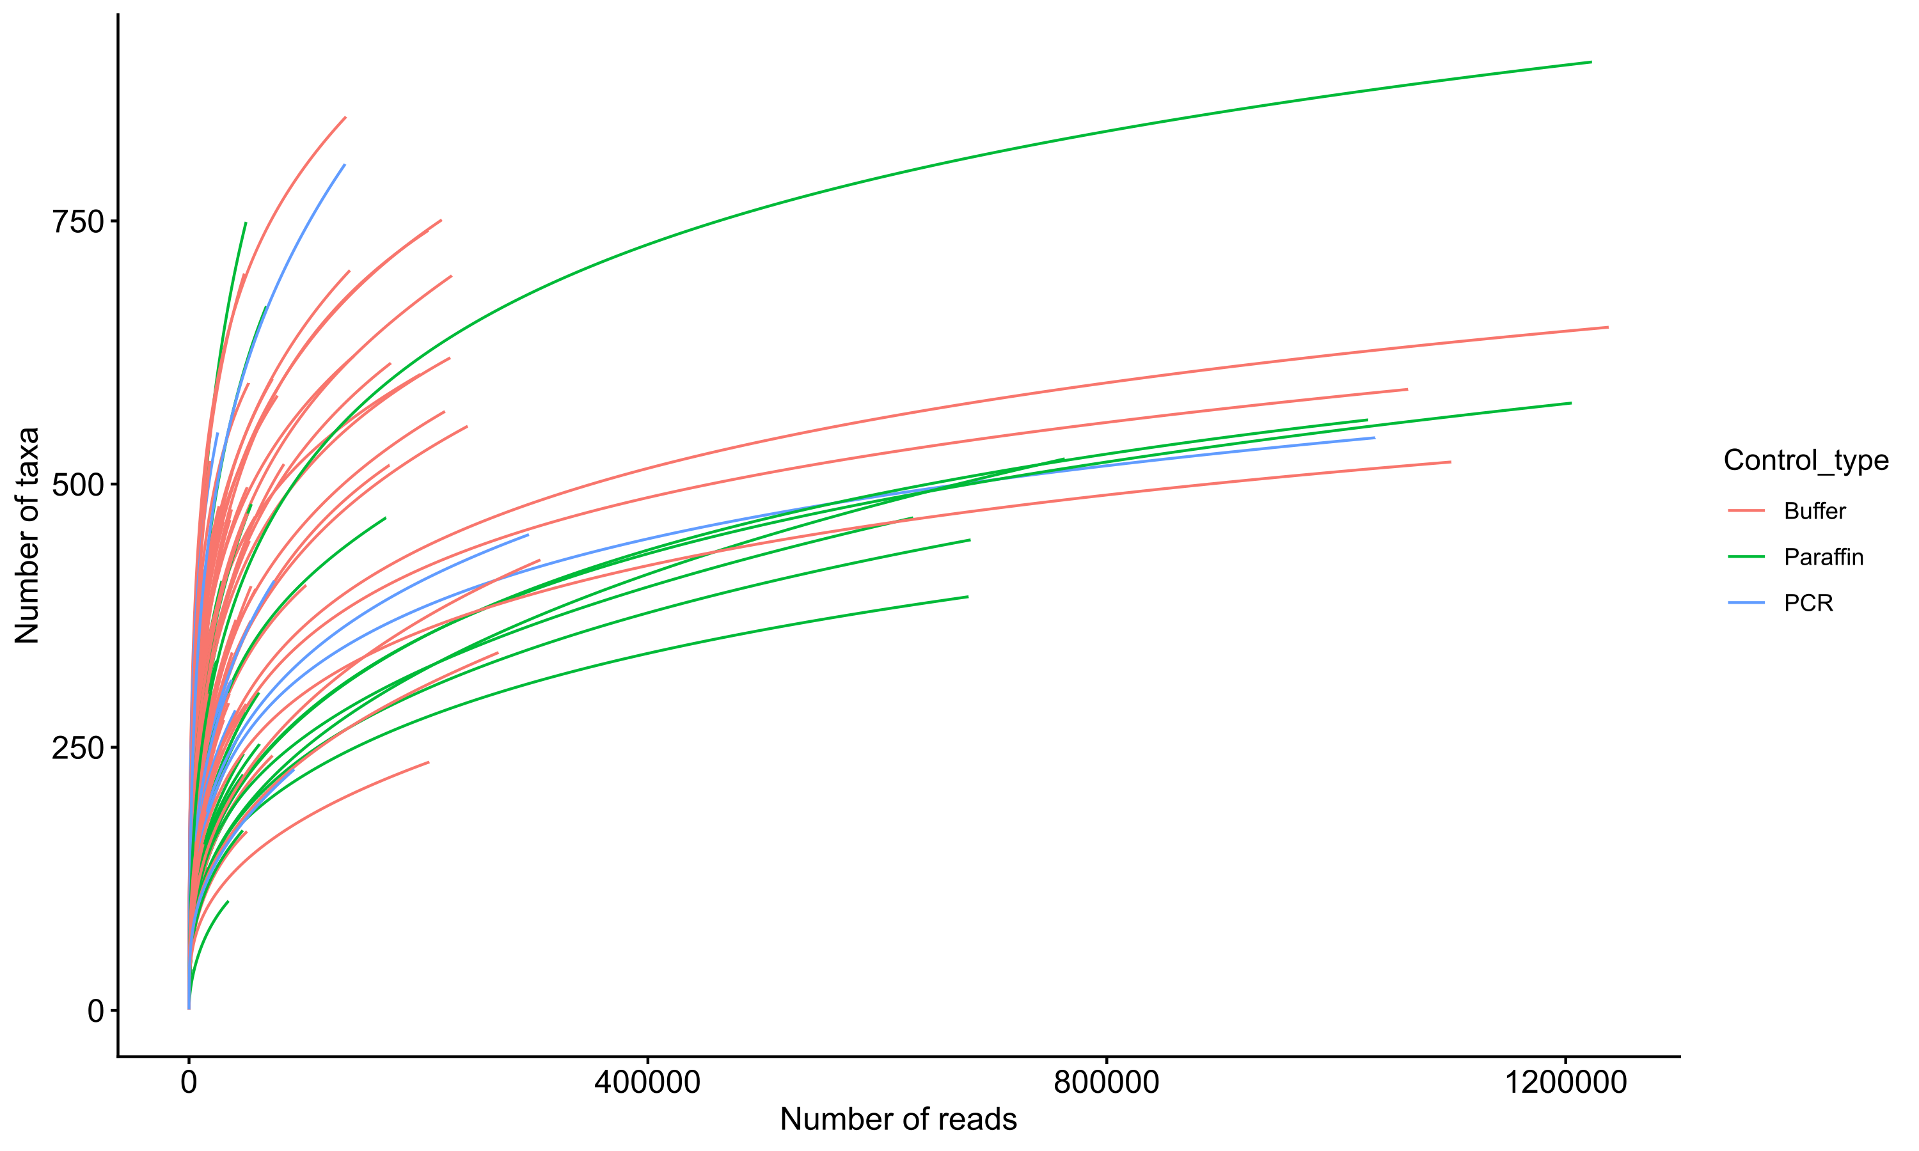
Fig. S5: Rarefaction curve for negative controls in the longitudinal contamination assessment. Y-axis shows the number of different species per sample. In total, 262 NCT are displayed that were included in the analysis. A prevalence filter was applied before (please refer to the results).

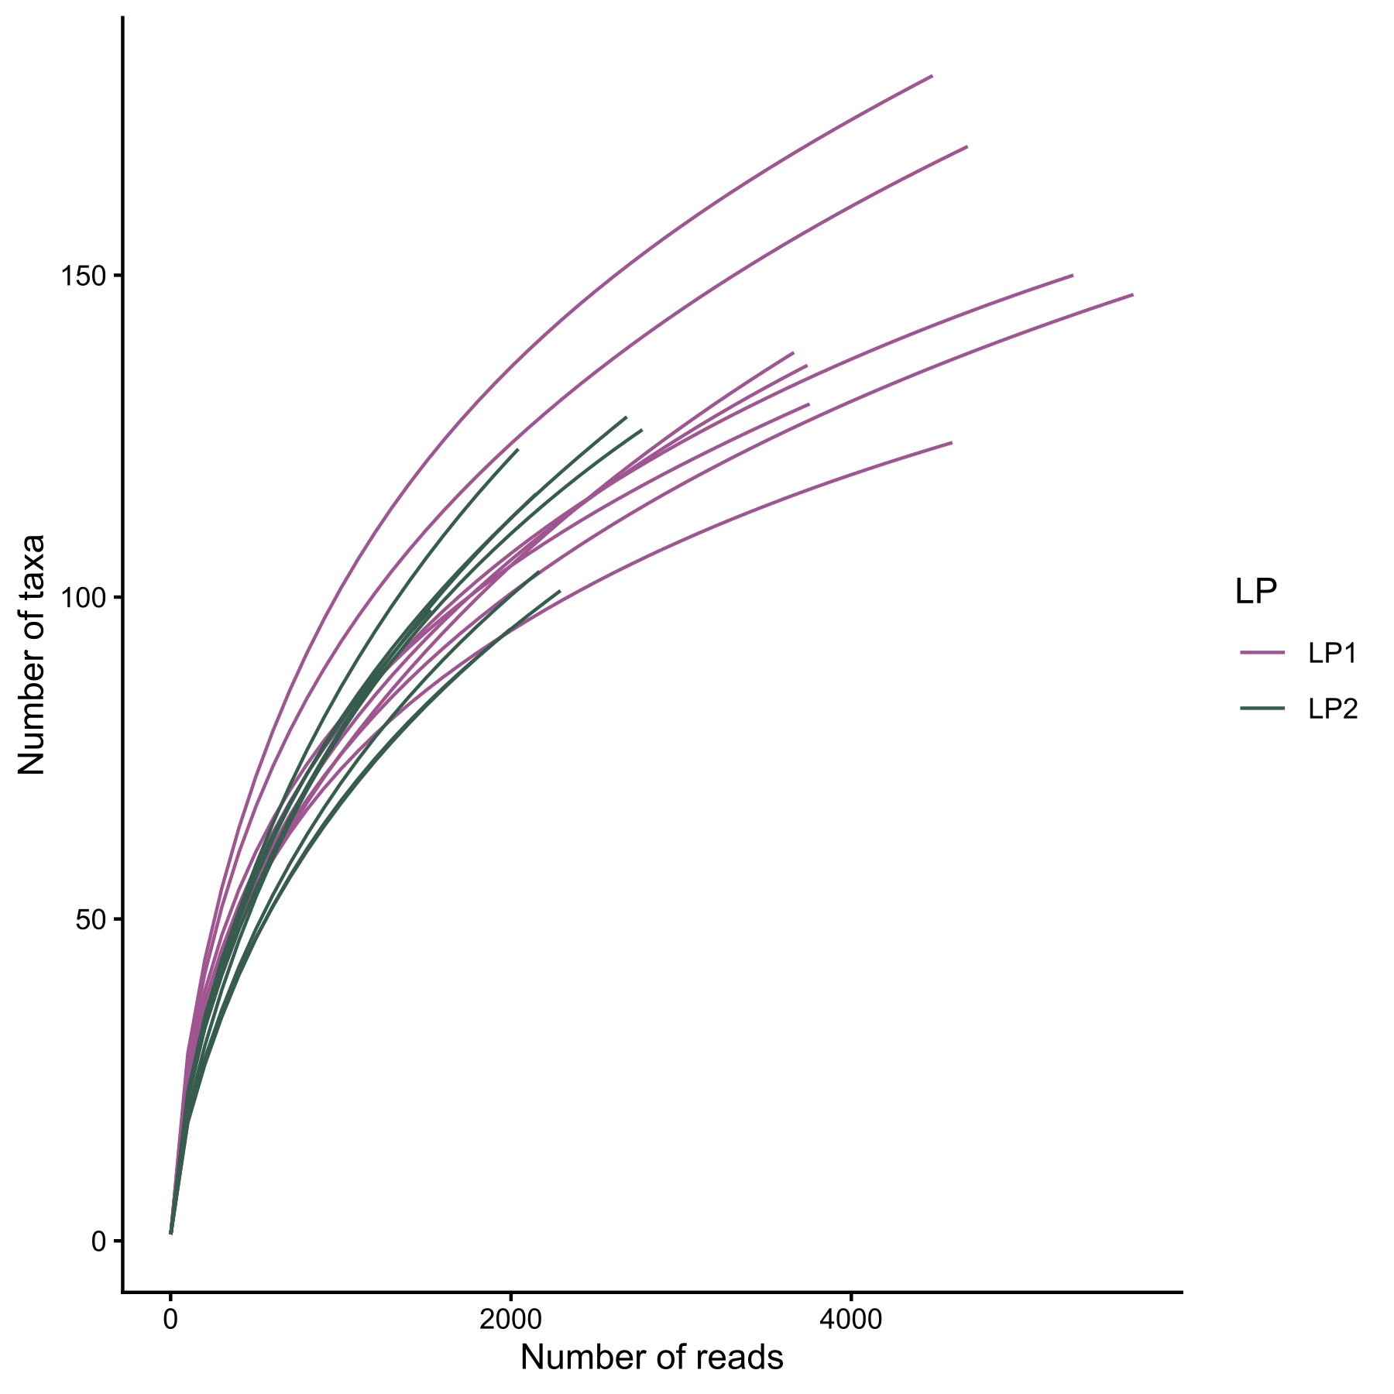
Fig. S6: Rarefaction curve in Laboratory person (LP)-Environment study. Y-axis shows the number of different species per sample.

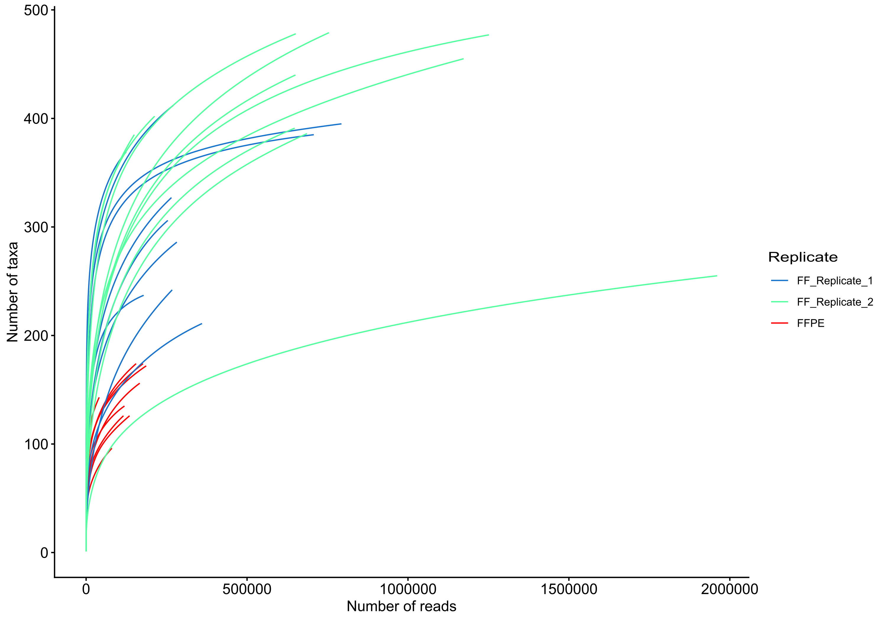
Fig. S7: Rarefaction curve of 30 samples from 10 tumor samples, including 2 fresh frozen (FF) replicates and paired formalin-fixed paraffin embedded (FFPE) samples.

Fig. S8: Barplot illustrating the determination of the prevalence cutoff in negative controls (NCT). The x-axis represents the prevalence of taxa in NCT, while the y-axis indicates the percentage of taxa in true samples that would be removed when applying the corresponding prevalence cutoff for filtering. Based on this analysis, a prevalence cutoff of 0.45 was considered a reasonable threshold for our study.
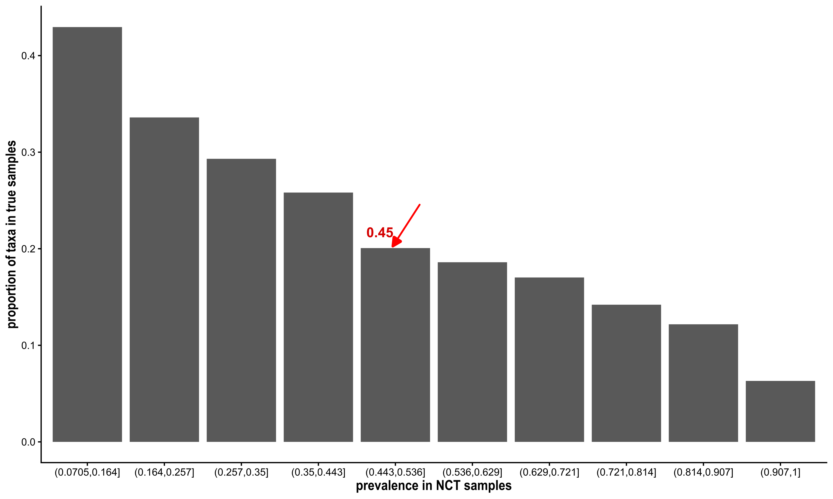

Supplementary tables

Table S1: Negative control samples collected across years, stratified by control types.
Control type ↓ Year → | 2021 | 2022 | 2023 | 2024 | 2025
Buffer | 26 | 67 | 17 | 38 | 19
Paraffin | 2 | 56 | 9 | 1 | 7
PCR | 0 | 4 | 4 | 8 | 4

Table S2 Alpha diversity was analyzed by control type, adjusting for laboratory personnel, year, and season. Observed species were modeled using multivariable negative binomial regression, while the Shannon index was modeled using multivariable gamma regression with a log-link. IRR – incidence rate ratio, LCL - lower confidence limit and UCL - upper confidence limit
Observed species | IRR | LCL | UCL | adj. p-value
Buffer - Paraffin | 0.81 | 0.65 | 1 | 0.05*
Buffer - PCR | 1.32 | 1.02 | 1.71 | 0.03*
Paraffin - PCR | 1.63 | 1.22 | 2.19 | <0.001***
Shannon index | exp(β) | LCL | UCL | adj. p-value
Buffer - Paraffin | 1 | 0.97 | 1.03 | 1
Buffer - PCR | 0.98 | 0.95 | 1.02 | 0.48
Paraffin - PCR | 0.98 | 0.94 | 1.02 | 0.55

Table S3: distance-based redundancy analyses for Bray-Curtis dissimilarity of negative controls with respect to a variable after adjusting the others. PERMANOVA test was applied.
Variable | adj. R² | adj. p-value
Control type | 0.02 | <0.001***
Person | 0.15 | <0.001***
Year | 0.07 | <0.001***
Season | 0.06 | <0.001***

Table S4: Top 30 genera by total abundance of all negative controls
Genera | Reads | Cumulative Proportion
Sphingomonas | 5134397 | 28.61
Caldibacillus | 3035664 | 45.52
Streptococcus | 1034676 | 51.28
Burkholderia | 605995 | 54.66
Fervidibacillus | 593031 | 57.97
Bradyrhizobium | 583338 | 61.22
Sporosarcina | 506091 | 64.03
Cutibacterium | 482878 | 66.73
Veillonella | 373869 | 68.81
Delftia | 367958 | 70.86
Bacillus | 295277 | 72.5
Staphylococcus | 247026 | 73.88
Variovorax | 195094 | 74.97
Haemophilus | 192174 | 76.04
Peptoniphilus | 149080 | 76.87
Niallia | 146140 | 77.68
Finegoldia | 140391 | 78.46
Caldifermentibacillus | 139994 | 79.24
Stenotrophomonas | 126861 | 79.95
Escherichia | 125426 | 80.65
Methylorubrum | 121398 | 81.33
Paracoccus | 93657 | 81.85
Anaerococcus | 91813 | 82.36
Gemella | 89796 | 82.86
Methylobacterium | 82573 | 83.32
Roseomonas | 82192 | 83.78
Clostridium | 80882 | 84.23
Neobacillus | 78431 | 84.67
Brucella | 73386 | 85.07
Achromobacter | 70440 | 85.47

Table S5: All species in NCT whose relative total abundance is at least 0.1%, sorted by the abundance.
Species | Prevalence | Abundance [%]
Caldibacillus__thermoamylovorans | 0.0700 | 16.91
Sphingomonas__paucimobilis | 0.5954 | 16.41
Sphingomonas__hankookensis | 0.7634 | 5.19
Fervidibacillus__albus | 0.0649 | 3.16
Sporosarcina__sp.__Marseille-Q4063 | 0.0840 | 2.80
Cutibacterium__acnes | 0.7863 | 2.55
Delftia__acidovorans | 0.3511 | 1.86
Sphingomonas__sp.__AAP5 | 0.7748 | 1.79
Veillonella__parvula | 0.4618 | 1.37
Bradyrhizobium__elkanii | 0.2252 | 1.28
Burkholderia__contaminans | 0.3473 | 1.24
Sphingomonas__alpina | 0.7290 | 1.22
Streptococcus__mitis | 0.6756 | 1.20
Variovorax__paradoxus | 0.2863 | 1.00
Streptococcus__oralis | 0.6870 | 0.94
Haemophilus__parainfluenzae | 0.3053 | 0.87
Bradyrhizobium__sp.__41S5 | 0.1527 | 0.85
Niallia__sp.__XMNu-256 | 0.0992 | 0.80
Finegoldia__magna | 0.2710 | 0.78
Caldifermentibacillus__hisashii | 0.0878 | 0.78
Streptococcus__thermophilus | 0.6565 | 0.71
Escherichia__coli | 0.6908 | 0.68
Sphingomonas__sp.__QA11 | 0.7672 | 0.66
Methylorubrum__extorquens | 0.2786 | 0.55
Sphingomonas__sp.__NY01 | 0.5076 | 0.54
Peptonophilus__genitalis | 0.2443 | 0.54
Sphingomonas__sanguinis | 0.4351 | 0.49
Roseomonas__mucosa | 0.1183 | 0.45
Bacillus__sp.__OxB-1 | 0.0954 | 0.44
Staphylococcus__epidermidis | 0.6145 | 0.42
Burkholderia__cenocepacia | 0.2901 | 0.41
Abiotrophia__defectiva | 0.2824 | 0.39
Streptococcus__pneumoniae | 0.6718 | 0.38
Neobacillus__sp.__PS3-40 | 0.0802 | 0.37
Sphingomonas__sp.__So64.6b | 0.7176 | 0.36
Staphylococcus__hominis | 0.4313 | 0.36
Bacillus__sp.__S3 | 0.0763 | 0.35
Bradyrhizobium__septentrionale | 0.1870 | 0.34
Burkholderia__cepacia | 0.2366 | 0.33
Macrococcus__equipercicus | 0.0573 | 0.32
Bradyrhizobium__quebecense | 0.1603 | 0.31
Bacillus__sp.__T3 | 0.0725 | 0.31
Burkholderia__aenigmatica | 0.2176 | 0.30
Sphingomonas__panacis | 0.7290 | 0.30
Brucella__anthropi | 0.1489 | 0.30
Gemella__haemolysans | 0.5038 | 0.30
Mesorhizobium__terrae | 0.3931 | 0.30
Granulicatella__adiacens | 0.4695 | 0.28
Methylobacterium__sp.__FF17 | 0.1565 | 0.25
Streptococcus__salivarius | 0.5802 | 0.24
Burkholderia__lata | 0.2748 | 0.24
Parvimonas__micra | 0.2672 | 0.24
Peribacillus__asahii | 0.1756 | 0.22
Prevotella__melaninogenica | 0.2328 | 0.21
Brevundimonas__sp.__PAMC22021 | 0.2137 | 0.20
Streptococcus__gordonii | 0.4504 | 0.20
Planococcus__versutus | 0.0687 | 0.20
Sphingomonas__sp.__HMP6 | 0.7099 | 0.20
Streptococcus__parasanguinis | 0.5038 | 0.20
Sphingomonas__sp.__CL5.1 | 0.5802 | 0.19
Burkholderia__glumae | 0.2901 | 0.19
Burkholderia__arboris | 0.2099 | 0.17
Priestia__filamentosa | 0.0763 | 0.17
Fenollaria__massiliensis | 0.1031 | 0.16
Anaerococcus__obesiensis | 0.1527 | 0.16
Veillonella__rogosae | 0.4122 | 0.16
Stenotrophomonas__sp.__KCTC__12332 | 0.0534 | 0.15
Peptoniphilus__harei | 0.2405 | 0.15
Ralstonia__sp.__RRA.1 | 0.3588 | 0.15
Paracoccus__contaminans | 0.2519 | 0.15
Veillonella__atypica | 0.3244 | 0.15
Blastococcus__sp.__PRF04-17 | 0.0534 | 0.15
Staphylococcus__aureus | 0.6374 | 0.15
Sphingomonas__sp.__NIBR02145 | 0.3702 | 0.14
Fervidibacillus__halotolerans | 0.0687 | 0.14
Veillonella__nakazawae | 0.3550 | 0.14
Stenotrophomonas__maltophilia | 0.4008 | 0.14
Clostridium__isatidis | 0.0802 | 0.14
Methylobacterium__indicum | 0.1641 | 0.14
Clostridium__chauvoei | 0.0802 | 0.13
Macrococcoides__caseolyticum | 0.0878 | 0.13
Aquabacterium__olei | 0.2328 | 0.13
Anaerococcus__sp.__Marseille-Q7828 | 0.2634 | 0.13
Cutibacterium__granulosum | 0.2214 | 0.13
Streptococcus__mutans | 0.2099 | 0.13
Streptococcus__sp.__FSL__W8-0197 | 0.5420 | 0.12
Bacillus__subtilis | 0.2137 | 0.12
Bacillus__smithii | 0.0687 | 0.12
Veillonella__sp.__S12025-13 | 0.3359 | 0.12
Sphingomonas__sp.__LK11 | 0.1374 | 0.12
Sphingomonas__sp.__FARSPH | 0.7061 | 0.12
Exiguobacterium__aurantiacum | 0.0725 | 0.12
Peptostreptococcus__equinus | 0.2023 | 0.12
Sphingomonas__melonis | 0.6832 | 0.12
Bradyrhizobium__sp.__200 | 0.2252 | 0.12
Stenotrophomonas__acidaminiphila | 0.0840 | 0.12
Achromobacter__xylosoxidans | 0.0802 | 0.12
Haemophilus__haemolyticus | 0.1832 | 0.11
Mogibacterium__diversum | 0.2786 | 0.11
Peptoniphilus__ivorii | 0.1374 | 0.11
Sphingopyxis__sp.__EG6 | 0.0802 | 0.11
Veillonella__dispar | 0.3511 | 0.11
Streptococcus__gwangjuense | 0.5382 | 0.11
Moraxella__osloensis | 0.4656 | 0.11
Gemella__morbillorum | 0.3855 | 0.11
Sphingomonas__sp.__R1 | 0.3473 | 0.11
Ureibacillus__sp.__FSL__K6-0786 | 0.0496 | 0.10
Blautia__wexlerae | 0.1374 | 0.10
Schaalia__odontolytica | 0.1221 | 0.10
Staphylococcus__warneri | 0.4695 | 0.10

Table S6: Alpha diversity analyses of LP and environment. Multivariable negative binomial distribution for number of observed species and multivariable linear regression for Shannon index were applied. IRR – incidence rate ratio, LCL - lower confidence limit, LP – laboratory person, UCL - upper confidence limit
Observed species | IRR | LCL | UCL | adj. p-value
LP1 - LP2 | 1.32 | 1.17 | 1.48 | <0.001***
Low-germ - standard | 0.97 | 0.86 | 1.09 | 0.58
Shannon | β | LCL | UCL | adj. p-value
LP1 - LP2 | 1.74 | 1.54 | 1.96 | <0.001***
Low-germ - standard | 0.95 | 0.84 | 1.07 | 0.35

Table S7: Distance-based redundancy analyses with respect to environment and laboratory person (LP), after adjusting effect of each other, with Bray Curtis dissimilarity metric.
Wrench w.r.t LP normalization + Bray-Curtis | adj. R² | adj. p-value
Environment | 0.05 | 0.245
LP | 0.46 | 0.005**
Rarefaction + Bray-Curtis | adj. R² | adj. p-value
Environment | 0.04 | 0.015*
LP | 0.68 | 0.005**

Supplementary Table S8: Pairwise comparison based on a Wilcoxon paired test for composite score among non-decontaminated samples (ND) and various decontamination methods. A one-sided p-test was applied with the alternative is set as "greater", comparing a method in row versus a method in a column. Nj – Nejman et al. approach
Approach | Nj | Restrictive | SCRuB | Decontam | ND
Nj | NA | <0.001*** | <0.001*** | <0.001*** | <0.001***
Restrictive | 1 | NA | <0.001*** | <0.001*** | <0.001***
SCRuB | 1 | 1 | NA | 1 | 1
Decontam | 1 | 1 | <0.001*** | NA | <0.001***
ND | 1 | 1 | <0.001*** | 1 | NA

Table S9: Pairwise comparison based on a Wilcoxon paired test for inter-replicate distance among non-decontaminated samples (ND) and various decontamination methods. The alternative is set as "less", comparing a method in row versus a method in a column. Nj – Nejman et al. approach
Approach | Nj | Restrictive | SCRuB | Decontam | ND
Nj | NA | 0.001** | 0.003** | 0.001** | 0.001**
Restrictive | 1 | NA | 0.08 | 0.003** | 0.001**
SCRuB | 1 | 1 | NA | 0.001** | 0.001**
Decontam | 1 | 1 | 1 | NA | 0.001**
ND | 1 | 1 | 1 | 1 | NA

Table S10: Pairwise comparisons among two fresh-frozen FF replicates and a formalin-fixed paraffin embedded FFPE replicate based on adonis2 with various normalization and decontamination methods. ND – Non-decontaminated, Nj – Nejman et al approach, R – Technical replicate
Normalization | Decontamination | Pair | R² | adj. p-value
Wrench | ND | R1_vs_R2 | 0.2517 | <0.001***
Wrench | ND | R1_vs_FFPE | 0.1513 | <0.001***
Wrench | ND | R2_vs_FFPE | 0.3125 | <0.001***
Wrench | Restrictive | R1_vs_R2 | 0.0737 | 0.0589
Wrench | Restrictive | R1_vs_FFPE | 0.1061 | <0.001***
Wrench | Restrictive | R2_vs_FFPE | 0.1068 | <0.001***
Wrench | Decontam | R1_vs_R2 | 0.1243 | 0.0017**
Wrench | Decontam | R1_vs_FFPE | 0.2864 | <0.001***
Wrench | Decontam | R2_vs_FFPE | 0.3285 | <0.001***
Wrench | SCRuB | R1_vs_R2 | 0.0639 | 0.1807
Wrench | SCRuB | R1_vs_FFPE | 0.0998 | <0.001***
Wrench | SCRuB | R2_vs_FFPE | 0.0915 | 0.0017**
Wrench | Nj | R1_vs_R2 | 0.0649 | 0.1384
Wrench | Nj | R1_vs_FFPE | 0.1250 | <0.001***
Wrench | Nj | R2_vs_FFPE | 0.1211 | <0.001***
Rarefaction | ND | R1_vs_R2 | 0.2430 | <0.001***
Rarefaction | ND | R1_vs_FFPE | 0.1678 | <0.001***
Rarefaction | ND | R2_vs_FFPE | 0.4010 | <0.001***
Rarefaction | Restrictive | R1_vs_R2 | 0.0726 | 0.0634
Rarefaction | Restrictive | R1_vs_FFPE | 0.0977 | <0.001***
Rarefaction | Restrictive | R2_vs_FFPE | 0.0949 | <0.001***
Rarefaction | Decontam | R1_vs_R2 | 0.1313 | 0.0036**
Rarefaction | Decontam | R1_vs_FFPE | 0.3547 | <0.001***
Rarefaction | Decontam | R2_vs_FFPE | 0.4007 | <0.001***
Rarefaction | SCRuB | R1_vs_R2 | 0.0603 | 0.2724
Rarefaction | SCRuB | R1_vs_FFPE | 0.1049 | <0.001***
Rarefaction | SCRuB | R2_vs_FFPE | 0.0955 | 0.0016**
Rarefaction | Nj | R1_vs_R2 | 0.0822 | 0.0608
Rarefaction | Nj | R1_vs_FFPE | 0.1472 | <0.001***
Rarefaction | Nj | R2_vs_FFPE | 0.1476 | <0.001***

