Supplementary

Supplementary methods

Trivial Filtering Taxa by Prevalence and Abundance
Removing trivial noise taxa in lab-specific longitudinal contaminant survey
# pseq is phyloseq object created from count table
require(phyloseq)
require(microViz)
pseq %>%
microViz::tax_filter(prev_detection_threshold = 2,
min_prevalence = 2,
min_total_abundance = 1e-6)

For true samples and NCT sampls in PDAC study:
# pseq_true: intratumor PDAC sample created from count table
pseq_true <- pseq_true %>%
microViz::tax_filter(min_prevalence = 1,
prev_detection_threshold = 2,
min_total_abundance = 1e-6)
# pseq_NCT: negative control corresponding for the study
pseq_NCT <- pseq_NCT %>%
microViz::tax_filter(min_prevalence = 1,
prev_detection_threshold = 2,
min_total_abundance = 5e-7)

Composite Score Calculation

Let be the putative contaminant set derived from the NCT survey, and be a set of taxa remained after a certain decontamination method. To be rigorous, we only consider taxa whose prevalence greater or equal 50% as putative true taxa in , denoted this set as 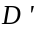. The formula for the metric yield and purity as follows:

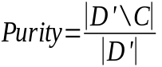
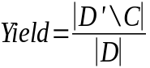

Thus, the composite score is:
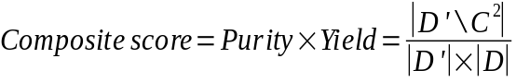

Supplementary figures
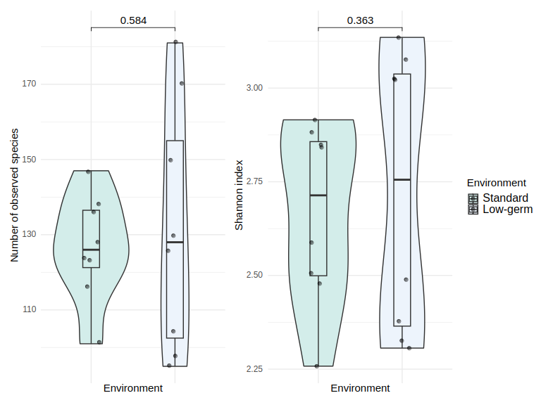
Fig. S1: Alpha diversity with respect to processing environment after adjusting effect of laboratory person. Low-germ environment includes sterile gloves, facial mask, working under the hood. Standard processing refers to working with standard gloves, no facial mask and at the bench. Multivariable negative binomial distribution for number of observed species and gaussian distribution for Shannon index were applied.

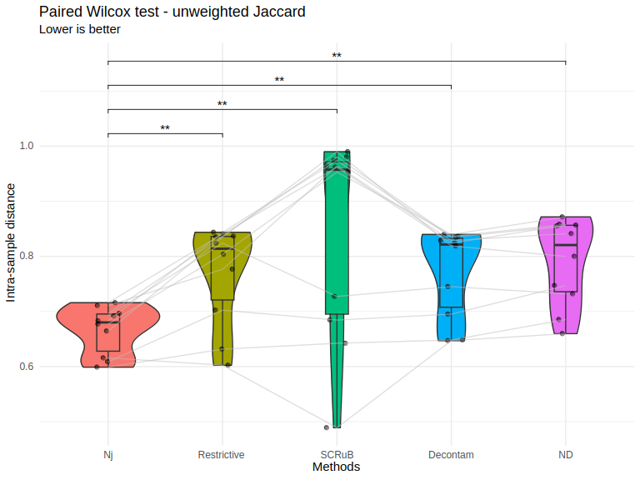
Fig. S2: Paired Wilcox-signed test of inter-replica distance of non-decontaminated samples (ND) and various decontamination methods. Nj – Nejman et al. approach

Fig. S3: Venn diagram showing the overlap of number of taxa in species level of paired formalin-fixed paraffin-embedded samples and two fresh frozen replicates. Rows are tumor samples and columns are decontamination methods.
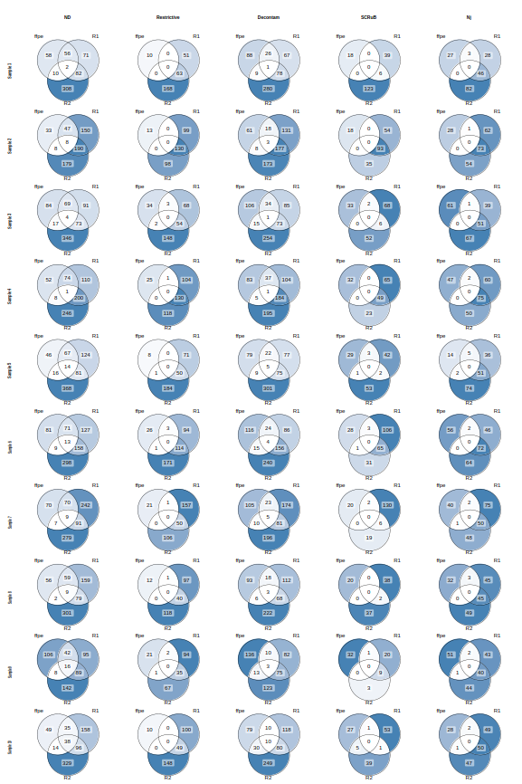

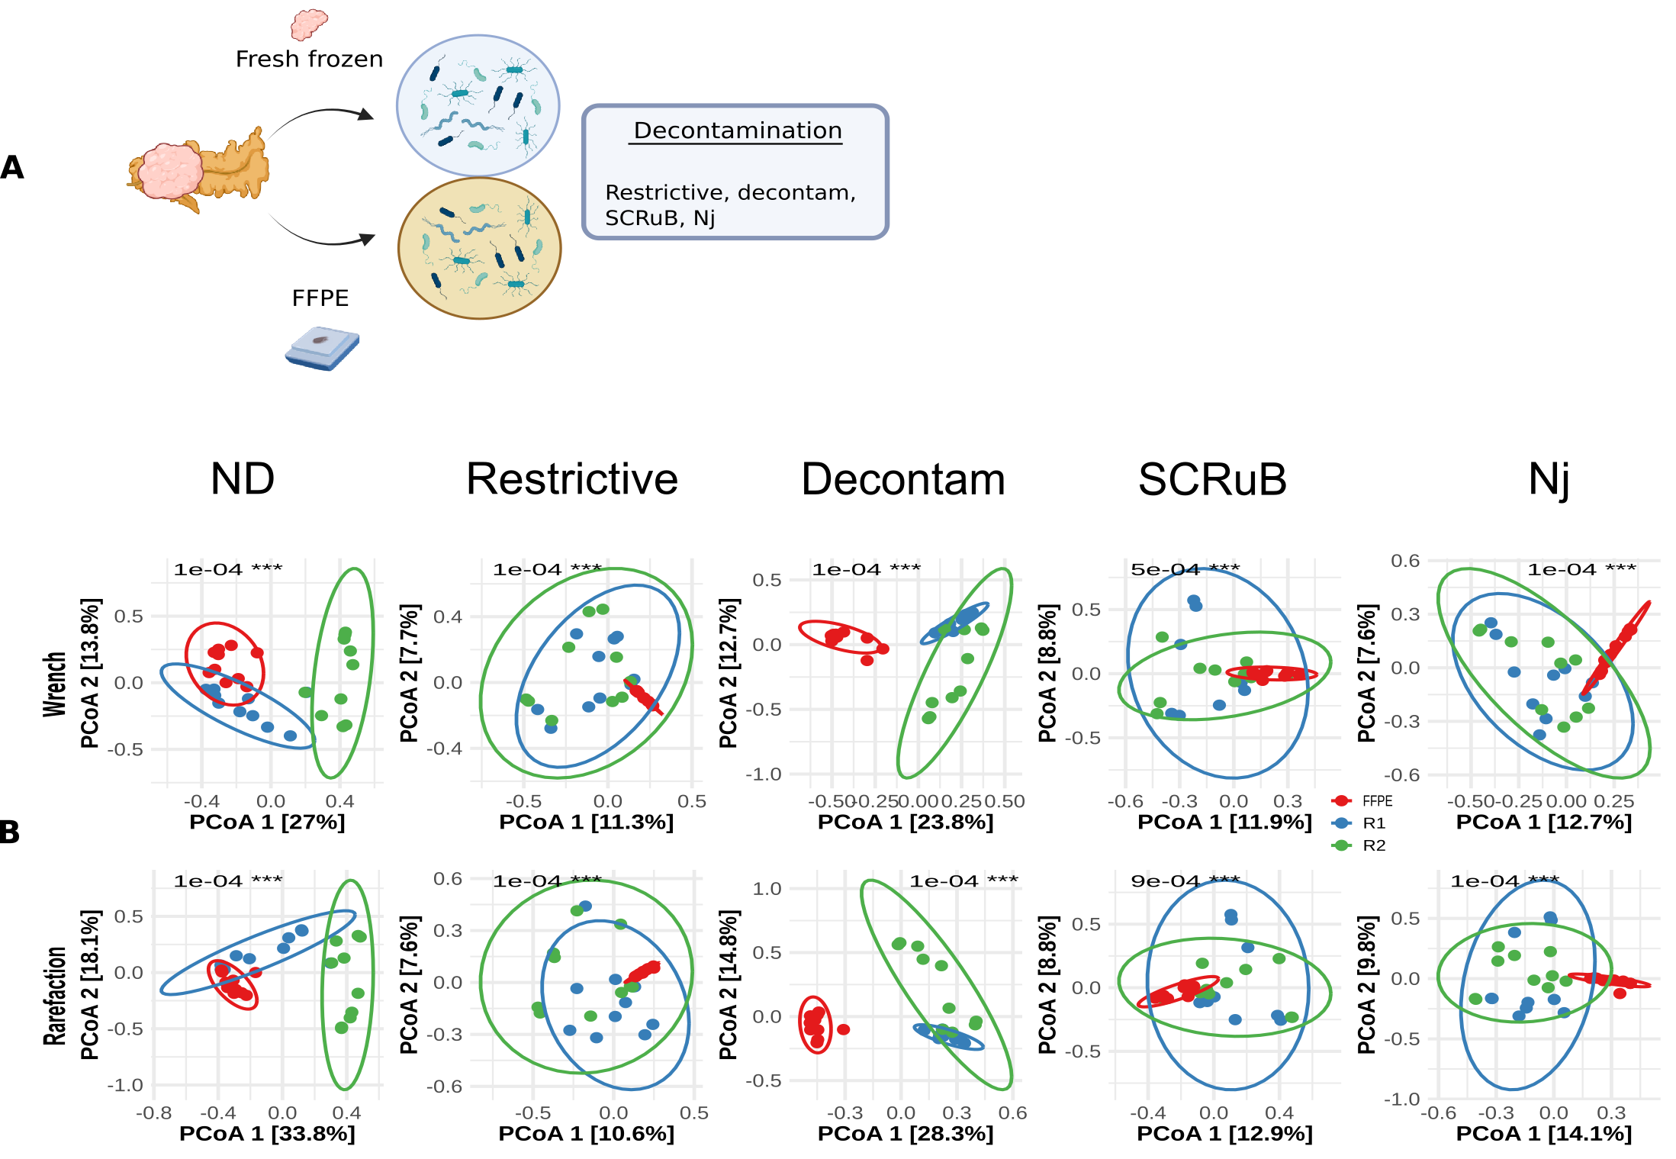Fig. S4: paired FFPE and fresh-frozen replicates experimental design and their beta diversity analyses. A) Schematic overview of the study design: Ten paired tumor from KPC mice were profiled by whole 16S rRNA sequencing using both FF and FFPE samples from the sample tumors. Two independent sequencing runs were performed for the FF samples to generate technical replicates. B) Bray-Curtis dissimilarity of the two FF technical replicates and paired FFPE samples. Samples are colored and grouped by technical replicate. Analyses were performed using rarefaction as normalization. The plot is ordinated with Principal Coordinate Analysis (PCoA) and p-values were calculated by PERMANOVA.

Supplementary tables

Table S1: Negative control samples collected across years, stratified by control types.
Control type ↓ Year → | 2021 | 2022 | 2023 | 2024 | 2025
Buffer | 26 | 67 | 17 | 38 | 19
Paraffin | 2 | 56 | 9 | 1 | 7
PCR | 0 | 4 | 4 | 8 | 4

Table S2 Alpha diversity was analyzed by control type, adjusting for laboratory personnel, year, and season. Observed species were modeled using multivariable negative binomial regression, while the Shannon index was modeled using multivariable gamma regression with a log-link. IRR – incidence rate ratio, LCL - lower confidence limit and UCL - upper confidence limit
Observed species | IRR | LCL | UCL | adj. p-value
Buffer - Paraffin | 0.81 | 0.65 | 1 | 0.05*
Buffer - PCR | 1.32 | 1.02 | 1.71 | 0.03*
Paraffin - PCR | 1.63 | 1.22 | 2.19 | <0.001***
Shannon index | exp(β) | LCL | UCL | adj. p-value
Buffer - Paraffin | 1 | 0.97 | 1.03 | 1
Buffer - PCR | 0.98 | 0.95 | 1.02 | 0.48
Paraffin - PCR | 0.98 | 0.94 | 1.02 | 0.55

Table S3: distance-based redundancy analyses for Bray-Curtis dissimilarity of negative controls with respect to a variable after adjusting the others. PERMANOVA test was applied.
Variable | adj. R² | adj. p-value
Control type | 0.02 | <0.001***
Person | 0.15 | <0.001***
Year | 0.07 | <0.001***
Season | 0.06 | <0.001***

Table S4: Top 30 genera by total abundance of all negative controls
Genera | Reads | Cumulative Proportion
Sphingomonas | 5134397 | 28.61
Caldibacillus | 3035664 | 45.52
Streptococcus | 1034676 | 51.28
Burkholderia | 605995 | 54.66
Fervidibacillus | 593031 | 57.97
Bradyrhizobium | 583338 | 61.22
Sporosarcina | 506091 | 64.03
Cutibacterium | 482878 | 66.73
Veillonella | 373869 | 68.81
Delftia | 367958 | 70.86
Bacillus | 295277 | 72.5
Staphylococcus | 247026 | 73.88
Variovorax | 195094 | 74.97
Haemophilus | 192174 | 76.04
Peptoniphilus | 149080 | 76.87
Niallia | 146140 | 77.68
Finegoldia | 140391 | 78.46
Caldifermentibacillus | 139994 | 79.24
Stenotrophomonas | 126861 | 79.95
Escherichia | 125426 | 80.65
Methylorubrum | 121398 | 81.33
Paracoccus | 93657 | 81.85
Anaerococcus | 91813 | 82.36
Gemella | 89796 | 82.86
Methylobacterium | 82573 | 83.32
Roseomonas | 82192 | 83.78
Clostridium | 80882 | 84.23
Neobacillus | 78431 | 84.67
Brucella | 73386 | 85.07
Achromobacter | 70440 | 85.47

Table S5: All species in NCT whose relative total abundance is at least 0.1%, sorted by the abundance.
Species | Prevalence | Abundance
Caldibacillus__thermoamylovorans | 0.0700 | 0.1691
Sphingomonas__paucimobilis | 0.5954 | 0.1641
Sphingomonas__hankookensis | 0.7634 | 0.0519
Fervidibacillus__albus | 0.0649 | 0.0316
Sporosarcina__sp.__Marseille-Q4063 | 0.0840 | 0.0280
Cutibacterium__acnes | 0.7863 | 0.0255
Delftia__acidovorans | 0.3511 | 0.0186
Sphingomonas__sp.__AAP5 | 0.7748 | 0.0179
Veillonella__parvula | 0.4618 | 0.0137
Bradyrhizobium__elkanii | 0.2252 | 0.0128
Burkholderia__contaminans | 0.3473 | 0.0124
Sphingomonas__alpina | 0.7290 | 0.0122
Streptococcus__mitis | 0.6756 | 0.0120
Variovorax__paradoxus | 0.2863 | 0.0100
Streptococcus__oralis | 0.6870 | 0.0094
Haemophilus__parainfluenzae | 0.3053 | 0.0087
Bradyrhizobium__sp.__41S5 | 0.1527 | 0.0085
Niallia__sp.__XMNu-256 | 0.0992 | 0.0080
Finegoldia__magna | 0.2710 | 0.0078
Caldifermentibacillus__hisashii | 0.0878 | 0.0078
Streptococcus__thermophilus | 0.6565 | 0.0071
Escherichia__coli | 0.6908 | 0.0068
Sphingomonas__sp.__QA11 | 0.7672 | 0.0066
Methylorubrum__extorquens | 0.2786 | 0.0055
Sphingomonas__sp.__NY01 | 0.5076 | 0.0054
Peptonophilus__genitalis | 0.2443 | 0.0054
Sphingomonas__sanguinis | 0.4351 | 0.0049
Roseomonas__mucosa | 0.1183 | 0.0045
Bacillus__sp.__OxB-1 | 0.0954 | 0.0044
Staphylococcus__epidermidis | 0.6145 | 0.0042
Burkholderia__cenocepacia | 0.2901 | 0.0041
Abiotrophia__defectiva | 0.2824 | 0.0039
Streptococcus__pneumoniae | 0.6718 | 0.0038
Neobacillus__sp.__PS3-40 | 0.0802 | 0.0037
Sphingomonas__sp.__So64.6b | 0.7176 | 0.0036
Staphylococcus__hominis | 0.4313 | 0.0036
Bacillus__sp.__S3 | 0.0763 | 0.0035
Bradyrhizobium__septentrionale | 0.1870 | 0.0034
Burkholderia__cepacia | 0.2366 | 0.0033
Macrococcus__equipercicus | 0.0573 | 0.0032
Bradyrhizobium__quebecense | 0.1603 | 0.0031
Bacillus__sp.__T3 | 0.0725 | 0.0031
Burkholderia__aenigmatica | 0.2176 | 0.0030
Sphingomonas__panacis | 0.7290 | 0.0030
Brucella__anthropi | 0.1489 | 0.0030
Gemella__haemolysans | 0.5038 | 0.0030
Mesorhizobium__terrae | 0.3931 | 0.0030
Granulicatella__adiacens | 0.4695 | 0.0028
Methylobacterium__sp.__FF17 | 0.1565 | 0.0025
Streptococcus__salivarius | 0.5802 | 0.0024
Burkholderia__lata | 0.2748 | 0.0024
Parvimonas__micra | 0.2672 | 0.0024
Peribacillus__asahii | 0.1756 | 0.0022
Prevotella__melaninogenica | 0.2328 | 0.0021
Brevundimonas__sp.__PAMC22021 | 0.2137 | 0.0020
Streptococcus__gordonii | 0.4504 | 0.0020
Planococcus__versutus | 0.0687 | 0.0020
Sphingomonas__sp.__HMP6 | 0.7099 | 0.0020
Streptococcus__parasanguinis | 0.5038 | 0.0020
Sphingomonas__sp.__CL5.1 | 0.5802 | 0.0019
Burkholderia__glumae | 0.2901 | 0.0019
Burkholderia__arboris | 0.2099 | 0.0017
Priestia__filamentosa | 0.0763 | 0.0017
Fenollaria__massiliensis | 0.1031 | 0.0016
Anaerococcus__obesiensis | 0.1527 | 0.0016
Veillonella__rogosae | 0.4122 | 0.0016
Stenotrophomonas__sp.__KCTC__12332 | 0.0534 | 0.0015
Peptoniphilus__harei | 0.2405 | 0.0015
Ralstonia__sp.__RRA.1 | 0.3588 | 0.0015
Paracoccus__contaminans | 0.2519 | 0.0015
Veillonella__atypica | 0.3244 | 0.0015
Blastococcus__sp.__PRF04-17 | 0.0534 | 0.0015
Staphylococcus__aureus | 0.6374 | 0.0015
Sphingomonas__sp.__NIBR02145 | 0.3702 | 0.0014
Fervidibacillus__halotolerans | 0.0687 | 0.0014
Veillonella__nakazawae | 0.3550 | 0.0014
Stenotrophomonas__maltophilia | 0.4008 | 0.0014
Clostridium__isatidis | 0.0802 | 0.0014
Methylobacterium__indicum | 0.1641 | 0.0014
Clostridium__chauvoei | 0.0802 | 0.0013
Macrococcoides__caseolyticum | 0.0878 | 0.0013
Aquabacterium__olei | 0.2328 | 0.0013
Anaerococcus__sp.__Marseille-Q7828 | 0.2634 | 0.0013
Cutibacterium__granulosum | 0.2214 | 0.0013
Streptococcus__mutans | 0.2099 | 0.0013
Streptococcus__sp.__FSL__W8-0197 | 0.5420 | 0.0012
Bacillus__subtilis | 0.2137 | 0.0012
Bacillus__smithii | 0.0687 | 0.0012
Veillonella__sp.__S12025-13 | 0.3359 | 0.0012
Sphingomonas__sp.__LK11 | 0.1374 | 0.0012
Sphingomonas__sp.__FARSPH | 0.7061 | 0.0012
Exiguobacterium__aurantiacum | 0.0725 | 0.0012
Peptostreptococcus__equinus | 0.2023 | 0.0012
Sphingomonas__melonis | 0.6832 | 0.0012
Bradyrhizobium__sp.__200 | 0.2252 | 0.0012
Stenotrophomonas__acidaminiphila | 0.0840 | 0.0012
Achromobacter__xylosoxidans | 0.0802 | 0.0012
Haemophilus__haemolyticus | 0.1832 | 0.0011
Mogibacterium__diversum | 0.2786 | 0.0011
Peptoniphilus__ivorii | 0.1374 | 0.0011
Sphingopyxis__sp.__EG6 | 0.0802 | 0.0011
Veillonella__dispar | 0.3511 | 0.0011
Streptococcus__gwangjuense | 0.5382 | 0.0011
Moraxella__osloensis | 0.4656 | 0.0011
Gemella__morbillorum | 0.3855 | 0.0011
Sphingomonas__sp.__R1 | 0.3473 | 0.0011
Ureibacillus__sp.__FSL__K6-0786 | 0.0496 | 0.0010
Blautia__wexlerae | 0.1374 | 0.0010
Schaalia__odontolytica | 0.1221 | 0.0010
Staphylococcus__warneri | 0.4695 | 0.0010

Table S6: Alpha diversity analyses of LP and environment. Multivariable negative binomial distribution for number of observed species and multivariable linear regression for Shannon index were applied. IRR – incidence rate ratio, LCL - lower confidence limit, LP – laboratory person, UCL - upper confidence limit
Observed species | IRR | LCL | UCL | adj. p-value
LP1 - LP2 | 1.32 | 1.17 | 1.48 | <0.001***
Low-germ - standard | 0.97 | 0.86 | 1.09 | 0.58
Shannon | β | LCL | UCL | adj. p-value
LP1 - LP2 | 1.74 | 1.54 | 1.96 | <0.001***
Low-germ - standard | 0.95 | 0.84 | 1.07 | 0.35

Table S7: Distance-based redundancy analyses with respect to Environment and laboratory person (LP), after adjusting effect of each other, with Bray Curtis dissimilarity metric.
Wrench w.r.t LP normalization + Bray-Curtis | adj. R² | adj. p-value
Environment | 0.05 | 0.245
LP | 0.46 | 0.005**
Rarefaction + Bray-Curtis | adj. R² | adj. p-value
Environment | 0.04 | 0.015*
LP | 0.68 | 0.005**

Supplementary Table S8: Pairwise comparison based on Wilcox paired test for composite score among non-decontaminated samples (ND) and various decontamination methods. The alternative is set as "greater", comparing a method in row versus a method in a column. Nj – Nejman et al. approach
Approach | Nj | Restrictive | SCRuB | Decontam | ND
Nj | NA | <0.001*** | <0.001*** | <0.001*** | <0.001***
Restrictive | 1 | NA | <0.001*** | <0.001*** | <0.001***
SCRuB | 1 | 1 | NA | 1 | 1
Decontam | 1 | 1 | <0.001*** | NA | <0.001***
ND | 1 | 1 | <0.001*** | 1 | NA

Table S9: Pairwise comparison based on Wilcox paired test for inter-replicate distance among non-decontaminated samples (ND) and various decontamination methods. The alternative is set as "less", comparing a method in row versus a method in a column. Nj – Nejman et al. approach
Approach | Nj | Restrictive | SCRuB | Decontam | ND
Nj | NA | 0.001** | 0.003** | 0.001** | 0.001**
Restrictive | 1 | NA | 0.08 | 0.003** | 0.001**
SCRuB | 1 | 1 | NA | 0.001** | 0.001**
Decontam | 1 | 1 | 1 | NA | 0.001**
ND | 1 | 1 | 1 | 1 | NA

Table S10: Pairwise comparisons among two FF replicates and a FFPE replicate based on adonis2 with various normalization and decontamination methods.
Normalization | Decontamination | Pair | R² | adj. p-value
Wrench | ND | R1_vs_R2 | 0.2517 | 0.0001
Wrench | ND | R1_vs_FFPE | 0.1513 | 0.0005
Wrench | ND | R2_vs_FFPE | 0.3125 | 0.0001
Wrench | Restrictive | R1_vs_R2 | 0.0737 | 0.0589
Wrench | Restrictive | R1_vs_FFPE | 0.1061 | 0.0001
Wrench | Restrictive | R2_vs_FFPE | 0.1068 | 0.0001
Wrench | Decontam | R1_vs_R2 | 0.1243 | 0.0017
Wrench | Decontam | R1_vs_FFPE | 0.2864 | 0.0001
Wrench | Decontam | R2_vs_FFPE | 0.3285 | 0.0001
Wrench | SCRuB | R1_vs_R2 | 0.0639 | 0.1807
Wrench | SCRuB | R1_vs_FFPE | 0.0998 | 0.0001
Wrench | SCRuB | R2_vs_FFPE | 0.0915 | 0.0017
Wrench | Nj | R1_vs_R2 | 0.0649 | 0.1384
Wrench | Nj | R1_vs_FFPE | 0.1250 | 0.0001
Wrench | Nj | R2_vs_FFPE | 0.1211 | 0.0001
Rarefaction | ND | R1_vs_R2 | 0.2430 | 0.0001
Rarefaction | ND | R1_vs_FFPE | 0.1678 | 0.0004
Rarefaction | ND | R2_vs_FFPE | 0.4010 | 0.0001
Rarefaction | Restrictive | R1_vs_R2 | 0.0726 | 0.0634
Rarefaction | Restrictive | R1_vs_FFPE | 0.0977 | 0.0001
Rarefaction | Restrictive | R2_vs_FFPE | 0.0949 | 0.0001
Rarefaction | Decontam | R1_vs_R2 | 0.1313 | 0.0036
Rarefaction | Decontam | R1_vs_FFPE | 0.3547 | 0.0001
Rarefaction | Decontam | R2_vs_FFPE | 0.4007 | 0.0002
Rarefaction | SCRuB | R1_vs_R2 | 0.0603 | 0.2724
Rarefaction | SCRuB | R1_vs_FFPE | 0.1049 | 0.0002
Rarefaction | SCRuB | R2_vs_FFPE | 0.0955 | 0.0016
Rarefaction | Nj | R1_vs_R2 | 0.0822 | 0.0608
Rarefaction | Nj | R1_vs_FFPE | 0.1472 | 0.0001
Rarefaction | Nj | R2_vs_FFPE | 0.1476 | 0.0001

