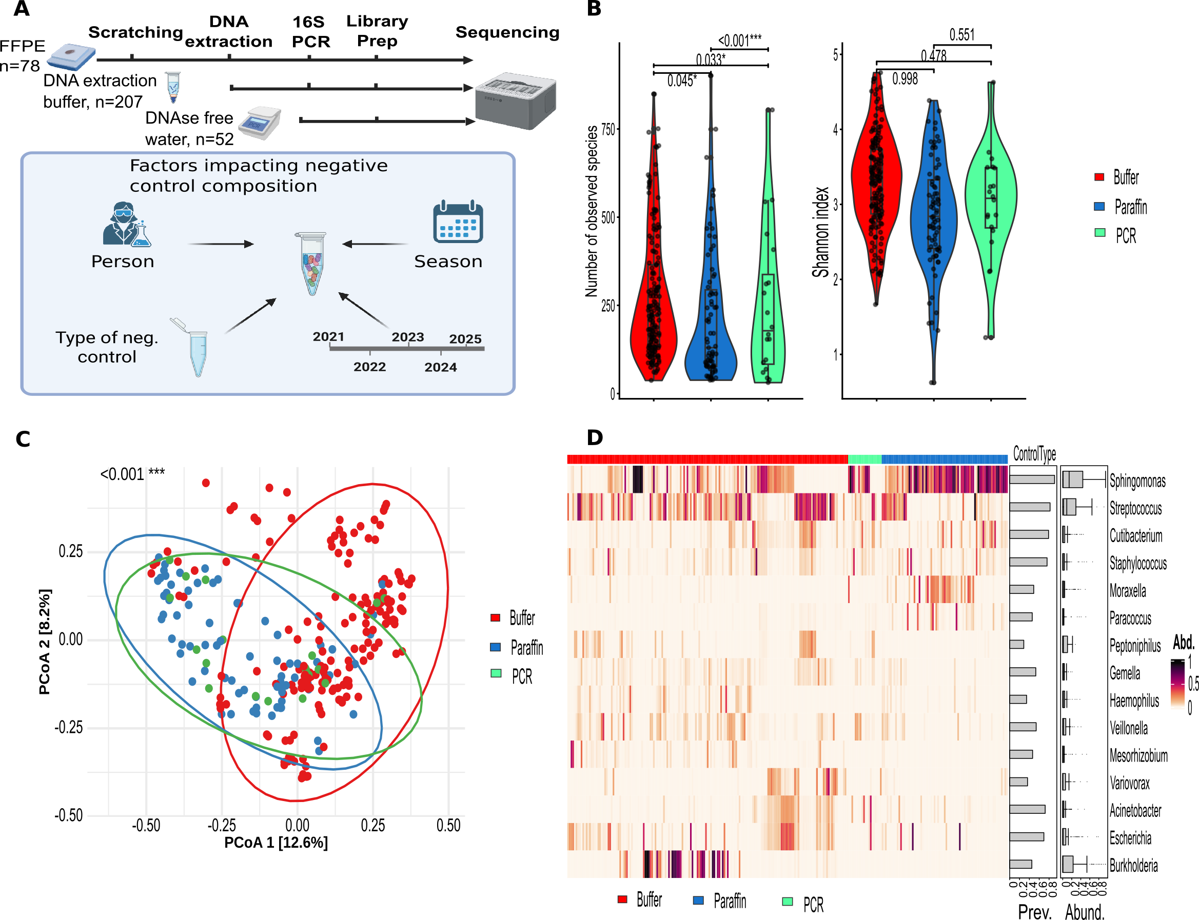
Figure 1: Characterization of negative controls (NCT) collected throughout the wet-lab workflow. A) Schematic illustration of the collection strategy. NCT were collected at three steps of the wet-lab workflow together with associated metadata factors including laboratory personnel (LP), sequencing year, and season. B) Alpha diversity was analyzed by control type adjusting for LP, year, and season. Observed species were modeled using multivariable negative binomial regression, while the Shannon index was modeled using multivariable gamma regression with a log-link. C) Beta diversity analysis of NCT with samples colored and grouped according to control type. P-value derived from distance-based redundancy analyses for Bray-Curtis dissimilarity of control types after adjusting for LP, year, and season. PERMANOVA test was applied D) Taxonomic composition heatmap showing the relative abundance of the top 15 genera identified in NCT samples. The overall abundance of each genus across samples is represented by color intensity. Corresponding bar plots summarize the prevalence and abundance distribution of each taxon across NCT.

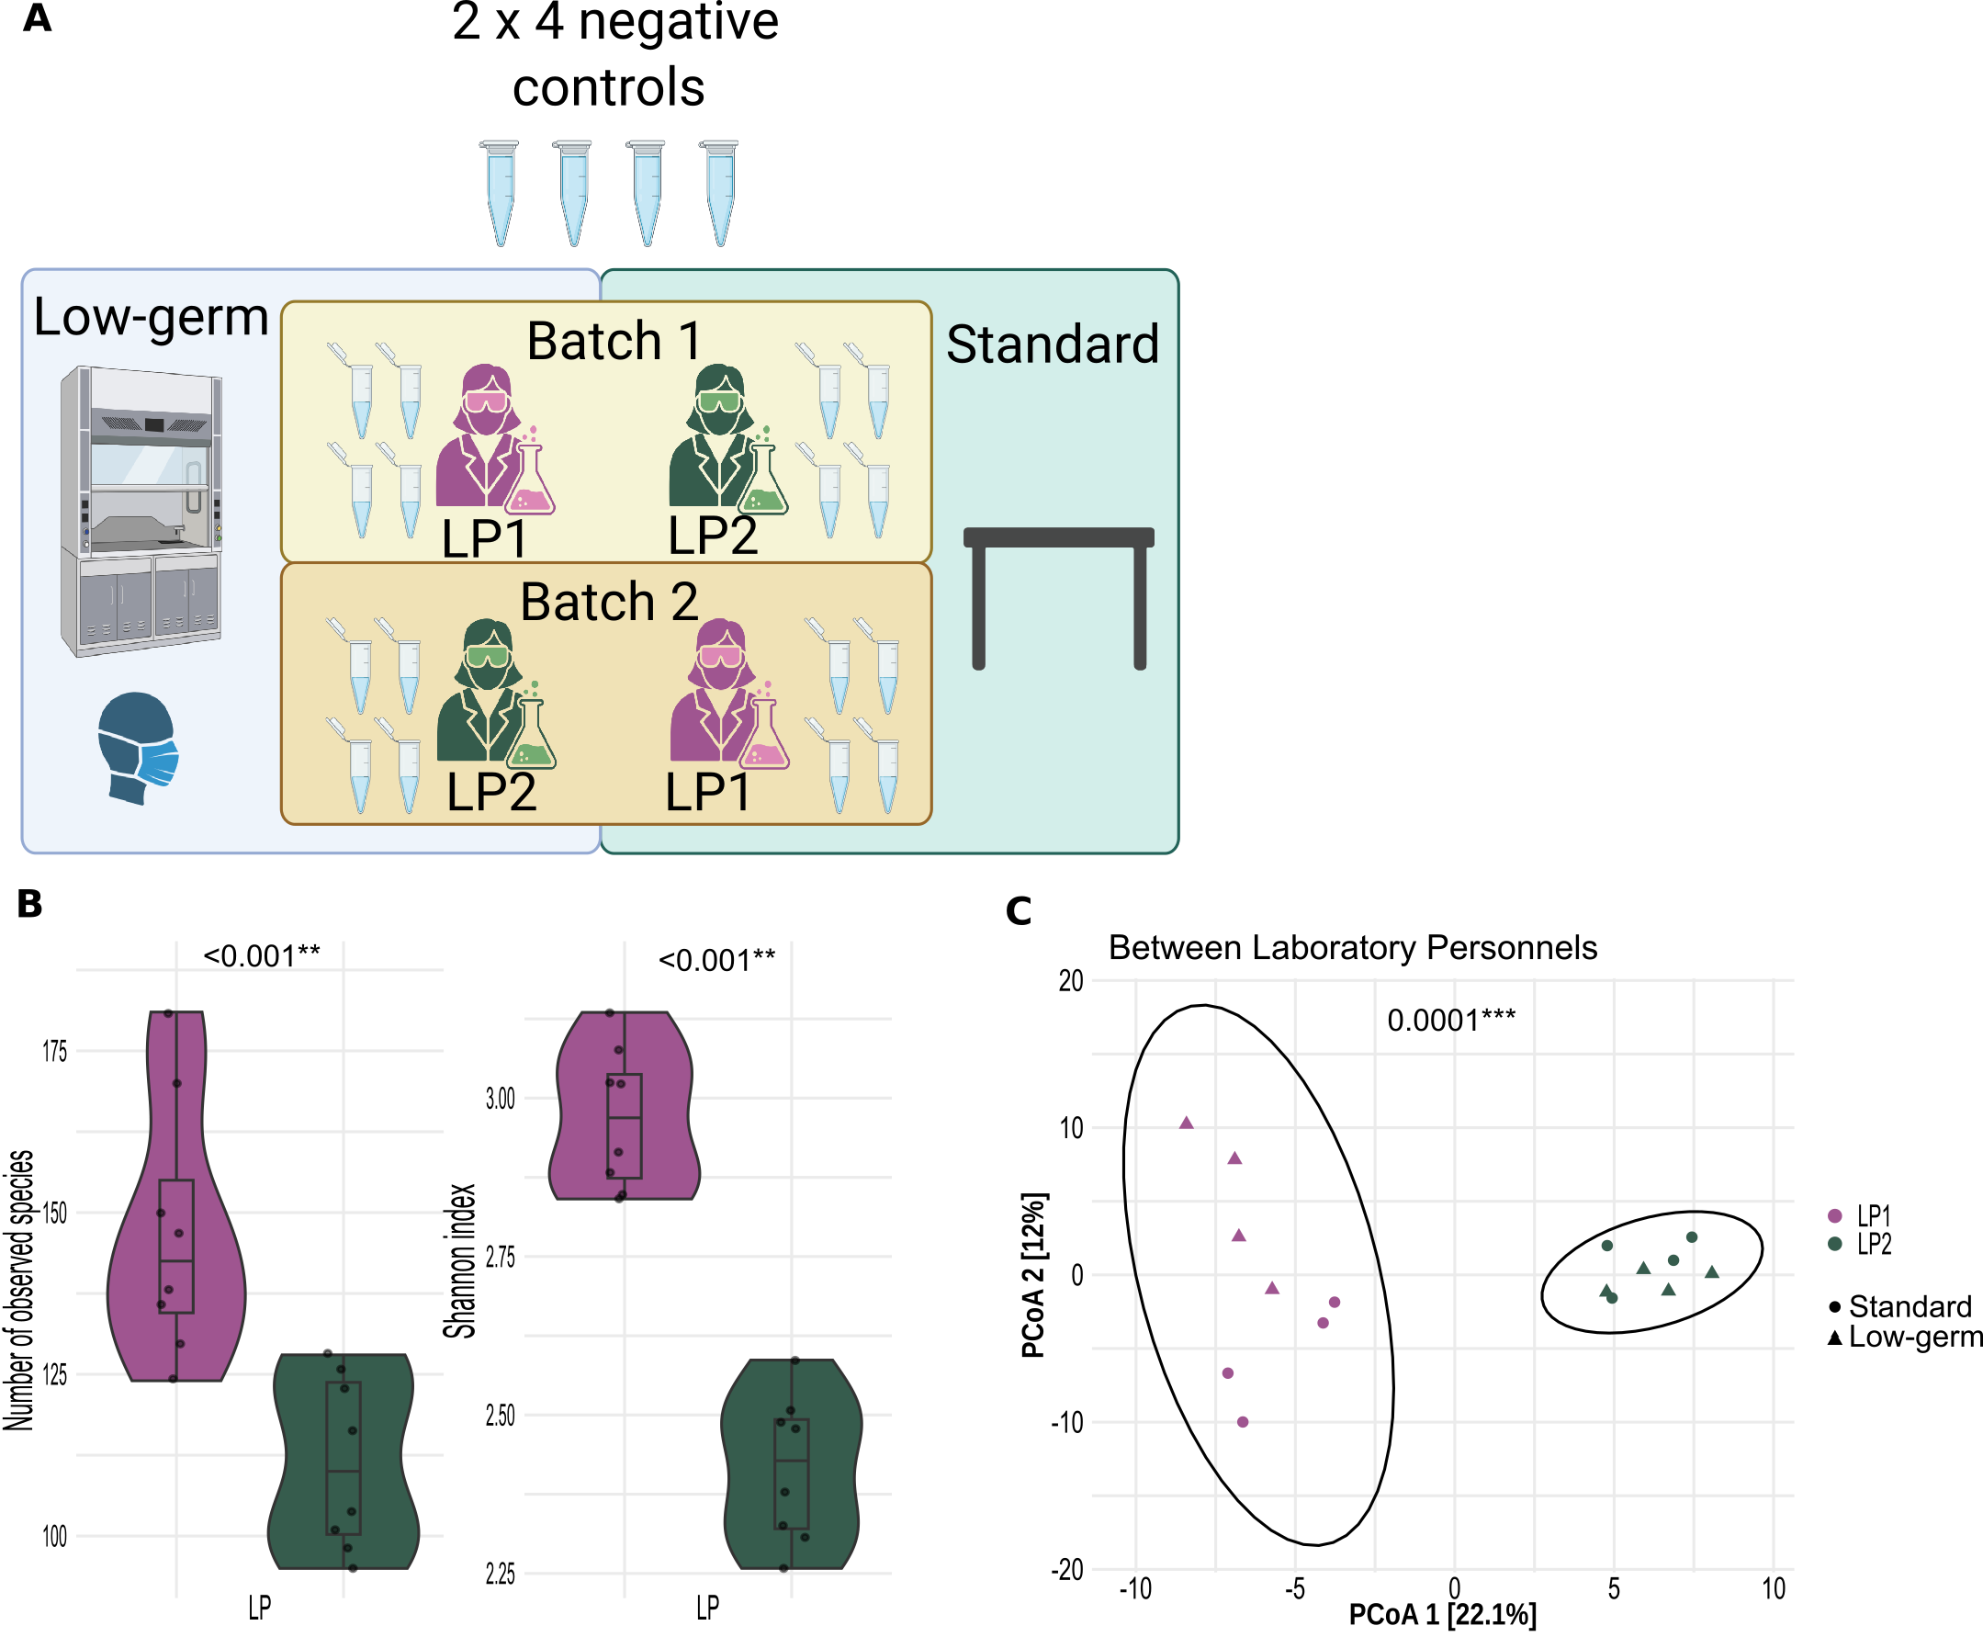
Figure 2: The laboratory personnel (LP) contributes more to the contamination composition than the processing environment. A) Illustration of two-factor experimental design: Each LP at each environment processed 4 shared blank samples to acquire the lab contaminant profile. Standard environment is where LP processed samples on the bench, wearing standard gloves and no facial mask, while low-germ environment is where samples were processed under the ventilated hood, with LP wearing mask and sterile gloves. B) Alpha diversity analyses of blank samples, showing the number of observed species and Shannon diversity index of both LP stratified for processing environment. Multivariable negative binomial distribution for number of observed species and multivariable linear regression for Shannon index were applied. C) Bray–Curtis dissimilarity for blank samples is displayed, colored by LP and shaped by environment. The p-value was obtained from distance-based redundancy analysis, with LP as explanatory variables, controlled for processing environment. The plot is ordinated with Principal Coordinate Analysis (PCoA).

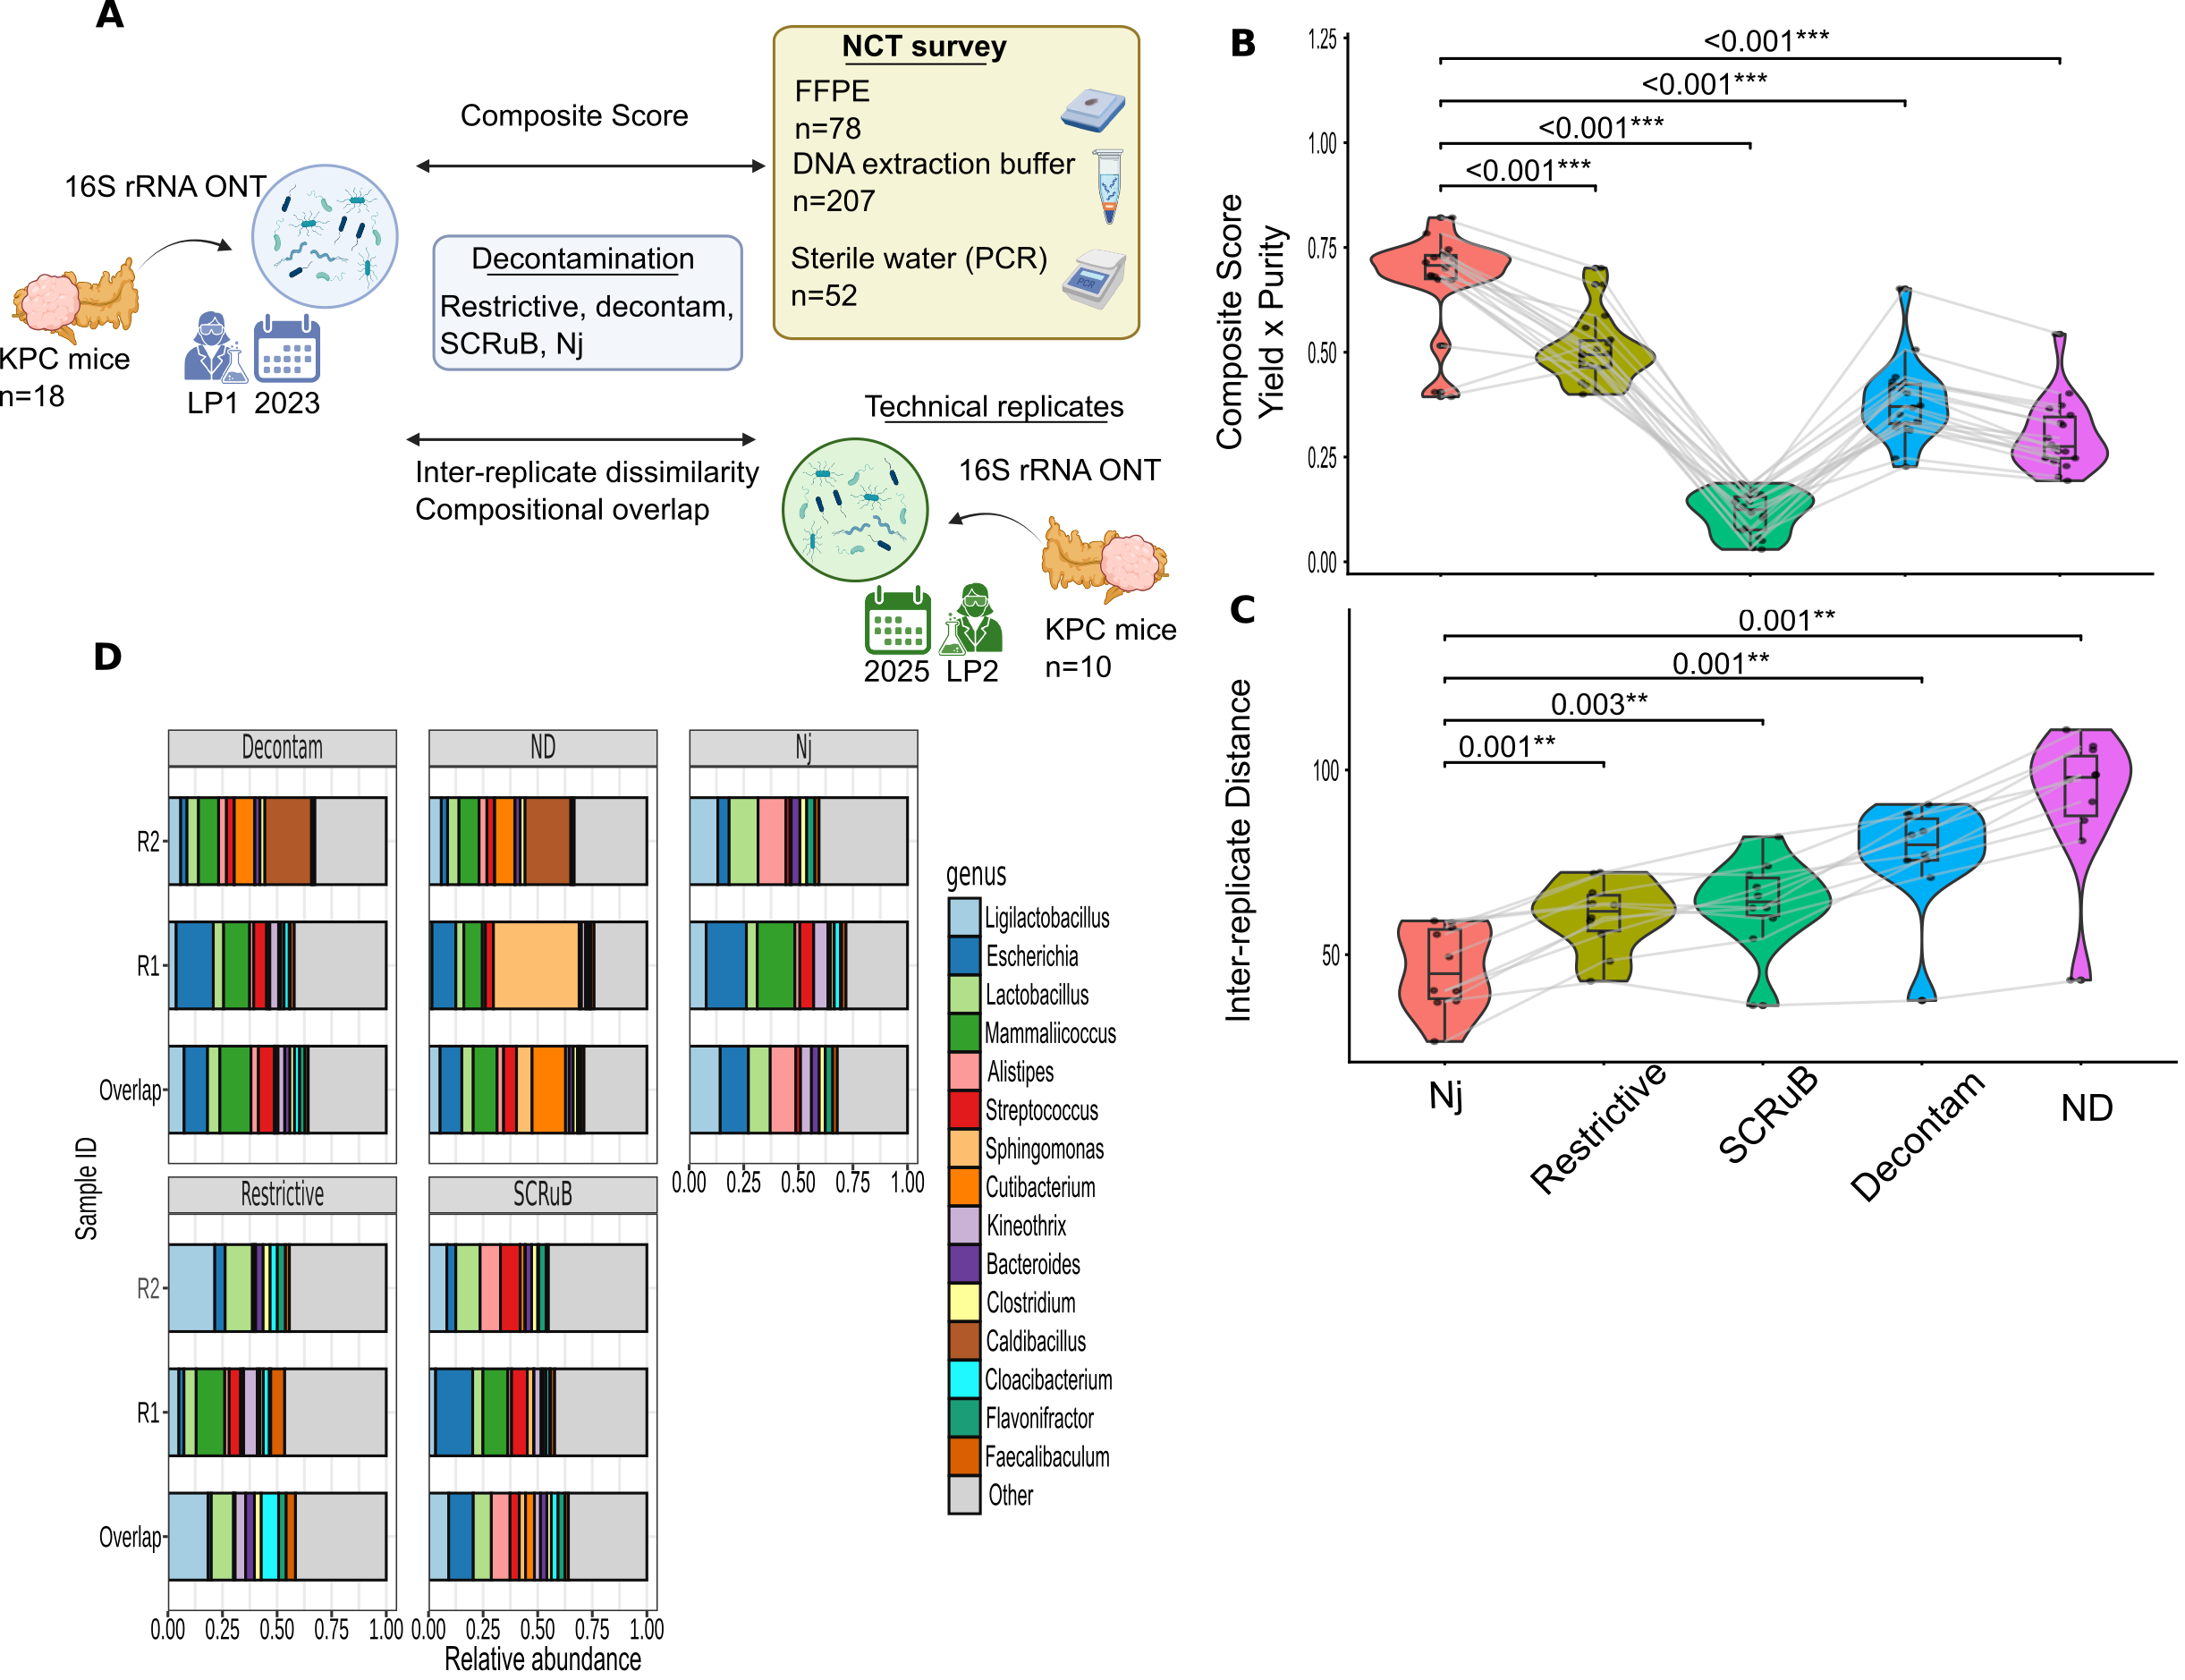
Figure 3: Benchmarking strategy for evaluating microbial decontamination methods. A) Experimental design: 18 fresh frozen tumor samples (FF) from KPC mice were sequenced together with their corresponding negative controls (NCT). Non-decontaminated (ND) profiles were decontaminated through four approaches: restrictive, decontam, SCRuB, and the Nejman et al derived method (Nj) (6). Later, ten out of 18 FF tumors from KPC mice were sequenced again as technical replicates by another laboratory person. B) Comparison of the four decontamination methods and the ND profile using a Wilcoxon signed-rank test based on a composite score integrating sample bacterial profiles and the longitudinal contamination assessment. Higher scores indicate better performance. C) Comparison of decontamination methods based on the compositional distance between technical replicates. Inter-replicate dissimilarity was quantified using Aitchison distance of centered-log ratio transformed data, with pairwise comparisons assessed by paired Wilcoxon signed-rank test on species level. Lower inter-replicate distances indicate higher performance. D) Overall bacterial composition of the two FF technical replicates and their overlap.
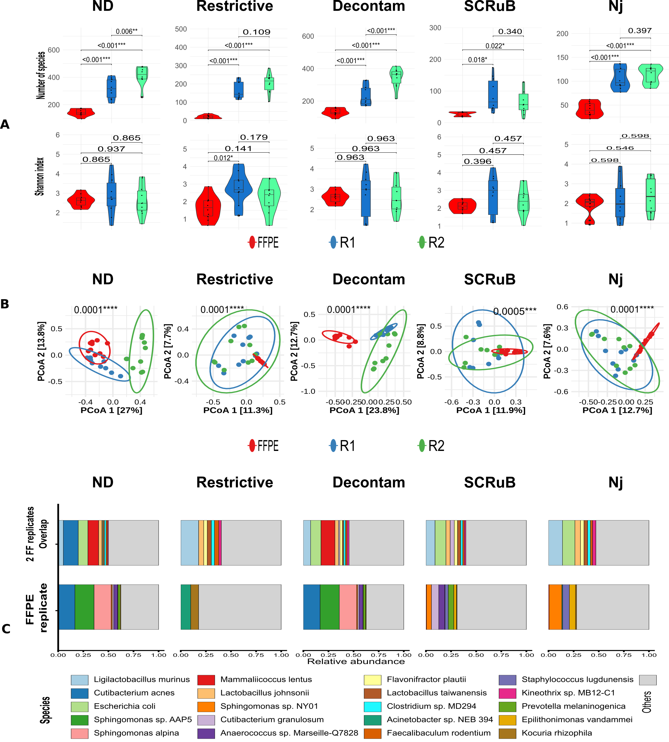
Figure 4: Comparative analysis of paired fresh frozen (FF) and formalin-fixed paraffin embedded (FFPE) tumor samples. A) Alpha diversity analyses comparing FFPE samples and the two FF technical replicates across the non-decontaminated (ND) data and four decontamination strategies: restrictive filtering, decontam, SCRuB, and Nejman et al derived method (Nj) (6). Diversity was assessed using the number of observed species and the Shannon index. Univariable negative binomial regression for number of observed species and univariable linear regression for Shannon index were applied. B) Bray-Curtis dissimilarity of the two FF technical replicates and paired FFPE samples. Samples are colored and grouped by technical replicates. Analyses were performed using Wrench normalization. The plot is ordinated with Principal Coordinate Analysis (PCoA) and p-values were calculated by PERMANOVA. C) Overall bacterial composition of FF overlap and FFPE samples without (ND) and with various decontamination. R – technical replicates

