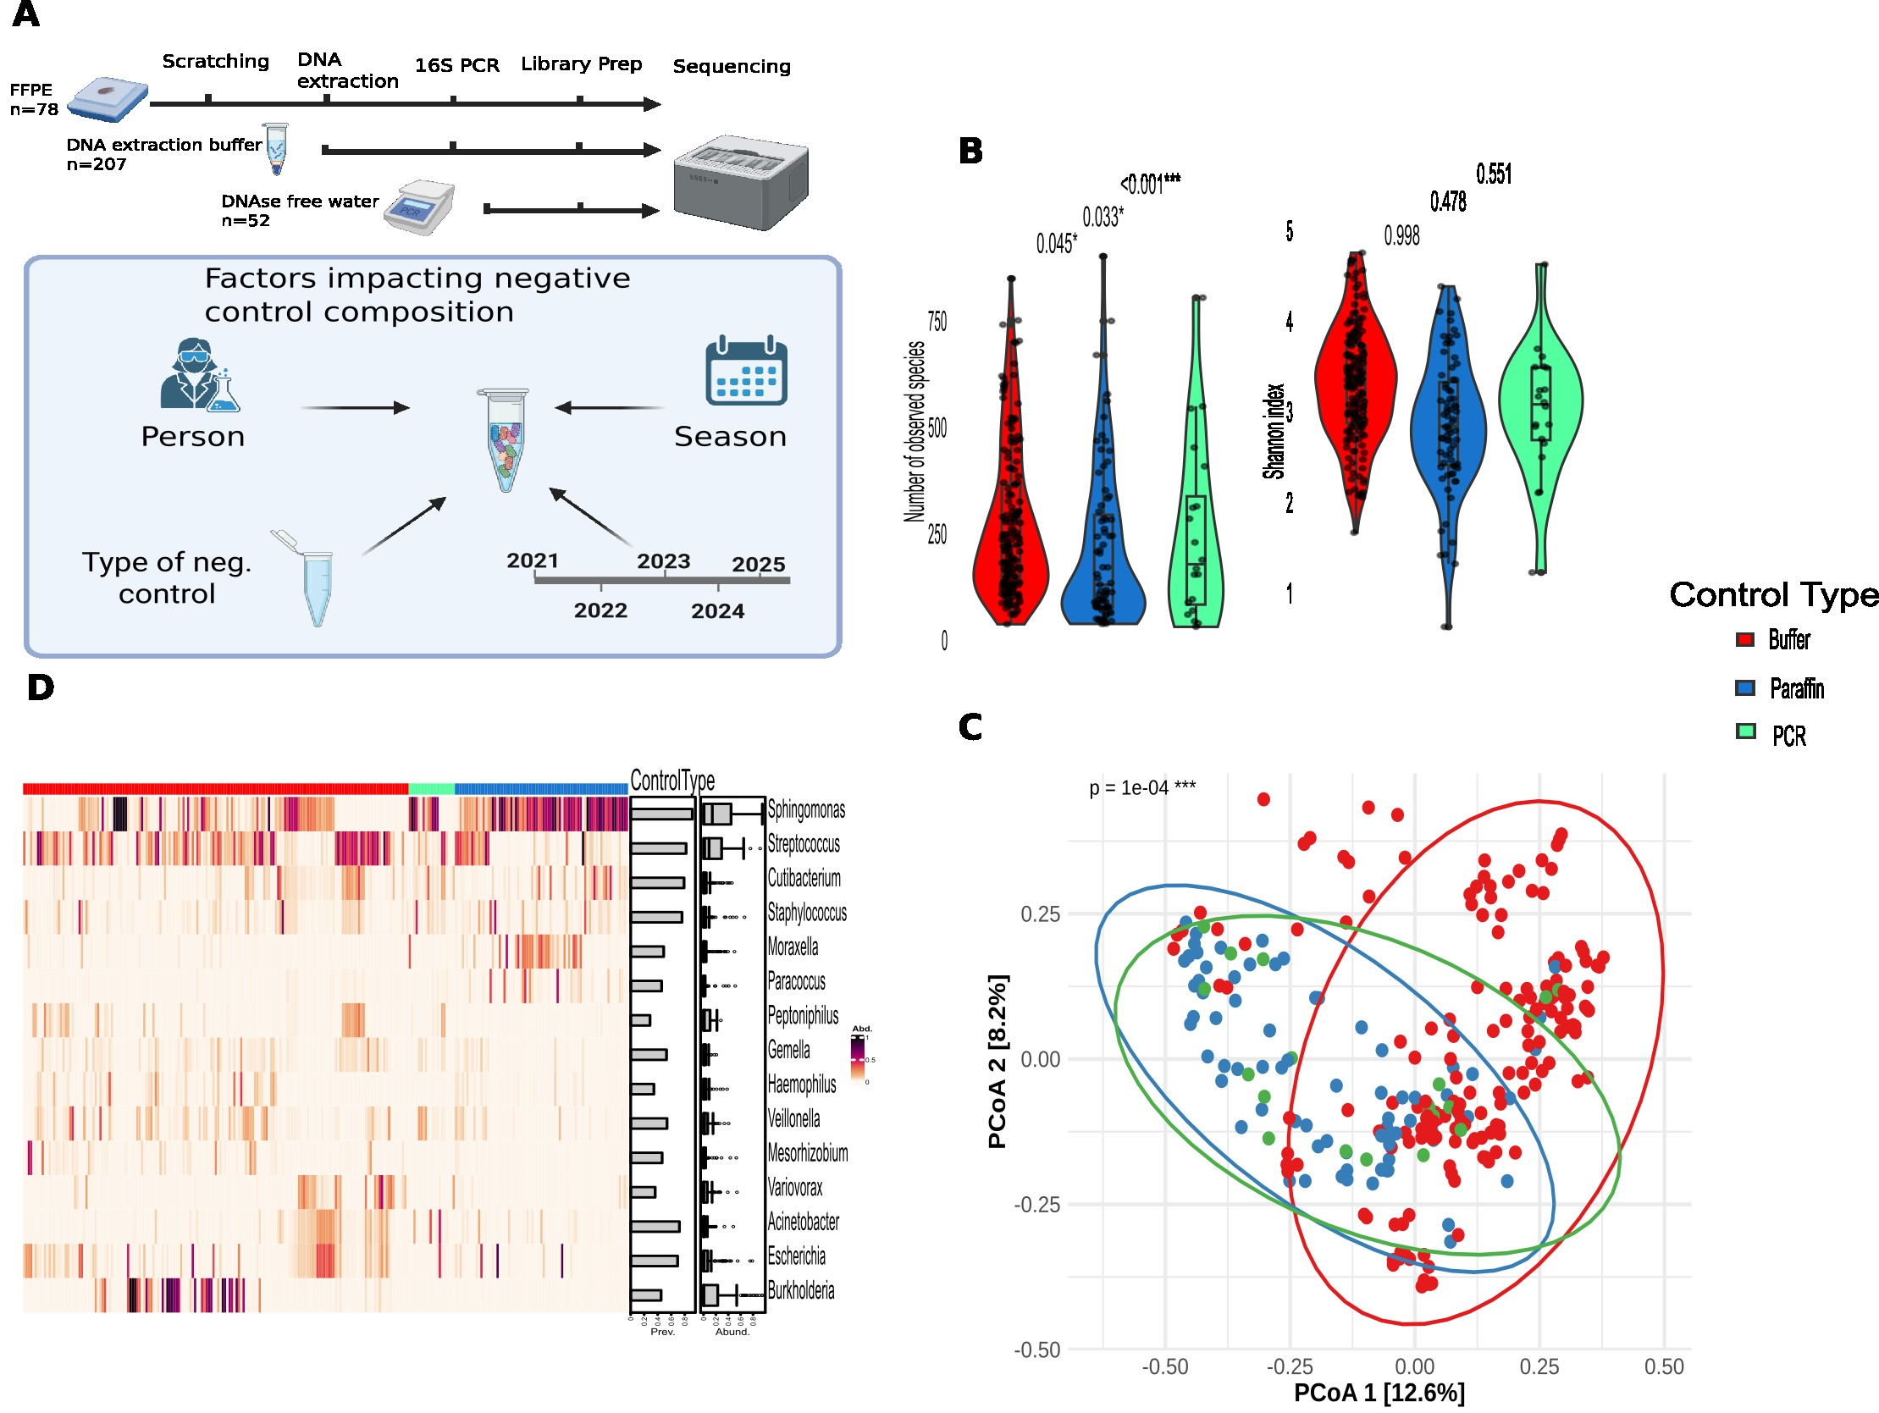Figure 1: Characterization of NCTs collected throughout the wet-lab workflow. A) Schematic illustration of the negative control collection strategy. Negative controls were collected at each step of the wet-lab workflow, together with associated metadata factors, including LP, sequencing year, and season. B) Alpha diversity analysis of NCT samples, showing the number of observed species and Shannon diversity index stratified by control type. C) Beta diversity analysis of NCT samples, with samples colored and grouped according to control type. D) Taxonomic composition heatmap showing the relative abundance of the top 15 genera identified in NCT samples. The overall abundance of each genus across samples is represented by color intensity. Corresponding bar plots summarize the prevalence and abundance distribution of each taxon across NCT samples.
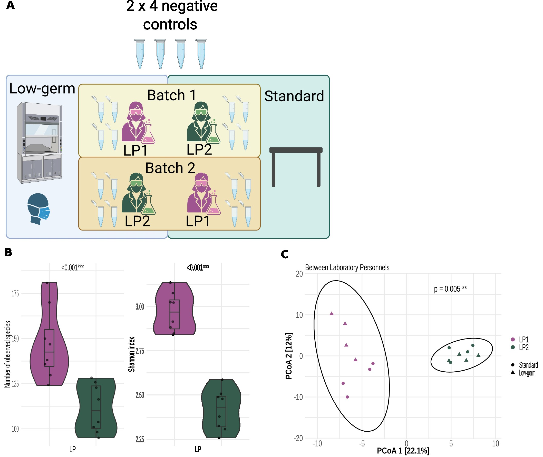Figure 2: 2-factor experiment and its analyses. A) Illustration of 2-factor experimental design: laboratory personnel and processing environment. Each LP at each environment processed 4 blank samples to acquire the lab contaminant profile. Standard environment is where LP processed samples on the bench, without wearing mask and gloves, while low-germ environment is where samples were processed under the ventilated hood, with LP wearing mask and gloves. B) Alpha diversity analyses of blank samples, showing the number of observed species and Shannon diversity index stratified by LP. C) Beta diversity analyses of blank samples, with samples colored by LP and different symbols by processing environments.

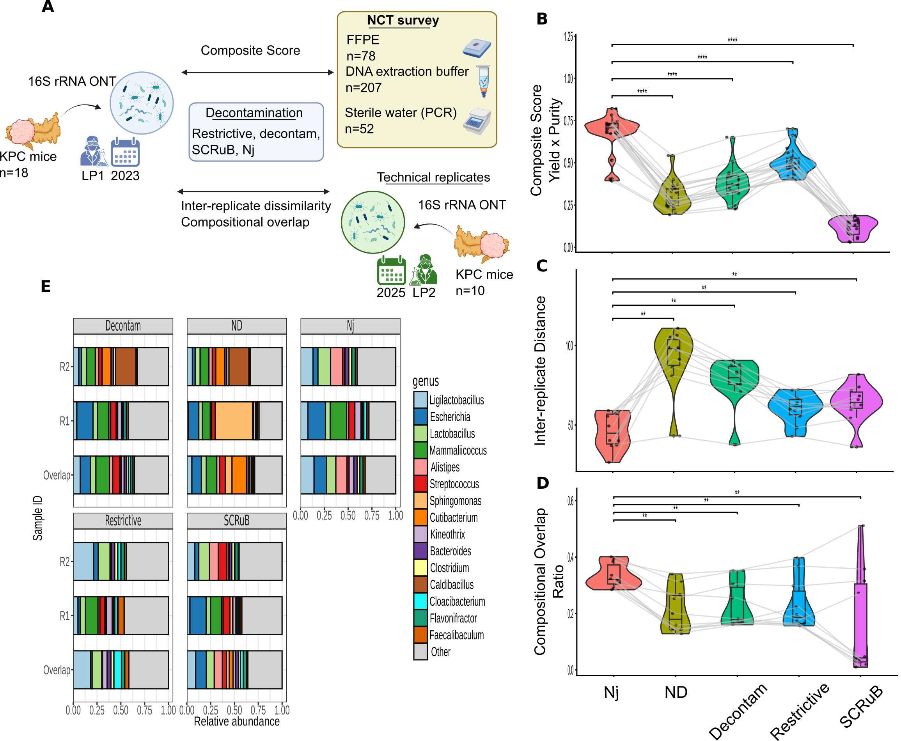Figure 3: Benchmarking strategy for evaluating microbial decontamination methods. A) Experimental design: 18 PDAC samples from KPC mice were sequenced, together with their corresponding negative controls. ND profile was decontaminated through 4 benchmarking methods: restrictive, decontam, SCRuB, and Nj. Later 10/18 fresh frozen PDAC samples from KPC mice were sequenced again as technical replicates. B) Comparison of the 4 decontamination methods and ND profile using a Wilcoxon signed-rank test based on a composite score integrating sample bacterial profiles and the longitudinal NCT survey. Higher scores indicate better performance. C) Comparison of decontamination methods based on the compositional distance between technical replicates. Lower inter-replicate distances indicate higher performance. D) Evaluation of decontamination performance using the compositional overlap ratio between technical replicates. Higher overlap ratios indicate greater performance. E) Overall bacterial composition of the two FF technical replicates and their corresponding FFPE samples.

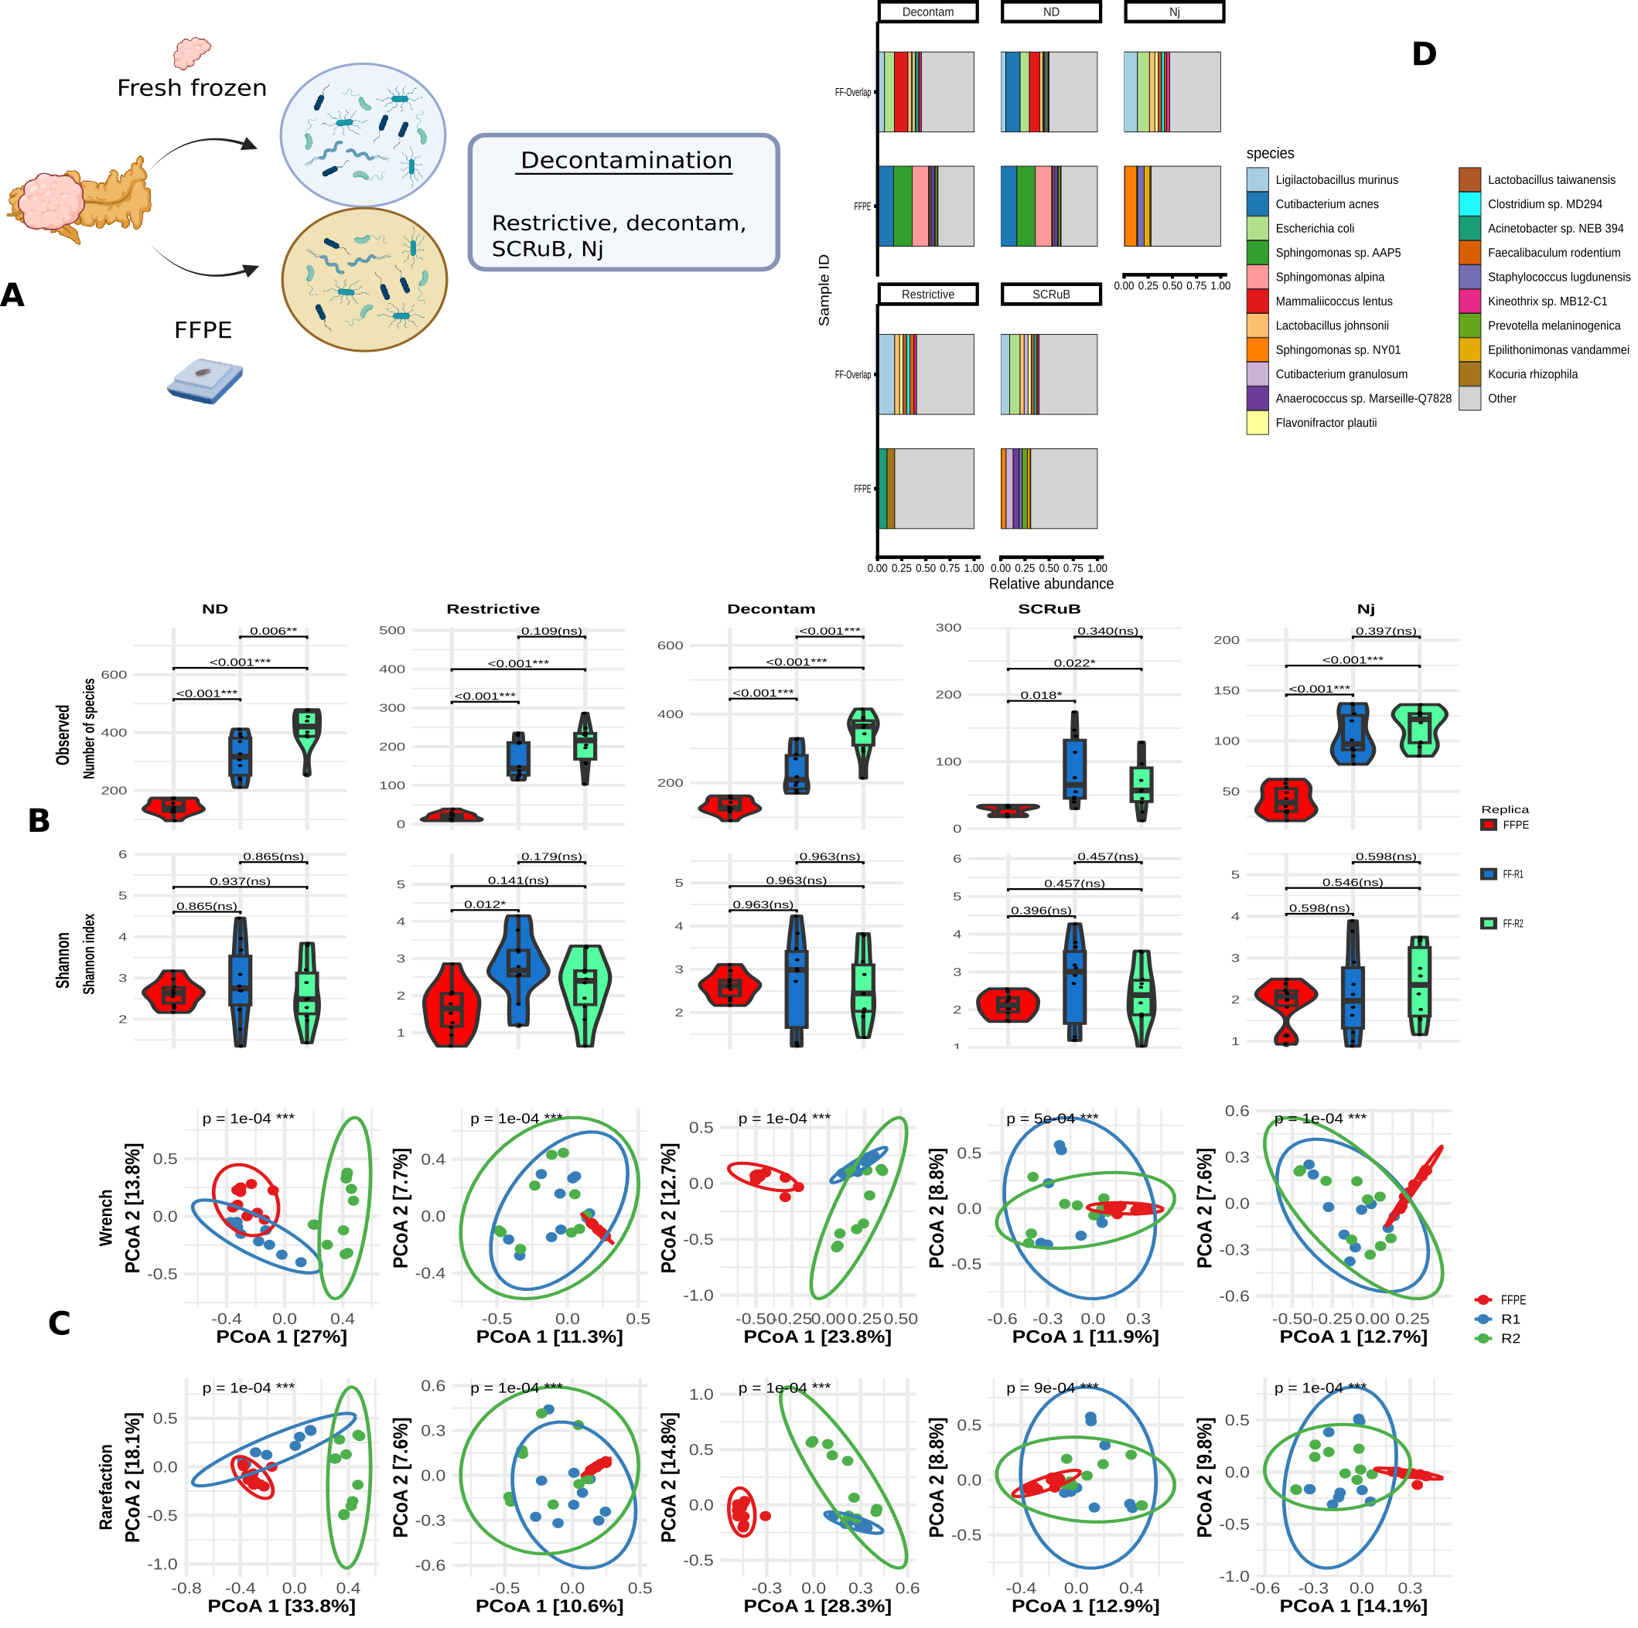Figure 4: Comparative analysis of paired FF and FFPE PDAC samples. A) Schematic overview of the study design: 10 paired PDAC samples from KPC mice were profiled by 16S rRNA sequencing using both FF and FFPE samples. Two independent sequencing runs were performed for the FF samples to generate technical replicates. B) Alpha diversity analyses comparing FFPE samples and the two FF technical replicates across the ND data and four decontamination strategies. Diversity was assessed using the number of observed species and the Shannon diversity index. C) Beta diversity analyses of the two FF technical replicates and paired FFPE samples. Samples are colored and grouped by technical replicate. Analyses were performed using both Wrench normalization and rarefaction. D) Overall bacterial composition of FF overlap and FFPE samples without (ND) and with various decontamination.

