Supplementary

Supplementary methods

Supplementary figures
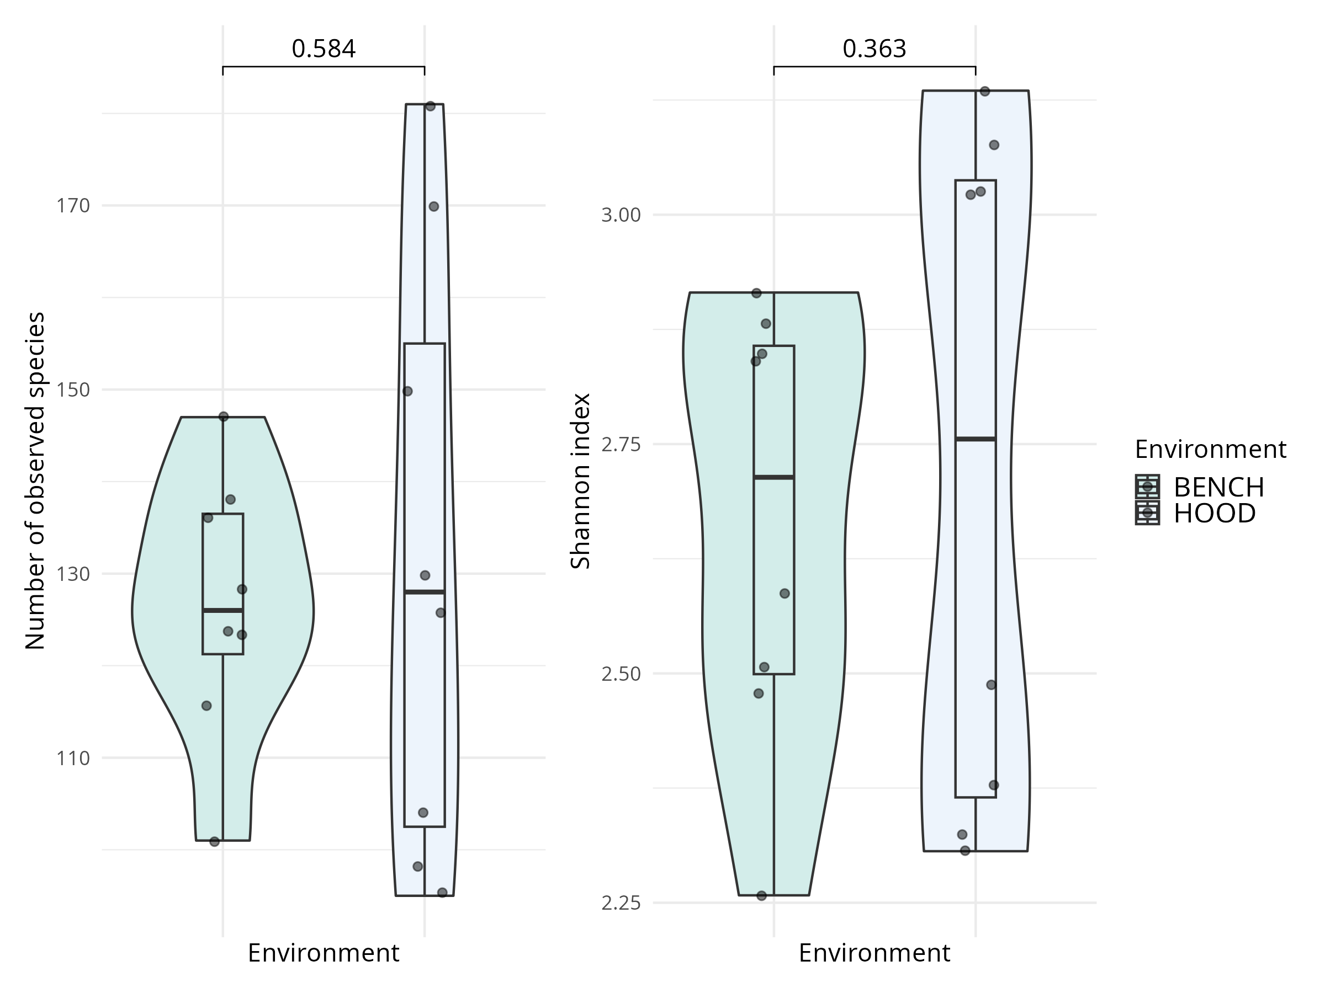
Supplementary figure S1: Alpha diversity with respect to processing environment after adjusting effect of laboratory person. Low-germ environment includes sterile gloves, facial mask, working under the hood. Standard processing refers to working with standard gloves, no facial mask and at the bench. Multivariable negative binomial distribution for number of observed species and gaussian distribution for Shannon index were applied.

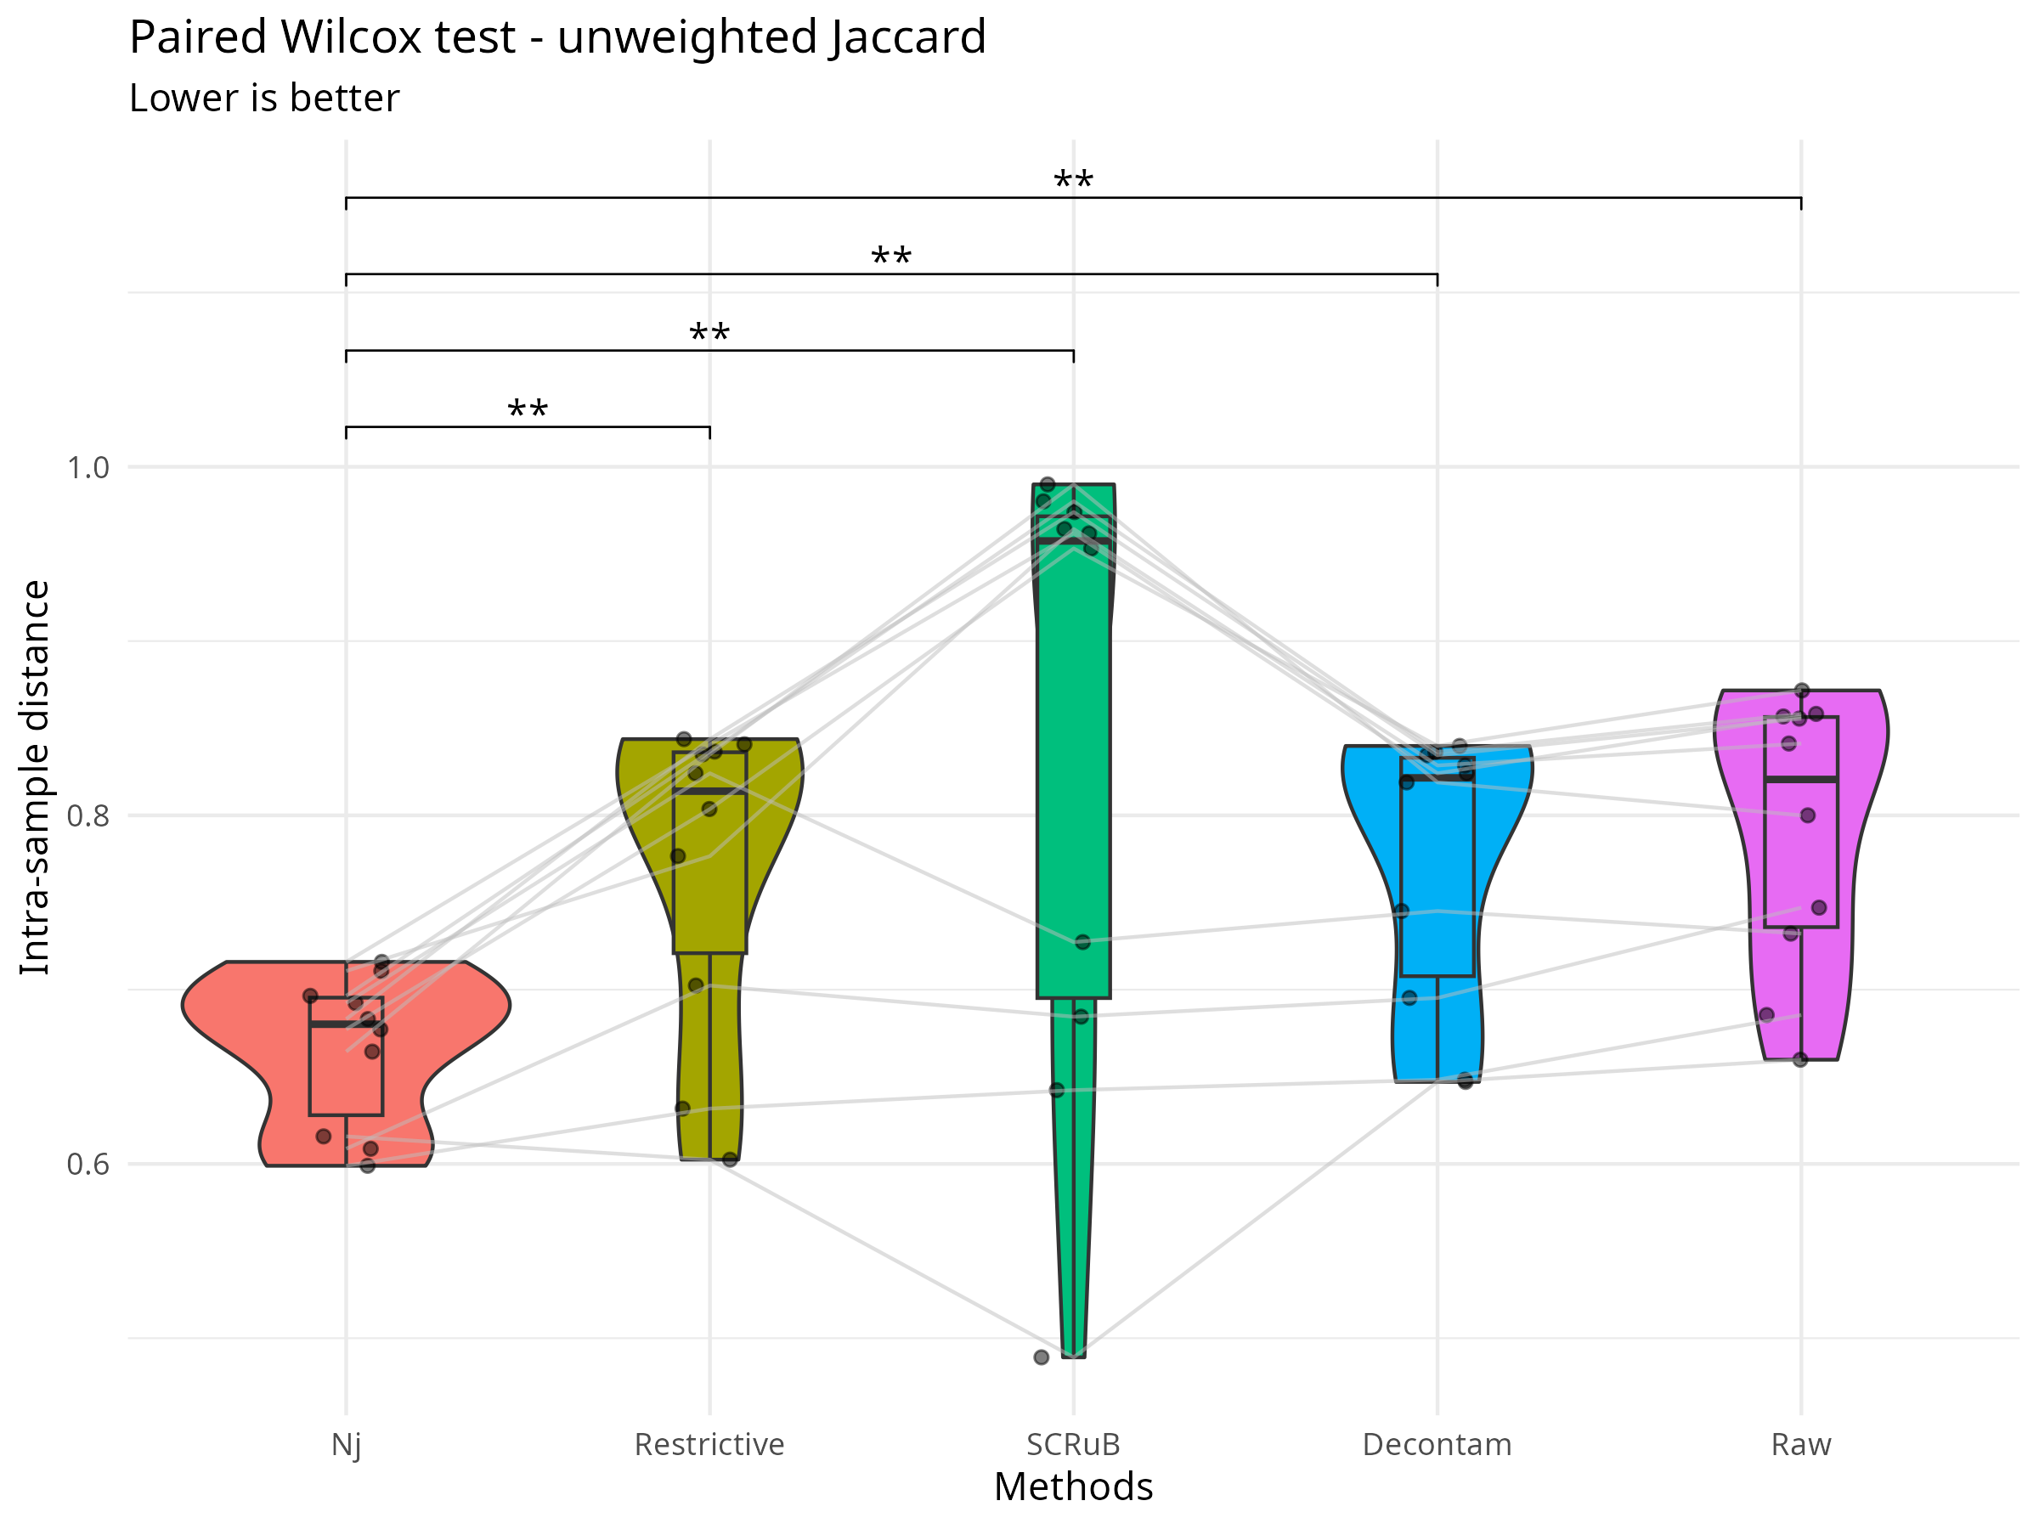Supplementary figure S2: paired Wilcox-signed test of inter-replica distance of ND and various decontamination methods.

Supplementary tables

Control type ↓ Year → | 2021 | 2022 | 2023 | 2024 | ‍2025
Buffer | 26 | 67 | 17 | 38 | ‍19
Paraffin | 2 | 56 | 9 | 1 | ‍7
PCR | 0 | 4 | 4 | 8 | ‍4
Supplementary table S1: Negative control samples collected across years, stratified by control types.

Observed species | p-value | IRR | LCL | UCL
Buffer - Paraffin | 0.04* | 0.81 | 0.65 | 1
Buffer - PCR | 0.03* | 1.32 | 1.02 | 1.71
Paraffin - PCR | <0.001*** | 1.63 | 1.22 | 2.19
Shannon | p-value | exp(β) | LCL | UCL
Buffer - Paraffin | 1 | 1 | 0.97 | 1.03
Buffer - PCR | 0.48 | 0.98 | 0.95 | 1.02
Paraffin - PCR | 0.55 | 0.98 | 0.94 | 1.02
Supplementary table S2: Alpha analyses with respect to control type after adjusting other covariates such as laboratory person, year and season with multivariable negative binomial regression for observed species and multivariable gamma regression with log-link. IRR – incidence rate ratio, LCL - lower confidence limit and UCL - upper confidence limit

Variable | R² | Omega-squared | p-value
Control type | 0.02 | 0.01 | <0.001***
Person | 0.15 | 0.11 | <0.001***
Year | 0.07 | 0.06 | <0.001***
Season | 0.06 | 0.05 | <0.001***
Supplementary table S3: distance-based redundancy analyses for Bray-Curtis dissimilarity of negative controls with respect to a variable after adjusting the others. PERMANOVA test was applied.
Supplementary table S4: Top 30 genera by total abundance of all NCT samples
Genera | Reads | Cumulative Proportion
Sphingomonas | 5134397 | 28.61
Caldibacillus | 3035664 | 45.52
Streptococcus | 1034676 | 51.28
Burkholderia | 605995 | 54.66
Fervidibacillus | 593031 | 57.97
Bradyrhizobium | 583338 | 61.22
Sporosarcina | 506091 | 64.03
Cutibacterium | 482878 | 66.73
Veillonella | 373869 | 68.81
Delftia | 367958 | 70.86
Bacillus | 295277 | 72.5
Staphylococcus | 247026 | 73.88
Variovorax | 195094 | 74.97
Haemophilus | 192174 | 76.04
Peptoniphilus | 149080 | 76.87
Niallia | 146140 | 77.68
Finegoldia | 140391 | 78.46
Caldifermentibacillus | 139994 | 79.24
Stenotrophomonas | 126861 | 79.95
Escherichia | 125426 | 80.65
Methylorubrum | 121398 | 81.33
Paracoccus | 93657 | 81.85
Anaerococcus | 91813 | 82.36
Gemella | 89796 | 82.86
Methylobacterium | 82573 | 83.32
Roseomonas | 82192 | 83.78
Clostridium | 80882 | 84.23
Neobacillus | 78431 | 84.67
Brucella | 73386 | 85.07
Achromobacter | 70440 | 85.47
Supplementary table S4: Top 30 genera by total abundance of all negative controls

Species | Prevalence | Abundance
Caldibacillus__thermoamylovorans | 0.07 | 0.17
Sphingomonas__paucimobilis | 0.6 | 0.16
Sphingomonas__hankookensis | 0.76 | 0.05
Fervidibacillus__albus | 0.06 | 0.03
Sporosarcina__sp.__Marseille-Q4063 | 0.08 | 0.03
Cutibacterium__acnes | 0.79 | 0.03
Delftia__acidovorans | 0.35 | 0.02
Sphingomonas__sp.__AAP5 | 0.77 | 0.02
Veillonella__parvula | 0.46 | 0.01
Bradyrhizobium__elkanii | 0.23 | 0.01
Burkholderia__contaminans | 0.35 | 0.01
Sphingomonas__alpina | 0.73 | 0.01
Streptococcus__mitis | 0.68 | 0.01
Variovorax__paradoxus | 0.29 | 0.01
Streptococcus__oralis | 0.69 | 0.01
Haemophilus__parainfluenzae | 0.31 | 0.01
Bradyrhizobium__sp.__41S5 | 0.15 | 0.01
Niallia__sp.__XMNu-256 | 0.1 | 0.01
Finegoldia__magna | 0.27 | 0.01
Caldifermentibacillus__hisashii | 0.09 | 0.01
Streptococcus__thermophilus | 0.66 | 0.01
Escherichia__coli | 0.69 | 0.01
Sphingomonas__sp.__QA11 | 0.77 | 0.01
Methylorubrum__extorquens | 0.28 | 0.01
Sphingomonas__sp.__NY01 | 0.51 | 0.01
Peptonophilus__genitalis | 0.24 | 0.01
Sphingomonas__sanguinis | 0.44 | 0
Roseomonas__mucosa | 0.12 | 0
Bacillus__sp.__OxB-1 | 0.1 | 0
Staphylococcus__epidermidis | 0.61 | 0
Burkholderia__cenocepacia | 0.29 | 0
Abiotrophia__defectiva | 0.28 | 0
Streptococcus__pneumoniae | 0.67 | 0
Neobacillus__sp.__PS3-40 | 0.08 | 0
Sphingomonas__sp.__So64.6b | 0.72 | 0
Staphylococcus__hominis | 0.43 | 0
Bacillus__sp.__S3 | 0.08 | 0
Bradyrhizobium__septentrionale | 0.19 | 0
Burkholderia__cepacia | 0.24 | 0
Macrococcus__equipercicus | 0.06 | 0
Bradyrhizobium__quebecense | 0.16 | 0
Bacillus__sp.__T3 | 0.07 | 0
Burkholderia__aenigmatica | 0.22 | 0
Sphingomonas__panacis | 0.73 | 0
Brucella__anthropi | 0.15 | 0
Gemella__haemolysans | 0.5 | 0
Mesorhizobium__terrae | 0.39 | 0
Granulicatella__adiacens | 0.47 | 0
Methylobacterium__sp.__FF17 | 0.16 | 0
Streptococcus__salivarius | 0.58 | 0
Burkholderia__lata | 0.27 | 0
Parvimonas__micra | 0.27 | 0
Peribacillus__asahii | 0.18 | 0
Prevotella__melaninogenica | 0.23 | 0
Brevundimonas__sp.__PAMC22021 | 0.21 | 0
Streptococcus__gordonii | 0.45 | 0
Planococcus__versutus | 0.07 | 0
Sphingomonas__sp.__HMP6 | 0.71 | 0
Streptococcus__parasanguinis | 0.5 | 0
Sphingomonas__sp.__CL5.1 | 0.58 | 0
Burkholderia__glumae | 0.29 | 0
Burkholderia__arboris | 0.21 | 0
Priestia__filamentosa | 0.08 | 0
Fenollaria__massiliensis | 0.1 | 0
Anaerococcus__obesiensis | 0.15 | 0
Veillonella__rogosae | 0.41 | 0
Stenotrophomonas__sp.__KCTC__12332 | 0.05 | 0
Peptoniphilus__harei | 0.24 | 0
Ralstonia__sp.__RRA.1 | 0.36 | 0
Paracoccus__contaminans | 0.25 | 0
Veillonella__atypica | 0.32 | 0
Blastococcus__sp.__PRF04-17 | 0.05 | 0
Staphylococcus__aureus | 0.64 | 0
Sphingomonas__sp.__NIBR02145 | 0.37 | 0
Fervidibacillus__halotolerans | 0.07 | 0
Veillonella__nakazawae | 0.35 | 0
Stenotrophomonas__maltophilia | 0.4 | 0
Clostridium__isatidis | 0.08 | 0
Methylobacterium__indicum | 0.16 | 0
Clostridium__chauvoei | 0.08 | 0
Macrococcoides__caseolyticum | 0.09 | 0
Aquabacterium__olei | 0.23 | 0
Anaerococcus__sp.__Marseille-Q7828 | 0.26 | 0
Cutibacterium__granulosum | 0.22 | 0
Streptococcus__mutans | 0.21 | 0
Streptococcus__sp.__FSL__W8-0197 | 0.54 | 0
Bacillus__subtilis | 0.21 | 0
Bacillus__smithii | 0.07 | 0
Veillonella__sp.__S12025-13 | 0.34 | 0
Sphingomonas__sp.__LK11 | 0.14 | 0
Sphingomonas__sp.__FARSPH | 0.71 | 0
Exiguobacterium__aurantiacum | 0.07 | 0
Peptostreptococcus__equinus | 0.2 | 0
Sphingomonas__melonis | 0.68 | 0
Bradyrhizobium__sp.__200 | 0.23 | 0
Stenotrophomonas__acidaminiphila | 0.08 | 0
Achromobacter__xylosoxidans | 0.08 | 0
Haemophilus__haemolyticus | 0.18 | 0
Mogibacterium__diversum | 0.28 | 0
Peptoniphilus__ivorii | 0.14 | 0
Sphingopyxis__sp.__EG6 | 0.08 | 0
Veillonella__dispar | 0.35 | 0
Streptococcus__gwangjuense | 0.54 | 0
Moraxella__osloensis | 0.47 | 0
Gemella__morbillorum | 0.39 | 0
Sphingomonas__sp.__R1 | 0.35 | 0
Ureibacillus__sp.__FSL__K6-0786 | 0.05 | 0
Blautia__wexlerae | 0.14 | 0
Schaalia__odontolytica | 0.12 | 0
Staphylococcus__warneri | 0.47 | 0
Supplementary table S5: All species in NCT whose relative total abundance is at least 0.1%, sorted by the abundance.

Observed species | IRR | LCL | UCL | p-value
LP1 - LP2 | 1.32 | 1.17 | 1.48 | <0.001***
Low-germ - standard | 0.97 | 0.86 | 1.09 | 0.58
Shannon | β | LCL | UCL | p-value
LP1 - LP2 | 1.74 | 1.54 | 1.96 | <0.001***
Low-germ - standard | 0.95 | 0.84 | 1.07 | 0.35
Supplementary table S7: Alpha diversity analyses of LP and environment. Multivariable negative binomial distribution for number of observed species and gaussian distribution for Shannon index were applied. IRR – incidence rate ratio, LCL - lower confidence limit, LP – laboratory person, UCL - upper confidence limit

Variable | p-value | R²
Environment | 0.25 | 0.05
LP | 0.01* | 0.46
Supplementary table S8: Distance-based redundancy analyses with respect to Environment and LP, after adjusting effect of each other, with Bray Curtis dissimilarity metric.

Supplementary table S9: differential abundant species between LP1 and LP2
feature | coef | stderr | pval | qval | Direction
Brevundimonas_sp._DS20 | 3.81 | 0.37 | 1.20E-07 | 1.19E-05 | LP2
Variovorax_sp._RA8 | -3.39 | 0.23 | 1.68E-09 | 3.89E-07 | LP1
Shigella_flexneri | 3.32 | 0.36 | 5.03E-07 | 3.88E-05 | LP2
Hydrogenophaga_taeniospiralis | -3.23 | 0.36 | 5.84E-07 | 4.05E-05 | LP1
Variovorax_paradoxus | -3.2 | 0.26 | 1.51E-08 | 2.61E-06 | LP1
Variovorax_sp._PAMC_28711 | -3.03 | 0.49 | 3.43E-05 | 0 | LP1
Variovorax_sp._PBL.H6 | -2.58 | 0.33 | 2.80E-06 | 1.62E-04 | LP1
Variovorax_sp._SRS16 | -2.52 | 0.36 | 9.96E-06 | 5.32E-04 | LP1
Brevundimonas_fontaquae | 2.43 | 0.28 | 1.07E-06 | 6.73E-05 | LP2
Fischerella_sp._NIES.3754 | -2.42 | 0.4 | 4.12E-05 | 0 | LP1
Sphingomonas_sinipercae | 2.4 | 0.55 | 8.27E-04 | 0.02 | LP2
Salmonella_enterica | 2.32 | 0.46 | 2.04E-04 | 0.01 | LP2
Escherichia_albertii | 2.24 | 0.41 | 1.09E-04 | 0 | LP2
Escherichia_fergusonii | 2.19 | 0.5 | 7.79E-04 | 0.02 | LP2
Calothrix_sp._NIES.3974 | -2.13 | 0.22 | 3.01E-07 | 2.62E-05 | LP1
Acinetobacter_baumannii | 2.04 | 0.05 | 2.84E-15 | 1.97E-12 | LP2
cyanobacterium_endosymbiont_of_Epithemia_turgida | -2.02 | 0.34 | 4.93E-05 | 0 | LP1
Sphingomonas_suaedae | -1.94 | 0.49 | 0 | 0.04 | LP1
Sphingomonas_sp._S2.65 | -1.8 | 0.37 | 2.75E-04 | 0.01 | LP1
Sphingomonas_koreensis | -1.72 | 0.4 | 7.92E-04 | 0.02 | LP1
Acidovorax_sp._KKS102 | -1.71 | 0.4 | 8.70E-04 | 0.02 | LP1
Sphingomonas_panacisoli | -0.99 | 0.19 | 1.33E-04 | 0.01 | LP1
Sphingomonas_sp._FARSPH | -0.99 | 0.19 | 1.94E-04 | 0.01 | LP1
Escherichia_coli | 0.92 | 0.05 | 9.75E-11 | 3.38E-08 | LP2
Klebsiella_quasipneumoniae | -0.77 | 0.07 | 1.12E-07 | 1.19E-05 | LP1
Stenotrophomonas_maltophilia | -0.64 | 0.06 | 9.56E-08 | 1.19E-05 | LP1

Supplementary table S10: pairwise comparison based on Wilcox paired test for composite score among ND and various decontamination methods. The alternative is set as "greater", comparing a method in row versus a method in a column.
 | Nj | Restrictive | SCRuB | Decontam | Raw
Nj | NA | 6.68e-05(****) | 5.44e-06(****) | 5.44e-06(****) | 5.44e-06(****)
Restrictive | 1(ns) | NA | 5.44e-06(****) | 5.44e-06(****) | 5.44e-06(****)
SCRuB | 1(ns) | 1(ns) | NA | 1(ns) | 1(ns)
Decontam | 1(ns) | 1(ns) | 1.9e-05(****) | NA | 5.44e-06(****)
Raw | 1(ns) | 1(ns) | 1.9e-05(****) | 1(ns) | NA

Supplementary table S11: pairwise comparison based on Wilcox paired test for inter-replica distance among ND and various decontamination methods. The alternative is set as "less", comparing a method in row versus a method in a column.
 | Nj | Restrictive | SCRuB | Decontam | Raw
Nj | NA | 0.001(**) | 0.003(**) | 0.001(**) | 0.001(**)
Restrictive | 1(ns) | NA | 0.08(ns) | 0.003(**) | 0.001(**)
SCRuB | 1(ns) | 1(ns) | NA | 0.001(**) | 0.001(**)
Decontam | 1(ns) | 1(ns) | 1(ns) | NA | 0.001(**)
Raw | 1(ns) | 1(ns) | 1(ns) | 1(ns) | NA

Supplementary table S12: pairwise comparison based on Wilcox paired test for overlap-overall ratio among ND and various decontamination methods. The alternative is set as "greater", comparing a method in row versus a method in a column.
 | Nj | Restrictive | SCRuB | Decontam | Raw
Nj | NA | 0.002(**) | 0.003(**) | 0.002(**) | 0.002(**)
Restrictive | 1(ns) | NA | 0.031(*) | 0.004(**) | 0.002(**)
SCRuB | 1(ns) | 1(ns) | NA | 0.968(ns) | 0.968(ns)
Decontam | 1(ns) | 1(ns) | 0.263(ns) | NA | 0.002(**)
Raw | 1(ns) | 1(ns) | 0.263(ns) | 1(ns) | NA

