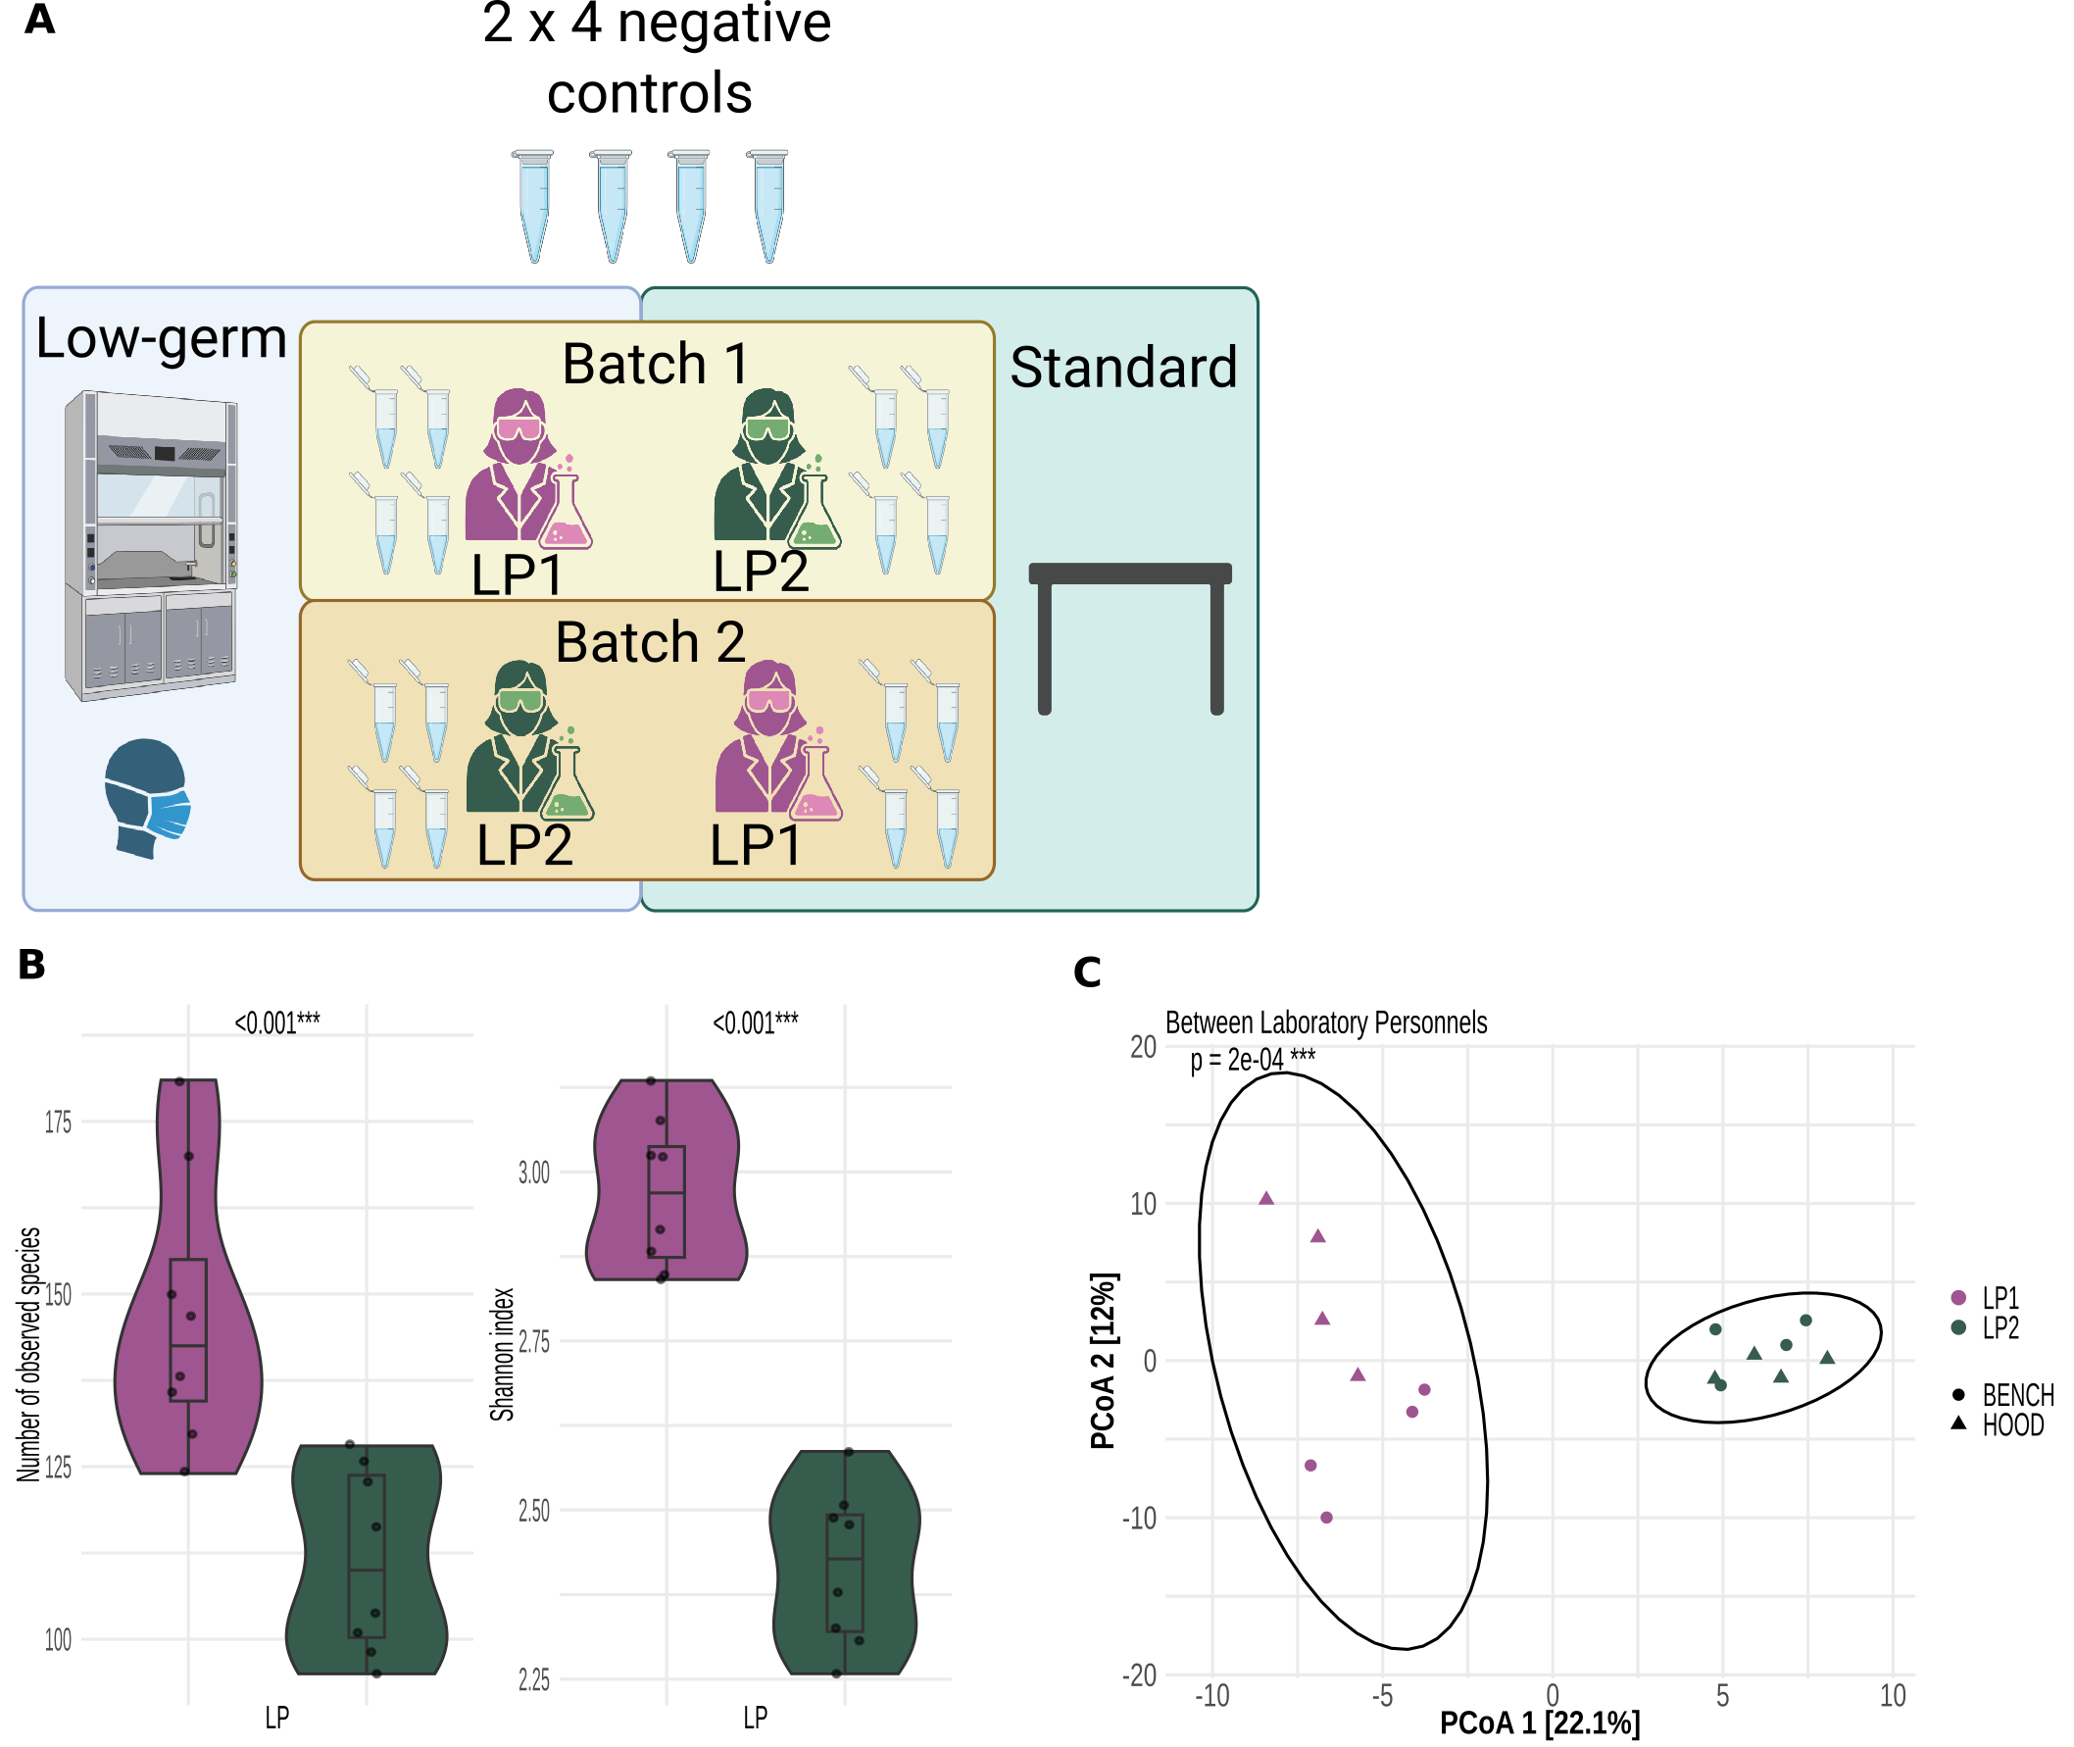Figure 2: 2-factor experiment and its analyses. A) Illustration of 2-factor experimental design: laboratory personnel and processing environment. Each LP at each environment processed 4 blank samples to acquire the lab contaminant profile. Standard environment is where LP processed samples on the bench, without wearing mask and gloves, while low-germ environment is where samples were processed under the ventilated hood, with LP wearing mask and gloves. B) Alpha diversity analyses of blank samples, showing the number of observed species and Shannon diversity index stratified by LP. C) Beta diversity analyses of blank samples, with samples colored by LP and different symbols by processing environments.
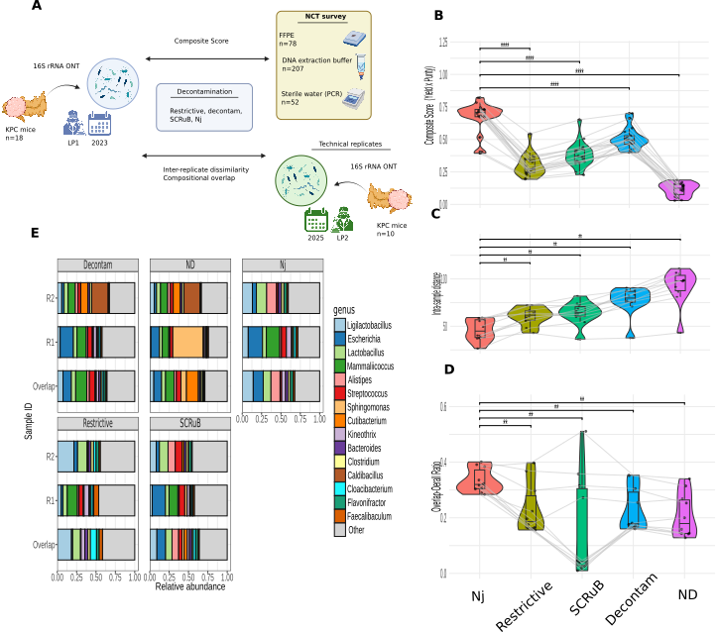Figure 3: Benchmarking strategy for evaluating microbial decontamination methods. A) Experimental design: 18 PDAC samples from KPC mice were sequenced, together with their corresponding negative controls. ND profile was decontaminated through 4 benchmarking methods: restrictive, decontam, SCRuB, and Nj. Later 10/18 fresh frozen PDAC samples from KPC mice were sequenced again as technical replicates. B) Comparison of the 4 decontamination methods and ND profile using a Wilcoxon signed-rank test based on a composite score integrating sample bacterial profiles and the longitudinal NCT survey. Higher scores indicate better performance. C) Comparison of decontamination methods based on the compositional distance between technical replicates. Lower inter-replicate distances indicate higher performance. D) Evaluation of decontamination performance using the compositional overlap ratio between technical replicates. Higher overlap ratios indicate greater performance. E) Overall bacterial composition of the two FF technical replicates and their corresponding FFPE samples.
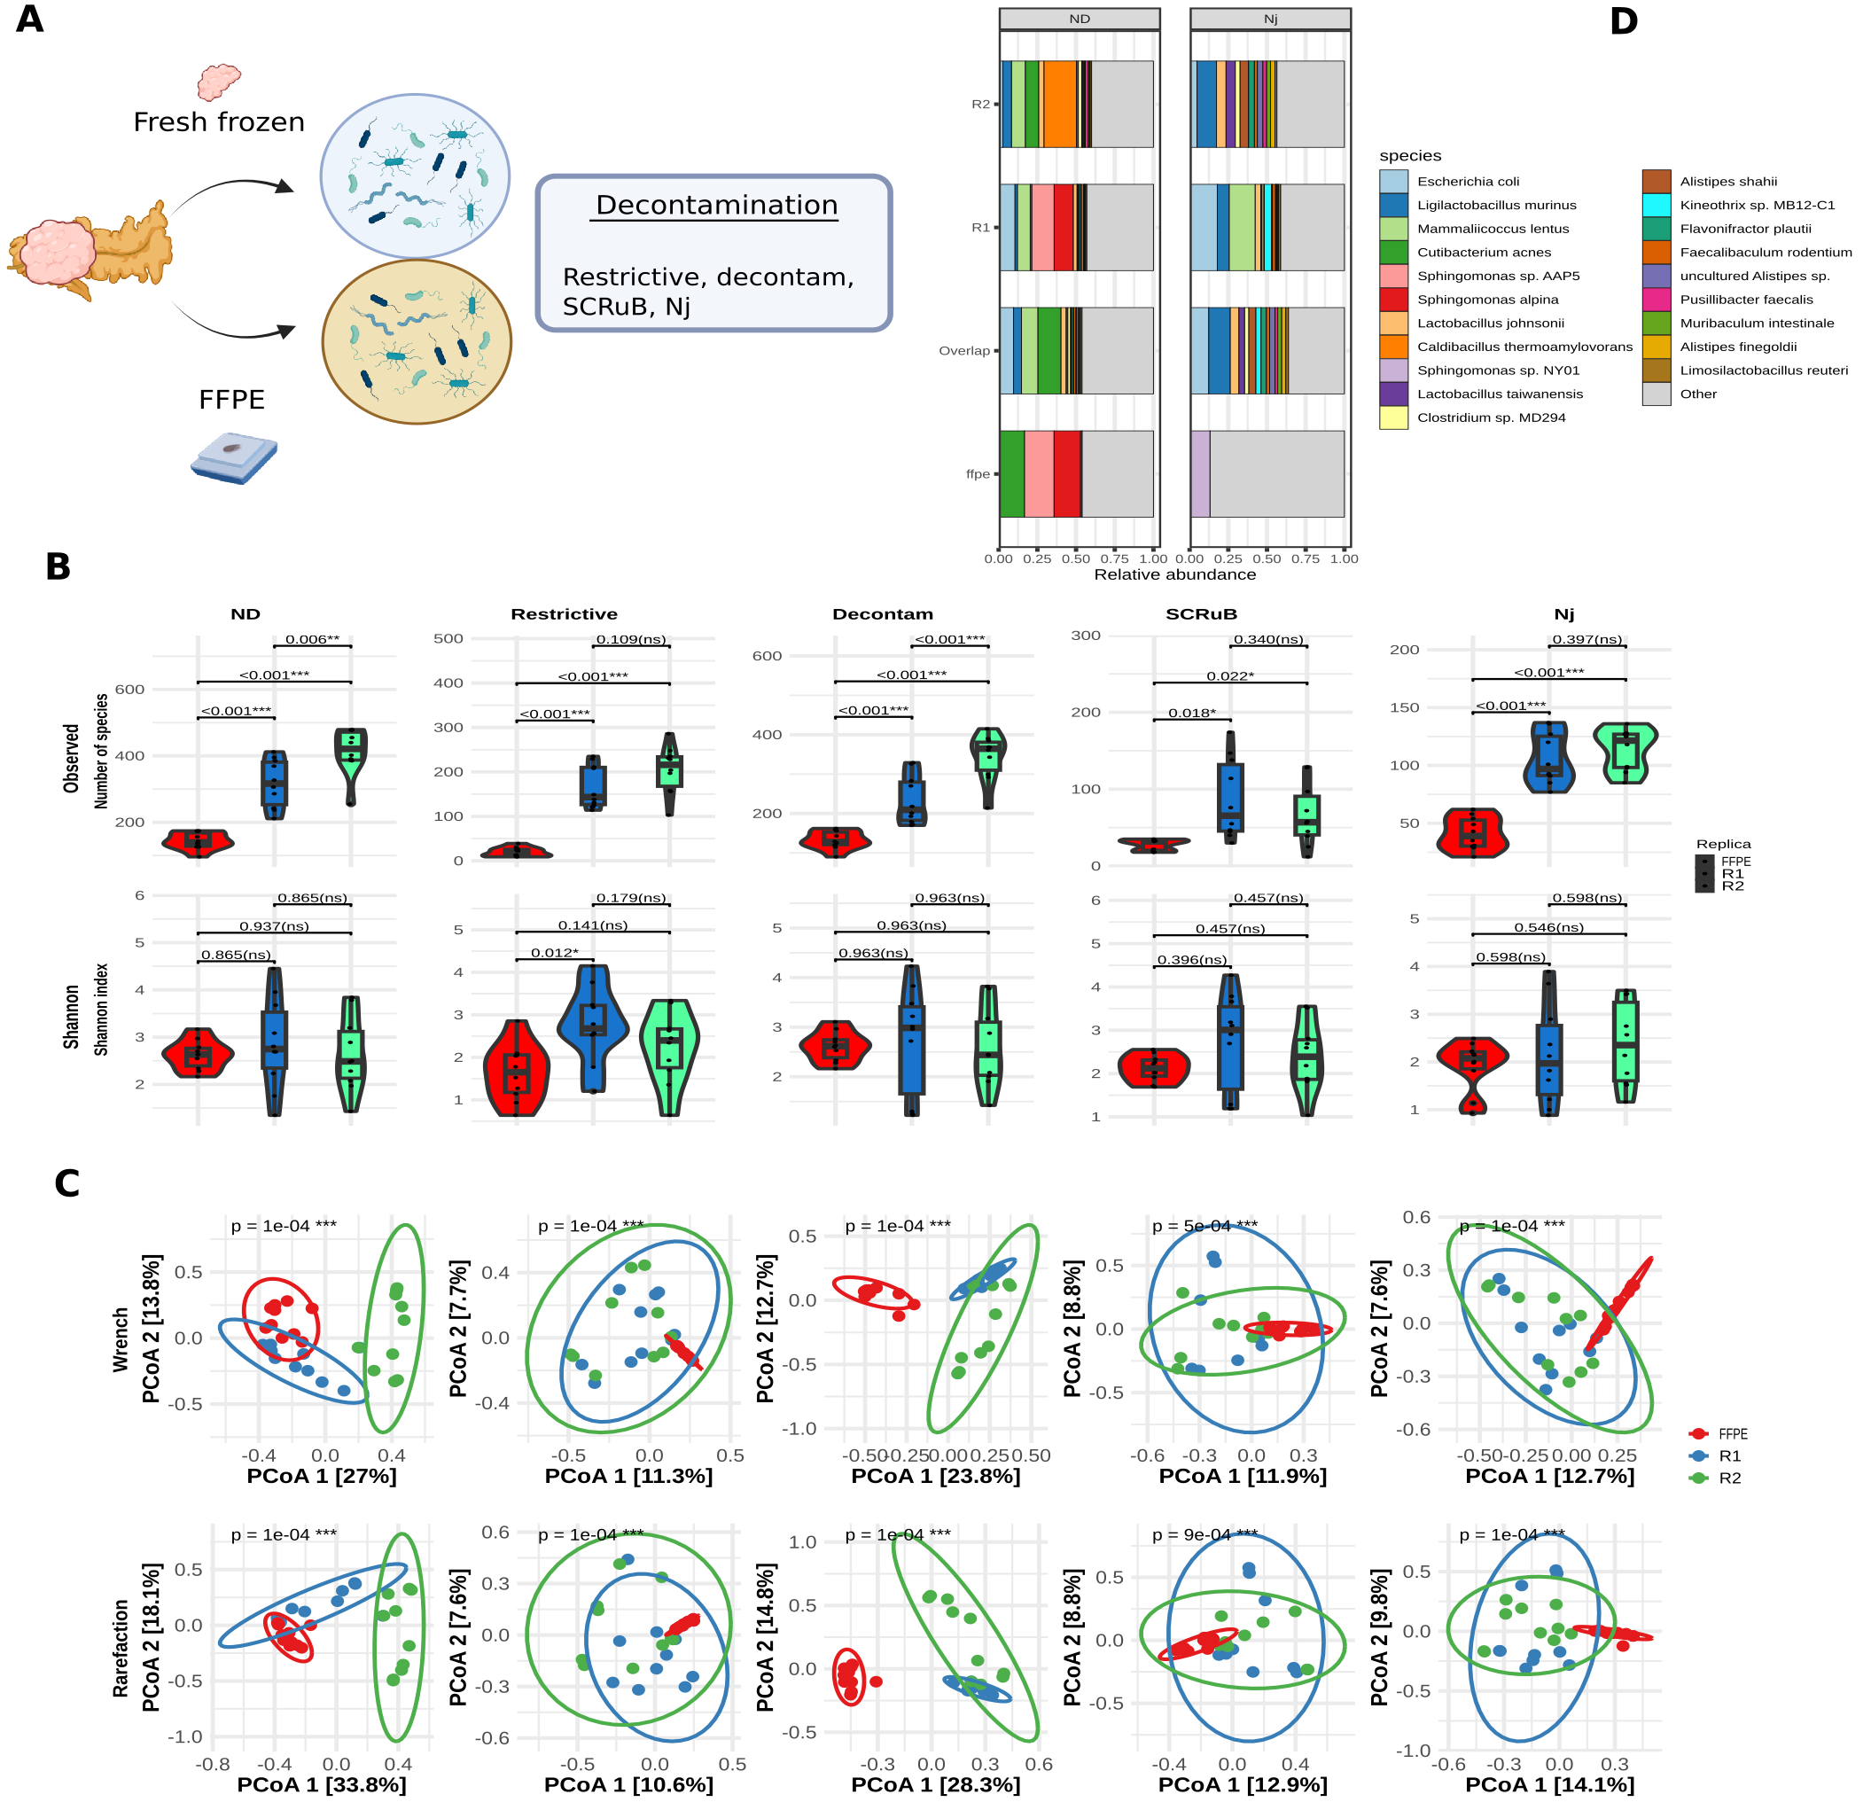Figure 4: paired FF and FFPE samples and its analyses. A) schematic workflow: 10 PDAC sample from KPC mice were profiled via 16S rRNA sequencing, both FF and FFPE paired sample. B) Alpha diversity analyses among FFPE and two FF replicates over ND, various decontamination methods, and different diversity: number of observed species and Shannon index. C) Beta diversity analyses of 2 FF and FFPE replicates, samples are colored and grouped by technical replicates. The analyses were conducted through Wrench and rarefaction normalization. D) Overall bacterial composition of FF and FFPE in ND and Nj decontamination.

