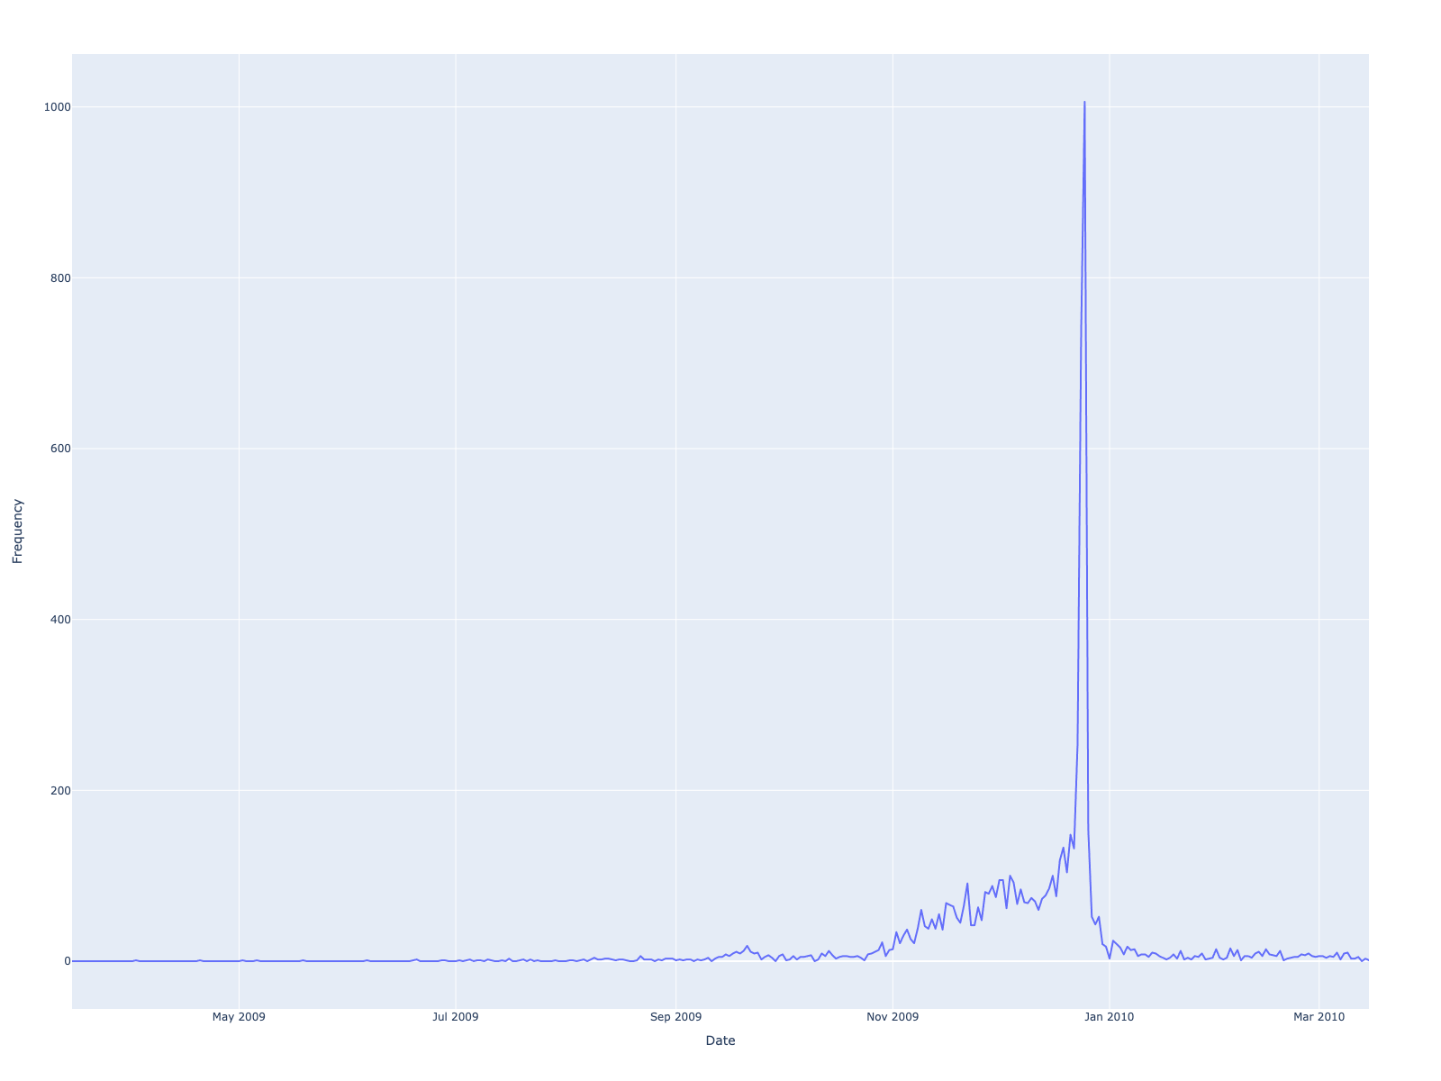
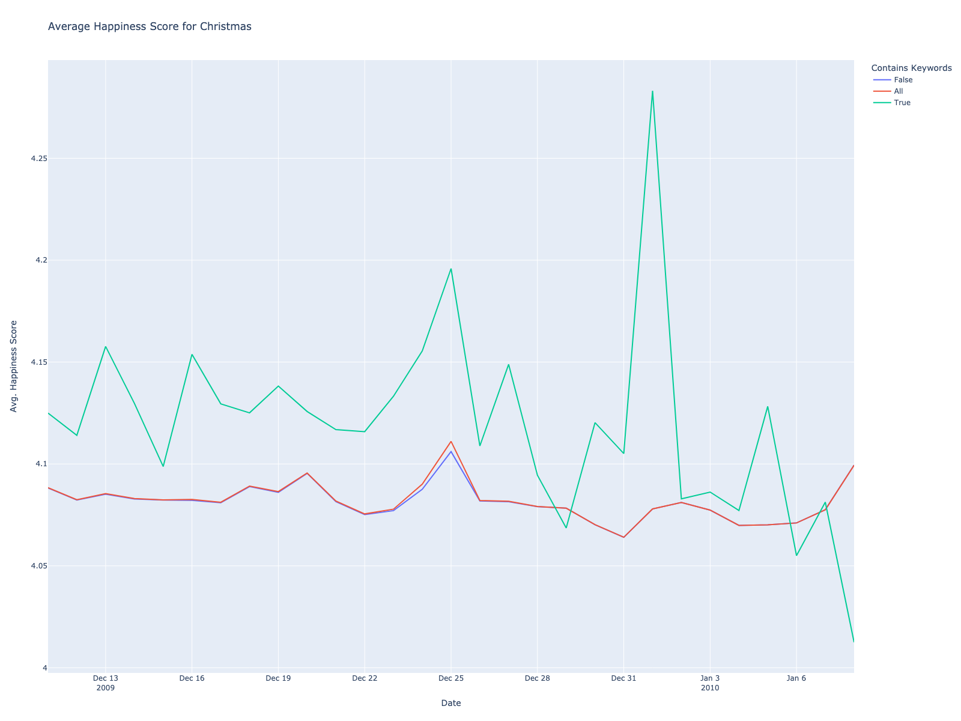

Figures 1.a, 1.b: (a) shows the average happiness on the 14-day periods before and after Christmas. (b) shows the frequency of our Christmas keywords over the whole span of our data.
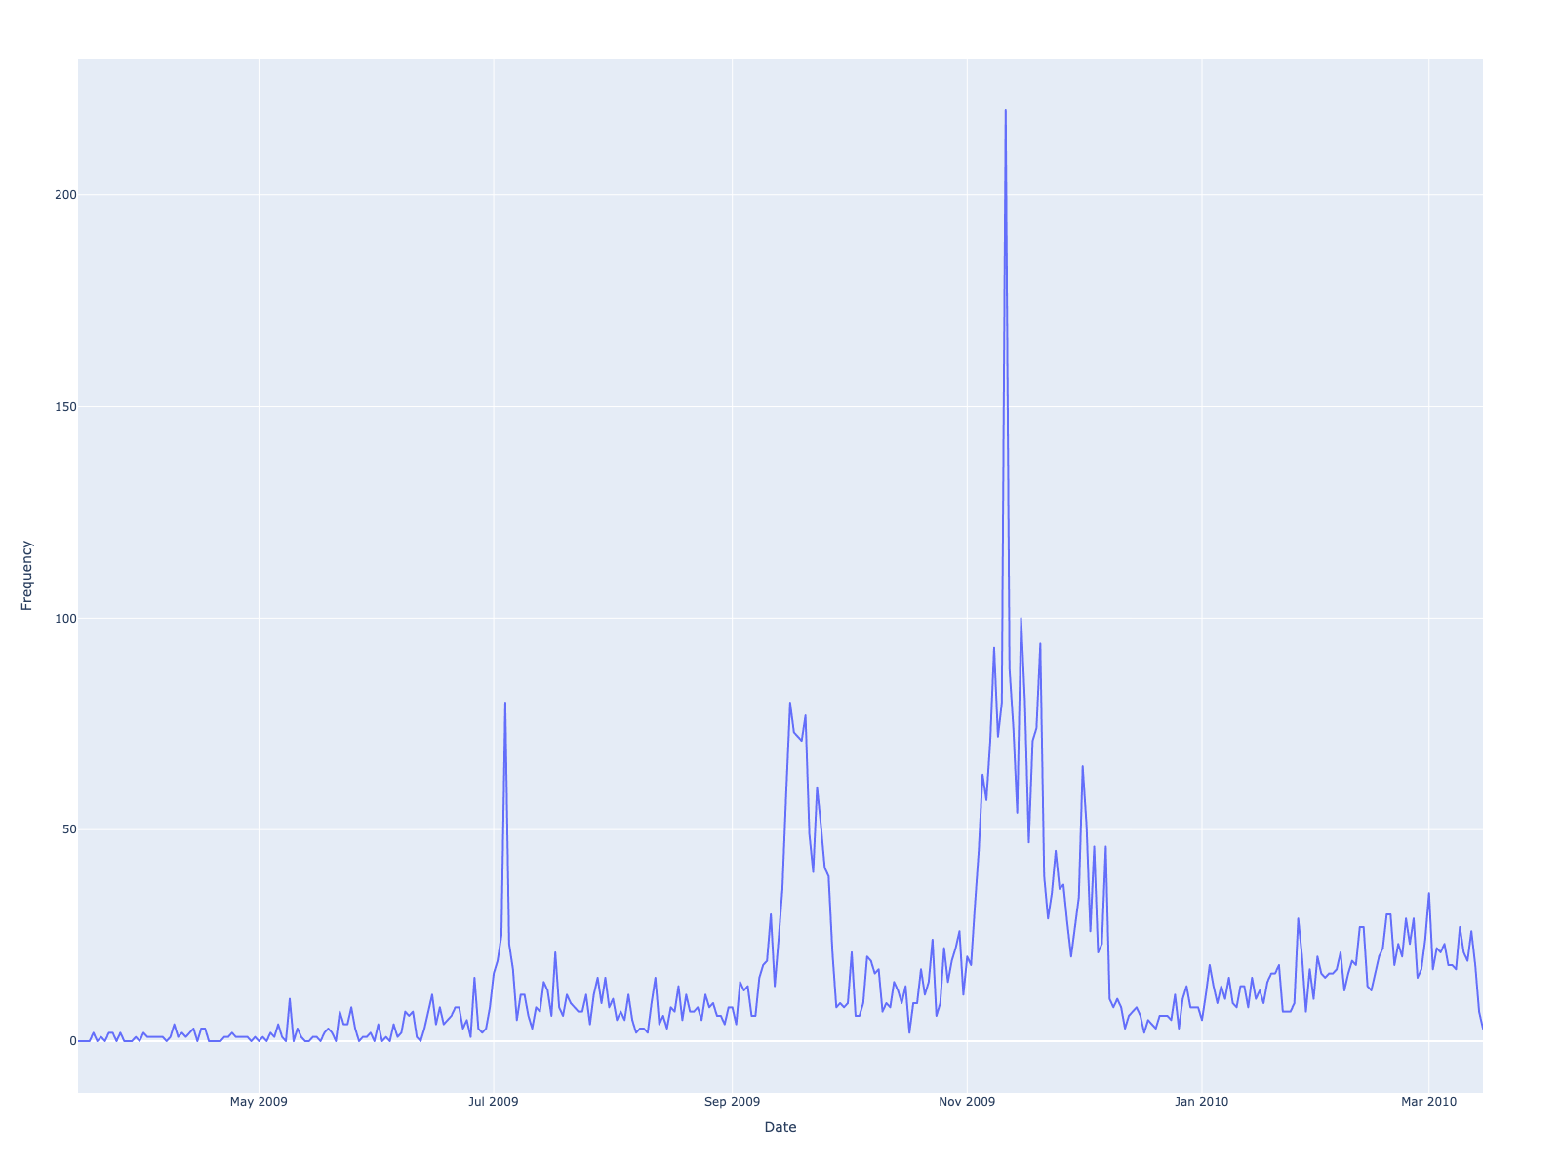
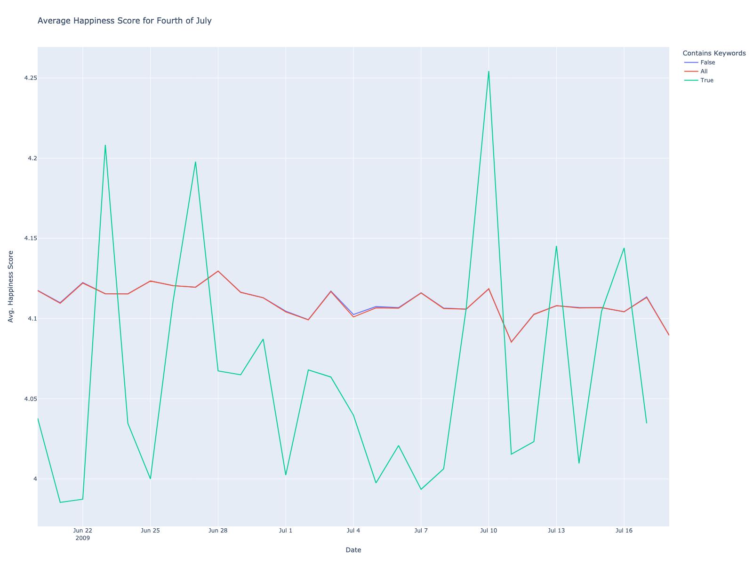
Figures 2.a, 2.b: (a) shows the average happiness on the 14-day periods before and after the Fourth of July. (b) shows the frequency of our Fourth of July keywords over the whole span of our data.
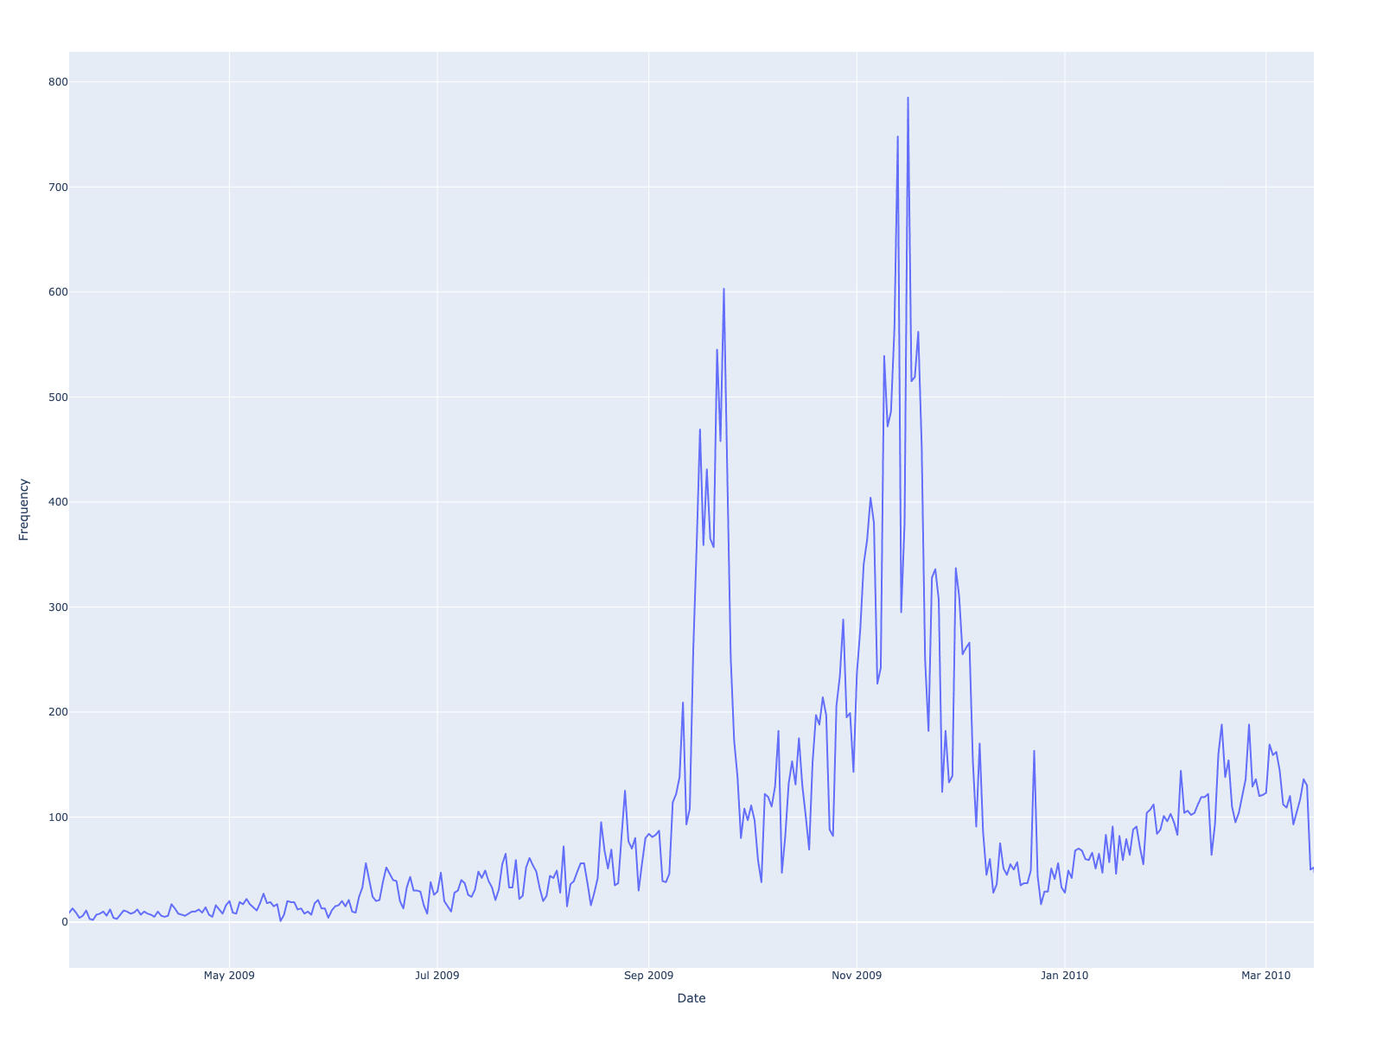
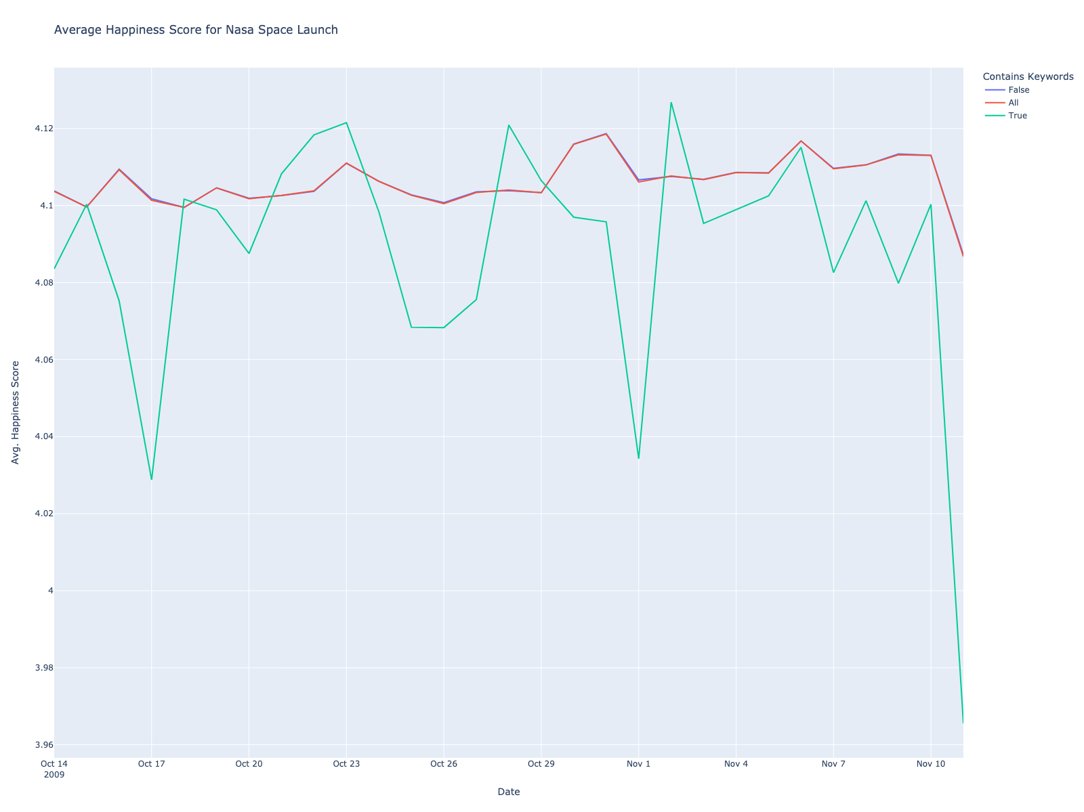

Figures 3.a, 3.b: (a) shows the average happiness on the 14-day periods before and after the October 2009 NASA launch. (b) shows the frequency of our NASA keywords over the whole span of our data.

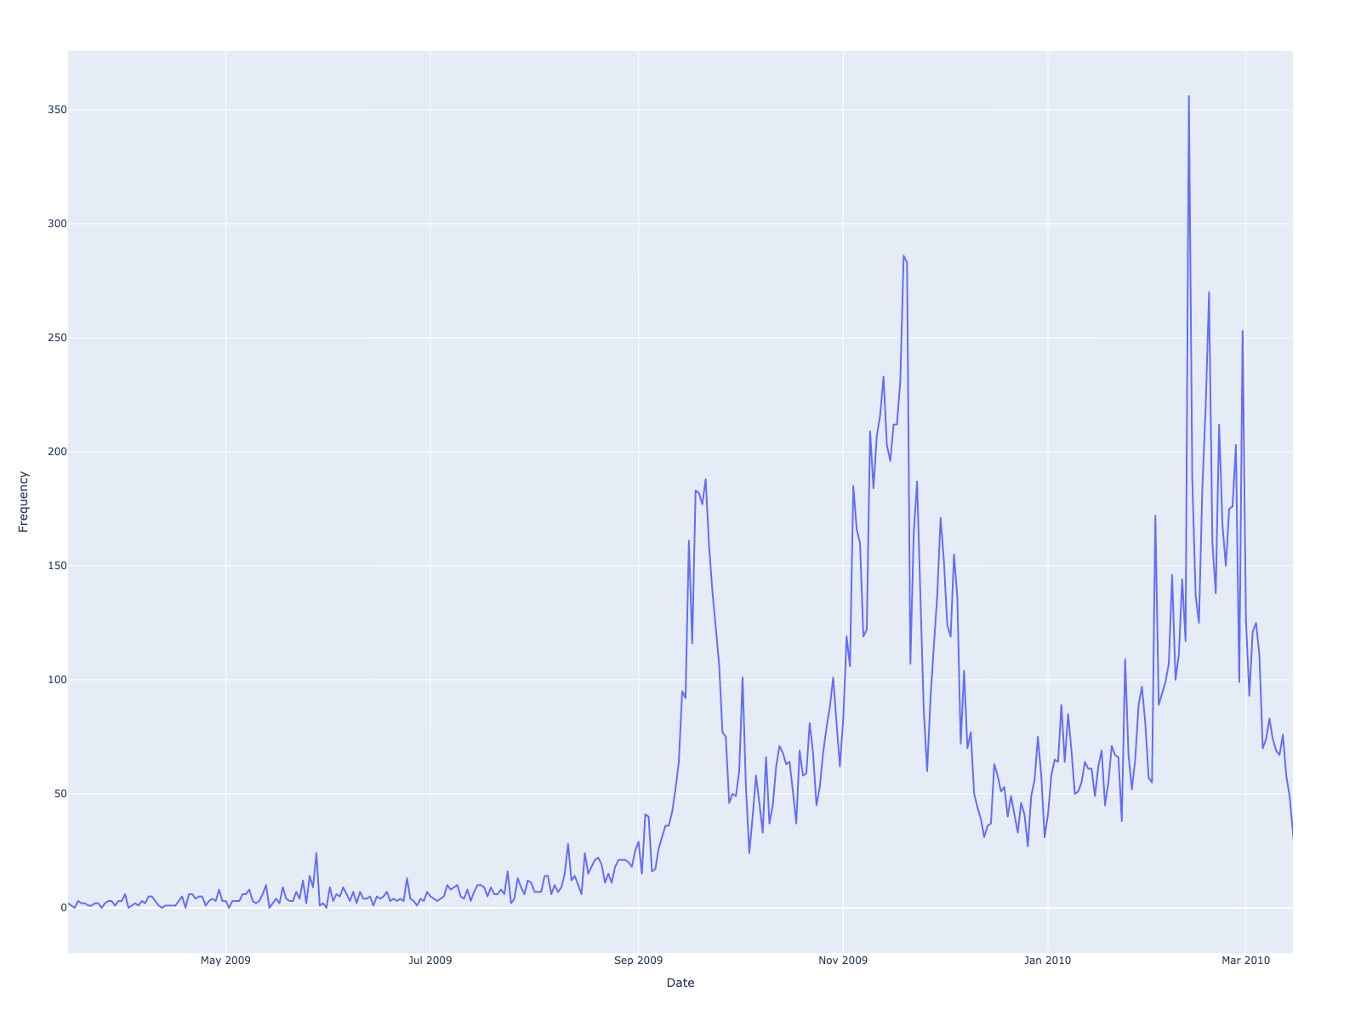
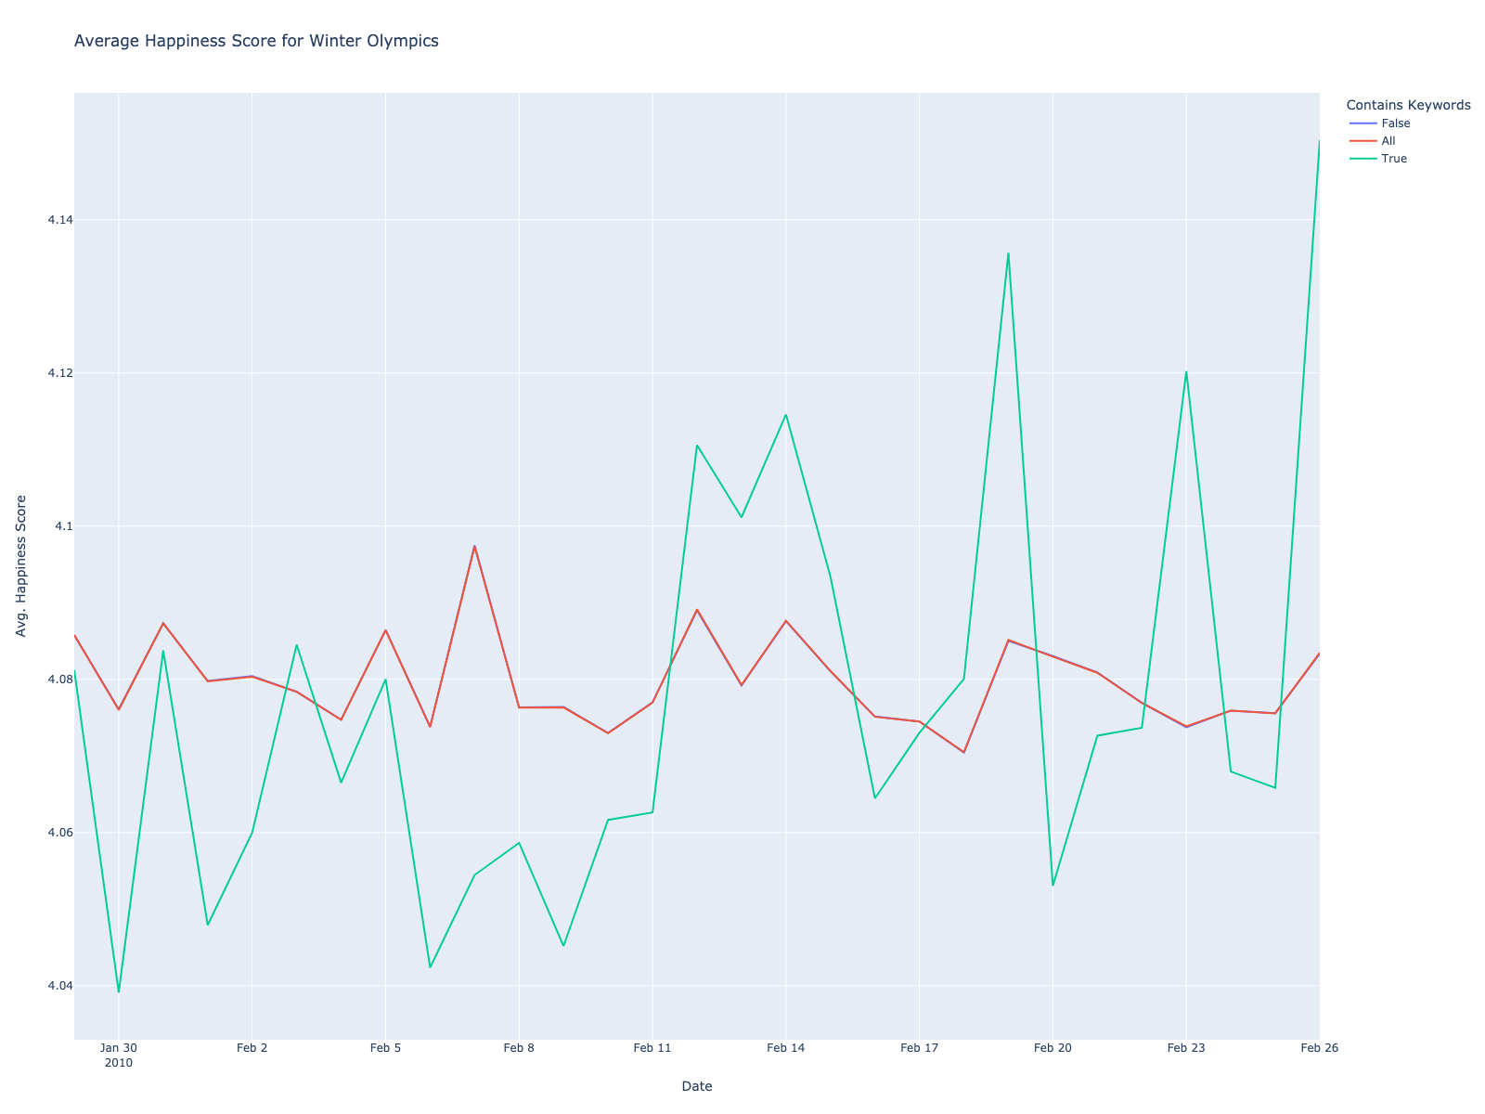

Figures 4.a, 4.b: (a) shows the average happiness on the 14-day periods before and after the start of the 2010 Winter Olympics. (b) shows the frequency of our Winter Olympics keywords over the whole span of our datad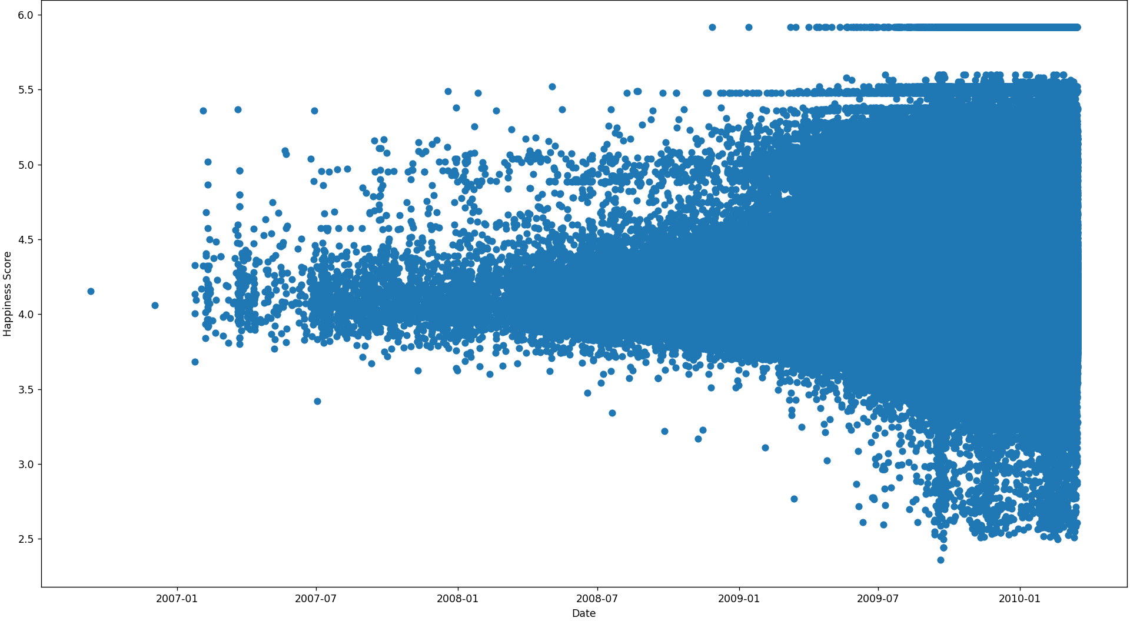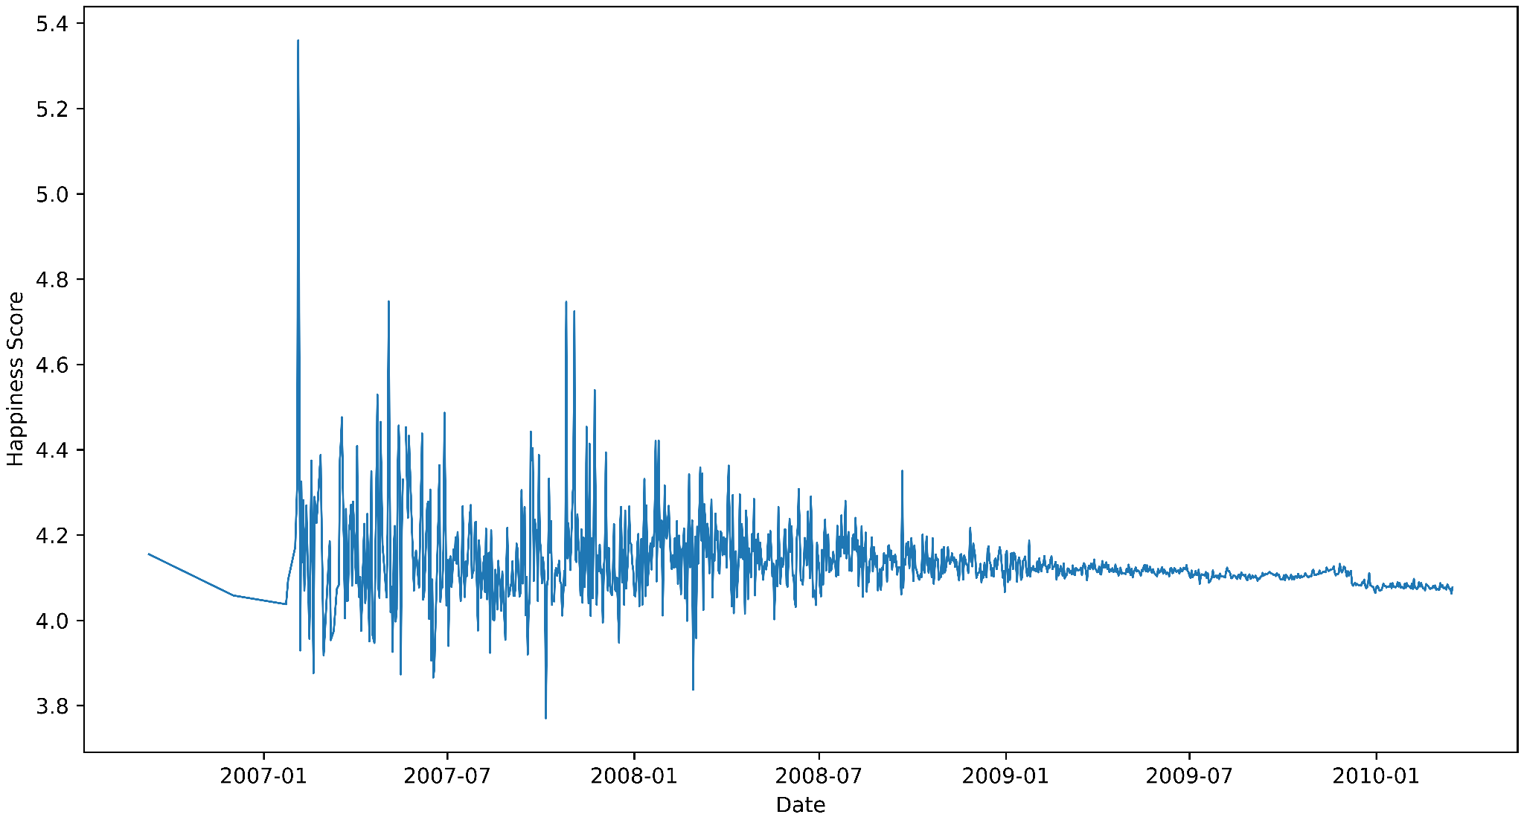

Figures 5.a, 5.b, 5.c: (a) Scatter Plot of All Individual Posts Date-Time of Posting vs. Hedonometer Scores (b) Average Daily Hedonometer Score of Posts

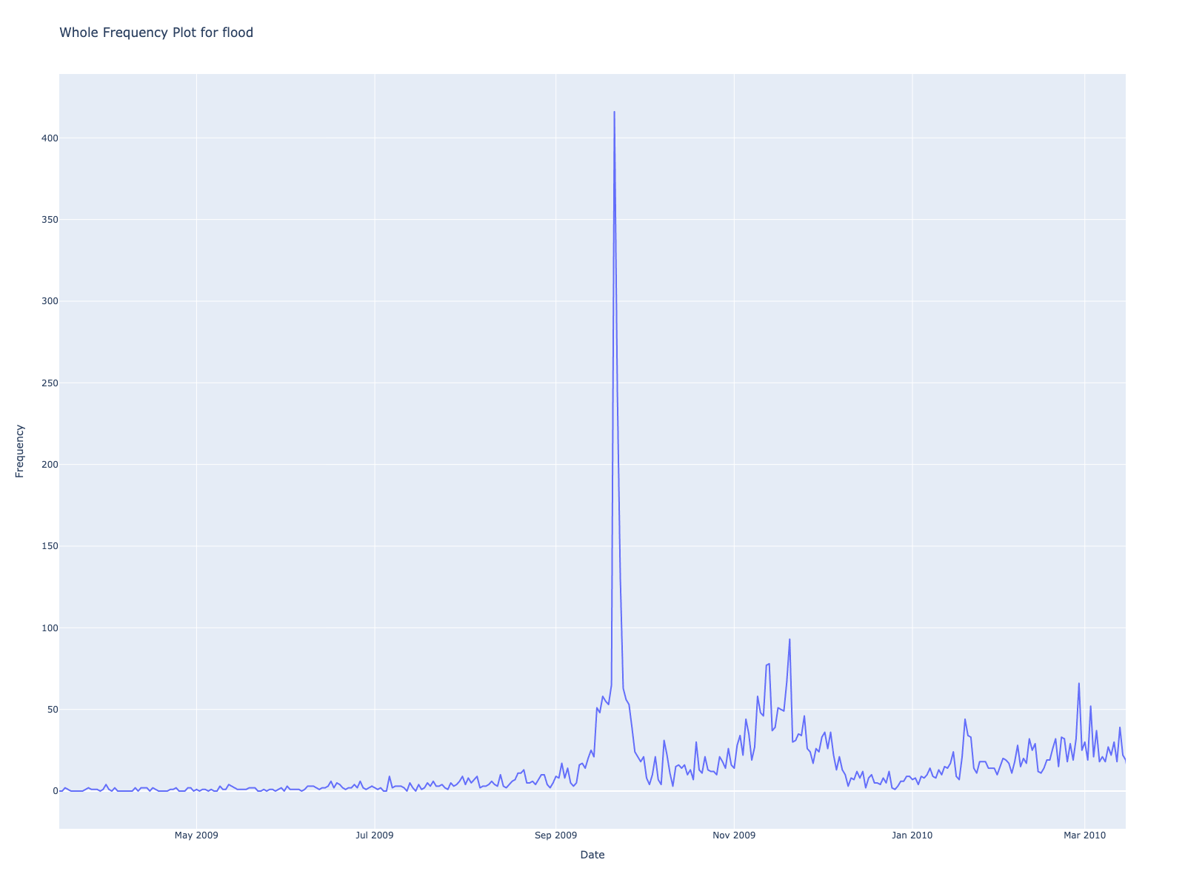
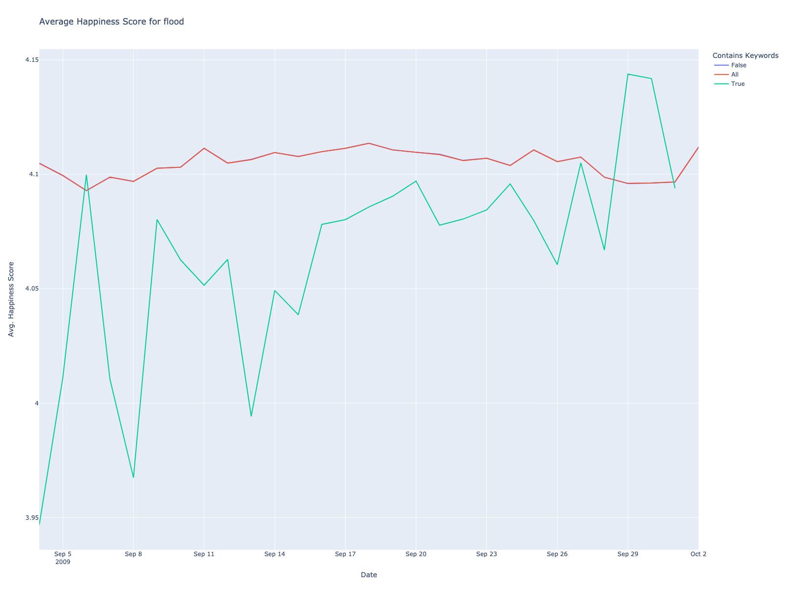
Figures 6.a, 6.b: (a) shows the average happiness on the 14-day periods before and after the start of the 2009 Southeastern United States floods. (b) shows the frequency of our flood keywords over the whole span of our data.
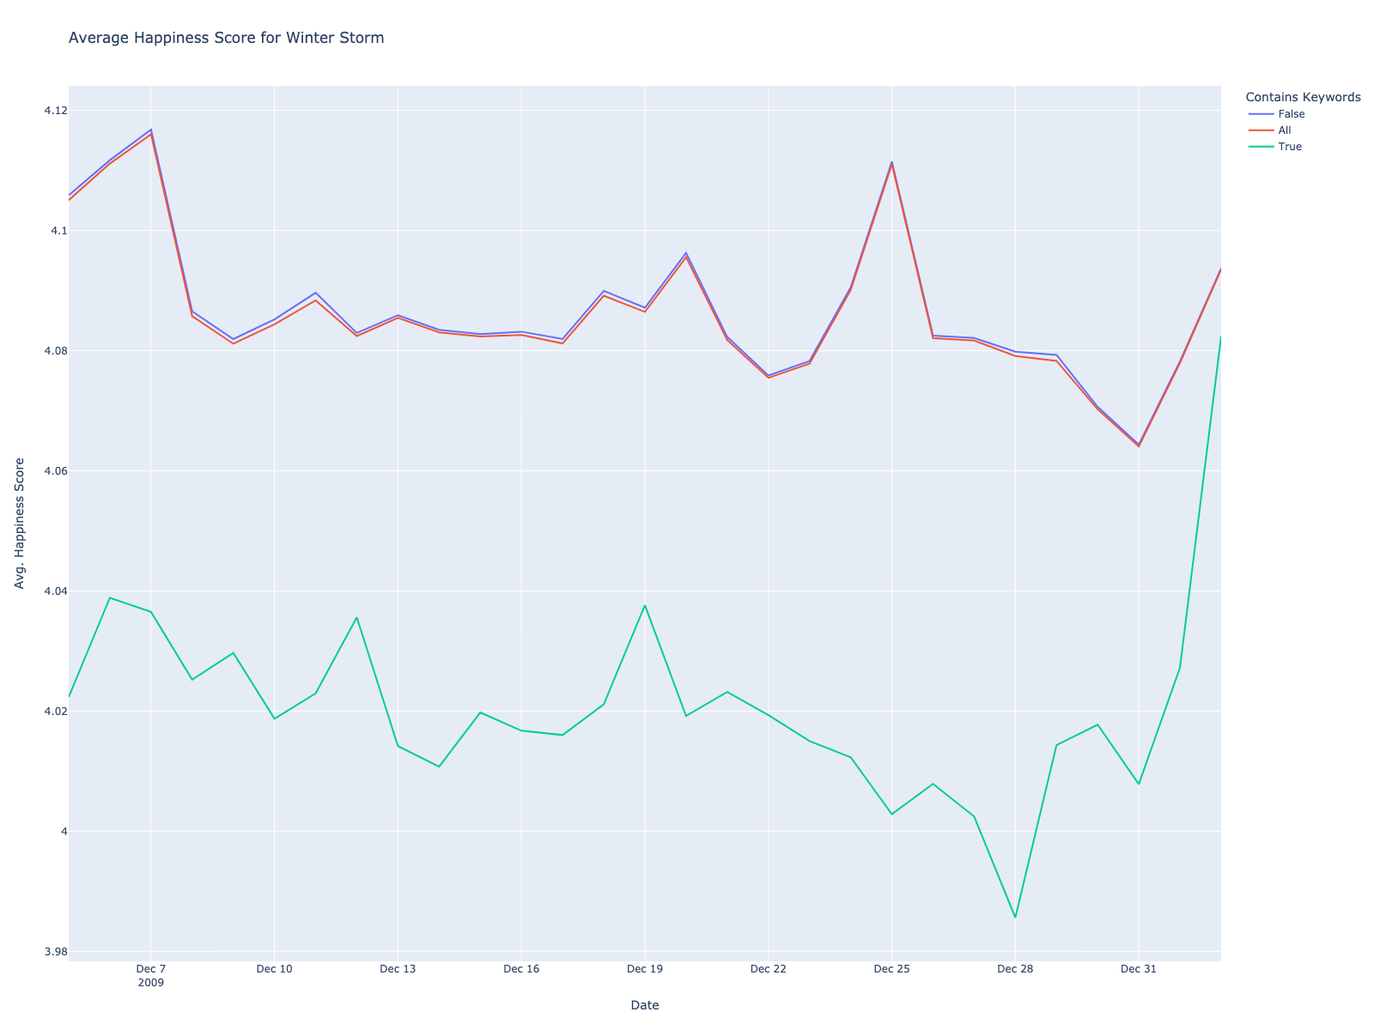

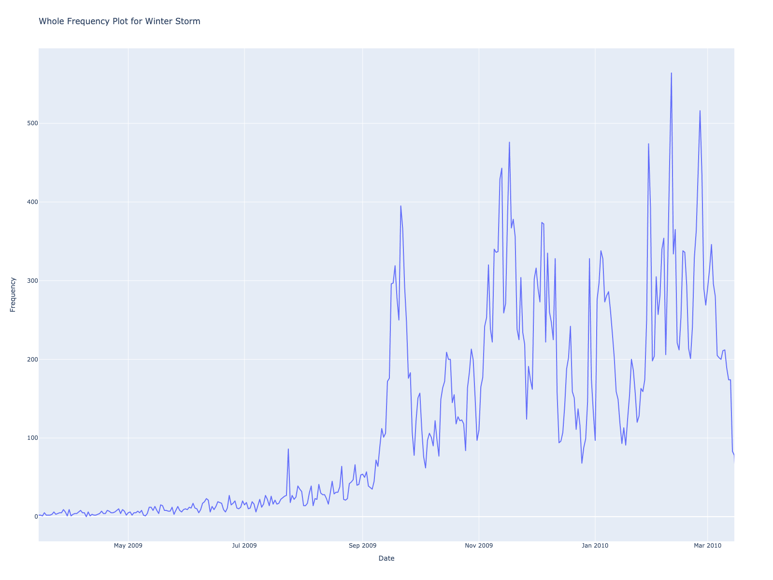
Figures 7.a, 7.b: (a) shows the average happiness on the 14-day periods before and after the start of the 2009 North American Blizzard. (b) shows the frequency of our winter storm keywords over the whole span of our data.

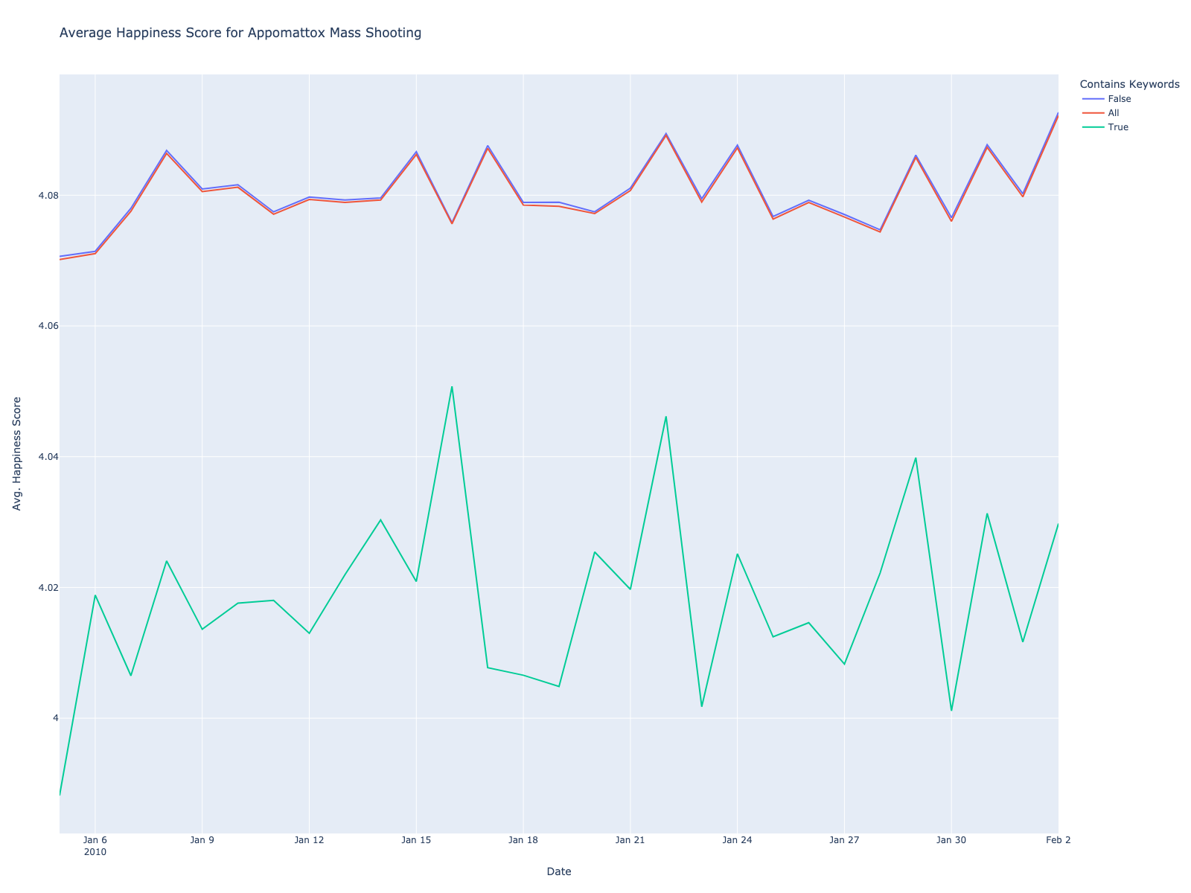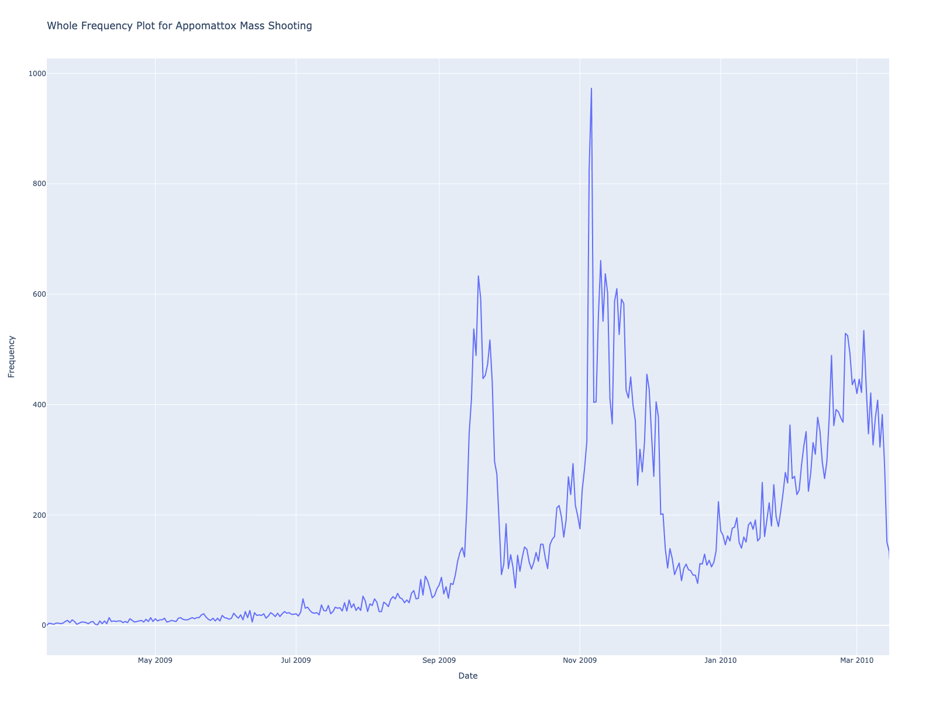
Figures 8.a, 8.b: (a) shows the average happiness on the 14-day periods before and after the start of the 2009 Appomattox Mass Shooting. (b) shows the frequency of our mass shooting keywords over the whole span of our data.

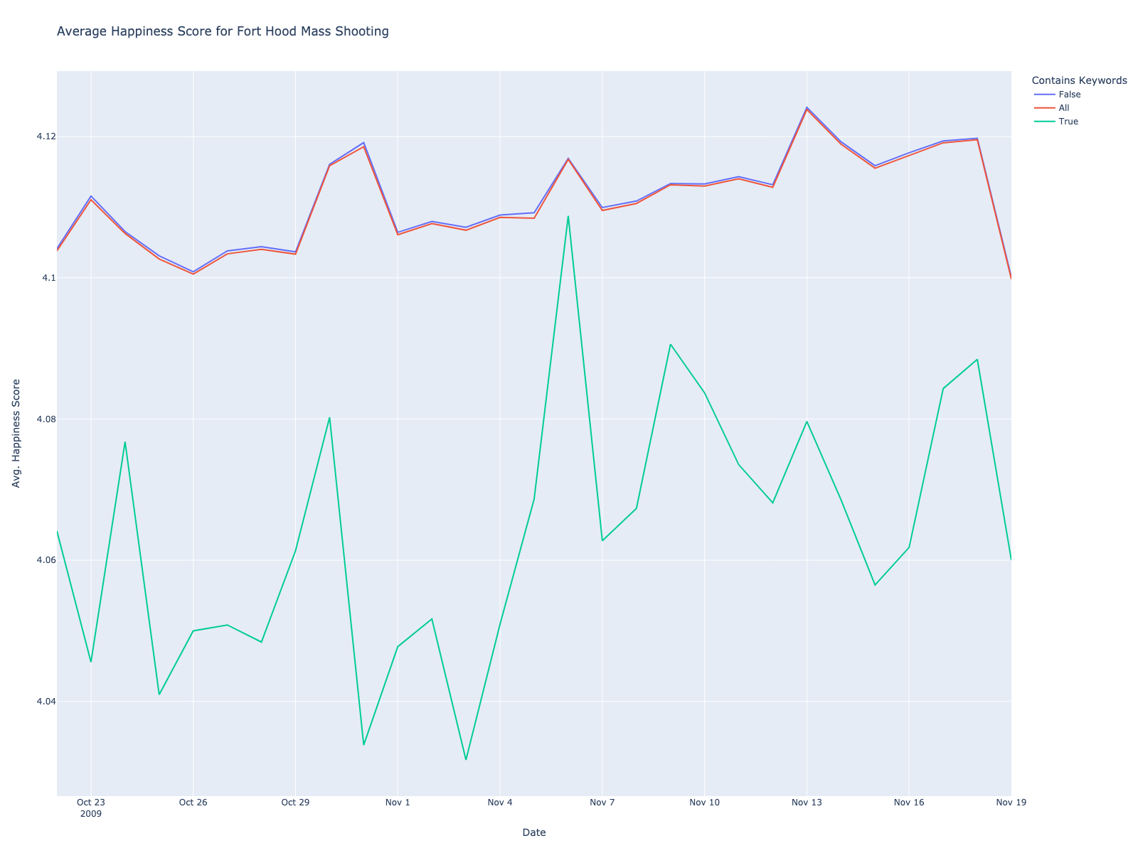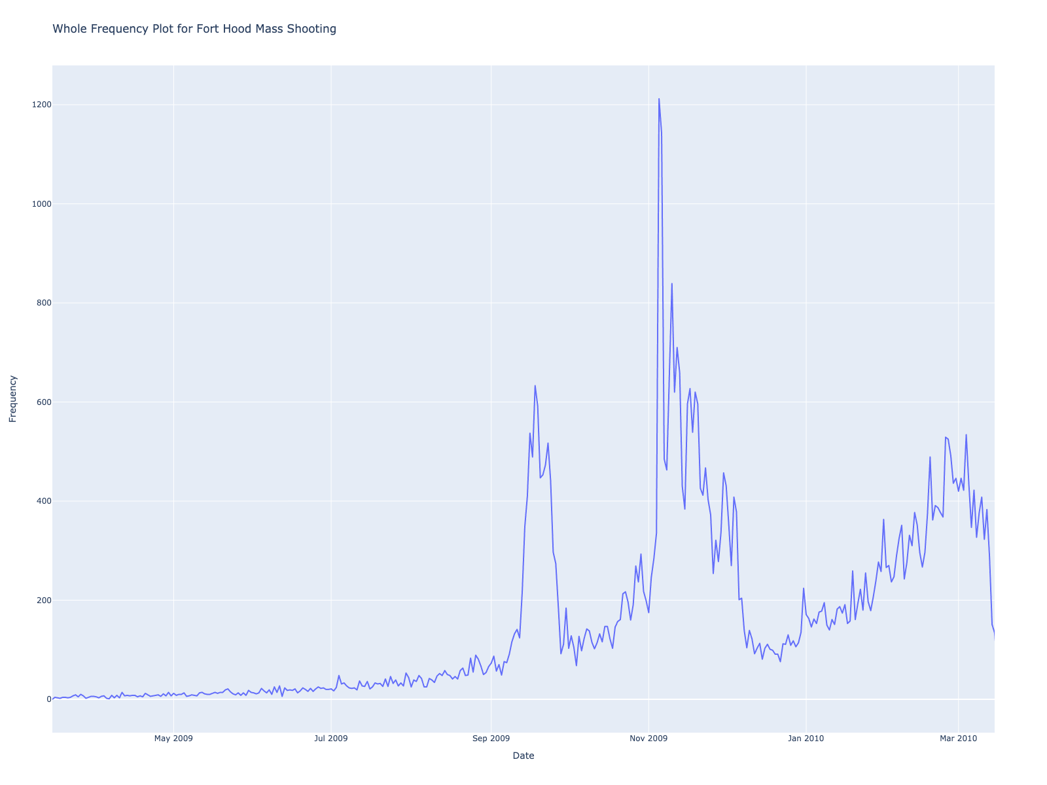
Figures 9.a, 9.b: (a) shows the average happiness on the 14-day periods before and after the start of the 2010 Fort Hood Mass shooting. (b) shows the frequency of our mass shooting keywords over the whole span of our data.

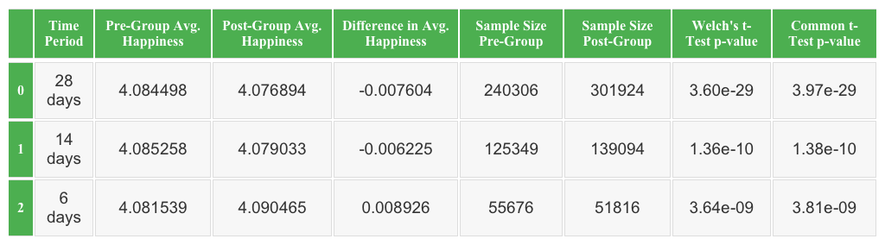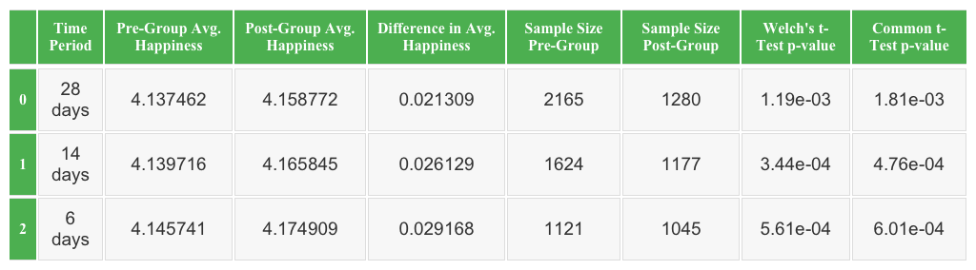
Tables 1.a, 1.b: (a) shows our analysis result for all tweets and Christmas. (b) shows our analysis result for only the tweets that contained keywords related to Christmas

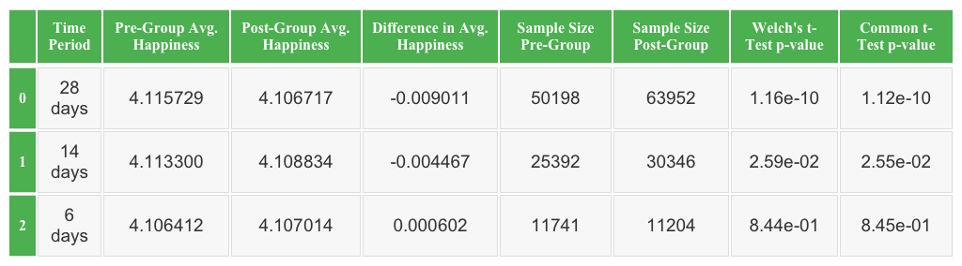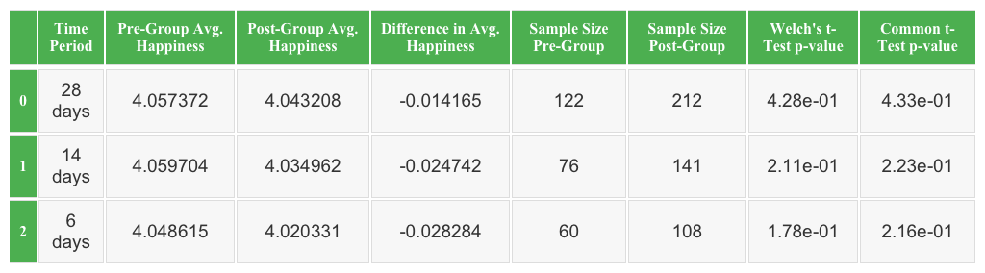
Tables 2.a, 2.b: (a) shows our analysis result for all tweets and the Fourth of July. (b) shows our analysis result for only the tweets that contained keywords related to the Fourth of July
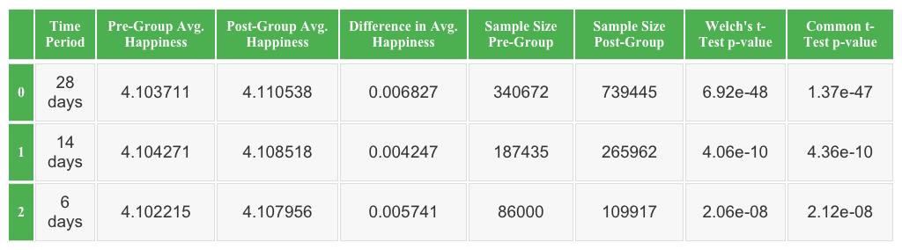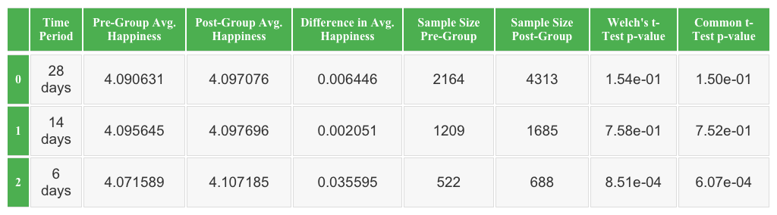
Tables 3.a, 3.b: (a) shows our analysis result for all tweets and the NASA space launch. (b) shows our analysis result for only the tweets that contained keywords related to the NASA space launch
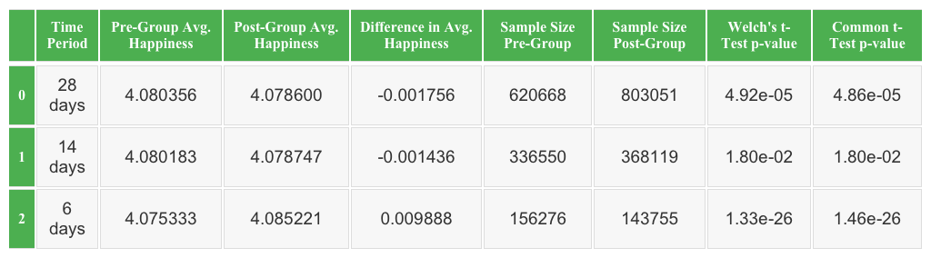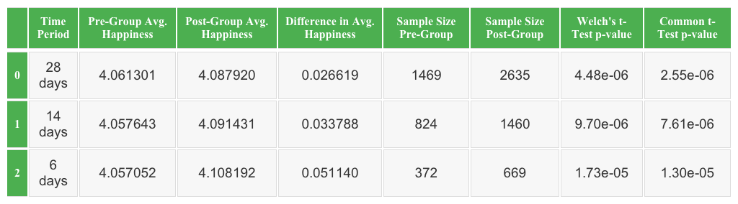Tables 4.a, 4.b: (a) shows our analysis result for all tweets and the Winter Olympics. (b) shows our analysis result for only the tweets that contained keywords related to the Winter Olympics
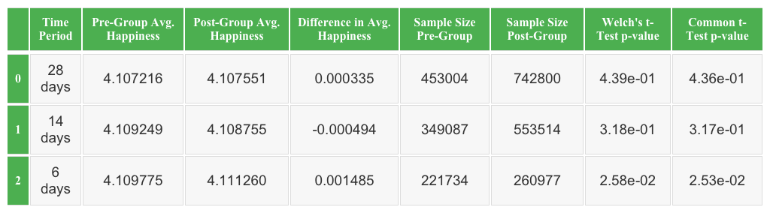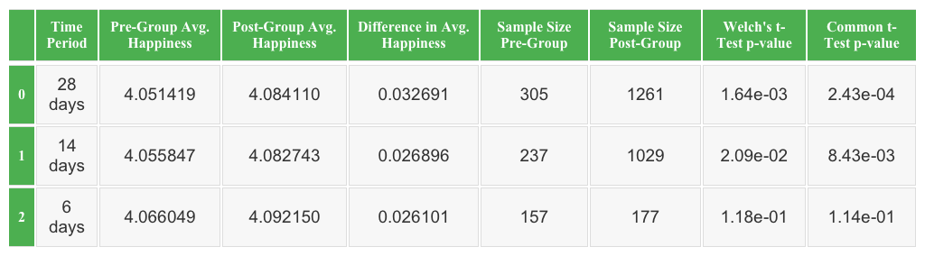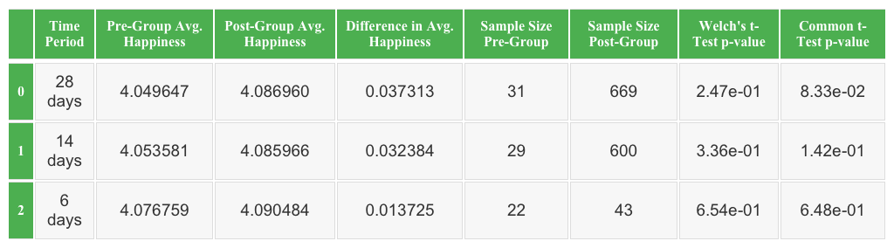

Tables 5.a, 5.b, 5.c: (a) shows our analysis result for all tweets and the flood. (b) shows our analysis result for only the tweets that contained keywords related to the flood (c) shows our analysis result for only the tweets that contained keywords related to the Flood in South East US

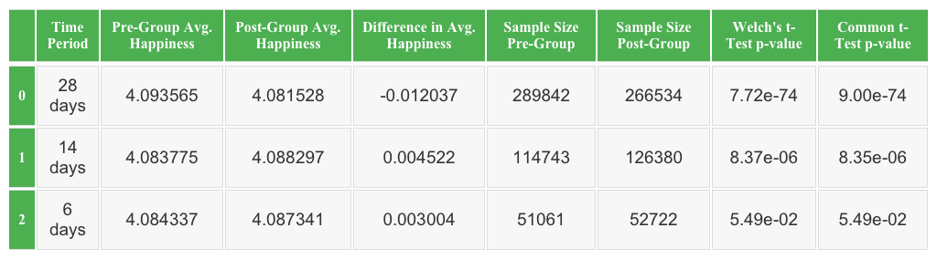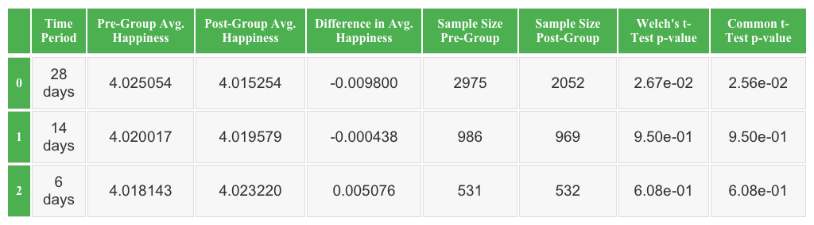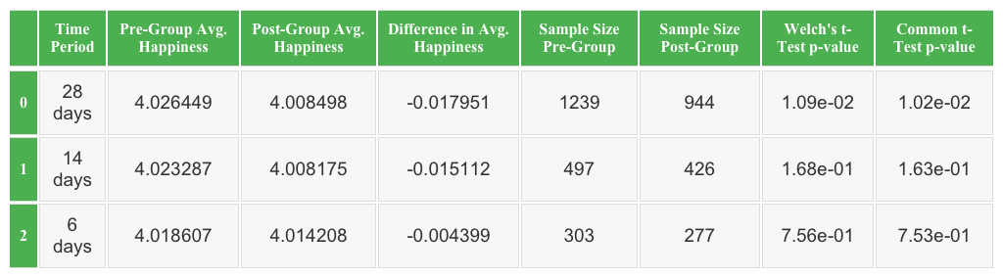
Tables 6.a, 6.b, 6.c: (a) shows our analysis result for all tweets and the winter storm. (b) shows our analysis result for only the tweets that contained keywords related to the winter storm. (c) shows our analysis result for only the tweets that contained keywords related to the winter storm in Washington D.C
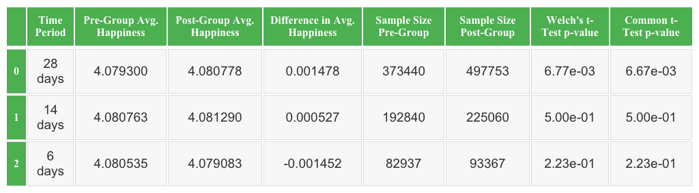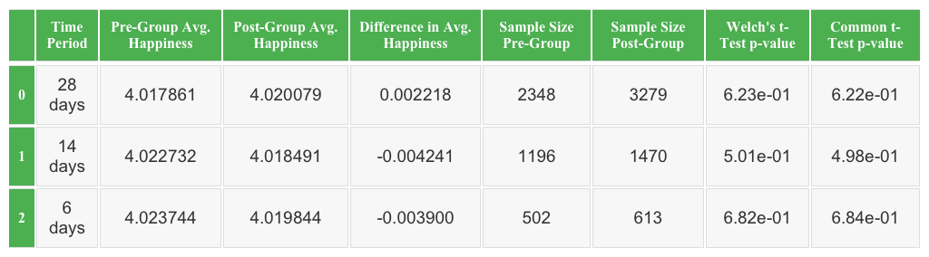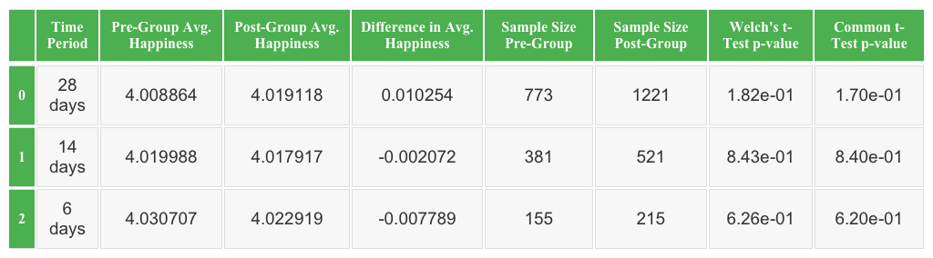
Tables 7.a, 7.b, 7.c: (a) shows our analysis result for all tweets and the appomattox mass shooting. (b) shows our analysis result for only the tweets that contained keywords related to the appomattox mass shooting. (c) shows our analysis result for only the tweets that contained keywords related to the appomattox mass shooting in Virginia.

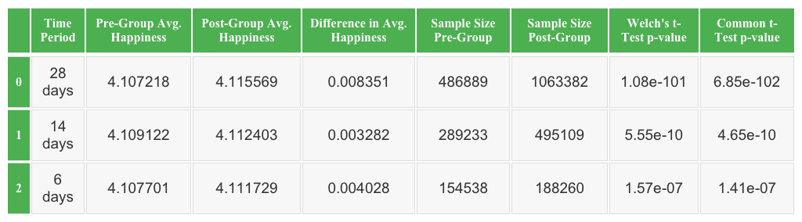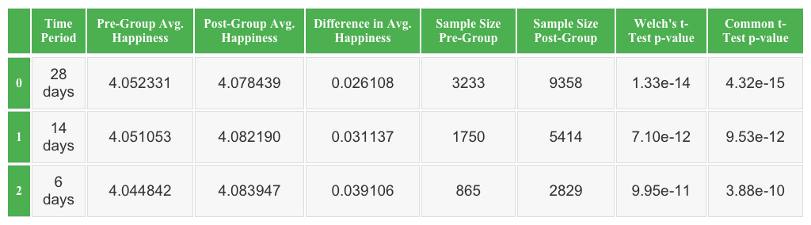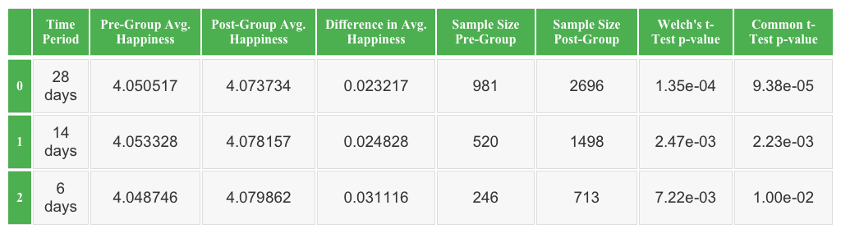
Tables 8.a, 8.b, 8.c: (a) shows our analysis result for all tweets and the Fort Hood mass shooting. (b) shows our analysis result for only the tweets that contained keywords related to the Fort Hood mass shooting. (c) shows our analysis result for only the tweets that contained keywords related to the Fort Hood mass shooting in Texas

