Classifying Retirement Plan Financial Adequacy Using Form 5500 Data
  - Exploratory Data Analysis and Data Transformation
Donnie Minnick, Statistical Learning - Fall A 2025
October 04, 2025

Pipeline Scope
This notebook encompasses checks for missing and zero values, exploratory data analysis, feature engineering and creation of a stratified sample to address a few dominant sectors in the source data.

Load Libraries
I leverage the following R packages: dplyr, lubridate, stringr and tidyr for data manipulation, knitr for table formatting, and ggplot2 and ggridges for visualization.

Load Data
Load the Form 5500 data.
plans <- readRDS("../data/plans.rds")
This analysis focuses on 401(k) plans because they are the dominant defined contribution vehicle in the U.S. private sector, offering broad sector coverage and stable representation in Form 5500 data. While I initially considered 403(b) plans, their sparse and sector-specific presence, primarily in nonprofits and education, limits their utility for benchmarking and fairness diagnostics.
The baseline dataset includes 5,579 plans and 21 variables.

Missing Data
Generate a table to check for missing values at the column and row level.
# Create column level summary.
col_missing <- plans %>%
summarise(across(everything(), ~ sum(is.na(.)))) %>%
pivot_longer(cols = everything(),
names_to = "Variable",
values_to = "Missing_Count") %>%
mutate(Missing_Percent = Missing_Count / nrow(plans) * 100)
# Create row level summary.
row_missing <- tibble(Variable = "Rows Any Missing",
Missing_Count = sum(!complete.cases(plans)),
Missing_Percent = sum(!complete.cases(plans)) / nrow(plans) * 100)
# Combine summaries.
missing_report <- bind_rows(col_missing, row_missing)
kable(missing_report,
col.names = c("Variable", "Missing Count", "Missing Percent"),
caption = "Missing Data",
format.args = list(big.mark = ","),
align = c("l", "r", "r"))
Missing Data
Variable | Missing Count | Missing Percent
ACK_ID | 0 | 0
PLAN_YEAR_BEGIN_DATE | 0 | 0
PLAN_YEAR_END_DATE | 0 | 0
PLAN_NAME | 0 | 0
PLAN_EFFECTIVE_DATE | 0 | 0
PLAN_TYPE | 0 | 0
SPONSOR_NAME | 0 | 0
SPONSOR_STATE | 0 | 0
SPONSOR_EIN | 0 | 0
BUSINESS_CODE | 0 | 0
TOTAL_ACCBAL_PARTCP_BOY | 0 | 0
TOTAL_ACCBAL_PARTCP_EOY | 0 | 0
TOTAL_CONTRIB_PARTCP_BOY | 0 | 0
TOTAL_CONTRIB_PARTCP_EOY | 0 | 0
TOTAL_CONTRIB_EMPLR_BOY | 0 | 0
TOTAL_CONTRIB_EMPLR_EOY | 0 | 0
TOTAL_LOANS_BOY | 0 | 0
TOTAL_LOANS_EOY | 0 | 0
TOTAL_ASSETS_BOY | 0 | 0
TOTAL_ASSETS_EOY | 0 | 0
INDUSTRY_TITLE | 0 | 0
Rows Any Missing | 0 | 0
There are no missing values in the dataset; verify if count and amount variables take on zero values, as these may indicate inactive plans, reporting artifacts, or edge cases requiring further review.

Zero Values
Generate a report to check or zero values at the column and row level.
# Create column level summary.
col_zero <- plans %>%
summarise(across(everything(), ~ sum(. == 0, na.rm = TRUE))) %>%
pivot_longer(cols = everything(),
names_to = "Variable",
values_to = "Zero_Count") %>%
mutate(Zero_Percent = Zero_Count / nrow(plans) * 100)
# Create row level summary.
row_zero <- tibble(Variable = "Rows Any Zero",
Zero_Count = sum(apply(plans == 0, 1, any, na.rm = TRUE)),
Zero_Percent = sum(apply(plans == 0, 1, any, na.rm = TRUE)) / nrow(plans) * 100)
# Combine summaries.
zero_report <- bind_rows(col_zero, row_zero)
kable(zero_report,
col.names = c("Variable", "Zero Count", "Zero Percent"),
caption = "Zero Value Summary",
format.args = list(big.mark = ","),
align = c("l", "r", "r"))
Zero Value Summary
Variable | Zero Count | Zero Percent
ACK_ID | 0 | 0
PLAN_YEAR_BEGIN_DATE | 0 | 0
PLAN_YEAR_END_DATE | 0 | 0
PLAN_NAME | 0 | 0
PLAN_EFFECTIVE_DATE | 0 | 0
PLAN_TYPE | 0 | 0
SPONSOR_NAME | 0 | 0
SPONSOR_STATE | 0 | 0
SPONSOR_EIN | 0 | 0
BUSINESS_CODE | 0 | 0
TOTAL_ACCBAL_PARTCP_BOY | 0 | 0
TOTAL_ACCBAL_PARTCP_EOY | 0 | 0
TOTAL_CONTRIB_PARTCP_BOY | 0 | 0
TOTAL_CONTRIB_PARTCP_EOY | 0 | 0
TOTAL_CONTRIB_EMPLR_BOY | 0 | 0
TOTAL_CONTRIB_EMPLR_EOY | 0 | 0
TOTAL_LOANS_BOY | 0 | 0
TOTAL_LOANS_EOY | 0 | 0
TOTAL_ASSETS_BOY | 0 | 0
TOTAL_ASSETS_EOY | 0 | 0
INDUSTRY_TITLE | 0 | 0
Rows Any Zero | 0 | 0
The dataset does not include any zero values.

Exploratory Data Analysis

Acknowledgement Id (ACK_ID)
Acknowledgement Id is a unique identifier assigned by the Department of Labor (DOL) or IRS when a Form 5500 filing is successfully received and acknowledged. Think of it as a receipt number; it confirms that the filing was accepted into the system. It’s used for tracking, auditing, or linking filings across systems.

Plan Year Begin/End Dates (PLAN_YEAR_BEGIN_DATE, PLAN_YEAR_END_DATE)
These dates define the reporting window for all financial and participant metrics. The dataset contains filings with a plan year begin date of January 1, 2023 and end date of December 31, 2023.

Plan Effective Date (PLAN_EFFECTIVE_DATE)
Plan effective date marks the official inception of a retirement plan; it anchors a plan’s life cycle.
From an analytic perspective, plan effective date enables several valuable transformations. Calculating plan age from this field allows for stratification by maturity, which is useful when assessing financial readiness across vintage cohorts. Plans initiated in different eras may reflect distinct design philosophies, contribution behaviors, or participant engagement patterns.
Generate a summary count of plans by plan effective year.
summary_by_plan_effective_year <- plans %>%
mutate(PLAN_EFFECTIVE_YEAR = as.character(year(PLAN_EFFECTIVE_DATE))) %>%
group_by(PLAN_EFFECTIVE_YEAR) %>%
arrange(PLAN_EFFECTIVE_YEAR) %>%
summarise(entries = n()) %>%
mutate(percent = round(entries / sum(entries), 2))
kable(summary_by_plan_effective_year,
col.names = c("Year", "Plans", "Percent"),
caption = "Summary By Plan Effective Year",
format.args = list(big.mark = ","),
align = c("l", "r", "r"))
Summary By Plan Effective Year
Year | Plans | Percent
1945 | 3 | 0.00
1948 | 1 | 0.00
1949 | 1 | 0.00
1950 | 3 | 0.00
1952 | 4 | 0.00
1953 | 6 | 0.00
1954 | 2 | 0.00
1955 | 3 | 0.00
1956 | 6 | 0.00
1957 | 5 | 0.00
1958 | 8 | 0.00
1959 | 7 | 0.00
1960 | 11 | 0.00
1961 | 6 | 0.00
1962 | 5 | 0.00
1963 | 9 | 0.00
1964 | 9 | 0.00
1965 | 7 | 0.00
1966 | 9 | 0.00
1967 | 14 | 0.00
1968 | 23 | 0.00
1969 | 25 | 0.00
1970 | 21 | 0.00
1971 | 19 | 0.00
1972 | 17 | 0.00
1973 | 30 | 0.01
1974 | 29 | 0.01
1975 | 28 | 0.01
1976 | 32 | 0.01
1977 | 24 | 0.00
1978 | 30 | 0.01
1979 | 35 | 0.01
1980 | 36 | 0.01
1981 | 38 | 0.01
1982 | 41 | 0.01
1983 | 62 | 0.01
1984 | 115 | 0.02
1985 | 140 | 0.03
1986 | 114 | 0.02
1987 | 135 | 0.02
1988 | 100 | 0.02
1989 | 138 | 0.02
1990 | 144 | 0.03
1991 | 129 | 0.02
1992 | 138 | 0.02
1993 | 172 | 0.03
1994 | 182 | 0.03
1995 | 163 | 0.03
1996 | 186 | 0.03
1997 | 213 | 0.04
1998 | 176 | 0.03
1999 | 149 | 0.03
2000 | 153 | 0.03
2001 | 110 | 0.02
2002 | 118 | 0.02
2003 | 105 | 0.02
2004 | 122 | 0.02
2005 | 128 | 0.02
2006 | 150 | 0.03
2007 | 133 | 0.02
2008 | 114 | 0.02
2009 | 98 | 0.02
2010 | 72 | 0.01
2011 | 104 | 0.02
2012 | 94 | 0.02
2013 | 107 | 0.02
2014 | 121 | 0.02
2015 | 124 | 0.02
2016 | 144 | 0.03
2017 | 132 | 0.02
2018 | 108 | 0.02
2019 | 114 | 0.02
2020 | 76 | 0.01
2021 | 84 | 0.02
2022 | 65 | 0.01
Plan formation is historically sparse, with most years before 1975 contributing fewer than 10 plans, and often just one or two. A modest uptick begins in the mid-1970s, reflecting regulatory shifts and greater employer adoption of defined contribution plans.
Plot plans by plan effective year.
ggplot(summary_by_plan_effective_year, aes(x = as.integer(PLAN_EFFECTIVE_YEAR), y = entries)) +
geom_col(fill = "steelblue", color = "white") +
labs(title = "Distribution of Plans by Plan Effective Year",
x = "Year",
y = "Plans") +
theme_minimal() +
theme(axis.text.x = element_text(angle = 0, hjust = 0.5),
plot.title = element_text(size = 14, face = "bold"))
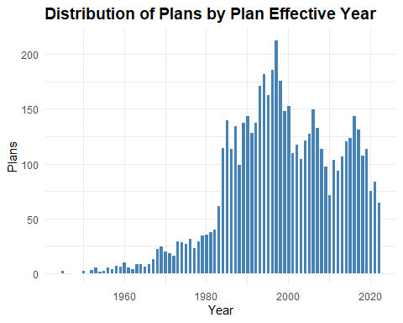
The gradual rise from the 1940s through the 1970s reflects the early institutionalization of employer-sponsored plans, driven by post-war economic expansion and the formalization of pension structures.
The uptick in the late 1970s through the 1990s coincides with major policy shifts, most notably the passage of ERISA in 1974 and the rise of defined contribution plans like 401(k) plans in the early 1980s. This era marks a surge in plan formation, especially among small and mid-sized employers responding to new tax incentives.
The peak in the late 1990s to early 2000s suggests a saturation point, after which the decline reflects consolidation of plans, sponsor exits, a shift toward pooled and multi-employer arrangements, and market volatility post-2008 influencing plan formation.
Grouping plans into vintages, i.e. multi-year cohorts based on effective year, helps mitigate the annual sparsity in the early years of the data.

Plan Vintage Group (PLAN_VINTAGE_GROUP)
Engineer a plan vintage group variable.
plans <- plans %>%
mutate(PLAN_EFFECTIVE_YEAR = year(PLAN_EFFECTIVE_DATE),
PLAN_VINTAGE_GROUP = case_when(
is.na(PLAN_EFFECTIVE_YEAR) ~ NA_character_,
PLAN_EFFECTIVE_YEAR < 1990 ~ "Legacy",
PLAN_EFFECTIVE_YEAR >= 1990 & PLAN_EFFECTIVE_YEAR <= 1999 ~ "Expansion",
PLAN_EFFECTIVE_YEAR >= 2000 & PLAN_EFFECTIVE_YEAR <= 2010 ~ "Modern",
PLAN_EFFECTIVE_YEAR > 2010 ~ "Recent"),
PLAN_VINTAGE_GROUP = factor(PLAN_VINTAGE_GROUP,
levels = c("Legacy", "Expansion", "Modern", "Recent"),
ordered = TRUE))
Plot plans by plan vintage group.
summary_by_plan_vintage_group <- plans %>%
group_by(PLAN_VINTAGE_GROUP) %>%
summarise(entries = n()) %>%
mutate(percent = round(entries / sum(entries), 2))
ggplot(summary_by_plan_vintage_group, aes(x = PLAN_VINTAGE_GROUP, y = entries)) +
geom_col(fill = "steelblue", color = "white") +
geom_text(aes(label = paste0(scales::comma(entries), "\n", round(percent * 100, 0), "%")),
vjust = -0.3, size = 3.0) +
labs(title = "Distribution of Plans By Plan Vintage Group",
x = "Period",
y = "Group") +
theme_minimal() +
theme(axis.text.x = element_text(angle = 0, hjust = 0.5),
plot.title = element_text(size = 14, face = "bold")) +
expand_limits(y = max(summary_by_plan_vintage_group$entries) * 1.2)
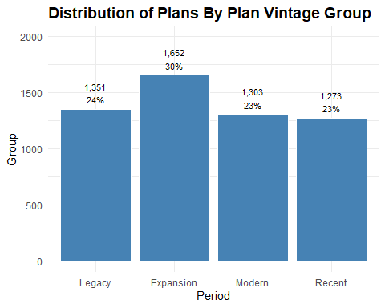
During the Expansion period, retirement plans surged. Legacy plans still hold strong at 24%. Modern and Recent vintages trail closely behind at 23% each, suggesting a stabilization in newer plan adoption. The distribution reflects pivotal growth phase during Expansion, followed by a leveling off in more recent years.

Business Code and Industry Title (BUSINESS_CODE, INDUSTRY_TITLE)
Business code refers to the six-digit code used to classify the primary business activity of the plan sponsor, based on the North American Industry Classification System (NAICS). It identifies the economic sector in which the sponsoring organization operates, such as manufacturing, healthcare, finance, or education. Industry title is the human-readable label associated with that code.
summary_by_industry_title <- plans %>%
group_by(INDUSTRY_TITLE) %>%
summarise(entries = n()) %>%
arrange(desc(entries)) %>%
mutate(percent = round(entries / sum(entries), 2))
kable(head(summary_by_industry_title, 20),
col.names = c("Industry", "Plans", "Percent"),
caption = "Summary By Industry Title - Top 20 Industries",
format.args = list(big.mark = ","),
align = c("l", "r", "r"))
Summary By Industry Title - Top 20 Industries
Industry | Plans | Percent
All other professional, scientific, and technical services | 190 | 0.03
Offices of physicians (except mental health specialists) | 186 | 0.03
New car dealers | 141 | 0.03
Offices of lawyers | 129 | 0.02
Management, scientific, and technical consulting services | 117 | 0.02
Other miscellaneous manufacturing | 108 | 0.02
Engineering services | 101 | 0.02
Other fabricated metal product manufacturing | 91 | 0.02
Offices of other holding companies | 86 | 0.02
Other computer related services | 77 | 0.01
Other specialty trade contractors | 77 | 0.01
Educational services | 76 | 0.01
Nursing and residential care facilities | 75 | 0.01
Commercial banking | 67 | 0.01
General freight trucking, long-distance | 66 | 0.01
Hospitals | 66 | 0.01
Plastics product manufacturing | 66 | 0.01
Nonresidential building construction | 64 | 0.01
Custom computer programming services | 60 | 0.01
Motor vehicle parts manufacturing | 56 | 0.01
Representation at the detailed industry title level is sparse. Most individual NAICS-derived titles contribute less than 0.03% of total plan filings. Modeling or benchmarking at this granularity may be noisy or unstable. A few industries dominate plan filings, while most contribute marginally. Using these titles directly in models could lead to poor generalization unless grouped.

Sector Code and Sector Title (SECTOR_CODE, SECTOR_TITLE, SECTOR_TITLE_SHORT)
Collapse industry titles to broader categories using existing code structure and group industries into sectors.
business_codes <- readRDS("../data/business_codes.rds")
business_codes <- business_codes %>%
rename(SECTOR_CODE = BUSINESS_CODE,
SECTOR_TITLE = INDUSTRY_TITLE) %>%
mutate(SECTOR_TITLE_SHORT = stringr::str_trunc(SECTOR_TITLE, width = 15))
plans <- plans %>%
mutate(SECTOR_CODE = as.integer(substr(BUSINESS_CODE, 1, 2)) * 10000)
plans <- left_join(plans, business_codes, by = "SECTOR_CODE")
Check counts for reference level, find the median category by count, relevel and set the reference level.
sector_counts <- plans %>%
count(SECTOR_TITLE_SHORT, name = "n") %>%
arrange(n)
central_sector <- sector_counts$SECTOR_TITLE_SHORT[ceiling(nrow(sector_counts) / 2)]
# Information is the central sector in the group.
plans$SECTOR_TITLE_SHORT <- relevel(factor(plans$SECTOR_TITLE_SHORT), ref = "Information")
Summarize plans by sector.
summary_by_sector_title <- plans %>%
group_by(SECTOR_TITLE_SHORT) %>%
summarise(entries = n()) %>%
arrange(desc(entries)) %>%
mutate(percent = round(entries / sum(entries), 2))
kable(summary_by_sector_title,
col.names = c("Sector Title", "Plans", "Percent"),
caption = "Summary By Sector Title",
format.args = list(big.mark = ","),
align = c("l", "r", "r"))
Summary By Sector Title
Sector Title | Plans | Percent
Manufacturing | 1,237 | 0.22
Professional… | 918 | 0.16
Health care … | 594 | 0.11
Retail trade | 365 | 0.07
Construction | 352 | 0.06
Finance and … | 339 | 0.06
Wholesale trade | 329 | 0.06
Transportati… | 260 | 0.05
Administrati… | 187 | 0.03
Other servic… | 168 | 0.03
Information | 160 | 0.03
Real estate … | 149 | 0.03
Accommodatio… | 115 | 0.02
Management o… | 93 | 0.02
Educational … | 76 | 0.01
Arts, entert… | 73 | 0.01
Utilities | 61 | 0.01
Mining, quar… | 47 | 0.01
Agriculture,… | 46 | 0.01
Public admin… | 10 | 0.00
Sector grouping reveals strong concentration and long-tail sparsity. Just three sectors, Manufacturing, Professional Services, and Health Care, account for nearly half of all plans, while the bottom dozen sectors each contribute less than 3%. This uneven distribution suggests structural disparities in retirement plan availability, with some sectors historically under-served or slower to adopt.
Plot by sector title.
ggplot(summary_by_sector_title, aes(x = forcats::fct_reorder(SECTOR_TITLE_SHORT,
entries, .desc = TRUE), y = entries)) +
geom_col(fill = "steelblue", color = "white") +
geom_text(aes(label = paste0(scales::comma(entries), "\n", round(percent * 100, 0), "%")),
vjust = -0.3, size = 3.0) +
labs(title = "Distribution of Plans By Sector",
x = "Sector",
y = "Plans") +
theme_minimal() +
theme(axis.text.x = element_text(angle = 90, hjust = 0.5),
plot.title = element_text(size = 14, face = "bold")) +
expand_limits(y = max(summary_by_sector_title$entries) * 1.2)
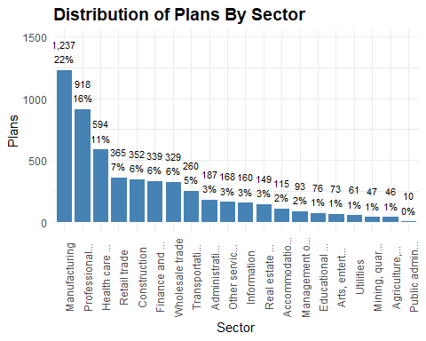
Given the high concentration in a few dominant sectors and the long tail of underrepresented sectors, a stratified sample will ensure equitable representation across sectors and improve diagnostic clarity when benchmarking plan adequacy.

Create Stratified Sample
Create a stratified sample with plan vintage and sector strata. Set a sector cap to ensure balanced representation.
# Count plans by vintage-sector strata.
strata_counts <- plans %>%
count(PLAN_VINTAGE_GROUP, SECTOR_TITLE_SHORT)
# Define initial sample size per stratum (proportional with minimum floor).
strata_counts <- strata_counts %>%
mutate(sample_n = pmax(round(n / sum(n) * 5000), 5))
# Compute total sample size per sector across vintages.
sector_totals <- strata_counts %>%
group_by(SECTOR_TITLE_SHORT) %>%
summarise(sector_sample_total = sum(sample_n), .groups = "drop")
# Set sector-level cap and compute scale factor.
sector_cap <- 100
sector_totals <- sector_totals %>%
mutate(scale_factor = pmin(1, sector_cap / sector_sample_total))
# Apply scale factor to each stratum's sample size.
strata_counts <- strata_counts %>%
left_join(sector_totals, by = "SECTOR_TITLE_SHORT") %>%
mutate(sample_n_capped = pmax(round(sample_n * scale_factor), 5))
# Join capped sample sizes to full plan data.
plans_joined <- plans %>%
inner_join(strata_counts %>%
select(PLAN_VINTAGE_GROUP, SECTOR_TITLE_SHORT, sample_n_capped),
by = c("PLAN_VINTAGE_GROUP", "SECTOR_TITLE_SHORT")) %>%
rename(sample_n = sample_n_capped)
# Split into strata and sample per stratum.
plans_split <- plans_joined %>%
group_split(PLAN_VINTAGE_GROUP, SECTOR_TITLE_SHORT)
plans_stratified <- purrr::map_dfr(plans_split, ~ slice_sample(.x, n = .x$sample_n[1]))
Check representation in the sample compared to the original distribution.
full_dist <- plans %>%
count(PLAN_VINTAGE_GROUP, SECTOR_TITLE_SHORT, name = "full_n")
sample_dist <- plans_stratified %>%
count(PLAN_VINTAGE_GROUP, SECTOR_TITLE_SHORT, name = "sample_n")
representation_check <- full_dist %>%
full_join(sample_dist, by = c("PLAN_VINTAGE_GROUP", "SECTOR_TITLE_SHORT")) %>%
mutate(full_n = replace_na(full_n, 0),
sample_n = replace_na(sample_n, 0),
sample_share = sample_n / sum(sample_n),
full_share = full_n / sum(full_n),
ratio = sample_share / full_share) %>% arrange(desc(ratio))
This representation check provides a ratio that shows how well each sector-vintage stratum is represented in the stratified sample relative to its full share.
Plot the ratios.
ggplot(representation_check, aes(x = reorder(SECTOR_TITLE_SHORT, ratio),
y = ratio,
fill = PLAN_VINTAGE_GROUP)) +
geom_col(position = "dodge") +
geom_hline(yintercept = 1,
linetype = "dashed",
color = "gray40") +
scale_fill_manual(values = c("Legacy" = "#4682B4",
"Expansion" = "#5A9BD4",
"Modern" = "#7FB3D5",
"Recent" = "#A9CCE3")) +
labs(title = "Stratified Sample Representation by Sector and Vintage",
x = "Sector",
y = "Sample Share / Full Share (Ratio)",
fill = "Vintage Group") +
coord_flip() +
theme_minimal() +
theme(axis.text.x = element_text(angle = 0, hjust = 0.5),
plot.title = element_text(size = 14, face = "bold"))
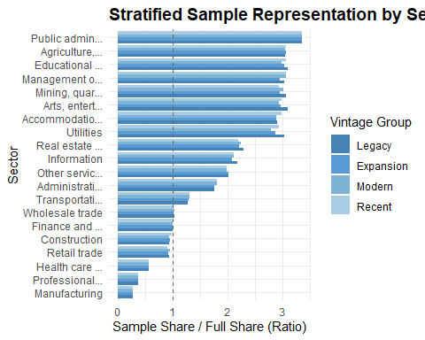
This plot confirms that the stratified sample reduces over-representation from dominant sectors. Lower sample-to-full ratios in sectors like Manufacturing and Professional Services reflect deliberate down-weighting, while ratios near 1 in sparse sectors preserve diagnostic signal. The result is a structurally balanced sample that supports balanced modeling across both sector and vintage dimensions.
Confirm balanced sample.
check_sample <- plans_stratified %>%
group_by(SECTOR_TITLE_SHORT) %>%
summarise(entries = n()) %>%
mutate(percent = round(entries / sum(entries), 2))
kable(check_sample,
col.names = c("Sector Title", "Plans", "Percent"),
caption = "Summary By Sector Title - Stratified Sample",
format.args = list(big.mark = ","),
align = c("l", "r", "r"))
Summary By Sector Title - Stratified Sample
Sector Title | Plans | Percent
Information | 101 | 0.06
Accommodatio… | 100 | 0.06
Administrati… | 100 | 0.06
Agriculture,… | 42 | 0.03
Arts, entert… | 65 | 0.04
Construction | 100 | 0.06
Educational … | 69 | 0.04
Finance and … | 101 | 0.06
Health care … | 99 | 0.06
Management o… | 84 | 0.05
Manufacturing | 100 | 0.06
Mining, quar… | 42 | 0.03
Other servic… | 100 | 0.06
Professional… | 99 | 0.06
Public admin… | 10 | 0.01
Real estate … | 99 | 0.06
Retail trade | 100 | 0.06
Transportati… | 100 | 0.06
Utilities | 54 | 0.03
Wholesale trade | 100 | 0.06
The table confirms a more balanced sample across sectors with dominant sectors capped at 100.
The sample includes 1,665 plans and 27 variables.
plans <- plans_stratified

Total Plan Assets (TOTAL_ASSETS_BOY, TOTAL_ASSETS_EOY)
These variables represent the total value of all plan assets held by the plan at the start and end of the plan year.
summary_by_plan_assets <- plans %>%
group_by(SECTOR_TITLE_SHORT) %>%
summarise(total_assets_boy = sum(TOTAL_ASSETS_BOY),
total_assets_eoy = sum(TOTAL_ASSETS_EOY))
kable(summary_by_plan_assets,
col.names = c("Sector", "BOY Assets", "EOY Assets"),
caption = "BOY and EOY Total Plan Assets By Sector",
format.args = list(big.mark = ","),
align = c("l", "r", "r"))
BOY and EOY Total Plan Assets By Sector
Sector | BOY Assets | EOY Assets
Information | 22,984,246,074 | 27,061,097,552
Accommodatio… | 11,130,428,580 | 13,081,939,126
Administrati… | 7,638,077,236 | 9,261,078,859
Agriculture,… | 4,232,638,654 | 4,751,018,680
Arts, entert… | 6,355,336,681 | 7,362,142,578
Construction | 3,755,532,147 | 4,590,491,959
Educational … | 7,401,831,941 | 8,775,948,392
Finance and … | 20,464,437,041 | 23,903,546,324
Health care … | 27,015,759,224 | 43,134,995,547
Management o… | 83,513,223,764 | 95,882,281,917
Manufacturing | 30,835,990,664 | 35,897,572,716
Mining, quar… | 7,806,493,812 | 9,029,257,958
Other servic… | 2,680,453,121 | 3,176,794,374
Professional… | 7,909,734,118 | 9,886,018,526
Public admin… | 208,619,022 | 248,932,490
Real estate … | 7,729,484,458 | 9,490,634,574
Retail trade | 8,574,236,743 | 10,305,326,799
Transportati… | 21,492,920,716 | 25,922,112,087
Utilities | 42,146,011,183 | 46,778,104,097
Wholesale trade | 19,192,100,157 | 23,105,019,578
Plot assets by sector.
assets_long <- summary_by_plan_assets %>%
pivot_longer(cols = c(total_assets_boy, total_assets_eoy),
names_to = "Asset_Type",
values_to = "Asset_Value")
ggplot(assets_long, aes(x = reorder(SECTOR_TITLE_SHORT, -Asset_Value),
y = Asset_Value / 1e9, fill = Asset_Type)) +
geom_bar(stat = "identity", position = "dodge") +
scale_fill_manual(values = c("total_assets_boy" = "steelblue",
"total_assets_eoy" = "lightsteelblue"),
labels = c("total_assets_boy" = "Beginning of Year",
"total_assets_eoy" = "End of Year")) +
labs(title = "BOY and EOY Total Plan Assets by Sector",
x = "Sector",
y = "Assets (Billions USD)",
fill = "Asset Type") +
theme_minimal() +
theme(axis.text.x = element_text(angle = 90, hjust = 0.5),
plot.title = element_text(size = 14, face = "bold"))
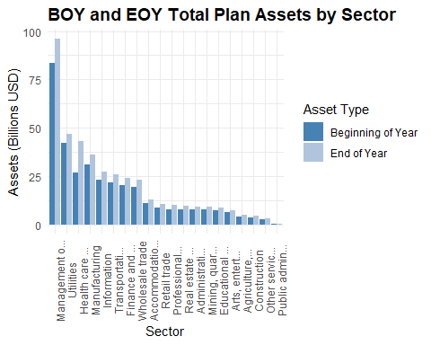
The plot reveals substantial variation in asset magnitude and growth across the economic landscape.
Manufacturing leads with the highest asset levels, suggesting strong plan stability or growth. Finance and Insurance, Health Care, and Professional Services also show robust asset volumes, reinforcing their structural weight in the retirement ecosystem. In contrast, sectors like Public Administration, Agriculture, and Arts & Entertainment show significantly lower asset totals, underscoring potential disparities in plan availability or funding adequacy.
The dual-bar format highlights year-over-year changes, with most sectors showing modest asset growth, though the magnitude varies.
This visualization is particularly valuable for stakeholders seeking to understand sector-level disparities, benchmark asset performance, and identify areas where retirement plan adequacy may be structurally constrained.

Total Assets Growth Rate (TOTAL_ASSETS_GROWTH_RATE)
Create a growth rate and assets per participant for each plan.
plans <- plans %>%
mutate(TOTAL_ASSETS_GROWTH_RATE = round((TOTAL_ASSETS_EOY - TOTAL_ASSETS_BOY) / TOTAL_ASSETS_BOY, 4))
Produce a density plot to show the distribution of asset growth rates.
ggplot(plans, aes(x = TOTAL_ASSETS_GROWTH_RATE)) +
geom_density(fill = "steelblue", alpha = 0.6) +
scale_y_continuous(labels = scales::percent_format(scale = 1, accuracy = 0.1)) +
geom_vline(xintercept = 0, linetype = "dashed", color = "gray40") +
labs(title = "Density of Total Assets Growth Rates",
x = "Growth Rate",
y = "Density (%)") +
theme_minimal() +
theme(axis.text.x = element_text(angle = 0, hjust = 0.5),
plot.title = element_text(size = 14, face = "bold"))
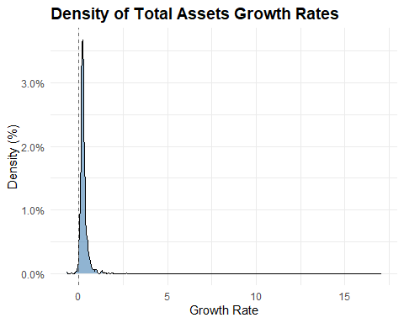
Most plans have modest or stagnant asset growth, likely reflecting market conditions, contribution behavior, or plan maturity.
The right skew indicates there is a subset of plans with strong growth, possibly due to rollovers, mergers, or aggressive investment strategies.
Create a ridgeline plot by sector. I exclude outliers to visualize pattern better across sectors.
ggplot(plans %>%
filter(TOTAL_ASSETS_GROWTH_RATE < 0.1 & TOTAL_ASSETS_GROWTH_RATE > -0.1),
aes(x = TOTAL_ASSETS_GROWTH_RATE, y = SECTOR_TITLE_SHORT)) +
geom_density_ridges(bandwidth = 0.05, fill = "steelblue", alpha = 0.6) +
labs(title = "Density of Total Assets Growth Rates by Sector",
subtitle = "Growth Rates Between -10% and 10%",
x = "Growth Rate",
y = "Sector") +
theme_minimal() +
theme(axis.text.x = element_text(angle = 0, hjust = 0.5),
plot.title = element_text(size = 14, face = "bold"))
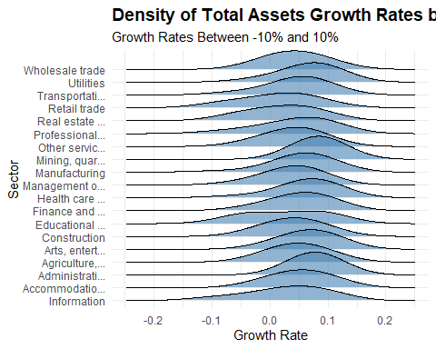
Most sectors show asset growth rates tightly clustered around 0%, indicating overall stability.

Total Assets Growth Tier (TOTAL_ASSETS_GROWTH_TIER)
Create total assets growth tiers.
plans <- plans %>%
mutate(
TOTAL_ASSETS_GROWTH_TIER = case_when(
TOTAL_ASSETS_GROWTH_RATE > 0.25 ~ "High",
TOTAL_ASSETS_GROWTH_RATE < 0.125 ~ "Negative",
TRUE ~ "Typical"),
TOTAL_ASSETS_GROWTH_TIER = factor(TOTAL_ASSETS_GROWTH_TIER,
levels = c("Negative", "Typical", "High"),
ordered = TRUE))
Plot density by tier.
summary_by_total_assets_growth_tier <- plans %>%
group_by(TOTAL_ASSETS_GROWTH_TIER) %>%
summarise(entries = n()) %>%
mutate(percent = round(entries / sum(entries), 2))
ggplot(summary_by_total_assets_growth_tier, aes(x = TOTAL_ASSETS_GROWTH_TIER, y = entries)) +
geom_col(fill = "steelblue", color = "white") +
geom_text(aes(label = paste0(scales::comma(entries), "\n", round(percent * 100, 0), "%")),
vjust = -0.3, size = 3.0) +
labs(title = "Distribution of Plans By Total Assets Growth Tier",
x = "Tier",
y = "Plans") +
theme_minimal() +
theme(axis.text.x = element_text(angle = 0, hjust = 0.5),
plot.title = element_text(size = 14, face = "bold")) +
expand_limits(y = max(summary_by_total_assets_growth_tier$entries) * 1.2)
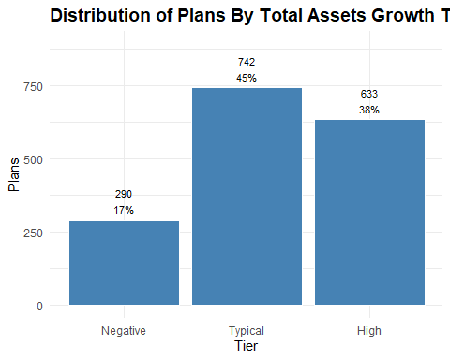
Nearly half of all plans fall into the “Typical” growth tier, signaling stable asset expansion across the board. 36% of plans show high growth, suggesting strong performance in a sizable segment. The remaining 18% with negative growth highlight a meaningful minority facing financial headwinds. This tiered distribution provides a clear snapshot of plan vitality and divergence.

Assets Per Participant (ASSETS_PER_PARTCP)
Engineer an assets per participant variable.
plans <- plans %>%
mutate(ASSETS_PER_PARTCP = round(TOTAL_ASSETS_EOY / TOTAL_ACCBAL_PARTCP_EOY, 0))
Plot assets per participant.
ggplot(plans, aes(x = ASSETS_PER_PARTCP)) +
geom_density(fill = "steelblue", alpha = 0.6) +
geom_vline(xintercept = mean(plans$ASSETS_PER_PARTCP, na.rm = TRUE),
linetype = "dashed", color = "darkred") +
scale_y_continuous(labels = scales::percent_format(scale = 1, accuracy = 0.00001)) +
scale_x_continuous(labels = scales::comma) +
labs(title = "Density of Assets per Participant",
x = "Assets Per Participant",
y = "Density (%)") +
theme_minimal() +
theme(axis.text.x = element_text(angle = 0, hjust = 0.5),
plot.title = element_text(size = 14, face = "bold"))
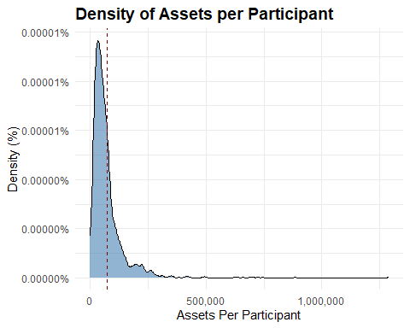
The sharp peak near the lower end, followed by a long right tail, suggests most plans cluster around $50,000 per participant with a mean of ~$80,000.
Plot the log-transformed distribution to reveal structure in the lower range.
ggplot(plans, aes(x = log1p(ASSETS_PER_PARTCP))) +
geom_density(fill = "steelblue", alpha = 0.6) +
scale_y_continuous(labels = scales::percent_format(accuracy = 0.1)) +
scale_x_continuous(labels = scales::comma) +
labs(title = "Log-Scaled Density of Assets Per Participant",
x = "log(Assets + 1)",
y = "Density (%)") +
theme_minimal() +
theme(axis.text.x = element_text(angle = 0, hjust = 0.5),
plot.title = element_text(size = 14, face = "bold"))
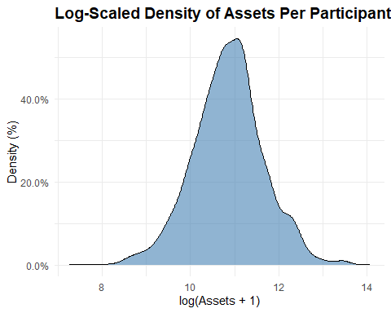
Most plans are below the mean: The log transformation shows that the bulk of plans have assets per participant of ~$59,000.

Assets Per Participant Tier (ASSETS_PER_PARTCP_TIER)
Create assets per participant tiers.
plans <- plans %>%
mutate(
ASSETS_PER_PARTCP_TIER = case_when(
ASSETS_PER_PARTCP < 50000 ~ "Low",
ASSETS_PER_PARTCP >= 50000 & ASSETS_PER_PARTCP < 100000 ~ "Moderate",
ASSETS_PER_PARTCP >= 100000 ~ "High",
TRUE ~ NA_character_),
ASSETS_PER_PARTCP_TIER = factor(ASSETS_PER_PARTCP_TIER,
levels = c("Low", "Moderate", "High"),
ordered = TRUE))
Plot density by tier.
summary_by_assets_per_partcp_tier <- plans %>%
group_by(ASSETS_PER_PARTCP_TIER) %>%
summarise(entries = n()) %>%
mutate(percent = round(entries / sum(entries), 2))
ggplot(summary_by_assets_per_partcp_tier, aes(x = ASSETS_PER_PARTCP_TIER, y = entries)) +
geom_col(fill = "steelblue", color = "white") +
geom_text(aes(label = paste0(scales::comma(entries), "\n", round(percent * 100, 0), "%")),
vjust = -0.3, size = 3.0) +
labs(title = "Distribution of Plans By Assets Per Participant Tier",
x = "Tier",
y = "Plans") +
theme_minimal() +
theme(axis.text.x = element_text(angle = 0, hjust = 0.5),
plot.title = element_text(size = 14, face = "bold")) +
expand_limits(y = max(summary_by_assets_per_partcp_tier$entries) * 1.2)
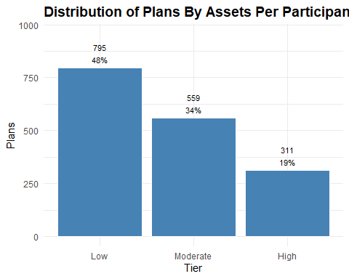
The distribution of plans by assets per participant reveals a clear skew toward lower tiers. Over 40% of plans fall into the “Low” category, while just 23% qualify as “High.” Most plans operate with relatively modest asset levels per participant, which may reflect sector constraints, legacy plan structures, or limited growth.
The “Moderate” tier, at 36%, anchors the middle ground but still trails the low tier. Overall, the distribution highlights a long tail of low savings per participant, reinforcing the need for adequacy diagnostics and tier-aware benchmarking.

Total Participants with Account Balances (TOTAL_ACCBAL_PARTCP_BOY, TOTAL_ACCBAL_PARTCP_EOY)
These variables provide the number of active participants in the plan with account balances as of the start and end of the reporting year.
summary_by_accbal_participants <- plans %>%
group_by(SECTOR_TITLE_SHORT) %>%
summarise(total_active_boy = sum(TOTAL_ACCBAL_PARTCP_BOY),
total_active_eoy = sum(TOTAL_ACCBAL_PARTCP_EOY))
kable(summary_by_accbal_participants,
col.names = c("Sector", "BOY Participants", "EOY Participants"),
caption = "BOY and EOY Total Active Participants By Sector",
format.args = list(big.mark = ","),
align = c("l", "r", "r"))
BOY and EOY Total Active Participants By Sector
Sector | BOY Participants | EOY Participants
Information | 177,367 | 176,683
Accommodatio… | 213,430 | 230,260
Administrati… | 156,863 | 166,040
Agriculture,… | 89,463 | 91,292
Arts, entert… | 120,301 | 125,051
Construction | 65,099 | 69,432
Educational … | 68,199 | 71,324
Finance and … | 157,928 | 160,106
Health care … | 421,802 | 523,255
Management o… | 573,324 | 551,275
Manufacturing | 214,604 | 221,001
Mining, quar… | 66,123 | 67,078
Other servic… | 70,327 | 73,055
Professional… | 99,177 | 102,457
Public admin… | 5,571 | 6,181
Real estate … | 143,797 | 152,719
Retail trade | 282,054 | 291,948
Transportati… | 228,819 | 241,949
Utilities | 216,128 | 217,062
Wholesale trade | 189,474 | 199,479
Plot active participants by sector.
active_long <- summary_by_accbal_participants %>%
pivot_longer(cols = c(total_active_boy, total_active_eoy),
names_to = "Active_Type",
values_to = "Active_Value")
ggplot(active_long, aes(x = reorder(SECTOR_TITLE_SHORT, -Active_Value),
y = Active_Value / 1e9,
fill = Active_Type)) +
geom_bar(stat = "identity", position = "dodge") +
scale_fill_manual(values = c("total_active_boy" = "steelblue",
"total_active_eoy" = "lightsteelblue"),
labels = c("total_active_boy" = "Beginning of Year",
"total_active_eoy" = "End of Year")) +
labs(title = "BOY and EOY Total Active Participants by Sector",
x = "Sector",
y = "Active Participants",
fill = "Active Type") +
theme_minimal() +
theme(axis.text.x = element_text(angle = 90, hjust = 0.5),
plot.title = element_text(size = 14, face = "bold"))
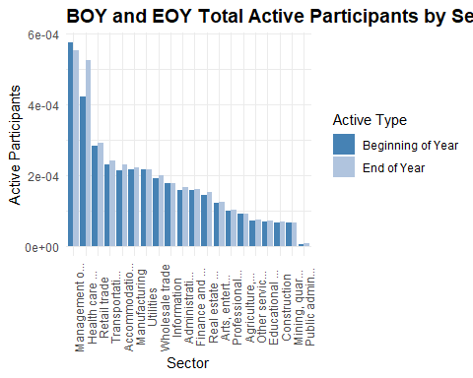
Manufacturing, Healthcare, and Professional Services again dominate in participant volume, mirroring their asset dominance. Sectors like Retail, Accommodation, and Arts show modest participant counts.
The EOY bars generally exceed BOY, suggesting net growth in active participation, but the magnitude varies by sector.

Participant Growth Rate (PARTCP_GROWTH_RATE)
Engineer participant growth rate at the plan level.
plans <- plans %>%
mutate(PARTCP_GROWTH_RATE = round((TOTAL_ACCBAL_PARTCP_EOY - TOTAL_ACCBAL_PARTCP_BOY) / TOTAL_ACCBAL_PARTCP_BOY, 4))
Produce a density plot to show the distribution of participant growth rates.
ggplot(plans, aes(x = PARTCP_GROWTH_RATE)) +
geom_density(fill = "steelblue", alpha = 0.6) +
geom_vline(xintercept = 0, linetype = "dashed", color = "gray40") +
labs(title = "Density of Participant Growth Rates",
x = "Growth Rate",
y = "Density (%)") +
theme_minimal() +
theme(axis.text.x = element_text(angle = 0, hjust = 0.5),
plot.title = element_text(size = 14, face = "bold"))
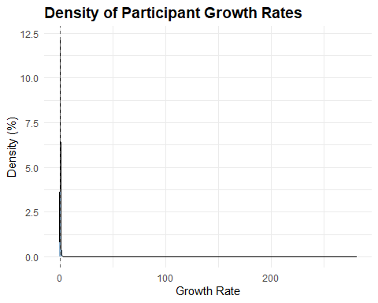
Most participant growth rates cluster tightly around zero, indicating minimal change for the majority. The long right tail reveals a small group experiencing significantly higher growth, suggesting outliers with rapid expansion. The overall distribution is sharply peaked and right-skewed.
Create a ridgeline plot by sector. I exclude outliers to visualize pattern better across sectors.
ggplot(plans %>%
filter(PARTCP_GROWTH_RATE < 0.5 & PARTCP_GROWTH_RATE > -0.5),
aes(x = PARTCP_GROWTH_RATE, y = SECTOR_TITLE_SHORT)) +
geom_density_ridges(bandwidth = 0.05, fill = "steelblue", alpha = 0.6) +
labs(title = "Participant Growth Rate by Sector",
subtitle = "Growth Rates Between -50% and 50%",
x = "Growth Rate",
y = "Sector") +
theme_minimal() +
theme(axis.text.x = element_text(angle = 0, hjust = 0.5),
plot.title = element_text(size = 14, face = "bold"))
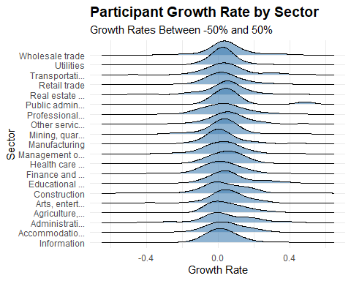
Participant growth rates across sectors are tightly centered around zero, indicating modest or stable expansion in most industries. However, some sectors show wider distributions, revealing greater variability in participant dynamics.

Participant Growth Rate Tier (PARTCP_GROWTH_TIER)
Create participant growth tiers.
plans <- plans%>%
mutate(PARTCP_GROWTH_TIER = case_when(PARTCP_GROWTH_RATE > 0.05 ~ "High",
PARTCP_GROWTH_RATE < -0.05 ~ "Negative",
TRUE ~ "Typical"),
PARTCP_GROWTH_TIER = factor(PARTCP_GROWTH_TIER,
levels = c("Negative", "Typical", "High"),
ordered = TRUE))
Plot participant growth rates by sector with the growth tiers.
summary_by_partcp_growth_tier <- plans %>%
group_by(PARTCP_GROWTH_TIER) %>%
summarise(entries = n()) %>%
mutate(percent = round(entries / sum(entries), 2))
ggplot(summary_by_partcp_growth_tier, aes(x = PARTCP_GROWTH_TIER, y = entries)) +
geom_col(fill = "steelblue", color = "white") +
geom_text(aes(label = paste0(scales::comma(entries), "\n", round(percent * 100, 0), "%")),
vjust = -0.3, size = 3.0) +
labs(title = "Distribution of Plans By Participant Growth Tier",
x = "Tier",
y = "Plans") +
theme_minimal() +
theme(axis.text.x = element_text(angle = 0, hjust = 0.5),
plot.title = element_text(size = 14, face = "bold")) +
expand_limits(y = max(summary_by_partcp_growth_tier$entries) * 1.2)
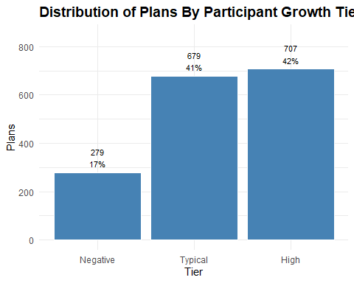
Plans are nearly evenly split between high and typical participant growth tiers, at 42% and 41% respectively. This indicates strong or stable expansion for most. 18% fall into the negative tier, highlighting a notable subset experiencing participant decline.

Total Participant Contributions (TOTAL_CONTRIB_PARTCP_BOY, TOTAL_CONTRIB_PARTCP_EOY)
These variables capture the total dollar amount of participant contributions on record as of the start and end of the reporting year. The first reflects contributions made prior to the current plan year but still held in the plan. This is useful for understanding carryover balances or prior-year contribution momentum.
The latter includes all contributions made by participants during the year, plus any prior balances still retained. It is often used to assess current-year contribution activity and participant engagement.
summary_by_partcp_contributions <- plans %>%
group_by(SECTOR_TITLE_SHORT) %>%
summarise(total_contrib_boy = sum(TOTAL_CONTRIB_PARTCP_BOY),
total_contrib_eoy = sum(TOTAL_CONTRIB_PARTCP_EOY),
.groups = "drop")
kable(summary_by_partcp_contributions,
col.names = c("Sector", "BOY Contributions", "EOY Contributions"),
caption = "BOY and EOY Total Contributions By Sector",
format.args = list(big.mark = ","),
align = c("l", "r", "r"))
BOY and EOY Total Contributions By Sector
Sector | BOY Contributions | EOY Contributions
Information | 31,124,482 | 32,741,412
Accommodatio… | 9,428,295 | 11,853,778
Administrati… | 15,669,010 | 13,993,271
Agriculture,… | 8,308,817 | 7,663,311
Arts, entert… | 8,848,483 | 10,420,345
Construction | 6,149,350 | 7,096,741
Educational … | 4,092,762 | 5,575,971
Finance and … | 22,238,232 | 26,356,712
Health care … | 25,670,033 | 39,383,143
Management o… | 58,651,870 | 65,101,939
Manufacturing | 17,010,447 | 19,613,155
Mining, quar… | 7,462,348 | 11,202,368
Other servic… | 5,883,963 | 6,427,487
Professional… | 18,422,606 | 20,490,104
Public admin… | 515,954 | 379,164
Real estate … | 4,751,719 | 4,668,658
Retail trade | 11,671,447 | 13,177,522
Transportati… | 31,126,868 | 34,207,037
Utilities | 35,017,596 | 39,479,020
Wholesale trade | 8,922,356 | 10,551,335
Plot contributions by sector.
contributions_long <- summary_by_partcp_contributions %>%
pivot_longer(cols = c(total_contrib_boy, total_contrib_eoy),
names_to = "Contribution_Type",
values_to = "Contribution_Value")
ggplot(contributions_long, aes(x = reorder(SECTOR_TITLE_SHORT, -Contribution_Value),
y = Contribution_Value / 1e9,
fill = Contribution_Type)) +
geom_bar(stat = "identity", position = "dodge") +
scale_fill_manual(values = c("total_contrib_boy" = "steelblue",
"total_contrib_eoy" = "lightsteelblue"),
labels = c("total_contrib_boy" = "Beginning of Year",
"total_contrib_eoy" = "End of Year")) +
labs(title = "BOY and EOY Total Contributions by Sector",
x = "Sector",
y = "Contributions",
fill = "Contribution Type") +
theme_minimal() +
theme(axis.text.x = element_text(angle = 90, hjust = 0.5),
plot.title = element_text(size = 14, face = "bold"))
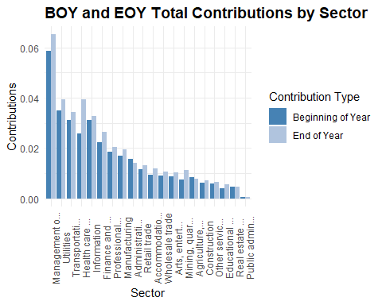
Manufacturing, Professional Services, and Hotels & Restaurants lead in total contributions, echoing their asset and participant dominance. Sectors like Information and Mining show relatively flat or modest contribution growth, which may flag under-engagement or structural constraints.
The EOY bars generally exceed BOY, suggesting net contribution inflows, but the magnitude and slope vary by sector.

Participant Contribution Growth Rate (CONTRIB_PARTCP_GROWTH_RATE)
Engineer a contribution growth rate.
plans <- plans %>%
mutate(CONTRIB_PARTCP_GROWTH_RATE = round((TOTAL_CONTRIB_PARTCP_EOY - TOTAL_CONTRIB_PARTCP_BOY) / TOTAL_CONTRIB_PARTCP_BOY, 4))
Produce a density plot to show the distribution of contribution growth rates.
ggplot(plans, aes(x = CONTRIB_PARTCP_GROWTH_RATE)) +
geom_density(fill = "steelblue", alpha = 0.6) +
geom_vline(xintercept = 0, linetype = "dashed", color = "gray40") +
labs(title = "Density of Contribution Growth Rates",
x = "Growth Rate",
y = "Density (%)") +
theme_minimal() +
theme(axis.text.x = element_text(angle = 0, hjust = 0.5),
plot.title = element_text(size = 14, face = "bold"))
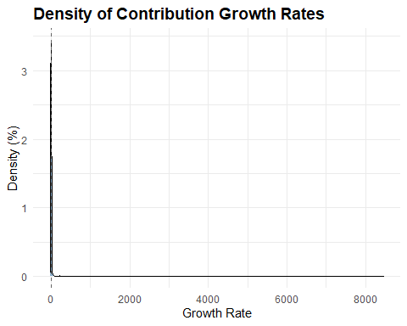
This is a familiar dynamic, most contribution growth rates cluster tightly around zero, indicating minimal change for the majority. The long right tail reveals a small group experiencing significantly higher contribution growth. The overall distribution is sharply peaked and right-skewed.
Create a ridgeline plot by sector, adjusted for outliers.
ggplot(plans %>%
filter(CONTRIB_PARTCP_GROWTH_RATE < 0.5 & CONTRIB_PARTCP_GROWTH_RATE > -0.5),
aes(x = CONTRIB_PARTCP_GROWTH_RATE, y = SECTOR_TITLE_SHORT)) +
geom_density_ridges(bandwidth = 0.05, fill = "steelblue", alpha = 0.6) +
labs(title = "Contribution Growth Rate by Sector",
subtitle = "Growth Rates Between -50% and 50%",
x = "Growth Rate",
y = "Sector") +
theme_minimal() +
theme(axis.text.x = element_text(angle = 0, hjust = 0.5),
plot.title = element_text(size = 14, face = "bold"))
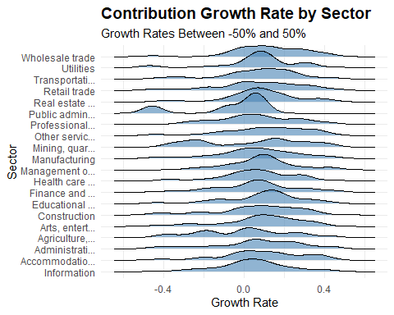
Contribution growth rates cluster near zero across most sectors, but several show wide variability, especially in the tails. The presence of negative growth rates likely reflects borrowing activity or early withdrawals, signaling financial strain or plan leakage. This distribution highlights sector-level differences in contribution dynamics and potential risk exposure.

Participant Contribution Growth Tier (CONTRIB_PARTCP_GROWTH_TIER)
Create a contribution growth rate tiers.
plans <- plans%>%
mutate(CONTRIB_PARTCP_GROWTH_TIER = case_when(CONTRIB_PARTCP_GROWTH_RATE > 0.10 ~ "High",
CONTRIB_PARTCP_GROWTH_RATE < -0.10 ~ "Negative",
TRUE ~ "Typical"),
CONTRIB_PARTCP_GROWTH_TIER = factor(CONTRIB_PARTCP_GROWTH_TIER,
levels = c("Negative", "Typical", "High"),
ordered = TRUE))
Plot contribution growth tiers by sector with the growth flags.
summary_by_contrib_partcp_growth_tier <- plans %>%
group_by(CONTRIB_PARTCP_GROWTH_TIER) %>%
summarise(entries = n()) %>%
mutate(percent = round(entries / sum(entries), 2))
ggplot(summary_by_contrib_partcp_growth_tier, aes(x = CONTRIB_PARTCP_GROWTH_TIER, y = entries)) +
geom_col(fill = "steelblue", color = "white") +
geom_text(aes(label = paste0(scales::comma(entries), "\n", round(percent * 100, 0), "%")),
vjust = -0.3, size = 3.0) +
labs(title = "Distribution of Plans By Participant Contribution Growth Tier",
x = "Tier",
y = "Plans") +
theme_minimal() +
theme(axis.text.x = element_text(angle = 0, hjust = 0.5),
plot.title = element_text(size = 14, face = "bold")) +
expand_limits(y = max(summary_by_contrib_partcp_growth_tier$entries) * 1.2)
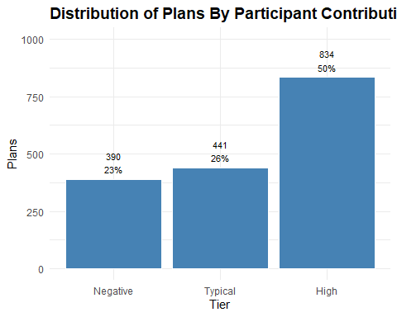
Half of all plans fall into the high participant contribution growth tier, signaling strong engagement and financial momentum for these plans. Typical growth accounts for 26%, while 24% show negative growth, potentially reflecting borrowing or early withdrawals. The distribution highlights both robust contribution trends and areas of concern.

Employer Contributions (TOTAL_CONTRIB_EMPLR_BOY, TOTAL_CONTRIB_EMPLR_EOY)
These variables represent the total dollar amount of employer contributions on record as of the start and end of the reporting year. They include contributions made during the year plus any retained prior balances and are often used to assess current-year employer funding and plan support.
summary_er_contributions <- plans %>%
group_by(SECTOR_TITLE_SHORT) %>%
summarise(total_contrib_boy = sum(TOTAL_CONTRIB_EMPLR_BOY),
total_contrib_eoy = sum(TOTAL_CONTRIB_EMPLR_EOY),
.groups = "drop")
kable(summary_er_contributions,
col.names = c("Sector", "BOY Contributions", "EOY Contributions"),
caption = "BOY and EOY Total Employer Contributions By Sector",
format.args = list(big.mark = ","),
align = c("l", "r", "r"))
BOY and EOY Total Employer Contributions By Sector
Sector | BOY Contributions | EOY Contributions
Information | 59,682,112 | 55,171,657
Accommodatio… | 58,506,034 | 67,267,326
Administrati… | 22,761,378 | 23,245,771
Agriculture,… | 13,783,770 | 13,889,906
Arts, entert… | 48,648,058 | 54,178,005
Construction | 34,484,794 | 33,787,684
Educational … | 10,881,966 | 12,299,570
Finance and … | 101,704,104 | 108,746,007
Health care … | 397,539,059 | 433,956,687
Management o… | 574,754,728 | 618,090,432
Manufacturing | 149,742,450 | 179,821,964
Mining, quar… | 40,581,843 | 57,418,327
Other servic… | 18,610,211 | 18,424,312
Professional… | 44,726,772 | 51,781,826
Public admin… | 287,607 | 316,815
Real estate … | 242,250,550 | 300,823,035
Retail trade | 90,159,385 | 115,680,740
Transportati… | 80,779,054 | 85,972,382
Utilities | 178,397,583 | 201,016,383
Wholesale trade | 200,112,302 | 168,298,831
Plot contributions by sector.
er_contributions_long <- summary_er_contributions %>%
pivot_longer(cols = c(total_contrib_boy, total_contrib_eoy),
names_to = "Contribution_Type",
values_to = "Contribution_Value")
ggplot(er_contributions_long, aes(x = reorder(SECTOR_TITLE_SHORT, -Contribution_Value),
y = Contribution_Value / 1e9,
fill = Contribution_Type)) +
geom_bar(stat = "identity", position = "dodge") +
scale_fill_manual(values = c("total_contrib_boy" = "steelblue",
"total_contrib_eoy" = "lightsteelblue"),
labels = c("total_contrib_boy" = "Beginning of Year",
"total_contrib_eoy" = "End of Year")) +
labs(title = "BOY and EOY Total Employer Contributions by Sector",
x = "Sector",
y = "Contributions",
fill = "Contribution Type") +
theme_minimal() +
theme(axis.text.x = element_text(angle = 90, hjust = 0.5),
plot.title = element_text(size = 14, face = "bold"))
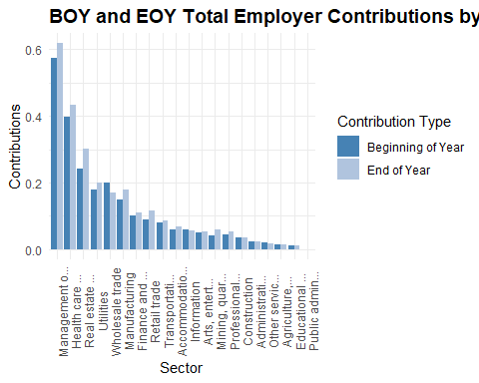
Health care, Manufacturing, and Professional Services lead in employer contributions at both BOY and EOY, suggesting sustained institutional support. Sectors like Arts & Entertainment, Accommodation, and Administrative Support show relatively low employer contributions, which could signal structural gaps in plan generosity.
The EOY bars generally exceed BOY, indicating net inflows, but the slope varies by sector. Some sectors show flat or modest growth..

Employer Contribution Growth Rate (CONTRIB_EMPLR_GROWTH_RATE)
Engineer a contribution growth rate.
plans <- plans %>%
mutate(CONTRIB_EMPLR_GROWTH_RATE = round((TOTAL_CONTRIB_EMPLR_EOY - TOTAL_CONTRIB_EMPLR_BOY) / TOTAL_CONTRIB_EMPLR_BOY, 4))
Produce a density plot to show the distribution of contribution growth rates.
ggplot(plans, aes(x = CONTRIB_EMPLR_GROWTH_RATE)) +
geom_density(fill = "steelblue", alpha = 0.6) +
geom_vline(xintercept = 0, linetype = "dashed", color = "gray40") +
labs(title = "Density of Employer Contribution Growth Rates",
x = "Growth Rate",
y = "Density") +
theme_minimal() +
theme(axis.text.x = element_text(angle = 0, hjust = 0.5),
plot.title = element_text(size = 14, face = "bold"))
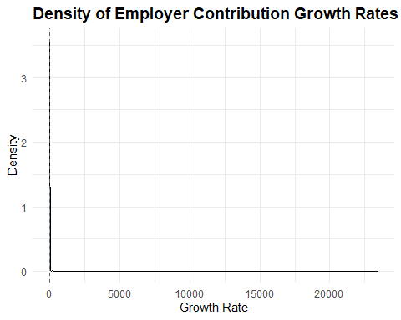
Tight clustering around zero with a long tail.
Create a ridgeline plot by sector, filter high values.
ggplot(plans %>%
filter(CONTRIB_EMPLR_GROWTH_RATE < 0.10 & CONTRIB_EMPLR_GROWTH_RATE > -0.10),
aes(x = CONTRIB_EMPLR_GROWTH_RATE, y = SECTOR_TITLE_SHORT)) +
geom_density_ridges(bandwidth = 0.05, fill = "steelblue", alpha = 0.6) +
labs(title = "Employer Contribution Growth Rate by Sector",
subtitle = "Growth Rates Between -10% and 10%",
x = "Growth Rate",
y = "Sector") +
theme_minimal() +
theme(axis.text.x = element_text(angle = 90, hjust = 0.5),
plot.title = element_text(size = 14, face = "bold"))
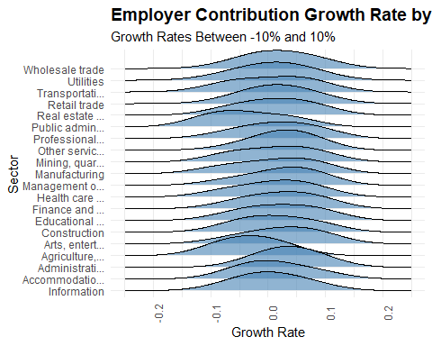
Employer contribution growth rates are tightly centered around zero across most sectors, indicating general stability. However, some sectors show wider spreads, suggesting variability in employer funding behavior.

Employer Contribution Growth Tier (CONTRIB_EMPLR_GROWTH_TIER)
Create employer contribution growth tiers.
plans <- plans%>%
mutate(CONTRIB_EMPLR_GROWTH_TIER = case_when(CONTRIB_EMPLR_GROWTH_RATE > 0.10 ~ "High",
CONTRIB_EMPLR_GROWTH_RATE < -0.10 ~ "Negative",
TRUE ~ "Typical"),
CONTRIB_EMPLR_GROWTH_TIER = factor(CONTRIB_EMPLR_GROWTH_TIER,
levels = c("Negative", "Typical", "High"),
ordered = TRUE))
Plot contribution growth rates by sector with the growth flags.
summary_by_contrib_emplr_growth_tier <- plans %>%
group_by(CONTRIB_EMPLR_GROWTH_TIER) %>%
summarise(entries = n()) %>%
mutate(percent = round(entries / sum(entries), 2))
ggplot(summary_by_contrib_emplr_growth_tier, aes(x = CONTRIB_EMPLR_GROWTH_TIER, y = entries)) +
geom_col(fill = "steelblue", color = "white") +
geom_text(aes(label = paste0(scales::comma(entries), "\n", round(percent * 100, 0), "%")),
vjust = -0.3, size = 3.0) +
labs(title = "Distribution of Plans By Employer Contribution Growth Tier",
x = "Tier",
y = "Plans") +
theme_minimal() +
theme(axis.text.x = element_text(angle = 0, hjust = 0.5),
plot.title = element_text(size = 14, face = "bold")) +
expand_limits(y = max(summary_by_contrib_emplr_growth_tier$entries) * 1.2)
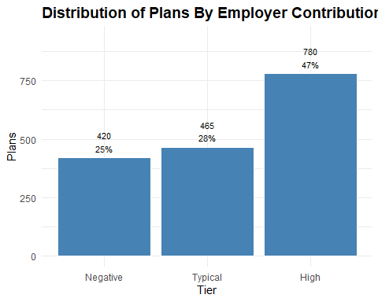
Nearly half of all plans fall into the high employer contribution growth tier, signaling strong and increasing support from employers. Typical growth accounts for 29%, while 25% of plans show negative growth, potentially reflecting funding reductions or volatility.

Participant Loans (TOTAL_LOANS_BOY, TOTAL_LOANS_EOY)
These fields reflect the aggregate amount participants have borrowed from their retirement accounts and not yet repaid. Loans are typically allowed under 401(k) and some 403(b) plans, subject to IRS limits (usually up to $50,000 or 50% of vested account balance).
Comparing BOY vs. EOY values helps surface net borrowing or repayment trends. A rising EOY balance may signal increased participant financial stress or plan leniency.
High loan balances can erode retirement adequacy. Plans with high loan-to-asset ratios or frequent borrowing as needing closer scrutiny.
summary_loans <- plans %>%
group_by(SECTOR_TITLE_SHORT) %>%
summarise(total_loans_boy = sum(TOTAL_LOANS_BOY),
total_loans_eoy = sum(TOTAL_LOANS_EOY),
.groups = "drop")
kable(summary_loans,
col.names = c("Sector", "BOY Loans", "EOY Loans"),
caption = "BOY and EOY Total Loan Balances By Sector",
format.args = list(big.mark = ","),
align = c("l", "r", "r"))
BOY and EOY Total Loan Balances By Sector
Sector | BOY Loans | EOY Loans
Information | 240,472,192 | 254,575,163
Accommodatio… | 170,355,015 | 194,022,389
Administrati… | 150,967,385 | 174,052,726
Agriculture,… | 208,026,681 | 221,589,309
Arts, entert… | 145,158,862 | 158,112,608
Construction | 59,305,271 | 69,955,562
Educational … | 39,086,249 | 43,939,341
Finance and … | 180,143,314 | 191,547,005
Health care … | 329,193,595 | 467,356,833
Management o… | 1,072,871,093 | 1,154,124,871
Manufacturing | 339,169,197 | 372,625,750
Mining, quar… | 129,212,482 | 145,898,321
Other servic… | 64,066,096 | 69,021,028
Professional… | 53,728,845 | 62,772,794
Public admin… | 7,827,536 | 9,157,545
Real estate … | 111,310,623 | 123,325,926
Retail trade | 181,216,831 | 198,920,471
Transportati… | 350,575,639 | 404,095,446
Utilities | 607,227,520 | 623,413,804
Wholesale trade | 368,658,460 | 404,369,157
Plot loans by sector.
er_loans_long <- summary_loans %>%
pivot_longer(cols = c(total_loans_boy, total_loans_eoy),
names_to = "Loan_Type",
values_to = "Loan_Value")
ggplot(er_loans_long, aes(x = reorder(SECTOR_TITLE_SHORT, -Loan_Value),
y = Loan_Value,
fill = Loan_Type)) +
geom_bar(stat = "identity", position = "dodge") +
scale_fill_manual(values = c("total_loans_boy" = "steelblue",
"total_loans_eoy" = "lightsteelblue"),
labels = c("total_loans_boy" = "Beginning of Year",
"total_loans_eoy" = "End of Year")) +
labs(title = "BOY and EOY Total Loan Balances by Sector",
x = "Sector",
y = "Loans",
fill = "Loan Type") +
theme_minimal() +
theme(axis.text.x = element_text(angle = 90, hjust = 0.5),
plot.title = element_text(size = 14, face = "bold"))
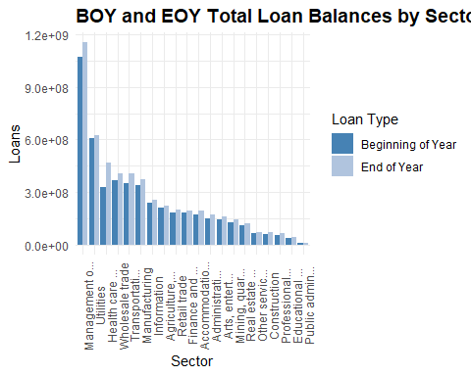
Loan balances are rising in most sectors. That’s a potential red flag for participant liquidity strain or plan leniency.
Manufacturing leads in total loan volume. These sectors show the highest absolute balances, likely due to large participant bases and higher plan penetration. Professional and Technical Services show modest growth. Possibly reflecting more conservative borrowing behavior or stronger financial wellness programs.

Loan Leakage Ratio (LOAN_LEAKAGE_RATIO)
Create a loan leakage ratio feature.
plans <- plans %>%
mutate(LOAN_LEAKAGE_RATIO = round(TOTAL_LOANS_EOY / TOTAL_ASSETS_EOY, 4))

Loan Leakage Tier (LOAN_LEAKAGE_TIER)
Create loan leakage tiers.
plans <- plans %>%
mutate(LOAN_LEAKAGE_TIER = case_when(LOAN_LEAKAGE_RATIO <= 0.015 ~ "Low",
LOAN_LEAKAGE_RATIO <= 0.03 ~ "Moderate",
TRUE ~ "High"),
LOAN_LEAKAGE_TIER = factor(LOAN_LEAKAGE_TIER,
levels = c("Low", "Moderate", "High"),
ordered = TRUE))
Plot loan leakage tier.
summary_by_loan_leakage_tier <- plans %>%
group_by(LOAN_LEAKAGE_TIER) %>%
summarise(entries = n()) %>%
mutate(percent = round(entries / sum(entries), 2))
ggplot(summary_by_loan_leakage_tier, aes(x = LOAN_LEAKAGE_TIER, y = entries)) +
geom_col(fill = "steelblue", color = "white") +
geom_text(aes(label = paste0(scales::comma(entries), "\n", round(percent * 100, 0), "%")),
vjust = -0.3, size = 3.0) +
labs(title = "Distribution of Plans By Loan Leakage Tier",
x = "Tier",
y = "Plans") +
theme_minimal() +
theme(axis.text.x = element_text(angle = 0, hjust = 0.5),
plot.title = element_text(size = 14, face = "bold")) +
expand_limits(y = max(summary_by_loan_leakage_tier$entries) * 1.2)
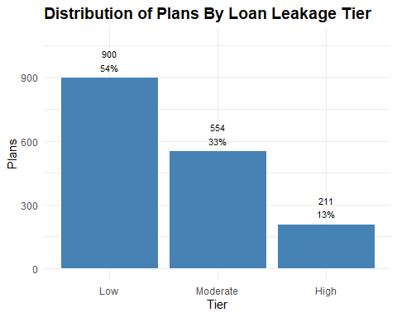
Over half of all plans fall into the low loan leakage tier, suggesting strong retention and minimal borrowing activity. 31% show moderate leakage, and 12% fall into the high tier, highlighting a smaller but notable group at risk of financial strain or early withdrawals.

Retirement Adequacy Score (ADEQUACY_SCORE, ADEQUACY_IND, ADEQUACY_LABEL)
This response variable is designed to classify retirement plans as adequate or inadequate based on a principled, multi-signal framework. Rather than relying on a single metric, it integrates six structural indicators of plan health:
- Assets per Participant > $59,000 signals long-term saving capacity and participant wealth accumulation,
- Asset Growth Rate > 10% reflects sustained engagement and overall plan financial momentum over time,
- Participant Growth Rate > 3% signals strong plan adoption by employees,
- Participant Contribution Growth Rate > 10% indicates meaningful participant deferral behavior and plan utilization,
- Employer Contribution Growth Rate > 7% indicates meaningful employer support for employee financial wellness, and
- Loan Leakage Ratio < 1.3% captures erosion risk due to participant borrowing; lower ratios suggest stronger adequacy.
Each condition is evaluated as a binary flag, and the adequacy score is the sum of conditions met. Plans meeting four or more criteria are classified as adequate.
plans <- plans %>%
mutate(ADEQUACY_SCORE = (ASSETS_PER_PARTCP > 59000) +
(TOTAL_ASSETS_GROWTH_RATE > 0.10) +
(PARTCP_GROWTH_RATE > 0.03) +
(CONTRIB_PARTCP_GROWTH_RATE > 0.10) +
(CONTRIB_EMPLR_GROWTH_RATE > 0.07) +
(LOAN_LEAKAGE_RATIO < 0.013),
ADEQUACY_IND = if_else(ADEQUACY_SCORE >= 4, 1L, 0L),
ADEQUACY_LABEL = if_else(ADEQUACY_IND == 1L, "Adequate", "Inadequate"))
This approach offers several advantages.Stakeholders can trace adequacy classification to specific, transparent thresholds. Each component reflects a distinct dimension of plan health, accumulation, growth, engagement, and leakage. By leveraging multiple criteria, the model avoids overfitting to any one sector or plan type. And the binary label supports classification tasks, while the tiered label enables stakeholder previews and fairness overlays.
This response variable scaffolds ethical modeling, stakeholder trust, and reproducible diagnostics, all central to my analytic philosophy for this project.
Summarize plans by adequacy score.
summary_by_adequacy_score <- plans %>%
group_by(ADEQUACY_SCORE) %>%
summarise(entries = n()) %>%
mutate(percent = round(entries / sum(entries), 2))
kable(summary_by_adequacy_score,
col.names = c("Adequacy Score", "Plans", "Percent"),
caption = "Summary By Adequacy Score",
format.args = list(big.mark = ","),
align = c("l", "r", "r"))
Summary By Adequacy Score
Adequacy Score | Plans | Percent
0 | 26 | 0.02
1 | 120 | 0.07
2 | 311 | 0.19
3 | 443 | 0.27
4 | 436 | 0.26
5 | 234 | 0.14
6 | 95 | 0.06
Plot adequacy distribution.
ggplot(summary_by_adequacy_score, aes(x = ADEQUACY_SCORE, y = entries)) +
geom_col(fill = "steelblue", color = "white") +
geom_text(aes(label = paste0(scales::comma(entries), "\n", round(percent * 100, 0), "%")),
vjust = -0.3, size = 3.0) +
labs(title = "Distribution of Adequacy Scores",
x = "Adequacy Score",
y = "Number of Plans") +
theme_minimal() +
theme(axis.text.x = element_text(angle = 0, hjust = 0.5),
plot.title = element_text(size = 14, face = "bold")) +
expand_limits(y = max(summary_by_adequacy_score$entries) * 1.2)
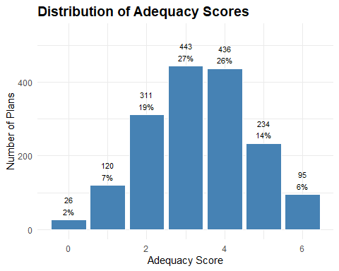
Most plans score between 3 and 4, suggesting moderate adequacy, while very few meet all six criteria. This distribution highlights a central tendency with room for improvement in comprehensive plan strength.
Plot distribution by adequacy class.
summary_by_adequacy_class <- plans %>%
group_by(ADEQUACY_LABEL) %>%
summarise(entries = n()) %>%
mutate(percent = round(entries / sum(entries), 2))
ggplot(summary_by_adequacy_class, aes(x = ADEQUACY_LABEL, y = entries)) +
geom_col(fill = "steelblue", color = "white") +
geom_text(aes(label = paste0(scales::comma(entries), "\n", round(percent * 100, 0), "%")),
vjust = -0.3, size = 3.0) +
labs(title = "Distribution of Adequacy Class",
x = "Adequacy Class",
y = "Number of Plans") +
theme_minimal() +
theme(axis.text.x = element_text(angle = 0, hjust = 0.5),
plot.title = element_text(size = 14, face = "bold")) +
expand_limits(y = max(summary_by_adequacy_class$entries) * 1.2)
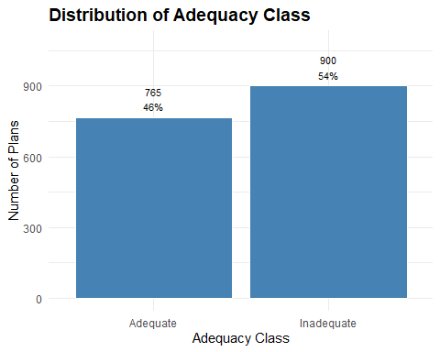
Just over half of plans are classified as inadequate (51%), while 49% meet adequacy criteria, revealing a near-even split. This suggests that while many plans show structural strength, a slight majority still fall short on key indicators like contributions, growth, or leakage. The distribution underscores the need for targeted improvement across the plan landscape.

Finalize and Save Dataset
Order variables and save plans data frame with updates and features.
plans <- plans %>%
select(ADEQUACY_LABEL,
ADEQUACY_IND,
ADEQUACY_SCORE,
ACK_ID,
PLAN_YEAR_BEGIN_DATE,
PLAN_YEAR_END_DATE,
PLAN_NAME,
PLAN_EFFECTIVE_DATE,
PLAN_EFFECTIVE_YEAR,
PLAN_VINTAGE_GROUP,
PLAN_TYPE,
SPONSOR_NAME,
SPONSOR_STATE,
SPONSOR_EIN,
BUSINESS_CODE,
INDUSTRY_TITLE,
SECTOR_CODE,
SECTOR_TITLE,
SECTOR_TITLE_SHORT,
TOTAL_ACCBAL_PARTCP_BOY,
TOTAL_ACCBAL_PARTCP_EOY,
PARTCP_GROWTH_RATE,
PARTCP_GROWTH_TIER,
TOTAL_CONTRIB_PARTCP_BOY,
TOTAL_CONTRIB_PARTCP_EOY,
CONTRIB_PARTCP_GROWTH_RATE,
CONTRIB_PARTCP_GROWTH_TIER,
TOTAL_CONTRIB_EMPLR_BOY,
TOTAL_CONTRIB_EMPLR_EOY,
CONTRIB_EMPLR_GROWTH_RATE,
CONTRIB_EMPLR_GROWTH_TIER,
TOTAL_LOANS_BOY,
TOTAL_LOANS_EOY,
LOAN_LEAKAGE_RATIO,
LOAN_LEAKAGE_TIER,
TOTAL_ASSETS_BOY,
TOTAL_ASSETS_EOY,
TOTAL_ASSETS_GROWTH_RATE,
TOTAL_ASSETS_GROWTH_TIER,
ASSETS_PER_PARTCP,
ASSETS_PER_PARTCP_TIER)
saveRDS(plans, "../data/plans_final.rds")
The final dataset includes 1,665 plans and 41 variables.

Next Steps
Next steps in this analysis include checking variable associations, multi-collinearity checks and subset selection for the optimal set of features.

