Classifying Retirement Plan Financial Adequacy Using Form 5500 Data
  - Exploratory Data Analysis
Donnie Minnick, Statistical Learning - Fall A 2025
October 03, 2025

Load Libraries
This analysis leverages the following R packages: dplyr, lubridate, stringr and tidyr for data manipulation, knitr for table formatting, and ggplot2 and ggridges for visualization.

Load Data
Load the Form 5500 data for 401(k) plans.
plans <- readRDS("../data/plans.rds")
This analysis focuses on 401(k) plans because they are the dominant defined contribution vehicle in the U.S. private sector, offering broad sector coverage and stable representation in Form 5500 data. While I initially considered 403(b) plans, their sparse and sector-specific presence, primarily in nonprofits and education, limits their utility for benchmarking and fairness diagnostics.
The baseline dataset includes 5,579 plans and 21 variables.

Missing Data
Generate a report to check for missing values in the data at both the column and row level.
# Create column level summary.
col_missing <- plans %>%
summarise(across(everything(), ~ sum(is.na(.)))) %>%
pivot_longer(cols = everything(),
names_to = "Variable",
values_to = "Missing_Count") %>%
mutate(Missing_Percent = Missing_Count / nrow(plans) * 100)
# Create row level summary.
row_missing <- tibble(Variable = "Rows Any Missing",
Missing_Count = sum(!complete.cases(plans)),
Missing_Percent = sum(!complete.cases(plans)) / nrow(plans) * 100)
# Combine summaries.
missing_report <- bind_rows(col_missing, row_missing)
kable(missing_report,
col.names = c("Variable", "Missing Count", "Missing Percent"),
caption = "Missing Data",
format.args = list(big.mark = ","),
align = c("l", "r", "r"))
Missing Data
Variable | Missing Count | Missing Percent
ACK_ID | 0 | 0
PLAN_YEAR_BEGIN_DATE | 0 | 0
PLAN_YEAR_END_DATE | 0 | 0
PLAN_NAME | 0 | 0
PLAN_EFFECTIVE_DATE | 0 | 0
PLAN_TYPE | 0 | 0
SPONSOR_NAME | 0 | 0
SPONSOR_STATE | 0 | 0
SPONSOR_EIN | 0 | 0
BUSINESS_CODE | 0 | 0
TOTAL_ACCBAL_PARTCP_BOY | 0 | 0
TOTAL_ACCBAL_PARTCP_EOY | 0 | 0
TOTAL_CONTRIB_PARTCP_BOY | 0 | 0
TOTAL_CONTRIB_PARTCP_EOY | 0 | 0
TOTAL_CONTRIB_EMPLR_BOY | 0 | 0
TOTAL_CONTRIB_EMPLR_EOY | 0 | 0
TOTAL_LOANS_BOY | 0 | 0
TOTAL_LOANS_EOY | 0 | 0
TOTAL_ASSETS_BOY | 0 | 0
TOTAL_ASSETS_EOY | 0 | 0
INDUSTRY_TITLE | 0 | 0
Rows Any Missing | 0 | 0
There are no missing values in the dataset; however, I need to also verify if count and amount variables take on zero values, as these may indicate inactive plans, reporting artifacts, or edge cases requiring further review.

Zero Values
Generate a report to check or zero values in the data at both the column and row level.
col_zero <- plans %>%
summarise(across(everything(), ~ sum(. == 0, na.rm = TRUE))) %>%
pivot_longer(cols = everything(),
names_to = "Variable",
values_to = "Zero_Count") %>%
mutate(Zero_Percent = Zero_Count / nrow(plans) * 100)
row_zero <- tibble(Variable = "Rows Any Zero",
Zero_Count = sum(apply(plans == 0, 1, any, na.rm = TRUE)),
Zero_Percent = sum(apply(plans == 0, 1, any, na.rm = TRUE)) / nrow(plans) * 100)
zero_report <- bind_rows(col_zero, row_zero)
kable(zero_report,
col.names = c("Variable", "Zero Count", "Zero Percent"),
caption = "Zero Value Summary",
format.args = list(big.mark = ","),
align = c("l", "r", "r"))
Zero Value Summary
Variable | Zero Count | Zero Percent
ACK_ID | 0 | 0
PLAN_YEAR_BEGIN_DATE | 0 | 0
PLAN_YEAR_END_DATE | 0 | 0
PLAN_NAME | 0 | 0
PLAN_EFFECTIVE_DATE | 0 | 0
PLAN_TYPE | 0 | 0
SPONSOR_NAME | 0 | 0
SPONSOR_STATE | 0 | 0
SPONSOR_EIN | 0 | 0
BUSINESS_CODE | 0 | 0
TOTAL_ACCBAL_PARTCP_BOY | 0 | 0
TOTAL_ACCBAL_PARTCP_EOY | 0 | 0
TOTAL_CONTRIB_PARTCP_BOY | 0 | 0
TOTAL_CONTRIB_PARTCP_EOY | 0 | 0
TOTAL_CONTRIB_EMPLR_BOY | 0 | 0
TOTAL_CONTRIB_EMPLR_EOY | 0 | 0
TOTAL_LOANS_BOY | 0 | 0
TOTAL_LOANS_EOY | 0 | 0
TOTAL_ASSETS_BOY | 0 | 0
TOTAL_ASSETS_EOY | 0 | 0
INDUSTRY_TITLE | 0 | 0
Rows Any Zero | 0 | 0
The dataset does not include any zero values.

Acknowledgement Id (ACK_ID)
Acknowledgement Id is a unique identifier assigned by the Department of Labor (DOL) or IRS when a Form 5500 filing is successfully received and acknowledged. Think of it as a receipt number; it confirms that the filing was accepted into the system. It’s often used for tracking, auditing, or linking filings across systems.

Plan Year Begin/End Dates (PLAN_YEAR_BEGIN_DATE, PLAN_YEAR_END_DATE)
These dates define the reporting window for all financial and participant metrics. The data contains filings with a plan year begin date of January 1, 2023 and end date of December 31, 2023.

Plan Effective Date (PLAN_EFFECTIVE_DATE)
Plan effective date marks the official inception of a retirement plan, i.e. the date it became active and enforceable under its governing provisions. This date anchors a plan’s life cycle, serving as a reference point for regulatory applicability, sponsor tenure, and cohort benchmarking.
From an analytic perspective, plan effective date enables several valuable transformations. Calculating plan age from this field allows for stratification by maturity, which is useful when assessing financial readiness across vintage cohorts. Plans initiated in different eras may reflect distinct design philosophies, contribution behaviors, or participant engagement patterns.
Generate a summary count of plans by plan effective year.
summary_by_plan_effective_year <- plans %>%
mutate(PLAN_EFFECTIVE_YEAR = as.character(year(PLAN_EFFECTIVE_DATE))) %>%
group_by(PLAN_EFFECTIVE_YEAR) %>%
arrange(PLAN_EFFECTIVE_YEAR) %>%
summarise(entries = n()) %>%
mutate(percent = round(entries / sum(entries), 2))
kable(summary_by_plan_effective_year,
col.names = c("Year", "Plans", "Percent"),
caption = "Summary By Plan Effective Year",
format.args = list(big.mark = ","),
align = c("l", "r", "r"))
Summary By Plan Effective Year
Year | Plans | Percent
1945 | 3 | 0.00
1948 | 1 | 0.00
1949 | 1 | 0.00
1950 | 3 | 0.00
1952 | 4 | 0.00
1953 | 6 | 0.00
1954 | 2 | 0.00
1955 | 3 | 0.00
1956 | 6 | 0.00
1957 | 5 | 0.00
1958 | 8 | 0.00
1959 | 7 | 0.00
1960 | 11 | 0.00
1961 | 6 | 0.00
1962 | 5 | 0.00
1963 | 9 | 0.00
1964 | 9 | 0.00
1965 | 7 | 0.00
1966 | 9 | 0.00
1967 | 14 | 0.00
1968 | 23 | 0.00
1969 | 25 | 0.00
1970 | 21 | 0.00
1971 | 19 | 0.00
1972 | 17 | 0.00
1973 | 30 | 0.01
1974 | 29 | 0.01
1975 | 28 | 0.01
1976 | 32 | 0.01
1977 | 24 | 0.00
1978 | 30 | 0.01
1979 | 35 | 0.01
1980 | 36 | 0.01
1981 | 38 | 0.01
1982 | 41 | 0.01
1983 | 62 | 0.01
1984 | 115 | 0.02
1985 | 140 | 0.03
1986 | 114 | 0.02
1987 | 135 | 0.02
1988 | 100 | 0.02
1989 | 138 | 0.02
1990 | 144 | 0.03
1991 | 129 | 0.02
1992 | 138 | 0.02
1993 | 172 | 0.03
1994 | 182 | 0.03
1995 | 163 | 0.03
1996 | 186 | 0.03
1997 | 213 | 0.04
1998 | 176 | 0.03
1999 | 149 | 0.03
2000 | 153 | 0.03
2001 | 110 | 0.02
2002 | 118 | 0.02
2003 | 105 | 0.02
2004 | 122 | 0.02
2005 | 128 | 0.02
2006 | 150 | 0.03
2007 | 133 | 0.02
2008 | 114 | 0.02
2009 | 98 | 0.02
2010 | 72 | 0.01
2011 | 104 | 0.02
2012 | 94 | 0.02
2013 | 107 | 0.02
2014 | 121 | 0.02
2015 | 124 | 0.02
2016 | 144 | 0.03
2017 | 132 | 0.02
2018 | 108 | 0.02
2019 | 114 | 0.02
2020 | 76 | 0.01
2021 | 84 | 0.02
2022 | 65 | 0.01
Plan formation was historically sparse, with most years before 1975 contributing fewer than 10 plans, and often just one or two. Even decades into the data, annual proportions still relatively low, underscoring how rare formal retirement plans were. A modest uptick begins in the mid-1970s, likely reflecting regulatory shifts.
Plot plans by plan effective year.
ggplot(summary_by_plan_effective_year, aes(x = as.integer(PLAN_EFFECTIVE_YEAR), y = entries)) +
geom_col(fill = "steelblue", color = "white") +
labs(title = "Distribution of Plans by Plan Effective Year",
x = "Year",
y = "Plans") +
theme_minimal() +
theme(axis.text.x = element_text(angle = 0, hjust = 0.5),
plot.title = element_text(size = 14, face = "bold"))
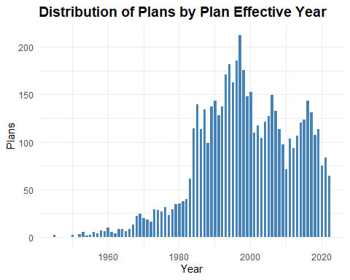
The gradual rise from the 1940s through the 1970s reflects the early institutionalization of employer-sponsored plans, driven by post-war economic expansion and the formalization of pension structures.
The uptick in the late 1970s through the 1990s coincides with major policy shifts, most notably the passage of ERISA in 1974 and the rise of defined contribution plans like 401(k) plans in the early 1980s. This era marks a surge in plan formation, especially among small and mid-sized employers responding to new regulatory clarity and tax incentives.
The peak in the late 1990s to early 2000s suggests a saturation point, after which the decline reflects consolidation of plans or sponsor exits, a shift toward pooled and multi-employer arrangements, and market volatility post-2008 influencing plan formation.
Grouping plans into vintages, i.e. multi-year cohorts based on effective year, helps mitigate the diagnostic noise of annual sparcity in the early years of the data. Plans initiated in different eras may have distinct design philosophies, contribution behaviors, or participant engagement patterns. A plan vintage feature (e.g. pre-1980, 1980–1999, post-2000) can help assess adequacy or access across cohorts.

Plan Vintage Group (PLAN_VINTAGE_GROUP)
Engineer a plan vintage group variable.
plans <- plans %>%
mutate(PLAN_EFFECTIVE_YEAR = year(PLAN_EFFECTIVE_DATE),
PLAN_VINTAGE_GROUP = case_when(
is.na(PLAN_EFFECTIVE_YEAR) ~ NA_character_,
PLAN_EFFECTIVE_YEAR < 1990 ~ "Legacy",
PLAN_EFFECTIVE_YEAR >= 1990 & PLAN_EFFECTIVE_YEAR <= 1999 ~ "Expansion",
PLAN_EFFECTIVE_YEAR >= 2000 & PLAN_EFFECTIVE_YEAR <= 2010 ~ "Modern",
PLAN_EFFECTIVE_YEAR > 2010 ~ "Recent"),
PLAN_VINTAGE_GROUP = factor(PLAN_VINTAGE_GROUP,
levels = c("Legacy", "Expansion", "Modern", "Recent"),
ordered = TRUE))
Plot plans by plan vintage group.
summary_by_plan_vintage_group <- plans %>%
group_by(PLAN_VINTAGE_GROUP) %>%
summarise(entries = n()) %>%
mutate(percent = round(entries / sum(entries), 2))
ggplot(summary_by_plan_vintage_group, aes(x = PLAN_VINTAGE_GROUP, y = entries)) +
geom_col(fill = "steelblue", color = "white") +
geom_text(aes(label = paste0(scales::comma(entries), "\n", round(percent * 100, 0), "%")),
vjust = -0.3, size = 3.0) +
labs(title = "Distribution of Plans By Plan Vintage Group",
x = "Period",
y = "Group") +
theme_minimal() +
theme(axis.text.x = element_text(angle = 0, hjust = 0.5),
plot.title = element_text(size = 14, face = "bold")) +
expand_limits(y = max(summary_by_plan_vintage_group$entries) * 1.2)
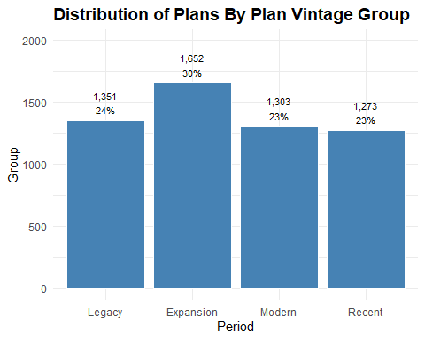
Given this distribution, where plan counts rise in the Expansion era and taper off in more recent vintages, we are dealing with a nonlinear, asymmetric pattern.

Business Code and Industry Title (BUSINESS_CODE, INDUSTRY_TITLE)
Business code refers to the six-digit code used to classify the primary business activity of the plan sponsor, based on the North American Industry Classification System (NAICS). It identifies the economic sector in which the sponsoring organization operates—such as manufacturing, healthcare, finance, or education. Industry title is the human-readable label associated with that code.
summary_by_industry_title <- plans %>%
group_by(INDUSTRY_TITLE) %>%
summarise(entries = n()) %>%
arrange(desc(entries)) %>%
mutate(percent = round(entries / sum(entries), 2))
kable(head(summary_by_industry_title, 20),
col.names = c("Industry", "Plans", "Percent"),
caption = "Summary By Industry Title - Top 20 Industries",
format.args = list(big.mark = ","),
align = c("l", "r", "r"))
Summary By Industry Title - Top 20 Industries
Industry | Plans | Percent
All other professional, scientific, and technical services | 190 | 0.03
Offices of physicians (except mental health specialists) | 186 | 0.03
New car dealers | 141 | 0.03
Offices of lawyers | 129 | 0.02
Management, scientific, and technical consulting services | 117 | 0.02
Other miscellaneous manufacturing | 108 | 0.02
Engineering services | 101 | 0.02
Other fabricated metal product manufacturing | 91 | 0.02
Offices of other holding companies | 86 | 0.02
Other computer related services | 77 | 0.01
Other specialty trade contractors | 77 | 0.01
Educational services | 76 | 0.01
Nursing and residential care facilities | 75 | 0.01
Commercial banking | 67 | 0.01
General freight trucking, long-distance | 66 | 0.01
Hospitals | 66 | 0.01
Plastics product manufacturing | 66 | 0.01
Nonresidential building construction | 64 | 0.01
Custom computer programming services | 60 | 0.01
Motor vehicle parts manufacturing | 56 | 0.01
Representation at the detailed industry title level is sparse. Most individual NAICS-derived titles contribute less than 0.03% of total plan filings, which suggests that modeling or benchmarking at this granularity may be noisy or unstable. A few industries dominate plan filings, while most contribute marginally. The detailed industry title field has many levels, but low support per level. Using these titles directly in models could lead to poor generalization unless grouped. Grouping into sectors addresses this sparcity.

Sector Code and Sector Title (SECTOR_CODE, SECTOR_TITLE, SECTOR_TITLE_SHORT)
Collapse to broader categories using existing business code structure and group industries into sectors.
business_codes <- readRDS("../data/business_codes.rds")
business_codes <- business_codes %>%
rename(SECTOR_CODE = BUSINESS_CODE,
SECTOR_TITLE = INDUSTRY_TITLE) %>%
mutate(SECTOR_TITLE_SHORT = stringr::str_trunc(SECTOR_TITLE, width = 15))
plans <- plans %>%
mutate(SECTOR_CODE = as.integer(substr(BUSINESS_CODE, 1, 2)) * 10000)
plans <- left_join(plans, business_codes, by = "SECTOR_CODE")
Check counts for reference level, find the median category by count, relevel and set the reference level.
sector_counts <- plans %>%
count(SECTOR_TITLE_SHORT, name = "n") %>%
arrange(n)
# Find the central category
central_sector <- sector_counts$SECTOR_TITLE_SHORT[ceiling(nrow(sector_counts) / 2)]
plans$SECTOR_TITLE_SHORT <- relevel(factor(plans$SECTOR_TITLE_SHORT), ref = "Information")
Summarize plans by sector.
summary_by_sector_title <- plans %>%
group_by(SECTOR_TITLE_SHORT) %>%
summarise(entries = n()) %>%
arrange(desc(entries)) %>%
mutate(percent = round(entries / sum(entries), 2))
kable(summary_by_sector_title,
col.names = c("Sector Title", "Plans", "Percent"),
caption = "Summary By Sector Title",
format.args = list(big.mark = ","),
align = c("l", "r", "r"))
Summary By Sector Title
Sector Title | Plans | Percent
Manufacturing | 1,237 | 0.22
Professional… | 918 | 0.16
Health care … | 594 | 0.11
Retail trade | 365 | 0.07
Construction | 352 | 0.06
Finance and … | 339 | 0.06
Wholesale trade | 329 | 0.06
Transportati… | 260 | 0.05
Administrati… | 187 | 0.03
Other servic… | 168 | 0.03
Information | 160 | 0.03
Real estate … | 149 | 0.03
Accommodatio… | 115 | 0.02
Management o… | 93 | 0.02
Educational … | 76 | 0.01
Arts, entert… | 73 | 0.01
Utilities | 61 | 0.01
Mining, quar… | 47 | 0.01
Agriculture,… | 46 | 0.01
Public admin… | 10 | 0.00
Sector grouping reveals strong concentration and long-tail sparcity. Just three sectors, Manufacturing, Professional Services, and Health Care, account for nearly half of all plans, while the bottom dozen sectors each contribute less than 3%. This uneven distribution suggests structural disparities in retirement plan availability, with some sectors historically underserved or slower to adopt.
Plot by sector title.
ggplot(summary_by_sector_title, aes(x = forcats::fct_reorder(SECTOR_TITLE_SHORT,
entries, .desc = TRUE), y = entries)) +
geom_col(fill = "steelblue", color = "white") +
geom_text(aes(label = paste0(scales::comma(entries), "\n", round(percent * 100, 0), "%")),
vjust = -0.3, size = 3.0) +
labs(title = "Distribution of Plans By Sector",
x = "Sector",
y = "Plans") +
theme_minimal() +
theme(axis.text.x = element_text(angle = 90, hjust = 0.5),
plot.title = element_text(size = 14, face = "bold")) +
expand_limits(y = max(summary_by_sector_title$entries) * 1.2)
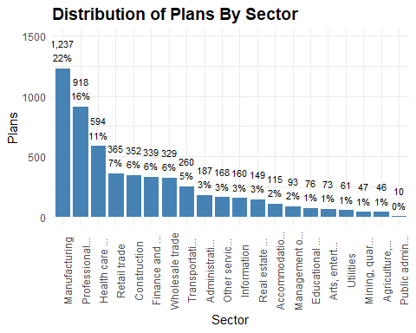
Given the high concentration in a few dominant sectors and the long tail of underrepresented sectors, the data over-represent high-density sectors and obscure structural disparities. A stratified sample can ensure equitable representation across sectors, especially those with low plan counts and improved diagnostic clarity when benchmarking adequacy.

Create Stratified Sample
# Step 1: Count plans by vintage-sector strata
strata_counts <- plans %>%
count(PLAN_VINTAGE_GROUP, SECTOR_TITLE_SHORT)
# Step 2: Define initial sample size per stratum (proportional with minimum floor)
strata_counts <- strata_counts %>%
mutate(sample_n = pmax(round(n / sum(n) * 5000), 5))
# Step 3: Compute total sample size per sector across vintages
sector_totals <- strata_counts %>%
group_by(SECTOR_TITLE_SHORT) %>%
summarise(sector_sample_total = sum(sample_n), .groups = "drop")
# Step 4: Set sector-level cap and compute scale factor
sector_cap <- 100 # Adjust this value as needed
sector_totals <- sector_totals %>%
mutate(scale_factor = pmin(1, sector_cap / sector_sample_total))
# Step 5: Apply scale factor to each stratum's sample size
strata_counts <- strata_counts %>%
left_join(sector_totals, by = "SECTOR_TITLE_SHORT") %>%
mutate(sample_n_capped = pmax(round(sample_n * scale_factor), 5))
# Step 6: Join capped sample sizes to full plan data
plans_joined <- plans %>%
inner_join(strata_counts %>%
select(PLAN_VINTAGE_GROUP, SECTOR_TITLE_SHORT, sample_n_capped),
by = c("PLAN_VINTAGE_GROUP", "SECTOR_TITLE_SHORT")) %>%
rename(sample_n = sample_n_capped)
# Step 7: Split into strata and sample per stratum
plans_split <- plans_joined %>%
group_split(PLAN_VINTAGE_GROUP, SECTOR_TITLE_SHORT)
plans_stratified <- purrr::map_dfr(plans_split, ~ slice_sample(.x, n = .x$sample_n[1]))
Check representation in the sample compared to the original distribution.
full_dist <- plans %>%
count(PLAN_VINTAGE_GROUP, SECTOR_TITLE_SHORT, name = "full_n")
sample_dist <- plans_stratified %>%
count(PLAN_VINTAGE_GROUP, SECTOR_TITLE_SHORT, name = "sample_n")
representation_check <- full_dist %>%
full_join(sample_dist, by = c("PLAN_VINTAGE_GROUP", "SECTOR_TITLE_SHORT")) %>%
mutate(
full_n = replace_na(full_n, 0),
sample_n = replace_na(sample_n, 0),
sample_share = sample_n / sum(sample_n),
full_share = full_n / sum(full_n),
ratio = sample_share / full_share
) %>%
arrange(desc(ratio))
This representation check provides a ratio that shows how well each sector-vintage stratum is represented in the stratified sample relative to its full share. Values near 1 indicate balanced representation, while ratios above 1 signal over-representation and those below 1 point to under-representation.
Plot the ratios.
ggplot(representation_check, aes(x = reorder(SECTOR_TITLE_SHORT, ratio), y = ratio, fill = PLAN_VINTAGE_GROUP)) +
geom_col(position = "dodge") +
geom_hline(yintercept = 1, linetype = "dashed", color = "gray40") +
labs(title = "Stratified Sample Representation by Sector and Vintage",
x = "Sector",
y = "Sample Share / Full Share (Ratio)",
fill = "Vintage Group") +
coord_flip() +
theme_minimal() +
theme(axis.text.x = element_text(angle = 0, hjust = 0.5),
plot.title = element_text(size = 14, face = "bold"))
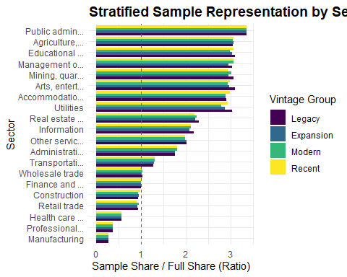
This plot confirms that the stratified sample was intentionally adjusted to reduce over-representation from dominant sectors. Lower sample-to-full ratios in sectors like Manufacturing and Professional Services reflect deliberate down-weighting, while ratios near 1 in sparse sectors preserve diagnostic signal. The result is a structurally balanced sample that supports fairness-aware modeling across both sector and vintage dimensions.
plans <- plans_stratified

Total Plan Assets (TOTAL_ASSETS_BOY, TOTAL_ASSETS_EOY)
These variables represent the total value of all plan assets held by the plan at the start and end of the plan year.
summary_by_plan_assets <- plans %>%
group_by(SECTOR_TITLE_SHORT) %>%
summarise(total_assets_boy = sum(TOTAL_ASSETS_BOY),
total_assets_eoy = sum(TOTAL_ASSETS_EOY))
kable(summary_by_plan_assets,
col.names = c("Sector", "BOY Assets", "EOY Assets"),
caption = "BOY and EOY Total Plan Assets By Sector",
format.args = list(big.mark = ","),
align = c("l", "r", "r"))
BOY and EOY Total Plan Assets By Sector
Sector | BOY Assets | EOY Assets
Information | 65,534,793,141 | 72,608,006,911
Accommodatio… | 13,613,782,600 | 15,919,691,489
Administrati… | 7,320,514,629 | 9,098,451,810
Agriculture,… | 4,285,382,257 | 4,811,732,376
Arts, entert… | 6,570,529,066 | 7,660,294,893
Construction | 2,370,614,744 | 2,961,334,388
Educational … | 7,417,167,983 | 8,790,708,778
Finance and … | 65,229,785,453 | 78,537,197,760
Health care … | 8,183,428,197 | 19,081,018,671
Management o… | 76,771,289,446 | 88,281,450,998
Manufacturing | 64,173,151,945 | 72,637,521,061
Mining, quar… | 8,040,769,510 | 9,277,992,234
Other servic… | 2,462,074,876 | 3,026,044,586
Professional… | 6,189,684,286 | 7,923,737,258
Public admin… | 208,619,022 | 248,932,490
Real estate … | 3,669,385,766 | 4,408,938,957
Retail trade | 37,269,451,121 | 43,585,942,601
Transportati… | 21,509,949,746 | 25,122,904,182
Utilities | 40,190,336,715 | 44,647,807,388
Wholesale trade | 8,036,302,329 | 9,446,241,032
Plot assets by sector.
assets_long <- summary_by_plan_assets %>%
pivot_longer(cols = c(total_assets_boy, total_assets_eoy),
names_to = "Asset_Type",
values_to = "Asset_Value")
ggplot(assets_long, aes(x = reorder(SECTOR_TITLE_SHORT, -Asset_Value),
y = Asset_Value / 1e9, fill = Asset_Type)) +
geom_bar(stat = "identity", position = "dodge") +
scale_fill_manual(values = c("total_assets_boy" = "steelblue", "total_assets_eoy" = "lightsteelblue"),
labels = c("total_assets_boy" = "Beginning of Year", "total_assets_eoy" = "End of Year")) +
labs(title = "BOY and EOY Total Plan Assets by Sector",
x = "Sector",
y = "Assets (Billions USD)",
fill = "Asset Type") +
theme_minimal() +
theme(axis.text.x = element_text(angle = 90, hjust = 0.5),
plot.title = element_text(size = 14, face = "bold"))
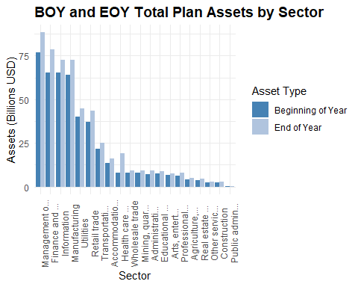
The plot reveals substantial variation in asset magnitude and growth across the economic landscape.
Manufacturing leads with the highest asset levels, maintaining its dominance from BOY to EOY, suggesting strong plan stability or growth. Finance and Insurance, Health Care, and Professional Services also show robust asset volumes, reinforcing their structural weight in the retirement ecosystem.
In contrast, sectors like Public Administration, Agriculture, and Arts & Entertainment exhibit significantly lower asset totals, underscoring potential disparities in plan availability or funding adequacy. The dual-bar format highlights year-over-year changes, with most sectors showing modest asset growth—though the magnitude varies.
This visualization is particularly valuable for stakeholders seeking to understand sector-level disparities, benchmark asset performance, and identify areas where retirement plan adequacy may be structurally constrained. It sets the stage for deeper diagnostics, such as growth rate overlays, adequacy tiering, or fairness-aware benchmarking.

Total Assets Growth Rate (TOTAL_ASSETS_GROWTH_RATE)
Create a growth rate and assets per participant for each plan.
plans <- plans %>%
mutate(TOTAL_ASSETS_GROWTH_RATE = round((TOTAL_ASSETS_EOY - TOTAL_ASSETS_BOY) / TOTAL_ASSETS_BOY, 4))
Produce a density plot to show the distribution of asset growth rates.
Two plans are outliers with 1708% and 1364% growth rates, which distort the overall distribution. I exclude the outliers in the following plot.
ggplot(plans, aes(x = TOTAL_ASSETS_GROWTH_RATE)) +
geom_density(fill = "steelblue", alpha = 0.6) +
scale_y_continuous(labels = scales::percent_format(scale = 1, accuracy = 0.1)) +
geom_vline(xintercept = 0, linetype = "dashed", color = "gray40") +
labs(title = "Density of Total Assets Growth Rates (Excluding Outliers)",
x = "Growth Rate",
y = "Density (%)") +
theme_minimal() +
theme(axis.text.x = element_text(angle = 0, hjust = 0.5),
plot.title = element_text(size = 14, face = "bold"))
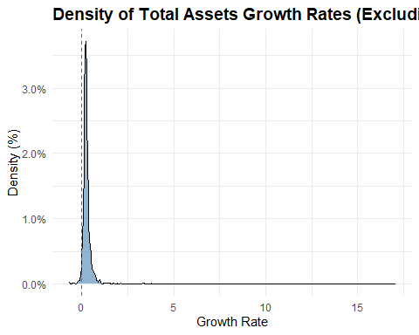
Most plans have modest or stagnant asset growth, likely reflecting market conditions, contribution behavior, or plan maturity.
The right skew suggests a subset of plans with strong growth, possibly due to rollovers, mergers, or aggressive investment strategies.
The sharp peak near zero could indicate structural inertia, plans that are underfunded, inactive, or not receiving contributions.
Create a ridgeline plot by sector.
ggplot(plans, aes(x = TOTAL_ASSETS_GROWTH_RATE, y = SECTOR_TITLE_SHORT)) +
geom_density_ridges(bandwidth = 0.05, fill = "steelblue", alpha = 0.6) +
labs(title = "Density of Total Assets Growth Rates (Excluding Outliers) by Sector",
x = "Growth Rate",
y = "Sector") +
theme_minimal() +
theme(axis.text.x = element_text(angle = 0, hjust = 0.5),
plot.title = element_text(size = 14, face = "bold"))
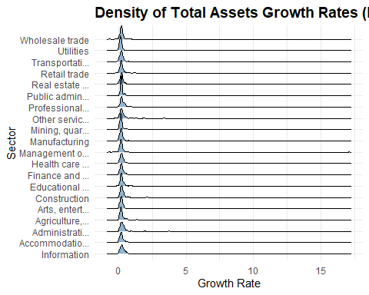
Most sectors cluster near zero; the sharp density around zero suggests widespread stagnation or minimal growth, possibly reflecting low contributions, market flatness, or plan maturity.
Right-skewed tails in sectors like Finance and Insurance, Real Estate, and Professional Services hint at pockets of aggressive growth, likely driven by rollovers, mergers, or high-income participant behavior.
Public sector plans (e.g. Educational Services, Health Care, Public Administration) show tighter distributions, possibly due to more regulated funding structures or consistent employer contributions.
Volatile sectors like Construction, Arts, and Accommodation show broader spread, likely reflecting economic sensitivity and participant turnover.

Total Assets Growth Tier (TOTAL_ASSETS_GROWTH_TIER)
Create assets per participant tier labels.
plans <- plans %>%
mutate(
TOTAL_ASSETS_GROWTH_TIER = case_when(
TOTAL_ASSETS_GROWTH_RATE > 0.25 ~ "High",
TOTAL_ASSETS_GROWTH_RATE < 0.125 ~ "Negative",
TRUE ~ "Typical"),
TOTAL_ASSETS_GROWTH_TIER = factor(TOTAL_ASSETS_GROWTH_TIER,
levels = c("Negative", "Typical", "High"),
ordered = TRUE))
Plot density by tier.
summary_by_total_assets_growth_tier <- plans %>%
group_by(TOTAL_ASSETS_GROWTH_TIER) %>%
summarise(entries = n()) %>%
mutate(percent = round(entries / sum(entries), 2))
ggplot(summary_by_total_assets_growth_tier, aes(x = TOTAL_ASSETS_GROWTH_TIER, y = entries)) +
geom_col(fill = "steelblue", color = "white") +
geom_text(aes(label = paste0(scales::comma(entries), "\n", round(percent * 100, 0), "%")),
vjust = -0.3, size = 3.0) +
labs(title = "Distribution of Plans By Total Assets Growth Tier",
x = "Tier",
y = "Plans") +
theme_minimal() +
theme(axis.text.x = element_text(angle = 0, hjust = 0.5),
plot.title = element_text(size = 14, face = "bold")) +
expand_limits(y = max(summary_by_total_assets_growth_tier$entries) * 1.2)
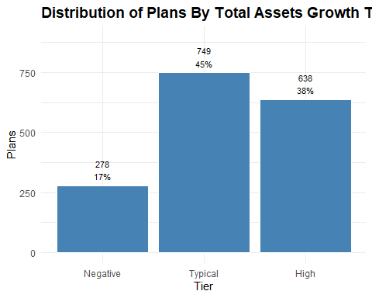

Assets Per Participant (ASSETS_PER_PARTCP)
Engineer an assets per participant variable.
plans <- plans %>%
mutate(ASSETS_PER_PARTCP = round(TOTAL_ASSETS_EOY / TOTAL_ACCBAL_PARTCP_EOY, 0))
Plot assets per participant.
ggplot(plans, aes(x = ASSETS_PER_PARTCP)) +
geom_density(fill = "steelblue", alpha = 0.6) +
geom_vline(xintercept = mean(plans$ASSETS_PER_PARTCP, na.rm = TRUE),
linetype = "dashed", color = "darkred") +
scale_y_continuous(labels = scales::percent_format(scale = 1, accuracy = 0.00001)) +
scale_x_continuous(labels = scales::comma) +
labs(title = "Density of Assets per Participant (Excluding Outliers)",
x = "Assets Per Participant",
y = "Density (%)") +
theme_minimal() +
theme(axis.text.x = element_text(angle = 0, hjust = 0.5),
plot.title = element_text(size = 14, face = "bold"))
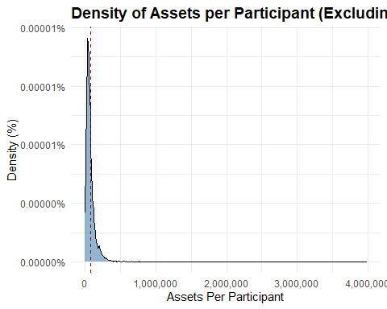
That sharp peak near the lower end, followed by a long right tail, suggests most plans cluster around $50,000 per participant with a mean of approximately $80,000.
Plot the log-transformed distribution to reveal structure in the lower range.
ggplot(plans, aes(x = log1p(ASSETS_PER_PARTCP))) +
geom_density(fill = "steelblue", alpha = 0.6) +
scale_y_continuous(labels = scales::percent_format(accuracy = 0.1)) +
scale_x_continuous(labels = scales::comma) +
labs(title = "Log-Scaled Density of Assets Per Participant",
x = "log(Assets + 1)",
y = "Density (%)") +
theme_minimal() +
theme(axis.text.x = element_text(angle = 0, hjust = 0.5),
plot.title = element_text(size = 14, face = "bold"))
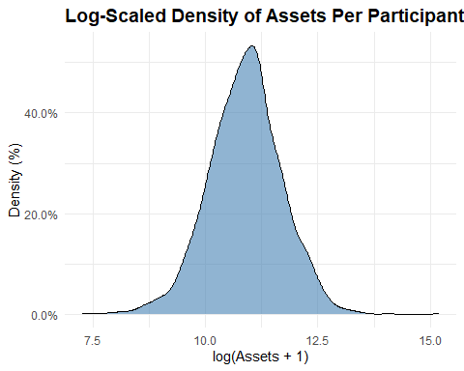
Most plans are far below the mean: The log transformation shows that the bulk of plans cluster near $59,000.

Assets Per Participant Tier (ASSETS_PER_PARTCP_TIER)
Create assets per participant tier labels.
plans <- plans %>%
mutate(
ASSETS_PER_PARTCP_TIER = case_when(
ASSETS_PER_PARTCP < 50000 ~ "Low",
ASSETS_PER_PARTCP >= 50000 & ASSETS_PER_PARTCP < 100000 ~ "Moderate",
ASSETS_PER_PARTCP >= 100000 ~ "High",
TRUE ~ NA_character_),
ASSETS_PER_PARTCP_TIER = factor(ASSETS_PER_PARTCP_TIER,
levels = c("Low", "Moderate", "High"),
ordered = TRUE))
Plot density by tier.
summary_by_assets_per_partcp_tier <- plans %>%
group_by(ASSETS_PER_PARTCP_TIER) %>%
summarise(entries = n()) %>%
mutate(percent = round(entries / sum(entries), 2))
ggplot(summary_by_assets_per_partcp_tier, aes(x = ASSETS_PER_PARTCP_TIER, y = entries)) +
geom_col(fill = "steelblue", color = "white") +
geom_text(aes(label = paste0(scales::comma(entries), "\n", round(percent * 100, 0), "%")),
vjust = -0.3, size = 3.0) +
labs(title = "Distribution of Plans By Assets Per Participant Tier",
x = "Tier",
y = "Plans") +
theme_minimal() +
theme(axis.text.x = element_text(angle = 0, hjust = 0.5),
plot.title = element_text(size = 14, face = "bold")) +
expand_limits(y = max(summary_by_assets_per_partcp_tier$entries) * 1.2)
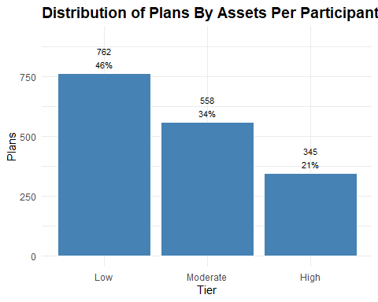
The distribution of plans by assets per participant reveals a clear skew toward lower tiers. Over 40% of plans fall into the “Low” category, while just 23% qualify as “High.” This suggests that most plans operate with relatively modest asset levels per participant, which may reflect sector constraints, legacy plan structures, or limited growth. The “Moderate” tier, at 36%, anchors the middle ground but still trails the low tier. Overall, the distribution highlights a long tail of undercapitalized plans and reinforces the need for adequacy diagnostics and tier-aware benchmarking.

Total Participants with Account Balances (TOTAL_ACCBAL_PARTCP_BOY, TOTAL_ACCBAL_PARTCP_EOY)
These variables provide the number of active participants in the plan with account balances as of the start and end of the reporting year. These variables reflect the current plan participation footprint.
summary_by_accbal_participants <- plans %>%
group_by(SECTOR_TITLE_SHORT) %>%
summarise(total_active_boy = sum(TOTAL_ACCBAL_PARTCP_BOY),
total_active_eoy = sum(TOTAL_ACCBAL_PARTCP_EOY))
kable(summary_by_accbal_participants,
col.names = c("Sector", "BOY Participants", "EOY Participants"),
caption = "BOY and EOY Total Active Participants By Sector",
format.args = list(big.mark = ","),
align = c("l", "r", "r"))
BOY and EOY Total Active Participants By Sector
Sector | BOY Participants | EOY Participants
Information | 508,771 | 494,784
Accommodatio… | 318,764 | 341,148
Administrati… | 147,326 | 158,291
Agriculture,… | 92,478 | 94,444
Arts, entert… | 126,304 | 131,704
Construction | 54,036 | 56,598
Educational … | 66,552 | 69,781
Finance and … | 560,250 | 574,948
Health care … | 148,464 | 227,757
Management o… | 543,829 | 524,978
Manufacturing | 365,268 | 371,413
Mining, quar… | 72,800 | 73,031
Other servic… | 64,069 | 68,657
Professional… | 92,214 | 96,224
Public admin… | 5,571 | 6,181
Real estate … | 72,112 | 76,931
Retail trade | 630,616 | 645,515
Transportati… | 331,547 | 330,120
Utilities | 213,123 | 214,522
Wholesale trade | 107,955 | 111,562
Plot active participants by sector.
active_long <- summary_by_accbal_participants %>%
pivot_longer(cols = c(total_active_boy, total_active_eoy),
names_to = "Active_Type",
values_to = "Active_Value")
ggplot(active_long, aes(x = reorder(SECTOR_TITLE_SHORT, -Active_Value), y = Active_Value / 1e9, fill = Active_Type)) +
geom_bar(stat = "identity", position = "dodge") +
scale_fill_manual(values = c("total_active_boy" = "steelblue", "total_active_eoy" = "lightsteelblue"),
labels = c("total_active_boy" = "Beginning of Year", "total_active_eoy" = "End of Year")) +
labs(title = "BOY and EOY Total Active Participants by Sector",
x = "Sector",
y = "Active Participants",
fill = "Active Type") +
theme_minimal() +
theme(axis.text.x = element_text(angle = 90, hjust = 0.5),
plot.title = element_text(size = 14, face = "bold"))
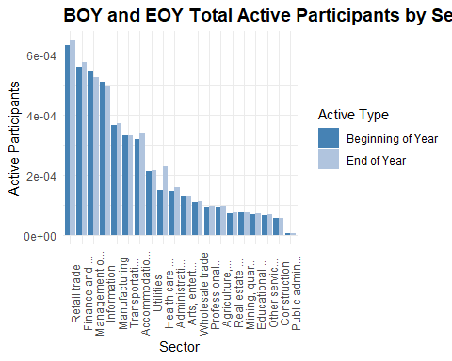
Manufacturing, Healthcare, and Professional Services again dominate in participant volume, mirroring their asset dominance. Sectors like Retail, Accommodation, and Arts show modest participant counts despite being labor-intensive, which may signal structural under-coverage.
The EOY bars generally exceed BOY, suggesting net growth in active participation, but the magnitude varies by sector.

Participant Growth Rate (PARTCP_GROWTH_RATE)
Engineer participant growth rate at the plan level.
plans <- plans %>%
mutate(PARTCP_GROWTH_RATE = round((TOTAL_ACCBAL_PARTCP_EOY - TOTAL_ACCBAL_PARTCP_BOY) / TOTAL_ACCBAL_PARTCP_BOY, 4))
Produce a density plot to show the distribution of participant growth rates.
ggplot(plans, aes(x = PARTCP_GROWTH_RATE)) +
geom_density(fill = "steelblue", alpha = 0.6) +
geom_vline(xintercept = 0, linetype = "dashed", color = "gray40") +
labs(title = "Density of Participant Growth Rates (Excluding Outliers)",
x = "Growth Rate",
y = "Density (%)") +
theme_minimal() +
theme(axis.text.x = element_text(angle = 0, hjust = 0.5),
plot.title = element_text(size = 14, face = "bold"))
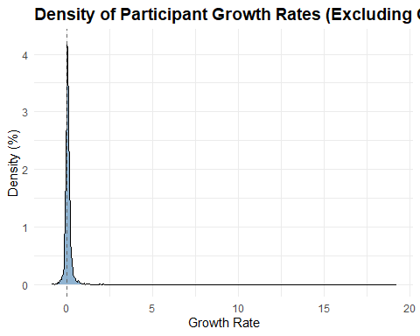
Create a ridgeline plot by sector.
ggplot(plans, aes(x = PARTCP_GROWTH_RATE, y = SECTOR_TITLE_SHORT)) +
geom_density_ridges(bandwidth = 0.05, fill = "steelblue", alpha = 0.6) +
labs(title = "Participant Growth Rate by Sector (≤ 100)",
x = "Growth Rate",
y = "Sector") +
theme_minimal() +
theme(axis.text.x = element_text(angle = 0, hjust = 0.5),
plot.title = element_text(size = 14, face = "bold"))
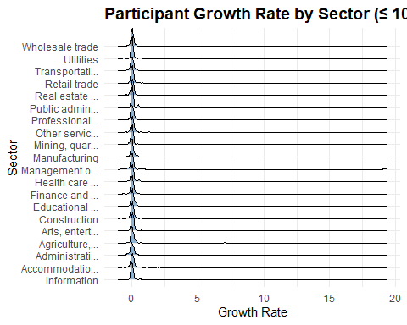
Most sectors seem tightly clustered near zero, and the horizontal scale compresses variation, making it hard to distinguish meaningful outliers or trends.

Participant Growth Rate Tier (PARTCP_GROWTH_TIER)
Create a participant growth tier flag to delineate between negative, typical, and high growth plans.
plans <- plans%>%
mutate(PARTCP_GROWTH_TIER = case_when(PARTCP_GROWTH_RATE > 0.05 ~ "High",
PARTCP_GROWTH_RATE < -0.05 ~ "Negative",
TRUE ~ "Typical"),
PARTCP_GROWTH_TIER = factor(PARTCP_GROWTH_TIER,
levels = c("Negative", "Typical", "High"),
ordered = TRUE))
Plot participant growth rates by sector with the growth tiers.
summary_by_partcp_growth_tier <- plans %>%
group_by(PARTCP_GROWTH_TIER) %>%
summarise(entries = n()) %>%
mutate(percent = round(entries / sum(entries), 2))
ggplot(summary_by_partcp_growth_tier, aes(x = PARTCP_GROWTH_TIER, y = entries)) +
geom_col(fill = "steelblue", color = "white") +
geom_text(aes(label = paste0(scales::comma(entries), "\n", round(percent * 100, 0), "%")),
vjust = -0.3, size = 3.0) +
labs(title = "Distribution of Plans By Participant Growth Tier",
x = "Tier",
y = "Plans") +
theme_minimal() +
theme(axis.text.x = element_text(angle = 0, hjust = 0.5),
plot.title = element_text(size = 14, face = "bold")) +
expand_limits(y = max(summary_by_partcp_growth_tier$entries) * 1.2)
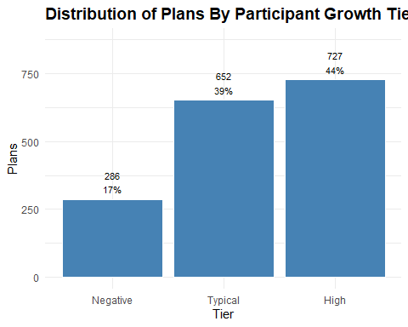
Participant growth rates vary meaningfully across sectors, and the flagged outliers, e.g. Manufacturing with high growth, Information with negative growth, suggest real economic or policy implications.

Total Participant Contributions (TOTAL_CONTRIB_PARTCP_BOY, TOTAL_CONTRIB_PARTCP_EOY)
These variables capture the total dollar amount of participant contributions on record as of the start and end of the reporting year. The first reflects contributions made prior to the current plan year but still held in the plan. This is useful for understanding carryover balances or prior-year contribution momentum.
The latter includes all contributions made by participants during the year, plus any prior balances still retained. It is often used to assess current-year contribution activity and participant engagement.
summary_by_partcp_contributions <- plans %>%
group_by(SECTOR_TITLE_SHORT) %>%
summarise(total_contrib_boy = sum(TOTAL_CONTRIB_PARTCP_BOY),
total_contrib_eoy = sum(TOTAL_CONTRIB_PARTCP_EOY),
.groups = "drop")
kable(summary_by_partcp_contributions,
col.names = c("Sector", "BOY Contributions", "EOY Contributions"),
caption = "BOY and EOY Total Contributions By Sector",
format.args = list(big.mark = ","),
align = c("l", "r", "r"))
BOY and EOY Total Contributions By Sector
Sector | BOY Contributions | EOY Contributions
Information | 55,990,071 | 57,817,833
Accommodatio… | 9,927,964 | 12,962,050
Administrati… | 7,956,910 | 9,119,044
Agriculture,… | 8,418,890 | 7,820,905
Arts, entert… | 9,060,389 | 11,513,722
Construction | 3,760,407 | 4,432,707
Educational … | 4,105,683 | 5,568,272
Finance and … | 76,115,859 | 90,814,526
Health care … | 18,120,380 | 27,808,515
Management o… | 57,734,188 | 64,295,285
Manufacturing | 31,737,298 | 36,074,522
Mining, quar… | 7,864,482 | 11,739,968
Other servic… | 4,676,396 | 5,331,496
Professional… | 13,401,550 | 13,812,961
Public admin… | 515,954 | 379,164
Real estate … | 6,326,524 | 6,178,876
Retail trade | 56,479,761 | 60,079,516
Transportati… | 18,713,364 | 18,427,695
Utilities | 32,796,557 | 37,283,644
Wholesale trade | 9,831,703 | 9,790,787
Plot contributions by sector.
contributions_long <- summary_by_partcp_contributions %>%
pivot_longer(cols = c(total_contrib_boy, total_contrib_eoy),
names_to = "Contribution_Type",
values_to = "Contribution_Value")
ggplot(contributions_long, aes(x = reorder(SECTOR_TITLE_SHORT, -Contribution_Value), y = Contribution_Value / 1e9, fill = Contribution_Type)) +
geom_bar(stat = "identity", position = "dodge") +
scale_fill_manual(values = c("total_contrib_boy" = "steelblue", "total_contrib_eoy" = "lightsteelblue"),
labels = c("total_contrib_boy" = "Beginning of Year", "total_contrib_eoy" = "End of Year")) +
labs(title = "BOY and EOY Total Contributions by Sector",
x = "Sector",
y = "Contributions",
fill = "Contribution Type") +
theme_minimal() +
theme(axis.text.x = element_text(angle = 90, hjust = 0.5),
plot.title = element_text(size = 14, face = "bold"))
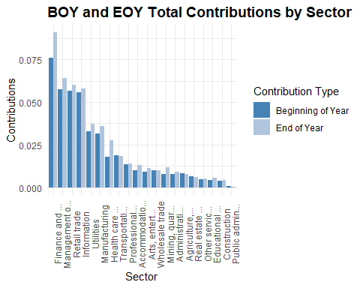
Manufacturing, Professional Services, and Hotels & Restaurants lead in total contributions, echoing their asset and participant dominance.
The EOY bars generally exceed BOY, suggesting net contribution inflows, but the magnitude and slope vary by sector.
Sectors like Information and Mining show relatively flat or modest contribution growth, which may flag under-engagement or structural constraints

Participant Contribution Growth Rate (CONTRIB_PARTCP_GROWTH_RATE)
Engineer a contribution growth rate at the plan level.
plans <- plans %>%
mutate(CONTRIB_PARTCP_GROWTH_RATE = round((TOTAL_CONTRIB_PARTCP_EOY - TOTAL_CONTRIB_PARTCP_BOY) / TOTAL_CONTRIB_PARTCP_BOY, 4))
Produce a density plot to show the distribution of contribution growth rates.
One plan with a participant growth rate of 299% is a serious outlier and distorting the overall distribution. I exclude the outlier in the following plot.
ggplot(plans, aes(x = CONTRIB_PARTCP_GROWTH_RATE)) +
geom_density(fill = "steelblue", alpha = 0.6) +
geom_vline(xintercept = 0, linetype = "dashed", color = "gray40") +
labs(title = "Density of Contribution Growth Rates",
x = "Growth Rate",
y = "Density") +
theme_minimal() +
theme(axis.text.x = element_text(angle = 0, hjust = 0.5),
plot.title = element_text(size = 14, face = "bold"))
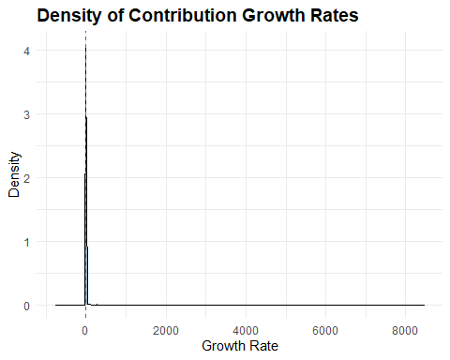
Create a ridgeline plot by sector.
ggplot(plans, aes(x = CONTRIB_PARTCP_GROWTH_RATE, y = SECTOR_TITLE_SHORT)) +
geom_density_ridges(bandwidth = 0.05, fill = "steelblue", alpha = 0.6) +
labs(title = "Contribution Growth Rate by Sector",
x = "Growth Rate",
y = "Sector") +
theme_minimal() +
theme(axis.text.x = element_text(angle = 0, hjust = 0.5),
plot.title = element_text(size = 14, face = "bold"))
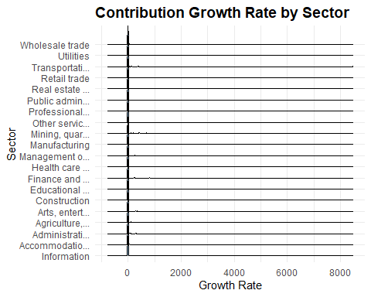
Most sectors seem tightly clustered near zero, and the horizontal scale compresses variation, making it hard to distinguish meaningful outliers or trends.

Participant Contribution Growth Tier (CONTRIB_PARTCP_GROWTH_TIER)
Create a contribution growth rate tier to delineate between negative, typical, and high growth plans.
plans <- plans%>%
mutate(CONTRIB_PARTCP_GROWTH_TIER = case_when(CONTRIB_PARTCP_GROWTH_RATE > 0.10 ~ "High",
CONTRIB_PARTCP_GROWTH_RATE < -0.10 ~ "Negative",
TRUE ~ "Typical"),
CONTRIB_PARTCP_GROWTH_TIER = factor(CONTRIB_PARTCP_GROWTH_TIER,
levels = c("Negative", "Typical", "High"),
ordered = TRUE))
Plot contribution growth tiers by sector with the growth flags.
summary_by_contrib_partcp_growth_tier <- plans %>%
group_by(CONTRIB_PARTCP_GROWTH_TIER) %>%
summarise(entries = n()) %>%
mutate(percent = round(entries / sum(entries), 2))
ggplot(summary_by_contrib_partcp_growth_tier, aes(x = CONTRIB_PARTCP_GROWTH_TIER, y = entries)) +
geom_col(fill = "steelblue", color = "white") +
geom_text(aes(label = paste0(scales::comma(entries), "\n", round(percent * 100, 0), "%")),
vjust = -0.3, size = 3.0) +
labs(title = "Distribution of Plans By Participant Contribution Growth Tier",
x = "Tier",
y = "Plans") +
theme_minimal() +
theme(axis.text.x = element_text(angle = 0, hjust = 0.5),
plot.title = element_text(size = 14, face = "bold")) +
expand_limits(y = max(summary_by_contrib_partcp_growth_tier$entries) * 1.2)
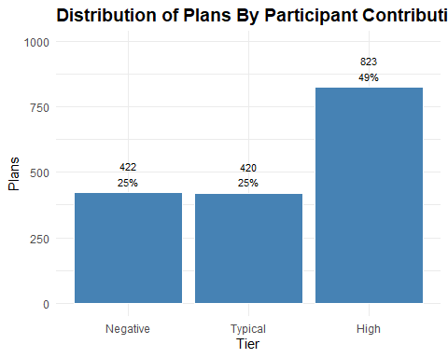
Transportation and warehousing, Mining, and Healthcare show strong contribution growth—suggesting active funding and participant engagement.
Information and Arts & Entertainment show negative growth, which could signal stagnation, plan attrition, or structural undercoverage.

Employer Contributions (TOTAL_CONTRIB_EMPLR_BOY, TOTAL_CONTRIB_EMPLR_EOY)
These variables represent the total dollar amount of employer contributions on record as of the start and end of the reporting year. They include contributions made during the year plus any retained prior balances and are often used to assess current-year employer funding and plan support.
summary_er_contributions <- plans %>%
group_by(SECTOR_TITLE_SHORT) %>%
summarise(total_contrib_boy = sum(TOTAL_CONTRIB_EMPLR_BOY),
total_contrib_eoy = sum(TOTAL_CONTRIB_EMPLR_EOY),
.groups = "drop")
kable(summary_er_contributions,
col.names = c("Sector", "BOY Contributions", "EOY Contributions"),
caption = "BOY and EOY Total Employer Contributions By Sector",
format.args = list(big.mark = ","),
align = c("l", "r", "r"))
BOY and EOY Total Employer Contributions By Sector
Sector | BOY Contributions | EOY Contributions
Information | 74,581,065 | 72,880,273
Accommodatio… | 69,053,026 | 81,336,258
Administrati… | 32,400,821 | 42,448,156
Agriculture,… | 13,676,693 | 13,968,196
Arts, entert… | 55,200,408 | 61,760,889
Construction | 26,867,087 | 29,565,237
Educational … | 10,724,705 | 12,207,158
Finance and … | 1,099,891,543 | 1,257,154,266
Health care … | 114,490,164 | 126,018,454
Management o… | 573,025,541 | 603,461,959
Manufacturing | 244,416,301 | 329,723,770
Mining, quar… | 41,255,704 | 55,106,943
Other servic… | 17,048,434 | 17,652,745
Professional… | 58,318,226 | 72,958,632
Public admin… | 287,607 | 316,815
Real estate … | 9,347,926 | 8,756,191
Retail trade | 145,855,388 | 137,151,858
Transportati… | 186,300,460 | 586,171,589
Utilities | 181,304,954 | 201,915,719
Wholesale trade | 88,910,086 | 92,489,313
Plot contributions by sector.
er_contributions_long <- summary_er_contributions %>%
pivot_longer(cols = c(total_contrib_boy, total_contrib_eoy),
names_to = "Contribution_Type",
values_to = "Contribution_Value")
ggplot(er_contributions_long, aes(x = reorder(SECTOR_TITLE_SHORT, -Contribution_Value), y = Contribution_Value / 1e9, fill = Contribution_Type)) +
geom_bar(stat = "identity", position = "dodge") +
scale_fill_manual(values = c("total_contrib_boy" = "steelblue", "total_contrib_eoy" = "lightsteelblue"),
labels = c("total_contrib_boy" = "Beginning of Year", "total_contrib_eoy" = "End of Year")) +
labs(title = "BOY and EOY Total Employer Contributions by Sector",
x = "Sector",
y = "Contributions",
fill = "Contribution Type") +
theme_minimal() +
theme(axis.text.x = element_text(angle = 90, hjust = 0.5),
plot.title = element_text(size = 14, face = "bold"))
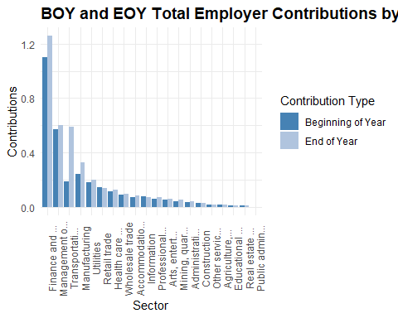
Health care, Manufacturing, and Professional Services lead in employer contributions at both BOY and EOY, suggesting sustained institutional support.
The EOY bars generally exceed BOY, indicating net inflows, but the slope varies by sector. Some sectors show flat or modest growth, which may flag underfunding or stagnation.
Sectors like Arts & Entertainment, Accommodation, and Administrative Support show relatively low employer contributions, which could signal structural gaps in plan generosity.

Employer Contribution Growth Rate (CONTRIB_EMPLR_GROWTH_RATE)
Engineer a contribution growth rate at the plan level.
plans <- plans %>%
mutate(CONTRIB_EMPLR_GROWTH_RATE = round((TOTAL_CONTRIB_EMPLR_EOY - TOTAL_CONTRIB_EMPLR_BOY) / TOTAL_CONTRIB_EMPLR_BOY, 4))
Produce a density plot to show the distribution of contribution growth rates.
ggplot(plans, aes(x = CONTRIB_EMPLR_GROWTH_RATE)) +
geom_density(fill = "steelblue", alpha = 0.6) +
geom_vline(xintercept = 0, linetype = "dashed", color = "gray40") +
labs(title = "Density of Employer Contribution Growth Rates",
x = "Growth Rate",
y = "Density") +
theme_minimal() +
theme(axis.text.x = element_text(angle = 90, hjust = 0.5),
plot.title = element_text(size = 14, face = "bold"))
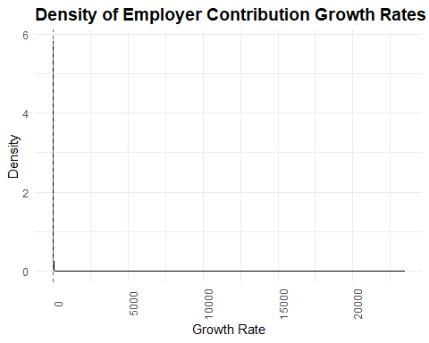
Create a ridgeline plot by sector.
plans %>%
ggplot(aes(x = CONTRIB_EMPLR_GROWTH_RATE, y = SECTOR_TITLE_SHORT)) +
geom_density_ridges(bandwidth = 0.05, fill = "steelblue", alpha = 0.6) +
labs(title = "Employer Contribution Growth Rate by Sector",
x = "Growth Rate",
y = "Sector") +
theme_minimal() +
theme(axis.text.x = element_text(angle = 90, hjust = 0.5),
plot.title = element_text(size = 14, face = "bold"))
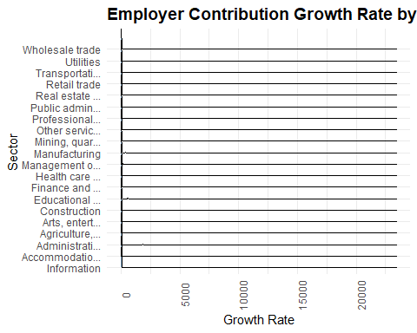
Most sectors seem tightly clustered near zero, and the horizontal scale compresses variation, making it hard to distinguish meaningful outliers or trends.

Employer Contribution Growth Tier (CONTRIB_EMPLR_GROWTH_TIER)
Create an employer contribution growth rate flag to delineate between negative, typical, and high growth plans.
plans <- plans%>%
mutate(CONTRIB_EMPLR_GROWTH_TIER = case_when(CONTRIB_EMPLR_GROWTH_RATE > 0.10 ~ "High",
CONTRIB_EMPLR_GROWTH_RATE < -0.10 ~ "Negative",
TRUE ~ "Typical"),
CONTRIB_EMPLR_GROWTH_TIER = factor(CONTRIB_EMPLR_GROWTH_TIER,
levels = c("Negative", "Typical", "High"),
ordered = TRUE))
Plot contribution growth rates by sector with the growth flags.
summary_by_contrib_emplr_growth_tier <- plans %>%
group_by(CONTRIB_EMPLR_GROWTH_TIER) %>%
summarise(entries = n()) %>%
mutate(percent = round(entries / sum(entries), 2))
ggplot(summary_by_contrib_emplr_growth_tier, aes(x = CONTRIB_EMPLR_GROWTH_TIER, y = entries)) +
geom_col(fill = "steelblue", color = "white") +
geom_text(aes(label = paste0(scales::comma(entries), "\n", round(percent * 100, 0), "%")),
vjust = -0.3, size = 3.0) +
labs(title = "Distribution of Plans By Employer Contribution Growth Tier",
x = "Tier",
y = "Plans") +
theme_minimal() +
theme(axis.text.x = element_text(angle = 0, hjust = 0.5),
plot.title = element_text(size = 14, face = "bold")) +
expand_limits(y = max(summary_by_contrib_emplr_growth_tier$entries) * 1.2)
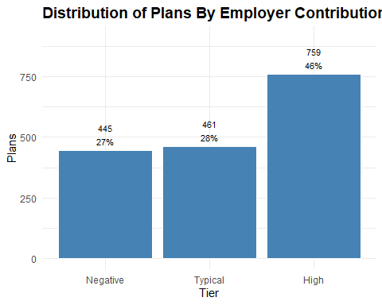
Transportation and warehousing stands out with exceptional growth—this could reflect increased employer investment, plan expansion, or policy shifts.
Educational services and Wholesale trade also show strong growth, which may signal rising institutional support in traditionally underfunded sectors.
Several sectors show negative growth (e.g., Information, Arts & Entertainment), which could indicate declining employer engagement, plan attrition, or funding retraction.

Participant Loans (TOTAL_LOANS_BOY, TOTAL_LOANS_EOY)
These fields reflect the aggregate amount participants have borrowed from their retirement accounts and not yet repaid. Loans are typically allowed under 401(k) and some 403(b) plans, subject to IRS limits (usually up to $50,000 or 50% of vested account balance).
Comparing BOY vs. EOY values helps surface net borrowing or repayment trends. A rising EOY balance may signal increased participant financial stress or plan leniency.
High loan balances can erode retirement adequacy. Plans with high loan-to-asset ratios or frequent borrowing as needing closer scrutiny.
summary_loans <- plans %>%
group_by(SECTOR_TITLE_SHORT) %>%
summarise(total_loans_boy = sum(TOTAL_LOANS_BOY),
total_loans_eoy = sum(TOTAL_LOANS_EOY),
.groups = "drop")
kable(summary_loans,
col.names = c("Sector", "BOY Loans", "EOY Loans"),
caption = "BOY and EOY Total Loan Balances By Sector",
format.args = list(big.mark = ","),
align = c("l", "r", "r"))
BOY and EOY Total Loan Balances By Sector
Sector | BOY Loans | EOY Loans
Information | 997,952,478 | 1,000,260,368
Accommodatio… | 204,887,822 | 230,129,335
Administrati… | 195,976,358 | 227,592,675
Agriculture,… | 209,918,022 | 224,232,193
Arts, entert… | 141,333,273 | 154,885,114
Construction | 50,007,279 | 61,271,927
Educational … | 39,168,514 | 43,753,065
Finance and … | 834,087,487 | 917,171,954
Health care … | 119,912,522 | 226,271,641
Management o… | 1,017,735,465 | 1,098,510,003
Manufacturing | 596,114,183 | 650,539,852
Mining, quar… | 135,938,781 | 152,349,671
Other servic… | 53,560,972 | 59,655,416
Professional… | 46,932,221 | 54,139,194
Public admin… | 7,827,536 | 9,157,545
Real estate … | 72,922,831 | 81,183,241
Retail trade | 657,639,997 | 716,138,103
Transportati… | 273,135,742 | 298,767,155
Utilities | 572,113,370 | 587,746,022
Wholesale trade | 119,144,605 | 133,367,397
Plot loans by sector.
er_loans_long <- summary_loans %>%
pivot_longer(cols = c(total_loans_boy, total_loans_eoy),
names_to = "Loan_Type",
values_to = "Loan_Value")
ggplot(er_loans_long, aes(x = reorder(SECTOR_TITLE_SHORT, -Loan_Value), y = Loan_Value, fill = Loan_Type)) +
geom_bar(stat = "identity", position = "dodge") +
scale_fill_manual(values = c("total_loans_boy" = "steelblue", "total_loans_eoy" = "lightsteelblue"),
labels = c("total_loans_boy" = "Beginning of Year", "total_loans_eoy" = "End of Year")) +
labs(title = "BOY and EOY Total Loan Balances by Sector",
x = "Sector",
y = "Loans",
fill = "Loan Type") +
theme_minimal() +
theme(axis.text.x = element_text(angle = 90, hjust = 0.5),
plot.title = element_text(size = 14, face = "bold"))
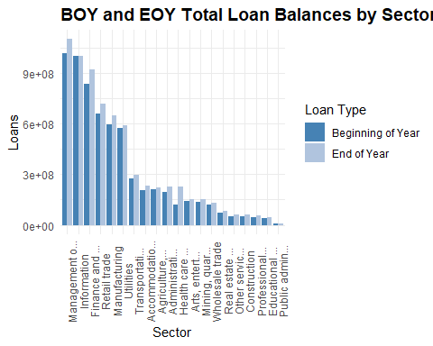
Loan balances are rising in most sectors.
The light blue EOY bars often exceed the dark blue BOY bars, suggesting net borrowing across the year. That’s a potential red flag for participant liquidity strain or plan leniency.
Manufacturing and Health Care lead in total loan volume. These sectors show the highest absolute balances—likely due to large participant bases and higher plan penetration. But it also raises questions about adequacy erosion and fallback logic.
Professional and Technical Services show modest growth. Possibly reflecting more conservative borrowing behavior or stronger financial wellness programs.
Church and public sectors (e.g., Educational Services, Public Administration) show lower balances. This aligns with structural plan constraints—403(b)(9) and some 403(b)(1) plans often restrict loans or discourage borrowing.

Loan Leakage Ratio (LOAN_LEAKAGE_RATIO)
plans <- plans %>%
mutate(LOAN_LEAKAGE_RATIO = round(TOTAL_LOANS_EOY / TOTAL_ASSETS_EOY, 4))

Loan Leakage Tier (LOAN_LEAKAGE_TIER)
plans <- plans %>%
mutate(LOAN_LEAKAGE_TIER = case_when(LOAN_LEAKAGE_RATIO <= 0.015 ~ "Low", # Combines 0 and values up to 0.015
LOAN_LEAKAGE_RATIO <= 0.03 ~ "Moderate",
TRUE ~ "High"),
LOAN_LEAKAGE_TIER = factor(LOAN_LEAKAGE_TIER,
levels = c("Low", "Moderate", "High"),
ordered = TRUE))
Plot loan leakage tier.
summary_by_loan_leakage_tier <- plans %>%
group_by(LOAN_LEAKAGE_TIER) %>%
summarise(entries = n()) %>%
mutate(percent = round(entries / sum(entries), 2))
ggplot(summary_by_loan_leakage_tier, aes(x = LOAN_LEAKAGE_TIER, y = entries)) +
geom_col(fill = "steelblue", color = "white") +
geom_text(aes(label = paste0(scales::comma(entries), "\n", round(percent * 100, 0), "%")),
vjust = -0.3, size = 3.0) +
labs(title = "Distribution of Plans By Loan Leakage Tier",
x = "Tier",
y = "Plans") +
theme_minimal() +
theme(axis.text.x = element_text(angle = 0, hjust = 0.5),
plot.title = element_text(size = 14, face = "bold")) +
expand_limits(y = max(summary_by_loan_leakage_tier$entries) * 1.2)
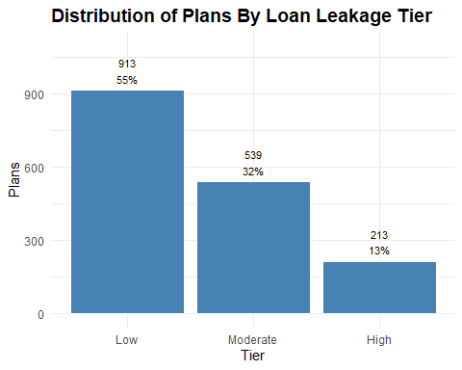

Retirement Adequacy Score (ADEQUACY_SCORE, ADEQUACY_IND, ADEQUACY_LABEL)
This response variable is designed to classify retirement plans as adequate or inadequate based on a principled, multi-signal framework. Rather than relying on a single metric, it integrates four structural indicators of plan health:
Assets per Participant > $50,000 signals long-term saving capacity and participant wealth accumulation.
Asset Growth Rate > 5% reflects sustained engagement and financial momentum over time.
Average Contributions per Participant > $2,000 indicates meaningful participant deferral behavior and plan utilization.
Loan Leakage Ratio < 0.5 captures erosion risk due to participant borrowing; lower ratios suggest stronger adequacy.
Each condition is evaluated as a binary flag, and the adequacy score is the sum of conditions met. Plans meeting three or more criteria are classified as adequate.
plans <- plans %>%
mutate(ADEQUACY_SCORE = (ASSETS_PER_PARTCP > 59000) +
(TOTAL_ASSETS_GROWTH_RATE > 0.10) +
(PARTCP_GROWTH_RATE > 0.03) +
(CONTRIB_PARTCP_GROWTH_RATE > 0.10) +
(CONTRIB_EMPLR_GROWTH_RATE > 0.07) +
(LOAN_LEAKAGE_RATIO < 0.013),
ADEQUACY_IND = if_else(ADEQUACY_SCORE >= 4, 1L, 0L),
ADEQUACY_LABEL = if_else(ADEQUACY_IND == 1L, "Adequate", "Inadequate"))
This approach offers several advantages:
Interpretability; Stakeholders can trace adequacy classification to specific, transparent thresholds.
Diagnostic clarity: Each component reflects a distinct dimension of plan health—accumulation, growth, engagement, and leakage.
Fairness-aware: By requiring multiple criteria, the model avoids overfitting to any one sector or plan type.
Model-ready: The binary label supports classification tasks, while the tiered label enables stakeholder previews and fairness overlays.
This response variable scaffolds ethical modeling, stakeholder trust, and reproducible diagnostics, all central to my analytic philosophy for this project.
Summarize plans by adequacy score.
summary_by_adequacy_score <- plans %>%
group_by(ADEQUACY_SCORE) %>%
summarise(entries = n()) %>%
mutate(percent = round(entries / sum(entries), 2))
kable(summary_by_adequacy_score,
col.names = c("Adequacy Score", "Plans", "Percent"),
caption = "Summary By Adequacy Score",
format.args = list(big.mark = ","),
align = c("l", "r", "r"))
Summary By Adequacy Score
Adequacy Score | Plans | Percent
0 | 20 | 0.01
1 | 126 | 0.08
2 | 335 | 0.20
3 | 411 | 0.25
4 | 421 | 0.25
5 | 251 | 0.15
6 | 101 | 0.06
Plot adequacy distribution.
ggplot(summary_by_adequacy_score, aes(x = ADEQUACY_SCORE, y = entries)) +
geom_col(fill = "steelblue", color = "white") +
geom_text(aes(label = paste0(scales::comma(entries), "\n", round(percent * 100, 0), "%")),
vjust = -0.3, size = 3.0) +
labs(title = "Distribution of Adequacy Scores",
x = "Adequacy Score",
y = "Number of Plans") +
theme_minimal() +
theme(axis.text.x = element_text(angle = 0, hjust = 0.5),
plot.title = element_text(size = 14, face = "bold")) +
expand_limits(y = max(summary_by_adequacy_score$entries) * 1.2)
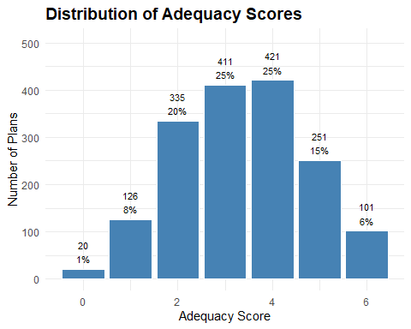
Plot distribution by adequacy class.
summary_by_adequacy_class <- plans %>%
group_by(ADEQUACY_LABEL) %>%
summarise(entries = n()) %>%
mutate(percent = round(entries / sum(entries), 2))
ggplot(summary_by_adequacy_class, aes(x = ADEQUACY_LABEL, y = entries)) +
geom_col(fill = "steelblue", color = "white") +
geom_text(aes(label = paste0(scales::comma(entries), "\n", round(percent * 100, 0), "%")),
vjust = -0.3, size = 3.0) +
labs(title = "Distribution of Adequacy Class",
x = "Adequacy Class",
y = "Number of Plans") +
theme_minimal() +
theme(axis.text.x = element_text(angle = 0, hjust = 0.5),
plot.title = element_text(size = 14, face = "bold")) +
expand_limits(y = max(summary_by_adequacy_class$entries) * 1.2)
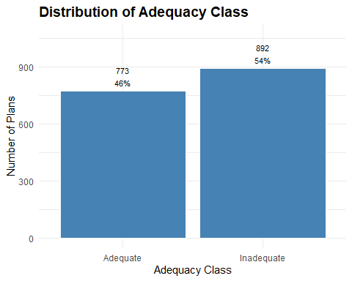

Finalize and Save Dataset
Order variables and save plans data frame with updates and features.
plans <- plans %>%
select(ADEQUACY_LABEL,
ADEQUACY_IND,
ADEQUACY_SCORE,
ACK_ID,
PLAN_YEAR_BEGIN_DATE,
PLAN_YEAR_END_DATE,
PLAN_NAME,
PLAN_EFFECTIVE_DATE,
PLAN_EFFECTIVE_YEAR,
PLAN_VINTAGE_GROUP,
PLAN_TYPE,
SPONSOR_NAME,
SPONSOR_STATE,
SPONSOR_EIN,
BUSINESS_CODE,
INDUSTRY_TITLE,
SECTOR_CODE,
SECTOR_TITLE,
SECTOR_TITLE_SHORT,
TOTAL_ACCBAL_PARTCP_BOY,
TOTAL_ACCBAL_PARTCP_EOY,
PARTCP_GROWTH_RATE,
PARTCP_GROWTH_TIER,
TOTAL_CONTRIB_PARTCP_BOY,
TOTAL_CONTRIB_PARTCP_EOY,
CONTRIB_PARTCP_GROWTH_RATE,
CONTRIB_PARTCP_GROWTH_TIER,
TOTAL_CONTRIB_EMPLR_BOY,
TOTAL_CONTRIB_EMPLR_EOY,
CONTRIB_EMPLR_GROWTH_RATE,
CONTRIB_EMPLR_GROWTH_TIER,
TOTAL_LOANS_BOY,
TOTAL_LOANS_EOY,
LOAN_LEAKAGE_RATIO,
LOAN_LEAKAGE_TIER,
TOTAL_ASSETS_BOY,
TOTAL_ASSETS_EOY,
TOTAL_ASSETS_GROWTH_RATE,
TOTAL_ASSETS_GROWTH_TIER,
ASSETS_PER_PARTCP,
ASSETS_PER_PARTCP_TIER)
saveRDS(plans, "../data/plans_final.rds")

