# Value Measurement Database Application

## Overview

The **Value Measurement Database Application** is a Python-based graphical user interface (GUI) that allows users to interact with a MySQL database for tracking transformation initiatives.

Built using Tkinter, it provides a tabbed interface for managing multiple database tables with CRUD (Create, Read, Update, Delete) functionality.

## Features

* **UI Generation**: Automatically creates input fields and displays data for multiple tables.
* **CRUD Operations**: Supports inserting, updating, deleting, and viewing records.
* **Scrollable Table View**: Displays data using a Treeview with vertical scrolling.
* **Automatic NULL Handling**: Ensures empty fields are correctly handled in the database.
* **Database Connectivity**: Interfaces with a MySQL database using mysql.connector and configuration file to store credentials.
* **Error Handling**: Use of try-except blocks that allows errors to be raised and presented in the GUI.
* **Query Storage, Execution and Download**: Storage of complex queries via table with execution in the GUI.

## Installation

### Prerequisites

* Python 3.x
* MySQL Server
* Required Python Packages:
* configparser  
  datetime  
  logging  
  mysql-connector  
  os  
  re  
  tkcalendar  
  tkinter  
  uuid

### Database Setup

1. Create a MySQL database named value.
2. Define the required tables:
   * initiative
   * event
   * metric
   * plan
   * event_plan
   * global_metric_value
   * plan_metric_value
   * user_query
3. Update the database connection details in config.ini.

## Usage

### Running the Application

Execute the following command:

python app.py

### GUI Functionality

1. **Navigate Tabs**: Each tab represents a database table.
2. **Add a Record**: Fill in the input fields and click **Add**.
3. **Update a Record**: Select a row, modify fields, and click **Update**.
4. **Delete a Record**: Select a row and click **Delete**.
5. **Refresh Data**: Click **Refresh** to reload data from the database.
6. **Query Execution**: Store, run and download results from complex SQL queries.

## File Structure

* config.ini -
* app.py - The main GUI application.
* database.py - Database interaction layer.
* downloader.py -
* messenger.py -
* widget_binder.py -

## Class Structure Diagram

The following diagrams provide a clear visual map of the system’s structure: its classes, attributes, methods, and relationships.

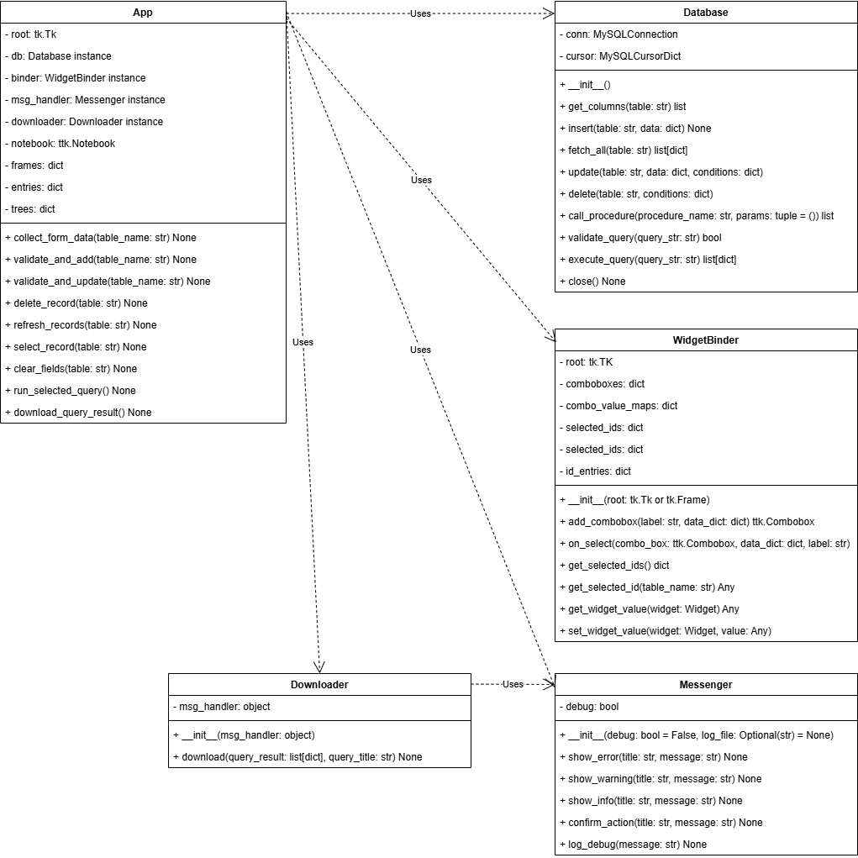

Class Structure Diagram

## Error Handling

To display exception messages from value_db.py in value_app.py, code in value_db.py raises exceptions instead of just printing them. Errors are then caught in value_app.py to be displayed in the GUI.

To accomplish this, database calls are wrapped in try-except blocks and any error messages are displayed via message boxes.

Here’s a comprehensive README section for SQL integration, detailing the database connection, functions, and usage for value_db.py. This documentation will help developers understand how to work with the MySQL database in your project.

## SQL Integration Guidelines

### Overview

This project includes value_db.py, which provides a Python-based interface to a MySQL database. The database handles value measurement operations, allowing users to insert, fetch, update, and delete records efficiently.

### Database Connection

The Database class in value_db.py establishes a connection to a MySQL database using the following credentials (configured in the script):

* **Host:** localhost
* **User:** root
* **Password:** XXXXXXXX
* **Database:** value

To modify the connection settings, update the __init__ method in value_db.py accordingly.

### Methods Overview

The Database class provides several methods to interact with MySQL tables:

#### 1. **get_columns(table)**

* Retrieves column names for a given table.
* **Usage:** db.get_columns("table_name")
* **Returns:** A list of column names.

#### 2. **insert(table, data)**

* Inserts a new record into a specified table, generating primary keys if not provided.
* **Usage:** python data = {"column1": "value1", "column2": "value2"} db.insert("table_name", data)
* **Returns:** None.

#### 3. **fetch_all(table)**

* Fetches all records from a given table.
* **Usage:** records = db.fetch_all("table_name")
* **Returns:** A list of dictionaries representing rows.

#### 4. **update(table, data, conditions)**

* Updates existing records in a table based on conditions.
* **Usage:** python data = {"column1": "new_value"} conditions = {"id": 1} db.update("table_name", data, conditions)
* **Returns:** None.

#### 5. **delete(table, conditions)**

* Deletes records from a table based on conditions.
* **Usage:** python conditions = {"id": 1} db.delete("table_name", conditions)
* **Returns:** None.

#### 6. **call_procedure(procedure_name, params=())**

* Calls a stored procedure.
* **Usage:** db.call_procedure("procedure_name", (param1, param2))
* **Returns:** Procedure output (if applicable).

#### 7. **close()**

* Closes the database connection.
* **Usage:** db.close()

## Error Handling

All SQL queries are wrapped in try-except blocks to catch mysql.connector.Error. If an error occurs, an exception is raised with a relevant message.

## Security Considerations

* **Do not hardcode credentials in production.** Use environment variables or a configuration file.
* **Validate user input** to prevent SQL injection.
* **Implement role-based access control (RBAC)** in MySQL for secure operations.

## Example Usage

Here’s how you can use the database class in a script:

from value_db import Database  
  
db = Database()  
  
# Insert a record  
db.insert("users", {"name": "Alice", "email": "alice@example.com"})  
  
# Fetch records  
records = db.fetch_all("users")  
print(records)  
  
# Update a record  
db.update("users", {"email": "alice@newdomain.com"}, {"name": "Alice"})  
  
# Delete a record  
db.delete("users", {"name": "Alice"})  
  
# Close connection  
db.close()

## Future Enhancements

* User authentication and access control.
* Advanced filtering and search functionality.
* Data export (CSV, Excel) features.

## License

This project is intended for internal use. Contact the author for usage permissions.

## Author

Developed by Donnie Minnick to satisfy the requirements for Deliverable 4 in the CS727 Relational Database Implementation and Applications course in the IIT MDS program.