1. **Technical Indicators:**
   1. Bollinger Band/Bollinger Band Percentage:

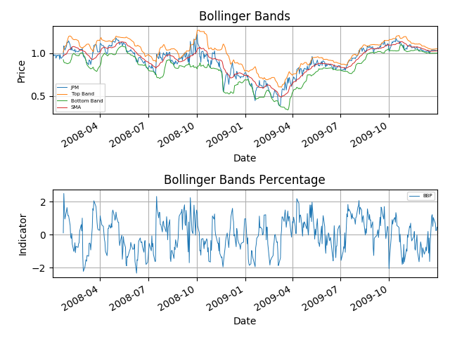

Description:

* Normalize these values to 1.0 at the start.
* Generate 14 days rolling means and rolling stdev:
  + Top Bands = rolling means + (2 * rolling stdev)
  + Bottom Bands = rolling means – (2 * rolling stdev)
  + Bollinger Band Percentage (BBP) = (Price – Bottom Band)/ (Top Band – Bottom Band)
* Standardize BBP by subtracting it by mean and dividing by stdev.
* A BUY signal is when BBP < 0% as the price is below the bottom band and SELL signal is when BBP > 1% as the price is above the top band.
  1. Momentum & Volatility:

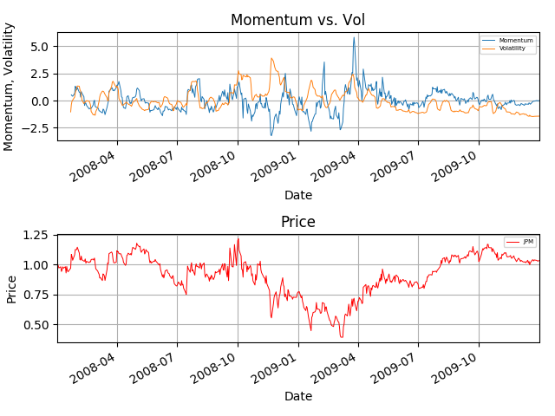

Description:

* Normalize price to be 1 at the start
* Generate momentum and volatility for 14 days window:
  + Momentum = (price[t]/price[t-N]) – 1
  + Volatility = stdev of daily returns
* Standardize these values by subtracting by means and dividing by stdev
* A BUY Signal is when Momentum < 0 and Volatility < 0.1. Low volatility can indicate that the price is about to turn in the different direction.
* A SELL Signal is when Momentum > 0 and Volatility > 0.3. These indicators signal period of turbulence in stock price, potential for drop.
  1. Price/SMA:

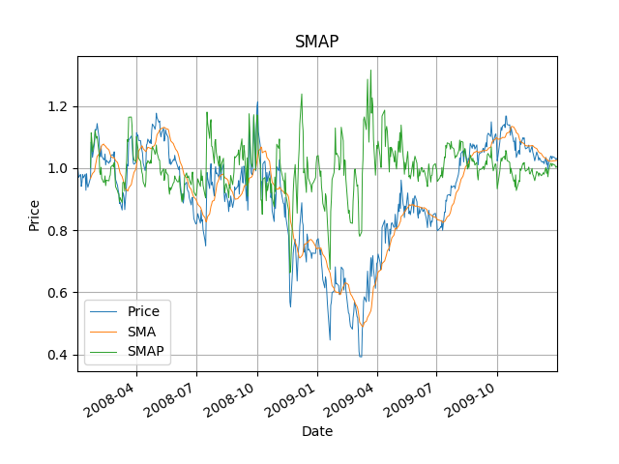

Description:

* Normalize Price to be 1.0 at the start and generate SMA for 14 days window
* Then compute SMAP = price/SMA
* A BUY signal is when SMAP < 0.95 as stock is oversold and a SELL signal is when SMAP > 1.05 as stock is overbought

1. **Best Possible Strategy:**

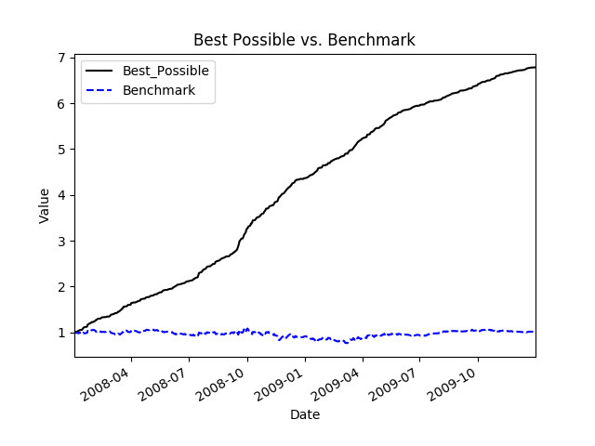

Portfolio values are normalized to start at 1.0 at the beginning. Orders are made with no 0 impact and $0 commission. To determine orders, we examine our current position and peek into the future 1 day, see the daily return of the next day, and decide:

* If we are longing the stock and it goes up or down, we will do nothing/short 2000 respectively
* If we are shorting the stock and it goes up or down, we will long 2000 or do nothing respectively.
* If we have no position and the stock goes up or down, we will long 1000 or short 1000 respectively.

|  |  |  |
| --- | --- | --- |
| **Statistics\Portfolio** | **Best Possible Portfolio** | **Benchmark** |
| Cumulative Return | 5.7861 | 0.0123 |
| Standard Deviation of Daily Return | 0.00454782319791 | 0.0170043662712 |
| Average Daily Return | 0.00381678615086 | 0.000168086978191 |

1. **Manual Strategy:**

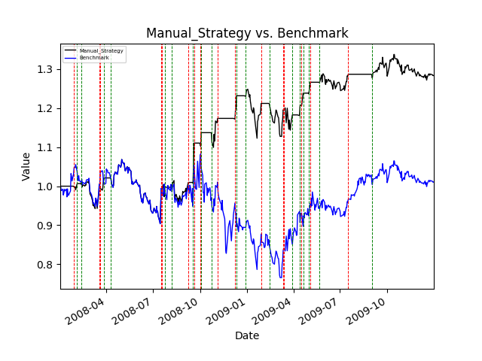

Description:

* Normalize prices and generate the following technical indicators for 14-day window
  + SMAP
  + Bollinger Band %
  + Momentum
  + Volatility

|  |  |
| --- | --- |
| * Oversold signal constituent: | * Overbought signal constituent |
| * + Price/SMA (SMAP) < 0.95   + Bollinger Band % (BBP) < 0   + Momentum < 0   + Volatility < 0.1 | * + Price/SMA (SMAP) > 1.05   + Bollinger Band % (BBP) > 1   + Momentum > 0   + Volatility > 0.3 |

* We buy when we see an oversold signal and sell when we see an overbought signal. The idea is we buy when the price has been going down, is traded below the average price and below the bottom band at low volatility. This suggests an imminent turning point which is an upward momentum. This means we should go long. Reversely, we want to sell out position when the price has been going up, is traded above the average and above the top band at high volatility. This signal suggests that the price will drop by reverting towards the mean, indicating we should go short. And we close positions when the symbol crosses through its SMA.

Performance:

|  |  |  |
| --- | --- | --- |
| **Statistics\Portfolio** | **Manual Strategy Portfolio** | **Benchmark** |
| Cumulative Return | 0.283117170158 | 0.0102362078485 |
| Standard Deviation of Daily Return | 0.0100806621122 | 0.0170412256784 |
| Average Daily Return | 0.000545124907955 | 0.000164660047203 |

As we can see, the manual strategy for in-sample backtests outperforms the benchmark. Adjusted for impact (0.005) and commission ($9.95), the manual rule-based strategy has a cumulative return of 0.28311 while the benchmark has a cumulative return 0f 0.01023 with lower standard deviation of daily return and higher mean daily return. As such, the Sharpe Ratio of the manual strategy is 0.858 while the Sharpe Ratio of the benchmark is 0.153

1. **Comparative Analysis:**

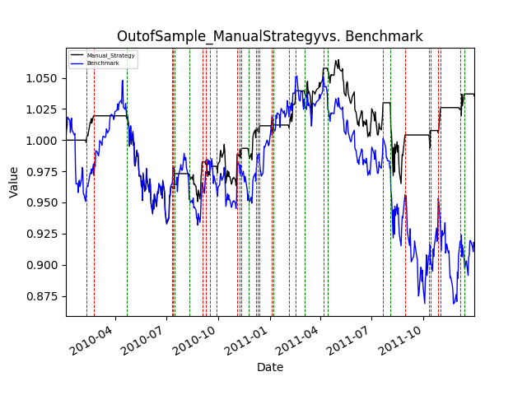

|  |  |  |  |
| --- | --- | --- | --- |
| **Statistics\Portfolio** | **In-Sample Portfolio** | **Out-of-Sample Portfolio** | **Benchmark** |
| Period | 01/01/2008 – 12/31/2009 | 01/01/2010 – 12/31/2011 | 01/01/2010 – 12/31/2011 |
| Sharpe Ratio | 0.85843464875 | 0.239267050482 | -0.263617228461 |
| Cumulative Return | 0.283117170158 | 0.0353855208593 | -0.0853088167944 |
| Standard Deviation of Daily Return | 0.0100806621122 | 0.00564063509598 | 0.00850128395312 |
| Average Daily Return | 0.000545124907955 | 8.50179503905e-05 | -0.000141175079753 |

Performance:

Similar to the performance of the strategy for the in-sample period, the manual strategy also outperforms the benchmark in the out-of-sample period. Adjusted for impact (0.005) and commission ($9.95), the manual rule-based strategy has a cumulative return of 0.0354 while the benchmark has a cumulative return 0f -0.0853 with lower standard deviation of daily return and higher mean daily return. As such, the Sharpe Ratio of the manual strategy is 0.239 while the Sharpe Ratio of the benchmark is -0.264.