MC3-P3

# Technical Indicators

## Bollinger Bands

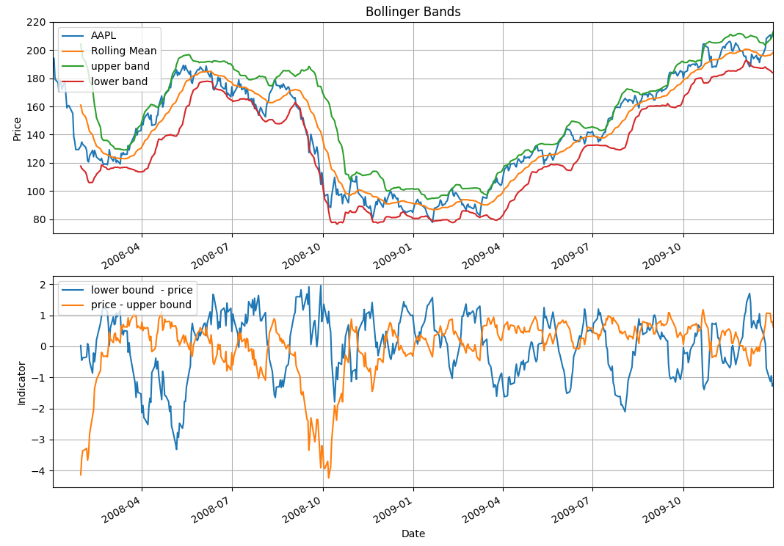

Steps to calculate the Bollinger Band and technical indicators using Bollinger Band:

1. Calculate the moving average of the stock price using 20 day window
2. Calculate the standard deviation of the stock price using 20 day window
3. Create the upper bound by adding 2 * standard deviation of the prices to the moving averages
4. Create the lower bound by subtracting 2 * standard deviation of the prices to the moving averages
5. Calculate the lower indicator = lower_bound – stock_price
   1. if this value is positive, it means stock price has went below the lower bound so it is a **signal to buy**
   2. Additionally you can normalize the values by “z-score” the indicator values
6. Calculate the upper indicator = stock_price – upper_band
   1. if this value is positive, it means that stock price has went above the upper bound so it is a **signal to sell**
   2. Additionally you can normalize the values by “z-score” the indicator values
7. Hence
   1. if upper_indicator > 0, SELL
   2. if lower_indicator > 0, BUY

## MACD (12,26,9)

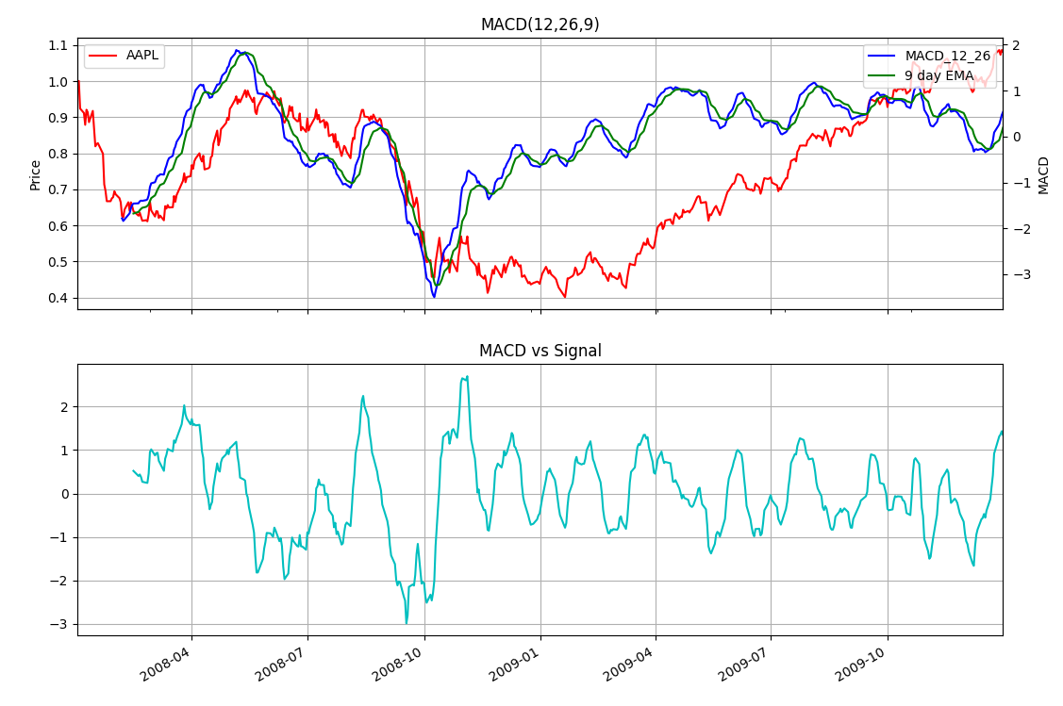

Steps to calculate the MACD(12,26,9):

1. Calculate EMA(12):
   1. Calculate the 12 day Exponential Moving Average using the Panda’s EWMA function and standardize it using z-score
2. Calculate EMA(26):
   1. Calculate the 26 day Exponential Moving Average and standardize it using z-score
3. Calculate MACD(12,26):
   1. Calculate the difference between the two using EMA(12) – EMA(26) as a formula and standardize it using z-score
4. Calculate EMA(9):
   1. Calculate the signal line which is the Exponential Moving Average of 9 days and standardize it using z-score
5. Calculate the MACD vs Signal:
   1. Calculate the technical indicator by using the below formula:
      1. MACD(12,26) – EMA(9) and normalize it using z-score
      2. If the value is positive or negative, it means there is a divergence
      3. If the value is zero or close to zero, it means MACD is about to converge with EMA(9), hence:
         1. If the previous difference was positive, then it signals the SELL
         2. If the previous difference was negative, then it signals the BUY

## Momentum vs Volatility

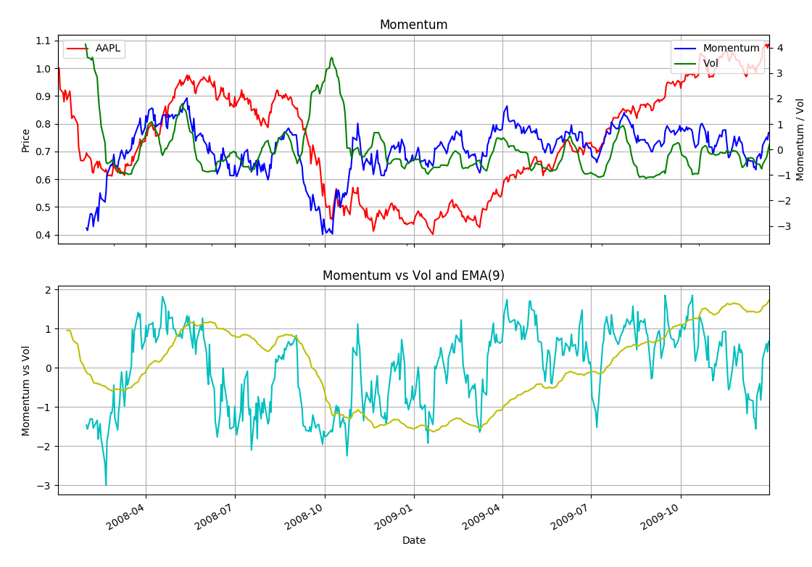

Steps to calculate Momentum vs Vol indicators:

1. Calculate the Momentum(20) and normalize them:
   1. Momentum(20) = Close(T) / Close(T-20) * 100
2. Calculate the Volatility of the stock history and normalize them
3. Calculate the Diff and normalize it:
   1. Diff = Momentum / Volatility
4. If diff > 2, it indicates that there is lots of momentum and very small volatility (risk) and it can indicates the turning points, SELL
5. If Diff < -2, it indicates that there is very little momentum and high volatility, SELL

# PART 2: Best Possible Strategy

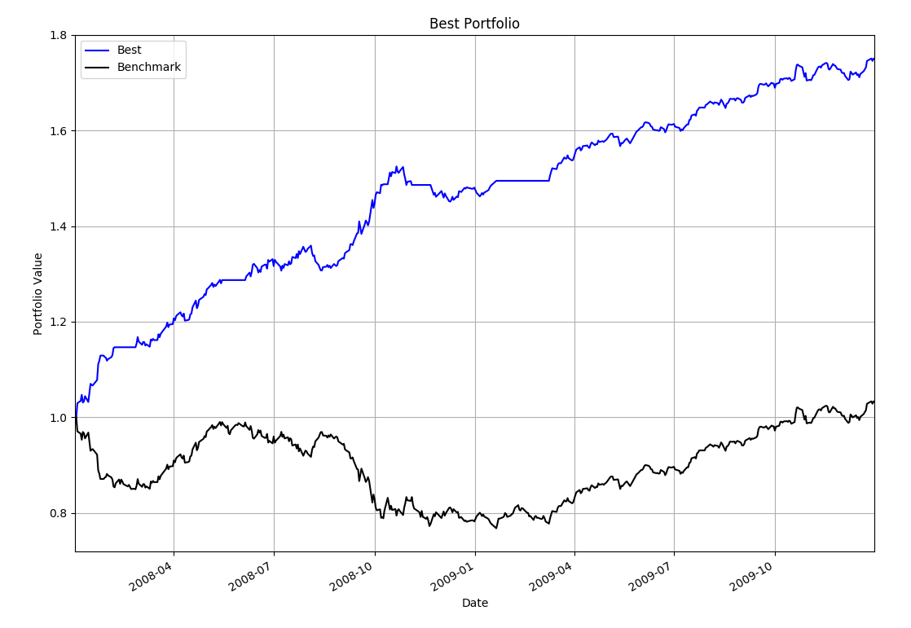

|  |  |  |
| --- | --- | --- |
|  | **Benchmark** | **Portfolio** |
| **Cumulative Return** | 0.74908 | 0.03164 |
| **Stdev** | 0.00874053752015 | 0.00530777337377 |
| **Mean** | 0.000100069116968 | 0.00112390747339 |
|  |  |  |

# PART 3: Manual Rule-Based Trader

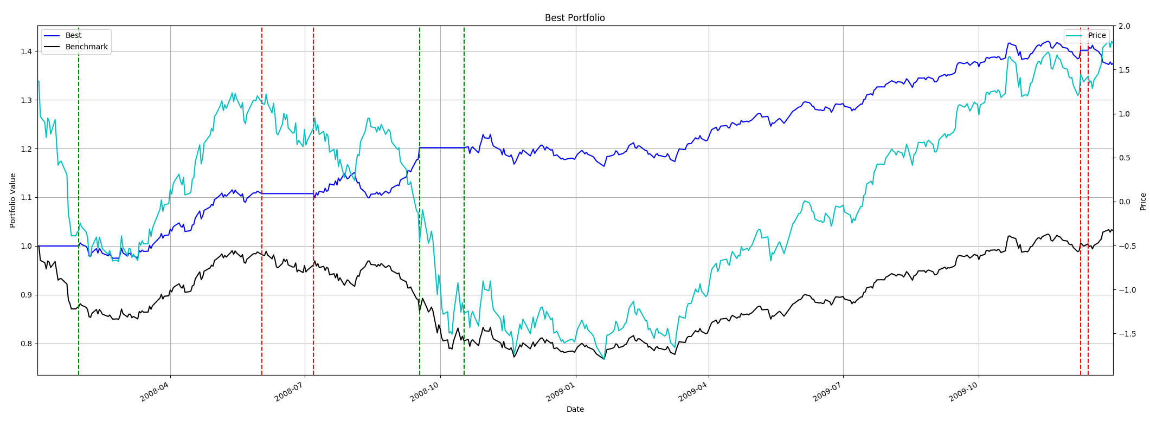

## Description

Technical indicators required:

BB_Upper, BB_Lower = Bollinger bands using 20 day window, normalized

Buy_indicator = BB_Lower – Normalized price of the stock

Sell_indicator = normalized price of the stock - BB_Upper

EMA(9) = Exponential Moving Average using 9 days window

Price = Normalized Stock Price

STD(20) = Standard Deviations using 20 days window

## Concept

Concept of this trading rule is extremely simple. Using the Bollinger bands as the trend indicators, if the price of the stock goes below the lower boundary, it triggers the buy signal. If the price goes above the upper bound of the bands, it looks at the two extra things before triggering the SELL signal:

* EMA(9) to check if the current trend is not upper trends: EMA(9) <= Price
* Standard Deviation to check if the market has some volatility: STD > 0.25

Sharpe Ratio of Fund: 2.16368431217

Cumulative Return of Fund: 0.40158 (40% return)

Standard Deviation of Fund: 0.00537760874196

Average Daily Return of Fund: 0.000732964307928

Final Portfolio Value: 140158.0

# PART 4: ML Trader

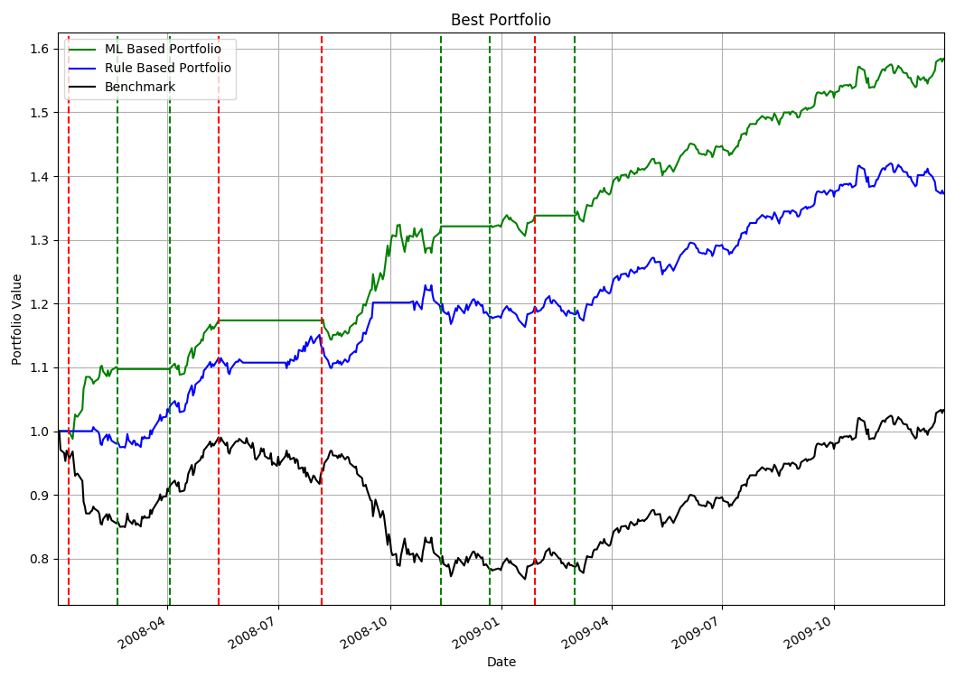

Date Range: 2008-01-04 00:00:00 to 2009-12-31 00:00:00

Sharpe Ratio of Fund: 1.95465429626

Cumulative Return of Fund: 0.3742

Standard Deviation of Fund: 0.00525597443412

Average Daily Return of Fund: 0.000647176787788

Final Portfolio Value: 137420.0

Description:

This Machine Learning based trader is built on using the following technical indicators:

BollingerLower = Lower bound of the Bollinger Band

BollginerUpper = Upper bound of the Bollinger Band

MACDSign = 9 days EMA which is the “Signal Line” in MACd

MACD = 12 days EMA – 26 days EMA

EMA =EMA on 9 days window

Also LONG (1) / HOLD (0) / SHORT(-1) Test Y data have been generated using :

YBUY = 0.02

YSELL = -0.02

That is, if the 21 days future return is above 2%, it will be signaling the LONG, if it is below 2%, it signals SHORT.

# PART 5: Visualization

## Chart 1 – Rule Based Strategy

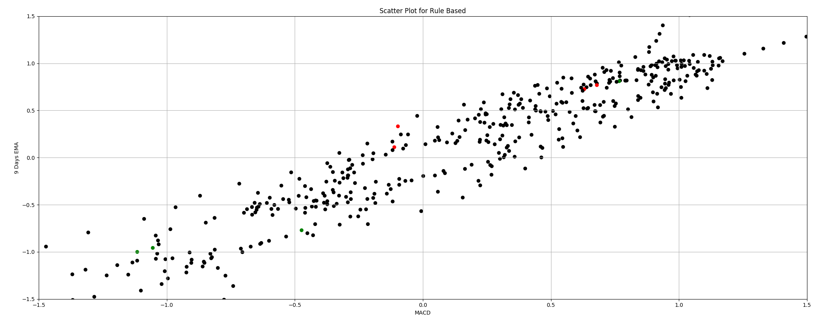

## Chart 2 – Training Data for ML Strategy

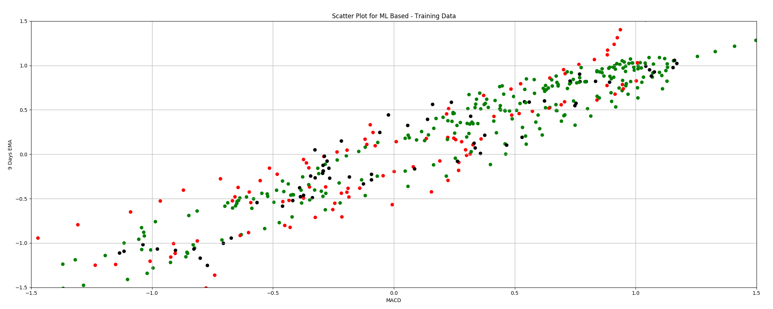

## Chart3 – Predict Data for ML Strategy

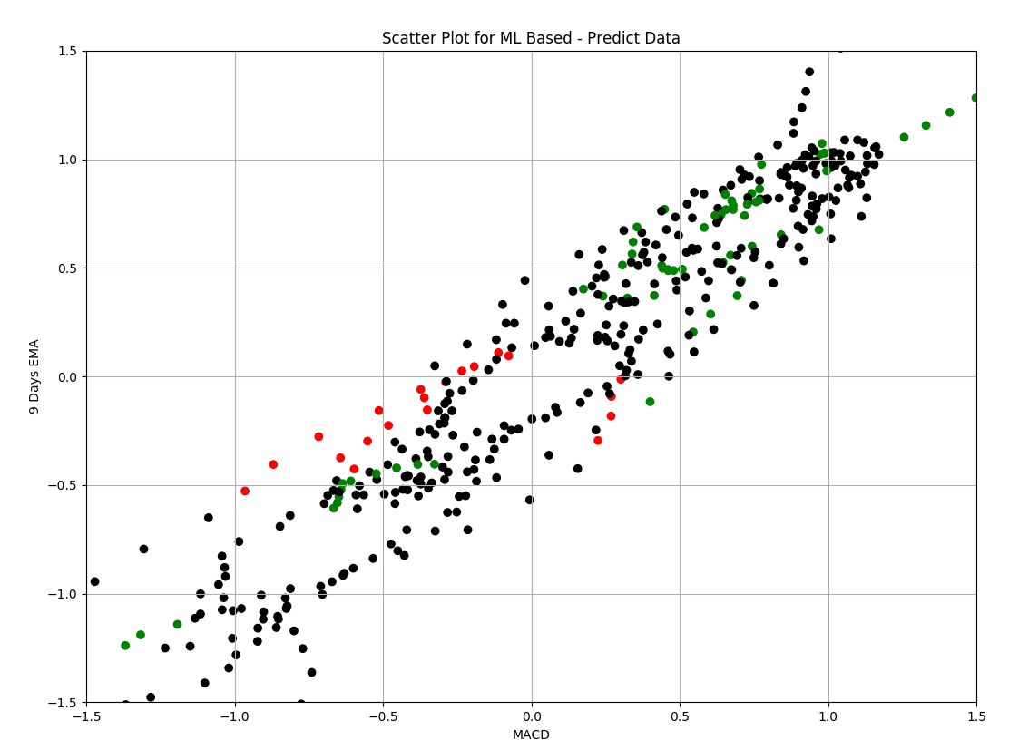

# PART 6 – Comparative Analysis

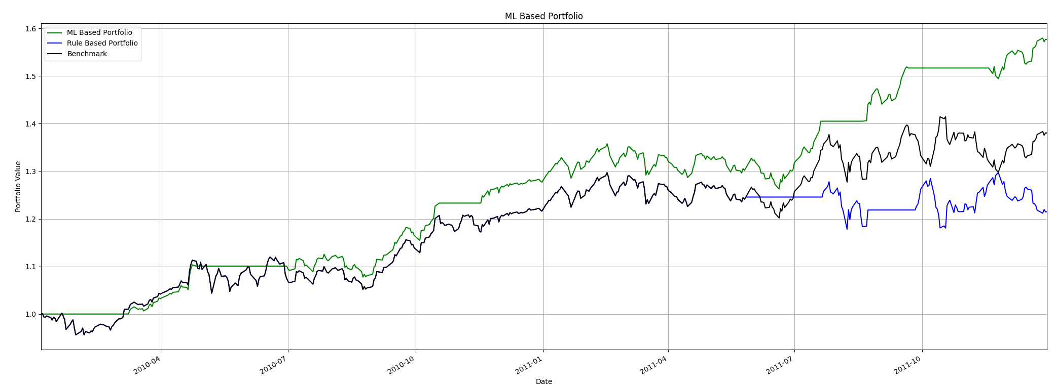

## Description:

|  |  |  |  |
| --- | --- | --- | --- |
| Out Sample (2010-01-1 to 2012-12-31) | | | |
|  | Cumulative Return | SR | Final Portfolio Value |
| Stock | 0.892 |  |  |
| Benchmark | 0.38034 | 1.257389713 | 138034 |
| Manual Strategy | 0.21484 | 0.801291751 | 121484 |
| ML Strategy | 0.40226 | 1.529870024 | 140226 |

|  |  |  |  |
| --- | --- | --- | --- |
| In Sample (2008-01-01 to 2009-12-31) | | | |
|  | Cumulative Return | SR | Final Portfolio Value |
| Stock | 0.081542 |  |  |
| Benchmark | 0.03164 | 0.181744885 | 103164 |
| Manual Strategy | 0.3742 | 1.950721086 | 137420 |
| ML Strategy | 0.60486 | 2.8139015 | 160486 |

It is quite interesting that Rule Based Portfolio performed very badly in the Out-Sample backtesting. I believe it is caused by the less volatile market nature of the Out Sample period compare to the In Sample period which spans across the famous ‘Lehman Collapse’ periods where the market volatility was much higher.

ML Strategy scored both highest SR and the cumulative returns in both tests.

However, it is notable that even the ML strategy did not outperform the cumulative return of the stocks in both test cases. Instead, ML maximized its profit from trading frequently in both directions, which resulted in the final portfolio value being much higher than that of the portfolio that holds 200 long shares and stick with it till the end of the period.