SIMULINK MODEL TECHNICAL REPORT
Hydroelectric Power Plant Digital Twin | Kavşak Bendi HEPP Reference
Project | Prepared by | Model scope | Date
Hydroelectric Power Plant Digital Twin | Duran Ali Toklu | Educational MATLAB/Simulink engineering model | 08 November 2026

Abstract
This report documents the supplied HPP_Digital_Twin_Model.slx file and the accompanying Simulink screenshots. The current model is broader than the initial hydraulic-power-only diagram: it contains hydraulic/reservoir, turbine-generator, transformer/grid, and protection subsystems. The turbine-generator conversion chain applies turbine and generator efficiencies and limits electrical output to the reference installed capacity.

1. Model architecture
The top-level Simulink model contains the following subsystems and monitoring elements:
Subsystem / element | Purpose
Hydraulics_and_Reservoir | Represents inflow/outflow, reservoir volume/level, net head, and hydraulic power signals.
Turbine_Generator_System | Converts hydraulic power to electrical power using turbine and generator efficiency gains and a saturation limit.
Transformer_and_Grid | Represents the transformer/grid interface and calculates an illustrative grid-side current signal.
Protection_System | Compares high-voltage current against an illustrative threshold and produces a trip signal.
Scopes / Display / signal blocks | Provide visual monitoring of selected model variables and outputs.

2. Turbine-generator conversion chain
The inspected turbine-generator subsystem has one hydraulic-power input, two Gain blocks, a Saturation block, and one electrical-power output. The block parameters are:
Block | Parameter | Meaning
Gain | 0.90 | Assumed turbine efficiency
Gain1 | 0.96 | Assumed generator efficiency
Saturation | Lower = 0; Upper = 191.28 | Limits output to the reference installed capacity (MW)
The conversion is represented by Pm = Ph × ηt and Pe = Pm × ηg, followed by 0 ≤ Pe ≤ 191.28 MW. The efficiency values are simplified model assumptions, not verified operating curves.

3. Hydraulic power reference calculation
The hydraulic-power equation is Ph = ρ × g × Q × Hn. For ρ = 1000 kg/m³, g = 9.81 m/s², Q = 237.55 m³/s, and Hn = 95 m:
Ph ≈ 221.39 MW
After applying ηt = 0.90 and ηg = 0.96, the estimated electrical output is approximately 191.28 MW, consistent with the 191.28 MW saturation limit. The displayed value is rounded.

4. Supplied model screenshots
Figure 1 shows the hydraulic-power calculation block chain. Figure 2 shows the conversion chain including turbine and generator efficiencies.
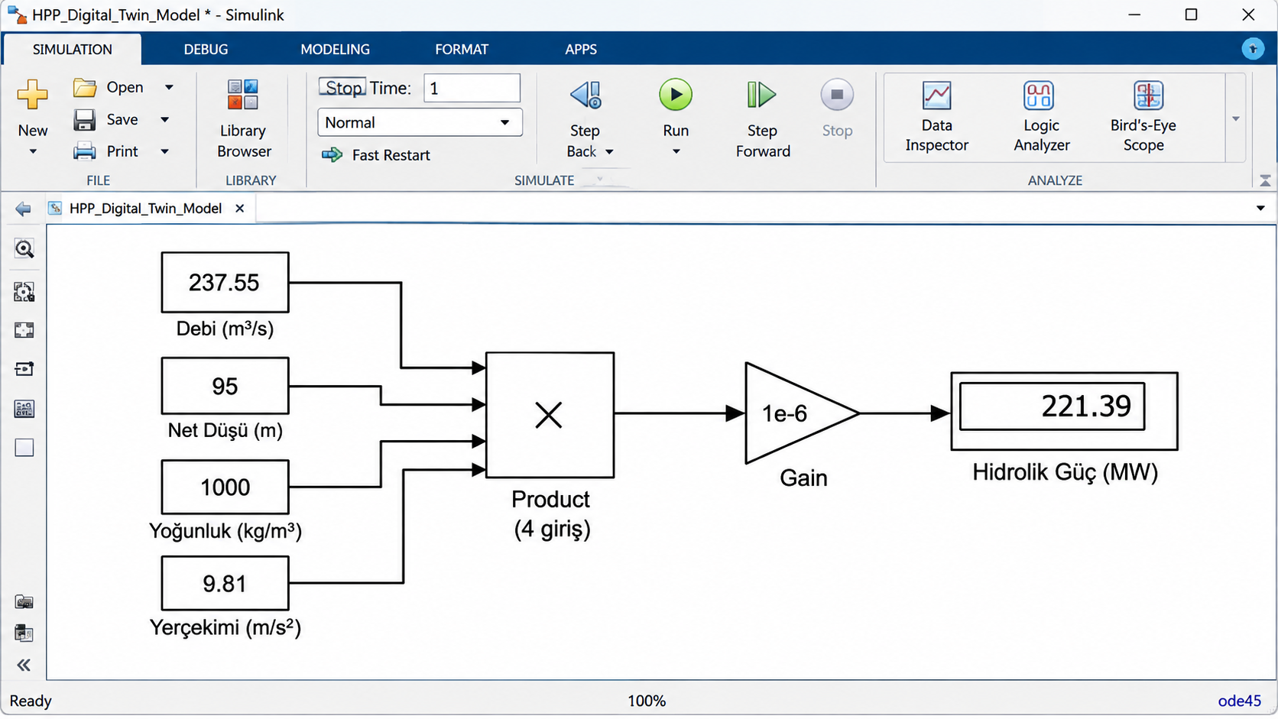
Figure 1. Hydraulic power calculation: four inputs → Product → 1e-6 Gain → Display.
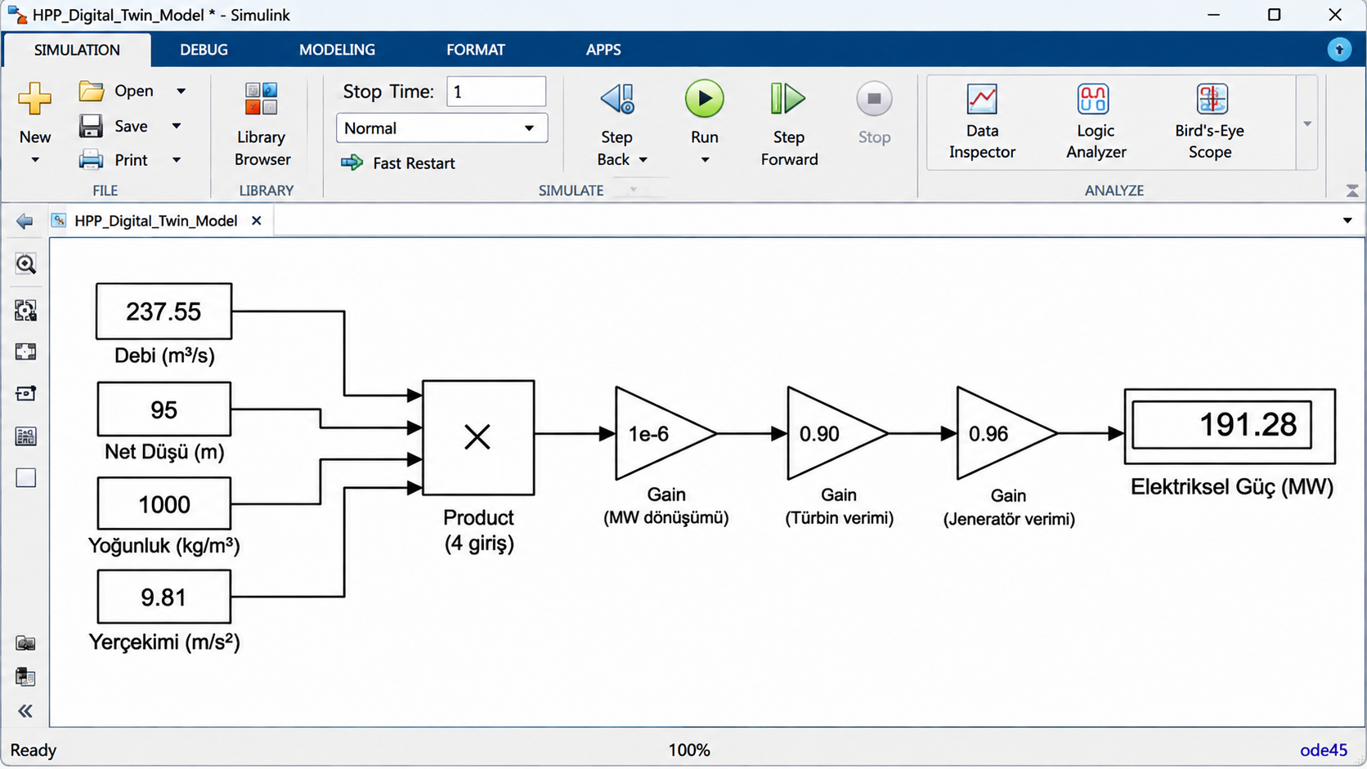
Figure 2. Electrical power conversion with efficiency gains and installed-capacity limit.

5. Transformer, grid, and protection representation
The transformer/grid subsystem includes a 0.995 gain and a high-voltage current calculation based on three-phase apparent power, 154 kV, and 0.90 power factor. The protection subsystem compares high-voltage current against an illustrative 850 A threshold. This is a simplified educational demonstration; it is not a protection coordination study and the threshold is not a real relay setting.

6. Assumptions and limitations
- The model uses reference and assumed inputs; it is not connected to live SCADA or plant sensors.
- The efficiencies 0.90 and 0.96 are fixed values and do not represent full turbine or generator performance maps.
- Reservoir dynamics are simplified and do not include detailed waterway transients or water hammer.
- The transformer/grid and protection subsystems are simplified representations, not validated plant single-line or relay models.
- The supplied screenshots and model file are retained as provided; the model has not been simulated in this packaging environment.

7. Running the model
Open Simulink/HPP_Digital_Twin_Model.slx in MATLAB/Simulink. Inspect the four main subsystems, confirm block parameters, and run the simulation. MATLAB/Simulink R2023b or a compatible later release is recommended. Compatibility adjustments may be required in other releases.

Conclusion
The supplied Simulink file represents a multi-subsystem educational model of the hydropower energy chain, extending from hydraulic/reservoir variables to turbine-generator conversion, transformer/grid interface, and illustrative protection logic. Further validation against verified plant data and detailed equipment models is required before any engineering or operational use.

