HYDROPOWER GENERATION AND
PERFORMANCE ANALYSIS USING PYTHON
Technical Project Report
Prepared by: Duran Ali Toklu
Energy Systems Engineering
Tools: Python, Google Colab, NumPy, Pandas, Matplotlib

Abstract
This study presents an educational Python model for assessing hydropower generation under varying inflow, ecological flow release, turbine flow capacity, and penstock hydraulic losses. Illustrative monthly inflow values are used rather than measured operating data from an actual plant. In the baseline case, gross head is 100 m, overall efficiency is 85%, ecological release is 10% of incoming flow, maximum turbine flow is 20 m³/s, and penstock diameter is 3.0 m. Darcy–Weisbach friction and minor losses are included. The calculated annual energy is 102.056 GWh, corresponding to an annual average power of 11.650 MW. A limited design sweep identifies 4.5 m penstock diameter and 24 m³/s maximum turbine flow as the highest-energy combination among the tested options. This is not an economic optimum.
Keywords: hydropower, Python, flow rate, net head, hydraulic losses, annual energy.

1. Introduction and Objective
Hydropower generation depends primarily on water flow rate, available hydraulic head, and the overall efficiency of the turbine-generator system. In practice, penstock friction and local hydraulic losses reduce the net head available to the turbine. Ecological flow requirements and turbine flow limits further constrain the amount of water that can be used for generation. The objective of this project is to build a reproducible Python simulation that combines these effects, estimates monthly and annual energy production, and compares selected penstock and turbine-capacity alternatives.
The model is intended for learning and preliminary engineering analysis. It does not represent the measured performance of Kavşak Bendi HEPP or any other real hydropower plant.

2. Methodology and Mathematical Model
The turbine flow is determined after reserving the ecological release and applying the turbine flow limit:
Qₜ = min[Qᵢₙ × (1 − rₑco), Qₜ,ₘₐₓ]
The penstock cross-sectional area is A = πD²/4 and the mean flow velocity is v = Qₜ/A. The Darcy–Weisbach friction head loss and the minor head loss are calculated as:
h_f = f (L/D) (v²/2g) h_m = K (v²/2g)
H_net = H_gross − (h_f + h_m)
Electrical power is estimated using P = ρηgQₜH_net, where ρ is water density, g is gravitational acceleration, η is the assumed overall efficiency, Qₜ is turbine flow, and H_net is net head. Monthly energy is calculated by multiplying power by the number of operating hours in each month.

3. Baseline Assumptions
Parameter | Baseline value
Monthly inflow (Jan–Dec) | 12, 14, 18, 25, 30, 28, 22, 16, 12, 10, 9, 11 m³/s
Gross head | 100 m
Overall efficiency | 85%
Ecological flow release | 10% of incoming flow
Maximum turbine flow | 20 m³/s
Penstock length / diameter | 1,000 m / 3.0 m
Darcy friction factor / minor-loss coefficient | 0.02 / 2.0
Water density / gravitational acceleration | 1,000 kg/m³ / 9.81 m/s²
All input values in this table are illustrative assumptions selected for demonstration. They are not measured plant data.

4. Results and Discussion
For the baseline case, annual energy production is 102,055.61 MWh (102.056 GWh), and annual average power is 11.650 MW. The day-weighted average hydraulic head loss is 1.991 m, giving an average net head of approximately 98.009 m.
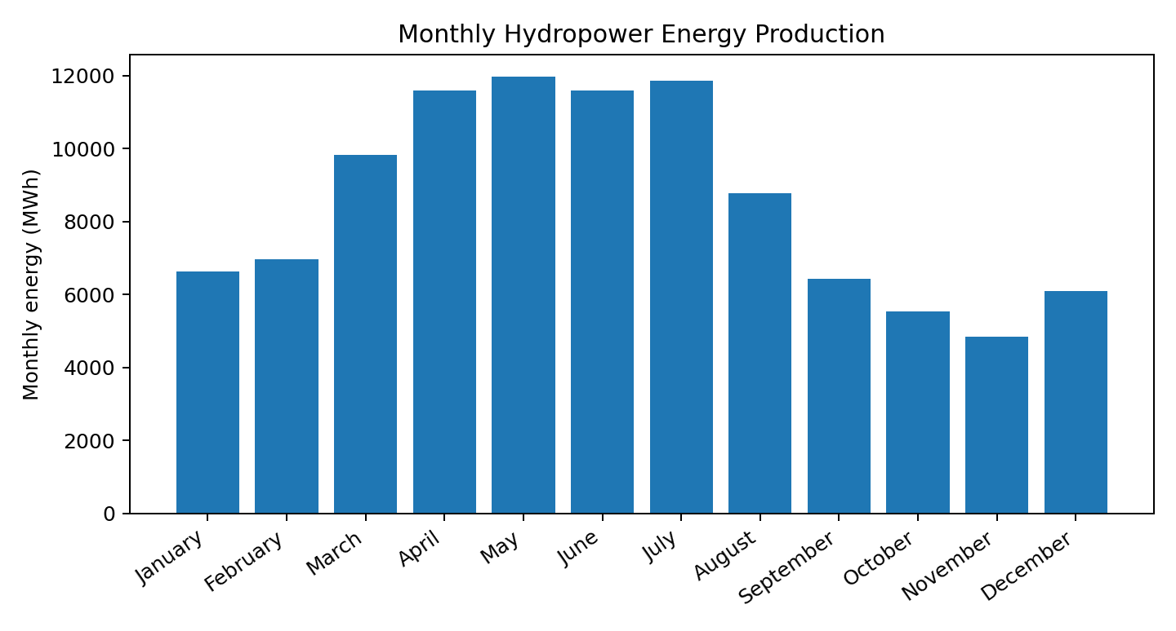
Figure 1. Monthly energy production calculated from the illustrative inflow profile.
The highest monthly production occurs in May, at approximately 11,969 MWh. During high-flow months, the turbine flow limit of 20 m³/s restricts the flow directed to the turbine even when incoming flow is higher. This illustrates how turbine capacity can limit energy production during periods of abundant water availability.

4.1 Design Parameter Comparison
A discrete design sweep was performed for penstock diameters from 2.5 to 4.5 m and maximum turbine flows from 12 to 24 m³/s. The highest annual energy among the tested combinations is 110.426 GWh, obtained at a penstock diameter of 4.5 m and maximum turbine flow of 24 m³/s. This is approximately 8.20% higher than the baseline design.
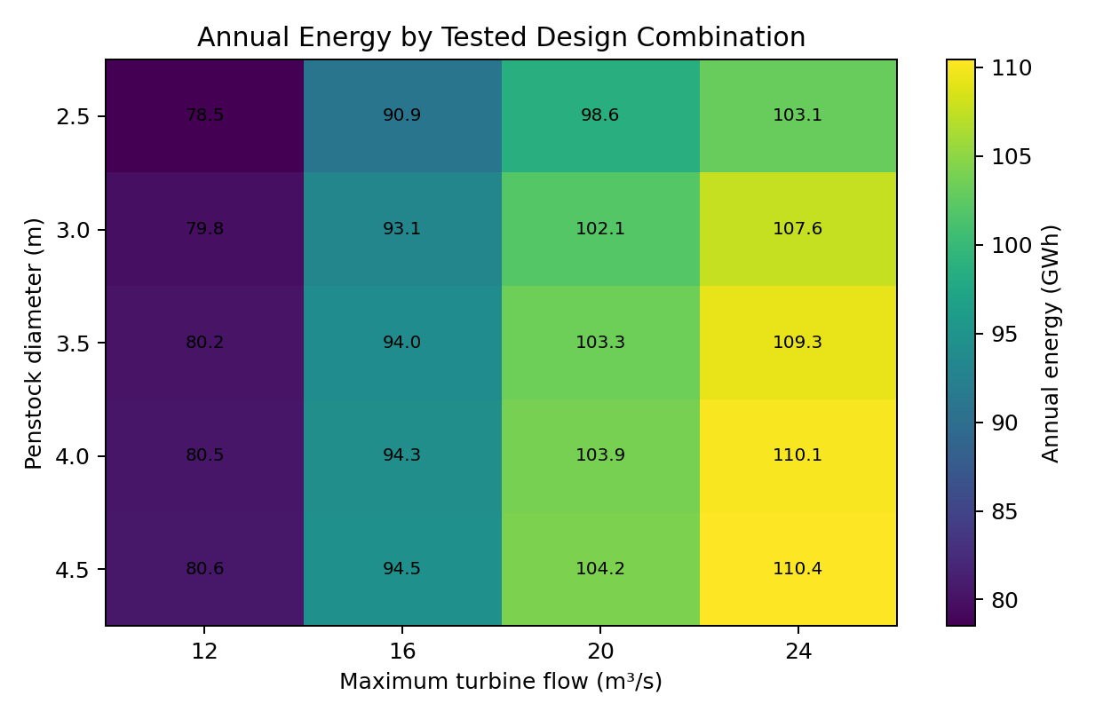
Figure 2. Annual energy across the tested penstock-diameter and turbine-capacity combinations.
Increasing penstock diameter generally reduces flow velocity and hydraulic losses for a given flow rate. Increasing turbine capacity can allow more water to be used during high-flow periods. However, larger penstocks and turbines may increase capital costs. Therefore, the combination with the highest simulated energy output should not be interpreted as the techno-economic optimum.

5. Conclusions, Limitations and Future Work
The Python model combines ecological flow release, turbine flow limitation, penstock friction, minor losses, and net head to estimate hydropower generation. Under the stated baseline assumptions, annual energy production is 102.056 GWh. The design sweep demonstrates that penstock diameter and turbine flow capacity can significantly affect the simulated energy yield.
The main limitations are: (i) monthly inflow values are assumed rather than measured; (ii) overall efficiency is constant; (iii) friction and minor-loss coefficients are fixed; (iv) turbine efficiency maps and part-load operation are not represented; and (v) maintenance outages, water hammer, cavitation, sediment, detailed environmental constraints, and economic costs are outside the current model. The design sweep is limited to a discrete set of candidate values.
Future work should use measured daily or hourly flow data, model turbine efficiency as a function of operating point, include economic and lifecycle-cost analysis, and perform uncertainty and sensitivity analyses. HydroGenerate was installed and its calculation interface was inspected during development; however, a numerical comparison has not yet been independently verified and is therefore not claimed in this report.

References
[1] Idaho National Laboratory, HydroGenerate Documentation. https://idaholabresearch.github.io/HydroGenerate/
[2] HydroGenerate Python package, PyPI. https://pypi.org/project/HydroGenerate/
[3] Darcy–Weisbach equation for pipe-flow head loss and the conventional hydropower equation P = ρηgQH.

