Activating Reservoir Operation in CaMa-Flood
15 April, 2024
Dai Yamazaki and CaMa-Flood development team
IIS U-Tokyo
In this document, the procedures to activate reservoir operation scheme in CaMa-Flood are explained.

Note: The format of dam parameter list file is slightly modified in v4.20 (fldsto/uparea parameter was excluded, construction year is added). Please use a dam parameter list which is generated by the updated script.

Setting Reservoir Operation Parameters
First step of activating reservoir operation scheme is to allocate reservoirs on to appropriate grids of CaMa-Flood River Map and setting reservoir operation parameters.

Allocation of Reservoir on CaMa-Flood River Map
The scripts to allocate reservoirs are prepared in $(CaMa-Flood)/map/src/src_param/ directory.

(1) Input data (included in CaMa-Flood package)
List of GRanD reservoirs is available in CaMa-Flood package.
$(CaMa-Flood)/map/data/GRanD_allocated.csv
Some reservoirs have error or mismatch of the attribute data required for allocation (lat, lon, uparea) compared to the MERIT Hydro river map (hydrography basemap for CaMa-Flood). Thus, we corrected the errors or mismatches by allocation reservoirs on 1-min resolution MERIT Hydro data.
The corrected data is (lat_alloc, lon_alloc , area_alloc). The corrected attribution data is used to allocate GRanD reservoirs on a CaMa-Flood river map. In addition, below attributes are included:
- DamName: Name of the dam
- RiverName: Name of the river
- CAP_MCM: Reservoir total capacity in Million cubic memer
- YEAR: Construction year
- ALT_YEAR: Dam alternation year
- RAM_YEAR: Dam construction year
- ELV_MASL: Elevation of the dam above mean sea level
- DAM_HGT_M: Height of the dam
- lat_ori, lon_ori, area_ori: original location attribute
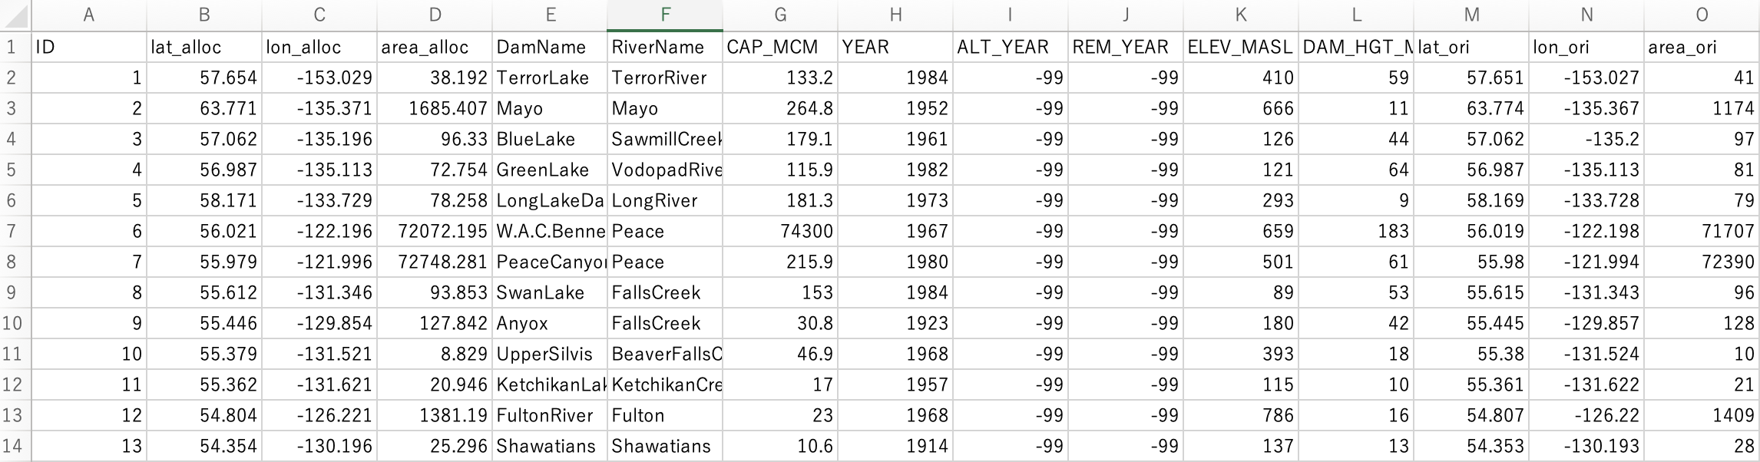
Example of GRanD_allocated.csv file.

(2) Allocate reservoirs on a CaMa-Flood river map
Please go to your working map directory (e.g. map/glb_15min/). Then copy map/src/src_param/ directory to your working map directory. Then, please go to src_param/ directory in your map directory. Compile the Fortran90 source code by make.
```
% cd map/glb_15min
% cp -r ../src/src_param .
% cd src_param/
% cd make all
```
Then, edit t02-alloc_dams.sh , and execute it. You can change the input dam list and output file names.
```
% vi t02-alloc_dams.sh
```
There are two output files in default setting.
- GRanD_river.txt: Dams allocated on CaMa-Flood river map, reservoir operation applied.
- GRanD_small.txt: Dams too small to be allocated on CaMa-Flood river map.
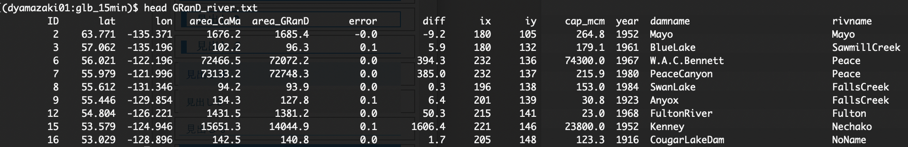
Example of GRanD_river.txt file.
Note; Detailed methodology for allocating reservoirs is explained in the manual of AllocateRiverGauge package.

Setting Reservoir Operation parameters

Working location
Please go to your working map directory (e.g. map/glb_15min/). Then copy map/src/src_dam/ directory to your working map directory.
```
% cd map/glb_15min
% cp -r ../src/src_dam .
% cd src_dam/
```

Input data for setting reservoir operation parameters
Then, please check the s00-link.sh script, and prepare the required input data for CaMa-Flood reservoir operation scheme.

[2a] DAMLIST: List of dams to be allocated
Please prepare the list of dams to be allocated on the CaMa-Flood river map
default: DAMLIST=${MAPDIR}/GRanD_river.txt

[2b] NATDIR: Naturalized simulation output directory
You first need to execute “no reservoir” simulation to estimate 100-year return-period discharge, to estimate flood discharge to start flood control operation. Please specify the location of the naturalized simulation data as NATDIR in s00-link.sh.
It is recommended that “no reservoir” is run with the same runoff forcing data and same river map data as “with reservoir” simulation to keep the consistency of the reservoir parameters. The python script in the current reservoir operation package assumes the output are in plain binary format with 1day time step. Output should be plain binary, and outflwYYYY.bin should be saved. It’s better to have ~30 years of simulations.
Note; the sample script s00-link.sh uses the output of the sample 2-year simulation “test1-glb_15min”, but this is just for the purpose of checking the reservoir operation scripts are working. It’s better to have 30-year-long simulation to estimate 100-year return-period discharge appropriately.

[2c] GRSAD (Global Reservoir Surface Area Dataset)
The reservoir surface area timeseries data is needed to decide normal water volume.
Data can be downloaded below. Please specify the directory where "*_intp" files are located as GRSADdir in s00-link.sh script.
https://dataverse.tdl.org/dataset.xhtml?persistentId=doi:10.18738/T8/DF80WG

Note: The sample GRSAD data (only 1 dam) is include in CaMa-Flood package

[2d] ReGeom data (Global Reservoir Geometry Database)
The reservoir geometry data (area-volume relationship) is needed to decide normal water volume & flood control volume.
Data can be downloaded below. Please specify the directory where "*.csv" data are located as ReGeomdir in s00-link.sh script.
https://zenodo.org/record/1322884#.YF1owUj7QW_

Note: The sample ReGeom data (only 1 dam) is include in CaMa-Flood package

Setting reservoir operation parameters
Please edit s01-calc_damparam.sh script, and execute it.
You need to set SYEAR,EYEAR,DT of the naturalized simulation. (Daily discharge data DT=86400 is assumed)
The Python scripts for (a) calculating annual mean and max discharge at each dam location, (b) calculating 100year discharge at each dam location, (c) estimating normal water storage from satellite data, (d) merging these information into one dam parameter list, (e) finalizing the dam parameter list for use in CaMa-Flood, are sequentially executed.
Temporally output file is saved in the directory set as TAG (default: tmpdat/)

[3a] Calculate annual mean and max discharge at each dam location
Annual mean and max discharge at each dam grid are calculated from daily discharge of naturalized simulation by using code script/p01_get_annualmax_mean.py
The output is plain binary data: tmp_p01_AnnualMax.bin, tmp_p01_AnnualMean.bin

[3b] Calculate 100-year discharge at each dam location
100-year return-period discharge is calculated from the annual maximum discharge timeseries calculated in the previous step, by using code script/p01_get_annualmax_mean.py. Plotting Position and L-moments methods are used to estimate Gumbel distribution parameters.
The output is plain binary data: tmp_p02_100year.bin

[3c] Estimate flood control volume
Then, flood control volume and normal volume are estimated, using satellite-based reservoir storage time-series, using p03_est_fldsto_surfacearea.py. The sum of flood control volume and normal volume is total storage of the reservoir.
We assume reservoir water level is kept at normal water level in wet season when inflow to reservoir is adequate, thus reservoir surface area corresponding to normal water level is frequently observed. Then, we assume the 75th percentile value (pc = 75 in p03 script) of the observed reservoir surface area corresponds to the normal water volume (with calibration and sensitivity check). The 75th percentile water surface area is taken from GRSAD reservoir surface area data, and it is converted to the corresponding volume using reservoir geometry data ReGeom.
The output is CSV file: tmp_p03_fldsto.csv

[3d] Combine outputs to create reservoir parameter datasts
Dam parameters estimated in previous steps are combined to create dam parameter list file, using p04_complete_damcsv.py. For reservoirs which does not have flood control capacity
- Flood discharge (discharge threshold to initiate flood control operation) is 30% of 100-year return-period discharge. If estimated flood discharge is smaller than annual mean discharge, modification is applied (40% of 100-year discharge, or 110% of annual mean discharge)
- For reservoirs with no GRSAD or ReGeom data, flood control storage is given as 37% of total storage.
- The upstream area threshold MINUPAREA is given as an argument to p04 script, and smaller reservoirs are excluded.
The output is CSV file: tmp_p04_damparam.csv

[3e] Finalize reservoir parameter list
The reservoir parameter list is finalized by adding the number of dams in 1st line of tmp_p04_damparam.csv
The name of the finalized reservoir parameter list is given as OUT_DAMPARAM in s01 script.
Default: OUT_DAMPARAM="../dam_param.csv"
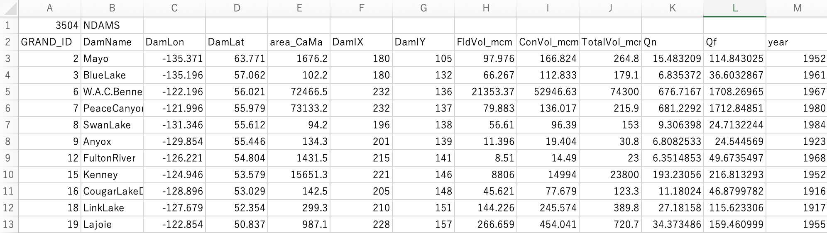
Sample of finalized reservoir parameter data: dam_param.csv

If modification of reservoir parameter is needed for your experiment, please edit "../dam_param.csv"

Add reservoirs not included in GRanD data
Reservoirs not included in GRanD data can be added by adding their information in input reservoir list data. The sample file is prepared as:
$(CaMa-Flood)/map/data/GRanD_alloc+Mekong.csv
Please find the latitude, longitude and upstream area of the new reservoir, using MERIT Hydro river map (or CaMa-Flood 1min river map), and specify the data as lat_MERIT, lon_MERIT, area_MERIT), and provide reservoir capacity in million M3 (CAP_MCM). The other fields can set to undef value (-99). Then please follow the above procedures to allocate reservoirs in CaMa-Flood map, and estimate reservoir parameters.
Note that satellite data to estimate normal water volume is not available for non-GRanD reservoirs. Please set an appropriate value by yourself.

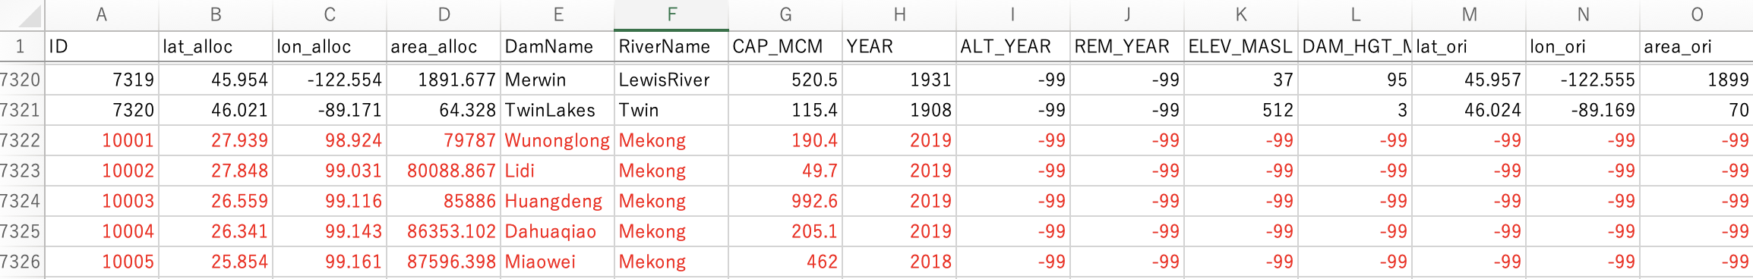
Sample of dams added to input damlist. 5 new dams in Mekong River basin were added.

Executing simulation with reservoir operation
Sample script to run CaMa-Flood simulation with reservoir operation is prepared in gosh/test6-reservoir_glb15min.sh.
Reservoir operation scheme can be activated by specifying the reservoir parameter list file. No additional forcing data is needed.

Namelist for reservoir operation scheme
Configuration of reservoir operation scheme is specified by Fortran90 NAMELIST file in CaMa-Flood. Please edit the namelist parameters in the gosh script to specify the reservoir scheme setting.
- LDAMOUT=".TRUE." # set to “.TRUE.” to activate reservoir operation (under development)
- CDAMFILE="${FMAP}/dam_param.csv" # Specify dam parameter list
- CVARSOUT="flddph,outflw,daminf,damsto,rivdph" # Inflow to dam, storage of dam can be outputted.
- LDAMTXT= ".TRUE." # set to “.TRUE.” for text-based reservoir data output
- LDAMH22= ".FALSE." # Default is FALSE (Funato-Yamazaki scheme is used, recommended). If set to TRUE, old version Hanazaki 2022 scheme is used (not recommended).
- LDAMYBY= ".TRUE." # Year-By-Year option. TRUE: reservoirs are activated following the construction year in dam parameter file. If set to FALSE, all reservoirs are activated in simulation.
- LiVnrom= ".FALSE." # Options on how to set initial reservoir storage when reservoir is first activated in Year-By-Year option. TRUE: reservoirs are activated with Normal Volume as initial storage. FALSE: Reservoirs are activated with zero additional storage.

Code for reservoir operation scheme
The reservoir operation is activated by LDAMOUT flag. You can check the codes related to reservoir operation by searching this tag in CaMa-Food Fortran90 codes.

Basic strategy to represent reservoir operation
Basic strategy to represent reservoir operation in CaMa-Flood is: [1] First, calculate “natural” river discharge using local-inertial equation for all grid cells (including grids with reservoir) by CALL CMF_CALC_OUTFLW ; [2] Then, replace the “natural” discharge of the grids with dams, by reservoir operation scheme, by CALL CMF_DAMOUT_CALC ; [3] Then, calculate “inflow” at all grid cells, and modify the discharge if water budget error happens by CALL CMF_CALC_INFLOW ; [4] Check reservoir operation scheme water balance by CALL CMF_DAMOUT_WATBAL.
This calculation flow appears as below in cmf_ctrl_physics_mod.F90.
```
!=== 1. Calculate river discharge
CALL CMF_CALC_OUTFLW !! Default: Local inertial

! --- v4.12: damout before pthout for water buget error
IF ( LDAMOUT ) THEN
CALL CMF_DAMOUT_CALC !! reservoir operation
ENDIF

! --- Water budget adjustment and calculate inflow
CALL CMF_CALC_INFLOW
IF ( LDAMOUT ) THEN
CALL CMF_DAMOUT_WATBAL !! reservoir operation
ENDIF
```

Reservoir operation module
The code for reservoir operation is prepared as Fortran90 module (cmf_ctrl_damout_mod.F90). The module contains below subroutines.

SUBROUTINE CMF_DAMOUT_NMLIST
Read Namelist parameters specific for reservoir operation scheme

SUBROUTINE CMF_DAMOUT_INIT
Initialize reservoir operation scheme.
- Specified reservoir parameter list is read, and parameters for each reservoir is determined.
- Reservoir storage is initialized (using restart file if specified)
- Deactivate bifurcation scheme around the reservoir lake, to avoid instability and un-expected water leakage from reservoir

SUBROUTINE CMF_DAMOUT_CALC
Primary code for calculating reservoir operation.

First, the inflow to the reservoir grid is replaced by using kinematic-wave equation (CALL UPDATE_INFLOW). This is needed to avoid “storage buffer effect” (unexpected rise of water level in upstream of reservoir, due to imperfect representation of reservoir topography and storage-stage relationship).

Then, reservoir outflow is calculated following the storage and inflow condition of each reservoir.
In CaMa-Flood v4.20, two reservoir operation schemes are prepared.
- LDAMH22=.TRUE. for Hanazaki et al. 2022 scheme. There was some issues in this scheme, so we don’t recommend to use this.
- LDAMH22=.FALSE. for Funato & Yamazaki (in prep) scheme. We made some updated to increase the stability and reality of Hanazaki 2022 scheme. The description paper is in preparation now.

SUBROUTINE CMF_DAMOUT_WATBAL
Water budget error specific for reservoir operation scheme is checked. Calculated water budget is written in the log file of CaMa-Flood simulation (log_CaMa.txt). Please confirm that the water budget error is adequately small (smaller than the order of rounding error).
CMF::TIME_NEXT: 1 0 1440 86400.0000
Strt of Tstep: KMIN, IYYYYMMDD, IHHMM 0 20010101 0
End of Tstep: KMINNEXT, JYYYYMMDD, JHHMM 1440 20010102 0
ADPSTP: NT= 259 86400.00 334.67 333.59
CMF::DAM_CALC: DamMiss at all dams: -4.3612718582153323E-013
2001/01/01_00:05 1 flx: 5138.649 5138.410 5138.662 -0.641E-12 10.009 10.247 stg: 5138.662 5138.662 -0.00 1537.359 3601.302 1639.659
CMF::DAM_CALC: DamMiss at all dams: 8.4400177001953130E-014
2001/01/01_00:11 2 flx: 5138.662 5138.425 5138.677 0.307E-11 10.008 10.245 stg: 5138.677 5138.677 -0.00 1537.385 3601.292 1639.725

SUBROUTINE CMF_DAMOUT_WRTE
If LDAMTXT= ".TRUE.” , the time series of the DamStorage, DamInflow, DamOutflow of each reservoir is saved.
The output text file name is ‘damtxt-(YYYY).txt”

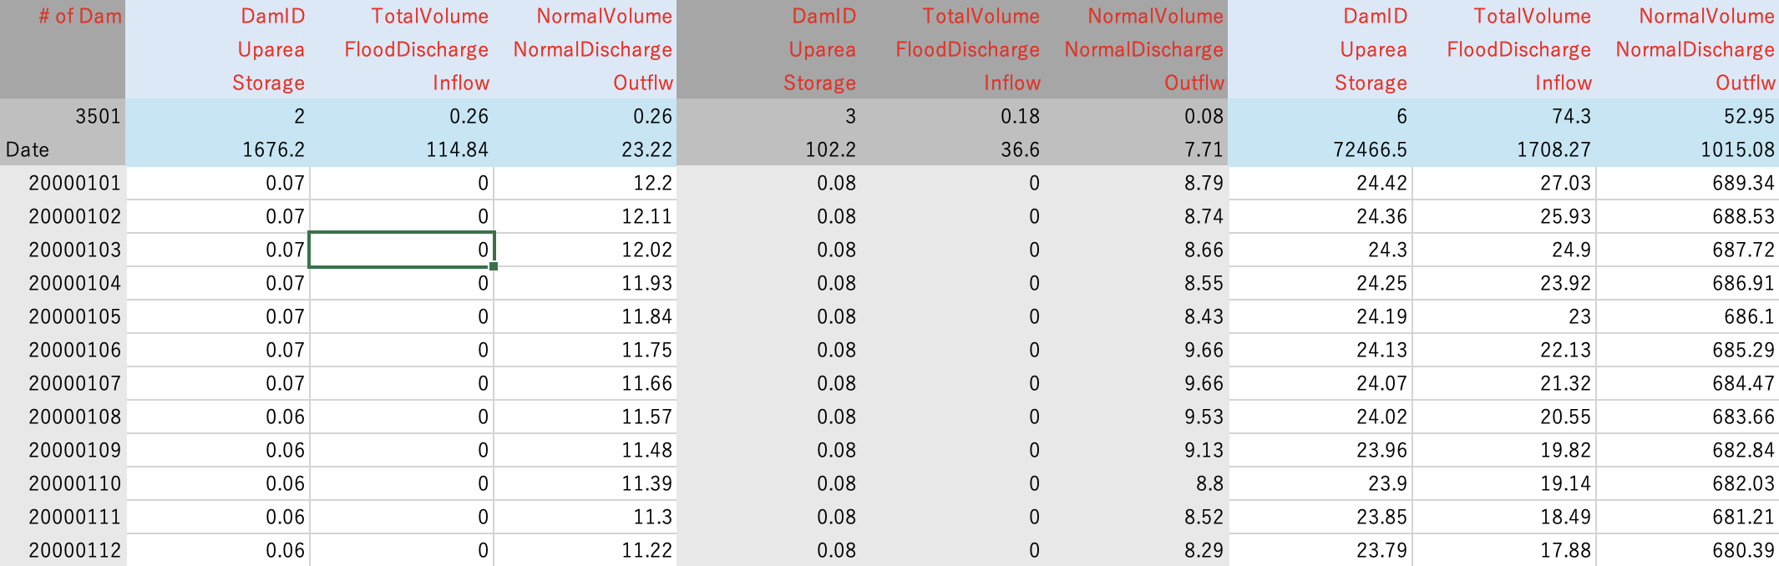
Example of damout-(YYYY).txt. In addition to the timeseries of DamStorage, DamInflow, DamOutflow, basic dam parameters (DamID, TotalVolume & Normal Volume [Million m3], Upstream area [km2], Flood Discharge and Normal Discharge [m3/s]) are written in the top pf the text file.

Options for reservoir operation scheme
Reservoir operation scheme has several options which can be specified in NAMELIST. Please edit gosh script to change the options.

Reservoir operation scheme
The current default reservoir operation scheme is “Funato-Yamazaki scheme” (description paper in preparation). It is the udated version of Hanazaki 2022 scheme.
It is recommended to use Funato-Yamazaki scheme by setting LDAMH22=.FALSE. in shell script
The outflow from reservoir is calculated primary as a function of the reservoir storage. In addition, flood control operation is performed to reduce peak discharge, when inflow to reservoir exceeds the flood control initiation inflow threshold (A1 and A2 in below figure). In addition, Adjustment volume is considered within Flood control volume to increase simulation stability.
Reservoir total volume is divided into three zones (Water use volume, Flood control volume, and Emergency volume). The outflow is decided by the equation corresponding to each volume zone, depending on the status of reservoir storage.
- [A1] Emergency release to avoid dam failure
- [A2] Flood control operation to reduce peak discharge
- [B1 & B2]: After flood event water release
- [AB3] Operation to keep reservoir storage close to the Normal Volume (= max water use capacity). Excess water is released to save flood control capacity.
- [AB4] When water is below the water use volume, water use operation is performed.
Figure: Outflow equations in each reservoir volume zone and inflow condition.

The relationship between reservoir storage and outflow is visualized in the below figure. The new Funato-Yamazaki scheme is designed considering following intentions.
- Fewer number of subjectively determined parameters. Smooth connection between different phases
- Smaller difference between flood control and water use phase. Less sensitivity to Qf parameter.
- Water volume kept close to normal volume in non-flood period.
- Dam outflow becomes more constant in water use phase
Figure: Relationshio betweeb reservoir storage and ourflow

Year-By-Year dam construction scheme
There are two options on how to activate reservoirs in the simulation.

All-reservoirs-in scheme
All reservoirs in the dam parameter list file is represented in simulation.
This scheme can be used by specifying LDAMYBY=.FALSE. in namelist.

Year-By-Year scheme
Reservoirs are activated following the construction year in the dam parameter list.
It is assumed that CaMa-Flood simulation is to be run in yearly-basis. (i.e. 1-year simulation from 1st January to 31st December is performed and terminated with a restart file. The next year simulations is executed using the restart file of the previous year). The reservoirs are activated in 1st January of the construction year specified in the dam parameter list.
The Year-By-Year scheme can be used by specifying LDAMYBY=.TRUE. in namelist.

There are two sub-options for Year-By-Year scheme about how to initialize the storage of the newly activated reservoirs.

[2a] iVzero scheme: Initialize with zero additional storage
When this option is used, the initial storage of the new reservoir is set as “rivsto+fldsto” of the grid where new reservoir is located. This means water budget is closed (no water added or removed by activating reservoir). This scheme is recommended for experiments which requires strict water budget conservation, such as climate model simulations. However, after activating new dam, the inflow to dam is used to fill the reservoir storage, so outflow from dam becomes very small for a while.
This option can be used by specifying LiVnorm=.FALSE. in namelist.

[2b] iVnorm scheme: Initialize with zero additional storage
When this option is used, the initial storage of the new reservoir is set to “Normal Volume” (=Water use volume) of the reservoir specified in dam parameter list.
This scheme can avoid the issues related to reservoir filling procedure. However, water budget is not closed (water is added to the system). This scheme is recommended for experiments which does not require strict water budget conservation, such as flood risk assessment.
This option can be used by specifying LiVnorm=.TRUE. in namelist.

Example of these options is shown in the below figure. The reservoir is activated on the 2nd simulation year (day=365) and the gaps in reservoir outflow are observed depending on which options are used.

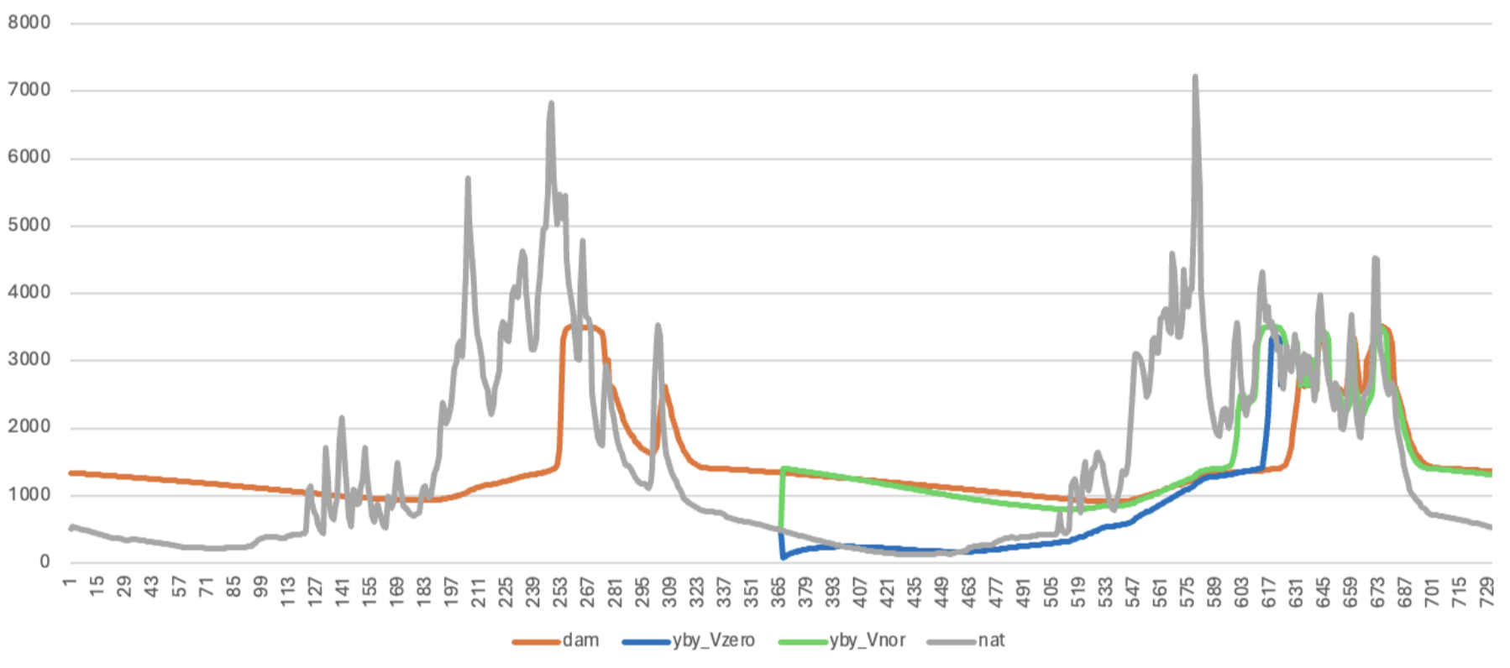
Figure: Example of the simulated reservoir outflow. Nat: naturalized simulation without reservoir. Dam: All-reservoirs-in scheme. YBY-Vzero: Year-By-Year scheme with iVzeo option. YBY-Vnor: Year-By-Year scheme with iVnorm option.

References
- <Funato-Yamazaki scheme>
Paper in preparation

- <Hanazaki 2022 scheme>
Risa Hanazaki, Dai Yamazaki, Kei Yoshimura
Development of a Reservoir Flood Control Scheme for Global Flood Models
Journal of Advances in Modeling Earth Systems, 14(3), e2021MS002944, 2022, DOI: 10.1029/2021MS002944
https://doi.org/10.1029/2021MS002944

