Flood depth downscaling in CaMa-Flood
(Sample codes are available in etc/downscale_flddph/)

<Contents>
# s01-downscale_flddph.sh
Sample script for downscaling
- Global 15min simulation
- Downscale to 1min resolution using high-res topo data (map/glb_15min/1min)
- Target: 2000 Sep

# s11-downscale_duration.sh
Sample script to downscale flood duration.
- Global 15min simulation
- First calculate the depth-day relationshio at each 15min grid, and then downscale the duration at 1min resolution.
- Target 2000,

<Downscaling Method>
Flood depth at each pixel is calculated based on flood depth at the outlet pixel and relative height of each pixel.
As the map data, the low-resolution river network map used for simulation (e.g. glb_06min), and its corresponding high-resolution data for downscaling (e.g. glb_06min/1min/) is needed, in addition to the simulated river water depth or flood depth data to be downscaled.

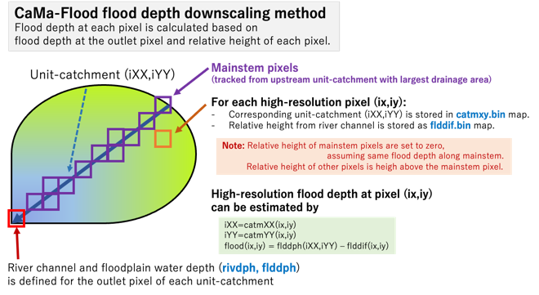

<Advanced downscaling method considering tributary inundation>
In default downscale scheme, only flooding from the mainstem of each unit-catchment is considered. Flooding from tributaries could be under-estimated.
Advanced downscaling scheme is developed in v4.13

