Flood depth downscaling in CaMa-Flood
16 April, 2024
Dai Yamazaki and CaMa-Flood development team
IIS U-Tokyo
In this document, the procedures to downscale floodplain water depth in CaMa-Flood are explained.
Sample codes are available in etc/downscale_flddph/

Contents of the downscaling sample package

s01-downscale_flddph.sh
Sample script for downscaling global 15min simulation to 1min resolution using high-res topo data (map/glb_15min/1min)

s11-downscale_duration.sh
Sample script to downscale flood durationa of global 15min simulation.
First calculate the depth-day relationshio at each 15min grid, and then downscale the duration at 1min resolution.

Downscaling Method
Flood depth at each pixel is calculated based on flood depth at the outlet pixel and relative height of each pixel.
As the map data, the low-resolution river network map used for simulation (e.g. glb_06min), and its corresponding high-resolution data for downscaling (e.g. glb_06min/1min/) is needed, in addition to the simulated river water depth or flood depth data to be downscaled.

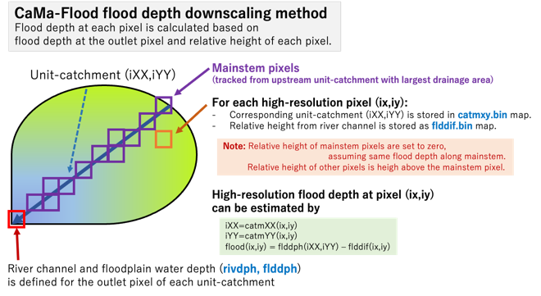

Advanced downscaling method considering tributary inundation
In default downscale scheme, only flooding from the mainstem of each unit-catchment is considered. Flooding from tributaries could be under-estimated.
Advanced downscaling scheme is developed in v4.13

