Procedures to allocate reservoirs on a CaMa-Flood river map (for CaMa-Flood v4.13)

Dai Yamazaki
1st Dec 2023

In this document, the procedures to allocate GRanD reservoirs on a CaMa-Flood river map is described. In addition, same scripts can be used to add reservoirs not included in GRanD database.

Note: The format of dam parameter list file is slightly modified in v4.12 (fldsto/uparea parameter was excluded). Please use a dam parameter list which is generated by the updated script.

- Input data (included in CaMa-Flood package)
List of GRanD reservoirs is available in CaMa-Flood package.
$(CaMa-Flood)/map/data/GRanD_alloc.csv

Some reservoirs have error or mismatch of the attribute data required for allocation (lat, lon, uparea) compared to the MERIT Hydro river map (hydrography basemap for CaMa-Flood). Thus, we corrected the errors or mismatches by allocation reservoirs on 1-min resolution MERIT Hydro data.

The original attribute data is (lat_ori, lon_ori, area_ori), and the corrected data is (lat_MERIT, lon_MERIT, area_MERIT). The corrected attribution data is used to allocate GRanD reservoirs on a CaMa-Flood river map.

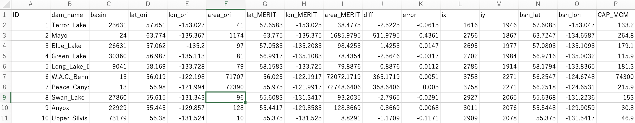
Example of GRanD_alloc.csv file.

- Allocate reservoirs on a CaMa-Flood river map
Please go to your working map directory (e.g. map/glb_15min/).
Then copy map/src/src_param/ directory to your working map directory.

Then, please go to src_param/ directory in your map directory. Then, edit s04-allocate_gauge.sh script, and execute it.
In default, the allocated reservoir list “GRanD_river.txt” and “GRanD_small.txt” are outputted. GRanD_river.txt is for large reservoirs allocated on the mainstem, while GRanD_small.txt represents small reservoirs which cannot be represented in CaMa-Flood unit-catchment.

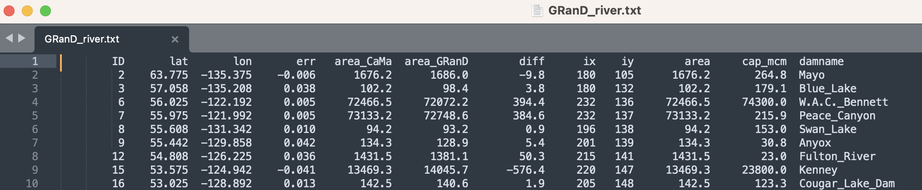
Example of GRanD_river.txt file.

- Prepare dam parameter list.
2.1 Working location
Please go to your working map directory (e.g. map/glb_15min/).
Then copy map/src/src_dam/ directory to your working map directory.

Note: you first need to execute “no reservoir” simulation in order to estimate 100-year return-period discharge.
It is recommended that “no reservoir” is run with the same runoff forcing data and same river channel parameters as “with reservoir” simulation to keep the consistency of the reservoir parameters. The python script in the current reservoir operation package assumes the output are in plain binary format with 1day time step. It’s better to have ~30 years of simulations.

2.2 Please edit the s00-link.sh script, and execute it
Please specify the input files and directories. Note that you need to download Reservoir Geometry data (ReGeom) and Reservoir surface area timeseries (GRSAD). Explanation on how to locate this data is available in s00-link.sh comments.

List of dams to be allocated
Please prepare DAMLIST file (Dam allocated on the CaMa-Flood river map)
(default: DAMLIST=${MAPDIR}/GRanD_river.txt)

NAT simulation: output directory
Execute simulation without dam to calculate mean and flood discharge, using same map data
Output should be plain binary, and outflwYYYY.bin should be saved

GRSAD data (Global Reservoir Surface Area Dataset)
Data can be downloaded below. Please specify the directory where "*_intp" files are located.
https://dataverse.tdl.org/dataset.xhtml?persistentId=doi:10.18738/T8/DF80WG

ReGeom data (Global Reservoir Geometry Database)
Data can be downloaded below. Please specify the directory where "*.csv" data are located.
https://zenodo.org/record/1322884#.YF1owUj7QW_

2.3 Please edit s01-calc_damparam.sh script, and execute it.
You need to set SYEAR,EYEAR,DT of the naturalized simulation.

The Python scripts for (1) calculating annual mean and max discharge at each dam location, (2) calculating 100year discharge at each dam location, (3) estimating normal water storage from satellite data, (4) merging these information into one dam parameter list, (5) finalizing the dam parameter list for use in CaMa-Flood, are executed.

The dam parameter list file is saved as dam_param.csv in your working map directory. CaMa-Flood reservoir operation scheme can be used by specifying this file as CDAMFILE in namelist.
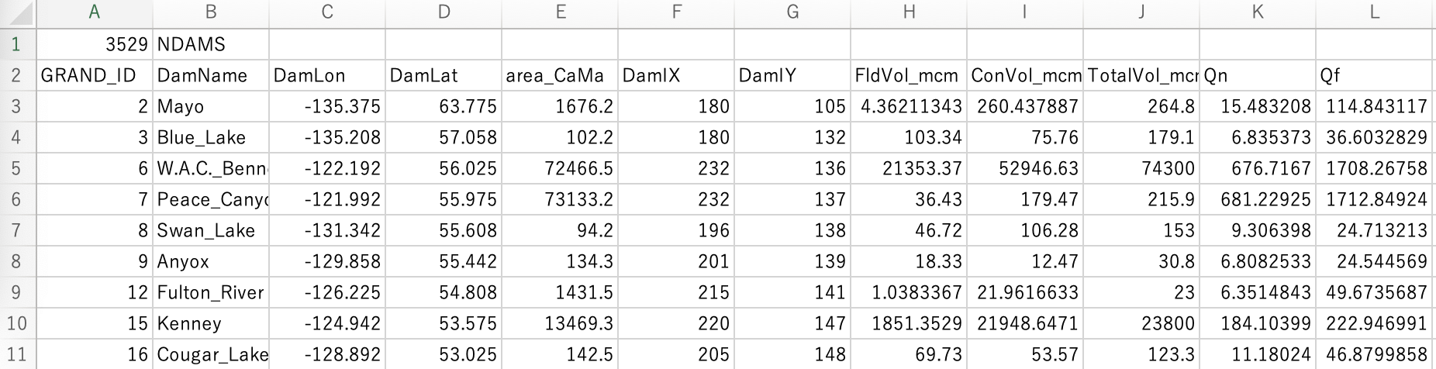
Sample dam parameter list file (CSV)

2.4 If you want to manually modify dam parameters:
Please edit the “dam_params.csv" file, to meet your purpose.

- Add reservoirs not included in GRanD data
Reservoirs not included in GRanD data can be added by adding their information in input reservoir list data. The sample file is prepared as:
$(CaMa-Flood)/map/data/GRanD_alloc+Mekong.csv
Please find the latitude, longitude and upstream area of the new reservoir, using MERIT Hydro river map (or CaMa-Flood 1min river map), and specify the data as lat_MERIT, lon_MERIT, area_MERIT), and provide reservoir capacity in million M³ (CAP_MCM). The other fields can set to undef value (-99). Then please follow the above procedures to allocate reservoirs in CaMa-Flood map, and estimate reservoir parameters.
Note that satellite data to estimate normal water volume is not available for non-GRanD reservoirs. Please set an appropriate value by yourself.
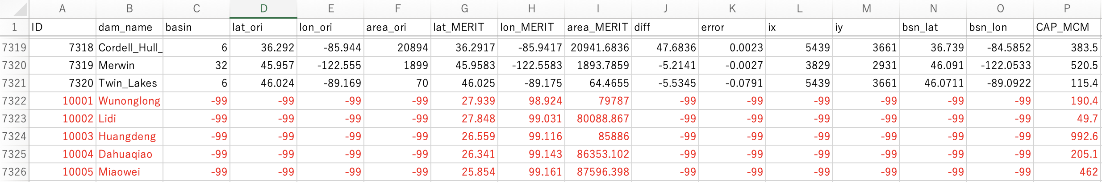
Example of adding new dams on input CSV data

