Guidelines for Preparing a Paper for the
European Conference on Artificial Intelligence
Name1 Surname1 and Name2 Surname2 and Name3 Surname3¹

Abstract. The purpose of this paper is to show a contributor the required style for a paper for ECAI-2012 and PAIS-2012. The specifications for layout are described so that non-LaTeX users can create their own style sheet to achieve the same layout. The source for the sample file is available for LaTeX users. A Microsoft Word template is also available. The PostScript and the PDF file is available for all. The layout is identical to ECAI'10 papers. The publisher (IOS Press) will insert a footer for each page.

PAGE LIMIT
The page limit for ECAI-2012 and PAIS-2012 long papers is 6 (six) pages in the required format. The page limit for short submissions is 2 pages. This is a strict limit. Overlength papers will not be reviewed.

GENERAL SPECIFICATIONS
The following details should allow contributors to set up the general page description for their paper:

- The paper is set in two columns each 20.5 picas (86 mm) wide with a column separator of 1.5 picas (6 mm).
- The typeface is Times Modern Roman.
- The body text size is 9 point (3.15 mm) on a body of 11 point (3.85 mm) (i.e., 61 lines of text).
- The effective text height for each page is 56 picas (237 mm). The first page has less text height. It requires an additional footer space of 3.5 picas (14.8 mm) for the copyright inserted by the publisher and 1.5 picas (6 mm) of space before the title. The effective text height of the first page is 51 picas (216 mm).
- There are no running feet for the final camera-ready version of the paper. The submission paper should have page numbers in the running feet.

TITLE, AUTHOR, AFFILIATION, COPYRIGHT AND RUNNING FEET

Title
The title is set in 20 point (7 mm) bold with leading of 22 point (7.7 mm), centered over the full text measure, with 1.5 picas (6 mm) of space before and after.

Author
The author's name is set in 11 point (3.85 mm) bold with leading of 12 point (4.2 mm), centered over full text measure, with 1.5 picas (6 mm) of space below. A footnote indicator is set in 11 point (3.85 mm) medium and positioned as a superscript character.

Affiliation
The affiliation is set as a footnote to the first column. This is set in 8 point (2.8 mm) medium with leading of 8.6 point (3.1 mm), with a 1 point (0.35 mm) footnote rule to column width.

Copyright
The copyright details will be inserted by the publisher.

Running feet
The running feet are inserted by the publisher. For submission you may insert page numbers in the middle of the running feet. Do not, however, insert page numbers for the camera-ready version of the paper.

ABSTRACT
The abstract for the paper is set in 9 point (3.15 mm) medium, on a body of 10 point (3.5 mm). The word Abstract is set in bold, followed by a full point and a 0.5 pica space.

HEADINGS
Three heading levels have been specified:

- A level headings
  - The first level of heading is set is 11 point (3.85 mm) bold, on a body of 12 point (4.2 mm), 1.5 lines of space above and 0.5 lines of space below.
  - The heading is numbered to one digit with a 1 pica space separating it from the text.
  - The text is keyed in capitals and is unjustified.
- B level headings
  - The second level of heading is set is 11 point (3.85 mm) bold, on a body of 12 point (4.2 mm), 1.5 lines of space above and 0.5 lines of space below.
  - The heading is numbered to two digits separated with a full point, with a 1 pica space separating it from the text.
  - The text is keyed in upper and lower case with an initial capital for first word only, and is unjustified.
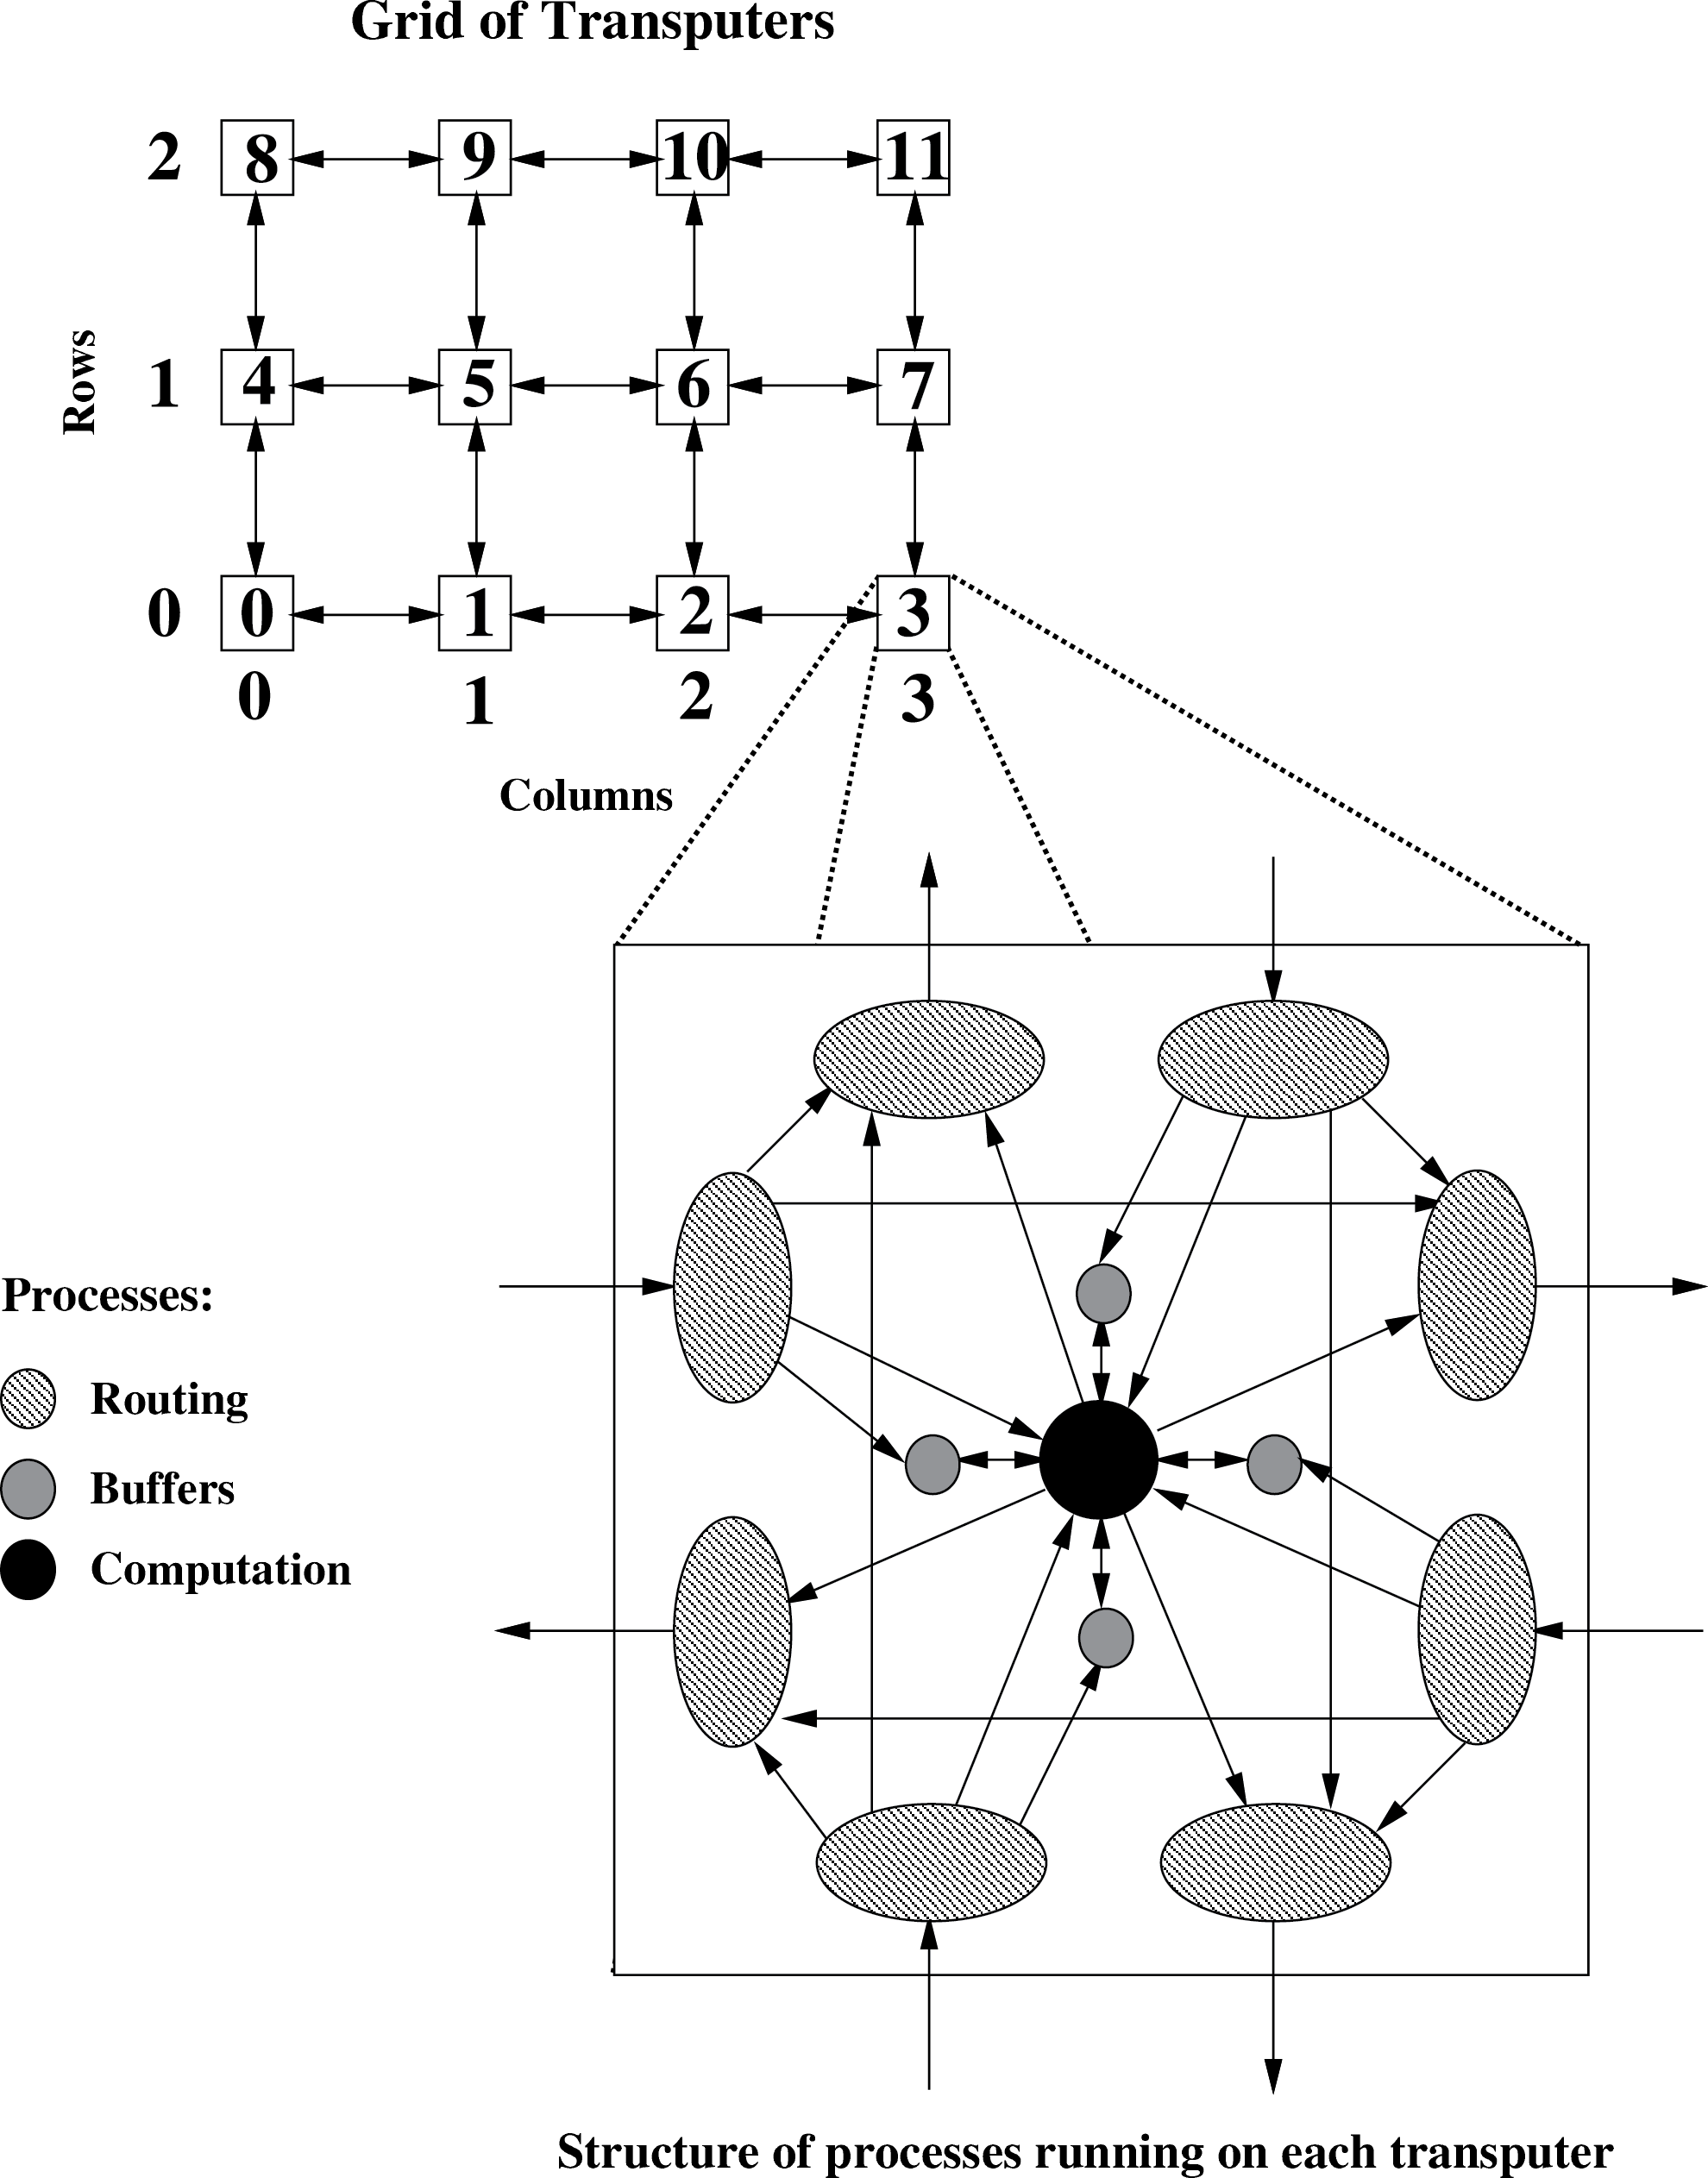
- C level headings
  - The third level of heading is set is 10 point (3.5 mm) italic, on a body of 11 point (3.85 mm), 1.5 lines of space above and 0.5 lines of space below.
  - The heading is numbered to three digits separated with a full point, with a 1 pica space separating it from the text.
  - The text is keyed in upper and lower case with an initial capital for first word only, and is unjustified.
- Acknowledgements
This heading is the same style as an A level heading but is not numbered.

TEXT
The first paragraph of text following any heading is set to the
complete measure (i.e., do not indent the first line).
Subsequent paragraphs are set with the first line indented by 1 pica (3.85 mm).
There isn't any inter-paragraph spacing.

LISTS
The list identifier may be an arabic number, a bullet, an em
rule or a roman numeral.
The items in a list are set in text size and indented by 1 pica (4.2 mm) from the left margin. Half a line of space is set above and below the list to separate it from surrounding text.
See layout of Section 5 on headings to see the results of the list macros.

TABLES
Tables are set in 8 point (2.8 mm) on a body of 10 point (3.5 mm). The table caption is set centered at the start of the table, with the word Table and the number in bold. The caption is set in medium with a 1 pica (4.2 mm) space separating it from the table number.
A one line space separates the table from surrounding text.

Table 1. The table caption is centered on the table measure. If it extends to two lines each is centered.
 | Processors
 | 1 |  | 2 |  |  | 4
Window | ◊ | ◊ | □ | ○ | ◊ | □ | ◊
1 | 1273 | 110 | 21.79 | 89% | 6717 | 22.42 | 61%
2 | 2145 | 116 | 10.99 | 50% | 5386 | 10.77 | 19%
3 | 3014 | 117 | 41.77 | 89% | 7783 | 42.31 | 58%
4 | 4753 | 151 | 71.55 | 77% | 7477 | 61.97 | 49%
5 | 5576 | 148 | 61.60 | 80% | 7551 | 91.80 | 45%
◊ execution time in ticks □ speed-up values ○ efficiency values

FIGURES
A figure caption is set centered in 8 point (2.8 mm) medium on a leading of 10 point (3.5 mm). It is set under the figure, with the word Figure and the number in bold and with a 1 pica (4.2 mm) space separating the caption text from the figure number.
One line of space separates the figure from the caption. A one line space separates the figure from surrounding text.

Figure 1. Network of transputers and the structure of individual processes

EQUATIONS
A display equation is numbered, using arabic numbers in parentheses. It is centered and set with one line of space above and below to separate it from surrounding text. The following example is a simple single line equation:

Ax=b | (1)

The next example is a multi-line equation:

(x + y)(x – y) | = x² – xy + xy – y² | (2)
(x + y)² | = x² + 2xy + y² | (3)

The equal signs are aligned in a multi-line equation.

PROGRAM LISTINGS
Program listings are set in 9 point (3.15 mm) Courier on a leading of 11 point (3.85 mm). That is to say, a non-proportional font is used to ensure the correct alignment.
A one line space separates the program listing from surrounding text.
void inc(x)
int* x;
{
*x++;
}

int y = 1;
inc(&y);
printf("%d\n",y);

THEOREMS
The text of a theorem is set in 9 point (3.15 mm) italic on a leading of 11 point (3.85 mm). The word Theorem and its number are set in 9 point (3.15 mm) bold.
A one line space separates the theorem from surrounding text.

Theorem 1 Let us assume this is a valid theorem. In reality it is a piece of text set in the theorem environment.

FOOTNOTES
Footnotes are set in 8 point (2.8 mm) medium with leading of 8.6 point (3.1 mm), with a 1 point (0.35 mm) footnote rule to column width.

REFERENCES
The reference identifier in the text is set as a sequential number in square brackets. The reference entry itself is set in 8 point (2.8 mm) with a leading of 10 point (3.5 mm), and appears in the sequence in which it is cited in the paper.

Subsection

Subsubsection
This subsubsection is only here to show an example of its C level heading.
ACKNOWLEDGEMENTS
We would like to thank the referees for their comments, which helped improve this paper considerably. Thanks also to Matthijs van Leeuwen for creating the Microsoft Word version of this document.
REFERENCES
- L. Adams, ‘m-Step preconditioned Gradient methods’, SIAM Journal of Scientific and Statistical Computing, 6, 452–463, (1985).
- P. Atkin. Performance maximisation. INMOS Technical Note 17.
- R.D. da Cunha and T.R. Hopkins, The Parallel Solution of Partial Differential Equations on Transputer Networks, 96–109, Transputing for Numerical and Neural Network Applications, IOS Press, Amsterdam, 1992. Also as Report No. 17/92, Computing Laboratory, University of Kent at Canterbury, U.K.
- R.D. da Cunha and T.R. Hopkins, The Parallel Solution of Systems of Linear Equations using Iterative Methods on Transputer Networks, 1–13, Transputing for Numerical and Neural Network Applications, IOS Press, Amsterdam, 1992. Also as Report No. 16/92, Computing Laboratory, University of Kent at Canterbury, U.K.
- U. de Carlini and U. Villano, Transputers and parallel architectures – message-passing distributed systems, Ellis Horwood, Chichester, 1991.
- S.C. Eisenstat, ‘Efficient implementation of a class of preconditioned Conjugate Gradient methods’, SIAM Journal of Scientific and Statistical Computing, 2, 1–4, (1981).
- G.H. Golub and C.F. Van Loan, Matrix Computations, Johns Hopkins University Press, Baltimore, 2nd edn., 1989.
- O.G. Johnson, C.A. Micchelli, and G. Paul, ‘Polynomial preconditioners for Conjugate Gradient calculations’, SIAM Journal of Numerical Analysis, 20, 362–376, (1983).

Computer Science department, Katholieke Universiteit Leuven, Belgium, email: somename@cs.kuleuven.be
This is an example of a footnote that occurs in the text. If the text runs to two lines the second line aligns with the start of text in the first line.

