week9

Dana Tomeh

3/22/2020

# Libraries

# Data Import

+data imported as a tibble + timeStart was converted to posixCT + gender was converted to a factor + condition was converted to a factor +Column Q1Q5means was added that contains the means of the responses on Q1 to Q5 for each person in the dataset +Column Q6Q10means was added that contains the means of the responses on Q6 to Q10 for each person in the dataset +filtered for q6==1

week9_tbl <- as_tibble(read_csv("../data/week3.csv"))

## Parsed with column specification:  
## cols(  
## timeStart = col_character(),  
## timeEnd = col_datetime(format = ""),  
## condition = col_character(),  
## gender = col_character(),  
## q1 = col_double(),  
## q2 = col_double(),  
## q3 = col_double(),  
## q4 = col_double(),  
## q5 = col_double(),  
## q6 = col_double(),  
## q7 = col_double(),  
## q8 = col_double(),  
## q9 = col_double(),  
## q10 = col_double()  
## )

week9_tbl_clean <- week9_tbl %>%  
 mutate(timeStart=ymd_hms(timeStart),  
 gender=factor(gender,levels=c("M","F"),labels=c("Male","Female")),  
 condition=factor(condition,levels=c("A","B","C"), labels=c("Block A","Block B","Control")),  
 Q1Q5means =rowMeans(week9_tbl[5:9]),  
 Q6Q10means=rowMeans(week9_tbl[10:14])) %>%  
 filter(q6==1)

# Visualization

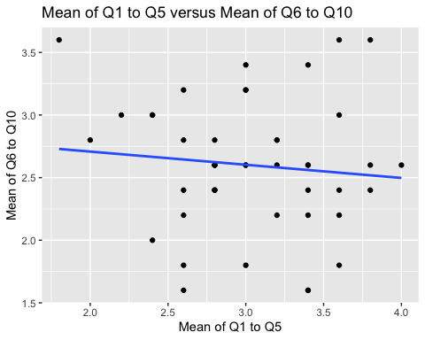 This plot contains the means of questions 1 through 5 plotted against the means of questions 6 through ten.

# Analysis

mean_cor <- cor.test(week9_tbl_clean$Q1Q5means, week9_tbl_clean$Q6Q10means)  
mean_cor$estimate

## cor   
## -0.100891

mean_cor$p.value

## [1] 0.5046764

The correlation was mean_cor$p.value and (p= mean_cor$p.value), which is not statistically significant.