Mall Membership System - Project Documentation

VI. Entity Relationship Diagram (ERD)
The database structure of the Mall Membership System handles customers, administrative permissions, merchant shops, product listings, loyalty points-based transactions, reward definitions, reward redemptions, and system-level notifications.

1. Database Entities & Attributes
Users, Admins, Memberships, Shops, Products, Transactions, Rewards, Reward Redemptions, Notifications, Events.

2. Relationships Model Diagram
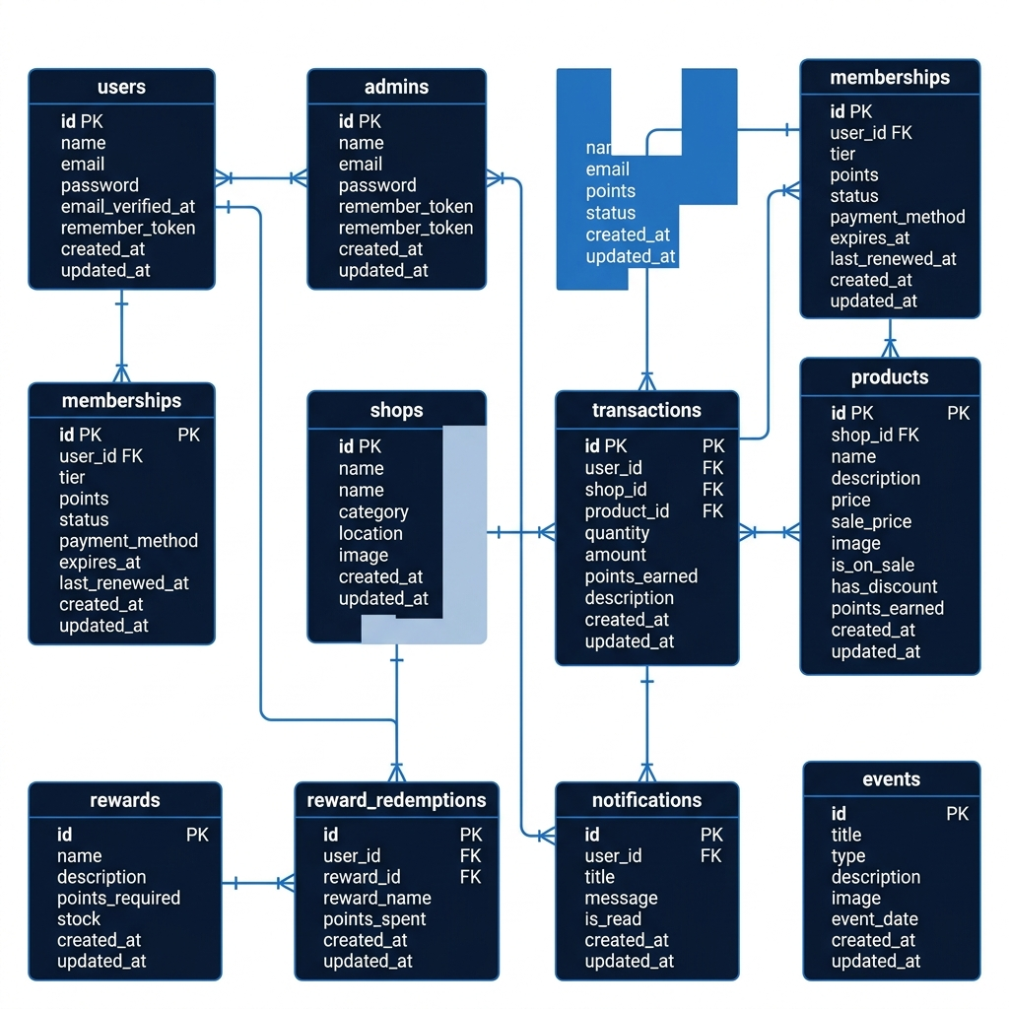

VII. User Interface Manual
This manual provides a detailed step-by-step user guide for customer members and system administrators.

1. Key Navigation Flows
Guest Navigation & Landing Page: Access the root URL. Browse shops and rewards.
Customer Portal Flow: Register, Login, Apply for Membership, View Dashboard, Purchase Products, Claim Rewards.
Administrator Portal Flow: Admin Login, Dashboard Statistics, Moderate Memberships, Manage Shops, Manage Rewards.

VIII. Gantt Chart
The project development was executed over a 4-week lifecycle involving requirements, database setups, UI styling, MVC implementation, and integration testing.
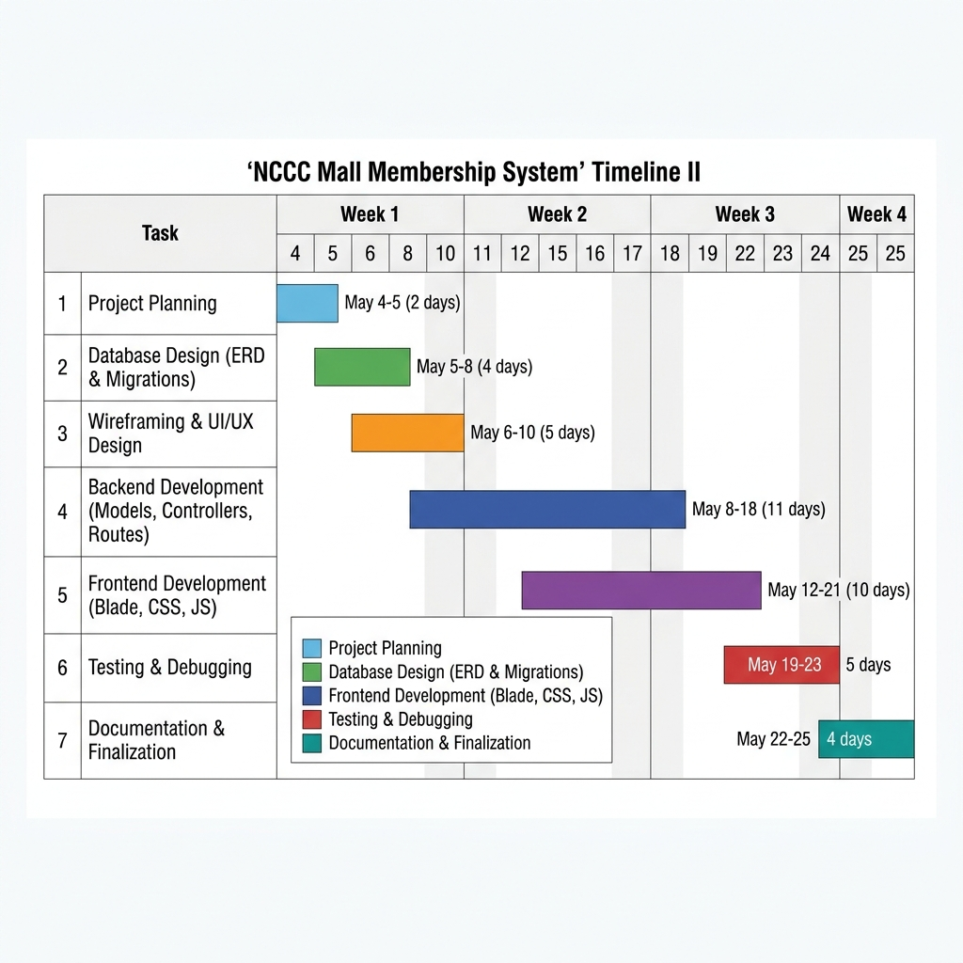

IX. UI/UX
Below are high-quality visual representations of each main application interface.

1. Public Landing Page
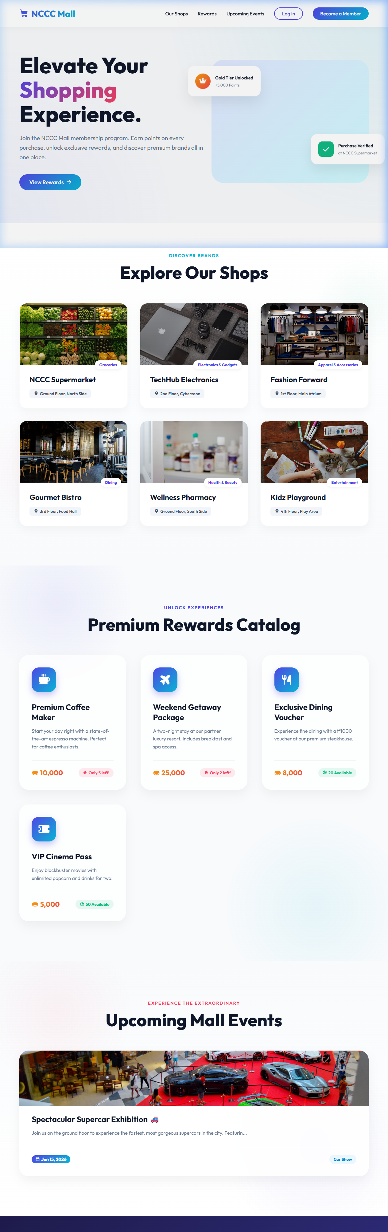

2. Admin Login Page
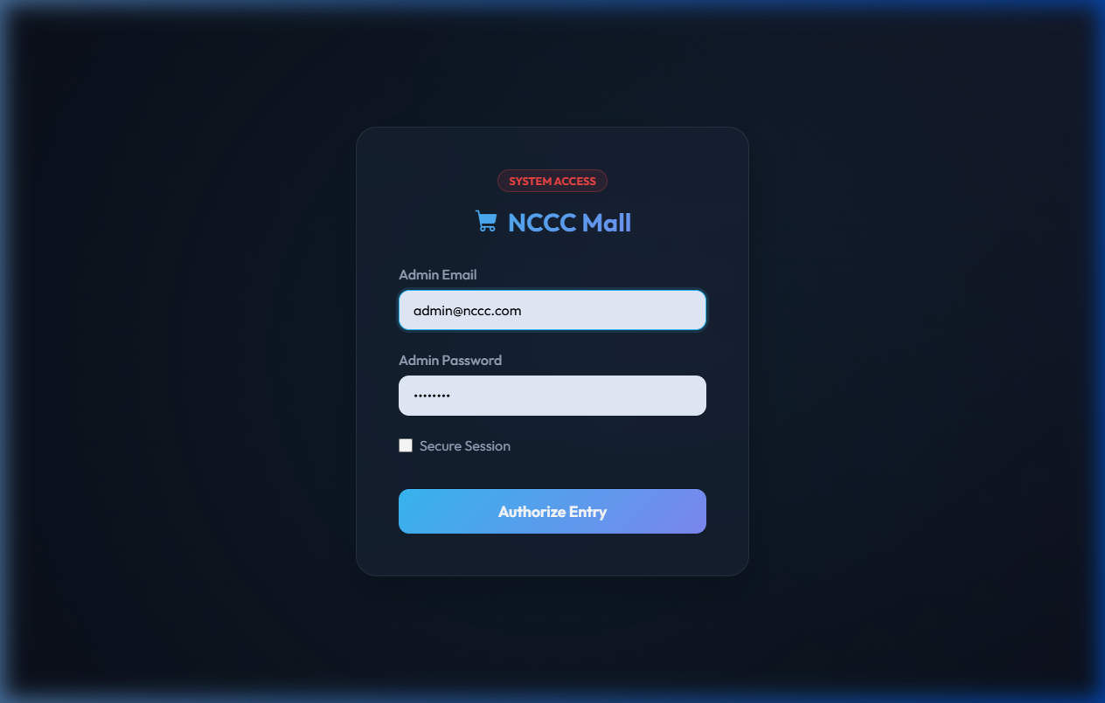

3. Admin Dashboard
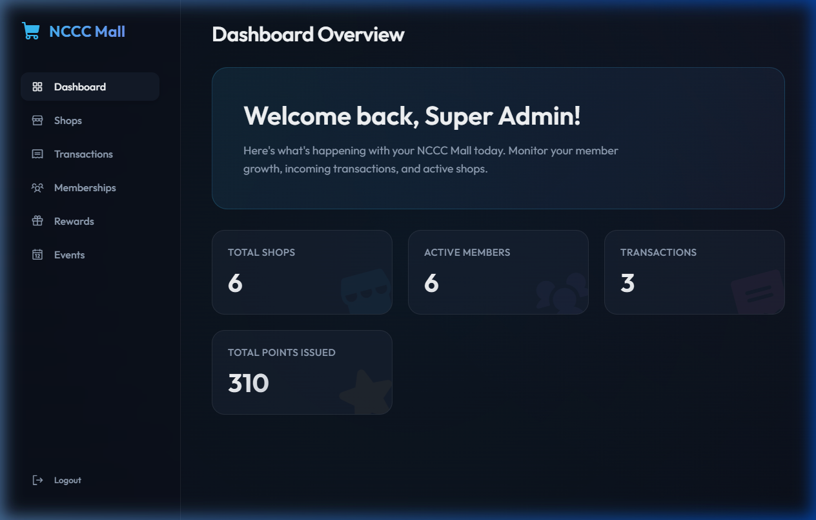

4. Admin Member Directory
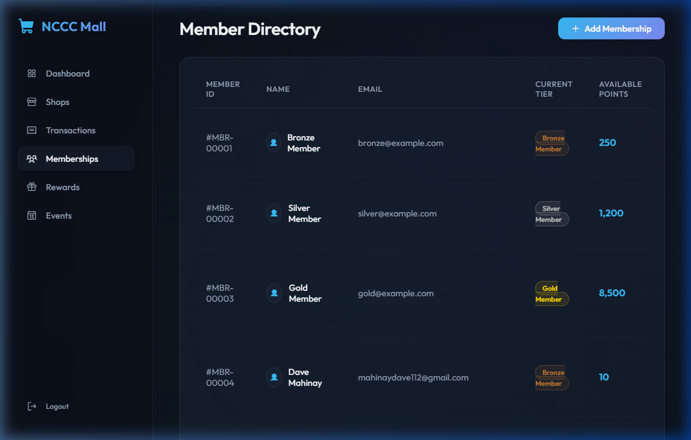

5. Admin Manage Shops
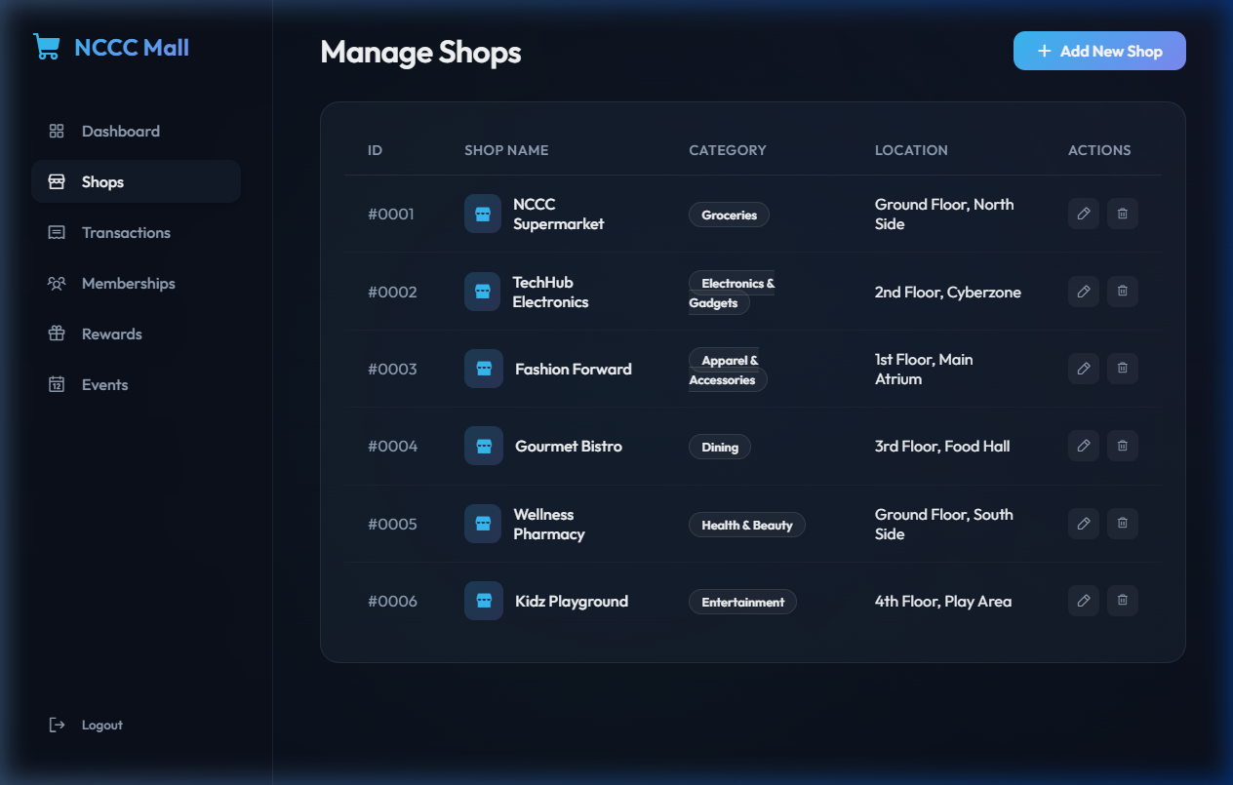

6. Admin Manage Rewards
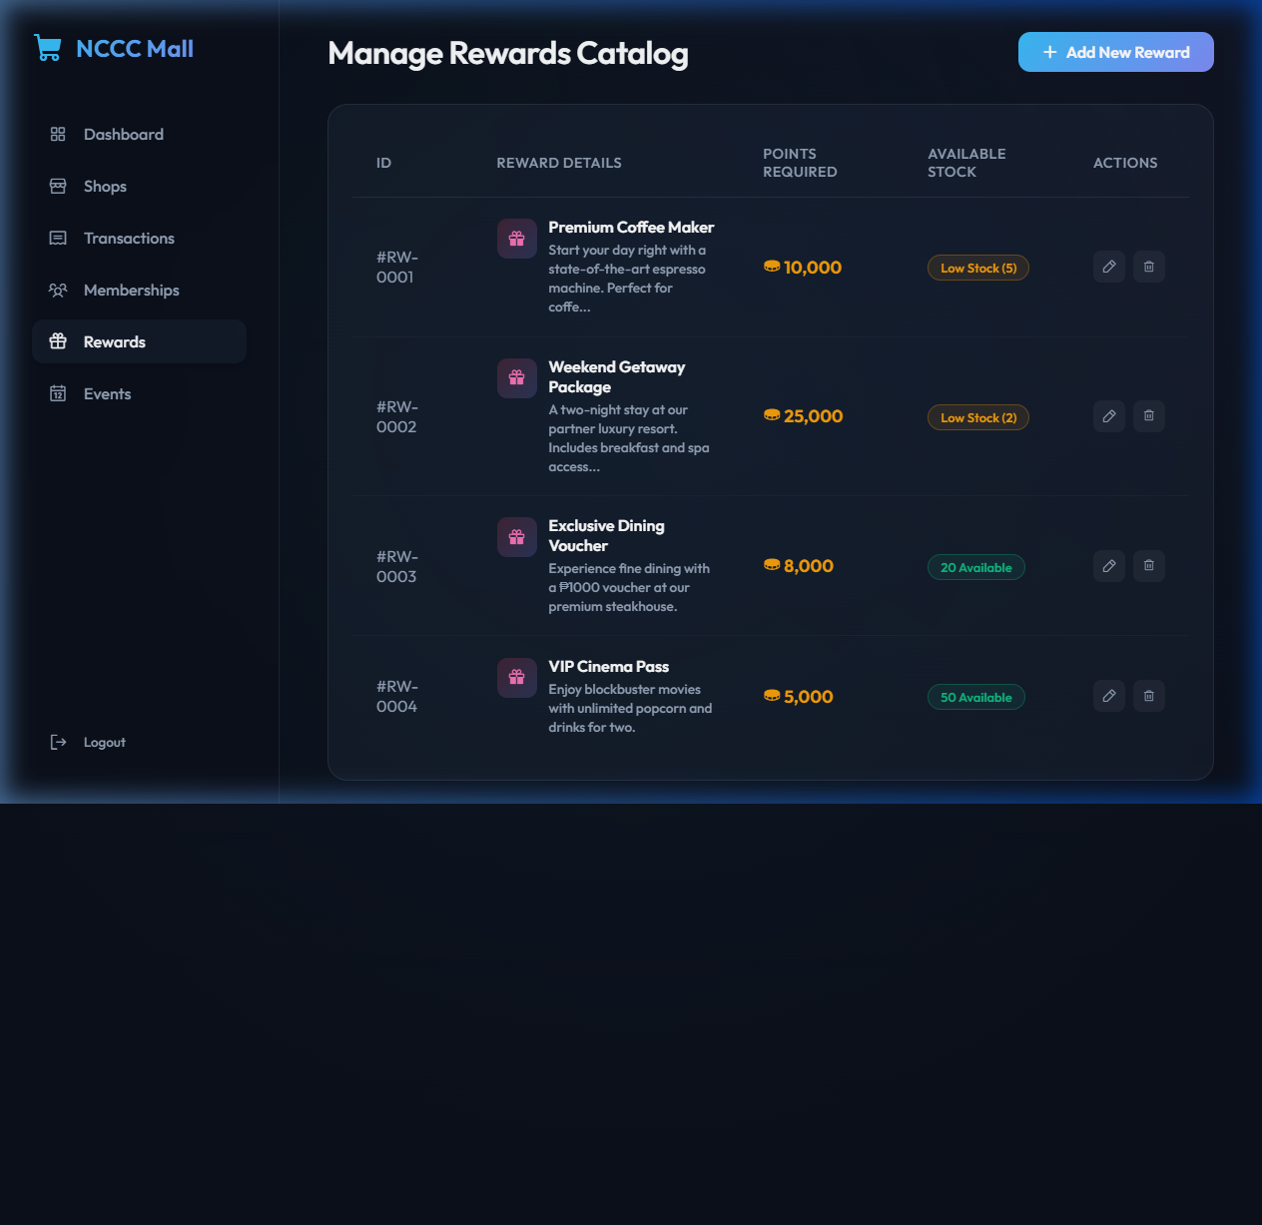

7. Admin Transactions
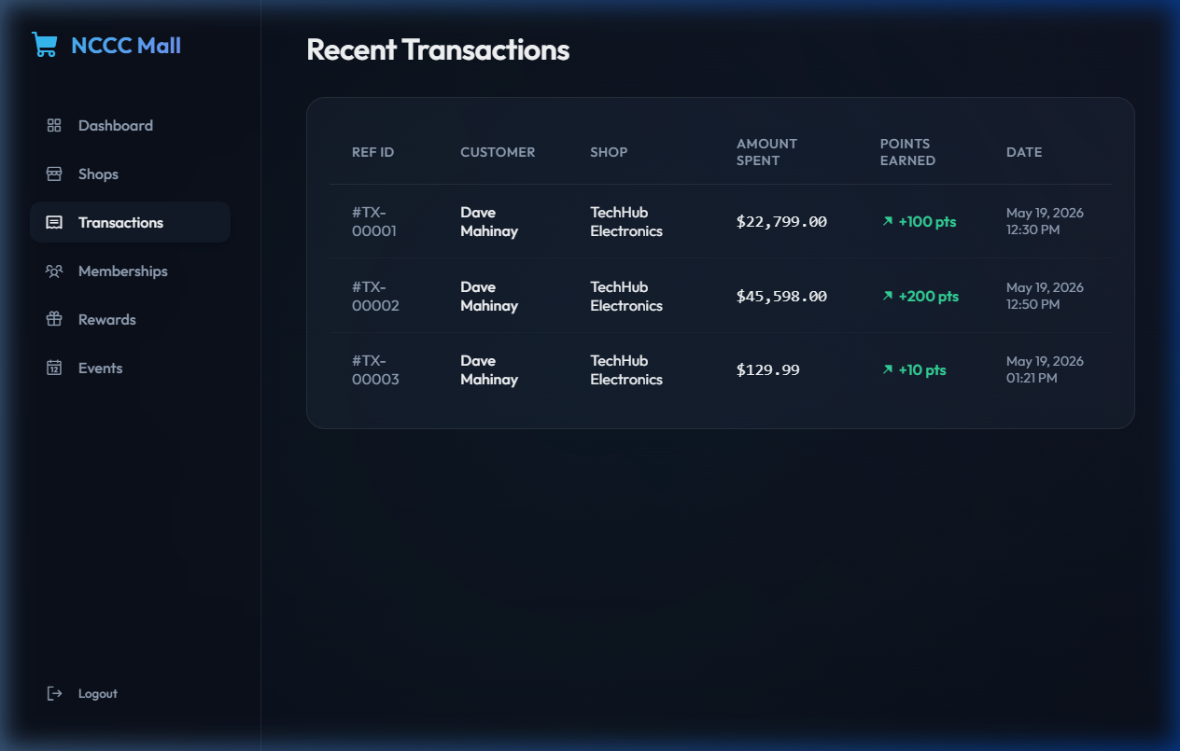

8. Admin Events
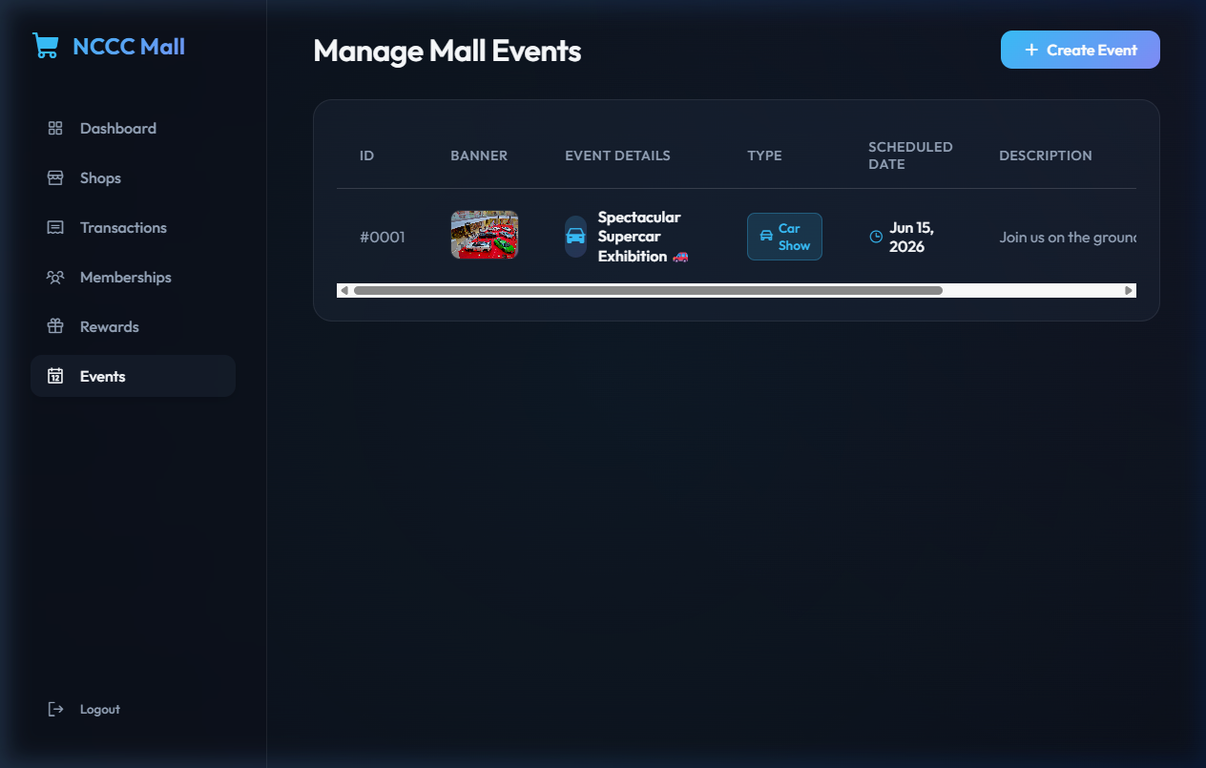

9. Customer Login
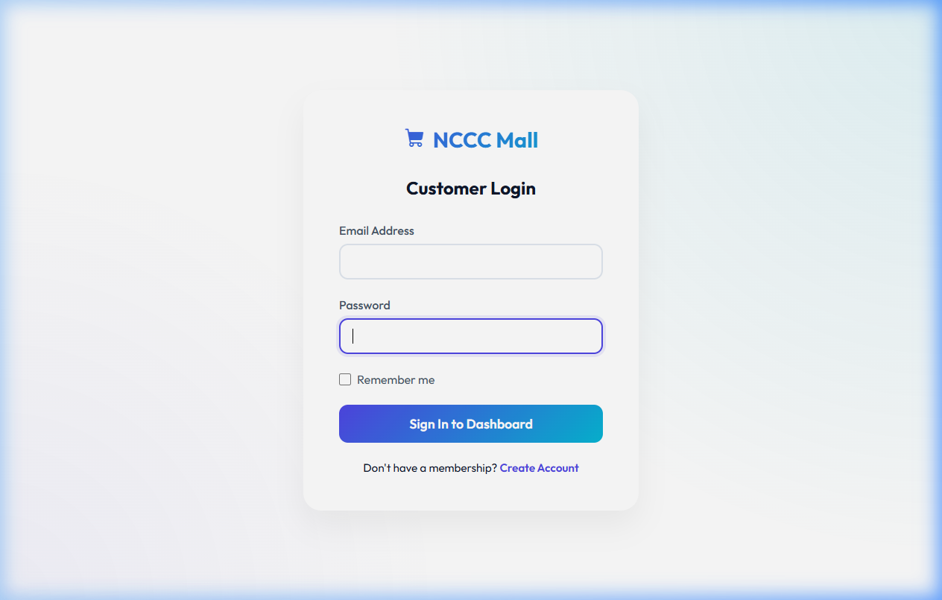

10. Customer Registration
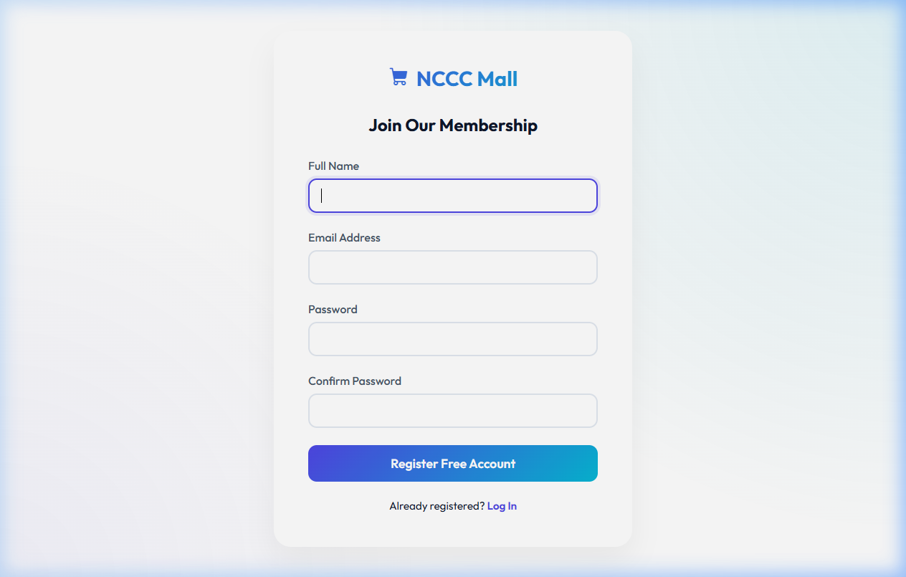

11. Member Dashboard
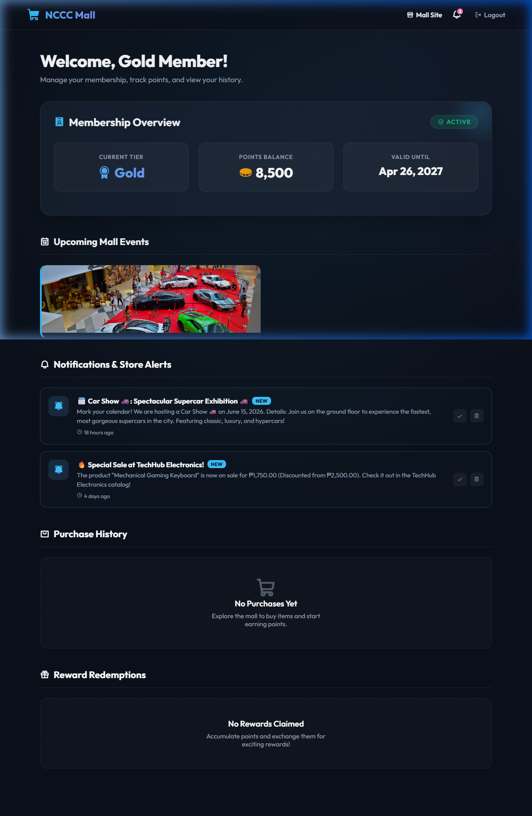

12. Apply for Membership
