

**Software Process, SOEN 341/4 S, Winter 2016**

Dr. Shang

Dr. Fancott

Mr. Morse

**TimeTurner** by team YAWD



**Project Testing and Delivery Document – Deliverable 3**

|  |  |
| --- | --- |
| **Team members information** | |
| **Name** | **SID** |
| **Aline Koftikian** | **27764162** |
| **Bryce Drewery-Schoeler** | **27283199** |
| **Claudia Della Serra** | **26766048** |
| **Daniel Di Corpo** | **26331602** |
| **Dimitri Topaloglou** | **29358269** |
| **Erin Benderoff** | **27768478** |
| **Ideawin-Bunthy Koun** | **26314155** |
| **Kevin Yasmine** | **27195346** |
| **Lori Dalkin** | **27738293** |
| **Marc-Andre Leclair** | **27754876** |
| **Philip Lim** | **27485506** |
| **Ryan Lee** | **27752504** |

Grading Sheet

|  |  |  |
| --- | --- | --- |
| Section | Evaluation criteria (see instructions in the template for details) | Grading |
| all | 10 marks are allocated for excellence, professionalism and quality of work above and beyond the correct meeting of specifications.. | /10 |
| 1 | Presentation of this document | /5 |
| 2 | Completeness and accuracy with regard to initial project description | /1 |
| 3.1 .  .  3.2  3.3 | Completeness and accuracy of the project functional requirements expressed as formal use cases, including difficulty and importance indicators  completeness and accuracy of the diagram and description of the domain model  completeness and accuracy with regard to initial project description accuracy with regard to initial project description, difficulty and importance ratings | /15  .  /3 .  /1 |
| 4.1 | Description of all team members’ capacities and schedule restrictions | /1 |
| 5 | List of goals removed from the project.  For each goal removed, give justifications in light of the resources available | /`1 |
| 6.1 .  6.2 | Clarity of textual description, validity of rationale, clarity and appropriateness of diagram, list of modules responsibilities  List of technologies used, validity of rationale | /2 .  /1 |
| 7.1 .  7.2 .  7.3 .  7.4  7.5  7.6 | Completeness of list of activities, clarity of their stated purpose, as well as statement of what artifacts they are producing  Completeness of list of artifacts to be produced during the project, validity of roles description of each artifact  Cost estimation of each individual artifact, validity of explanation of cost estimation, total cost estimate  Mapping of activities to individual project members  Accurate and complete presentation of milestones  *Assessment of risks `* | /1 .  /2 .  /2 .  /1  /1  /1 |
| 8 | Early Prototyping | /2 |
| Total |  | /50 |

DO NOT REMOVE THIS PAGE WHEN SUBMITTING YOUR DOCUMENT

**TABLE OF CONTENTS**

1. Introduction 4

2. Project Description 4

3. Testing Report 5

3.1 Test Coverage 5

3.1.1 Tested Items 5

3.1.2 Untested Items of Interest 5

3.2 Test Cases 5

3.2.1 3.2.1 Unit Testing 5

3.2.2 3.2.2 Requirements Testing 5

3.2.3 3.3.3 Stress Testing 5

3.2.4 3.3.4 Security Testing 5

4. System Delivery 5

4.1 Installation Manual 5

4.2 User Manual 6

5. Final Cost Estimation 6

# Introduction

# Project Description

The proposed and outlined web application, known as TimeTurner, is designed to auto-generate a student’s course sequence from their first semester up until the end of their degree. It takes into account user input preferences and and any previously completed courses or course prerequisites before creating this sequence. Preferences can be made by the student and include options such as night classes or having particular days off. The application will notify the user if a certain preference suggested results in an impossibility or conflict in the sequence. This sequence generator will be able to create a sequence at any point throughout the user’s degree, if sudden change in circumstances were to arise.

The goal of this application is to simplify the method with which students may decide and schedule their courses. If a course must be redone, the generator can decide what other courses should move where in regards to the remaining courses to be completed, which can be done in seconds, rather than hours. It saves the time of the user, in a simple and efficient manner. Ultimately, the system’s end goal will be to simplify a student’s task of creating their own course schedule in order to allow students to redirect their time to other more important activities, thus making course registration much simpler, quicker, and easier.

# Testing Report

## Test Coverage

Tested Items

Untested Items of Interest

## Test Cases

3.2.1 Unit Testing

3.2.2 Requirements Testing

3.2.2.5 View Course Sequence

|  |  |  |  |  |  |
| --- | --- | --- | --- | --- | --- |
| **~~UC5~~** | | **~~View Course Sequence~~** | | | |
| ~~Test ID~~ | ~~Description~~ | | ~~Expected Output~~ | ~~Actual Output~~ | ~~Result~~ |
| ~~5.1~~ | ~~Student requests to view course sequence with no saved schedule~~ | | ~~Course sequence is displayed~~ |  |  |
| ~~5.2~~ | ~~Student requests to view course sequence after adding a course~~ | | ~~Course sequence is displayed~~ |  |  |
| ~~5.3~~ | ~~Student requests to view course sequence after dropping a course~~ | | ~~Course sequence is displayed~~ |  |  |
| ~~5.4~~ | ~~Student requests to view course sequence after dropping all courses~~ | | ~~Course sequence is displayed~~ |  |  |

3.2.2.8 View Academic Record

|  |  |  |  |  |  |
| --- | --- | --- | --- | --- | --- |
| **UC8** | | **View Academic Record** | | | |
| Test ID | Description | | Expected Output | Actual Output | Result |
| 8.1 | Student requests to view Academic Record | | Page with a record of classes passed and the student’s gpa is displayed | Page with a record of classes is displayed, but no classes on the record | Pass (with errors when no classes completed) |

3.2.2.9 Drop Course

|  |  |  |  |  |  |
| --- | --- | --- | --- | --- | --- |
| **UC9** | | **Drop Course** | | | |
| Test ID | Description | | Expected Output | Actual Output | Result |
| 9.1 | Student requests to drop a non-prerequisite course, and confirms the choice | | Updated schedule is produced and displayed | Updated schedule is produced and displayed | Pass |
| 9.2 | Student requests to drop a non-prerequisite course, and cancels the confirmation dialog box | | Same schedule is displayed | Same schedule is displayed | Pass |
| 9.3 | Student requests to drop a course that is a prerequisite to another course saved later in the schedule, and confirms the choice | | Message indicating that that course could not be dropped due to it being a prerequisite for a later course that’s saved is displayed | The course is successfully dropped from the schedule, and the course requiring that prerequisite stays in the schedule | Fail |

3.2.2.13 Manage Courses (Administrator)

|  |  |  |  |  |  |
| --- | --- | --- | --- | --- | --- |
| **UC13** | | **Manage Courses** | | | |
| Test ID | Description | | Expected Output | Actual Output | Result |
| 13.1 | Administrator requests to manage courses | | Course management page is displayed | Course management page is displayed | Pass |
| 13.2 | Administrator enters an existing course I.D. to the search bar | | Course with the given I.D. is displayed, along with an option to edit the course | Course with the given I.D. is displayed, along with the course code, course description, and an option to view, edit, or delete the course | Pass |
| 13.3 | Administrator enters a non-existent course I.D. to the search bar | | Message indicating that a course with that I.D. does not exist | “No results found” message is displayed | Pass |
| 13.4 | Administrator enters an existent course code to the search bar | | Course with the given code is displayed, along with an option to edit the course | Course with the given code is displayed, along with the course I.D., course description, and an option to view, edit, or delete the course | Pass |
| 13.5 | Administrator enters a non-existent course code to the search bar | | Message indicating that a course with that course code does not exist | “No results found” message is displayed | Pass |
| 13.6 | Administrator enters an existent course description to the search bar | | Course with the given description is displayed, along with an option to edit the course | Course with the given description is displayed, along with the course I.D., course code, and an option to view, edit, or delete the course | Pass |
| 13.7 | Administrator enters a non-existent course description to the search bar | | Message indicating that a course with that description does not exist | “No results found” message is displayed | Pass |
| 13.8 | Administrator requests to delete a course and confirms dialog box | | Updated course bank without the deleted course is produced and displayed | Updated course bank without the deleted course is produced and displayed | Pass |
| 13.9 | Administrator requests to delete a course and cancels dialog box | | Same course bank including the chosen course is displayed with no changes | Same screen as before requesting course deletion is displayed | Pass |
| 13.10 | Administrator requests to update a course | | Course editing page is displayed | Course editing page is displayed | Pass |
| 13.11 | Administrator edits the course code of a course | | Updated course bank with the new code is produced and displayed | Updated course details with the new course code is displayed | Pass |
| 13.11 | Administrator edits the course code of a course | | Updated course bank with the new description is produced and displayed | Updated course details with the new course description is displayed | Pass |
| 13.12 | Administrator edits the number of credits of a course | | Updated course bank with the new number of credits is produced and displayed | Updated course details is displayed, and the new number of credits is produced | Pass |
| 13.13 | Administrator edits the type of the course | | Updated course bank with the new course type is produced and displayed | Updated course details is displayed, and the new course type is produced | Pass |

3.2.2.14 Create Course (Administrator)

|  |  |  |  |  |  |
| --- | --- | --- | --- | --- | --- |
| **UC14** | | **Create Course** | | | |
| Test ID | Description | | Expected Output | Actual Output | Result |
| 14.1 | Administrator requests to create a course | | Course creation page is displayed | Create Course page is displayed | Pass |
| 14.2 | Administrator enters a course ID, description and amount of credits | | Course info is registered and displayed | Course info is registered and displayed | Pass |
| 14.3 | Administrator enters a description and credits, but no course ID | | Error message indicating the course ID field has been left blank | Please fix the following input errors:   * Course Code cannot be blank. | Pass |
| 14.4 | Administrator enters a course ID and credits, but no description | | Error message indicating the description field has been left blank | Please fix the following input errors:   * Course Description cannot be blank. | Pass |
| 14.5 | Administrator enters a course ID and description, but no credits | | Error message indicating the credits field has been left blank | Please fix the following input errors:   * Credits cannot be blank. | Pass |

3.2.2.15 View Courses (Administrator)

|  |  |  |  |  |  |
| --- | --- | --- | --- | --- | --- |
| **UC15** | | **View Courses** | | | |
| Test ID | Description | | Expected Output | Actual Output | Result |
| 15.1 | Administrator requests to view courses | | List of all courses in the system is displayed | List of all courses in the system is displayed | Pass |
| 15.2 | Administrator clicks the create course link | | Create course page is displayed | Create course page is displayed | Pass |
| 15.3 | Administrator clicks the manage course link | | Manage courses page is displayed | Manage courses page is displayed | Pass |
| 15.4 | Administrator clicks on a course prerequisite | | Course information for that course is displayed | Course information for that course is displayed | Pass |

3.3.3 Stress Testing

3.3.4 Security Testing

# System Delivery

## Installation Manual

## User Manual

4.2.8 View Academic Record

A student wishing to view their academic record and/or GPA may do so from the ‘Profile’ tab (See Figure 1).

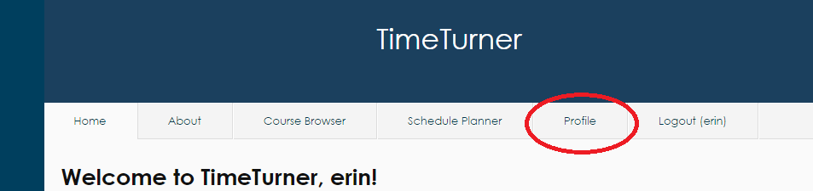

*Figure 1. Profile Tab located second from right at the top of the screen*

Once on the ‘Profile’ page, the student may click on the ‘View Academic Record’ displayed at the far right of the page (see Figure 2). Clicking this link will result in the display of all classes that the student has completed, as well as their grades for each course, and their GPA.

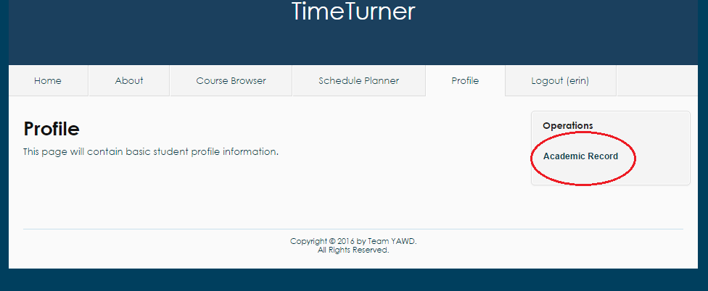

*Figure 2. Academic Record link in ‘Operations’ on far right of ‘Profile’ screen*

4.2.9 Drop Course

A student that is logged in the system and has at least one saved schedule containing at least one course has the option to drop a course. They can do so by clicking on the “View Saved Schedules” option in the Schedule Planner tab. The option appears on the right hand side of the Schedule Planner page (see Figure 1).

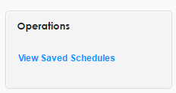

*Figure 1. View Saved Schedules operation*

A page displaying all currently saved schedules for the student is displayed. To choose the schedule from which a course will be dropped, the “View” option should be selected. It appears to the right of each saved schedule (See Figure 2).

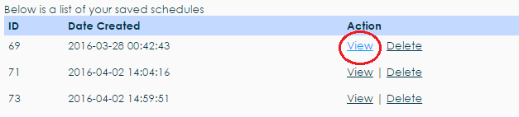

*Figure 2. View Saved Schedule action*

The selected saved schedule will load, displaying all courses that are currently in that schedule. Each course has a “Drop” option to the right of the number of credits (see Figure 3).

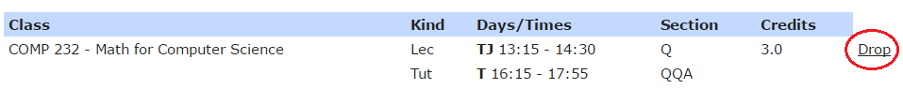*Figure 3. Drop Course action*

A dialog box prompting the user to confirm their choice will appear after clicking the Drop button. To successfully drop the selected course, the “Delete” button on the left will confirm the deletion of that course from the selected saved schedule (see Figure 4). If the student changes their mind, the cancel button will cancel the operation and the course is not dropped from the schedule.

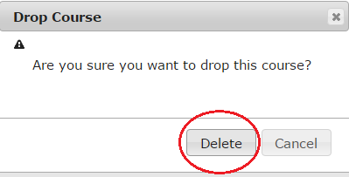

*Figure 4. Confirmation dialog box*

4.2.13 Manage Courses (Administrator)

An administrator that is logged in the system will have the option to manage courses. This option is found in the Courses tab, on the right hand side of the page (see Figure 5).

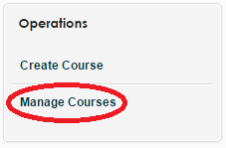

*Figure 5. Manage Courses operation*

Clicking the manage courses option will display the manage courses page. There are many possible actions for the administrator to take from here.

4.2.13.1 Search

If the Administrator wishes to manage a specific course, the search bars above the table containing all the courses may be used to search for a course (see Figure 6), or the “Advanced Search” setting may be used (see Figure 7).

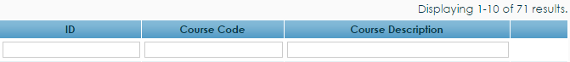

*Figure 6. Course search bars*

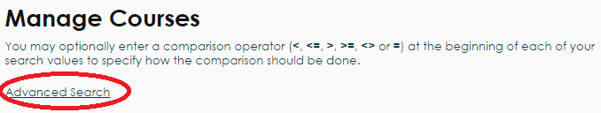

*Figure 7. Advanced search setting*

The advanced search setting will display two search bars on the page which will accept a course I.D. and/or course code to search the system (see Figure 8). Clicking the search button will perform the search.

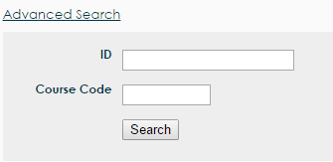

*Figure 8. Advanced search bars*

Once a course is searched and found, the administrator has the options of viewing, editing or deleting the course. These options can be seen on Figure 9, in the respective order.

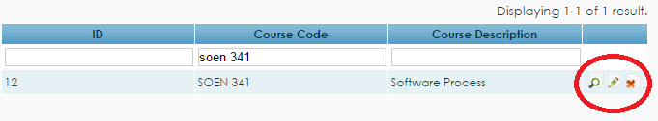

*Figure 9. View, edit, and delete buttons*

4.2.13.2 View Course

The view option will produce a page that displays the details of the course, including course I.D., course code, and course description (see Figure 10).

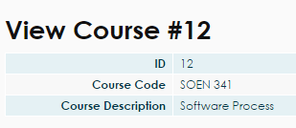

*Figure 10. View course table*

4.2.13.3 Edit Course

The edit function is selected by clicking the pencil icon to the right of the view button. Clicking the edit button will produce the update course page, which can edit the course code, description, number of credits, and type of the course (see Figure 11). Any changes made will be finalized by clicking the “Save” button below the editing boxes.

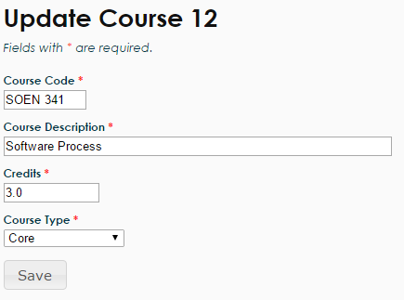

*Figure 11. Update course boxes*

4.2.13.4 Delete Course

The final operation that an administrator can do to manage a course is to delete a course, which can be performed by clicking the red “X” button to the right of the update course icon. Clicking the X icon will produce a dialog box that prompts the administrator to confirm their decision. To confirm their choice, the “OK” button should be pressed and the course will be deleted from the course bank (see Figure 12). If the administrator does not want to delete the course, they can simply press the cancel button or exit the dialog box.

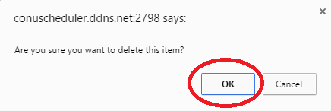

*Figure 12. Confirmation dialog box for course deletion*

4.2.14 Create Course (Administrator)

An administrator may wish to create a course to add to the database of courses that students can take. In order to do so, the administrator must first click on the ‘Courses’ tab to find themselves on the courses database page (see Figure 3). From here, the administrator must click the ‘Create Course’ link located on the far right of the page; this action will display the course creation page (see Figure 4).

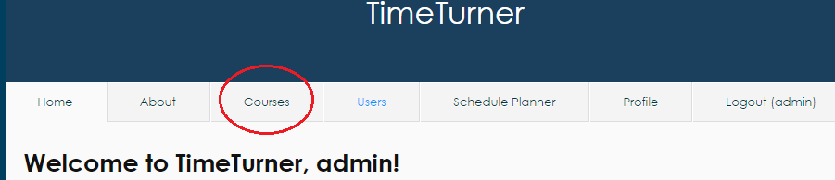

*Figure 3. Courses tab on top of page when logged in as Administrator*

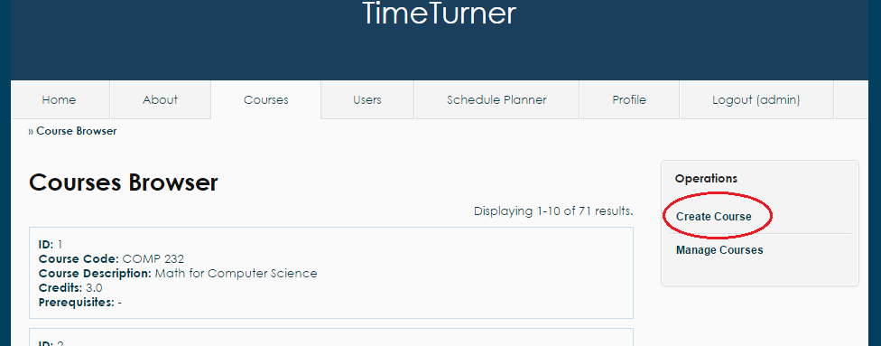

*Figure 4. Create course link on far right of Course Browser page*

This page will ask for the course code, the course description, and the amount of credits awarded by the course (see Figure 5 for example input). Once the administrator enters the appropriate course information, the system will log such information in the database, and the course information for the newly created course will be displayed on screen, along with the course’s newly assigned ID.

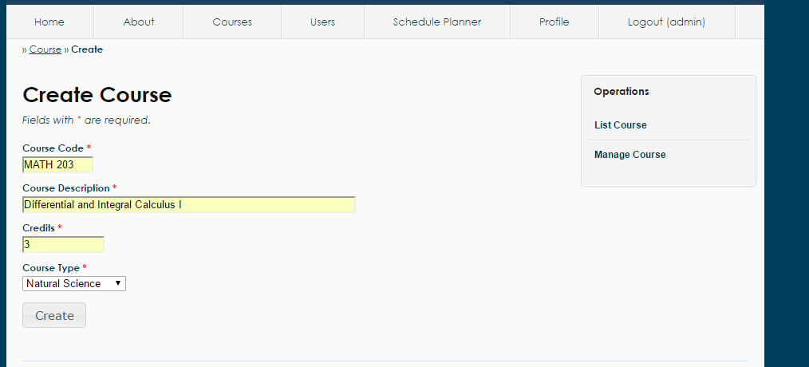

*Figure 5. Sample input for Create Course functionality*

4.2.15 Browse Courses (Administrator)

While logged in, the administrator may wish to view the database of courses in the system. To accomplish this, the administrator may simply click on the Courses tab; this will cause the list of all courses to be displayed on screen (see Figure 3). Courses are grouped by page, 10 to a page. If the administrator wishes to view more courses, he may scroll down to the bottom of the page and click on the desired page number.

While on the Courses tab, the administrator may navigate away by clicking the two links located in the ‘Operations’ box to the right of the page: Create Course and Manage Course. Clicking these links will bring the administrator to those respective pages where other activities and actions may be carried out.

If the administrator wishes to view the prerequisite information of a course, he may simply click on the name of the prerequisite to that course (see Figure 6). Clicking on the name of the prerequisite will display the course information of the prerequisite.

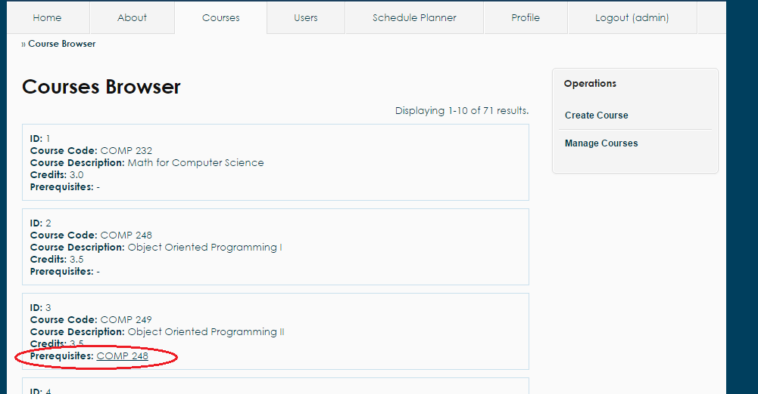

*Figure 6. Prerequisites for each Course located in the course information box*

# Final Cost Estimation