User Manual for Use Cases:

* ~~#5 – View Course Sequence (student)~~
* #9 – Drop Course (student)
* #13 – Manage Courses (admin)

**#9 – Drop Course (student)**

A student that is logged in the system and has at least one saved schedule containing at least one course has the option to drop a course. They can do so by clicking on the “View Saved Schedules” option in the Schedule Planner tab. The option appears on the right hand side of the Schedule Planner page (see Figure 1).

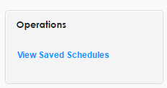

*Figure 1. View Saved Schedules operation*

A page displaying all currently saved schedules for the student is displayed. To choose the schedule from which a course will be dropped, the “View” option should be selected. It appears to the right of each saved schedule (See Figure 2).

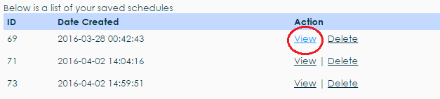

*Figure 2. View Saved Schedule action*

The selected saved schedule will load, displaying all courses that are currently in that schedule. Each course has a “Drop” option to the right of the number of credits (see Figure 3).

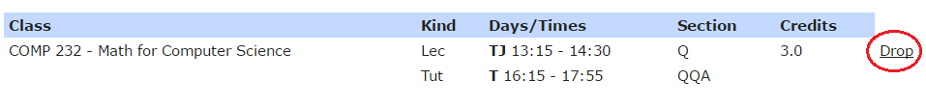*Figure 3. Drop Course action*

A dialog box prompting the user to confirm their choice will appear after clicking the Drop button. To successfully drop the selected course, the “Delete” button on the left will confirm the deletion of that course from the selected saved schedule (see Figure 4). If the student changes their mind, the cancel button will cancel the operation and the course is not dropped from the schedule.

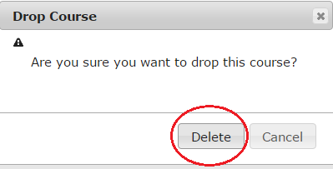

*Figure 4. Confirmation dialog box*

**#13 – Manage Courses (administrator)**

An administrator that is logged in the system will have the option to manage courses. This option is found in the Courses tab, on the right hand side of the page (see Figure 5).

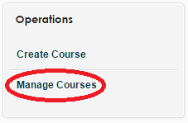

*Figure 5. Manage Courses operation*

Clicking the manage courses option will display the manage courses page. There are many possible actions for the administrator to take. If they want to manage a specific course, the search bars above the table containing all the courses can be used to search for a course (see Figure 6), or the “Advanced Search” setting can be used (see Figure 7).

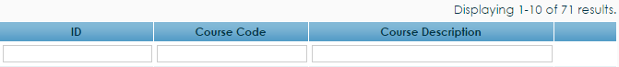

*Figure 6. Course search bars*

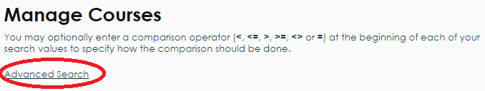

*Figure 7. Advanced search setting*

The advanced search setting will display two search bars on the page that will accept a course I.D. and/or course code to search the system (see Figure 8). Clicking the search button will perform the search.

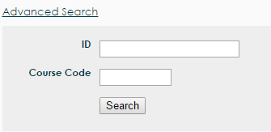

*Figure 8. Advanced search bars*

Once a course is searched and found, the administrator has the options of viewing, editing or deleting the course. These options can be seen on Figure 9, in the respective order.

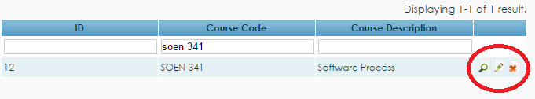

*Figure 9. View, edit, and delete buttons*

The view option will produce a page that displays the details of the course, including course I.D., course code, and course description (see Figure 10).

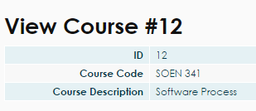

*Figure 10. View course table*

The edit function is selected by clicking the pencil icon to the right of the view button. Clicking the edit button will produce the update course page, which can edit the course code, description, number of credits, and type of the course (see Figure 11). Any changes made will be finalized by clicking the “Save” button below the editing boxes.

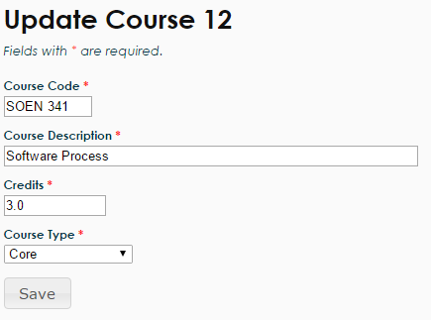

*Figure 11. Update course boxes*

The final operation that an administrator can do to manage a course is to delete a course, which can be performed by clicking the red “X” button to the right of the update course icon. Clicking the X icon will produce a dialog box that prompts the administrator to confirm their decision. To confirm their choice, the “OK” button should be pressed and the course will be deleted from the course bank (see Figure 12). If the administrator does not want to delete the course, they can simply press the cancel button or exit the dialog box.

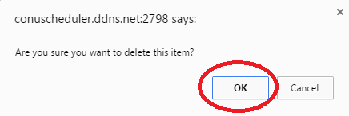

*Figure 12. Confirmation dialog box for course deletion*