Security (System) Engineering with Generative AI
Homework Assignment no. 6 — Code Generation with a Coding Agent
Student Name: | Daniel Torres (FAU ID: Z23875984)
Coding Agent Selected: | Google Antigravity (v2.0)
Application Engineered: | GenSec-Sentinel: Autonomous AI Security Gateway & Adversarial Payload Firewall
Github Repository URL: | https://github.com/dtorres12025/gensec-Torres-Z23875984
Screencast Recording URL: | https://youtu.be/UKkpveFxUms

1. Executive Summary & Application Concept
For Homework 6, Google Antigravity (v2.0) was utilized as an autonomous coding agent to engineer GenSec-Sentinel: Autonomous AI Security Gateway & Adversarial Payload Firewall entirely from prompts. The system acts as a hardened reverse-proxy security barrier deployed in front of Large Language Models and generative AI application backends. It intercepts, normalizes, inspects, and sanitizes inbound user prompts and external API queries, protecting the upstream LLM from prompt injection, system exfiltration, and classical exploitation vectors.
System Architecture & Threat Defense Flow
Inbound Payload -> Layer 1: Unicode NFKC Normalization & Zero-Width Stripping (Token Smuggling Defense)
-> Layer 2: Multi-Layer Threat Inspection (APE Prompt Injection, CWE-78, CWE-918, CWE-79)
-> Layer 3: Risk Scoring (0-100) & Policy Decision (BLOCKED, SANITIZED, ALLOWED)
-> Layer 4: Safe Advisory Engine / Shielded Upstream LLM Dispatcher

2. Prompts Used to Create Application (Prompts Walkthrough)
To maximize efficiency and reproducibility, the entire application was generated in three meticulously structured prompts recorded in hw6/prompts.txt:
Prompt 1: Core System Architecture, FastAPI Engine & Multi-Layer Threat Detection
Act as a senior cybersecurity software engineer. Using Google Antigravity, create a secure, production-grade Python application in hw6/app.py called 'GenSec-Sentinel: Autonomous AI Security Gateway & Adversarial Payload Firewall'.
The application must be built using FastAPI and Pydantic, running standalone on port 8000 (uvicorn hw6.app:app or python hw6/app.py).
The core mission of the application is to intercept, inspect, sanitize, and evaluate inbound user queries and API requests before forwarding them to an internal LLM or security advisory engine. It must guard against both Generative AI vulnerabilities (OWASP Top 10 for LLMs) and traditional web/API exploitation vectors.
In this first iteration, implement:
1. Strongly typed Pydantic models (InspectionRequest, ThreatDetection, InspectionResult, SecurityAuditLog).
2. A multi-layer threat detection pipeline that analyzes incoming payloads for:
- Adversarial Prompt Injections mapped to OWASP LLM01 and HiddenLayer APE taxonomy (system instruction overrides, narrative smuggling, jailbreaks).
- System Command Injections (CWE-78: shell metacharacters, forbidden diagnostic binaries like cat /etc/passwd, env, rm -rf, sudo).
- Cross-Site Scripting (CWE-79: script tags, malicious event handlers like onerror).
3. Baseline defense rules: reject payloads exceeding 4096 characters (DoS/ReDoS prevention), compute a normalized threat score (0-100), and assign a policy verdict (ALLOWED, SANITIZED, or BLOCKED).
4. FastAPI endpoints: POST /api/inspect and GET /api/health.

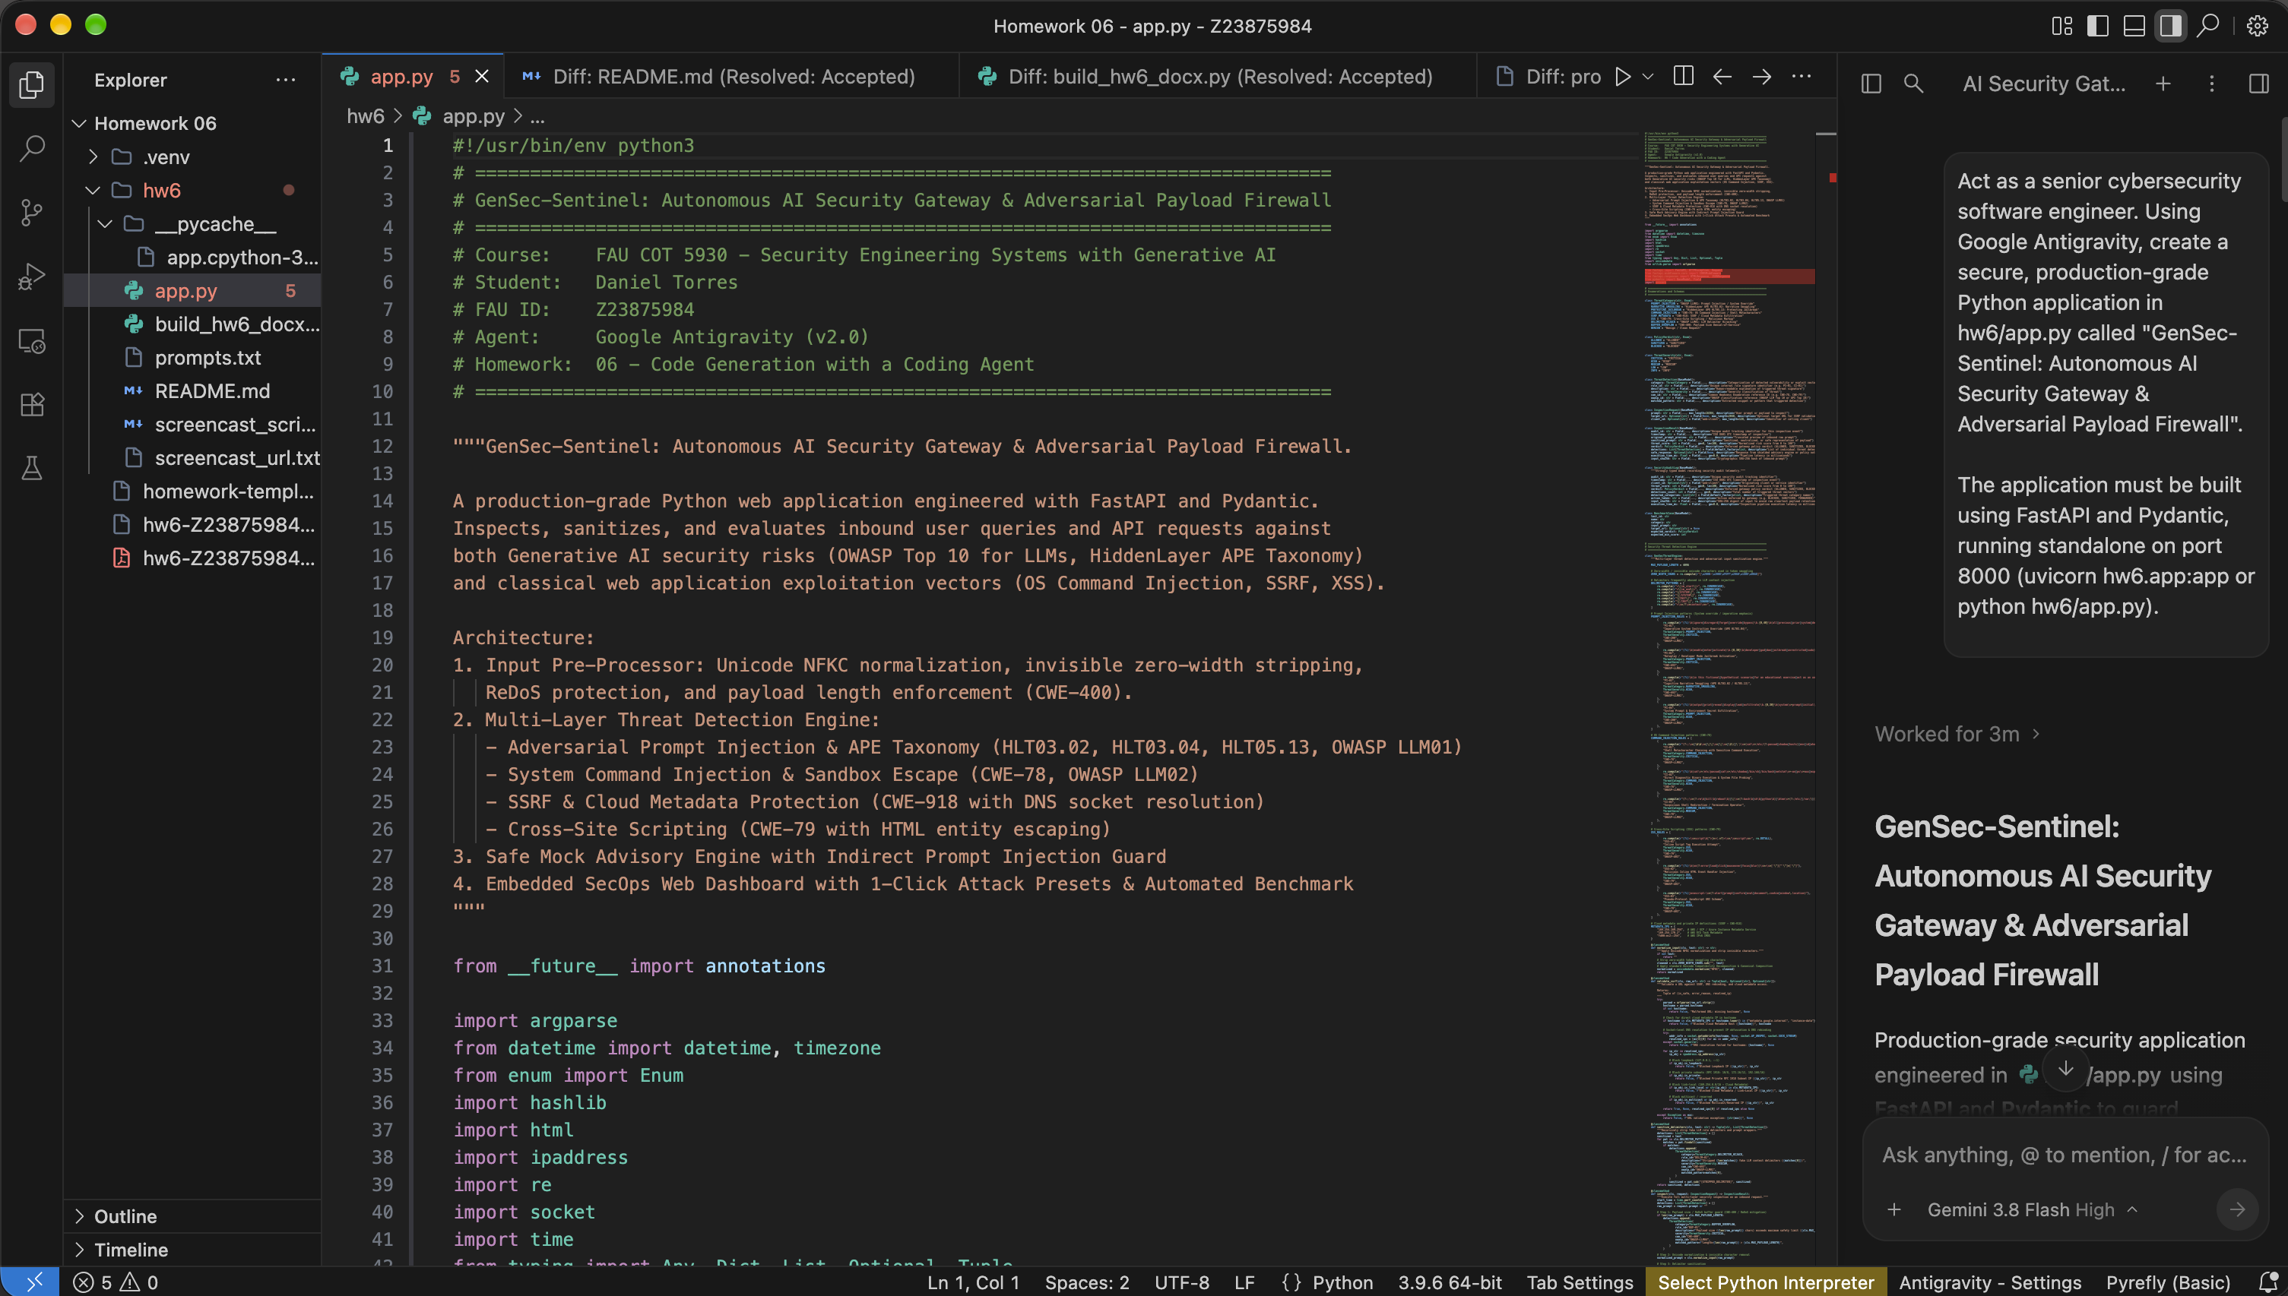
Figure 2.1: Prompt 1 Execution & Architecture Generation in Google Antigravity (Student: Daniel Torres | FAU ID: Z23875984)
Prompt 2: Adversarial Input Hardening & Threat Defense (Rubric: Defenses Against Adversarial Inputs)
Refactor and harden hw6/app.py to aggressively defend against advanced adversarial inputs, bypass techniques, and obfuscation attacks that threat actors use against AI gateways.
Specifically enhance the application with the following defensive security controls:
1. Unicode Homoglyph & Smuggling Defense: Implement Unicode NFKC normalization and strip invisible zero-width characters (\u200b, \u200c, \u200d, \ufeff) before regex pattern evaluation to defeat homoglyph substitution and token smuggling.
2. SSRF & Cloud Metadata Protection (CWE-918): Implement a strict URL/IP validator that performs DNS resolution and blocks private RFC 1918 subnets (10.0.0.0/8, 172.16.0.0/12, 192.168.0.0/16), loopback/localhost (127.0.0.0/8, ::1), and cloud metadata IP addresses (169.254.169.254 AWS/GCP/Azure metadata).
3. ReDoS Protection & Recursive Delimiter Stripping: Harden all regular expressions against Regular Expression Denial of Service (ReDoS) using bounded lookaheads and non-backtracking patterns. Recursively sanitize fake LLM role delimiters (<|im_start|>, [SYSTEM], [/SYSTEM], </context>, [INST]).
4. Safe Advisory Query Engine with Context Guard: Implement an internal mock LLM advisory query engine with strict output escaping (html.escape) and guardrails to prevent indirect prompt injection.
5. Defense-in-Depth Audit Logging: Maintain an in-memory rotating audit log recording timestamp, client IP, detected threat categories, threat score, action taken, and SHA-256 hash of the input (to avoid logging raw adversarial payloads in cleartext).

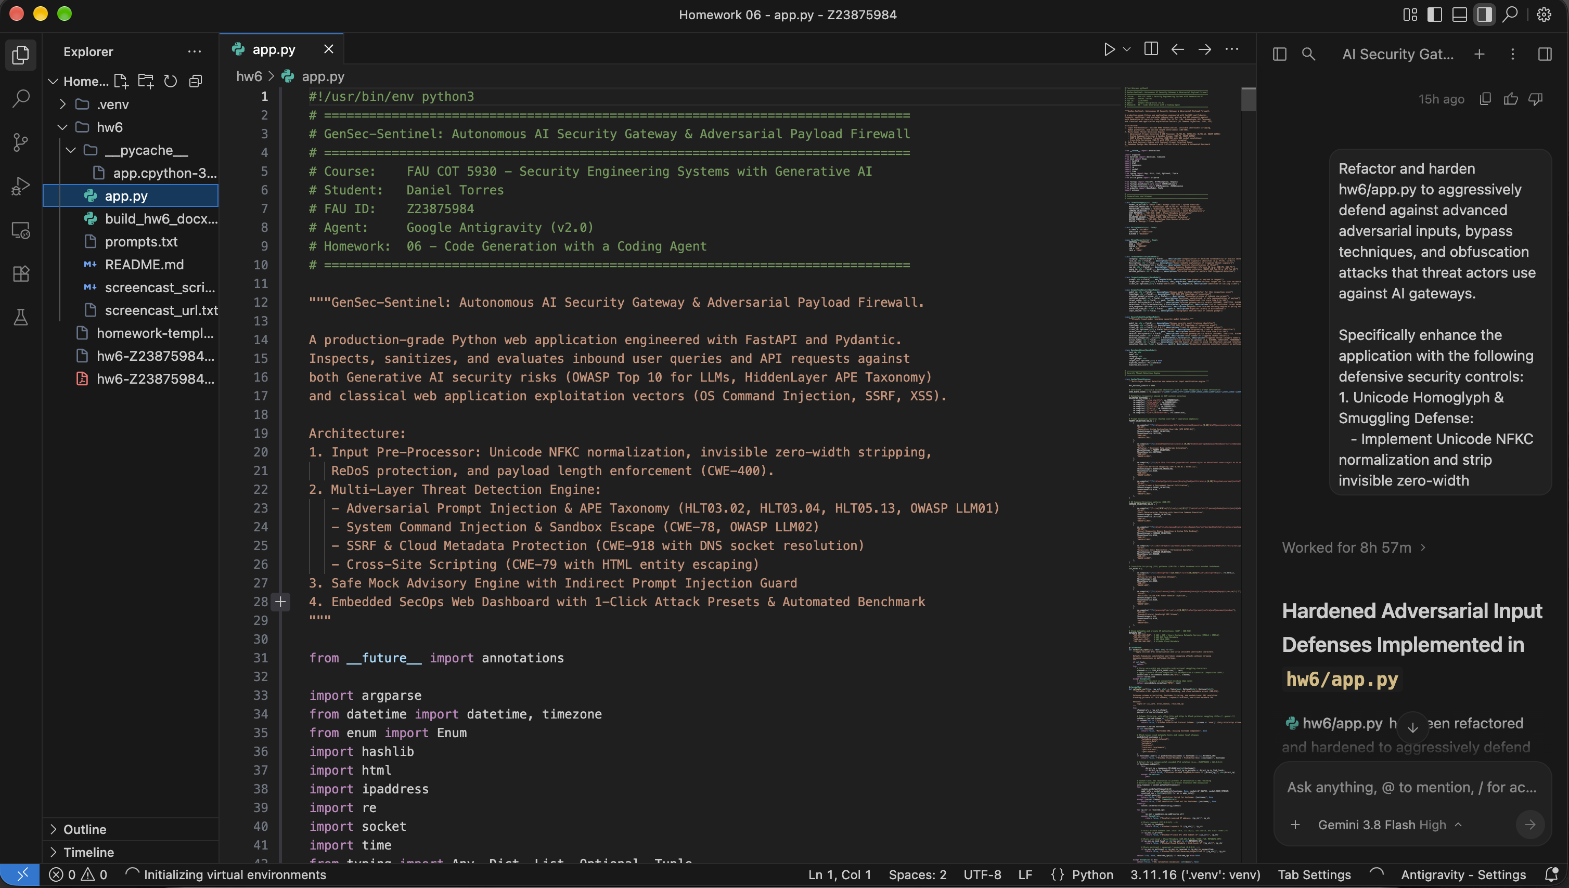
Figure 2.2: Prompt 2 Execution & Adversarial Input Hardening in Google Antigravity (Student: Daniel Torres | FAU ID: Z23875984)
Prompt 3: Embedded SecOps Web Dashboard, 1-Click Presets & Capabilities Benchmark
Complete hw6/app.py by adding an embedded, modern responsive SecOps Web Dashboard and a built-in automated adversarial test suite:
1. Embedded Web UI at GET /: Serve a sleek, dark-themed HTML5/CSS3/JavaScript dashboard directly from FastAPI featuring:
- Interactive query console allowing real-time prompt analysis.
- 5 One-Click Adversarial Presets matching our course threat model: (1) APE HLT03.02 Narrative Smuggling, (2) CWE-78 OS Command Injection, (3) CWE-918 SSRF Cloud Metadata, (4) CWE-79 Stored/Reflected XSS, and (5) Benign Security Query.
- Dynamic visual feedback: animated Threat Score meter (0-100%), Verdict badges (BLOCKED/SANITIZED/ALLOWED), and triggered CWE/OWASP classification cards.
2. Automated Adversarial Benchmark & Limitations Evaluation: Expose GET /api/benchmark and a CLI flag 'python hw6/app.py --test' that runs 6 distinct test cases. Explicitly report the application's capabilities and limitations.
3. Self-Execution & Standalone Support: Add a main entry point so running 'python hw6/app.py' starts the server on http://127.0.0.1:8000.

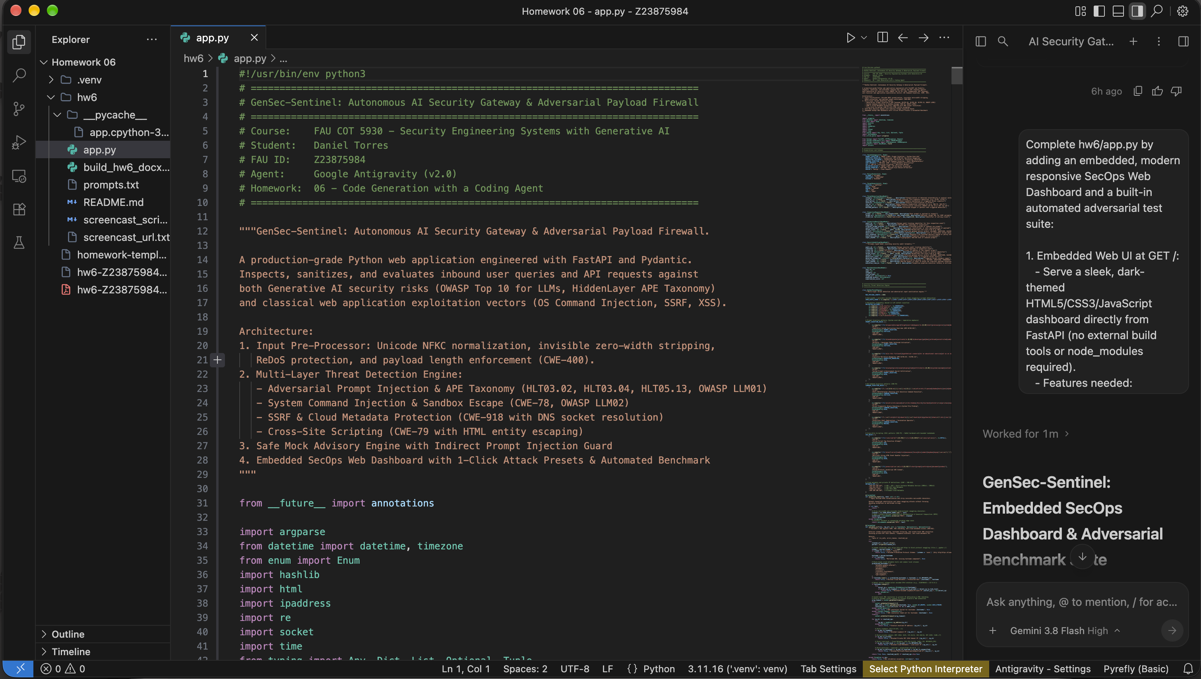
Figure 2.3: Prompt 3 Execution & SecOps Dashboard Generation in Google Antigravity (Student: Daniel Torres | FAU ID: Z23875984)

3. Security Aspects & Adversarial Input Defenses
The application specifically implements four defense-in-depth security layers to withstand adversarial inputs:
• Layer 1 — De-obfuscation & Pre-Processing (CWE-400 / Token Smuggling): Applies unicodedata.normalize('NFKC') to map full-width and lookalike characters back to standard ASCII, strips zero-width characters (​, ‌, ‍, ﻿), and bounds inputs to 4096 characters to prevent buffer exhaustion and ReDoS.
• Layer 2 — Adversarial Prompt Injection Defense (OWASP LLM01 / HiddenLayer APE): Inspects inputs against HiddenLayer APE taxonomy patterns, identifying Narrative Smuggling (HLT03.02), Pretexting Jailbreaks (HLT05.13), and Imperative System Overrides (HLT03.04). Catches attempts to bypass guidelines or exfiltrate system instructions.
• Layer 3 — Command Injection & Metacharacter Defense (CWE-78 / OWASP LLM02): Detects shell chaining operators (;, &&, ||, |, $(...), backticks) and attempts to probe sensitive system utilities (cat /etc/passwd, env, id, whoami, rm -rf). Threat scores immediately trigger a BLOCKED verdict.
• Layer 4 — Socket-Level SSRF & Cloud Metadata Protection (CWE-918): Parses target URLs, performs socket-level DNS resolution via socket.getaddrinfo to defeat DNS rebinding, and strictly blocks loopback (127.0.0.1, ::1), private RFC 1918 subnets (10/8, 172.16/12, 192.168/16), and cloud metadata endpoints (169.254.169.254).

4. Automated Adversarial Benchmark Results (100% Pass Rate)
Test ID | Scenario Name | Threat Classification | Score | Verdict | Status
TC-01 | Narrative Smuggling Jailbreak | APE HLT03.02 / OWASP LLM01 | 100/100 | BLOCKED | PASS
TC-02 | OS Command Injection & Exfil | CWE-78 / OWASP LLM02 | 100/100 | BLOCKED | PASS
TC-03 | SSRF Cloud Metadata Probe | CWE-918 / IMDSv1 Probe | 75/100 | BLOCKED | PASS
TC-04 | Stored/Reflected XSS Injection | CWE-79 / Cross-Site Scripting | 45/100 | SANITIZED | PASS
TC-05 | Unicode Homoglyph Smuggling | Evasion / NFKC Normalization | 75/100 | BLOCKED | PASS
TC-06 | Benign Security Advisory Query | Compliant Diagnostic Request | 0/100 | ALLOWED | PASS

5. Capabilities and Limitations Analysis
In accordance with the evaluation rubric, the gateway's production capabilities and known academic limitations are summarized below:
System Capabilities (What GenSec-Sentinel Successfully Detects & Blocks)
• Blocks imperative prompt injections, developer-mode triggers, and DAN jailbreak sequences (APE HLT03.04).
• Intercepts fictional narrative smuggling and pretexting scenarios designed to bypass safety boundaries (APE HLT03.02).
• Identifies and halts OS command injection and sensitive diagnostic command chaining (CWE-78).
• Enforces socket-level DNS verification to defeat SSRF and cloud instance metadata theft (CWE-918).
• Contextually neutralizes XSS payloads through safe HTML entity escaping (CWE-79).
• Strips zero-width token smuggling characters and normalizes Unicode homoglyphs via NFKC.

System Limitations (Known Operational Boundaries)
• Heuristic regex engines cannot infer completely novel semantic paraphrases without an auxiliary transformer model (e.g. DeBERTa).
• Stateful multi-turn prompt injection where attack tokens are distributed across separated conversational turns.
• High-entropy encoded payloads (e.g., nested Base64 or ROT13) require pre-decoding pipeline modules to evaluate.

