# Diego Torres

# 4/28/19

# Intro to Python

# Assignment 5

**Dictionaries**

**Introduction**

I’d like to apologize about the small mistakes I have made on the last assignments, I’ll have to be better about watching the videos that you provide after the grades are given. Also, I had a surprise birthday weekend, this caused this assignment to be late.

Our goal for week five was to create a program that took in a task and the priority of the task. We would also ask the user to choose from a list on what they would like to do. The main things we learned in this week’s module is about list that contain variables with more than value, dictionaries and we got more in depth about reading files. We learned about how a list can be separated by \ but python is smart enough to understand that everything within the brackets belong together. It goes into how the list index starts at 0 instead of 1, but if going from end to front it goes from 1 on. Lists have many features such as len(), sort (), index(), append() and remove. These features only work on list, they do not work on tuples or dictionaries. Dictionaries are mappings, they are collections of objects but they are store objects by keys. When we add a key to a dictionary we have to add a value to it. Dictionary mappings don’t maintain any reliable left to right order, it maps the keys to their associated values. Dictionaries only support accessing items by key and since they don’t maintain any dependable left to right order when running loops you may get them in different order. Tuples are much like a list but a tuples are immutable, we cannot replace or delete any of the information.

**Work**

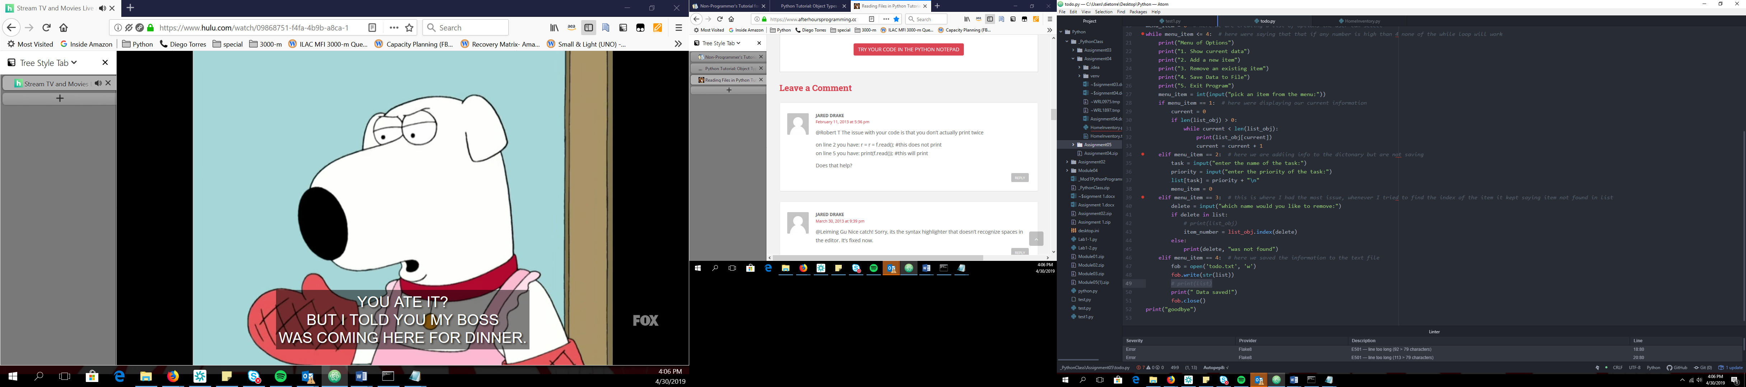

**Summary**

This assignment was to create an application that took in a task and the priority of the task. Eventually, we would save the data into a dictionary. We would also create a list using numbers choices. Then, the user can select a choice from that list. When the choice is selected, the appropriate action would occur. To start off this assignment, I started by opening the text file that we had added the two tasks and priority. I then created a “for” loop in order to get the items that were saved to the text file. According to the instructions, we were supposed to add the information to a dictionary and then add it to a list. When creating the menu, I created “while” loop. The ‘while’ loop allows the user to select a number between 1 and 4, if the number 5 or greater is selected the program will close. I was able to create an “if” statement that was linked to its appropriate choice. When the seller selected the first option, the current data would show. If the seller selected option two this would allow the seller to add a task and priority, this would be added to the list that had the dictionary in it. When it came to deleting an item I had a tough time trying to figure out what the issue was. Even though delete was found in the list, I was not able to find the index to delete the item. The error I kept getting was item not found in list. The only reason why I believe that this didn’t work is because the information was saved in a dictionary that was in a list. I was not able to find a resolution through the web. The fourth option was to save the information to append the information to the text file, for this I created a new list and added to the text file. I hope that you can help me out resolve the issue that I ran into. I use overstack a lot to try and get answer. It helped me with option number 1, when I was trying to separate the items on the text file. It is a little hard to write what resources I used after the I complete the assignment.