# Diego Torres

# 5/6/19

# Intro to Python

# Assignment 06

**Functions**

**Introduction**

This assignment was an addition to last week’s assignment which was to create a to-do list with task and priorities of the task. In last week’s assignment we had to create 4 different task that included the following: to see the overall list of items, add a new item, delete an item or to save the item to a text document. For the current assignment we are create functions for these task to simplify our code. Functions are the main focus of module 6. Functions are a block of code that is organized and reusable, the function can be used to perform a single or related action. Functions can help when you are repeatedly running the same takes over and over. You can have two types of variable that you can pass through a functions. Local variables, are created and stored within a function, the variable is deleted from memory when the function completes. Global variables can be accessible from anywhere within the program.

**Work**

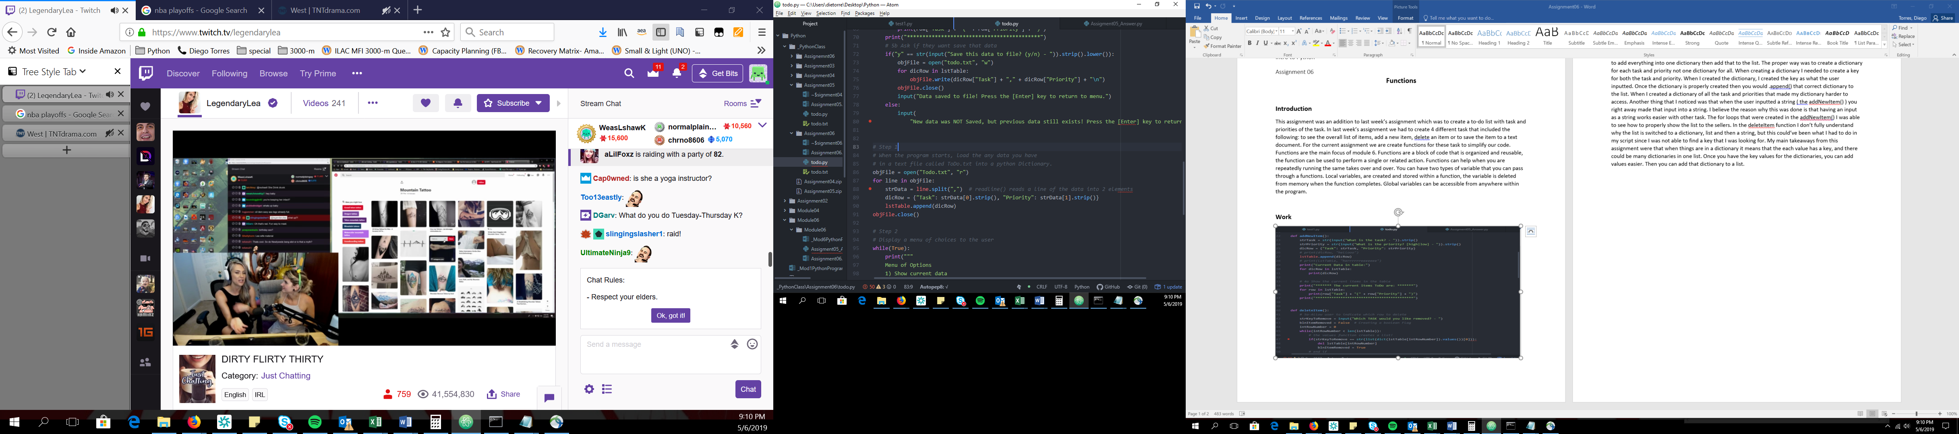

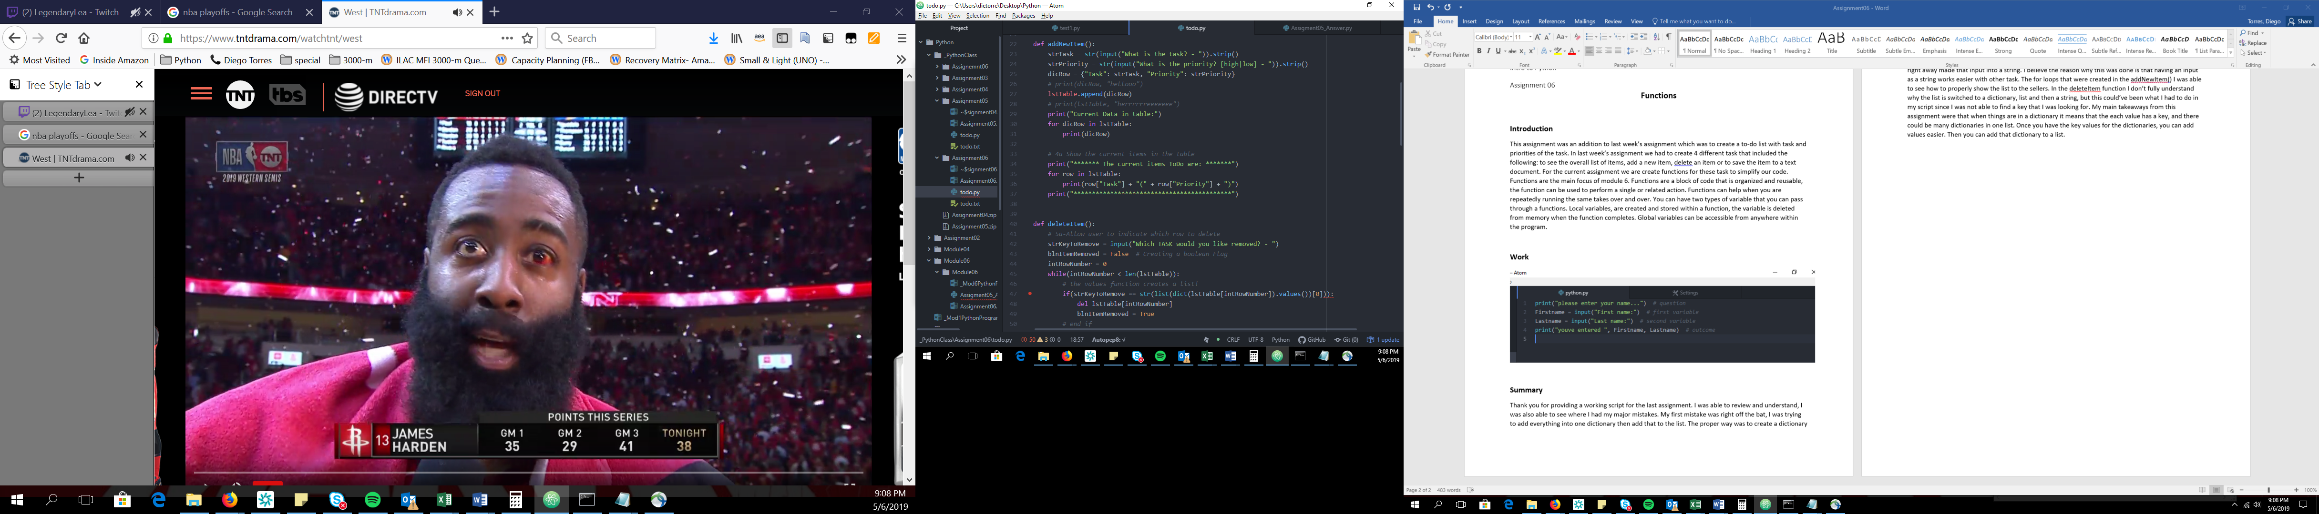

**Summary**

Thank you for providing a working script for the last assignment. I was able to review and understand, I was also able to see where I had my major mistakes. My first mistake was right off the bat, I was trying to add everything into one dictionary then add that to the list. The proper way was to create a dictionary for each task and priority not one dictionary for all. When creating a dictionary I needed to create a key for both the task and priority. When I created the dictionary, I created the key as what the user inputted. Once the dictionary is properly created then you would .append() that correct dictionary to the list. When I created a dictionary of all the task and priorities that made my dictionary harder to access. Another thing that I noticed was that when the user inputted a string ( the addNewItem() ) you right away made that input into a string. I believe the reason why this was done is that having an input as a string works easier with other task. The for loops that were created in the addNewItem() I was able to see how to properly show the list to the sellers. In the deleteItem function I don’t fully understand why the list is switched to a dictionary, list and then a string, but this could’ve been what I had to do in my script since I was not able to find a key that I was looking for. My main takeaways from this assignment were that when things are in a dictionary it means that the each value has a key, and there could be many dictionaries in one list. Once you have the key values for the dictionaries, you can add values easier. Then you can add that dictionary to a list.