EVI – Emotional Volatility Index: A Behavioral Analytics System for Crypto Traders
What actually done in my task:
1. Take real trading data (from Kaggle – historical data a CSV file)
2. Clean and prepare the data (timestamps, wins/losses, time gaps between trades, etc.)
3. Calculate important behavioural metrics using rolling windows
4. Compute EVI Score by combining performance + emotional factors
5.Generate a behaviour Report that tells the trader:
- Current emotional state (Excellent / Good / Average / Poor)
- Specific problems (tilt, revenge trading, overtrading)
- Practical recommendations
6. Create a chart showing how their EVI score changed over time
Explanation of my code:
1. Import Libraries
import pandas as pd
import numpy as np
import matplotlib.pyplot as plt
import matplotlib.dates as mdates

- pandas → for data handling
- numpy → for calculations
- matplotlib → for creating charts
2. Loading and Cleaning Data
Renames your columns into standard names:
df = pd.read_csv("historical_data.csv")
print(" Data loaded! Total trades:", len(df))

df = df.rename(columns={
'Timestamp': 'close_time',
'Account': 'account_id',
'Coin': 'symbol',
'Side': 'trade_type',
'Execution Price': 'entry_price',
'Size USD': 'volume',
'Closed PnL': 'profit'
}).copy()
- Timestamp → close_time
- Coin → symbol
- Size USD → volume
- Closed PnL → profit

- df['close_time'] = pd.to_datetime(df['close_time'], unit='ms')
- df = df.sort_values('close_time').reset_index(drop=True)

- df['time_gap_min'] = df.groupby('account_id')['close_time'].diff().dt.total_seconds() / 60
- df['time_gap_min'] = df['time_gap_min'].fillna(120)
- df['date'] = df['close_time'].dt.date
- df['is_win'] = df['profit'] > 0
- df['is_loss'] = df['profit'] < 0

- print(f"Date range: {df['close_time'].min().date()} to {df['close_time'].max().date()}\n")

Then:
- Converts timestamp from milliseconds to proper datetime
- Sorts trades by time
- Creates time_gap_min: How many minutes passed between your trades (very important for detecting impulsiveness)
- Creates is_win and is_loss flags
- Creates date, week, month, year for grouping
3. Core Function: calculate_evi()
def calculate_evi(group, window=10):
original_index = group.index

if len(group) < 5:
return pd.Series(np.nan, index=original_index)

group = group.copy().sort_values('close_time')
group = group.reset_index(drop=True)

win_rate = group['is_win'].rolling(window=window, min_periods=3).mean() * 100
avg_profit = group['profit'].rolling(window=window, min_periods=3).mean()
profit_std = group['profit'].rolling(window=window, min_periods=3).std()
consistency = 100 - (profit_std / (abs(avg_profit) + 1e-6) * 30)
consistency = consistency.clip(0, 100)

risk_control = 100 - (group['volume'].rolling(window=window, min_periods=3).mean() * 200)
risk_control = risk_control.clip(0, 100)

# --- Emotional analysis -----------
loss_streak = group['is_loss'].rolling(window=window, min_periods=1).sum()
loss_streak_score = (100 - loss_streak * 8).clip(0, 100)

volume_shift = group['volume'].shift(-1)
revenge = (volume_shift / (group['volume'] + 1e-6) - 1).where(group['is_loss']).fillna(0)
revenge_score = 100 - (revenge.rolling(window=window, min_periods=3).mean() * 60).clip(0, 100)

avg_gap = group['time_gap_min'].rolling(window=window, min_periods=3).mean()
impulse_penalty = (60 - avg_gap).clip(0, 60) * 1.5
impulse_score = (100 - impulse_penalty).clip(0, 100)

symbol_change = (group['symbol'] != group['symbol'].shift(1)).astype(int)
symbol_hop_score = (100 - symbol_change.rolling(window=window, min_periods=3).sum() * 8).clip(0, 100)

daily_counts = group.groupby(group['close_time'].dt.date)['profit'].transform('count')
frequency_penalty = (daily_counts - 5).clip(lower=0) * 8
frequency_score = (100 - frequency_penalty).clip(0, 100)

emotional_stability = (
loss_streak_score * 0.25 +
revenge_score * 0.25 +
impulse_score * 0.25 +
symbol_hop_score * 0.25
)

evi = (
win_rate * 0.25 +
consistency * 0.20 +
risk_control * 0.20 +
emotional_stability * 0.35
)

evi.index = original_index
return evi

print("Calculating EVI score...")
This function calculates the EVI score using a rolling window of 10 trades.
It has 4 major components:
- Win Rate : How often you win
- Consistency : How stable your profit/loss is
- Risk Control : How big your position sizes are
- Emotional Stability : Your emotional control (heaviest weight)

Emotional Stability is calculated from 4 sub-metrics:
- Loss Streak Control → Penalizes many consecutive losses.
- Revenge Trading → Detects if you increase trade size after a loss.
- Impulse Control → Checks how fast you enter the next trade after closing one.
- Symbol Hopping → Detects if you keep jumping between different coins.

There is also Trade Frequency (overtrading check).
Finally, all these are combined into one EVI score.

4. Applying EVI to Data

df['EVI'] = df.groupby('account_id', group_keys=False).apply(
lambda g: calculate_evi(g, window=10),
include_groups=False
)
print(" EVI calculation completed!")

Calculates EVI separately for each account (in case you have multiple accounts).
5. Aggregations (Weekly, Monthly, Yearly)
Groups the EVI scores to show trends over time:
- Weekly average EVI
- Monthly average EVI
- Yearly average EVI

# --- Weekly ---
df['week'] = df['close_time'].dt.to_period('W').astype(str)
weekly_evi = df.groupby('week')['EVI'].mean().reset_index()
weekly_evi['week_start'] = pd.to_datetime(weekly_evi['week'].str[:10])

# --- Monthly ---
df['month'] = df['close_time'].dt.to_period('M')
monthly_evi = df.groupby('month')['EVI'].mean().reset_index()
monthly_evi['month_start'] = monthly_evi['month'].dt.to_timestamp()
monthly_evi['month_label'] = monthly_evi['month_start'].dt.strftime('%b %Y')

# --- Yearly ---
df['year'] = df['close_time'].dt.year
yearly_evi = df.groupby('year')['EVI'].mean().reset_index()
yearly_evi['year_label'] = yearly_evi['year'].astype(str)

# --- Daily (for report) ---
daily_evi = df.groupby('date')['EVI'].mean().reset_index().dropna()

print(f" Aggregations ready → Weekly: {len(weekly_evi)} | Monthly: {len(monthly_evi)} | Yearly: {len(yearly_evi)}")

6. Main Behavior Report
Prints simple summary:
- Current Week EVI
- Current Month EVI
- Current Year EVI
- Overall Average EVI
- print("\n" + "="*70)
- print("MY BEHAVIOR REPORT")
- print("="*70)
- print(f"Current Week EVI : {weekly_evi['EVI'].iloc[-1]:.1f}/100")
- print(f"Current Month EVI : {monthly_evi['EVI'].iloc[-1]:.1f}/100")
- print(f"Current Year EVI : {yearly_evi['EVI'].iloc[-1]:.1f}/100")
- print(f"Overall Average : {daily_evi['EVI'].mean():.1f}/100")
- print("="*70)

7. Emotional Behavior Report
It analyzes your last 50 trades and gives:
- Latest EVI scores
- Detailed sub-scores with visual bars (████████░░)
- Behavioural Flags with [DANGER], [WARN], [GOOD]
- Final Emotional State Verdict
- def get_evi_label(score):
- if score >= 70: return "Disciplined"
- elif score >= 55: return "Moderate stress"
- elif score >= 40: return "Borderline"
- else: return "High risk"

- def get_subscore_status(score):
- if score >= 70: return "GOOD "
- elif score >= 40: return "CAUTION"
- else: return "HIGH RISK"

- def print_emotional_report(df, weekly_evi, monthly_evi, yearly_evi, daily_evi):

- # --- Compute sub-scores from the latest 50 trades ---
- latest = df.sort_values('close_time').tail(50).copy()
- window = 10

- loss_streak = latest['is_loss'].rolling(window, min_periods=1).sum().iloc[-1]
- loss_streak_score = max(0, min(100, 100 - loss_streak * 8))

- volume_shift = latest['volume'].shift(-1)
- revenge = (volume_shift / (latest['volume'] + 1e-6) - 1).where(latest['is_loss']).fillna(0)
- revenge_score = max(0, min(100, 100 - (revenge.rolling(window, min_periods=3).mean().iloc[-1] * 60)))

- avg_gap = latest['time_gap_min'].rolling(window, min_periods=3).mean().iloc[-1]
- impulse_score = max(0, min(100, 100 - max(0, 60 - avg_gap) * 1.5))

- symbol_change = (latest['symbol'] != latest['symbol'].shift(1)).astype(int)
- symbol_hop_score = max(0, min(100, 100 - symbol_change.rolling(window, min_periods=3).sum().iloc[-1] * 8))

- daily_counts = latest.groupby(latest['close_time'].dt.date)['profit'].transform('count')
- freq_penalty = max(0, daily_counts.iloc[-1] - 5) * 8
- frequency_score = max(0, min(100, 100 - freq_penalty))

- emotional_stability = (
- loss_streak_score * 0.25 +
- revenge_score * 0.25 +
- impulse_score * 0.25 +
- symbol_hop_score * 0.25
- )

- week_evi = weekly_evi['EVI'].iloc[-1]
- month_evi = monthly_evi['EVI'].iloc[-1]
- year_evi = yearly_evi['EVI'].iloc[-1]
- overall = daily_evi['EVI'].mean()

- print("\n" + "="*70)
- print(" EMOTIONAL BEHAVIOR REPORT")
- print("="*70)
- print(f" This Week EVI : {week_evi:5.1f}/100 → {get_evi_label(week_evi)}")
- print(f" This Month EVI : {month_evi:5.1f}/100 → {get_evi_label(month_evi)}")
- print(f" This Year EVI : {year_evi:5.1f}/100 → {get_evi_label(year_evi)}")
- print(f" All-Time Avg : {overall:5.1f}/100 → {get_evi_label(overall)}")
- print("="*70)

- print("\n EMOTION SUB-SCORES (latest 50-trade window)")
- print(f" {'Metric':<28} {'Score':>6} {'Bar':^12} Status")
- print(" " + "-"*62)

- subs = [
- ("Loss streak control", loss_streak_score),
- ("Revenge trading", revenge_score),
- ("Impulse control", impulse_score),
- ("Symbol hopping", symbol_hop_score),
- ("Trade frequency", frequency_score),
- ("Overall emotional", emotional_stability),
- ]
- for name, score in subs:
- filled = int(score // 10)
- bar = "█" * filled + "░" * (10 - filled)
- status = get_subscore_status(score)
- print(f" {name:<28} {score:5.1f} [{bar}] {status}")

- print("\n BEHAVIORAL FLAGS")
- print(" " + "-"*62)

- flags = []

- if loss_streak_score < 40:
- flags.append(("[DANGER]", f"Loss streak spiral — {int(loss_streak)} consecutive losses. Stop and take a break."))
- elif loss_streak_score < 70:
- flags.append(("[WARN] ", f"Loss streak building — {int(loss_streak)} losses in window. Stay disciplined."))
- else:
- flags.append(("[GOOD] ", "Loss streak under control. Good recovery behavior."))

- if revenge_score < 40:
- flags.append(("[DANGER]", "Revenge trading confirmed — volume spikes sharply after losses."))
- elif revenge_score < 70:
- flags.append(("[WARN] ", "Possible revenge trades — monitor your size after a loss."))
- else:
- flags.append(("[GOOD] ", "No revenge trading detected. Size is stable after losses."))

- if impulse_score < 40:
- flags.append(("[DANGER]", f"Very impulsive — avg gap only {avg_gap:.0f} min. Slow down significantly."))
- elif impulse_score < 70:
- flags.append(("[WARN] ", f"Some impulsiveness — avg gap {avg_gap:.0f} min (healthy target: >60 min)."))
- else:
- flags.append(("[GOOD] ", f"Patience is strong — avg {avg_gap:.0f} min between trades."))

- if symbol_hop_score < 40:
- flags.append(("[DANGER]", "Excessive symbol hopping — focus on fewer pairs."))
- elif symbol_hop_score < 70:
- flags.append(("[WARN] ", "Some symbol hopping detected — reduce pair switching."))
- else:
- flags.append(("[GOOD] ", "Symbol focus is strong — disciplined pair selection."))

- if frequency_score < 40:
- flags.append(("[DANGER]", "Severe overtrading — too many trades per day."))
- elif frequency_score < 70:
- flags.append(("[WARN] ", "High trade frequency — risk of overtrading detected."))
- else:
- flags.append(("[GOOD] ", "Trade frequency is healthy. Not overtrading."))

- for tag, msg in flags:
- print(f" {tag} {msg}")

- print("\n EMOTIONAL STATE VERDICT")
- print(" " + "-"*62)

- if emotional_stability >= 70:
- verdict = "You are trading with strong emotional control. Keep it up."
- elif emotional_stability >= 55:
- verdict = "Moderate emotional stress. Watch how you react after losses."
- elif emotional_stability >= 40:
- verdict = "Emotional discipline slipping. Consider reducing position size."
- else:
- verdict = "HIGH EMOTIONAL RISK. Stop trading today and review your plan."

- print(f" Emotional EVI Score : {emotional_stability:.1f}/100")
- print(f" Verdict : {verdict}")
- print("="*70)

- print_emotional_report(df, weekly_evi, monthly_evi, yearly_evi, daily_evi)

Example outputs it can show:
- "Revenge trading confirmed — volume spikes sharply after losses."
- "Very impulsive — avg gap only 8 min."
- "HIGH EMOTIONAL RISK. Stop trading today..."

8. Charts Creation
Three beautiful dark-themed charts are created and saved:
- EVI_Weekly.png → Line chart of weekly EVI
- # ====================== CHART 1 — WEEKLY ======================
- fig, ax = plt.subplots(figsize=(14, 5), facecolor='#0e1117')
- ax.plot(weekly_evi['week_start'], weekly_evi['EVI'],
- color='#58a6ff', linewidth=2.5, marker='o', markersize=5,
- markeredgecolor='white', label='Weekly EVI')
- ax.xaxis.set_major_formatter(mdates.DateFormatter('%d %b %Y'))
- plt.xticks(rotation=45, ha='right', color='white')
- style_ax(ax, 'EVI Score History — Weekly', 'Week')
- plt.tight_layout()
- plt.savefig('EVI_Weekly.png', dpi=150, facecolor='#0e1117')
- plt.show()
- print(" Weekly chart saved → EVI_Weekly.png")

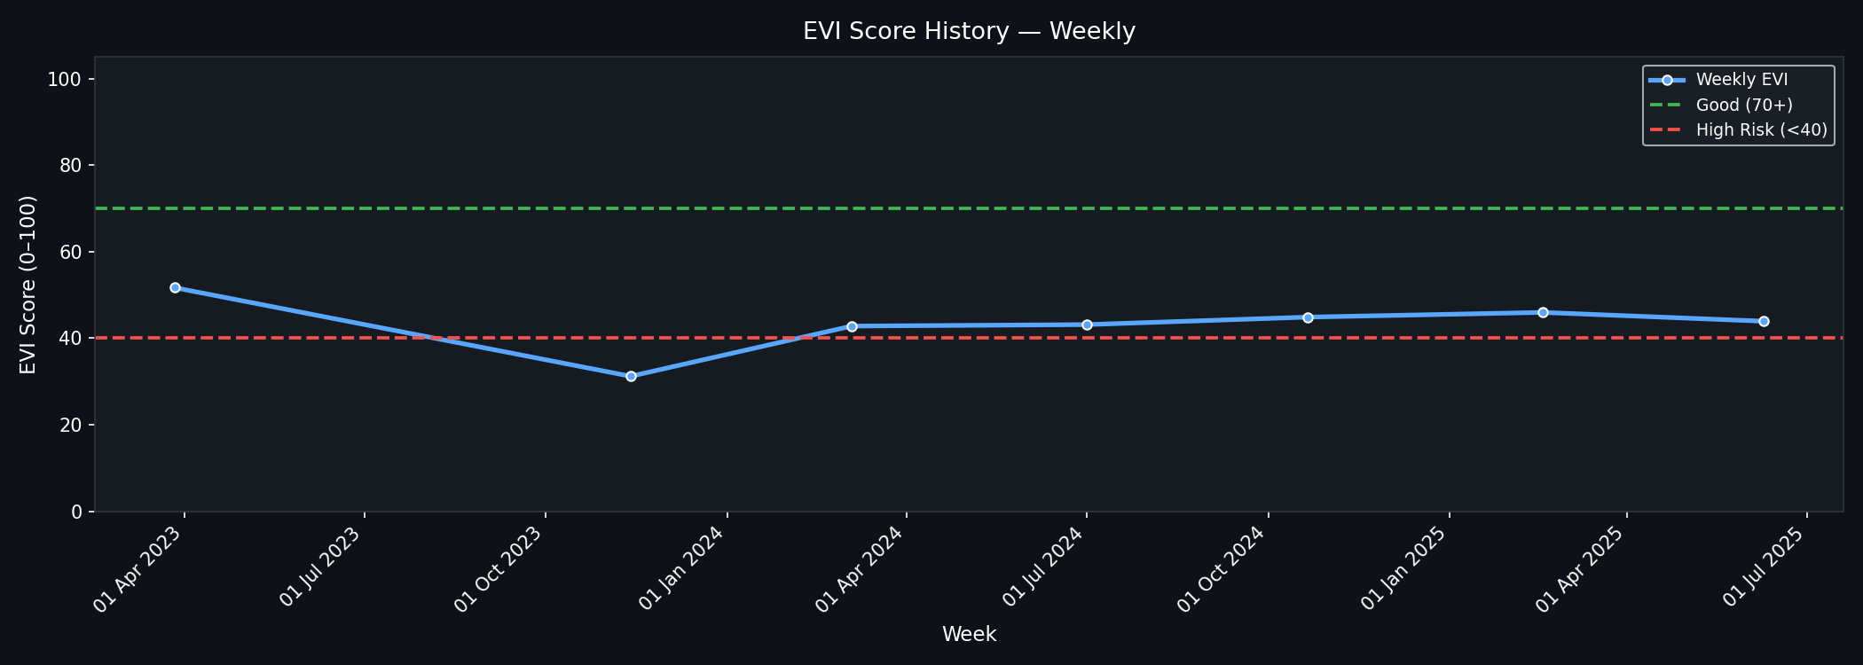
2.EVI_Monthly.png → Monthly trend with values
- fig, ax = plt.subplots(figsize=(14, 5), facecolor='#0e1117')
- ax.plot(monthly_evi['month_start'], monthly_evi['EVI'],
- color='#d2a8ff', linewidth=2.5, marker='s', markersize=7,
- markeredgecolor='white', label='Monthly EVI')

- for _, row in monthly_evi.iterrows():
- ax.annotate(f"{row['EVI']:.1f}",
- xy=(row['month_start'], row['EVI']),
- xytext=(0, 10), textcoords='offset points',
- ha='center', fontsize=8, color='#d2a8ff')

- ax.set_xticks(monthly_evi['month_start'])
- ax.set_xticklabels(monthly_evi['month_label'], rotation=45, ha='right', color='white')
- style_ax(ax, 'EVI Score History — Monthly', 'Month')
- plt.tight_layout()
- plt.savefig('EVI_Monthly.png', dpi=150, facecolor='#0e1117')
- plt.show()
- print("Monthly chart saved → EVI_Monthly.png")
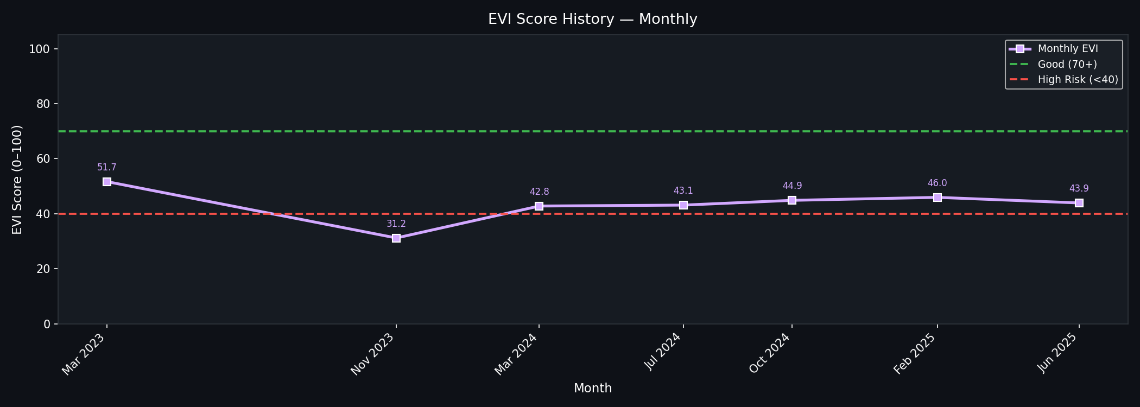
3.EVI_Yearly.png → Bar chart of yearly performance
- fig, ax = plt.subplots(figsize=(8, 5), facecolor='#0e1117')

- bars = ax.bar(yearly_evi['year_label'], yearly_evi['EVI'],
- color=['#3fb950' if v >= 70 else '#f0883e' if v >= 40 else '#f85149'
- for v in yearly_evi['EVI']],
- edgecolor='white', linewidth=0.8, width=0.5)

- for bar, val in zip(bars, yearly_evi['EVI']):
- ax.text(bar.get_x() + bar.get_width() / 2,
- bar.get_height() + 1.5,
- f"{val:.1f}", ha='center', va='bottom',
- color='white', fontsize=12, fontweight='bold')

- ax.axhline(70, color='#3fb950', linestyle='--', lw=1.8, label='Good (70+)')
- ax.axhline(40, color='#f85149', linestyle='--', lw=1.8, label='High Risk (<40)')
- ax.set_facecolor('#161b22')
- ax.tick_params(colors='white')
- for spine in ax.spines.values():
- spine.set_edgecolor('#30363d')
- ax.set_title('EVI Score Summary — Yearly', fontsize=13, color='white', pad=10)
- ax.set_xlabel('Year', fontsize=11, color='white')
- ax.set_ylabel('Average EVI Score (0–100)', fontsize=11, color='white')
- ax.set_ylim(0, 115)
- ax.legend(facecolor='#1c2128', labelcolor='white', fontsize=9)
- plt.xticks(color='white')
- plt.tight_layout()
- plt.savefig('EVI_Yearly.png', dpi=150, facecolor='#0e1117')
- plt.show()
- print("Yearly chart saved → EVI_Yearly.png")
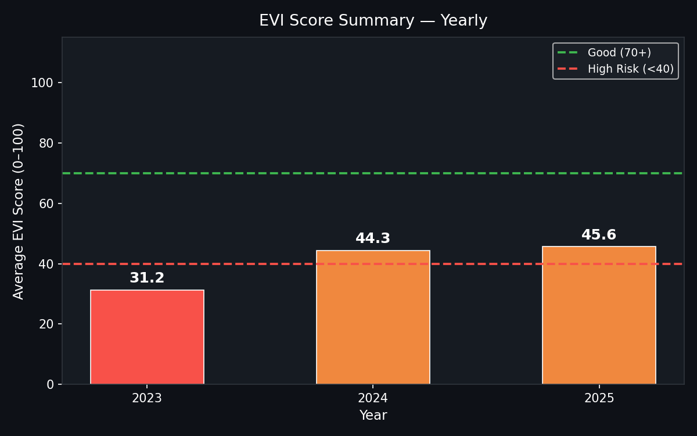

9. Saving Files
df.to_csv("preprocessed_trade_logs.csv", index=False)
weekly_evi.to_csv("EVI_weekly_summary.csv", index=False)
monthly_evi.to_csv("EVI_monthly_summary.csv", index=False)
yearly_evi.to_csv("EVI_yearly_summary.csv", index=False)
print("All data saved!")
Saves:
- preprocessed_trade_logs.csv
- EVI_weekly_summary.csv
- EVI_monthly_summary.csv
- EVI_yearly_summary.csv

Key Metrics Explaination :
- Loss Streak : Many losses in a row
- Revenge Trading : Bigger size after loss
- Impulse Control : Trading too fast (gap < 60 min)
- Symbol Hopping : Changing coins very frequently
- Trade Frequency : Too many trades per day

How to Use This Code
- Put your trade history file as historical_data.csv in the same folder.
- Run the script.
- Check the console output + the 3 PNG charts created.
- The final code is available in evi_final_anal.py

