Trade Pattern Analyser
Python Script — Code Explanation & Technical Reference
File: mock_trade_data_jyothsna.csv | Output: pattern_outputs/

1. Overview
This script analyses a CSV file of trading records to detect three psychological trading patterns: Revenge Trading, FOMO Trading, and Position Size Drift. It produces a heatmap, a cumulative P&L timeline, and an interactive HTML dashboard. A composite Risk Score (0-100) summarises overall trading discipline.

High-Level Architecture

Module / Function | Purpose | Output
SETTINGS block | Central config — file path, filter mode, date range | Global constants
load_data() | Reads CSV, parses datetime columns, sorts by open_time | Raw DataFrame
apply_time_filter() | Slices DataFrame to the requested time window | Filtered DataFrame + label
preprocess() | Derives new columns: duration, hour, day, rolling averages | Enriched DataFrame
detect_patterns() | Flags rows matching revenge / FOMO / size-drift criteria | Boolean flag columns
risk_score() | Converts flag rates into a single 0-100 score | Integer score
plot_heatmap() | Matplotlib heatmap of flagged trades by day x hour | PNG + screen
plot_timeline() | Matplotlib cumulative P&L line chart | PNG + screen
dashboard() | Plotly 4-panel interactive dashboard | HTML + screen
main() | Orchestrates all steps in order | All outputs

# ================== IMPORTS ==================
import pandas as pd
import numpy as np
import matplotlib.pyplot as plt
import seaborn as sns
import plotly.graph_objects as go
from plotly.subplots import make_subplots
from datetime import timedelta
import warnings, os
warnings.filterwarnings('ignore')

# ================== SETTINGS ==================
CSV_PATH = "mock_trade_data_jyothsna.csv" # ← change this

FILTER_MODE = "months" # hours / days / months / years / range / all
FILTER_N = 3

RANGE_START = "2025-10-01 00:00:00"
RANGE_END = "2026-01-31 23:59:59"

OUT_DIR = "pattern_outputs"
os.makedirs(OUT_DIR, exist_ok=True)

# ================== LOAD DATA ==================
def load_data(path):
df = pd.read_csv(path, parse_dates=['open_time','close_time'])
df = df.sort_values('open_time').reset_index(drop=True)
return df

# ================== TIME FILTER ==================
def apply_time_filter(df):
now = df['open_time'].max()

if FILTER_MODE == "hours":
cutoff = now - timedelta(hours=FILTER_N)
label = f"Last {FILTER_N} hours"

elif FILTER_MODE == "days":
cutoff = now - timedelta(days=FILTER_N)
label = f"Last {FILTER_N} days"

elif FILTER_MODE == "months":
cutoff = now - timedelta(days=FILTER_N*30)
label = f"Last {FILTER_N} months"

elif FILTER_MODE == "years":
cutoff = now - timedelta(days=FILTER_N*365)
label = f"Last {FILTER_N} years"

elif FILTER_MODE == "range":
s, e = pd.to_datetime(RANGE_START), pd.to_datetime(RANGE_END)
df = df[(df['open_time']>=s)&(df['open_time']<=e)]
return df.reset_index(drop=True), f"{s.date()} → {e.date()}"

else:
return df.reset_index(drop=True), "All time"

df = df[df['open_time']>=cutoff]
return df.reset_index(drop=True), label

# ================== PREPROCESS ==================
def preprocess(df):
df['duration_min'] = (df['close_time']-df['open_time']).dt.total_seconds()/60
df['open_hour'] = df['open_time'].dt.hour
df['day_of_week'] = df['open_time'].dt.day_name()
df['trade_date'] = df['open_time'].dt.date

df['time_since_last'] = df['open_time'].diff().dt.total_seconds().fillna(9999)
df['prev_profit'] = df['profit'].shift(1).fillna(0)

df['vol_base'] = df['volume'].rolling(10,1).mean()
df['vol_ratio'] = df['volume']/df['vol_base']

df['cum_pnl'] = df['profit'].cumsum()
return df

# ================== PATTERN DETECTION ==================
def detect_patterns(df):
df['is_revenge'] = (df['prev_profit']<0)&(df['time_since_last']<120)

hourly = df.groupby(df['open_time'].dt.floor('H')).size()
df['hour_count'] = df['open_time'].dt.floor('H').map(hourly)
df['is_fomo'] = df['hour_count'] > 2*hourly.median()

df['is_size_drift'] = df['vol_ratio']>2
df['any_flag'] = df[['is_revenge','is_fomo','is_size_drift']].any(axis=1)
return df

# ================== RISK SCORE ==================
def risk_score(df):
r = df['is_revenge'].mean()*100
f = df['is_fomo'].mean()*100
d = df['is_size_drift'].mean()*100
return min(100,int((0.4*r+0.35*f+0.25*d)*3))

# ================== HEATMAP (SHOW + SAVE) ==================
def plot_heatmap(df,label):
pivot = pd.pivot_table(
df[df['any_flag']],
values='id',
index='day_of_week',
columns='open_hour',
aggfunc='count',
fill_value=0
)
plt.figure(figsize=(14,6))
sns.heatmap(pivot, annot=True, fmt='d')
plt.title(f"Danger Hours Heatmap — {label}")
plt.tight_layout()
plt.savefig(f"{OUT_DIR}/danger_heatmap.png",dpi=200)
plt.show()

# ================== TIMELINE (SHOW + SAVE) ==================
def plot_timeline(df,label):
plt.figure(figsize=(14,5))
plt.plot(df['cum_pnl'])
plt.title(f"Cumulative P&L — {label}")
plt.tight_layout()
plt.savefig(f"{OUT_DIR}/timeline.png",dpi=200)
plt.show()

# ================== DASHBOARD (SHOW + SAVE) ==================
def dashboard(df,score,label):
fig = make_subplots(rows=2, cols=2,
specs=[[{'type':'indicator'},{'type':'scatter'}],
[{'type':'bar'},{'type':'histogram'}]])

fig.add_trace(go.Indicator(mode="gauge+number", value=score,
title={'text':'Risk Score'}), row=1,col=1)

fig.add_trace(go.Scatter(
x=df['open_time'], y=df['profit'],
mode='markers',
marker=dict(color=df['any_flag'].astype(int), colorscale='RdYlGn')
), row=1,col=2)

flags = df[['is_revenge','is_fomo','is_size_drift']].sum()
fig.add_trace(go.Bar(x=flags.index, y=flags.values), row=2,col=1)

fig.add_trace(go.Histogram(x=df['profit']), row=2,col=2)

fig.update_layout(height=700, title=f"Pattern Dashboard — {label}")
fig.write_html(f"{OUT_DIR}/dashboard.html")
fig.show()

# ================== MAIN ==================
def main():
df = load_data(CSV_PATH)
df, label = apply_time_filter(df)
df = preprocess(df)
df = detect_patterns(df)
score = risk_score(df)

print(f"\nTrades after filter: {len(df)} | Risk Score: {score}/100")

plot_heatmap(df,label)
plot_timeline(df,label)
dashboard(df,score,label)

print(f"\n✅ Files saved in folder: {OUT_DIR}")

if __name__ == "__main__":
main()

2. Imports & Dependencies
The script relies on the following Python libraries:

Library | Alias | Used For
pandas | pd | CSV loading, DataFrame manipulation, pivot tables, groupby
numpy | np | Numerical operations
matplotlib.pyplot | plt | Static heatmap and P&L timeline charts
seaborn | sns | sns.heatmap() for the danger-hours chart
plotly.graph_objects | go | Interactive gauge, scatter, bar, histogram
plotly.subplots | make_subplots | 2x2 subplot grid for the dashboard
datetime.timedelta | — | Arithmetic on datetime windows (hours/days/months)
warnings, os | — | Suppress warnings; create output directory

3. Settings Block
All user-configurable parameters are declared at the top of the script as global constants, making it easy to change behaviour without touching function logic.

Constant | Default | Meaning
CSV_PATH | mock_trade_data_jyothsna.csv | Path to the input CSV file
FILTER_MODE | months | Time-window mode: hours / days / months / years / range / all
FILTER_N | 3 | Number of units to look back (for hours/days/months/years modes)
RANGE_START | 2025-10-01 00:00:00 | Start of explicit date range (FILTER_MODE = range only)
RANGE_END | 2026-01-31 23:59:59 | End of explicit date range (FILTER_MODE = range only)
OUT_DIR | pattern_outputs | Folder where PNG and HTML outputs are saved

os.makedirs(OUT_DIR, exist_ok=True) ensures the output folder is created automatically if it does not already exist.

4. load_data(path)
Reads the CSV file from disk and prepares a clean, sorted DataFrame.
df = pd.read_csv(path, parse_dates=['open_time','close_time'])
df = df.sort_values('open_time').reset_index(drop=True)

- parse_dates converts the two timestamp columns to pandas Timestamp objects, enabling datetime arithmetic.
- sort_values ensures trades are in chronological order — critical for diff() and shift() used later.
- reset_index(drop=True) gives a clean 0-based integer index after sorting.
Expected CSV columns:

Column | Type | Description
id | int | Unique trade identifier
open_time | datetime | Timestamp when the trade was opened
close_time | datetime | Timestamp when the trade was closed
volume | float | Trade size / lot size
profit | float | Realised profit or loss for the trade

5. apply_time_filter(df)
Slices the DataFrame to a configurable time window and returns both the filtered data and a human-readable label for chart titles.

FILTER_MODE value | Behaviour
hours | Keeps trades opened within the last FILTER_N hours from the latest trade timestamp
days | Keeps trades from the last FILTER_N x 24 hours
months | Approximates months as FILTER_N x 30 days
years | Approximates years as FILTER_N x 365 days
range | Keeps trades between RANGE_START and RANGE_END (inclusive)
all | No filtering — returns the entire dataset

Note: The cutoff anchor is df['open_time'].max() — the most recent trade in the file — not the current system clock. This ensures reproducible results regardless of when the script is run.

6. preprocess(df)
Derives all engineered features needed by the pattern detector and visualisations.

New Column | Formula | Meaning
duration_min | (close_time - open_time) / 60 | How long the trade was open, in minutes
open_hour | open_time.dt.hour | Hour of day (0-23) the trade was opened
day_of_week | open_time.dt.day_name() | Day name for heatmap axis
trade_date | open_time.dt.date | Calendar date for daily grouping
time_since_last | open_time.diff().dt.total_seconds() | Seconds elapsed since the previous trade opened
prev_profit | profit.shift(1) | P&L of the immediately preceding trade
vol_base | volume.rolling(10, min_periods=1).mean() | Rolling 10-trade average volume (baseline)
vol_ratio | volume / vol_base | Current volume relative to the rolling baseline
cum_pnl | profit.cumsum() | Running cumulative P&L for the timeline chart

time_since_last for the very first row is set to 9999 (via fillna) so it never triggers the revenge-trade threshold. Similarly, prev_profit for the first row defaults to 0.
7. detect_patterns(df)
Applies three boolean flags to each trade row, modelling common psychological trading mistakes.

7.1 Revenge Trading (is_revenge)
Condition: the previous trade lost money AND the gap to the next entry is less than 2 minutes (120 seconds).
df['is_revenge'] = (df['prev_profit'] < 0) & (df['time_since_last'] < 120)
Rationale: A trader who lost money and immediately re-enters within 120 seconds is likely reacting emotionally rather than waiting for a valid setup.

7.2 FOMO Trading (is_fomo)
Condition: the number of trades opened in the same clock-hour exceeds twice the median hourly trade count.
hourly = df.groupby(df['open_time'].dt.floor('H')).size()
df['hour_count'] = df['open_time'].dt.floor('H').map(hourly)
df['is_fomo'] = df['hour_count'] > 2 * hourly.median()
Rationale: Unusually high trade frequency in a short window indicates the trader is chasing fast-moving markets (Fear Of Missing Out) rather than waiting for their strategy's signal.

7.3 Position Size Drift (is_size_drift)
Condition: the trade volume is more than twice the 10-trade rolling average.
df['is_size_drift'] = df['vol_ratio'] > 2
Rationale: A sudden doubling of lot size relative to recent history suggests the trader is deviating from risk-management rules, often after a loss or a winning streak.

7.4 Composite Flag (any_flag)
df['any_flag'] = df[['is_revenge','is_fomo','is_size_drift']].any(axis=1)
any_flag is True when at least one of the three patterns is present. It is used to filter rows for the heatmap and colour-code the dashboard scatter plot.

8. risk_score(df)
Converts the three pattern rates into a single composite score from 0 to 100.
r = df['is_revenge'].mean() * 100 # % of trades flagged as revenge
f = df['is_fomo'].mean() * 100 # % of trades flagged as FOMO
d = df['is_size_drift'].mean()* 100 # % of trades flagged as size drift
score = min(100, int((0.4*r + 0.35*f + 0.25*d) * 3))

Pattern | Weight | Reasoning
Revenge trading (r) | 40% | Highest weight — most destructive to capital
FOMO trading (f) | 35% | Second highest — leads to overtrading and poor entries
Size drift (d) | 25% | Signals rule-breaking but not always immediately harmful

The raw weighted sum is multiplied by 3 to scale it into a meaningful 0-100 range (individual percentages are typically small), then capped at 100 with min().

9. Visualisations

9.1 Danger Hours Heatmap — plot_heatmap()
Library: Matplotlib + Seaborn
Builds a pivot table of flagged trades (any_flag = True) counting occurrences by day-of-week (rows) x hour-of-day (columns). sns.heatmap renders colour-coded counts so the trader can instantly spot which days and hours they are most prone to bad decisions.
- Saved as: pattern_outputs/danger_heatmap.png (200 dpi)
- Also displayed on screen via plt.show()

9.2 Cumulative P&L Timeline — plot_timeline()
Library: Matplotlib
Plots cum_pnl (the running sum of all profits/losses) over the open_time index. The equity curve shows overall account growth or drawdown and makes it visually obvious when the account started declining.
- Saved as: pattern_outputs/timeline.png (200 dpi)
- Also displayed on screen via plt.show()

9.3 Interactive Dashboard — dashboard()
Library: Plotly (2x2 subplot grid)

Panel | Chart Type | Shows
Top-left (1,1) | Gauge indicator | Risk Score (0-100) as a speedometer dial
Top-right (1,2) | Scatter plot | Each trade's profit over time; green = clean, red = flagged
Bottom-left (2,1) | Bar chart | Count of is_revenge, is_fomo, is_size_drift flags
Bottom-right (2,2) | Histogram | Distribution of individual trade profits

- Saved as: pattern_outputs/dashboard.html (fully interactive in any browser)
- Also displayed in the notebook / IDE via fig.show()

10. main() — Execution Flow
The main() function is the single entry point that orchestrates all steps.

Step | Call | What Happens
1 | load_data(CSV_PATH) | Reads CSV into raw DataFrame
2 | apply_time_filter(df) | Slices to time window; returns filtered df + label
3 | preprocess(df) | Adds all engineered columns
4 | detect_patterns(df) | Adds boolean flag columns
5 | risk_score(df) | Computes composite score (int 0-100)
6 | plot_heatmap(df, label) | Renders + saves danger-hours heatmap
7 | plot_timeline(df, label) | Renders + saves cumulative P&L chart
8 | dashboard(df, score, label) | Renders + saves interactive HTML dashboard

The guard if __name__ == "__main__": main() ensures the script runs when executed directly but does not run when imported as a module.

11. End-to-End Data Flow

CSV file
└─► load_data() → raw DataFrame (id, open_time, close_time, volume, profit)
└─► apply_time_filter() → subset DataFrame + label string
└─► preprocess() → +duration_min, open_hour, day_of_week,
time_since_last, prev_profit,
vol_base, vol_ratio, cum_pnl
└─► detect_patterns() → +is_revenge, is_fomo,
is_size_drift, any_flag
├─► risk_score() → score (int 0–100)
├─► plot_heatmap() → danger_heatmap.png
├─► plot_timeline() → timeline.png
└─► dashboard() → dashboard.html

12. Output Files Summary

File | Format | Tool | Description
danger_heatmap.png | PNG (200 dpi) | Matplotlib / Seaborn | Day x hour count of flagged trades
timeline.png | PNG (200 dpi) | Matplotlib | Cumulative P&L equity curve
dashboard.html | Interactive HTML | Plotly | 4-panel drill-down dashboard

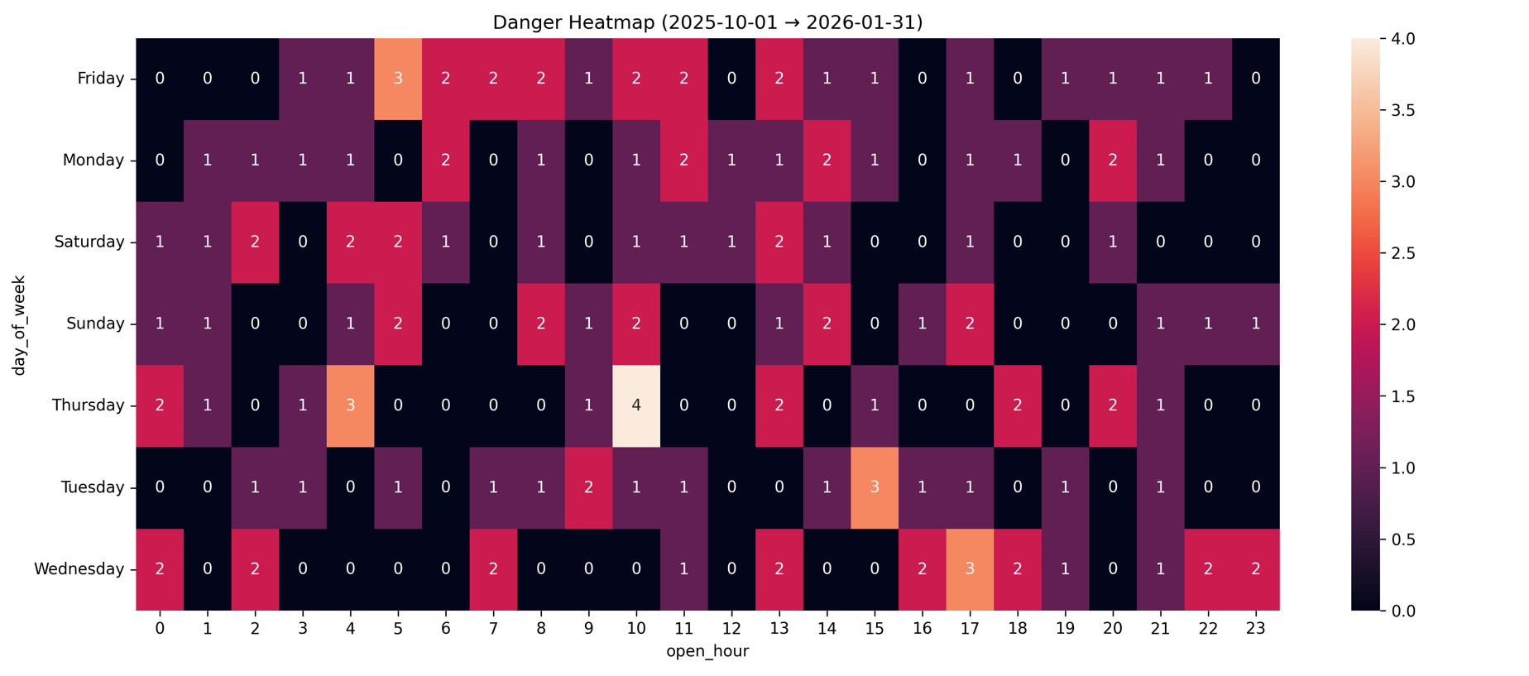

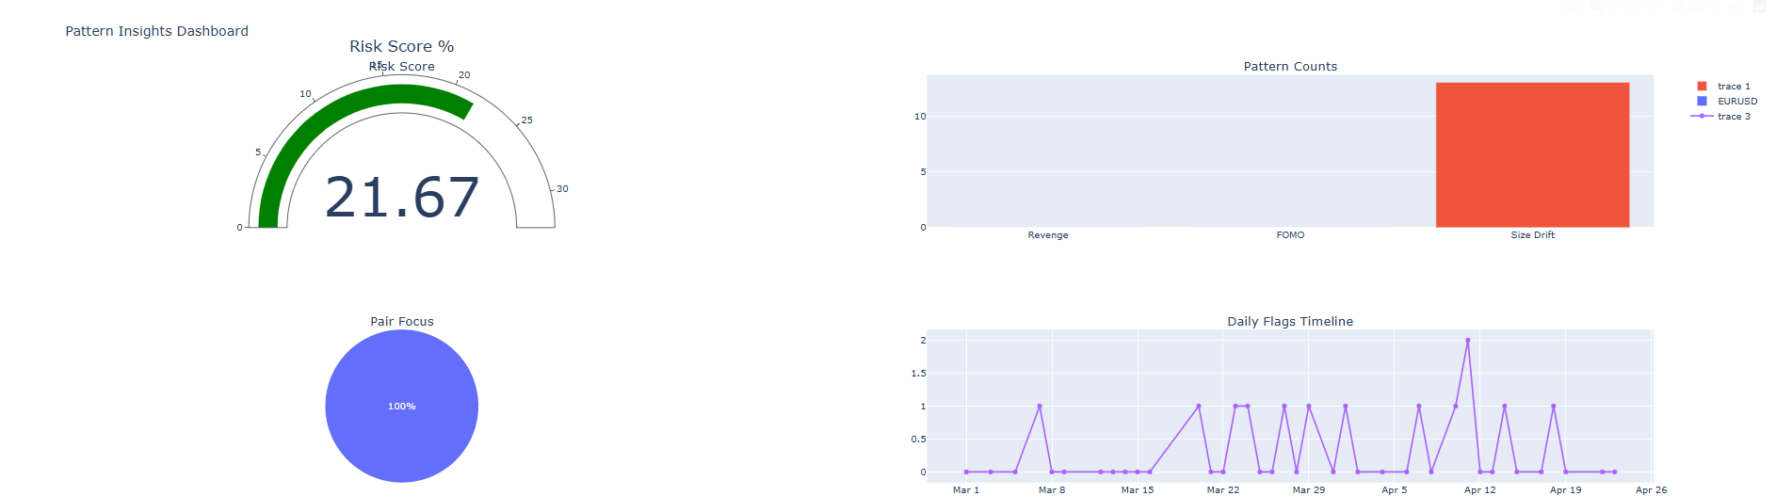

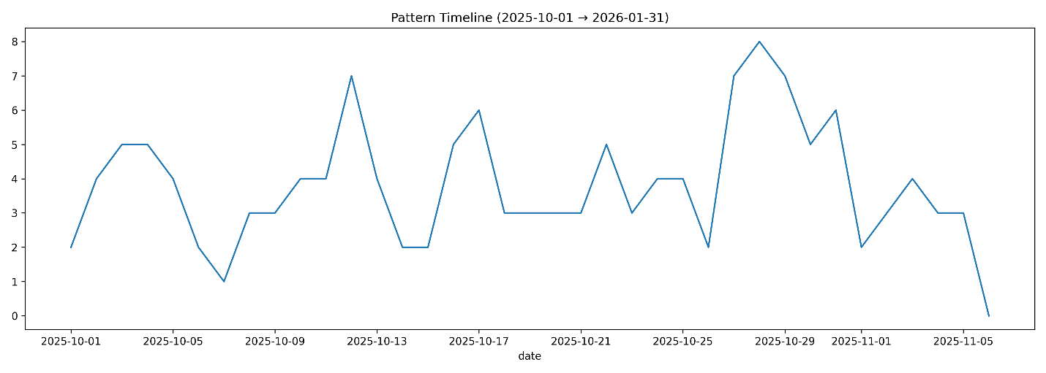

13. How to Customise

Goal | What to Change
Analyse a different file | Set CSV_PATH to your file path
Change the time window | Set FILTER_MODE and FILTER_N (e.g., FILTER_MODE='days', FILTER_N=7)
Use a specific date range | Set FILTER_MODE='range' and update RANGE_START / RANGE_END
Adjust revenge threshold | Change 120 (seconds) in detect_patterns() to a different value
Adjust FOMO sensitivity | Change the multiplier 2 in is_fomo to a higher/lower value
Change size-drift threshold | Change > 2 in is_size_drift to a different vol_ratio threshold
Alter risk score weights | Modify 0.4 / 0.35 / 0.25 in risk_score() (must sum to 1.0)
Save to a different folder | Change OUT_DIR to any valid path

Trade Pattern Analyser — Code Documentation

