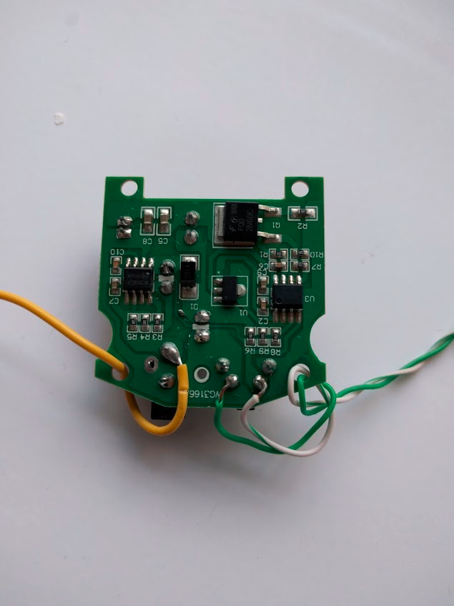

Solid Green and Banded Green wires (see fritzing diagram) are soldered to the WG3166A mister control board as shown. The yellow wire (soldered to 5v pin) is not used for this project, so you do not need to include it.