CSE 616
THE HEART ATTACK CARE-SEEKING STUDY [HACS]
System Requirements Specification Document

Dec 5, 2005

Team Pending:
Jennifer Cleary <cleary.35@osu.edu>
Trent Hoverman <hoverman.8@osu.edu>
Brian Mandalis <mandalis.1@osu.edu>
Brian Weaver <weaver.300@osu.edu>
Eric Grosscup <soldyne@yahoo.com>
Table of Contents

1 Introduction
1.1 Purpose of Document
1.2 Project Summary
1.3 Project Scope
1.4 Background
1.5 System Purpose
1.6 Document Overview

2 Charter: Functional Objectives
2.1 Definitions
2.2 High Priority Objectives
2.3 Medium Priority Objectives
2.4 Low Priority Objectives

3 Charter: Non-Functional Objectives
3.1 Reliability and Maintainability
3.2 Usability
3.3 User Qualifications
3.4 Performance
3.5 Security
3.6 Scalability
3.7 Design Constraints
3.8 Interfaces
3.9 Budget
3.10 Administration

4 Context Model
4.1 Goal Statement
4.2 Context Diagram
4.3 Diagram Definitions
4.4 System Externals/Roles

5 The Use Case Model
5.1 Use Case Model Diagram
5.1.1 Survey Respondent and System Clock Use Cases
5.1.2 System Administrator Use Cases
5.1.3 Miscellaneous Use Cases

5.2 Use Case Scenarios, Prototypes and Sequence Diagrams
5.2.1 Get Next Question
5.2.2 Save Survey
5.2.3 Update Survey
5.2.4 Auto Log Out
5.2.5 Flag Fast Survey
5.2.6 Create Medical Term
5.2.7 Edit Medical Term
5.2.8 Delete Medical Term
5.2.9 Create Administrator Login
5.2.10 Edit Administrator Login
5.2.11 Review Administrator Login
5.2.12 Delete Administrator Login
5.2.13 Enter Fourth ID
5.2.14 Ask Identifier Question

6 The Class Diagram

Introduction

Purpose of Document
The purpose of this Requirements Specification Document is to detail the specifications for a web based medical history survey system. Currently the survey is paper based where multiple pages must be printed for each survey taken and the data must be collected and tallied by hand. The new system will create an electronic version of the survey where those being surveyed (hereby referred to as customers) will access the system via remote computer access. The customers will not only be able to take the survey at their convenience but also be able to save their progress in the survey (by way of unique URLs) so as to finish it at a later time. The survey data will be saved in an easy to retrieve format (database) on a single server which can be accessed by Dr. Alonzo and his team so that they may more easily interpret the data collected.

Project Summary
Project Name: THE HEART ATTACK CARE-SEEKING STUDY [HACS]
Project Manager: Ms. Bettina Bair
Responsible Analysts: Eric Grosscup, Jennifer Cleary, Trent Hoverman,
Brian Mandalis, Brian Weaver
Responsible Users: Dr. Angelo Anthony Alonzo and his research staff

Project Scope
The scope of this system is to survey those customers which have had heart attacks. The expected age range of customers will be those in their 50's or older and who may have little experience with the internet or computer use in general. Customers will be chosen at random via advertising through hospitals, libraries and nursing homes throughout the city of Columbus. The system will keep track of both finished and unfinished surveys on a single server which must have the capacity to store as many as 5000 surveys and as few as 2413 surveys (minimum number of needed surveys for the study to have use). The system will have the ability to report the raw data of all collected surveys so that the responsible users may better perform their study. The system will not record any personal information about the customers. The system will not be in use for more than 18 months (the length of the survey) and individual, incomplete surveys will only remain active (updateable by the customer) for at most 30 days. No other systems or projects are known to interact with this system at this time.

Background
The current system is a paper and pencil survey system. Each individual survey is printed on multiple pages of paper and the customer is instructed to complete the form by hand. The completed surveys are then collected and reviewed by graduate students and staff of the Ohio State University Sociology department. This is an inefficient system as during the course of a paper survey, surveys may become lost, damaged or filled out with illegible handwriting.

The new system will turn this cumbersome and wasteful paper system into a user friendly web based electronic survey system. The new system will allow users to answer survey questions by typing in their responses into text boxes or by clicking their mouse on radio buttons/check boxes. Users will be able to take multiple paths through the survey and save their progress at any time to make the survey more convenient and less likely to be lost or damaged. Completed surveys are saved to a remote sever which will increase the likelihood of the surveys being returned in a timely manner. Ultimately the new system will increase the efficiency of distributing surveys thus increasing survey response numbers and data collection abilities.

System Purpose
- The system will be used by customers who were heart attack patients
- The system will also be used by Dr. Alonzo and his research staff in the Ohio State University's Sociology department
- The system will be responsible for:
  - Maintaining incomplete surveys for 30 days to allow customers to finish the survey at their convenience
  - After 30 days incomplete surveys will no longer be available for update by the customer but will be maintained for purposes of data collection.
  - Maintaining completed surveys for 18 months to allow the client (Dr. Alonzo) to access the survey data and analyze its value.
  - Reporting the raw data of completed and incomplete surveys so that the client may view the information in an orderly fashion and use third party software (such as PERL scripts or DataVision) to create reports, charts and graphs
  - Maintaining at minimum 2413 individual completed surveys and as many as 5000 or more completed and incomplete surveys.
  - Supporting computer users across a wide range of education levels, degree of computer sophistication, physical abilities.
  - Supporting peaks of 100 users in an 8 hr day. Maximum concurrent access by at most 5 users.
  - Supporting a wide variety of operating systems (MacOS 9 and 10, Windows 95, NT, ME, XP Home and Office). Browsers: Internet Explorer5, 6. Mozilla Netscape 4.0 and above, including Firefox. Must have acceptable speed from low (dial-up) and high bandwidth connections.
- The system will not be responsible for:
  - Maintaining or collect information which could identify a customer (the surveys must remain anonymous)
  - Using cookies to store information on remote computers.
  - Costing a lot of money to maintain.
  - Maintaining code embedded user names or passwords.
  - Creating charts, graphs or any interpretation of the data collected.
    - The system is needed to help increase the efficiency and accuracy of survey data collection as well as saving money by reducing paper work and saving time by allowing computer software to help facilitate data interpretation.

Document Overview
This document contains several numbered sections which detail the specific requirements of the system being built. Each section contains a number of subsections detailing each heading.

- Section 1: Introduction. This section contains the Purpose of the Document, the Summary, Scope, Background and Purpose of the system and the Overview of Document itself (this very section).
- Section 2: Function Objectives. This section will detail what the system will be designed to do and what features will be implemented. The features will be listed in order of priority.
- Section 3: Non-Functional Objectives. This section will detail how the system will perform, maintain security, reliability, usability and supportability.
- Section 4: Context Model. This model will diagram the flow of information and detail the relationships between the system and its users.
- Section 5: Use Case Models. This section will detail how the system will be used by the individual actors and the steps the system will take to perform the Functional Objectives.

2 Functional Objectives

2.1 Definitions
- Revenue - as this project is not being built for the purpose of economic gain revenue will hereby be in reference to data and not money.
- Survey respondent - those people taking the survey.
- System administrator - Dr. Alonzo and his research staff.

2.2 High Priority Objectives
- The system will allow survey respondents to login to the system remotely. This will increase revenue over paper surveys by enticing x% more survey respondents to take the survey and reduce lost, damaged and unreadable surveys by y%. This will avoid costs by reducing the amount of paper necessary to print and store the required number of surveys to 0.
- The system will allow survey respondents to save their survey progress and update incomplete, active surveys by accessing a unique URL or logging in with a unique User ID (chosen by the survey respondent) which will identify their specific survey instance within 30 days of the initiation of the survey,. This will increase revenue by reducing the number of incomplete surveys by z%.
- The system will give the system administrator the ability to generate reports of the raw survey data using various sorting criteria. This will improve service making the data easier to view and process thus reducing the system administrator's research time by as much as h hours.
- The system will automatically log out a user after 30 minuets of inactivity thus preventing another person from submitting potentially incorrect data. This will increase revenue by improving the quality of p% of surveys over the course of the research term.
- The system will allow survey respondents to take multiple paths through the survey thus making the survey dynamic. This will increase revenue by making the data submitted in surveys more accurate and relevant to the study by a factor of j%. This will also increase service to the survey respondent by reducing the average time to take the survey by k minuets.

2.3 Medium Priority Objectives
- The system will generate an interactive timeline of events based on the survey respondent's survey answers. This will increase revenue by making the survey data more accurate by a factor of r%.
- The system will allow the system administrator to manipulate survey questions. This will increase revenue by t% by increasing the quality of the questions asked and thereby increasing the quality of the answers received.
- The system will allow the administrator to archive submitted surveys and thus remove them from the reports. This will increase revenue by making the reports zz% more accurate by allowing the administrator to control outliers in the data collection process.

2.4 Low Priority Objectives
- The system will change the status of incomplete surveys which are more than 30 days old to a "dead" status. These "dead" surveys and their data will be maintained separately from the data of completed surveys. s% of most surveys will remain incomplete due to a number of factors. This incomplete data will help increase revenue by giving the system administrator s% more data with which to do better research.
- The system will flag surveys which are completed quickly (within 15 minuets). This will increase revenue by v% by allowing the system administrator to take notice of data which may be potentially erroneous.
- The system will provide medical terminology on demand. This will increase revenue by providing education to the survey respondent and thus increasing the accuracy and quality of the survey respondent's responses by w%.
- The system will allow the system administrator to manipulate the medical terminology. This will increase revenue by xx% by increasing the quality of information given to the survey respondents.
- The system will allow system administrators to manipulate other system administrator login information. This will avoid costs by allowing the system administrators to limit the number of total users who have access to the system thus preventing the possibility of hh hours of redundant work and reduce mistakes in reporting by mm%.

3 Non-Functional Objectives

3.1 Reliability and Maintainability

3.1.1 - The system uptime must be at least X% during the 8 hour day. Outside of this period, a less strict uptime of Y% will be acceptable.

3.1.2 - The system must be easily maintained, with downtime for non-critical maintenance, backups, and upgrades to occur outside of the 8 hour day. Critical maintenance will be permitted during the 8 hour day, with the appropriate authorization.

3.1.3 - System power must be protected from surges and brownouts.

3.1.4 - The mean time between failure (MBTF) of the system will be X hours. The mean time to recovery (MTTR) of the system will be Y hours, and the defect rates of the system components will be Z%.

3.2 Usability

3.2.1 - The survey will conform to a format that reflects the industry
standards for web forms and paper surveys. It will be simple and logical. X% of all users should be able to complete the survey without any kind of tutorial or non-physical assistance.

3.2.2 - The system will support access from both private and public
computers.

3.3 User Qualifications

3.3.1 - The survey system will support computer users across a wide range of education levels, degree of computer sophistication, and physical abilities. X% of all users should be able to complete the survey within Y minutes.

3.3.2 - The survey system will support user review and revision of the completed form. This requirement will limit the submission of erroneous data to less than X errors per 100 carefully completed forms.

3.3.3 - System administrators must have experience setting up and maintaining a LAMP (Linux, Apache, MySQL, and PHP) server. Perl and XML experience is preferred, but not required.

3.4 Performance

3.4.1 - The system will be able to store data for up to 10,000 survey users.

3.4.2 - The response time for users trying to access the survey system for the purpose of taking the survey will be less than 1 second.

3.4.3 - System users will be able to access the raw survey data in X seconds. System users will be able to access the survey data for reports in Y seconds.

3.5 Security

3.5.1 - Survey user access will be completely anonymous. Once a user
accesses the survey system for the first time, they will need to create a
unique userid and password. This is necessary to support the ability for
users to revise their surveys. No personally identifiable information will
be entered by the user at any point.

3.5.2 - System user access will be restricted with database user ids and passwords stored in an encrypted file on the database server.

3.5.3 - System servers will be located in an area with limited and
controlled access. Backup media will be stored offsite in a controlled
access location.

3.5.4 - A standard security architecture will be implemented to control non-physical access to the servers.

3.5.5 - The system will mitigate denial-of-service attacks using fixed-size connection pooling on the web and database servers.

3.5.6 The system will prevent SQL-injection attacks by adhering to standard development practices.

3.6 Scalability

3.6.1 - Maximum concurrent access to the survey will be limited to X users.

3.6.2 - The system will be able to support peaks of X survey users.

3.6.3 - The configuration of the system servers will not extend beyond two
computers.

3.7 Design Constraints

3.7.1 - The system will use the MySQL GA Release 4.1 or higher database
to store and manage surveys.

3.7.2 - The system will use the Apache 2.0 or higher web server for web
access to the survey management system.

3.7.3 - The system will use PHP 5.0 or higher for the survey application,
business logic, and presentation.

3.7.4 - The system will use PERL 2.0 or higher for scripting and reporting
applications.

3.8 Interfaces

3.8.1 - The survey web pages will conform to Web Content Accessibility Guidelines 1.0 of the W3C Recommendation 5-May-1999 to ensure the greatest accessibility.

3.8.2 - The system will run on Linux OS 9.0 or higher. Linux is being chosen as the server operating system because of its low cost.

3.8.3 - The survey system will ensure browser interoperability.

3.9 Budget

3.9.1 - The system will be low cost, adherent to a budget of $X for software and hardware purchases and licenses.

3.10 Administration

3.10.1 - The system will be administrated in a way that conforms to the standards, and security and privacy provisions of the Health Insurance Portability and Accountability Act (HIPAA).

4 THE CONTEXT MODEL

4.1 Goal Statement

The goal of this system is to create a user friendly, paperless survey which will increase the number of survey respondents by x% over paper surveys and reduce research time by y hours by:
- Allowing survey respondents to access the system remotely in areas they deem to be more convenient.
- Allowing survey respondents to finish the survey at their own pace and schedule.
- Allowing the system administrator to sort, filter and examine data to facilitate data gathering and analysis.

4.2 Context Diagram
Fourth ID, sex, date of birth, zip code, response

HACS
System Administrator
Survey Respondent
Active Survey, Timeline, Medical Info, next survey question
Sorting Criteria, survey question, medical term
Submitted Survey responses, questions, Medical terms

4.3 Diagram Definitions:
- Active Survey Instance - A survey which has been created by a new survey respondent, currently less than 30 days old and has not been submitted.
- Submitted Survey Instance - A survey which has been completed and submitted before the 30 day time limit.
- Dead Survey Instance - A survey which is 30 days or older and has never been submitted
- Submitted/Dead Survey Responses - the collection of responses given to survey questions by active survey respondents for a particular survey instance.
- Fourth ID - provided by the customer at time of active survey instance saving. The system will associate User ID with an active survey instance to provide a unique key to identify the survey. The system will keep track of all User IDs and will not allow an ID to be reproduced.
- Sorting Criteria - filters provided by the system administrator used to sort the survey data in various ways (perhaps by survey creation time, a specific survey question, or any other reasonable sorting priority).
- Medical Term - this is information input by the system administrator or requested by an active survey respondent that will explain or define a particular/list of medical term(s).

4.4 System Externals/Roles:
- System Administrator - Dr. Alonzo, his staff, members of the biostatistics lab and computer programmer. The system administrator will interact with the system by providing sorting criteria to extract data from both submitted and dead survey instances. The system administrator will also be able to provide submitted and dead survey instance IDs to facilitate archiving of survey data in order to remove certain sets of data from the reporting events. The System administrator will also be able to add, update, remove and report the questions on the survey and the medical information for specific terms.
- Survey Respondent - a person taking the survey. Survey respondents will begin by logging into the system remotely. The system will then display a blank active survey instance. Survey respondents will interact with the survey instance by answering questions, saving surveys for later update and submitting active surveys. Survey Respondents may also demand medical information from particular terms within the survey and update a timeline generated by their survey answers. To save a survey the respondent must provide their date of birth, sex, and 5-digit zip code. If that combination would produce a non-unique identifier then the respondent must also provide a Fourth ID. The respondent may then access their saved survey using this set of criteria and update the answers at their convenience.

Note: it is possible for a single person to have access to more than one active survey instance, however, it is the confidence of Dr. Alonzo that under normal circumstances most people will only bother to submit a single survey.

5 THE USE CASE MODEL

5.1 The Use Case Model Diagram

5.1.1 Survey Respondent and System Clock Use Cases


Create Survey
Display Survey
UpdateTimeline
Save Survey
Submit Survey
Display Medical Term
Kill Survey
Auto-Logout
Survey Respondent
System Clock
Update Survey
Get Next Question
Flag Fast Survey
Enter Fourth ID
Ask Identifier Question
System
Administrator
DisplayTimeline

5.1.2 System Administrator Use Cases

Add Question
Report Submitted Survey Data
System Administrator
Report Dead Survey Data
Archive Survey
Update Question
Delete Question
Display Question
Add Medical Terms
Update Medical Terms
Delete Medical Terms
Display Medical Terms

5.1.3 Miscellaneous Use Cases
Create Administrator Log in
System Administrator
Edit Administrator Log in
Delete Log In ID
Review Administrator Log in
Survey Respondent
Log in
Log out

5.2 Use Case Scenarios and Sequence Diagrams

5.2.1 Get Next Question
Use Case Name: | Get Next Question
Summary: | An active survey respondent will answer questions as they show up during the survey. Depending on how they respond, the correct type of sequential question will show up next.
Basic Flow: | - Survey respondent starts survey  - Respondent answers questions as they come  - <<extend>> Record respondent answers to survey questions  - System looks at answers based on yes or no response  - CASE 1 (answer = yes), continue on with sequential questions in that field  - CASE 2 (answer = no), skip the sequential questions dealing with that field  - Respondent continues on with survey until finished
Alternative Flow(s) | 4. If respondent selects N/A, the computer will respond as if they selected no  4. If respondent doesn’t answer the question, the computer will respond as if they selected no
Extension Points: | 3. In Basic flow, <<extend>> Record respondent answers to survey questions
Precondition: | The respondent has been selected to be involved with the survey
Postcondition: | The respondent is able to answer the questions
Business Rules: | The respondent must give multiple forms of id to take the survey, and is willing to take the survey.

Prototype: Get Next Question
Steps 1-3:
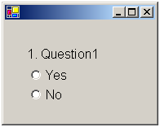

Step 5:
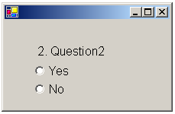 Step 4:

If answer = yes, the go to next question.

If answer = no, then go to next set of new questions.

Survey Respondent
Question
Survey
CreateSurvey()
DisplayQuestion()
(QuestionText)
GetNextQuestion(Response)
Response
SetResponseData(Response)
Response:=GetResponseData()
Get Next Question

5.2.2 Save Survey
Use Case Name | Save Survey
Summary | The system saves the completed portion of the survey with a respondent’s identification information
Basic Flow | - Respondent gives identification information and confirms request  - Incomplete survey information is sent to system.  - System archives it as “incomplete”, allowing access by respondent using the given identification information.  - If x days elapse without access, <<extend>> Kill Survey.
Alternative flow | 2. System already has identical identification information and requests that respondent give an additional piece of information.
Extension Points | After x days, <<extend>> Kill Survey.
Precondition | Respondent is taking survey and wishes to continue at a later date.
Postcondition | Incomplete survey information is stored in system and available for edit and completion.
Business Rules | Identification information – the respondent’s date of birth, zip code and sex.  Incomplete – a survey that is completed up to a particular point.

Prototype: Save surveys by sex, DOB, and zip of respondent

- Handled after the respondent clicks the 'save survey' button
- Incomplete survey information is stored in system

Survey Respondant
Survey
SaveSurvey()
Save Survey

5.2.3 Update Survey
Use Case Name | Update Survey
Summary | The system allows the respondent to edit an incomplete survey using their saved identification information.
Basic Flow | 1. Respondent enters their Sex/DOB/Zip Code information in designated area to access their saved survey.
 | 2.System saves entries made by the respondent
 | CASE 1, respondent changes previous entries
 | CASE 2, respondent makes new entries
 | 3. <<extend>>Control the sequence of survey questions according to path
 | 4. Respondent finishes the survey.
Alternative Flow(s) | 1. If respondent's identification matches another, <<include>>Ask for fourth ID
 | 1. If respondent's identification information is not found, <<include>> Ask the identifier question to send their identification information
 | 4. <<extend>>Respondent decides to Save incomplete survey
Extension Points | 3. In basic flow, <<extend>>Control the sequence of survey questions according to path
 | 1. In alternative flow(s), <<include>>Ask for fourth ID
 | 1. In alternative flow(s), <<include>>Ask the identifier question to send their identification information
 | 4. In alternative flow(s), <<extend>>Respondent decides to Save incomplete survey
Precondition | Respondent has chosen to edit the survey. Respondent has previously saved a survey and gave their identification information.
Postcondidtion | The survey has been updated and will be saved either as an incomplete survey or completed survey.
Business Rules | The survey must be completed, to the best of the respondents ability, in a truthful manner.

Prototype: update surveys
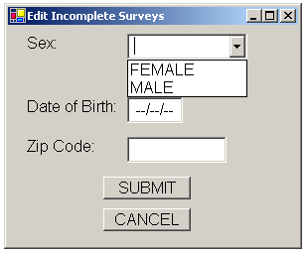

Alternative Flow:

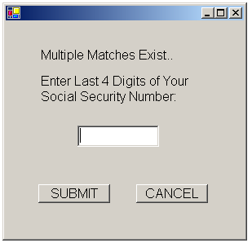
1st
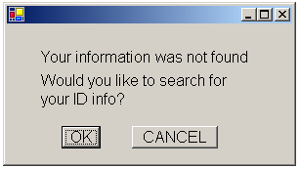

2nd
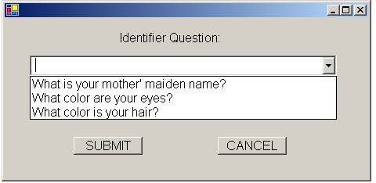

Return with:
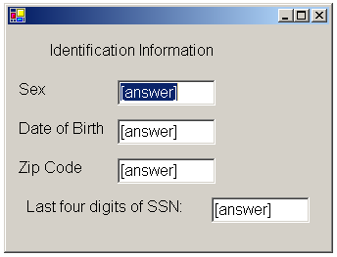

Survey Respondent
Survey
Question
Update Survey
Login(DOB, Sex, Zip, Time)
EnterFourthID(SS#)
Answer Question
Finish Survey
IdentifierQuestion(Question, Response)
getLogin()
5.2.4 Auto Log Out
Use Case Name | Auto Log Out
Summary | After x minutes of inactivity and the respondent stated at the beginning that the survey was being taken on a public machine, the survey times out, stores the incomplete data and restarts the survey for use by another respondent.
Basic Flow | - 15 minutes of inactivity elapse on the respondent’s system.  - The partially completed survey is submitted to the data system as incomplete.  - Survey Respondent is Logged out.  - The respondent’s system returns to the beginning screen for the survey.
Alternative Flow
Extension Points | none
Precondition | Respondent is taking survey and has stated at the beginning of the survey that he or she is using a public machine.
Postcondition | Incomplete survey information is stored in system and is flagged as ‘incomplete’ for later analysis.
Business Rules | Incomplete – a survey that is completed up to a particular point.  Public Machine – an internet-capable computer that is available for use in a public place, e.g. in a library or retirement home.

Prototype: Mark surveys as incomplete after x minutes of activity.

- Handled by the clock of the public machine the survey is being taken on.
- Incomplete survey information is stored in system and is flagged as ‘incomplete’ for later
analysis.

Survey Respondent
Survey
Survey Respondent
[15 minuets inactivity] SaveSurvey()
Logout()
Auto Log Out

5.2.5 Flag Fast Survey
Use Case Name: | Flag Fast Survey
Summary: | An active survey respondent will take the survey. If the respondent completes the survey in a time less than x minutes, the survey will be flagged for possible false answers.
Basic Flow: | - Respondent submits survey  - System selects case, based on minutes used to complete the survey  - CASE 1 (minutes < 60), flag survey  - CASE 2 (minutes >= 60), do not flag survey  - System stores survey
Alternative Flow(s) | 4. If respondent doesn’t finish survey, then <<include>> Mark incomplete surveys as “dead” after 30 days
Extension Points: | 4. In alternative flow, <<include>> Mark incomplete surveys as “dead” after 30 days
Precondition: | The respondent is logged in to survey
Postcondition: | The respondent’s survey will be used depending on whether or not it was flagged
Business Rules: | The respondent must answer the questions in a truthful and legal manner in a timely fashion.

Prototype: Flag surveys if completed in less than X minutes.

Steps 1-4:
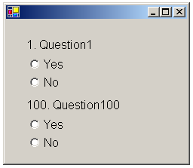

Step 5:

If minutes < X, then flag survey

If minutes >= X, then do not flag survey

Step 6:

Survey stored

Flag Fast Survey
Survey Respondent
Survey
SubmitSurvey(Date, Time)

5.6.2 Create Medical Terms
Use Case Name | Create Medical Terms
Summary | System Administrators create tips and definitions for specific terms or phrases in the survey. The system verifies that the term or phrase entered exists in the survey.  When the information has been created, the system stores it and updates the survey.
Basic Flow | 1. A system administrator will enter the term or phrase for which they want to create any tips or definitions  2. The system verifies that the term or phrase entered is located in the survey and that tips or a definition have not been entered  3. The system prompts the system administrator to enter the information for the term or phrase  5. The system stores the term or phrase information that the system administrator entered  6. The system updates the survey to reflect that a tip or definition exists for the term or phrase and its aliases
Alternative Flow(s) | 2. Term or phrase not found, go to 1
Extension Points
Precondition | The survey exists
Postcondition | The survey has been updated to reflect that tips or definitions exist for the term or phrase
Business Rules | Term/phrase information includes any tips, a definition, or aliases that are associated with the term or phrase

Prototype: Create/Edit/Review/Delete tips and definitions.

Create tips and definitions
Step 1:
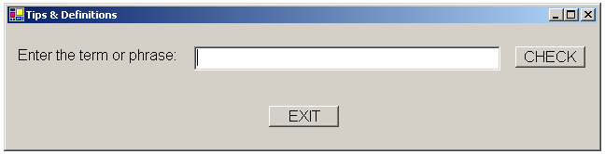

Step 3:
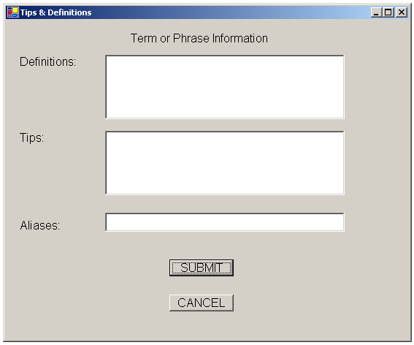

Survey
System Administrator
Medical Term
Create medical terms
Valid := verifyTerm(TermName)
[term is valid] UpdateSurvey()
AddTerm(name, description)

5.2.7 Edit Medical Terms
Use Case Name | Edit Medical Terms
Summary | System administrators edit tips or definitions of a term or phrase for which a definition or tip has been created. They can search for a specific term or phrase or they can browse the terms and phrases that exist. When the information has been updated, the system stores it and updates the survey.
Basic Flow | 1. The system offers a system administrator the choice of browsing terms or phrases that have definitions or tips, or the system administrator can enter a specific term or phrase to review  2. The system executes one and only one of the following subflows:  - If the system administrator selected “browse,” the Browse subflow is executed  - If the system administrator selected “user input,” then the User Input subflow is executed  Subflow: Browse  1. The system displays all terms or phrases for which a definition or tip exists  2. The system administrator selects a term or phrase to review  Subflow: User Input  1. The system administrator enters the term or phrase they wish to review  2. The system verifies that the term or phrase entered by the system administrator has an associated definition or tip  5. The system displays the information for a specific term or phrase  6. The system administrator edits the appropriate information  7. The system stores the updated information for the term or phrase
Alternative Flow | 4. Term or phrase not found, go to 1
Extension Points
Precondition | The survey exists
Postcondition | The edited term/phrase information for the term has been stored
Business Rules | Term/phrase information includes any tips, a definition, or aliases that are associated with the term or phrase

Prototype: Review/Edit tips and definitions
Step 1:
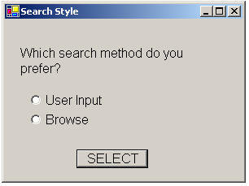

Subflow: User Input Step1

Subflow: Browse Step 1
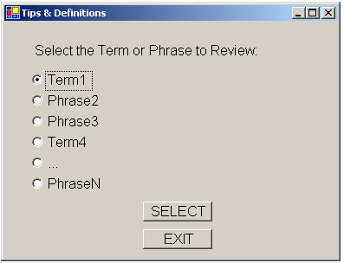

Return with:
Steps 3-4 (for Edit tips and definitions), Step 3 (for Review tips and definitions)

Note: If the user is reviewing tips and definitions, there will be no submit button.

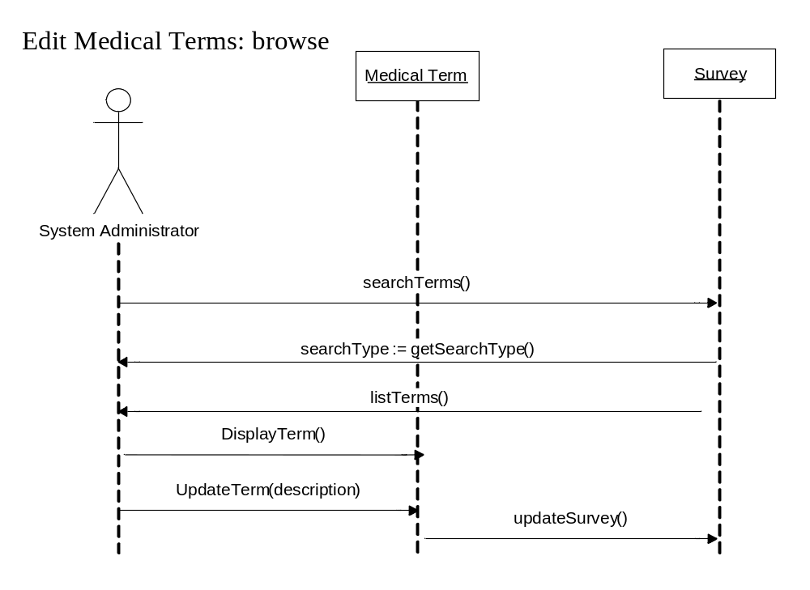
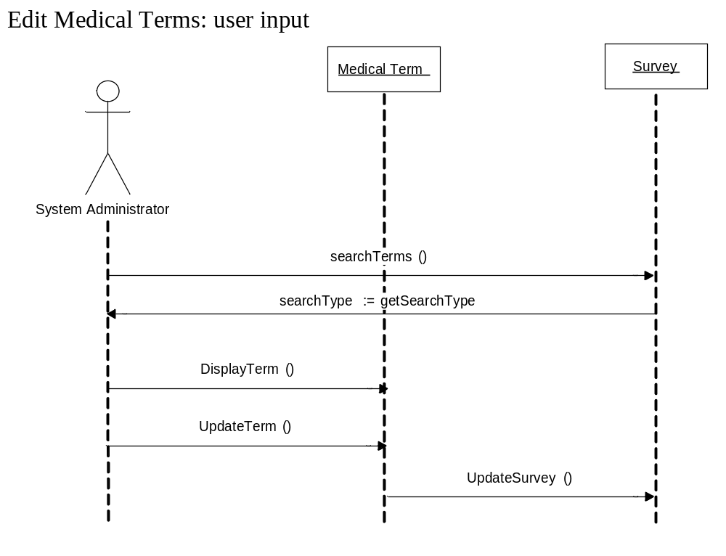
5.2.8 Delete Medical Terms
Use Case Name | Delete Medical Terms
Summary | System administrators delete tips and definitions associated with a term or phrase. They can search for a specific term or phrase or they can browse the terms and phrases that exist. The information is presented to the system administrator
Basic Flow | 1. The system offers a system administrator the choice of browsing terms or phrases that have definitions or tips, or the system administrator can enter a specific term or phrase to delete  2. The system executes one and only one of the following subflows:  - If the system administrator selected “browse,” the Browse subflow is executed  - If the system administrator selected “user input,” then the User Input subflow is executed  Subflow: Browse  1. The system displays all terms or phrases for which a definition or tip exists  2. The system administrator selects a term or phrase to review  Subflow: User Input  1. The system administrator enters the term or phrase they wish to review  2. The system verifies that the term or phrase entered by the system administrator has an associated definition or tip  3. The system displays the information for a specific term or phrase, along with the option to delete the information  4. The system updates the survey to reflect that a tip or definition no longer exists for the term or phrase and its aliases
Alternative Flow | If in Use Case User Input, and the term or phrase is not found, go to 1.  4. If user does not select delete, then the system leaves the information and survey unchanged.
Extension Points
Precondition | The survey exists. At least one term or phrase has information defined for it.
Postcondition | The term or phrase no longer has information stored for it, and the survey shows no information exists for the term or phrase
Business Rules | Term/phrase information includes any tips, a definition, or aliases that are associated with the term or phrase

Delete tips and definitions
Step 1:

Step 2:

OR

Return With:
Steps 3-4: 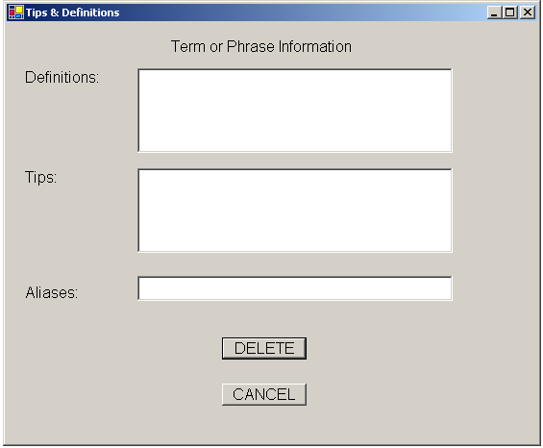

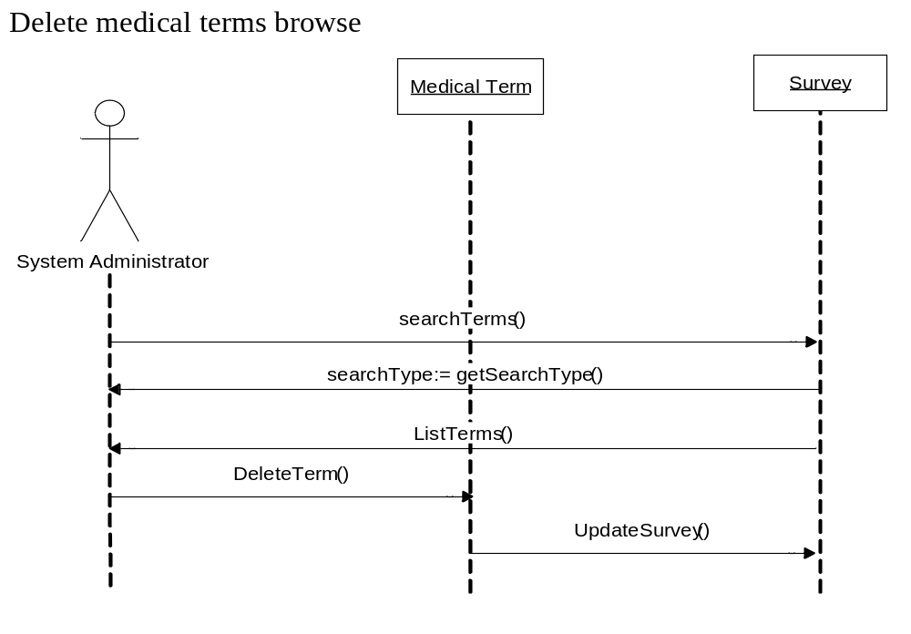

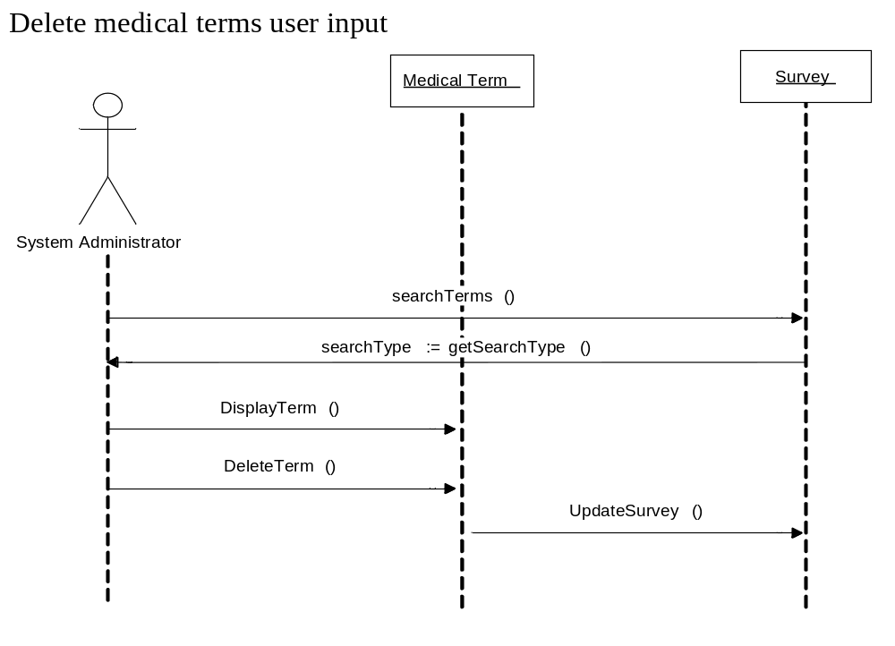

5.2.9 Create Administrator Login
Use Case Name | Create Administrator Login
Summary | The system administrators create login IDs and login passwords to access the system.
Basic Flow | 1. Administrator accesses the system.
 | 2. System prompts for the administrator to enter a unique ID, password and verification password
 | 3. Administrator enters a unique login ID, password and verification password
 | 4. System Saves log in ID and password
Alternative Flow(s) | 3. If the system already has the login ID in the system, return to basic flow 2.
 | 3. If the new password and verification password do not match exactly, return to basic flow 2.
Extension Points
Precondition | The administrator does not have a login ID and password
Postcondidtion | The administrator will have a unique login ID and password in order to access data from the surveys
Business Rules | System administrators are able to access the Survey data.

Prototype: Create administrator login
Step 2:
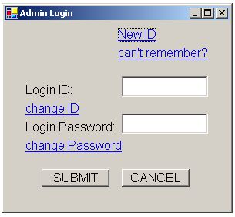

Steps 3-4:
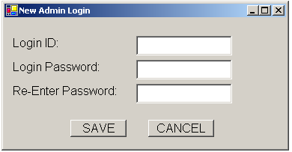

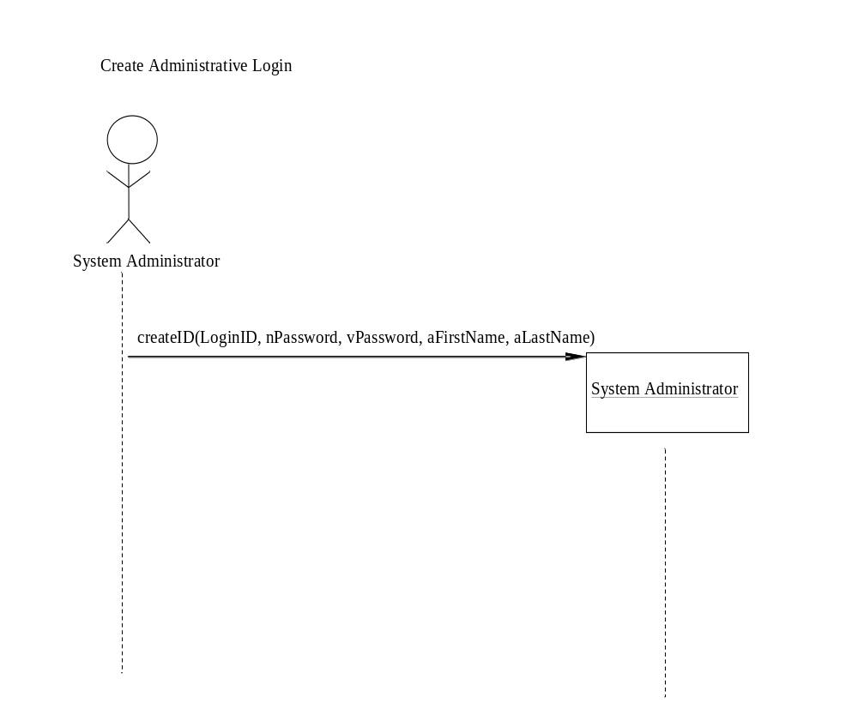

5.2.10 Edit Administrative Login
Use Case Name | Edit Administrator Login
Summary | The system administrators edit their previous login IDs and login passwords to access the system.
Basic Flow | 1. Administrator accesses the system.
 | 2. System offers the administrator the chance to change the previous login password
 | 3. Administrator enters their current login ID, current password, a new password, and verification password
Alternative Flow(s) | 3. If the entered current login ID and password don't have a match in the system, return to basic flow 2.
 | 3. If the new password and the re-entered new password are not identical, return to basic flow 2.
Extension Points
Precondition | The administrator must have a previous login ID and password.
Postcondidtion | The administrator will have a new unique login password and identifier in order to access data from the surveys
Business Rules | Any Administrator is able to edit their own login password and identifier. The Administrator must be authorized by the Super Administrator to access the system's data.

Prototype: Edit Administrator login
Step: 2

Steps 3:
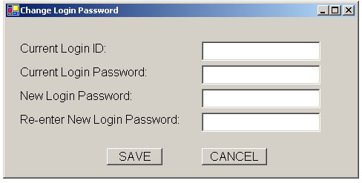

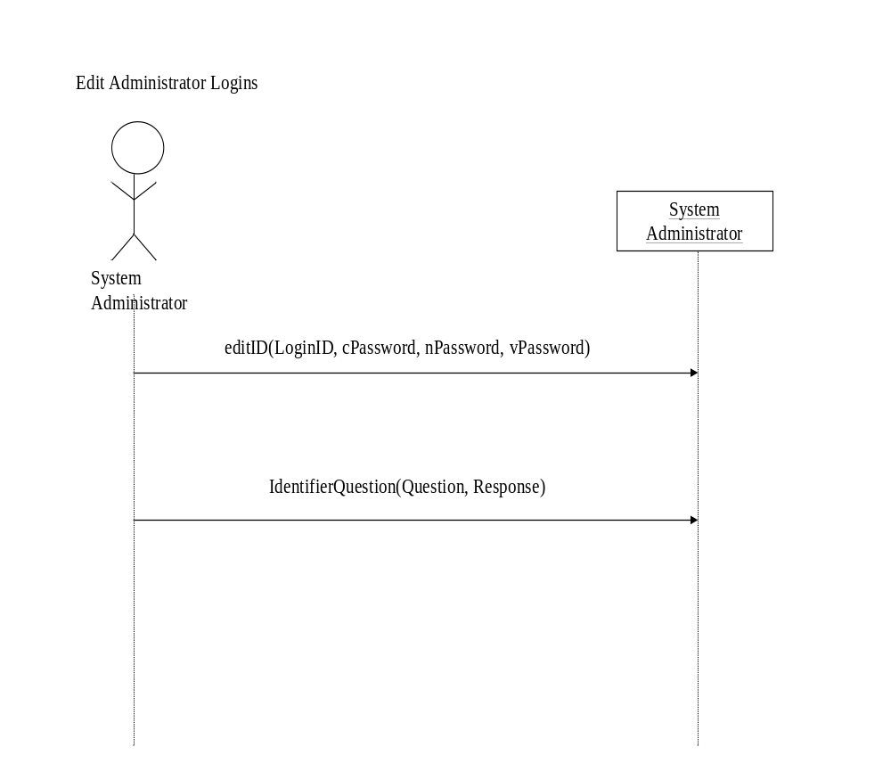

5.2.11 Review Administrator Login
Use Case Name | Review Administrator Login
Summary | The system administrators review login IDs and login passwords to access the system.
Basic Flow | 1. Administrator accesses the system.
 | 2. System offers the administrator the chance to review his/her personal login information
 | 3. System <<include>>Ask identifier question to send the identification information
 | 4. Administrator answers the identifier question
 | 5. System allows the administrator to view their personal login ID and password
Alternative Flow(s) | 4. If the system doesn't recognize the identifier answer, return to basic flow 2.
Extension Points | 3. In basic flow, <<include>>Ask identifier question to send the identification information
Precondition | The administrator does have a login ID and password
Postcondidtion | The administrator will be able to view their unique login ID and password in order to access data from the surveys
Business Rules | The administrator must be authorized by the Super Administrator to access the system's data.

Prototype: Review administrator login
Step 2:

Steps 3-4:

Step 5:
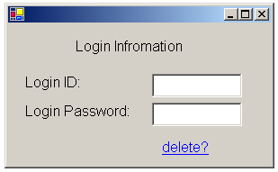
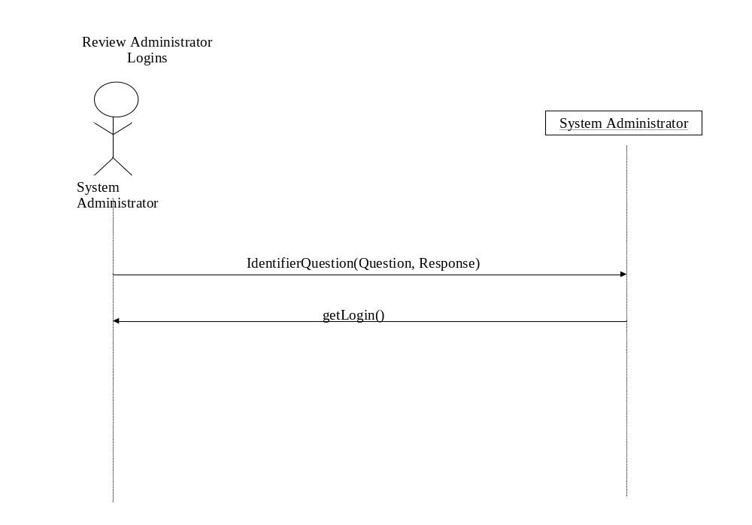
5.2.12 Delete Administrator Login
Use Case Name | Delete Administrator Login
Summary | The system administrators delete login IDs and login passwords that were used to access the system.
Basic Flow | 1. Administrator accesses the system.
 | 2. The system prompts the Administrator to enter their login ID and password.
 | 3. Administrator enters an Administrator login ID to be deleted
 | 4. System asks administrator if they are sure that they want to delete the record.
 | 5. System allows the administrator to delete the login information from the database
Alternative Flow(s) | 4. If the administrator cancels, go to basic flow 1.
Extension Points
Precondition | The Administrator's account has been created. The administrator previously has made a login ID and password
Postcondidtion | The administrator will no longer be able to access the system.
Business Rules

Prototype: Delete administrator login
Step 2:

Steps 3:

[ picture was corrupted in transfer]

Administrator enters Login ID to delete.

Step 4-5:
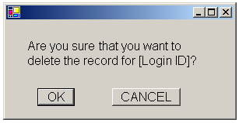

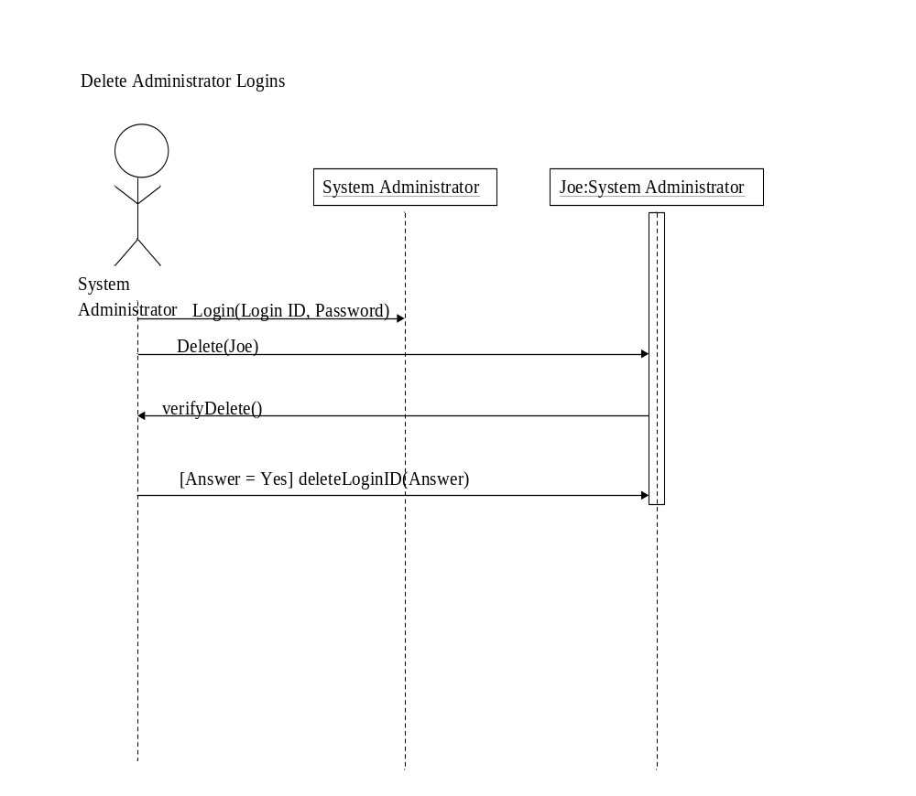

5.2.13 Enter Fourth ID
Use Case Name | Enter Fourth ID
Summary | The system only asks for this fourth ID when the Sex/DOB/Zip Code of the respondent match with another respondent's. This willl separate the two identities and give the respondent the correct survey.
Basic Flow | 1. The system will prompt the respondent to enter their last four digits of their social security number.
 | 2. Respondent enters the fourth ID in the designated area.
Alternative Flow(s) | 2. If the system doesn't find a matching fourth ID, return to basic flow 1.
Extension Points
Precondition | Respondent has previously obtained a fourth ID
Postcondidtion | Respondent will be sent back to edit the incomplete survey.
Business Rules | The respondent will only be asked for this fourth ID when there is a matching ID from another. The first respondent to enter the ID information will not be asked for the fourth ID.
Prototype: Enter Fourth ID
Steps 1-2:
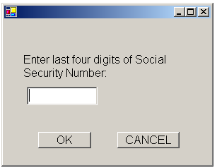

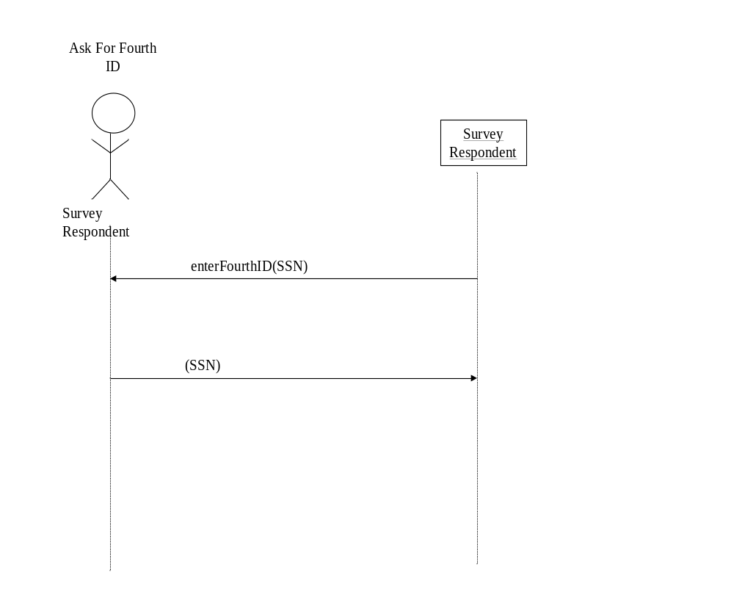

5.2.14 Ask Identifier Question
Use Case Name | Ask Identifier Question
Summary | Whenever a respondent or User Administrator forgets their login information they will be asked to answer their saved identifier question before being allowed to view their info.
Basic Flow | 1. The system will ask the respondent or User Administrator to answer their saved question.
 | 2. The respondent or User Administrator will enter the previously designated answer in the designated area.
 | 3. System will access the respondent's or User Administrator's information and display it.
Alternative Flow(s) | 2. The answer does not mathch the saved answer, return to basic flow 1.
Extension Points
Precondition | Identifier question and answer were previously saved.
Postcondidtion | The respondent or User administrator will be able to enter their information to either edit and incomplete survey or review administrative logins.
Business Rules

Prototype: Ask Identifier Question
Steps 1-2:
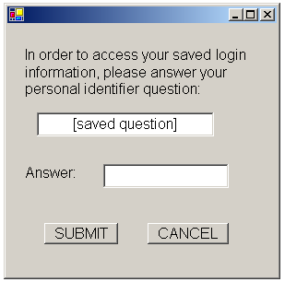

Step 3 (for respondent)

OR (for administrator)

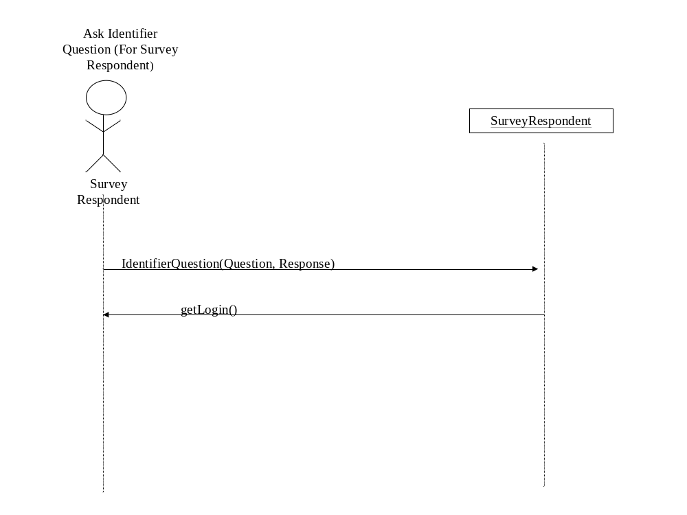

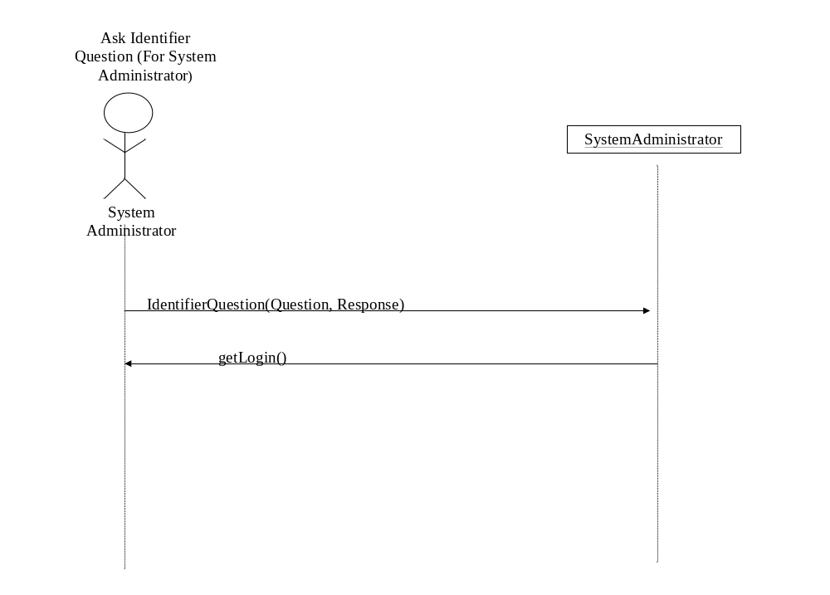

6 The Class Model

Survey Respondent
Date of Birth
Fourth ID
Sex
Zip Code
Login Time
Identifier Question
Identifier Answer
System Administrator
Login ID
Password
First Name
Last Name
Identifier Question
Identifier Answer
Survey
Status
Creation Time
Submission Time
1
0…*
1
Question
Question Text
Number
Order
Timeline
Phase Times
1
1…*
1
1…*
Medical Term
Term Name
Description
1…*
0…*
1
0…*
0…*
0…*
0…*
CreateSurvey(Date, Time)
SubmitSurvey(Date, Time)
KillSurvey(Date, Time)
SaveSurvey()
UpdateSurvey()
DisplaySurvey()
ArchiveSurvey()
ReportDeadSurvey()
ReportSubmittedSurvey()
FlagFastSurvey()
Login(Login ID, Password),
createAdministratorLogin(Login ID, nPassword, vPassword, aFirstName, aLastName),
editAdministratorLogin(Login ID, cPassword, nPassword, vPassword),
AskIdentifierQuestion(Question, Response),
Delete(Login ID),
verifyDelete(),
deleteLoginID(Answer)
ObtainAdminIDQuestion()

Login(DOB, Sex, Zip, Time)
Logout()
AskIdentifierQuestion(Question,
Response)
EnterFourthID(SS#)
AutoLogout()

AddQuestion(Question, Number);
UpdateQuestion(Question, Number);
DeleteQuestion();
DisplayQuestion();
GetNextQuestion(ResponseData);
DisplayTimeline()
UpdateTimeline()
AddMedicalTerm(name, description)
UpdateMedicalTerm(description)
DeleteMedicalTerm()
DisplayMedicalTerm()
0…*
Response
Response Data

