BUSINESS PROSPECTUS · FEASIBILITY STUDY · FIVE-YEAR PLAN
MR WALLABOO
GAMES
A milestone-gated plan for an original tabletop-game studio and publisher
RECOMMENDATION | CONDITIONAL GO
CURRENT POSTURE | Six-month capped validation phase · no manufacturing commitment

The next investment should buy evidence: one validated game, a cleared brand, a qualified audience, and firm supplier and fulfillment quotes.
Prepared for | Dan Trezise and Micah Trezise
Prepared | July 17, 2026
Planning horizon | 2027–2031
Version | WORKING v0.1
Document status | Internal decision document — not a securities offering
Illustrative, unaudited planning analysis. See the disclaimer and source appendix.

1. Executive Summary
Mr Wallaboo Games is a proposed independent tabletop-game studio and publisher built around original games designed by Dan Trezise and Micah Trezise, individually and together. The recovered strategy source deliberately leaves the brand personality, target audience, product mix, publishing model, and manufacturing strategy open. The only named game concept recovered from the shared conversation is The Republic, a game about rising to power in 1930s Germany; its separate design dossier was not publicly recoverable.
The commercial opportunity is real but crowded. The U.S. Games/Puzzles supercategory reached $4.9 billion in 2025, and Kickstarter reported $220 million pledged to successful tabletop campaigns in 2024. Those totals overstate the specific opportunity for a new original-game publisher: Pokémon and trading cards drove much of recent market growth, trading-card games represent roughly two-thirds of hobby-game dollars, and thousands of tabletop campaigns compete for attention. [S01–S06]
The recommended entry strategy is therefore narrow:
- Develop one approachable, paper-heavy flagship game with a $29–$39 target MSRP, 20–45 minute playtime, two-to-five-player reach, and no custom molds.
- Use public playtesting and a print-and-play prototype to establish demand before expensive art or tooling.
- Launch primarily through crowdfunding/direct sales, but build retail-compatible unit economics from the first bill of materials.
- Keep The Republic as a separate adult historical-strategy track until its design, historical framing, content policy, and retailer/platform fit are independently validated.
- Treat the company as a disciplined side-stage venture until the catalog supports repeat demand and founder compensation.
Under the illustrative base case, net revenue grows from approximately $67,000 in 2027 to $688,000 in 2031. EBITDA after modest founder compensation turns positive in 2030 and reaches approximately $112,000 in 2031. The modeled $75,000 seed reserve covers the base-case operating trough, but the conservative case consumes approximately $158,000 over five years. The upside case turns positive in year two. These outcomes are highly sensitive to unit volume, direct-to-consumer mix, landed cost, and title quality.

2. Investment Snapshot
Item | Working position
Stage | Pre-seed / pre-prototype business formation
Readiness | Brand name and founders confirmed; product and audience unvalidated
Opportunity feasibility | 68 / 100 — credible niche with manageable production pathways
Launch readiness | 24 / 100 — no recoverable prototype, blind-test data, list, quote, or clearance
Recommended first capital | $75,000 milestone-gated reserve
Recommended campaign gate | Do not launch until a $60,000 product-pledge goal is supported by measurable prelaunch demand
Base-case operating break-even | 2030 after modest founder compensation; 2029 before founder compensation
Strategic posture | Crowdfunding/DTC first; retail-compatible; one hero title before portfolio expansion
Principal risks | Product-market fit, attention, name clearance, tariff/landed cost, fulfillment, founder capacity

3. Source Provenance and What Is Actually Known

3.1 Recovered facts
- Mr Wallaboo is intended as a board-game brand.
- Dan and Micah Trezise are founders/designers; games may be solo or collaborative.
- The working pipeline stages are Concept, Prototype, Playtesting, Blind Testing, Pre-Production, and Manufacturing Ready.
- The master source contemplates party, family-strategy, hobby, heavy-strategy, card-only, boxed, and expansion-driven games, but does not select among them.
- The Republic exists as a concept about rising to power in 1930s Germany.
- Separate Micah's Games and The Republic — Design Dossier canvases were created, but their bodies are not visible in the supplied shares.

3.2 Research-based conclusions
- A narrow flagship is more financeable than a broad multi-genre slate.
- A paper/cardboard-heavy product is more practical for a first run than custom miniatures, plastic inserts, or molds.
- Direct sales improve gross margin, but retailer/distributor compatibility is required for durable scale.
- The brand must be professionally cleared before packaging, campaign spend, or filing. An established Dutch baby-products business already uses WALLABOO; different goods may coexist, but the finding raises clearance risk. [S16–S18]

3.3 Planning assumptions
All revenue, cost, timing, audience, and capital figures are illustrative assumptions until validated by a finished bill of materials, quotes, historical sales, and campaign data. The linked Excel model is the calculation authority.

3.4 Project roles and methods
This prospectus was developed through six coordinated operating roles:
- Source archivist and provenance lead: recovered the supplied public shares, separated visible evidence from referenced-but-unavailable canvases, and preserved uncertainty.
- Tabletop market analyst: evaluated market size, crowdfunding, competitors, channel economics, and the difference between category growth and the addressable indie opportunity.
- Product and manufacturing feasibility lead: translated the open strategy into a testable flagship specification, stage gates, supplier pathway, quality controls, and fulfillment requirements.
- Financial modeler: built the linked scenario model, unit economics, cash reserve, break-even analysis, and formula checks.
- Legal, compliance, and risk reviewer: identified name-clearance, CPSC, contract, import, historical-content, and two-founder governance issues for professional follow-up.
- Prospectus editor: integrated the evidence into one decision document with explicit go/no-go thresholds.
The corresponding applied skills were browser-based source analysis, professional document production, and scenario-driven spreadsheet modeling. These roles were performed as one coordinated workstream; external legal, tax, customs, insurance, accounting, and product-safety professionals are still required where identified.

4. Company and Brand Thesis

4.1 Proposed mission
Create original tabletop games that reward smart choices, invite repeat play, and feel distinctive without imposing unnecessary rules or component complexity.
This mission translates the working source's example pillars—accessibility, memorable worlds, replayability, table presence, and elegant mechanics—into a testable direction. It does not lock those examples as canon.

4.2 Brand promise
Easy to invite. Worth replaying. Distinctive on the table.
Every release should pass four filters:
- A new player can understand why the game is fun within five minutes.
- The first play completes within the advertised time range.
- Player choices produce a reason to play again.
- The product can be explained in one sentence and recognized across a room.

4.3 Portfolio architecture
Use one master brand and two internal development lanes, not two consumer-facing subbrands at launch:
- Accessible lane: compact party, family, and gateway-strategy games; the recommended launch lane.
- Deep-strategy lane: longer, more demanding, or historically sensitive designs; The Republic belongs here unless testing proves otherwise.
Consumer-facing subbrands should be created only after two successful releases establish a real need for navigation.

5. Product Strategy

5.1 Recommended flagship specification
Attribute | Launch target | Rationale
Format | Cards, punchboard, stock dice/pawns, compact box | Keeps MOQ and tooling risk manageable [S09–S12]
MSRP | $29–$39 | Supports DTC value while leaving a plausible wholesale margin
Players | 2–5 | Covers couples, families, and small game groups
Playtime | 20–45 minutes | Easier demonstrations, reviews, and repeat sessions
Age position | 10+/12+ only if compliance plan supports it; otherwise design and market honestly for 14+ | Age grading affects CPSC obligations [S14–S15]
Complexity | Gateway to light-medium | Matches the proposed brand promise and widens test recruitment
Differentiator | One visible mechanical hook plus one memorable world/character hook | Improves explainability and shelf/campaign communication
Production | No bespoke plastic molds in the first edition | Avoids MOQ and capital escalation [S12]

5.2 Stage gates
- Concept gate: one-sentence hook, audience, playtime, and target cost approved by both founders.
- Prototype gate: complete game loop works with inexpensive components; ten internal sessions logged.
- Playtest gate: at least 30 observed external sessions across at least six groups; issues tracked by severity.
- Blind-test gate: at least ten groups can learn from the rulebook without a founder; at least 80% finish within the stated time; no critical rules ambiguity remains.
- Commercial gate: two comparable manufacturing quotes, fulfillment estimate, compliance classification, MSRP/wholesale margin check, and prelaunch demand threshold met.
- Manufacturing gate: final files, signed approvals, quality-control plan, cash reserve, and contingency approved.
These are management thresholds, not industry statistics.

5.3 The Republic
The Republic may become a distinctive adult historical-strategy title, but it should not carry the company's first-launch burden without evidence. Its premise creates four additional risks: longer development, historical accuracy and framing, platform/advertising sensitivity, and retailer/customer hesitation around extremist imagery or role-play. The project should remain WORKING and be evaluated through a separate design-and-content review. No unrecovered mechanics are assumed in this prospectus.

6. Market Research

6.1 Market size with the right caveat
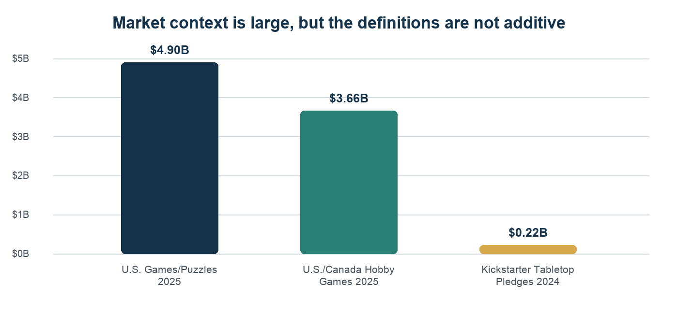
Figure 1. Context-only market measures; category definitions overlap and are not additive. Sources: S01, S03, S05.
The broad U.S. toy market generated $30.3 billion in tracked retail sales in 2025. Games/Puzzles was the largest supercategory at $4.9 billion, up 37%. Circana attributes the category surge primarily to Pokémon, so the number should be treated as an upper context boundary—not a serviceable market for an unknown original board game. [S01–S02]
ICv2 estimated the U.S./Canada hobby-games market at $3.66 billion in 2025, up 40%, but reported that trading-card games account for about two-thirds of hobby-game dollars while the other categories were flat or showed modest growth. Board-game publishers also faced tariff disruption and an unusually heavy flow of product. [S03]
The investable insight is not “the category is booming.” It is that consumers still spend heavily on social, collectible, and repeat-play products, but original board games must win attention one title at a time.

6.2 Crowdfunding
Kickstarter reported 6,646 tabletop projects launched in 2024, 5,314 funded, and $220 million pledged to successful tabletop campaigns. The 80% platform success rate includes established publishers, low-goal projects, RPGs, expansions, and small items; it must not be used as Wallaboo's probability of success. In 2025, tabletop project count rose while overall Kickstarter dollars declined, and Gamefound/BackerKit continued to compete for tabletop projects. [S05–S06]
Kickstarter charges a 5% platform fee and approximately 3%–5% payment processing. The financial model uses 9% combined. Shipping charged through a campaign can inflate the funding total and fee base; the campaign budget should separate product revenue, collected shipping, taxes, and fulfillment liabilities. [S07–S08]

6.3 Customer segments
Segment | Need | Wallaboo entry message | Primary channel
Social families and mixed-experience groups | Fast teaching, reliable duration, replay value | “A smart game everyone can join” | DTC, gift, specialty retail
Gateway hobby gamers | A distinctive hook without a rules wall | “Interesting choices in under 45 minutes” | Kickstarter, reviewers, hobby stores
Collectors / super-fans | Creator story, limited extras, early access | “Founders' edition without gameplay fragmentation” | Crowdfunding, email, conventions
Deep-strategy audience | Historical or systems depth | Separate positioning for The Republic and later designs | Hobby media, conventions, specialist crowdfunding

6.4 Competitive reference models
- Focused micro-publisher: Button Shy demonstrates how a strict physical format and frequent small releases can create identity and lower product risk. Wallaboo should borrow the focus, not the monthly cadence. [S21]
- Distinctive strategy studio: Leder Games combines a recognizable design point of view, replayability, and holistic product/art development. Wallaboo cannot match its catalog initially but can emulate the discipline of one clear mechanical identity per title. [S22]
- Premium catalog publisher: Stonemaier illustrates a broad price ladder, DTC infrastructure, expansions, and accessories. That is a mature-state reference, not a launch template. [S23]
Wallaboo's defendable position is not “another indie publisher.” It must become a trusted curator of a specific play experience. The proposed first position—approachable, clever, replayable, visually distinctive—is promising but still too broad until one product proves it.

7. Go-to-Market Plan

7.1 Channel sequence
- Audience development: development diary, print-and-play signups, local/public tests, designer notes, and email capture.
- Proof campaign: Kickstarter or comparable platform after audience gates; one core pledge, one premium bundle, limited add-ons.
- DTC continuity: own email list and webstore for late pledges, replacement parts, and reorders.
- Retail-direct pilots: 20–40 stores with low case packs, demo support, and reorder tracking.
- Distribution: only after demonstrated sell-through and a landed cost that works at approximately 40% of MSRP. [S13]

7.2 Prelaunch metrics and gates
Do not launch based on follower count alone. Require:
- 1,500 qualified prelaunch followers across owned email and platform followers.
- At least 600 opted-in email subscribers with tracked source and engagement.
- At least 150 completed public playtest sessions across the development period.
- At least 100 written intent-to-back responses or refundable reservations where lawful and platform-compliant.
- A day-one support plan representing at least 30% of the campaign goal.
- Two independent reviews/previews scheduled, with no paid-review influence over conclusions.
These are internal risk gates. They are intentionally stricter than simply opening a campaign page.

7.3 Marketing system
Use a founder-led content engine: one meaningful development update per week, one playtest/reviewer outreach batch per month, and quarterly public prototype milestones. Paid media should amplify proven creative, not discover the product's audience from scratch. The email list is the durable asset; platform followers are rented reach.

8. Operating and Manufacturing Plan

8.1 Build-versus-partner recommendation
Use a hybrid publishing model:
- Retain game IP, creative direction, brand, community, and commercial decisions.
- Contract specialist development/editing, illustration, graphic design, manufacturing, freight, fulfillment, accounting, and legal work.
- Do not hire fixed full-time staff until the catalog produces repeatable contribution margin.

8.2 Manufacturing economics
Public 2026 budgetary data indicates that a straightforward folding-board/card/token game may cost $8–$15 per unit at 1,500+ copies; one published sample was $10.60 at 1,000 copies and $14.28 at 500. PrintNinja's minimum is 500 games and Panda's is 1,500. A typical production-plus-ocean timeline can be 10–14 weeks after proof approval, before contingency. [S09–S11]
The base model begins at a $12.50 landed unit cost and declines to $9.25 as volume rises. “Landed” includes manufacturing, ordinary freight, duty/tariff reserve, inbound handling, and quality loss. This is a model assumption, not a quote.

8.3 Import policy
The U.S. imposed a temporary 10% import surcharge through July 24, 2026 unless modified or extended, while China-specific arrangements and legal authorities have changed repeatedly. The company should never price a campaign using a stale tariff snapshot. Every production approval needs a current customs classification, country-of-origin analysis, and downside quote. [S19–S20]

8.4 Quality and fulfillment
- Approve white sample, digital proof, and pre-production copy before mass production.
- Define acceptable-quality limits for color, registration, component counts, warping, and packaging damage.
- Hold 2%–3% replacement stock.
- Collect shipping after the campaign only if the pledge-manager economics and customer communication are explicit.
- Do not subsidize worldwide shipping without lane-level quotes.
- Require fulfillment data ownership, export access, and service-level reporting.

9. Regulatory, Legal, and Governance

9.1 Product classification
CPSC says traditional board/table games that appeal equally to children and adults may be general-use products; child-directed features, junior positioning, age, small parts, and marketing can change the classification. Toys intended primarily for children 12 and under generally require third-party testing and a Children's Product Certificate. [S14–S15]
Age grading must follow actual design and marketing, not be used as a label-only shortcut. Obtain a written compliance plan before final packaging.

9.2 Intellectual property
Before public launch:
- Complete professional federal, state, domain, marketplace, and common-law clearance for MR WALLABOO and WALLABOO-related marks.
- Resolve the existing Dutch WALLABOO brand finding with counsel; different goods do not eliminate all risk.
- Assign all founder-created game, art, text, and brand IP to the company under written agreements.
- Use contractor work-made-for-hire and assignment language.
- File only after the goods/services strategy is clear; the current USPTO base fee is $350 per class before legal and additional fees. [S16–S18]

9.3 Founder governance
Execute an operating/founders agreement before outside spend. It should address equity, cash contributions, time commitments, design credits, solo versus joint IP, approval thresholds, deadlock, departure, incapacity, expense authority, and treatment of archived concepts. A two-founder company needs a deadlock mechanism before it needs a logo.
Proposed operating roles, subject to founder agreement:
- Creative/Product Lead: game vision, prototype ownership, playtest synthesis, design sign-off.
- Publishing/Operations Lead: budget, schedules, suppliers, campaign, fulfillment, compliance coordination.
- Joint reserved matters: product greenlight, print quantity, debt/equity, IP sale/license, founder compensation, and brand changes.

10. Feasibility Study

10.1 Opportunity feasibility: 68 / 100
Dimension | Weight | Score | Weighted result | Finding
Market attractiveness | 20 | 3.5 / 5 | 14.0 | Large demand context, but growth is concentrated in TCG/licensed properties
Manufacturability | 15 | 4.0 / 5 | 12.0 | Standard components and multiple MOQ pathways make production practical
Unit-economics potential | 20 | 3.5 / 5 | 14.0 | DTC can work; distribution punishes high landed cost
Channel access | 15 | 3.0 / 5 | 9.0 | Crowdfunding is proven but attention is crowded and shifting
Team model | 15 | 2.5 / 5 | 7.5 | Two designers are identified; commercial roles/capacity are not
Scalability | 15 | 3.8 / 5 | 11.4 | Catalog, expansions, and reprints can compound if a hero product emerges
Total | 100 |  | 67.9 | Conditionally feasible

10.2 Launch readiness: 24 / 100
Readiness item | Weight | Score | Weighted result | Evidence gap
Flagship design | 20 | 1.0 / 5 | 4.0 | No recoverable prototype or specifications
Playtest proof | 20 | 0.5 / 5 | 2.0 | No logged external or blind tests
Audience | 15 | 0.5 / 5 | 1.5 | No list, followers, reservations, or conversion data
Brand/IP | 15 | 1.5 / 5 | 4.5 | Name exists, but preliminary conflict and no clearance
Supply chain | 15 | 1.5 / 5 | 4.5 | Public benchmarks only; no product quote or fulfillment plan
Financial/operating plan | 15 | 2.5 / 5 | 7.5 | Initial model exists; founder capacity and quotes are unverified
Total | 100 |  | 24.0 | Pre-launch evidence phase

10.3 Feasibility conclusion
Proceed with a capped validation phase. Do not order inventory or present the company as investment-ready until the commercial gate is met. The venture can be tested in small, reversible increments; that is its greatest advantage.

11. Financial Plan

11.1 Base-case five-year summary
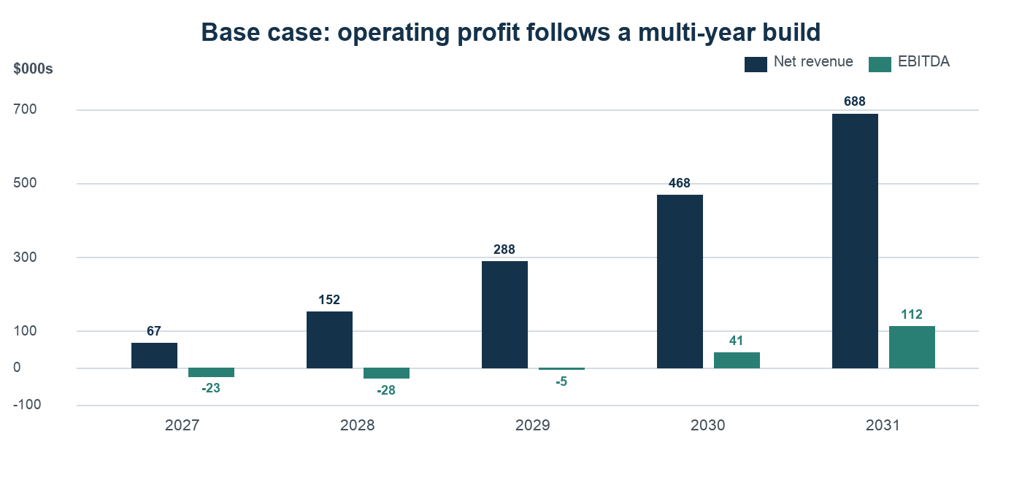
Figure 2. Illustrative base case from the linked financial model; values are unaudited planning assumptions.
$000s except units | 2027 | 2028 | 2029 | 2030 | 2031
Units sold | 2,000 | 5,000 | 10,000 | 17,000 | 26,000
Net revenue | 67 | 152 | 288 | 468 | 688
Contribution profit | 31 | 71 | 142 | 242 | 367
EBITDA before founder compensation | (23) | (4) | 43 | 113 | 202
Founder compensation | - | 24 | 48 | 72 | 90
EBITDA after founder compensation | (23) | (28) | (5) | 41 | 112

The base case is intentionally not a “hockey stick.” It implies approximately 60,000 cumulative units across five years and only modest founder compensation. It becomes an attractive small business if unit demand and DTC share hold; it does not support two market-rate salaries early.

11.2 Scenario outcomes
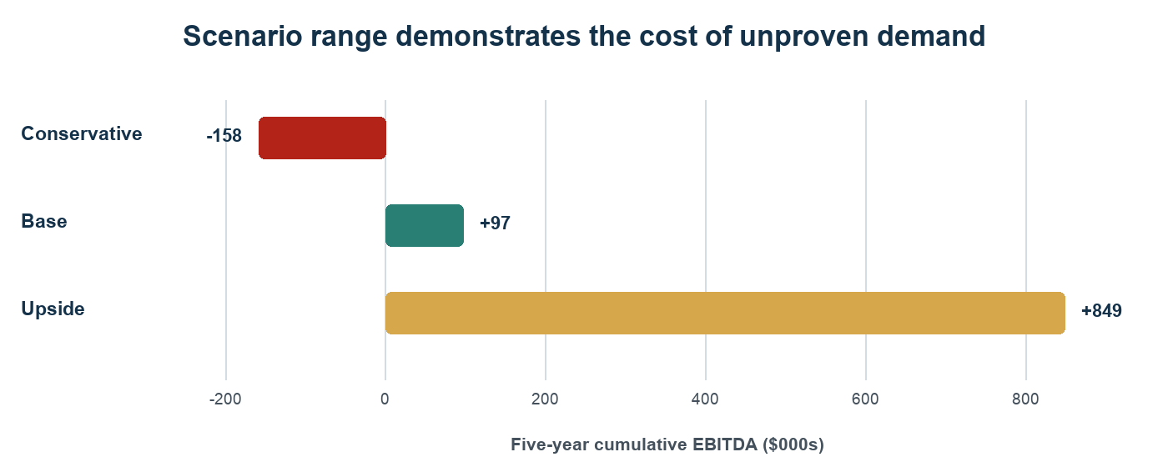
Figure 3. Five-year cumulative EBITDA range; scenarios are planning cases, not probabilities.
Scenario | Year-5 revenue | Year-5 EBITDA | Five-year cumulative EBITDA | Interpretation
Conservative | $302K | $(8)K | $(158)K | Do not scale; license or pause after validation failure
Base | $688K | $112K | $97K | Sustainable small publisher after a three-year build
Upside | $1.44M | $457K | $849K | Supports team expansion and faster catalog investment

11.3 Initial capital reserve: $75,000
Use | Amount | Release condition
Prototypes and playtesting | $5,000 | Concept gate
Development, art, and graphic design | $18,000 | External playtest gate; staged contracts
Campaign creative and prelaunch marketing | $12,000 | Blind-test and audience gates
Legal, IP, insurance, compliance planning | $4,000 | Before public brand spend
Manufacturing/fulfillment working capital | $20,000 | Successful campaign and final quotes
General overhead/tools | $4,000 | Monthly cap
Contingency | $12,000 | Joint founder approval
Total | $75,000

The capital should be released by gate, not spent as an annual budget. If the flagship fails a product or audience gate, uncommitted capital should be preserved.

11.4 Unit-economics discipline
Traditional distribution may yield only about 40% of MSRP to the publisher, versus approximately 50% in retail-direct arrangements and close to full MSRP before fees in DTC. [S13] A $39 game with a $12.50 landed cost can work in DTC but becomes thin through distribution. The commercial gate should require:
- landed cost no more than 25% of MSRP for a distribution-intended edition, ideally lower;
- DTC contribution margin above 45% after platform fees, refund reserve, and fulfillment handling;
- distributor-channel contribution above 15% before fixed overhead;
- no campaign stretch goal that makes the retail edition uneconomic.

11.5 Break-even
At base launch economics, the weighted contribution is roughly $15 per unit. Cash fixed costs before founder compensation are approximately $54,000, implying about 3,500 units for year-one operating break-even. The base plan sells 2,000 units, so a planned first-year loss is expected. By 2031, scale and cost reduction lower the all-in annual break-even to roughly 18,000 units including modeled founder compensation, compared with 26,000 base-case units.

12. Risk Register
Risk | Probability | Impact | Early warning | Mitigation
Flagship is not compelling | High | Critical | Weak repeat-play scores; blind-test failure | Kill or redevelop before final art
Audience too small | High | Critical | Low email growth; <30% day-one support | Delay campaign; continue public testing
Name conflict | Medium | High | Clearance finds related marks/claims | Rebrand before packaging or filing
Landed cost shock | High | High | Quote age, tariff change, freight surge | Two-country/two-supplier quote; 15% contingency; short quote validity
Fulfillment overrun | Medium | High | Unpriced zones, dimensional-weight changes | Charge shipping transparently; lane-level quotes
Founder deadlock/capacity | Medium | High | Missed milestones, unclear approvals | Written roles, time commitments, deadlock mechanism
Inventory overhang | Medium | High | Weak post-campaign reorders | First run tied to paid demand; no speculative deluxe inventory
Historical-content backlash | Medium | High for The Republic | Reviewer discomfort; platform/retailer restrictions | Expert review, content policy, adult positioning, separate launch decision
Compliance failure | Low–Medium | Critical | Unresolved age grading or lab plan | Written classification and test plan before production
One-title concentration | High initially | Medium | Revenue collapses after campaign | Develop second title only after flagship gate; preserve cash

13. 24-Month Execution Roadmap

Phase 0 — Formation and clearance (0–30 days)
- Execute founder/operating and IP-assignment agreements.
- Run professional trademark clearance and reserve viable domains/social handles.
- Select the flagship from a scored shortlist; define target customer, promise, and component ceiling.
- Set repository governance, decision log, and monthly budget.
Exit gate: company/IP ownership is unambiguous and the working brand is commercially clear enough to test.

Phase 1 — Prototype and problem/solution proof (months 1–4)
- Build a low-cost physical and print-and-play prototype.
- Log at least ten internal and 30 external sessions.
- Publish development notes and begin email capture.
- Test the one-sentence pitch, teach time, game duration, and desire to replay.
Exit gate: external players request another play and the design meets the target experience.

Phase 2 — Blind testing and commercial design (months 4–8)
- Run at least ten blind-test groups.
- Lock rules architecture and preliminary bill of materials.
- Obtain two manufacturer estimates and one domestic/small-run comparison.
- Obtain fulfillment, product-safety, and insurance guidance.
Exit gate: rulebook works without founders; target MSRP supports all three channels.

Phase 3 — Audience and campaign proof (months 7–12)
- Commission final art/graphic work in stages.
- Build prelaunch page, email sequence, preview prototypes, and campaign budget.
- Reach audience thresholds and document day-one commitments.
- Requote manufacturing, duty, freight, and fulfillment immediately before launch.
Exit gate: $60,000 product-pledge goal is supported by evidence, not hope.

Phase 4 — Campaign and production (months 12–18)
- Run a focused campaign with limited SKUs.
- Finalize quantity only after collected funds and late-pledge assumptions are reconciled.
- Approve samples, testing, packaging, and quality controls.
- Communicate monthly through fulfillment.

Phase 5 — Delivery, retail proof, and catalog decision (months 18–24)
- Deliver, resolve replacements, and publish a fulfillment postmortem.
- Pilot retail-direct accounts and track sell-through/reorders.
- Measure review sentiment, repeat demand, list retention, and contribution margin.
- Greenlight title two, license the design, or pause based on evidence.

14. Decision Framework

Approve the next phase only if
- the preceding gate is documented;
- committed spend fits within the remaining reserve;
- current quotes preserve target contribution margin;
- both founders approve reserved matters; and
- no unresolved critical legal, compliance, or fulfillment issue remains.

Stop, license, or redesign if
- blind testers cannot learn the game reliably;
- prelaunch demand cannot support the true funding goal;
- landed cost exceeds retail-compatible economics;
- the brand cannot be cleared at reasonable cost; or
- founder time commitments cannot sustain delivery.

15. Final Recommendation
Authorize a six-month, capped validation program—not a full company launch. The objective is to convert Mr Wallaboo from a broad creative intention into one commercially testable promise. Spend first on prototype quality, testing, ownership, clearance, and audience evidence. Defer deluxe components, speculative inventory, payroll expansion, and The Republic production until the flagship proves that the company can create, sell, and deliver one game well.
If the commercial gate is reached, proceed with a focused crowdfunding/DTC launch and preserve retail compatibility. If it is not reached, the company will have learned at low cost and can redesign, license, or stop without an inventory crisis.

16. Sources
See research/SOURCE_REGISTER.md for full URLs, access context, and caveats. The principal sources are the Toy Association/Circana, ICv2, Kickstarter, CPSC, USPTO, PrintNinja, Panda Game Manufacturing, and public publisher wholesale terms. Research is current through July 17, 2026.

Disclaimer
This document is an internal planning prospectus and feasibility study. It is not an offer to sell securities, a valuation opinion, or legal, tax, customs, accounting, product-safety, or investment advice. Financial projections are illustrative, unaudited, and dependent on assumptions that have not been validated by operating history. Professional legal, tax, customs, safety, insurance, and accounting advice is required before launch.

Appendix A — Research Source Register
Research was current through July 17, 2026. Market totals are contextual, manufacturing figures are budgetary examples rather than quotes, and the name search is not a legal clearance opinion.
ID | Topic | Key evidence used | Source
S01 | U.S. toy and games market | U.S. retail toy sales were $30.3B in 2025; Games/Puzzles was the largest supercategory at $4.9B. | Open source
S02 | 2025 category composition | Games & Puzzles grew 37% in 2025, driven primarily by Pokémon; category growth is not a direct proxy for indie board-game demand. | Open source
S03 | Hobby market | ICv2 estimated the U.S./Canada hobby-games market at $3.66B in 2025, but TCGs were roughly two-thirds of dollars and other categories were flat to modestly growing. | Open source
S04 | Market stability and crowding | ICv2 estimated a $2.84B 2024 hobby-games market and described heavy product flow and difficulty getting noticed. | Open source
S05 | Crowdfunding scale | Kickstarter reported 6,646 tabletop launches, 5,314 successful campaigns, an 80% success rate, and $220M pledged to successful tabletop campaigns in 2024. | Open source
S06 | Crowdfunding direction | ICv2 reported that Kickstarter tabletop project count rose but overall dollars declined in 2025; creators used crowdfunding partly to offset tariff risk through full-retail sales. | Open source
S07 | Kickstarter fees | Kickstarter charges 5%; payment processing is approximately 3%–5%. | Open source
S08 | Funding-goal discipline | Kickstarter recommends including production, shipping, fees, and contingencies and stresses that goals must work at exactly 100% funding. | Open source
S09 | Manufacturing economics | PrintNinja states that a straightforward board game can cost about $8–$15 per unit at 1,500+ units, with total production and transit commonly 10–14 weeks. | Open source
S10 | Sample manufacturing price | PrintNinja's April 2026 sample for a conventional board game was $14.28/unit at 500 copies and $10.60/unit at 1,000 copies. | Open source
S11 | Minimum runs | PrintNinja requires 500 board-game units; Panda's stated minimum is 1,500 games. | Source 1 Source 2
S12 | Component risk | Paper components can work at lower minimums, while custom plastic, molds, inserts, and specialty components increase setup cost and MOQ. | Open source
S13 | Wholesale economics | Public publisher terms show common distributor net pricing around 40%–45% of MSRP and retailer-direct pricing around 50% of MSRP. | Source 1 Source 2
S14 | Children's-product rules | CPSC says traditional all-ages games may be general-use products, but child-directed features and age positioning can make a game a children's product. | Open source
S15 | Toy testing | Toys intended primarily for children 12 and under generally require third-party testing and a Children's Product Certificate; ASTM F963-23 applies to products manufactured after April 20, 2024. | Open source
S16 | Trademark clearance | USPTO recommends a comprehensive clearance search before filing; confusing similarity is a common refusal basis. | Open source
S17 | Trademark filing cost | USPTO's base electronic application fee is $350 per class, with possible additional fees. | Open source
S18 | Preliminary name conflict | A Dutch company has used WALLABOO for baby products since 2006 and claims proprietary rights in the name. This does not establish U.S. game-class conflict, but it makes professional clearance important. | Source 1 Source 2
S19 | Current import-policy risk | A temporary 10% U.S. import surcharge applies through July 24, 2026 unless changed or extended; China-specific arrangements remain fluid. | Open source
S20 | China trade arrangement | The White House described a continuing 10% reciprocal rate during a suspension period through November 10, 2026, subject to the changing legal/trade framework. | Open source
S21 | Small-publisher archetype | Button Shy documents a focused 18-card wallet-game model and a high-frequency small-game release cadence. | Open source
S22 | Strategy-publisher archetype | Leder Games emphasizes repeat play, holistic art/product development, and asymmetric strategy. | Open source
S23 | Premium catalog archetype | Stonemaier's catalog illustrates a broad direct-to-consumer price ladder from microgames through premium strategy titles and expansions. | Open source

