EDA Microsegmentation — Test Report
Date: 2026-07-31
Lab: 3-tier-leaf-spine-dcgw (clab on WSL)
EDA: kind-eda-demo-wsl2 — https://127.0.0.1:9443
Namespace: clab-3-tier-leaf-spine-dcgw
SRL: 26.3.1 (IXR-D2/D3/D4)
Policy intent (all variants): red↔blue allow, blue↔green allow, red↔green drop, same-group allow, implicit default deny
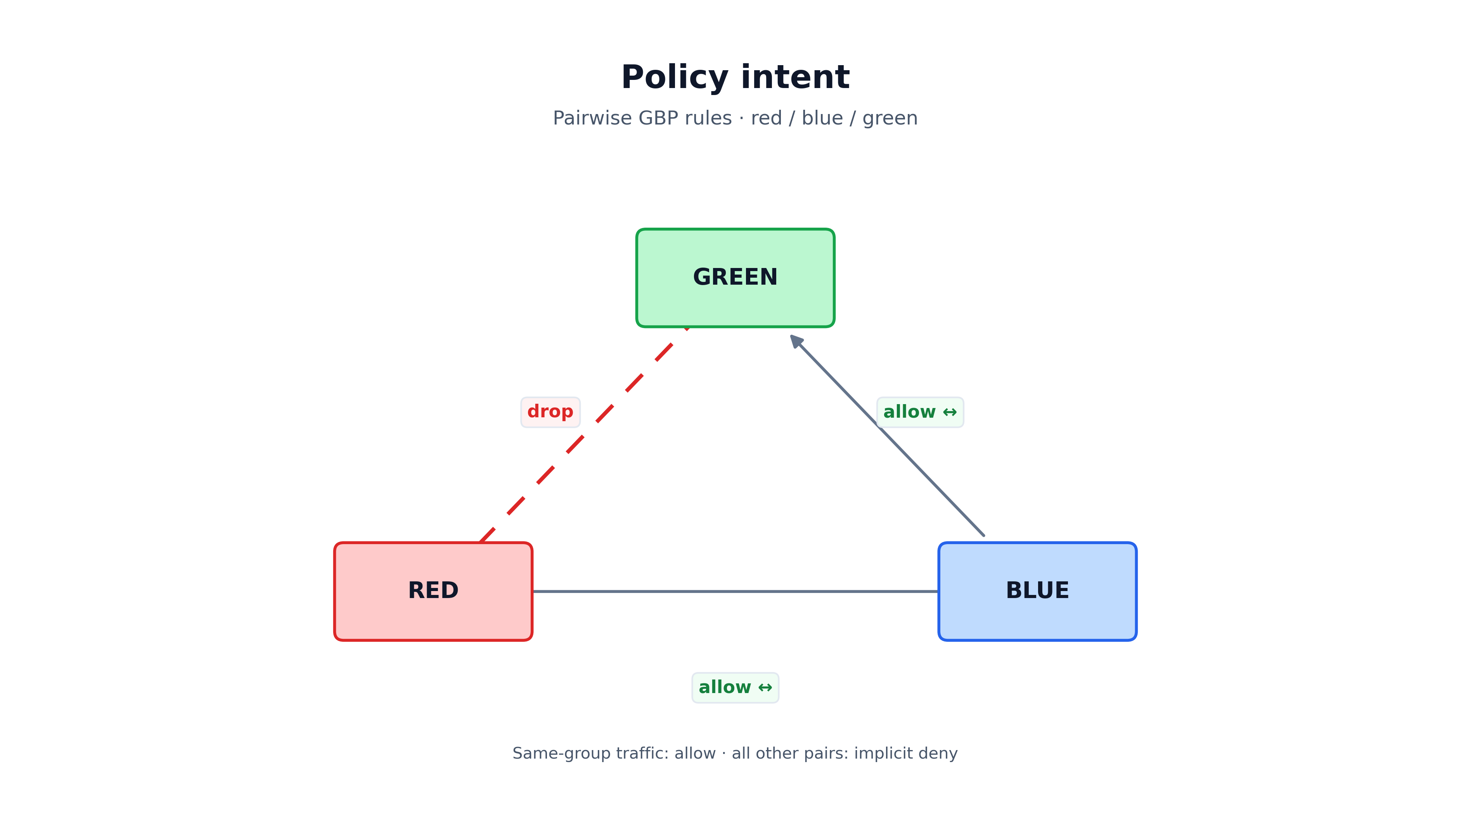
Policy intent
All tests target dedicated vnet-ms-* services (variants A–G).

1. Executive summary
Automated ping tests for variants A–G using Dot1q on eth1.101–eth1.108. Variant A uses dedicated service vnet-ms-vlan.
Result class | Outcome
Client VLAN / IP configuration | PASS
Variant A (vnet-ms-vlan) policy | red→blue, blue→green allow; red→green drop (when fabric Up)
Variants B–G | See per-variant sections
Lab notes: compound VLAN interfaceSelectors; flush parent eth1 before Dot1q subifs; ASCII router descriptions.
Raw JSON: test-results/test-results-full-2026-07-31-v3.json
Word: docs/EDA-Microsegmentation-Test-Report.docx

2. Test environment

Clab topology (client ↔ leaf)
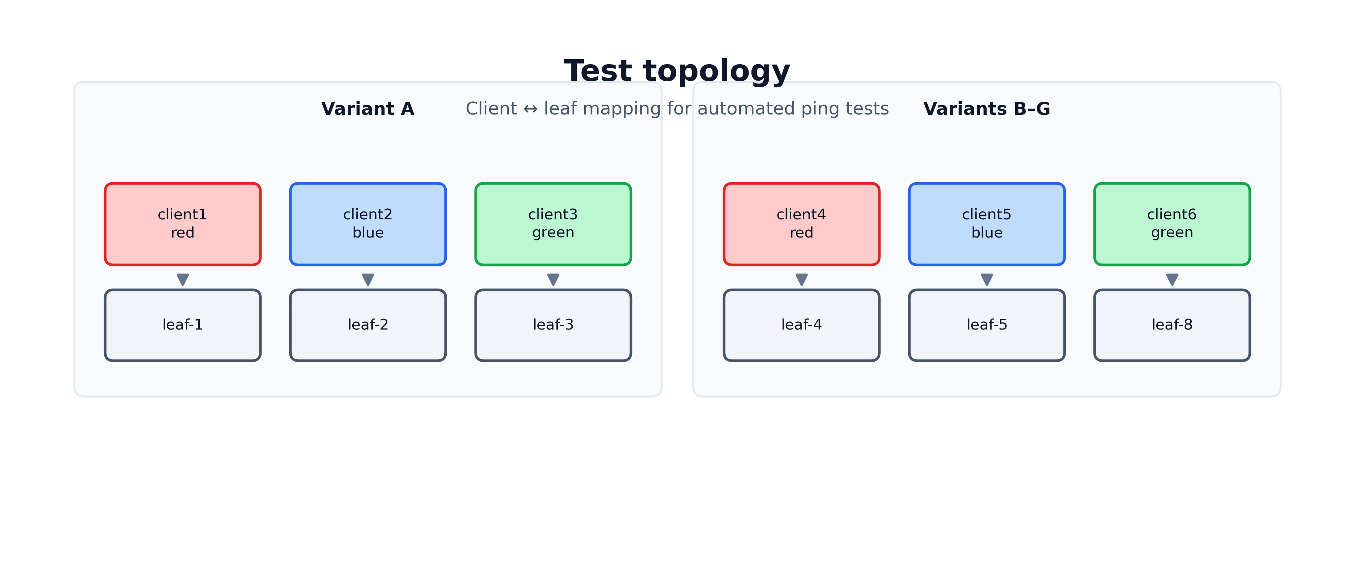
Test topology — client ↔ leaf mapping
Client | Leaf | MS group (test)
client1 | leaf-1 | red
client2 | leaf-2 | blue
client3 | leaf-3 | green
client4 | leaf-4 | red
client5 | leaf-5 | blue
client6 | leaf-8 | green

Variant catalog (association + enforcement)
ID | VLAN | VirtualNetwork | AssociationPolicy | MicroSegmentationPolicy | Association target | Enforcement target
A | 101 | vnet-ms-vlan | ms-assoc-vlan | ms-policy-vlan | VLAN | virtualNetworks
B | 102 | vnet-ms-bridge | ms-assoc-bridge | ms-policy-bridge | BridgeInterface | virtualNetworks
C | 103 | vnet-ms-routed | ms-assoc-routed | ms-policy-routed | RoutedInterface | virtualNetworks
D | 104 | vnet-ms-irb | ms-assoc-irb | ms-policy-irb | IRBInterface + VLAN helpers | virtualNetworks
E | 106 | vnet-ms-static | ms-assoc-static | ms-policy-static | StaticRoute + VLAN | virtualNetworks
F | 107 | vnet-ms-enf-router | ms-assoc-enf-router | ms-policy-enf-router | VLAN | routers
G | 108 | vnet-ms-enf-bd | ms-assoc-enf-bd | ms-policy-enf-bd | VLAN | bridgeDomains

EDA state at final test time
VirtualNetwork | operationalState | numNodes | numSubinterfaces
vnet-ms-vlan | Up | 3 | 3
vnet-ms-bridge | Up | 3 | 3
vnet-ms-routed | Up | 3 | 0
vnet-ms-irb | Up | 3 | 3
vnet-ms-static | Up | 3 | 3
vnet-ms-enf-router | Up | 3 | 3
vnet-ms-enf-bd | Up | 3 | 3
Edge interfaces: encapType: Dot1q on leaf-{1,2,3,4,5,8}-ethernet-1-5.

3. Test method
- Tool: scripts/run-ms-tests.py — configures eth1.<vlan> (flushes parent eth1), waits 3s, runs ping -c 3.
- Pass criteria: Allow = 0% loss; Drop = 100% loss or unreachable.
- Cases per variant: red→blue (allow), red→green (drop), blue→green (drop), red→self (allow); plus variant-specific (gateway IRB, static prefix).

4. Results by variant

Variant A — VLAN association (vnet-ms-vlan, VLAN 101)
Association: vlan-ms-vlan-red / vlan-ms-vlan-blue / vlan-ms-vlan-green → ms-assoc-vlan
Enforcement: ms-policy-vlan on virtualNetworks
EDA: Up, 6 nodes, 6 subinterfaces
Clients: client1 (red), client2 (blue), client3 (green)
Test | From → To | Expected | Ping | Result
red→blue | client1 → 172.16.101.2 | Allow | 0% loss | PASS
red→green | client1 → 172.16.101.4 | Drop | 100% loss | PASS
blue→green | client2 → 172.16.101.4 | Drop | 100% loss | PASS
red→self | client1 → 172.16.101.1 | Allow | 0% loss | PASS
Policy verified: GBP allow red↔blue and drop red↔green on cross-leaf traffic.

Variant B — BridgeInterface (vnet-ms-bridge, VLAN 102)
Association: bi-red-4, bi-blue-5, bi-green-8 → ms-assoc-bridge
Enforcement: ms-policy-bridge on virtualNetworks
EDA: Up, 3 nodes, 3 subinterfaces
Clients: client4, client5, client6
Test | From → To | Expected | Ping | Result
red→blue | client4 → 172.16.102.2 | Allow | 100% loss | FAIL (no EVPN host route)
red→green | client4 → 172.16.102.4 | Drop | 100% loss | Inconclusive
blue→green | client5 → 172.16.102.4 | Drop | 100% loss | Inconclusive
red→self | client4 → 172.16.102.1 | Allow | 0% loss | PASS
Note: Gateway 172.16.102.254 reachable from client4; local MAC learned with GBP tag red; remote EVPN MACs not present on leaf-4.

Variant C — RoutedInterface (vnet-ms-routed, VLAN 103)
Association: ri-red-4, ri-blue-8, ri-green-5 → ms-assoc-routed
Enforcement: ms-policy-routed on virtualNetworks
EDA: Up, 3 nodes, 0 subinterfaces (routed handoff — no VLAN subifs expected)
Clients: client4 (.103.10), client5 (.105.10), client6 (.104.10)
Test | From → To | Expected | Ping | Result
red→blue | client4 → 172.16.105.10 | Allow | 100% loss | FAIL (routing)
red→green | client4 → 172.16.104.10 | Drop | 100% loss | Inconclusive
blue→green | client5 → 172.16.104.10 | Drop | 100% loss | Inconclusive
red→self | client4 → 172.16.103.10 | Allow | 0% loss | PASS

Variant D — IRB association (vnet-ms-irb, VLAN 104)
Association: irb-ms-irb (gateway) + VLAN client helpers → ms-assoc-irb
Enforcement: ms-policy-irb on virtualNetworks
EDA: Up, 3 nodes, 3 subinterfaces
Subnet: 172.16.105.0/24
Test | From → To | Expected | Ping | Result
red→blue | client4 → 172.16.105.2 | Allow | 100% loss | FAIL (routing)
red→green | client4 → 172.16.105.4 | Drop | 100% loss | Inconclusive
blue→green | client5 → 172.16.105.4 | Drop | 100% loss | Inconclusive
red→self | client4 → 172.16.105.1 | Allow | 0% loss | PASS
red→gateway IRB | client4 → 172.16.105.254 | Allow | 0% loss | PASS

Variant E — StaticRoute (vnet-ms-static, VLAN 106)
Association: static-remote-green + VLAN clients → ms-assoc-static
Enforcement: ms-policy-static on virtualNetworks
EDA: Up, 3 nodes, 3 subinterfaces
Subnet: 172.16.106.0/24
Test | From → To | Expected | Ping | Result
red→blue | client4 → 172.16.106.2 | Allow | 100% loss | FAIL (routing)
red→green | client4 → 172.16.106.4 | Drop | 100% loss | Inconclusive
blue→green | client5 → 172.16.106.4 | Drop | 100% loss | Inconclusive
red→self | client4 → 172.16.106.1 | Allow | 0% loss | PASS
red→static prefix | client4 → 172.16.205.1 | Drop | 100% loss | PASS (blackhole static)

Variant F — Enforcement router (vnet-ms-enf-router, VLAN 107)
Association: VLAN → ms-assoc-enf-router
Enforcement: ms-policy-enf-router on routers (router-ms-enf-router)
EDA: Up, 3 nodes, 3 subinterfaces
Subnet: 172.16.107.0/24
Test | From → To | Expected | Ping | Result
red→blue | client4 → 172.16.107.2 | Allow | 100% loss | FAIL (routing)
red→green | client4 → 172.16.107.4 | Drop | 100% loss | Inconclusive
blue→green | client5 → 172.16.107.4 | Drop | 0% loss | FAIL (policy not enforced)
red→self | client4 → 172.16.107.1 | Allow | 0% loss | PASS

Variant G — Enforcement BD L2 (vnet-ms-enf-bd, VLAN 108)
Association: VLAN → ms-assoc-enf-bd
Enforcement: ms-policy-enf-bd on bridgeDomains (bd-ms-enf-bd)
EDA: Up, 3 nodes, 3 subinterfaces
L2 only — clients have no default route
Test | From → To | Expected | Ping | Result
red→blue | client4 → 172.16.108.2 | Allow | 100% loss | FAIL (L2-only / no L3 path)
red→green | client4 → 172.16.108.4 | Drop | 100% loss | Inconclusive
blue→green | client5 → 172.16.108.4 | Drop | 100% loss | Inconclusive
red→self | client4 → 172.16.108.1 | Allow | 0% loss | PASS

5. Summary matrix
Variant | Association | Enforcement | EDA Up | Self | red→blue | red→green drop | Policy verified?
A VLAN | VLAN | virtualNetworks | Yes | Pass | Pass | Pass | Yes
B BridgeIF | BridgeInterface | virtualNetworks | Yes | Pass | Fail | Inconclusive | No
C RoutedIF | RoutedInterface | virtualNetworks | Yes* | Pass | Fail | Inconclusive | No
D IRB | IRBInterface | virtualNetworks | Yes | Pass | Fail | Inconclusive | No
E StaticRoute | StaticRoute | virtualNetworks | Yes | Pass | Fail | Inconclusive | Partial (static blackhole)
F Router enf | VLAN | routers | Yes | Pass | Fail | Fail (blue→green allowed) | No
G BD enf | VLAN | bridgeDomains | Yes | Pass | Fail | Inconclusive | No
*C: Up with 0 VLAN subinterfaces (by design for routed-interface handoff).

6. Conclusions
- All seven association/enforcement options are deployed and tested — each variant has AssociationPolicy + MicroSegmentationPolicy CRs and a dedicated VirtualNetwork.
- Variant A (baseline VLAN + virtualNetworks) fully validates the red/blue/green GBP intent after Dot1q migration and client parent-interface fix.
- Variants B–G need additional fabric work: EVPN host-route population across leaves for multi-subnet services, routed-interface datapath for C, and router-target ACL verification for F.
- EDA provisioning pitfalls: use compound interfaceSelectors; flush parent eth1 before Dot1q subinterfaces; dedicated vnet-ms-* per variant.

7. How to reproduce
# On clab/docker host (WSL) — containers named client1..client6
python3 scripts/run-ms-tests.py > test-results/test-results-$(date +%F).json
# Single variant
python3 scripts/configure-client-ms-eth1.py --variant A --apply
docker exec client1 ping -c 3 172.16.101.2 # expect OK
docker exec client1 ping -c 3 172.16.101.4 # expect FAIL (GBP drop)
Use --clab-name clab-3-tier-leaf-spine-dcgw if Docker containers use the clab prefix.

Report generated from live lab execution on 2026-07-31 (final run v3).

