EDA Microsegmentation
Environment: WSL EDA (kind-eda-demo-wsl2) — UI https://127.0.0.1:9443
Namespace: clab-3-tier-leaf-spine-dcgw
Services: Seven dedicated vnet-ms-* VirtualNetworks (variants A–G)

1. Purpose
Microsegmentation divides an internal L3 service into security groups and enforces east–west rules between them. In this lab:
- Red can talk to Blue
- Blue can talk to Green
- Red cannot talk to Green
- All other cross-group traffic is denied by default (zero-trust)
Note: You don’t need the Red to Green Rule for Drop. This would be covered in implicit default deny. This is just a lab exercise. There may be a need if logging was required example.
This uses Nokia EDA’s microsegmentation application, which programs Group-Based Policy (GBP) on SR Linux 26.3+ (7220 IXR-D2L/D3L) leaf nodes.
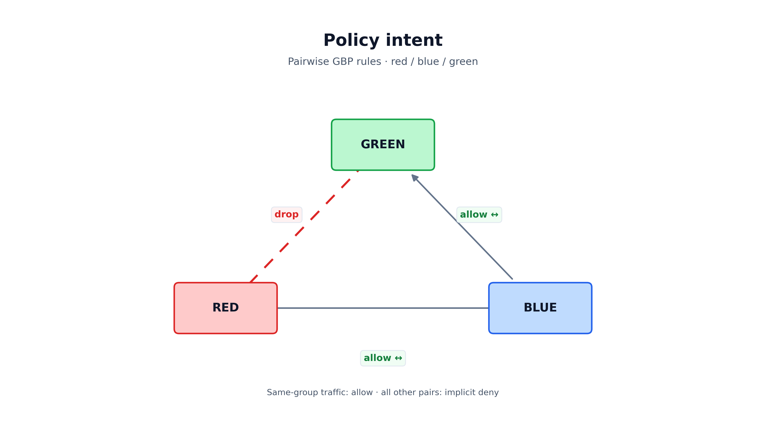
Policy intent — red / blue / green
The diagram uses a triangle layout: each edge is one pairwise relationship — allow on red↔blue and blue↔green, drop on red↔green.

2. Architecture overview (Variant A / vnet-ms-vlan)
Traffic is classified on the client edge port in the MAC-VRF, then filtered by a group-based ACL on the L3 router before forwarding locally or across EVPN.

Physical topology
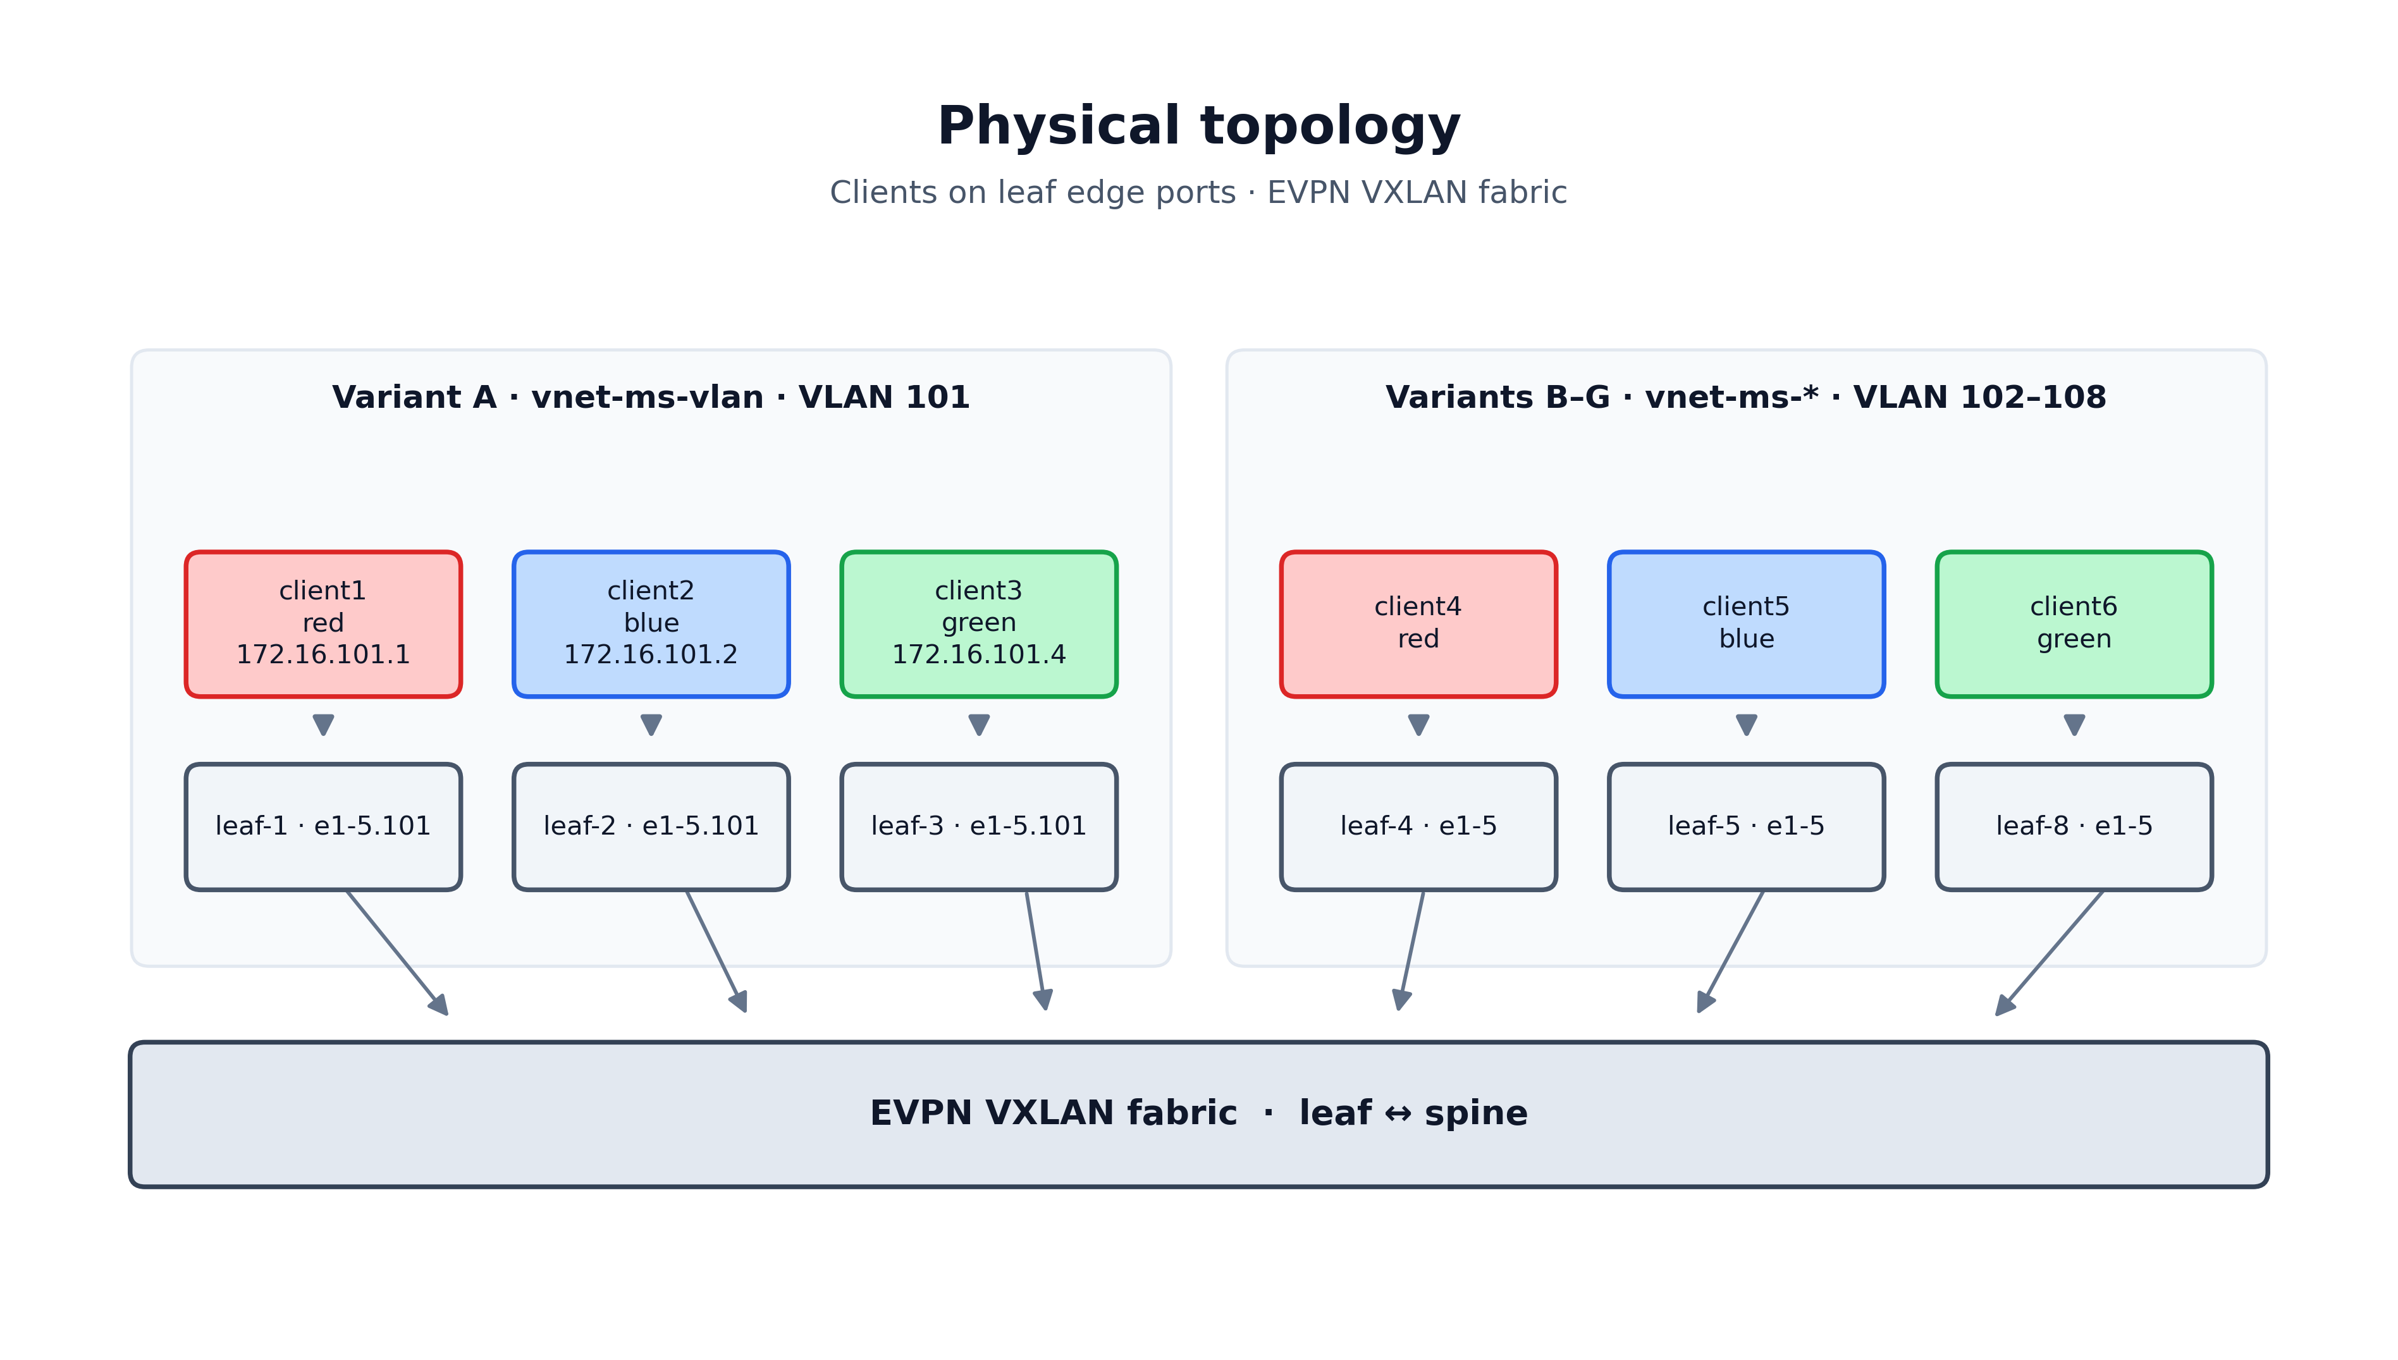
Physical topology — clients, leafs, spine, EVPN fabric

Packet path (Variant A) GBP policy is applied before step5??
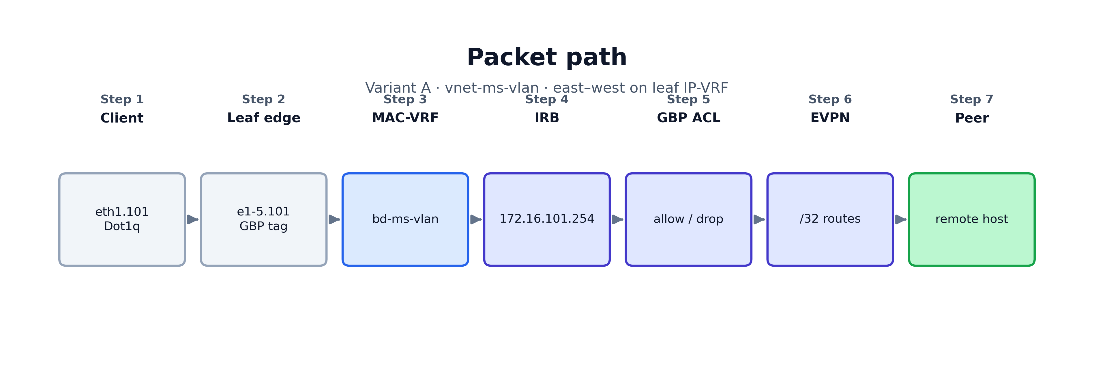
Packet path — Variant A vnet-ms-vlan

Kubernetes object chain (per variant)
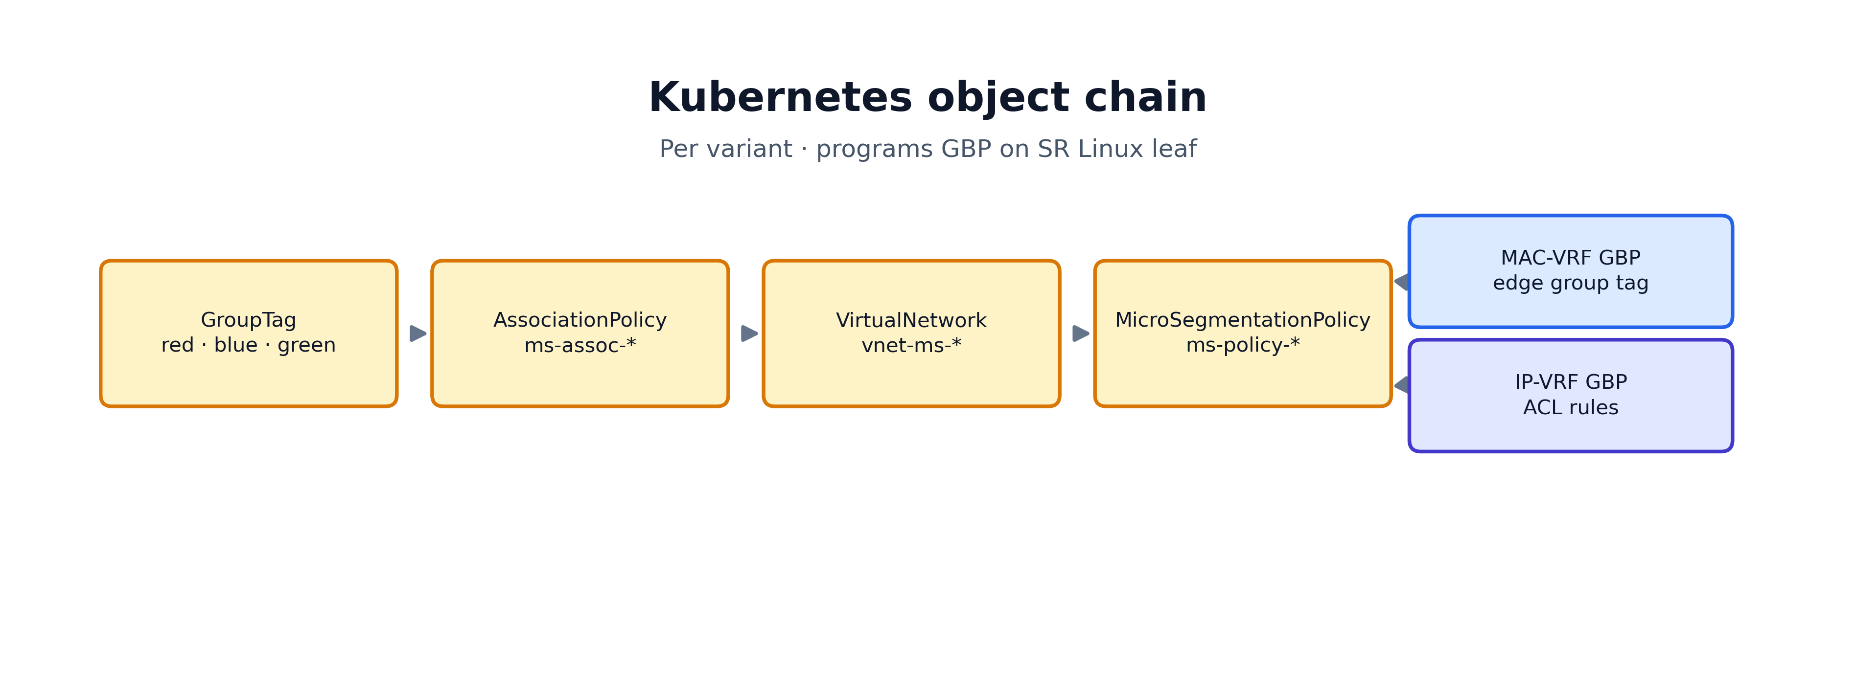
Kubernetes object chain

3. The four Kubernetes objects

3.1 GroupTag
Defines logical segments: red, blue, green.
Field | Value
API | microsegmentation.eda.nokia.com/v1alpha1
Kind | GroupTag
Scope | Local (per VirtualNetwork scope; IDs from group-tag-pool-local)

3.2 AssociationPolicy
Maps GroupTags to network resources inside each vnet-ms-* service.
Variant A example (ms-assoc-vlan on vnet-ms-vlan):
VLAN object | GroupTag
vlan-ms-vlan-red | red
vlan-ms-vlan-blue | blue
vlan-ms-vlan-green | green
EDA associates the tag with the VLAN + bridge attachment so SRL programs GBP on the edge subinterface.

3.3 VirtualNetwork (vnet-ms-vlan — Variant A)
Component | Name | Details
Bridge domain | bd-ms-vlan | EVPN VXLAN, MAC learning
Router | router-ms-vlan | IP-VRF, nodeSelectors: [eda.nokia.com/role=leaf]
IRB | irb-ms-vlan | 172.16.101.254/24
VLANs | vlan-ms-vlan-red/blue/green | VLAN 101, compound interfaceSelectors
Host route populate (required for multi-leaf same-subnet): This is superseded by RFC
hostRoutePopulate:
dynamic: { populate: true }
evpn: { populate: true, datapathProgramming: true }
static: { populate: true }

3.4 MicroSegmentationPolicy (ms-policy-vlan)
Ordered rules — first match wins:
Order | Source | Destination | Action
1–3 | same group | same group | Accept
4 | red | blue | Accept
5 | blue | green | Accept
6 | red | green | Drop
7 | * | * | Drop (implicit deny)
bidirectional: true generates reverse ACL entries on the switch.
serviceTargets:
virtualNetworks:
- vnet-ms-vlan

3.5 Rule design — minimal allows, explicit combinations, and logging
GBP evaluates each packet against source group + destination group (not hop-by-hop). Rules are ordered; the first match wins. bidirectional: true programs the reverse direction on the switch (e.g. red → blue also covers blue → red).

Minimal cross-group policy (smallest enforceable set)
For the chain intent (red ↔ blue, blue ↔ green, red ↔ green blocked), only two allow entries are required:
Entry | Match | Action | Covers (with bidirectional: true)
1 | red → blue | Accept | red ↔ blue
2 | blue → green | Accept | blue ↔ green
Anything else — including red ↔ green and green ↔ red — falls through to deny. GBP is not transitive: red → blue and blue → green allowed does not allow red → green.
Add same-group allow entries (red ↔ red, blue ↔ blue, green ↔ green) only if you need intra-group or self traffic; the two cross-group rules do not cover them. Check this

What the lab policy adds beyond the minimum
The generated policies (variants/gen-microsegmentation-policies.py) use a richer entry list on purpose:
Entry | Enforcement need | Why keep it
Same-group × 3 | Required for self / intra-group pings in tests | Not redundant with cross-group allows
red ↔ blue, blue ↔ green | Core chain | Minimum cross-group set
red ↔ green Drop | Not required for correctness (implicit deny already blocks) | Explicit combination for operations
default deny (match: {}) | May be required by the platform to program a terminal deny on SRL | Catch-all for any pair not listed above

Why an explicit deny can still be a valid combination
An explicit red → green Drop duplicates the outcome of implicit deny, but it is still useful when you want that pair to be visible and measurable:
Benefit | Explanation
Entry counters | EDA UI → Policy → Entry Counters show hits on that rule, not buried in a generic catch-all
Logging | action.log: true on a specific Drop entry surfaces blocked red → green attempts in logs without logging every other denied pair
Intent in the CR | Operators see “block red ↔ green” in the policy object without inferring from absence of allows
Ordering | Placed before the catch-all, it wins first for that pair — useful if the catch-all is ever broadened
In the generator, the red ↔ green rule uses log: true; allows and the default deny use log: false to avoid noise.

Logging — when to enable it
Pattern | Typical log | Rationale
Cross-group Allow (red ↔ blue) | false | High volume; counters (collectStats: true) usually enough
Explicit Drop for a sensitive pair (red ↔ green) | true | Security signal: prove the deny is firing and aid troubleshooting
Default deny catch-all | false | Would flood logs with every unexpected flow
Gateway / IRB entries (variant D) | per entry | Log gateway violations separately from host-to-host rules
collectStats: true on each entry is low-cost and complements logging: use counters for volume, logging for exceptions you care about.

Valid combination summary
Goal | Suggested entries
Leanest cross-group | 2 allows (red↔blue, blue↔green) + platform deny
Lab / connectivity tests | + 3 same-group allows
Auditable deny of red ↔ green | + explicit red↔green Drop with log: true (redundant for enforcement, valid for ops)
Explicit zero-trust tail | + match: {} Drop as last entry
Gateway-centric (IRB variant) | + red/blue/green ↔ gateway allows before host rules
Choose minimal allows for simplicity; add explicit combinations when counters, logs, or readable policy intent matter more than the shortest YAML.

4. Lab endpoint mapping (Variant A)
Group | Container | Leaf | Edge port | IPv4
Red | client1 | leaf-1 | ethernet-1/5 | 172.16.101.1/24
Blue | client2 | leaf-2 | ethernet-1/5 | 172.16.101.2/24
Green | client3 | leaf-3 | ethernet-1/5 | 172.16.101.4/24
Gateway: 172.16.101.254 on VLAN 101 (eth1.101).
Interface labels: eda.nokia.com/ms-group=red|blue|green and eda.nokia.com/vnet-ms-vlan=bd-ms-vlan.
Variants B–G use client4/5/6 on leaf-4/5/8 — see variants/README.md.

5. Packet walkthrough (Variant A)

Red → Blue (allowed)
- client1 sends ICMP to 172.16.101.2 via gateway 172.16.101.254.
- On leaf-1, source traffic from ethernet-1/5.101 is group red.
- router-ms-vlan has host route 172.16.101.2/32 (EVPN).
- GBP ACL: red → blue → Accept.
- Ping succeeds.

Red → Green (blocked)
GBP ACL: red → green → Drop.

Blue → Green (allowed)
GBP ACL: blue → green → Accept.

6. Where policy is applied
Location | Applied?
MAC-VRF (bd-ms-*) on each leaf | Yes — group tag on edge subinterface
IP-VRF (router-ms-*) on each leaf | Yes — GBP ACL
Fabric underlay (default NI) | No — BGP only
Other vnet-ms-* services | No — separate VirtualNetwork scope

7. Expected behaviour matrix
Source → Destination | Result
red ↔ blue | Allow
blue ↔ green | Allow
red ↔ green | Drop
green ↔ red | Drop (implicit deny)
same group | Allow
Host → gateway | Allow

8. Validation
python3 scripts/configure-client-ms-eth1.py --variant A --apply
docker exec client1 ping -c 3 172.16.101.2 # red→blue OK
docker exec client2 ping -c 3 172.16.101.4 # blue→green OK
docker exec client1 ping -c 3 172.16.101.4 # red→green FAIL
EDA UI: Microsegmentation → Policies → ms-policy-vlan → Entry Counters.

9. Deploy
cd variants && bash apply-all.sh && bash apply-dot1q.sh

10. Troubleshooting
Symptom | Check
Policy on but red↔blue fails | VLAN subif on leaf; parent eth1 must not hold the IP (use eth1.101)
Tags missing on switch | AssociationPolicy VLAN targets; interface ms-group + vnet-ms-vlan labels
VNet not Up | kubectl get virtualnetwork vnet-ms-vlan -n clab-3-tier-leaf-spine-dcgw

11. Artifact files
Path | Purpose
variants/virtualnetworks.yaml | All seven vnet-ms-* services
variants/association-policies.yaml | Per-variant AssociationPolicy
variants/microsegmentation-policies.yaml | Per-variant MicroSegmentationPolicy
variants/edge-interfaces-dot1q.yaml | Dot1q + MS labels on edge ports
variants/apply-dot1q.sh | Apply edge + vnets + policies
scripts/configure-client-ms-eth1.py | Client VLAN/IP switcher
scripts/run-ms-tests.py | Automated test suite A–G
variants/README.md | Full service catalog
docs/diagrams/generate_diagrams.py | Regenerate PNG diagrams for docs

12. Association and enforcement options (full catalog)
Microsegmentation uses two independent choices:
- Where endpoints get a GroupTag — AssociationPolicy.associationTargets
- Where the GBP ACL is applied — MicroSegmentationPolicy.serviceTargets

12.1 Association targets
Target | Typical use
VLAN | Variant A — vnet-ms-vlan
BridgeInterface | Variant B — vnet-ms-bridge
RoutedInterface | Variant C — vnet-ms-routed
IRBInterface | Variant D — vnet-ms-irb
StaticRoute | Variant E — vnet-ms-static

12.2 Enforcement targets
Target | Typical use
VirtualNetwork | Variants A–E — recommended
Router | Variant F — vnet-ms-enf-router
BridgeDomain | Variant G — vnet-ms-enf-bd (L2 only)

12.3 Lab variant services
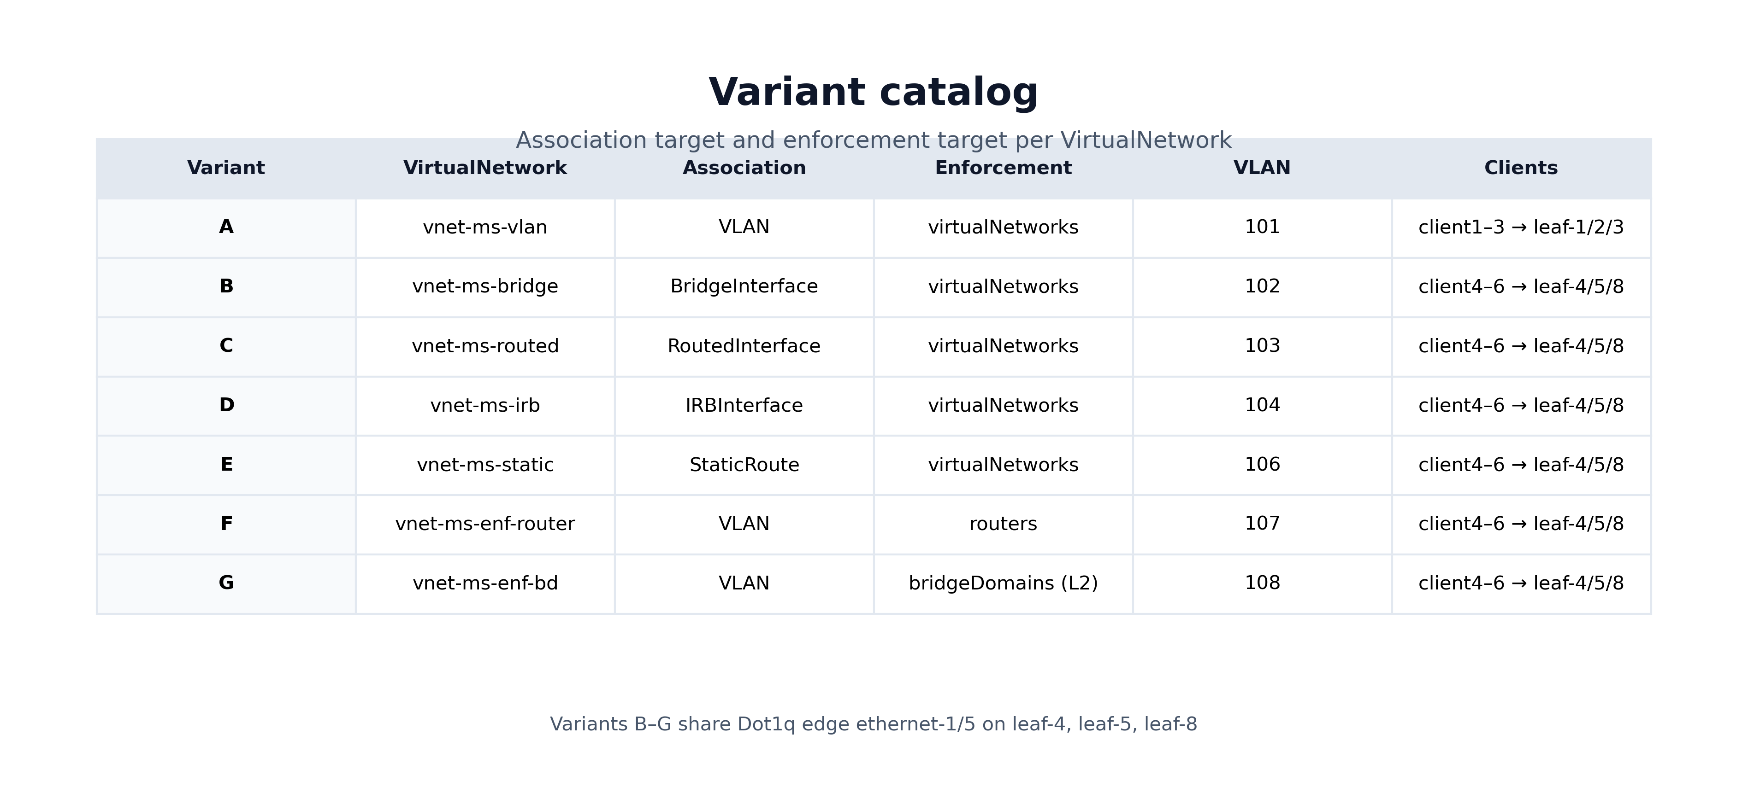
Variant catalog — association and enforcement
ID | VirtualNetwork | Association | Enforcement
A | vnet-ms-vlan | VLAN | virtualNetworks
B | vnet-ms-bridge | BridgeInterface | virtualNetworks
C | vnet-ms-routed | RoutedInterface | virtualNetworks
D | vnet-ms-irb | IRBInterface | virtualNetworks
E | vnet-ms-static | StaticRoute | virtualNetworks
F | vnet-ms-enf-router | VLAN | routers
G | vnet-ms-enf-bd | VLAN | bridgeDomains
Port sharing: Variant A uses leaf-1/2/3 (VLAN 101); variants B–G use leaf-4/5/8 (VLANs 102–108) on the same ethernet-1/5 (Dot1q). See physical topology diagram in §2.

13. Test results
See docs/EDA-Microsegmentation-Test-Report.md for automated ping results per variant.

Document version: dedicated vnet-ms- services, July 2026*

