ZONE NETWORKS

BASE-YEAR DATA

FUTURE PLANNING DATA

DATABASE

BASE YEAR FUTURE YEAR

TRIP GENERATION

TRIP DISTRIBUTION

MODAL SPLIT

TRIP ASSIGNMENT

EVALUATION

Figure 1. Classic four stage transport model (Source: Ortuzar and Willumsen (1996))

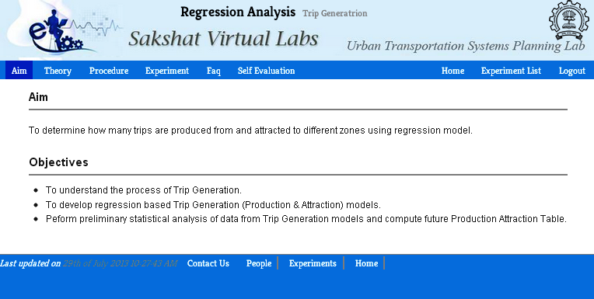

Figure 2. Snapshot showing modules of the experiment.

**Results**

**User**

**Yes**

**No**

**Homepage**

**Login**

**Aim**

**Is Authorized?**

**Theory**

**Procedure**

**Perform Experiment**

**Self Evaluation**

**FAQ**

**Experiment Module**

**Feedback**

**PHP-Based Simulation**

**JAVA-Based Simulation**

**Register**

Figure 3. Flowchart of the procedure for performing experiments.

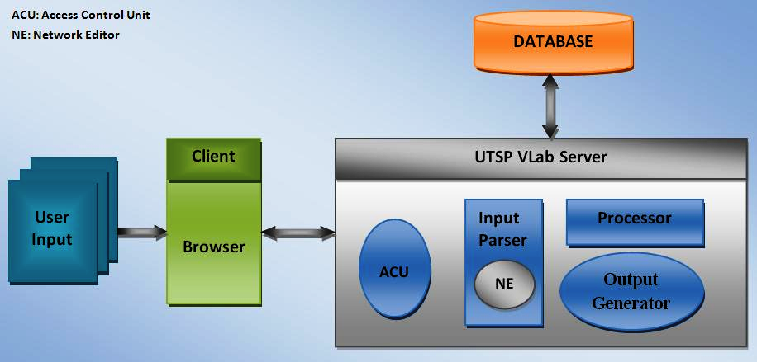

Figure 4. Architecture of UTSP Virtual Laboratory

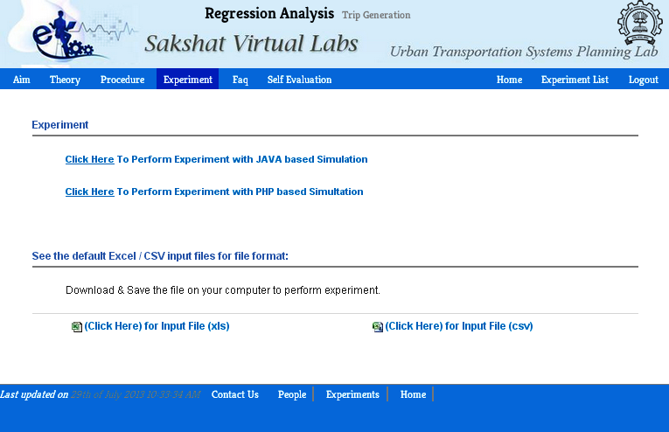

Figure 5(a). Graphical User Interface Showing Experiment Module.

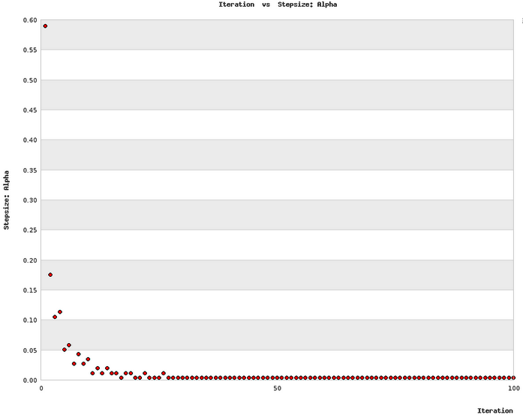

Figure 5(b). Interface Showing Plot Result for User Equilibrium Assignment taking step size as criteria for convergence.

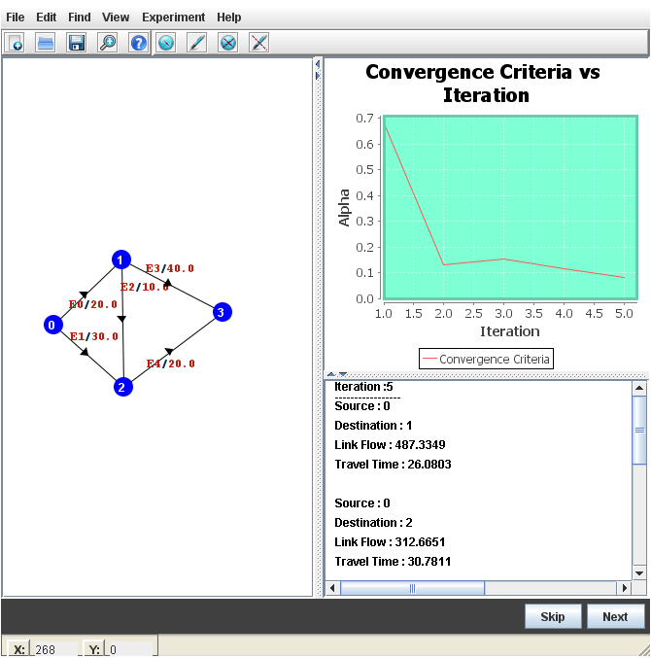

Figure 5(c). JAVA-based Graphical User Interface showing Network Editor.

(c)

(b)

(a)

Figure 6 (a). To what degree do you think the actual lab environment simulated? (b). Whether the manuals (Theory and Procedure) provided was helpful?(c). Whether the results of the experiment were easy to interpret?

Figure 7. User responses to the questions asked in feedback form.

Figure 8. Self evaluation results