Classification
Linear regression used for classification

0: Negative class (e.g. benign tumor)
1: Positive class (e.g. malignant tumor)

Linear regression can be messed up by outlier examples as it pulls the regression to the right.

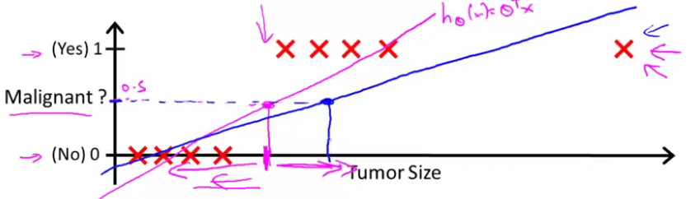

Logistic regression
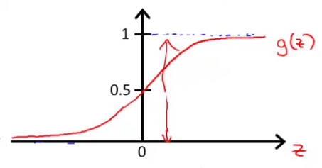
Want
=
Sigmoid function / Logistic function – terms are interchangeable
- As Z approaches infinity, g(z) approaches one
- As Z approaches negative infinity, g(z) approaches zero

Interpretation of Hypothesis Output

Example:
“probability that y=1, given x,parameterized by theta”

Decision Boundary
Halfway through, decision boundary video

