**PREVIOUS CREATIVE PROJECT**

I created this GeoQuiz app several months ago. Without any knowledge in Java or Android Studio, I hacked my way through and made this simple and fun app on my phone. This project took me 1 -2 weeks, because of the big learning curve. However, I felt so happy when the app functioned well on my phone.

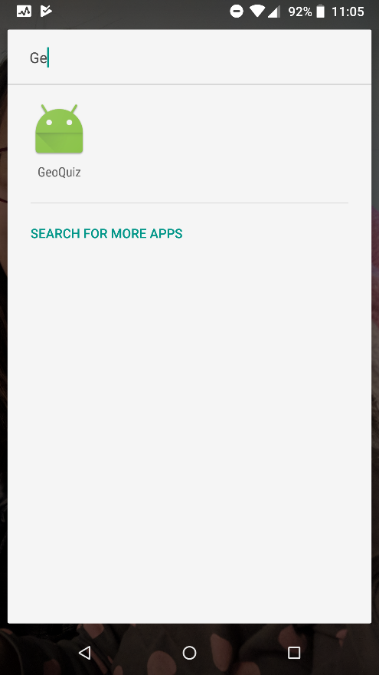 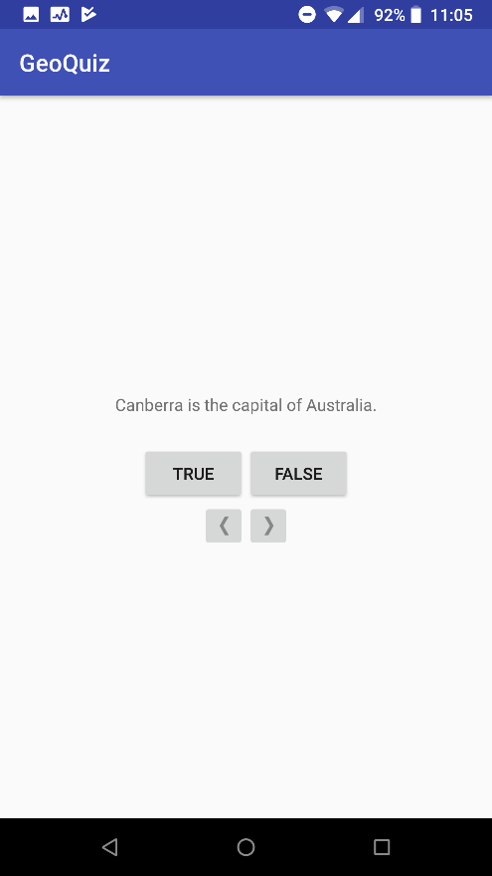 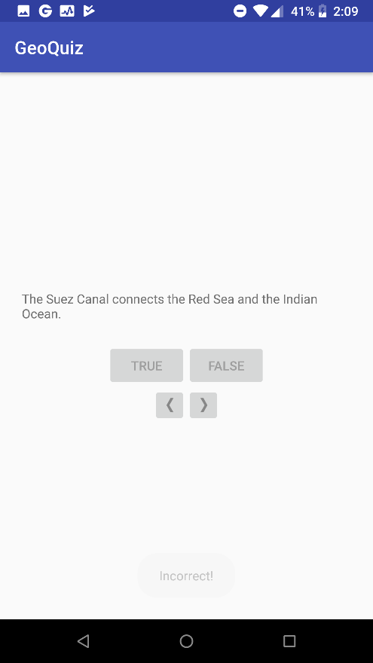

Right now, I am building my portfolio site. This site is still under construction and I am so excited about it.

