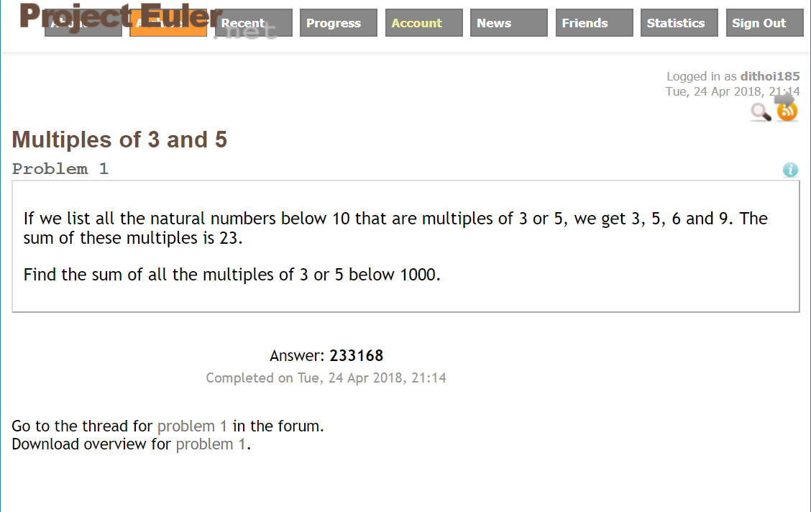

I chose to solve this problem on Project Euler. You can see my correct answer above, 233168.

This is my code:

const mCheck =(ceiling)=>{

let sum = 0;

for(let i=3; i<ceiling;i++){

if (i%3===0||i%5===0)sum+=i;

}

return sum;

}

mCheck(1000);

This is how I approached the problem. I chose to go with thought 2. After running the code, I got the correct answer of 233168.

A close up of text on a white background

Description generated with high confidenceA close up of text on a white background

Description generated with very high confidence