Dat Truong

SDEV 300

Professor Mathew

Lab’s Assignment 8:

Security and Cipher Tools

Register:

Input: Output:

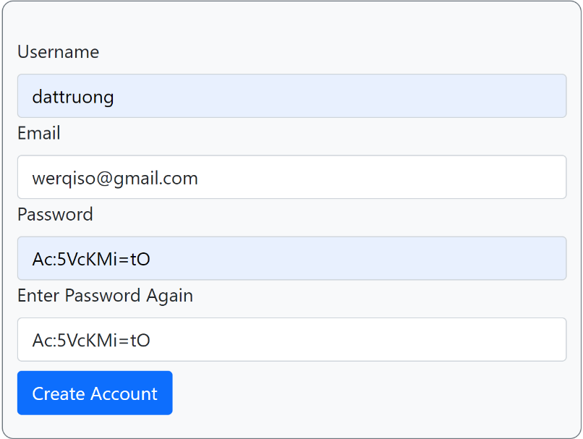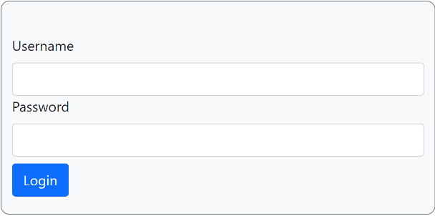

Failed Login:

Input: Output:

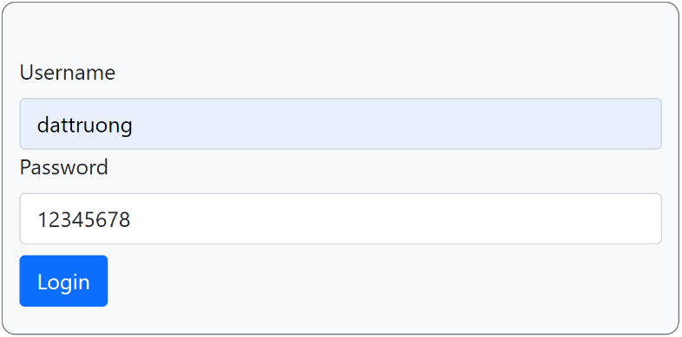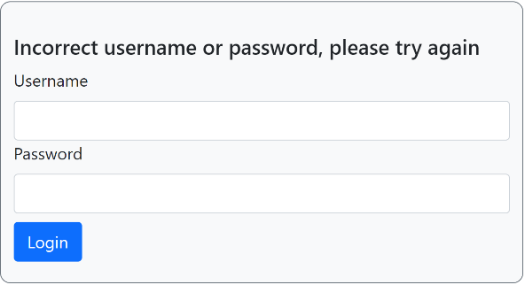

Users.json:

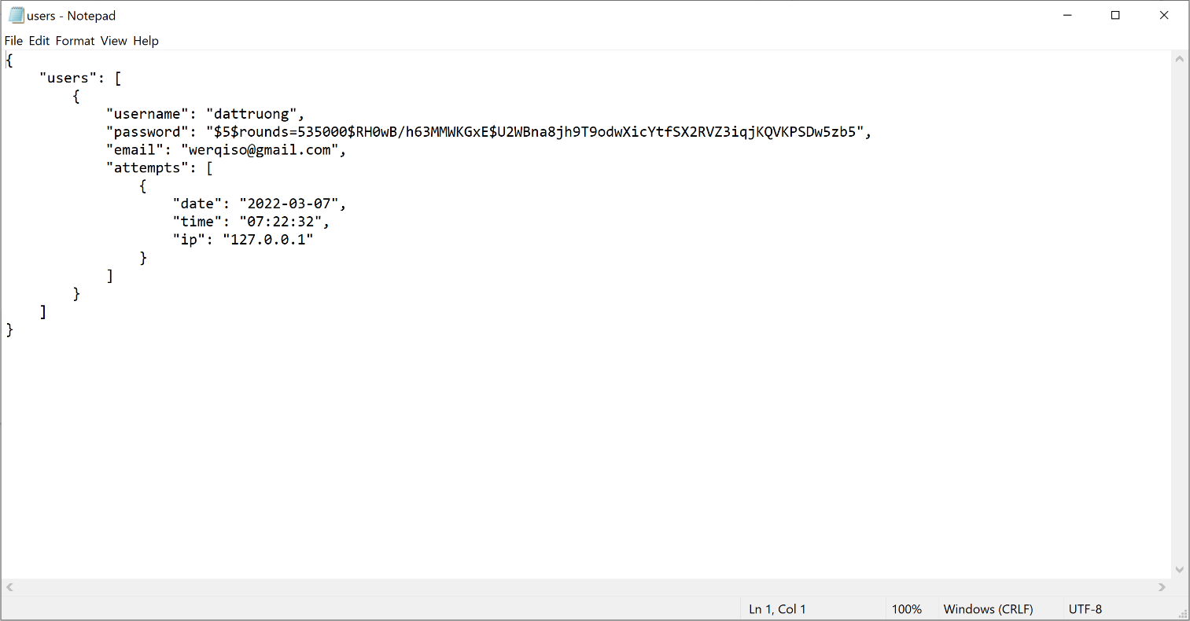

Successful Login:

Input:

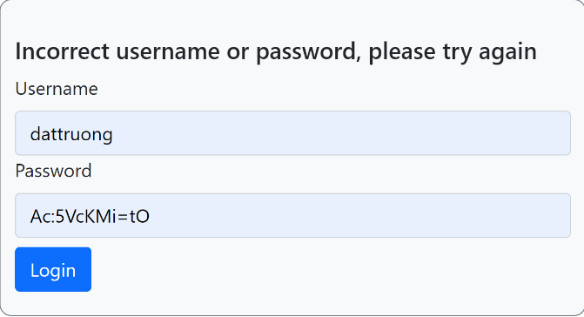

Output:

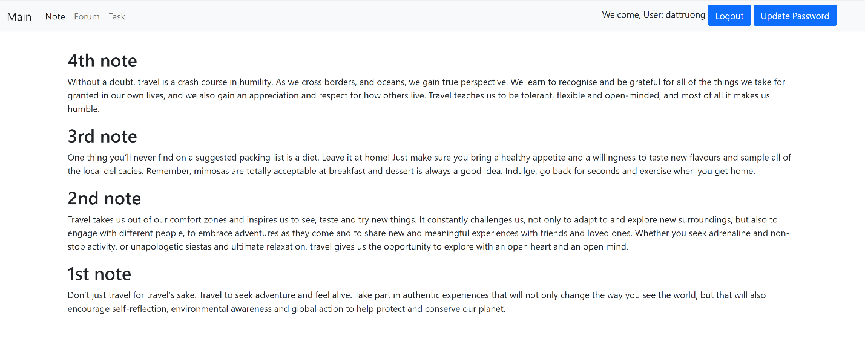

Update Password:

Input: Output:

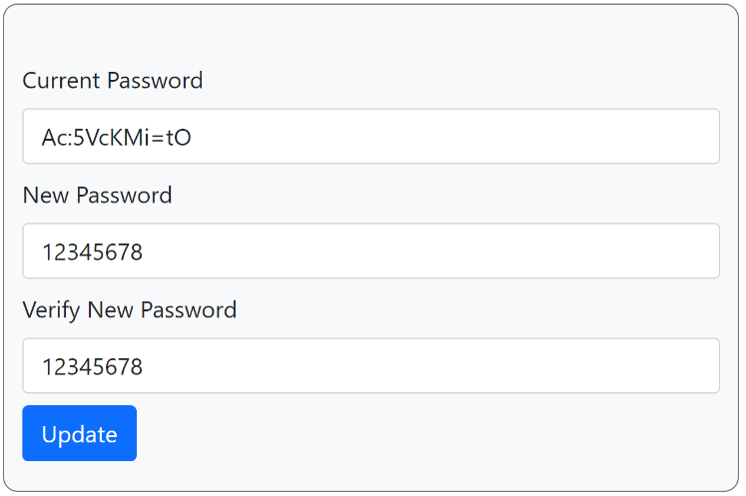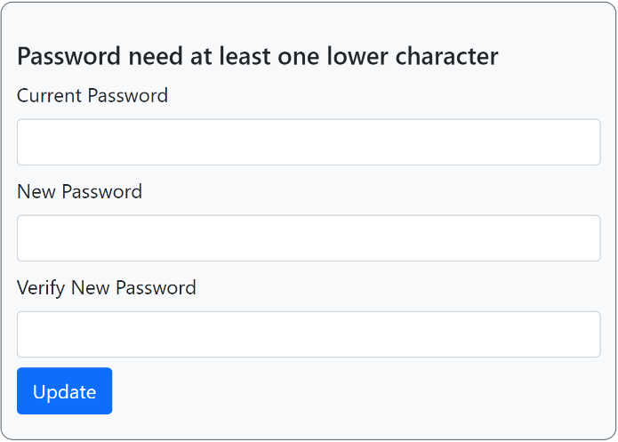

Input: Output:

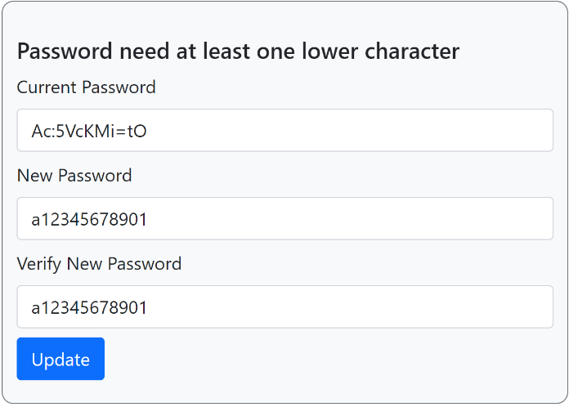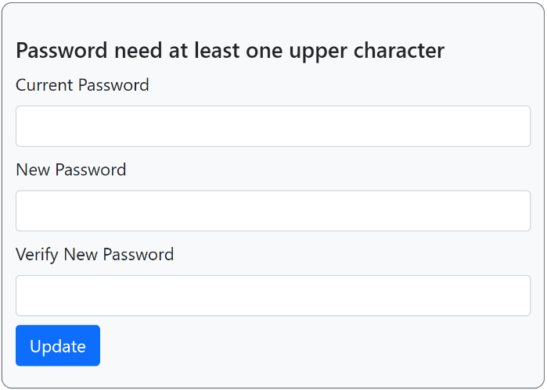

Input: Output:

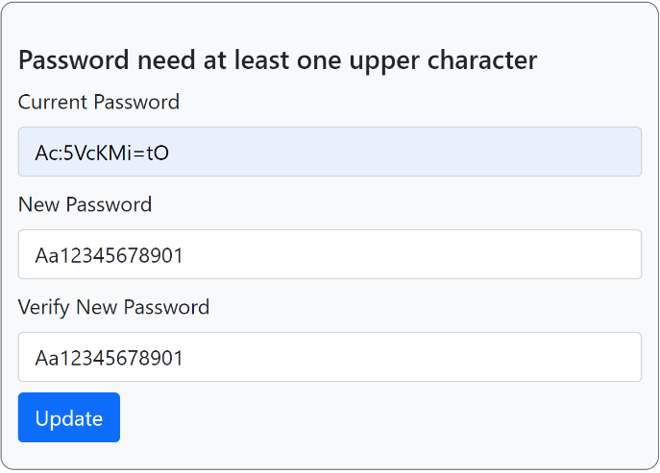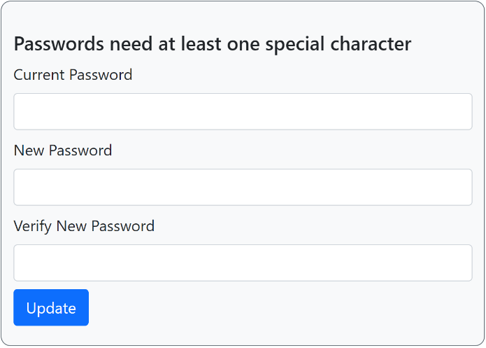

Input: Output:

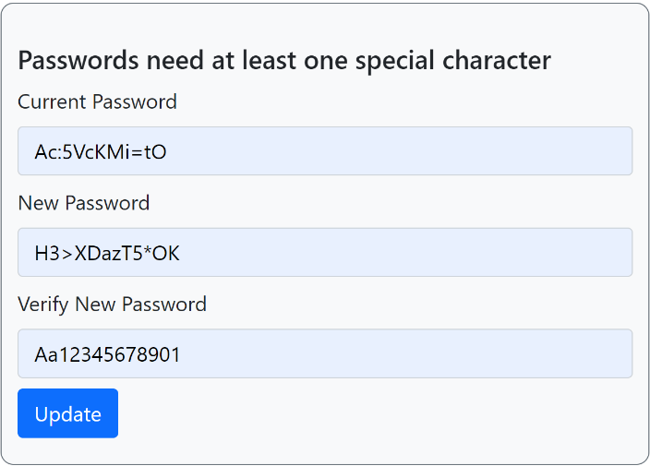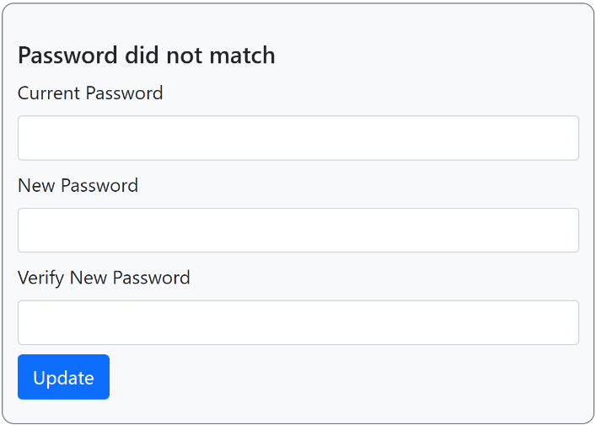

Input: Output:

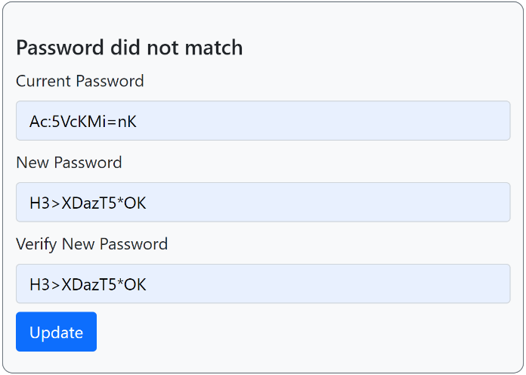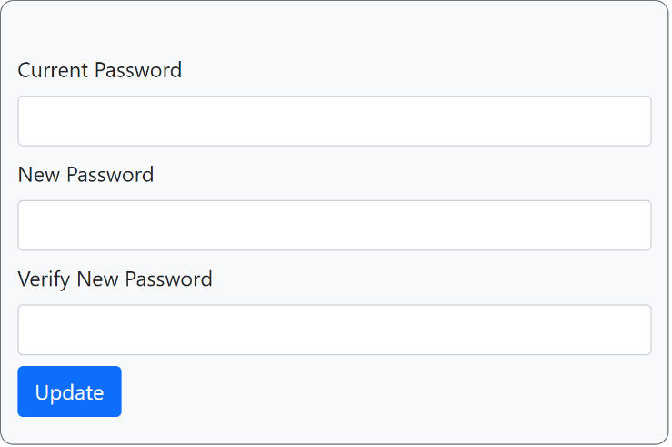

Changing password Test case

|  |  |  |  |
| --- | --- | --- | --- |
| Input | Expected Output | Actual Output | Pass |
| Password contain only number | Password need at least one lower character | Password need at least one lower character | Yes |
| Password contain only number and lower case character | Password need at least one upper character | Password need at least one upper character | Yes |
| Password does not contain special character | Password need at least one special character | Password need at least one special character | Yes |
| Unmatching password | Password did not match | Password did not match | Yes |

Successful login after changing password

Input:

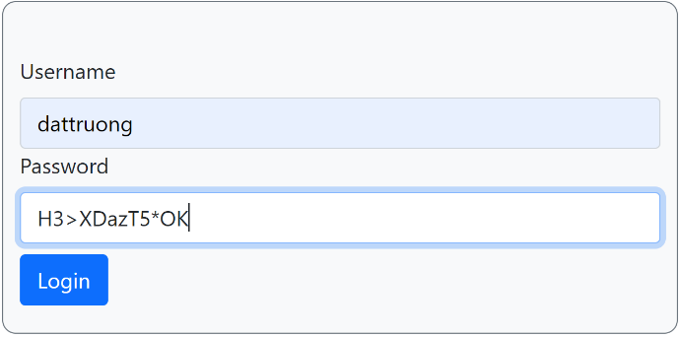

Output: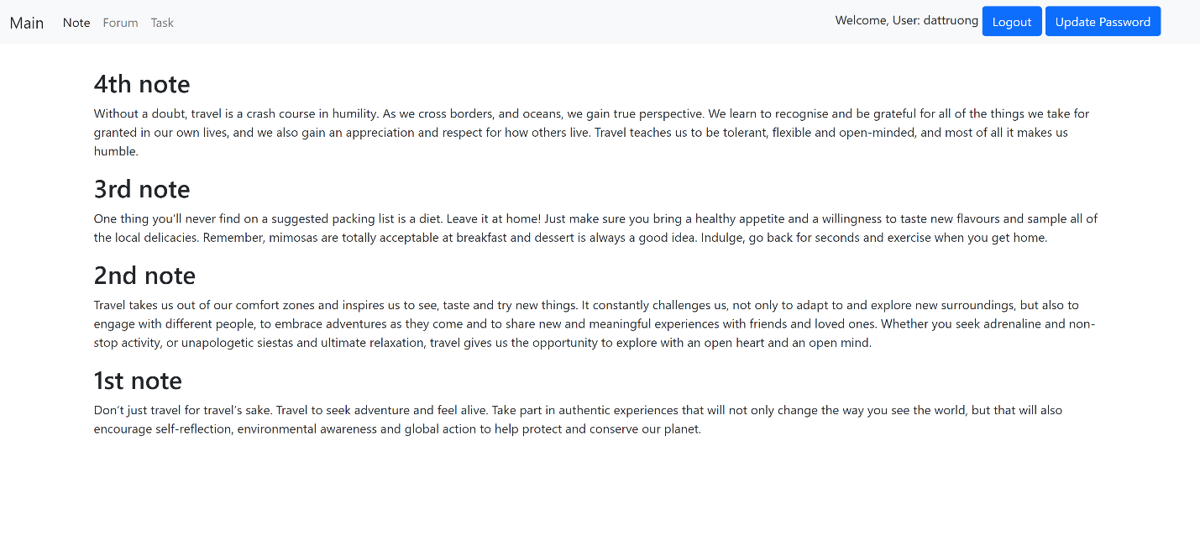

Pylint report:

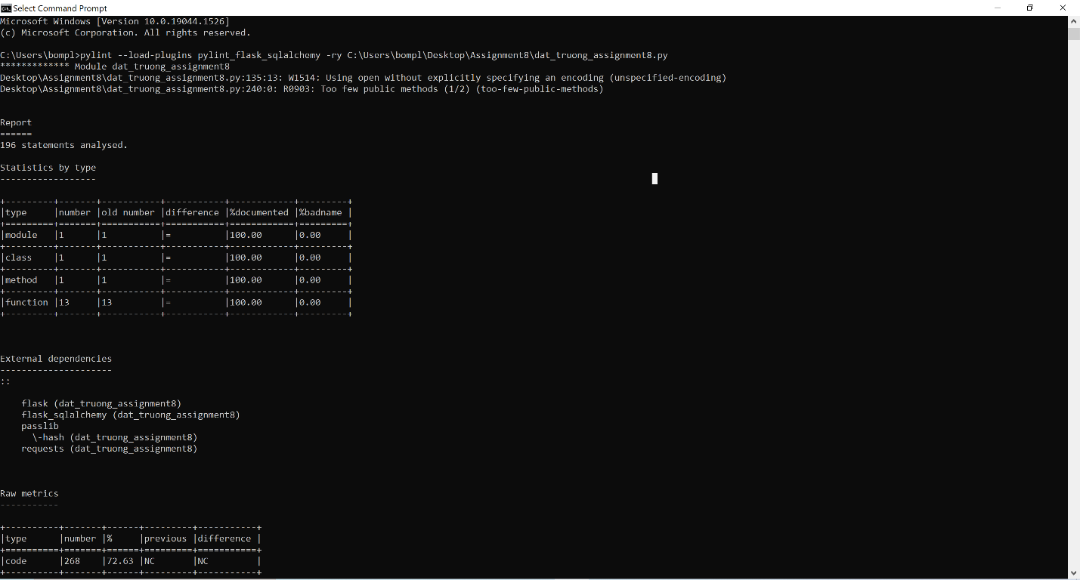

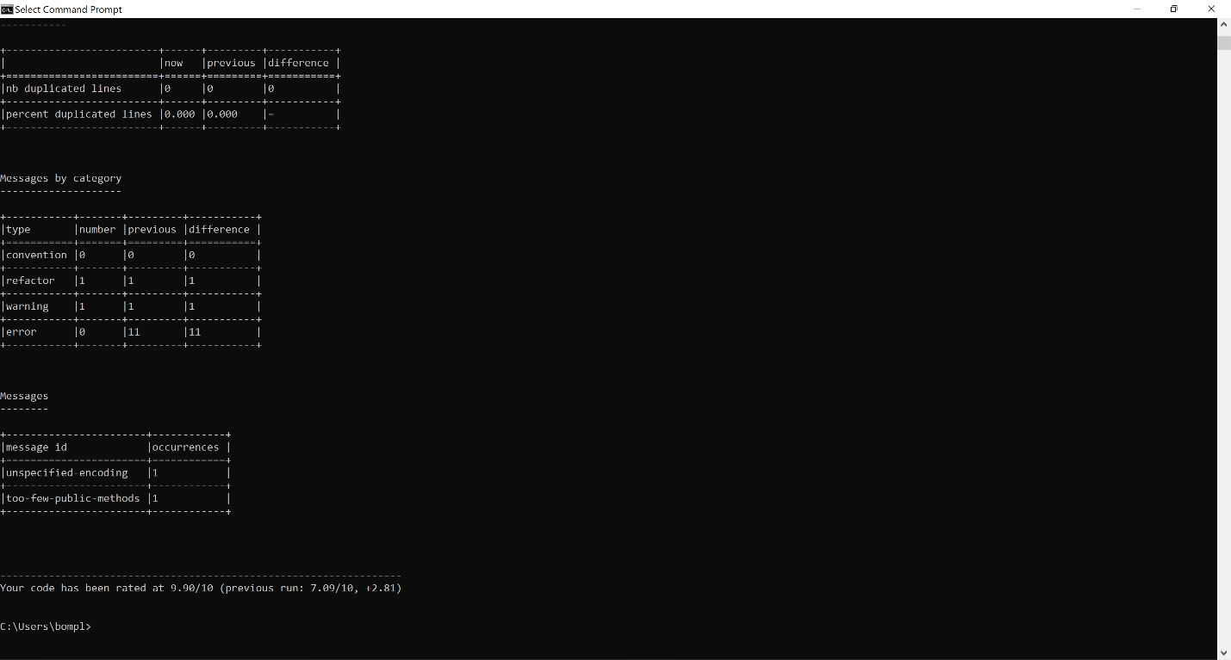

Bandit report:

