ΚΕΦΑΛΑΙΟ 1
Σχεσιακό διάγραμμα:
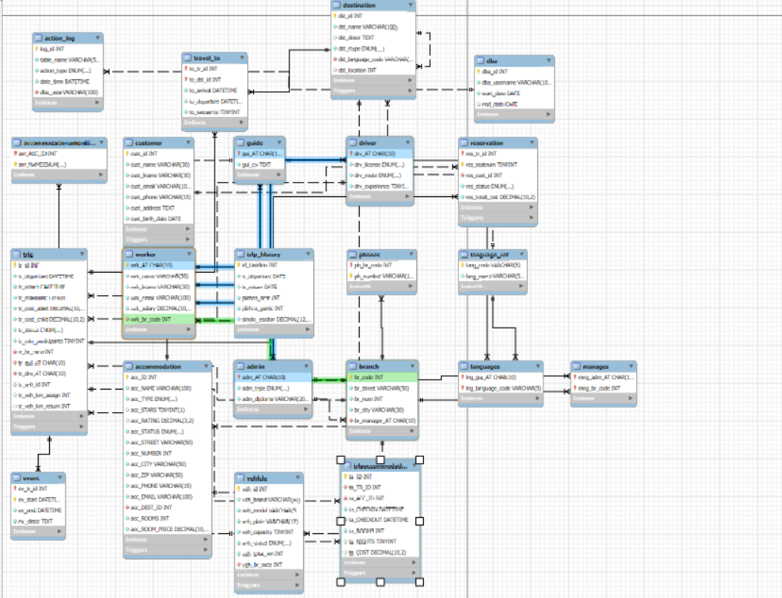
Το ζητούμενο του project ήταν να δημιουργηθεί μία βάση δεδομένων η οποία αφορά την διαχείρηση των εργασιών ενός ταξιδιωτικού γραφείου. Αρχικά δημιουργήσαμε τους πίνακες που υπήρχαν στο σχεσιακό διάγραμμα και εισάγαμε δεδομένα.
Νέες απαιτήσεις :
- Φτιάξαμε πίνακα accommodation για κάθε κατάλυμα , accommodationΑmenities για τις παροχές κάθε δωματίου και καταχωρήσαμε εγγραφές. Επίσης φτιάξαμε τον πίνακα tripAccomodation για τις κρατήσεις διαμονής και τα δεδομένα του καταχωρήστηκαν από την εκτέλεση του stored procedure του ερωτήματος 3.1.3.3 procedureBookTripAccomodation
- Φτιάξαμε πίνακα vehicles για τα οχήματα και καταχωρήσαμε 6 εγγραφές
- Φτιάξαμε τον πίνακα trip_history ο οποίος δεν έχει περιορισμούς αναφορικής ακεραιότητας με άλλους πίνακες της βάσης μας όπως αναφέρεται και στην εκφώνηση. Για να καταχωρηθούν εγγραφές σε αυτό τον πίνακα δημιουργήσαμε την stored procedure eggrafes_90000 .Με την κλήση της καταχωρούνται 90.000 εγγραφές.
- Φτιάξαμε τον πίνακα dba και καταχωρήσαμε ως διαχειρηστή της βάσης τον root.
- Φτιάξαμε τον πίνακα action_log στον οποίο καταγράφονται οι ενέργειες του dba.
- Με την χρήση του alter επεκτάθηκε ο πίνακας trip . Προσθέσαμε τα γνωρίσματα : tr_veh_id το id για τα οχήματα που καταχωρήστηκαν και αποτελεί foreign key προς vehicle(veh_id) , tr_veh_km_assign για να αποθηκεύει τα χιλιόμετρα του οχήματος την στιγμή που ανατέθηκε στο συγκεκριμένο ταξίδι , tr_veh_km_return

ΕΝΤΟΛΕΣ CREATE
DROP DATABASE IF EXISTS travel_agency_2025;
CREATE DATABASE travel_agency_2025;
USE travel_agency_2025;

SET FOREIGN_KEY_CHECKS = 0;

CREATE TABLE language_ref(
lang_code VARCHAR(5) NOT NULL,
lang_name VARCHAR(50) NOT NULL,
PRIMARY KEY(lang_code)
) engine=InnoDB;

CREATE TABLE branch(
br_code INT(11) NOT NULL,
br_street VARCHAR(50) NOT NULL,
br_num INT(4) NOT NULL,
br_city VARCHAR(30) NOT NULL,
br_manager_AT CHAR(10) NOT NULL,
PRIMARY KEY(br_code),
CONSTRAINT BR_MNG FOREIGN KEY (br_manager_AT) REFERENCES admin(adm_AT)
ON UPDATE CASCADE ON DELETE CASCADE
) engine=InnoDB;

CREATE TABLE worker(
wrk_AT CHAR(10) NOT NULL,
wrk_name VARCHAR(30) DEFAULT 'unknown' NOT NULL,
wrk_lname VARCHAR(30) DEFAULT 'unknown' NOT NULL,
wrk_email VARCHAR(100) NOT NULL,
wrk_salary DECIMAL(10,2) NOT NULL,
wrk_br_code INT(11) NOT NULL,
PRIMARY KEY(wrk_AT),
CONSTRAINT WRK_BRANCH FOREIGN KEY (wrk_br_code) REFERENCES branch(br_code)
ON UPDATE CASCADE ON DELETE CASCADE
) engine=InnoDB;

CREATE TABLE admin(
adm_AT CHAR(10) NOT NULL,
adm_type ENUM('LOGISTICS','ADMINISTRATIVE','ACCOUNTING') NOT NULL,
adm_diploma VARCHAR(200) NOT NULL,
PRIMARY KEY(adm_AT),
CONSTRAINT ADM_IS_WRK FOREIGN KEY (adm_AT) REFERENCES worker(wrk_AT)
ON UPDATE CASCADE ON DELETE CASCADE
)engine=InnoDB;

CREATE TABLE driver(
drv_AT CHAR(10) NOT NULL,
drv_license ENUM('A','B','C','D') NOT NULL,
drv_route ENUM('LOCAL','ABROAD') NOT NULL,
drv_experience TINYINT(4) NOT NULL,
PRIMARY KEY(drv_AT),
CONSTRAINT DRV_IS_WRK FOREIGN KEY (drv_AT) REFERENCES worker(wrk_AT)
ON UPDATE CASCADE ON DELETE CASCADE
)engine=InnoDB;

CREATE TABLE guide(
gui_AT CHAR(10) NOT NULL,
gui_cv TEXT NOT NULL,
PRIMARY KEY(gui_AT),
CONSTRAINT GUI_IS_WRK FOREIGN KEY (gui_AT) REFERENCES worker(wrk_AT)
ON UPDATE CASCADE ON DELETE CASCADE
) engine=InnoDB;

CREATE TABLE languages(
lng_gui_AT CHAR(10) NOT NULL,
lng_language_code VARCHAR(5) NOT NULL,
PRIMARY KEY(lng_gui_AT, lng_language_code),
CONSTRAINT LNG_GUI FOREIGN KEY (lng_gui_AT) REFERENCES guide(gui_AT)
ON UPDATE CASCADE ON DELETE CASCADE,
CONSTRAINT LNG_CODE FOREIGN KEY (lng_language_code) REFERENCES language_ref(lang_code)
ON UPDATE CASCADE ON DELETE CASCADE
) engine=InnoDB;

CREATE TABLE manages(
mng_adm_AT CHAR(10) NOT NULL,
mng_br_code INT(11) NOT NULL,
PRIMARY KEY(mng_adm_AT,mng_br_code),
CONSTRAINT MNG_ADMIN FOREIGN KEY (mng_adm_AT) REFERENCES admin(adm_AT)
ON UPDATE CASCADE ON DELETE CASCADE,
CONSTRAINT MNG_BRANCH FOREIGN KEY (mng_br_code) REFERENCES branch(br_code)
ON UPDATE CASCADE ON DELETE CASCADE
)engine=InnoDB;

CREATE TABLE phones(
ph_br_code INT(11) NOT NULL,
ph_number VARCHAR(15) NOT NULL,
PRIMARY KEY(ph_br_code, ph_number),
CONSTRAINT PH_BRANCH FOREIGN KEY (ph_br_code) REFERENCES branch(br_code)
ON UPDATE CASCADE ON DELETE CASCADE
) engine=InnoDB;

CREATE TABLE trip(
tr_id INT(11) NOT NULL AUTO_INCREMENT,
tr_departure DATETIME NOT NULL,
tr_return DATETIME NOT NULL,
tr_maxseats TINYINT(4) NOT NULL,
tr_cost_adult DECIMAL(10,2) NOT NULL,
tr_cost_child DECIMAL(10,2) NOT NULL,
tr_status ENUM('PLANNED', 'CONFIRMED', 'ACTIVE', 'COMPLETED', 'CANCELLED') NOT NULL,
tr_min_participants TINYINT(4) NOT NULL,
tr_br_code INT(11) NOT NULL,
tr_gui_AT CHAR(10) NOT NULL,
tr_drv_AT CHAR(10) NOT NULL,
PRIMARY KEY(tr_id),
CONSTRAINT TRIP_BRANCH FOREIGN KEY (tr_br_code) REFERENCES branch(br_code)
ON UPDATE CASCADE ON DELETE CASCADE,
CONSTRAINT TRIP_GUIDE FOREIGN KEY (tr_gui_AT) REFERENCES guide(gui_AT)
ON UPDATE CASCADE ON DELETE CASCADE,
CONSTRAINT TRIP_DRIVER FOREIGN KEY (tr_drv_AT) REFERENCES driver(drv_AT)
ON UPDATE CASCADE ON DELETE CASCADE
) engine=InnoDB;

ALTER TABLE trip
ADD COLUMN tr_veh_id INT(11) NULL,
ADD CONSTRAINT TRIP_VEHICLE
FOREIGN KEY (tr_veh_id) REFERENCES vehicle (veh_id)
ON UPDATE CASCADE
ON DELETE SET NULL;

ALTER TABLE trip
ADD COLUMN tr_veh_km_assign INT NULL;

ALTER TABLE trip
ADD COLUMN tr_veh_km_return INT NULL;

CREATE TABLE destination(
dst_id INT(11) NOT NULL AUTO_INCREMENT,
dst_name VARCHAR(100) NOT NULL,
dst_descr TEXT,
dst_rtype ENUM('LOCAL','ABROAD') NOT NULL,
dst_language_code VARCHAR(5) NOT NULL,
dst_location INT(11),
PRIMARY KEY(dst_id),
CONSTRAINT DST_LANG FOREIGN KEY (dst_language_code) REFERENCES language_ref(lang_code)
ON UPDATE CASCADE ON DELETE CASCADE,
CONSTRAINT DST_PARENT FOREIGN KEY (dst_location) REFERENCES destination(dst_id)
ON UPDATE CASCADE ON DELETE SET NULL
) engine=InnoDB;

CREATE TABLE travel_to(
to_tr_id INT(11) NOT NULL,
to_dst_id INT(11) NOT NULL,
to_arrival DATETIME NOT NULL,
to_departure DATETIME NOT NULL,
to_sequence TINYINT(4) NOT NULL,
PRIMARY KEY(to_tr_id,to_dst_id),
CONSTRAINT TRV_TRIP FOREIGN KEY (to_tr_id) REFERENCES trip(tr_id)
ON UPDATE CASCADE ON DELETE CASCADE,
CONSTRAINT TRV_DEST FOREIGN KEY (to_dst_id) REFERENCES destination(dst_id)
ON UPDATE CASCADE ON DELETE CASCADE
)engine=InnoDB;

CREATE TABLE event(
ev_tr_id INT(11) NOT NULL,
ev_start DATETIME NOT NULL,
ev_end DATETIME NOT NULL,
ev_descr TEXT NOT NULL,
PRIMARY KEY(ev_tr_id, ev_start),
CONSTRAINT EV_TRIP FOREIGN KEY (ev_tr_id) REFERENCES trip(tr_id)
ON UPDATE CASCADE ON DELETE CASCADE
) engine=InnoDB;

CREATE TABLE customer(
cust_id INT(11) NOT NULL AUTO_INCREMENT,
cust_name VARCHAR(30) NOT NULL,
cust_lname VARCHAR(30) NOT NULL,
cust_email VARCHAR(100) NOT NULL,
cust_phone VARCHAR(15) NOT NULL,
cust_address TEXT NOT NULL,
cust_birth_date DATE NOT NULL,
PRIMARY KEY(cust_id)
)engine=InnoDB;

CREATE TABLE reservation(
res_tr_id INT(11) NOT NULL,
res_seatnum TINYINT(4) NOT NULL,
res_cust_id INT(11) NOT NULL,
res_status ENUM('PENDING','CONFIRMED','PAID','CANCELLED') NOT NULL,
res_total_cost DECIMAL(10,2) NOT NULL,
PRIMARY KEY(res_tr_id,res_seatnum),
CONSTRAINT RES_TRIP FOREIGN KEY (res_tr_id) REFERENCES trip(tr_id)
ON UPDATE CASCADE ON DELETE CASCADE,
CONSTRAINT RES_CUST FOREIGN KEY (res_cust_id) REFERENCES customer(cust_id)
ON UPDATE CASCADE ON DELETE CASCADE
)engine=InnoDB;

CREATE TABLE vehicle(
veh_id INT(11) NOT NULL AUTO_INCREMENT,
veh_brand VARCHAR(50) NOT NULL,
veh_model VARCHAR(50) NOT NULL,
veh_plate VARCHAR(12) NOT NULL,
veh_capacity TINYINT(4) NOT NULL,
veh_status ENUM('AVAILABLE','IN_USE','MAINTENANCE') NOT NULL DEFAULT 'AVAILABLE',
veh_total_km INT(11) NOT NULL DEFAULT 0,
veh_br_code INT(11) NOT NULL,

PRIMARY KEY (veh_id),
UNIQUE KEY UK_vehicle_plate (veh_plate),

CONSTRAINT VEH_BRANCH
FOREIGN KEY (veh_br_code) REFERENCES branch(br_code)
ON UPDATE CASCADE
ON DELETE RESTRICT,

CONSTRAINT CHK_VEH_CAPACITY CHECK (veh_capacity BETWEEN 1 AND 60),
CONSTRAINT CHK_VEH_KM CHECK (veh_total_km >= 0)
)ENGINE=InnoDB;

CREATE TABLE accommodation(
acc_ID INT(11) NOT NULL AUTO_INCREMENT,
acc_NAME VARCHAR(100) NOT NULL,
acc_TYPE ENUM('HOTEL','HOSTEL','RESORT','APARTMENT','ROOM_RENTAL') NOT NULL,
acc_STARS TINYINT(1),
acc_RATING DECIMAL(3,2),
acc_STATUS ENUM('ACTIVE','INACTIVE') NOT NULL DEFAULT 'ACTIVE',

acc_STREET VARCHAR(50) NOT NULL,
acc_NUMBER INT(4) NOT NULL,
acc_CITY VARCHAR(50) NOT NULL,
acc_ZIP VARCHAR(50) NOT NULL,
acc_PHONE VARCHAR(15) NOT NULL,
acc_EMAIL VARCHAR(100) NOT NULL,

acc_DEST_ID INT(11) NOT NULL,
acc_ROOMS INT(11) NOT NULL,
acc_ROOM_PRICE DECIMAL(10,2) NOT NULL,
PRIMARY KEY(acc_ID),

CONSTRAINT ACC_DEST FOREIGN KEY (acc_DEST_ID) REFERENCES destination(dst_id)
ON UPDATE CASCADE ON DELETE CASCADE,

CONSTRAINT CHECK_STARS CHECK (acc_STARS IS NULL OR (acc_STARS >= 1 AND acc_STARS <= 5)),

CONSTRAINT CHECK_RATING CHECK (acc_RATING >= 0.00 AND acc_RATING <= 5.00)
)engine=InnoDB;

CREATE TABLE accommodationAmenities(
am_ACC_ID INT(11) NOT NULL,
am_NAME ENUM('WIFI','BAR_RESTAURANT','AC','ACCESIBILITY') NOT NULL,
PRIMARY KEY(am_ACC_ID,am_NAME),

CONSTRAINT AM_ACC FOREIGN KEY (am_ACC_ID) REFERENCES accommodation(acc_ID)
ON UPDATE CASCADE ON DELETE CASCADE
)engine=InnoDB;

CREATE TABLE tripAccommodation(
ta_ID INT(11) NOT NULL AUTO_INCREMENT,
ta_TR_ID INT(11) NOT NULL,
ta_ACC_ID INT(11) NOT NULL,
ta_CHECKIN DATETIME NOT NULL,
ta_CHECKOUT DATETIME NOT NULL,
ta_ROOMS INT(11) NOT NULL,
ta_NIGHTS TINYINT(4),
ta_COST DECIMAL(10,2),

PRIMARY KEY(ta_ID),
CONSTRAINT TA_TRIP FOREIGN KEY (ta_TR_ID) REFERENCES trip(tr_id)
ON UPDATE CASCADE ON DELETE CASCADE,
CONSTRAINT TA_ACC FOREIGN KEY (ta_ACC_ID) REFERENCES accommodation(acc_ID)
ON UPDATE CASCADE ON DELETE CASCADE
)engine=InnoDB;

CREATE TABLE dba (
dba_id INT AUTO_INCREMENT PRIMARY KEY,
dba_username VARCHAR(100) NOT NULL,
start_date DATE NOT NULL,
end_date DATE NULL
) ENGINE=InnoDB;

ALTER TABLE dba
ADD CONSTRAINT uq_dba_username UNIQUE (dba_username);

CREATE TABLE action_log (
log_id INT AUTO_INCREMENT PRIMARY KEY,
table_name VARCHAR(50) NOT NULL,
action_type ENUM('INSERT','UPDATE','DELETE') NOT NULL,
date_time DATETIME NOT NULL,
dba_user VARCHAR(100) NOT NULL,
CONSTRAINT fk_actionlog_dba
FOREIGN KEY (dba_user )
REFERENCES dba(dba_username)
ON DELETE RESTRICT
ON UPDATE RESTRICT
) ENGINE=InnoDB;

CREATE TABLE trip_history (
id_taxidiou INT NOT NULL,
tr_departure DATE NOT NULL,
tr_return DATE NOT NULL,
plithos_dest INT NOT NULL,
plithos_partic INT NOT NULL,
sinolo_esodon DECIMAL(12,2) NOT NULL,
PRIMARY KEY (id_taxidiou)
) ENGINE=InnoDB;

SET FOREIGN_KEY_CHECKS = 1;
ΕΝΤΟΛΕΣ INSERT
USE travel_agency_2025;
SET FOREIGN_KEY_CHECKS = 0;

INSERT INTO language_ref(lang_code, lang_name) VALUES
('EN', 'English'),
('GR', 'Greek'),
('FR', 'French'),
('DE', 'German'),
('JP', 'Japanese'),
('CN', 'Chinese'),
('IT', 'Italian'),
('ES', 'Spanish'),
('RU', 'Russian');

INSERT INTO branch (br_code, br_street, br_num, br_city, br_manager_AT) VALUES
(1, 'Ermou', 15, 'Athens', 'AT00000001'),
(2, 'Tsimiski', 45, 'Thessaloniki', 'AT00000002'),
(3, 'Maizonos', 120, 'Patras', 'AT00000003'),
(4, 'Panepistimiou', 12, 'Athens', 'AT00000004'),
(5, 'Aristotelous', 58, 'Thessaloniki', 'AT00000005'),
(6, 'Karaiskaki', 24, 'Patras', 'AT00000006'),
(7, 'Stadiou', 12, 'Athens', 'AT00000027'),
(8, 'Egnatia', 80, 'Thessaloniki', 'AT00000028'),
(9, 'Agiou Andreou', 35, 'Patras', 'AT00000029');

INSERT INTO worker(wrk_AT, wrk_name, wrk_lname, wrk_email, wrk_salary, wrk_br_code) VALUES
('AT00000001', 'Giorgos', 'Papadopoulos', 'g.pap@agency.gr', 1500.00, 1),
('AT00000002', 'Maria', 'Ioannou', 'm.ioan@agency.gr', 1450.00, 2),
('AT00000003', 'Nikos', 'Georgiou', 'n.geor@agency.gr', 1400.00, 3),
('AT00000004', 'Eleni', 'Dimitriou', 'el.dim@agency.gr', 1300.00, 1),
('AT00000005', 'Kostas', 'Nikolou', 'k.nikol@agency.gr', 1350.00, 4),
('AT00000006', 'Vasilis', 'Chalkias', 'v.chalk@agency.gr', 1700.00, 5),
('AT00000007', 'Thodoris', 'Lazarou', 'thod.laz@agency.gr', 1200.00, 6),
('AT00000008', 'Marinnos', 'Triantafyllou', 'mar.triant@agency.gr', 1430.00, 4),
('AT00000009', 'Elena', 'Papageorgiou', 'el.pap@agency.gr', 1550.00, 6),
('AT00000010', 'Niki', 'Paliou', 'niki.pal@agency.gr', 1670.00, 5),
('AT00000011', 'Kostas', 'Oikonomou', 'k.oik@agency.gr', 800.00, 3),
('AT00000012', 'Maria', 'Aggelou', 'm.aggelou@agency.gr', 1100.00, 6),
('AT00000013', 'Aris', 'Roubos', 'ar.roub@agency.gr', 690.00, 2),
('AT00000014', 'Ioannis', 'Mitropoulos', 'i.mitr@agency.gr', 900.00, 1),
('AT00000015', 'Kostas', 'Varouxas', 'k.var@agency.gr', 1000.00, 5),
('AT00000016', 'Vasiliki', 'Augeri', 'v.aug@agency.gr', 730.00, 4),
('AT00000017', 'Theodora', 'Perikou', 'theod.perik@agency.gr', 600.00, 2),
('AT00000018', 'Dimitris', 'Tsarouxis', 'd.tsar@agency.gr', 730.00, 4),
('AT00000019', 'Sofia', 'Tremouli', 'sof.trem@agency.gr', 890.00, 2),
('AT00000020', 'Lydia', 'Riga', 'lyd.rig@agency.gr', 1000.00, 6),
('AT00000021', 'Ermis', 'Krtikos', 'er.kritik@agency.gr', 785.00, 3),
('AT00000022', 'Spyros', 'Papakonstantinou', 'sp.pap@agency.gr', 930.00, 6),
('AT00000023', 'Konstantina', 'Diamantidi', 'kon.diam@agency.gr', 1050.00, 3),
('AT00000024', 'Marilida', 'Dimitriou', 'mar.dim@agency.gr', 980.00, 5),
('AT00000025', 'Markella', 'Loudari', 'mark.loud.perik@agency.gr', 1100.00, 1),
('AT00000026', 'Dimitra', 'Theotokatou', 'd.theot@agency.gr', 840.00, 2),
('AT00000027', 'Giorgos', 'Katsaros', 'g.katsaros@agency.gr', 1520.00, 1),
('AT00000028', 'Eleni', 'Karagianni', 'e.karagianni@agency.gr', 1480.00, 2),
('AT00000029', 'Nikos', 'Samaras', 'n.samaras@agency.gr', 1410.00, 3),
('AT00000030', 'Maria', 'Kotsou', 'm.kotsou@agency.gr', 1390.00, 4),
('AT00000031', 'Dimitris', 'Papageorgiou', 'd.papageorgiou@agency.gr', 1600.00, 5),
('AT00000032', 'Katerina', 'Stavropoulou', 'k.stavropoulou@agency.gr', 920.00, 6),
('AT00000033', 'Panagiotis', 'Theodorou', 'p.theodorou@agency.gr', 880.00, 2),
('AT00000034', 'Ioanna', 'Mavridou', 'i.mavridou@agency.gr', 950.00, 1),
('AT00000035', 'Christos', 'Anagnostou', 'c.anagnostou@agency.gr', 910.00, 3),
('AT00000036', 'Sofia', 'Lazaridou', 's.lazaridou@agency.gr', 990.00, 4),
('AT00000037', 'Vasilis', 'Antonakis', 'v.antonakis@agency.gr', 1020.00, 5),
('AT00000038', 'Niki', 'Papantoniou', 'n.papantoniou@agency.gr', 980.00, 6),
('AT00000039', 'Alexandros', 'Kyriazis', 'a.kyriazis@agency.gr', 1100.00, 1);

INSERT INTO admin(adm_AT, adm_type, adm_diploma) VALUES
('AT00000001', 'ADMINISTRATIVE', 'MBA in Management'),
('AT00000002', 'LOGISTICS', 'MSc Logistics'),
('AT00000003', 'ACCOUNTING', 'BSc Economics'),
('AT00000004', 'ADMINISTRATIVE', 'BSc Economics'),
('AT00000005', 'LOGISTICS', 'Diploma in Supply Chain'),
('AT00000006', 'ACCOUNTING', 'MSc Financial Analysis'),
('AT00000007', 'ADMINISTRATIVE', 'Diploma in Office Administration'),
('AT00000008', 'LOGISTICS', 'BSc Transport & Shipping'),
('AT00000009', 'ACCOUNTING', 'Certified Public Accountant'),
('AT00000010', 'LOGISTICS', 'MBA in Supply Chain Management'),
('AT00000027', 'ADMINISTRATIVE', 'Πτυχίο Διοίκησης Επιχειρήσεων'),
('AT00000028', 'LOGISTICS', 'Μεταπτυχιακό στη Διοίκηση Logistics'),
('AT00000029', 'ACCOUNTING', 'Πτυχίο Λογιστικής & Χρηματοοικονομικών'),
('AT00000030', 'ADMINISTRATIVE', 'Δίπλωμα Γραμματειακής Υποστήριξης'),
('AT00000031', 'LOGISTICS', 'Πιστοποίηση Supply Chain Management');

INSERT INTO manages(mng_adm_AT, mng_br_code) VALUES
('AT00000001', 1),
('AT00000002', 2),
('AT00000003', 3),
('AT00000004', 4),
('AT00000005', 5),
('AT00000006', 6),
('AT00000027', 7),
('AT00000028', 8),
('AT00000029', 9);

INSERT INTO driver(drv_AT, drv_license, drv_route, drv_experience) VALUES
('AT00000011', 'D', 'LOCAL', 3),
('AT00000012', 'C', 'ABROAD', 6),
('AT00000013', 'A', 'ABROAD', 8),
('AT00000014', 'B', 'ABROAD', 7),
('AT00000015', 'A', 'LOCAL', 5),
('AT00000016', 'C', 'ABROAD', 12),
('AT00000017', 'B', 'ABROAD', 9),
('AT00000018', 'D', 'LOCAL', 11),
('AT00000032', 'D', 'LOCAL', 14),
('AT00000033', 'C', 'ABROAD', 24),
('AT00000034', 'B', 'LOCAL', 10),
('AT00000035', 'C', 'ABROAD', 18);

INSERT INTO guide(gui_AT, gui_cv) VALUES
('AT00000019', 'History expert with 5 years experience in ancient Greek sites'),
('AT00000020', 'Art history specialist, fluent in French and Japanese'),
('AT00000021', 'Local culture expert with 18 years experience in rural Greece'),
('AT00000022', 'Nature guide with 9 years experience in eco-tourism'),
('AT00000023', 'Archaeology specialist with 6 years experience in excavations'),
('AT00000024', 'Mountain guide, certified in alpine routes and hiking'),
('AT00000025', 'Museum tour professional, multilingual speaker'),
('AT00000026', 'Cultural heritage expert, specializes in Byzantine sites'),
('AT00000036', 'Ξεναγός με ειδίκευση σε αρχαιολογικούς χώρους και ιστορικούς περιπάτους'),
('AT00000037', 'Πιστοποιημένος ξεναγός πόλεων – μουσεία, αρχιτεκτονική, πολιτισμός'),
('AT00000038', 'Οικοτουρισμός & πεζοπορία – ορεινές διαδρομές και φυσιολατρικές ξεναγήσεις'),
('AT00000039', 'Γαστρονομικές ξεναγήσεις και τοπική κουλτούρα – εμπειρία 8 ετών');

INSERT INTO languages(lng_gui_AT, lng_language_code) VALUES
('AT00000019', 'EN'),
('AT00000020', 'JP'),
('AT00000021', 'CN'),
('AT00000022', 'FR'),
('AT00000023', 'DE'),
('AT00000024', 'GR'),
('AT00000025', 'EN'),
('AT00000026', 'JP'),
('AT00000026', 'DE'),
('AT00000036', 'GR'),
('AT00000037', 'EN'),
('AT00000038', 'FR'),
('AT00000039', 'IT');

INSERT INTO phones(ph_br_code, ph_number) VALUES
(1, '2101234567'),
(1, '2101432768'),
(2, '2310674213'),
(2, '2310987655'),
(3, '2610555555'),
(4, '2101234569'),
(3, '2610468921'),
(2, '2310947134'),
(2, '2310187256'),
(3, '2610354555'),
(7, '2103301122'),
(7, '2103301133'),
(8, '2310556677'),
(9, '2610223344'),
(9, '2610223355');

INSERT INTO destination(dst_id, dst_name, dst_descr, dst_rtype, dst_language_code, dst_location) VALUES
(1, 'Santorini', 'Beautiful volcanic island with stunning sunsets and white houses', 'LOCAL', 'GR', NULL),
(2, 'Paris', 'City of lights with iconic Eiffel Tower and world-class museums', 'ABROAD', 'FR', NULL),
(3, 'Tokyo', 'Modern metropolis blending ancient tradition and cutting-edge technology', 'ABROAD', 'JP', NULL),
(4, 'Rome', 'Eternal city with Colosseum, Vatican and ancient Roman ruins', 'ABROAD', 'EN', NULL),
(5, 'Meteora', 'Impressive rock formations with historic monasteries', 'LOCAL', 'GR', NULL),
(6, 'Delphi', 'Ancient sanctuary of Apollo and center of the ancient world', 'LOCAL', 'GR', 5),
(7, 'Berlin', 'Historic German capital with rich culture and vibrant nightlife', 'ABROAD', 'DE', NULL),
(8, 'Barcelona', 'Vibrant Spanish city with Gaudi architecture and beaches', 'ABROAD', 'EN', NULL),
(9, 'Mykonos', 'Famous Cycladic island with windmills and beautiful beaches', 'LOCAL', 'GR', NULL),
(10, 'Amsterdam', 'Dutch capital with canals, Van Gogh Museum and historic center', 'ABROAD', 'EN', NULL),
(11, 'Fira', 'Κεντρικός οικισμός στη Σαντορίνη με θέα στην καλντέρα', 'LOCAL', 'GR', 1),
(12, 'Nafplio', 'Ιστορική πόλη με παλιά πόλη, Παλαμήδι και Μπούρτζι', 'LOCAL', 'GR', NULL),
(13, 'Milan', 'Ιταλική μητρόπολη της μόδας και της αρχιτεκτονικής', 'ABROAD', 'IT', NULL),
(14, 'Madrid', 'Πρωτεύουσα της Ισπανίας με μουσεία και ζωντανή νυχτερινή ζωή', 'ABROAD', 'ES', NULL),
(15, 'Moscow', 'Πόλη με ιστορία και αξιοθέατα όπως το Κρεμλίνο', 'ABROAD', 'RU', NULL);

INSERT INTO trip(tr_id, tr_departure, tr_return, tr_maxseats, tr_cost_adult, tr_cost_child, tr_status, tr_min_participants, tr_br_code, tr_gui_AT, tr_drv_AT) VALUES
(1, '2025-01-15 08:00:00', '2025-01-17 20:00:00', 30, 450.00, 300.00, 'CONFIRMED', 10, 1, 'AT00000019', 'AT00000011'),
(2, '2025-02-10 07:00:00', '2025-02-15 22:00:00', 25, 850.00, 550.00, 'PLANNED', 8, 2, 'AT00000020', 'AT00000012'),
(3, '2025-03-05 09:00:00', '2025-03-12 18:00:00', 20, 1200.00, 800.00, 'PLANNED', 12, 3, 'AT00000021', 'AT00000013'),
(4, '2025-04-20 06:00:00', '2025-04-25 21:00:00', 35, 680.00, 420.00, 'CONFIRMED', 15, 1, 'AT00000022', 'AT00000014'),
(5, '2025-05-01 08:30:00', '2025-05-03 19:00:00', 40, 320.00, 200.00, 'ACTIVE', 5, 4, 'AT00000023', 'AT00000015'),
(6, '2024-11-10 07:00:00', '2024-11-12 20:00:00', 28, 280.00, 180.00, 'COMPLETED', 8, 5, 'AT00000024', 'AT00000016'),
(7, '2024-10-05 06:30:00', '2024-10-08 22:00:00', 22, 520.00, 350.00, 'COMPLETED', 10, 6, 'AT00000025', 'AT00000017'),
(8, '2025-06-15 08:00:00', '2025-06-20 19:00:00', 30, 750.00, 500.00, 'PLANNED', 12, 2, 'AT00000026', 'AT00000018'),
(9, '2025-07-01 07:00:00', '2025-07-05 21:00:00', 25, 620.00, 400.00, 'PLANNED', 10, 3, 'AT00000019', 'AT00000012'),
(10, '2025-07-20 06:00:00', '2025-07-23 20:00:00', 35, 480.00, 320.00, 'PLANNED', 8, 4, 'AT00000020', 'AT00000013'),
(11, '2025-08-05 08:00:00', '2025-08-08 19:00:00', 28, 390.00, 250.00, 'PLANNED', 6, 5, 'AT00000021', 'AT00000014'),
(12, '2025-08-20 07:00:00', '2025-08-25 22:00:00', 22, 890.00, 580.00, 'PLANNED', 12, 6, 'AT00000022', 'AT00000015'),
(13, '2025-09-10 06:30:00', '2025-09-14 20:00:00', 30, 720.00, 480.00, 'PLANNED', 10, 1, 'AT00000023', 'AT00000016'),
(14, '2025-09-25 08:00:00', '2025-09-28 21:00:00', 26, 550.00, 360.00, 'PLANNED', 8, 2, 'AT00000024', 'AT00000017'),
(15, '2025-10-10 08:00:00', '2025-10-12 20:00:00', 30, 410.00, 260.00, 'PLANNED', 8, 7, 'AT00000036', 'AT00000032'),
(16, '2025-10-25 07:30:00', '2025-10-29 21:30:00', 25, 920.00, 620.00, 'PLANNED', 10, 8, 'AT00000037', 'AT00000033'),
(17, '2025-11-08 09:00:00', '2025-11-10 19:00:00', 20, 300.00, 190.00, 'PLANNED', 6, 9, 'AT00000038', 'AT00000034'),
(18, '2025-11-20 06:45:00', '2025-11-24 22:00:00', 35, 780.00, 520.00, 'PLANNED', 12, 7, 'AT00000039', 'AT00000035'),
(19, '2025-12-05 08:15:00', '2025-12-07 18:45:00', 28, 360.00, 240.00, 'PLANNED', 7, 8, 'AT00000036', 'AT00000032'),
(20, '2025-12-18 07:00:00', '2025-12-22 21:00:00', 26, 860.00, 590.00, 'PLANNED', 10, 9, 'AT00000037', 'AT00000033'),
(21, '2026-01-08 09:30:00', '2026-01-11 20:30:00', 22, 520.00, 340.00, 'PLANNED', 8, 7, 'AT00000038', 'AT00000034');

INSERT INTO travel_to(to_tr_id, to_dst_id, to_arrival, to_departure, to_sequence) VALUES
(1, 1, '2025-01-15 14:00:00', '2025-01-17 10:00:00', 1),
(2, 2, '2025-02-10 18:00:00', '2025-02-14 08:00:00', 1),
(3, 3, '2025-03-06 06:00:00', '2025-03-11 20:00:00', 1),
(4, 4, '2025-04-20 16:00:00', '2025-04-24 10:00:00', 1),
(5, 5, '2025-05-01 12:00:00', '2025-05-02 17:00:00', 1),
(5, 6, '2025-05-02 18:00:00', '2025-05-03 14:00:00', 2),
(6, 5, '2024-11-10 11:00:00', '2024-11-11 18:00:00', 1),
(6, 6, '2024-11-11 19:00:00', '2024-11-12 15:00:00', 2),
(7, 7, '2024-10-05 16:00:00', '2024-10-08 10:00:00', 1),
(8, 2, '2025-06-15 18:00:00', '2025-06-19 10:00:00', 1),
(9, 8, '2025-07-01 17:00:00', '2025-07-04 10:00:00', 1),
(10, 9, '2025-07-20 14:00:00', '2025-07-22 18:00:00', 1),
(11, 10, '2025-08-05 16:00:00', '2025-08-07 12:00:00', 1),
(12, 4, '2025-08-20 18:00:00', '2025-08-24 10:00:00', 1),
(13, 1, '2025-09-10 14:00:00', '2025-09-13 10:00:00', 1),
(14, 7, '2025-09-25 17:00:00', '2025-09-27 12:00:00', 1),
(15, 12, '2025-10-10 12:30:00', '2025-10-12 10:00:00', 1),
(16, 13, '2025-10-25 16:30:00', '2025-10-29 09:00:00', 1),
(17, 11, '2025-11-08 14:00:00', '2025-11-10 09:30:00', 1),
(18, 14, '2025-11-20 17:30:00', '2025-11-24 10:00:00', 1),
(19, 12, '2025-12-05 12:00:00', '2025-12-07 09:00:00', 1),
(20, 15, '2025-12-18 18:30:00', '2025-12-22 10:00:00', 1),
(21, 11, '2026-01-08 15:00:00', '2026-01-11 10:30:00', 1);

INSERT INTO event(ev_tr_id, ev_start, ev_end, ev_descr) VALUES
(1, '2025-01-15 16:00:00', '2025-01-15 18:00:00', 'Sunset viewing at Oia village'),
(1, '2025-01-16 10:00:00', '2025-01-16 13:00:00', 'Wine tasting tour at local vineyard'),
(2, '2025-02-11 09:00:00', '2025-02-11 12:00:00', 'Eiffel Tower visit and photo session'),
(2, '2025-02-12 14:00:00', '2025-02-12 17:00:00', 'Louvre Museum guided tour'),
(3, '2025-03-07 10:00:00', '2025-03-07 14:00:00', 'Tokyo Imperial Palace and gardens tour'),
(3, '2025-03-08 09:00:00', '2025-03-08 18:00:00', 'Mount Fuji day trip with lunch'),
(4, '2025-04-21 09:00:00', '2025-04-21 13:00:00', 'Colosseum and Roman Forum guided tour'),
(4, '2025-04-22 10:00:00', '2025-04-22 15:00:00', 'Vatican Museums and Sistine Chapel visit'),
(5, '2025-05-01 14:00:00', '2025-05-01 17:00:00', 'Meteora monasteries hiking tour'),
(6, '2024-11-10 13:00:00', '2024-11-10 16:00:00', 'Great Meteoron Monastery guided visit'),
(7, '2024-10-06 10:00:00', '2024-10-06 14:00:00', 'Berlin Wall Memorial and history tour'),
(8, '2025-06-16 10:00:00', '2025-06-16 13:00:00', 'Seine River cruise with lunch'),
(8, '2025-06-17 09:00:00', '2025-06-17 17:00:00', 'Versailles Palace full day tour'),
(9, '2025-07-02 10:00:00', '2025-07-02 14:00:00', 'Sagrada Familia guided tour'),
(9, '2025-07-03 09:00:00', '2025-07-03 13:00:00', 'Park Guell and Gaudi architecture walk'),
(10, '2025-07-21 10:00:00', '2025-07-21 16:00:00', 'Mykonos beach day and town exploration'),
(11, '2025-08-06 09:00:00', '2025-08-06 15:00:00', 'Van Gogh Museum and canal cruise'),
(12, '2025-08-21 10:00:00', '2025-08-21 14:00:00', 'Roman Forum and Palatine Hill exploration'),
(13, '2025-09-11 15:00:00', '2025-09-11 18:00:00', 'Caldera sunset cruise with dinner'),
(14, '2025-09-26 09:00:00', '2025-09-26 13:00:00', 'Brandenburg Gate and Reichstag tour'),
(15, '2025-10-10 17:00:00', '2025-10-10 19:00:00', 'Περίπατος στην παλιά πόλη & ελεύθερος χρόνος'),
(15, '2025-10-11 11:00:00', '2025-10-11 13:00:00', 'Ξενάγηση σε κάστρο & ιστορικά σημεία'),
(16, '2025-10-26 10:00:00', '2025-10-26 12:00:00', 'Ξενάγηση σε κέντρο πόλης & αξιοθέατα'),
(16, '2025-10-27 16:00:00', '2025-10-27 18:00:00', 'Μουσείο/πινακοθήκη – οργανωμένη επίσκεψη'),
(17, '2025-11-08 18:00:00', '2025-11-08 20:00:00', 'Τοπική γαστρονομική εμπειρία & δοκιμές'),
(17, '2025-11-09 10:30:00', '2025-11-09 12:30:00', 'Οδηγούμενη πεζοπορία σε φυσική διαδρομή'),
(18, '2025-11-21 10:00:00', '2025-11-21 12:00:00', 'City tour με ιστορικά σημεία'),
(18, '2025-11-22 17:00:00', '2025-11-22 19:00:00', 'Επίσκεψη σε μουσείο & ελεύθερος χρόνος'),
(20, '2025-12-19 11:00:00', '2025-12-19 13:00:00', 'Ξενάγηση σε κεντρικά αξιοθέατα'),
(21, '2026-01-09 16:30:00', '2026-01-09 18:30:00', 'Δραστηριότητα πολιτιστικού χαρακτήρα');

INSERT INTO customer(cust_id, cust_name, cust_lname, cust_email, cust_phone, cust_address, cust_birth_date) VALUES
(1, 'Alexandros', 'Papadakis', 'alex.pad@email.com', '6971234567', 'Kifisias 45, Athens', '1985-03-15'),
(2, 'Christina', 'Vlachou', 'chr.vlach@email.com', '6942345678', 'Egnatias 120, Thessaloniki', '1990-07-22'),
(3, 'Panagiotis', 'Konstantinou', 'pan.konst@email.com', '6983456789', 'Korinthou 89, Patras', '1978-11-08'),
(4, 'Dimitra', 'Andreou', 'dim.andr@email.com', '6954567890', 'Vouliagmenis 200, Athens', '1992-02-14'),
(5, 'Stavros', 'Makris', 'stav.mak@email.com', '6915678901', 'Mitropoleos 55, Athens', '1988-09-30'),
(6, 'Anna', 'Papanikolaou', 'anna.papan@email.com', '6926789012', 'Tsimiski 78, Thessaloniki', '1995-05-18'),
(7, 'Michalis', 'Georgopoulos', 'mich.georg@email.com', '6937890123', 'Kolokotroni 33, Patras', '1982-12-25'),
(8, 'Katerina', 'Alexiou', 'kat.alex@email.com', '6948901234', 'Stadiou 15, Athens', '1993-04-07'),
(9, 'Nikos', 'Stefanou', 'nik.stef@email.com', '6959012345', 'Aristotelous 90, Thessaloniki', '1987-08-19'),
(10, 'Eleftheria', 'Diamantopoulou', 'elef.diam@email.com', '6960123456', 'Panepistimiou 25, Athens', '1991-01-03'),
(11, 'Georgios', 'Karamanlis', 'g.karam@email.com', '6971112233', 'Ermou 100, Athens', '1980-06-11'),
(12, 'Sofia', 'Nikolaou', 'sof.nikol@email.com', '6982223344', 'Vas. Olgas 150, Thessaloniki', '1994-10-28'),
(13, 'Petros', 'Mavridis', 'pet.mavr@email.com', '6993334455', 'Solonos 75, Athens', '1983-04-20'),
(14, 'Ioanna', 'Katsarou', 'io.kats@email.com', '6974445566', 'Egnatias 200, Thessaloniki', '1996-08-12'),
(15, 'Andreas', 'Lamprou', 'andr.lamp@email.com', '6955556677', 'Agiou Andreou 45, Patras', '1979-12-05'),
(16, 'Maria', 'Oikonomidou', 'mar.oikon@email.com', '6936667788', 'Voukourestiou 30, Athens', '1989-06-28'),
(17, 'Vasilis', 'Papadimitriou', 'vas.papad@email.com', '6917778899', 'Politechniou 80, Thessaloniki', '1984-02-17'),
(18, 'Elena', 'Christodoulou', 'el.christ@email.com', '6998889900', 'Riga Fereou 55, Patras', '1997-10-09'),
(19, 'Christos', 'Antonopoulos', 'chr.anton@email.com', '6979990011', 'Akadimias 100, Athens', '1981-07-14'),
(20, 'Despina', 'Vasileiou', 'desp.vasil@email.com', '6950001122', 'Tsimiski 150, Thessaloniki', '1992-03-25'),
(21, 'Giorgos', 'Pappas', 'g.pappas@email.com', '6901112233', 'Stadiou 25, Athens', '1990-05-14'),
(22, 'Eleni', 'Kontou', 'e.kontou@email.com', '6902223344', 'Patission 120, Athens', '1995-09-02'),
(23, 'Nikos', 'Makris', 'n.makris@email.com', '6903334455', 'Egnatia 140, Thessaloniki', '1987-01-20'),
(24, 'Maria', 'Vlachou', 'm.vlachou@email.com', '6904445566', 'Tsimiski 88, Thessaloniki', '1998-11-11'),
(25, 'Dimitris', 'Kotronis', 'd.kotronis@email.com', '6905556677', 'Maizonos 90, Patras', '1982-07-30'),
(26, 'Sofia', 'Karali', 's.karali@email.com', '6906667788', 'Agiou Andreou 60, Patras', '1993-03-08'),
(27, 'Panagiotis', 'Delis', 'p.delis@email.com', '6907778899', 'Panepistimiou 35, Athens', '1989-12-22'),
(28, 'Niki', 'Sideri', 'n.sideri@email.com', '6908889900', 'Aristotelous 12, Thessaloniki', '2000-06-05'),
(29, 'Vasilis', 'Koutsis', 'v.koutsis@email.com', '6909990011', 'Riga Fereou 20, Patras', '1991-10-19'),
(30, 'Christina', 'Galanou', 'c.galanou@email.com', '6910001122', 'Akadimias 55, Athens', '1996-02-16');

INSERT INTO reservation(res_tr_id, res_seatnum, res_cust_id, res_status, res_total_cost) VALUES
(1, 1, 1, 'PAID', 450.00),
(1, 2, 2, 'PAID', 450.00),
(1, 3, 3, 'CONFIRMED', 450.00),
(2, 1, 4, 'PAID', 850.00),
(2, 2, 5, 'CONFIRMED', 850.00),
(3, 1, 6, 'PENDING', 1200.00),
(3, 2, 7, 'PENDING', 1200.00),
(4, 1, 8, 'PAID', 680.00),
(4, 2, 9, 'CONFIRMED', 680.00),
(5, 1, 10, 'PAID', 320.00),
(6, 1, 11, 'PAID', 280.00),
(6, 2, 12, 'PAID', 280.00),
(7, 1, 13, 'PAID', 520.00),
(7, 2, 14, 'PAID', 520.00),
(8, 1, 15, 'PENDING', 750.00),
(8, 2, 16, 'PENDING', 750.00),
(9, 1, 17, 'PENDING', 620.00),
(9, 2, 18, 'PENDING', 620.00),
(10, 1, 19, 'PENDING', 480.00),
(10, 2, 20, 'PENDING', 480.00),
(11, 1, 1, 'PENDING', 390.00),
(12, 1, 2, 'PENDING', 890.00),
(13, 1, 3, 'PENDING', 720.00),
(14, 1, 4, 'PENDING', 550.00),
(15, 1, 21, 'PENDING', 410.00),
(15, 2, 22, 'PENDING', 410.00),
(15, 3, 23, 'CONFIRMED', 410.00),
(16, 1, 24, 'PENDING', 920.00),
(16, 2, 25, 'CONFIRMED', 920.00),
(17, 1, 26, 'PAID', 300.00),
(17, 2, 27, 'PAID', 300.00),
(18, 1, 28, 'PENDING', 780.00),
(18, 2, 29, 'PENDING', 780.00),
(19, 1, 30, 'CONFIRMED', 360.00),
(20, 1, 21, 'PENDING', 860.00),
(21, 1, 22, 'PENDING', 520.00);

INSERT INTO vehicle(veh_brand,veh_model,veh_plate,veh_capacity,veh_status,veh_total_km,veh_br_code) VALUES
('Mercedes','Tourismo','XAB-1001',49,'AVAILABLE',180000,1),
('Iveco','Daily Minibus','XAB-2002',19,'AVAILABLE',95000,2),
('Ford','Transit Van','XAB-3003',9,'MAINTENANCE',210000,3),
('Toyota','Corolla','XAB-4004',5,'AVAILABLE',120000,4),
('Volkswagen','Crafter','XAB-5005',20,'AVAILABLE',160000,5),
('Setra','S515HD','XAB-6006',53,'AVAILABLE',300000,6);

INSERT INTO accommodation(acc_ID, acc_NAME, acc_TYPE, acc_STARS, acc_RATING, acc_STATUS, acc_STREET, acc_NUMBER, acc_CITY, acc_ZIP, acc_PHONE, acc_EMAIL, acc_DEST_ID, acc_ROOMS, acc_ROOM_PRICE) VALUES
(1, 'Santorini Sunset Hotel', 'HOTEL', 5, 4.80, 'ACTIVE', 'Oia Main Road', 12, 'Oia', '84702', '2286071234', 'info@santorinisunset.gr', 1, 30, 180.00),
(2, 'Volcano View Suites', 'RESORT', 4, 4.50, 'ACTIVE', 'Caldera View', 5, 'Fira', '84700', '2286072345', 'book@volcanoview.gr', 1, 20, 220.00),
(3, 'Paris Le Marais Hotel', 'HOTEL', 4, 4.30, 'ACTIVE', 'Rue de Rivoli', 45, 'Paris', '75004', '0142789012', 'reservations@lemarais.fr', 2, 50, 150.00),
(4, 'Montmartre Boutique', 'HOSTEL', 3, 4.10, 'ACTIVE', 'Rue Lepic', 78, 'Paris', '75018', '0142789013', 'stay@montmartreboutique.fr', 2, 25, 85.00),
(5, 'Tokyo Shibuya Inn', 'HOTEL', 4, 4.40, 'ACTIVE', 'Shibuya Street', 23, 'Tokyo', '150-0002', '0335678901', 'info@tokyoshibuya.jp', 3, 80, 120.00),
(6, 'Shinjuku Capsule Hotel', 'HOSTEL', 2, 3.80, 'ACTIVE', 'Shinjuku Dori', 100, 'Tokyo', '160-0022', '0335678902', 'book@shinjukucapsule.jp', 3, 100, 45.00),
(7, 'Roma Colosseum View', 'HOTEL', 5, 4.70, 'ACTIVE', 'Via dei Fori Imperiali', 8, 'Rome', '00184', '0669123456', 'info@colosseumview.it', 4, 40, 200.00),
(8, 'Trastevere Apartments', 'APARTMENT', NULL, 4.20, 'ACTIVE', 'Via della Lungaretta', 15, 'Rome', '00153', '0669123457', 'stay@trastevere.it', 4, 15, 130.00),
(9, 'Meteora Mountain Lodge', 'RESORT', 4, 4.60, 'ACTIVE', 'Kalampaka Road', 3, 'Kalampaka', '42200', '2432022345', 'welcome@meteoralodge.gr', 5, 25, 95.00),
(10, 'Delphi Oracle Hotel', 'HOTEL', 3, 4.00, 'ACTIVE', 'Apollo Street', 7, 'Delphi', '33054', '2265082345', 'info@delphioracle.gr', 6, 20, 75.00),
(11, 'Berlin Mitte Hotel', 'HOTEL', 4, 4.35, 'ACTIVE', 'Friedrichstrasse', 120, 'Berlin', '10117', '03012345678', 'reservations@berlinmitte.de', 7, 60, 110.00),
(12, 'Kreuzberg Hostel', 'HOSTEL', 2, 3.90, 'ACTIVE', 'Oranienstrasse', 45, 'Berlin', '10999', '03012345679', 'stay@kreuzberghostel.de', 7, 40, 55.00),
(13, 'Barcelona Beach Resort', 'RESORT', 5, 4.75, 'ACTIVE', 'Passeig Maritim', 88, 'Barcelona', '08003', '934567890', 'book@barcelonabeach.es', 8, 70, 175.00),
(14, 'Mykonos Windmill Suites', 'HOTEL', 5, 4.85, 'ACTIVE', 'Chora Main', 2, 'Mykonos Town', '84600', '2289023456', 'info@windmillsuites.gr', 9, 18, 250.00),
(15, 'Amsterdam Canal House', 'APARTMENT', NULL, 4.45, 'ACTIVE', 'Prinsengracht', 234, 'Amsterdam', '1016HJ', '0206123456', 'stay@canalhouse.nl', 10, 12, 160.00),
(16, 'Fira Caldera Rooms', 'ROOM_RENTAL', 3, 4.15, 'ACTIVE', 'Danezi Street', 18, 'Fira', '84700', '2286083456', 'book@firacaldera.gr', 11, 10, 90.00),
(17, 'Nafplio Old Town Hotel', 'HOTEL', 4, 4.55, 'ACTIVE', 'Staikopoulou', 22, 'Nafplio', '21100', '2752028901', 'info@nafpliooldtown.gr', 12, 22, 105.00),
(18, 'Milan Central Suites', 'APARTMENT', NULL, 4.25, 'ACTIVE', 'Via Torino', 50, 'Milan', '20123', '0212345678', 'stay@milancecentral.it', 13, 18, 140.00);

INSERT INTO accommodationAmenities(am_ACC_ID, am_NAME) VALUES
(1, 'WIFI'), (1, 'BAR_RESTAURANT'), (1, 'AC'),
(2, 'WIFI'), (2, 'AC'), (2, 'ACCESIBILITY'),
(3, 'WIFI'), (3, 'BAR_RESTAURANT'), (3, 'AC'), (3, 'ACCESIBILITY'),
(4, 'WIFI'), (4, 'AC'),
(5, 'WIFI'), (5, 'BAR_RESTAURANT'), (5, 'AC'), (5, 'ACCESIBILITY'),
(6, 'WIFI'), (6, 'AC'),
(7, 'WIFI'), (7, 'BAR_RESTAURANT'), (7, 'AC'), (7, 'ACCESIBILITY'),
(8, 'WIFI'), (8, 'AC'),
(9, 'WIFI'), (9, 'BAR_RESTAURANT'),
(10, 'WIFI'), (10, 'AC'),
(11, 'WIFI'), (11, 'BAR_RESTAURANT'), (11, 'AC'),
(12, 'WIFI'),
(13, 'WIFI'), (13, 'BAR_RESTAURANT'), (13, 'AC'), (13, 'ACCESIBILITY'),
(14, 'WIFI'), (14, 'BAR_RESTAURANT'), (14, 'AC'),
(15, 'WIFI'), (15, 'AC'),
(16, 'WIFI'), (16, 'AC'),
(17, 'WIFI'), (17, 'BAR_RESTAURANT'), (17, 'AC'),
(18, 'WIFI'), (18, 'AC'), (18, 'ACCESIBILITY');

INSERT INTO dba (dba_username, start_date, end_date)
VALUES ('root', CURDATE(), NULL);

SET FOREIGN_KEY_CHECKS = 1;

3.1.2.3 - 90.000 εγγραφές
Στην χρησιμοποιήσαμε και ομαδοποιημένη εισαγωγή ανα 1000 εγγραφές , ώστ εοι εγγραφές να περνάνε σταδιακά. Το κάναμε έτσι γιατί όταν προσπαθήσαμε να τςι εισάγουμε όλες μαζί , η σύνδεση με τη MySQL διακοπτόταν .
Στο παρακάτω screenshot βλέπουμε τις εγγραφές που καταχωρήστηκαν στον πίνακα trip_history μετά την εκτέλεση της stored procedure που γράψαμε γαι τις 90.000 εγγραφές .
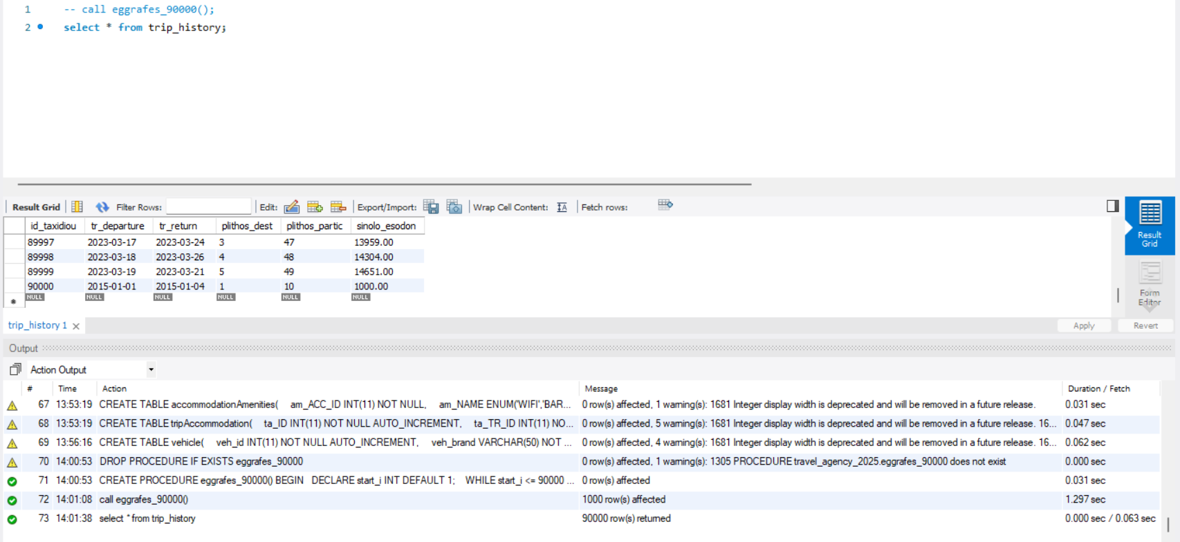
DROP PROCEDURE IF EXISTS eggrafes_90000;

DELIMITER $

CREATE PROCEDURE eggrafes_90000()
BEGIN
DECLARE start_i INT DEFAULT 1;

WHILE start_i <= 90000 DO

INSERT INTO trip_history
(id_taxidiou, tr_departure, tr_return, plithos_dest, plithos_partic, sinolo_esodon)
SELECT
n AS id_taxidiou,
DATE_ADD('2015-01-01', INTERVAL (n MOD 3000) DAY) AS tr_departure,
DATE_ADD(DATE_ADD('2015-01-01', INTERVAL (n MOD 3000) DAY), INTERVAL (2 + (n MOD 7)) DAY) AS tr_return,
1 + (n MOD 5) AS plithos_dest,
10 + (n MOD 40) AS plithos_partic,
(10 + (n MOD 40)) * (100 + (n MOD 200)) AS sinolo_esodon
FROM (
SELECT start_i + d AS n
FROM (
SELECT 0 d UNION ALL SELECT 1 UNION ALL SELECT 2 UNION ALL SELECT 3 UNION ALL SELECT 4
UNION ALL SELECT 5 UNION ALL SELECT 6 UNION ALL SELECT 7 UNION ALL SELECT 8 UNION ALL SELECT 9
UNION ALL SELECT 10 UNION ALL SELECT 11 UNION ALL SELECT 12 UNION ALL SELECT 13 UNION ALL SELECT 14
(... κανονικά γράψαμε ολες τις σείρες αλλά για συντομία της αναφοράς τις σβήσαμε)
UNION ALL SELECT 985 UNION ALL SELECT 986 UNION ALL SELECT 987 UNION ALL SELECT 988 UNION ALL SELECT 989
UNION ALL SELECT 990 UNION ALL SELECT 991 UNION ALL SELECT 992 UNION ALL SELECT 993 UNION ALL SELECT 994
UNION ALL SELECT 995 UNION ALL SELECT 996 UNION ALL SELECT 997 UNION ALL SELECT 998 UNION ALL SELECT 999
) AS nums
WHERE start_i + d <= 90000
) AS t;

SET start_i = start_i + 1000;
END WHILE;
END$$

DELIMITER ;

ΚΕΦΑΛΑΙΟ 2
3.1.3.1 H stored procedure που φτιάξαμε ονομάστηκε sp_assign_vehicle_to_trip και για την κλήση της χρησιμοποιήθηκαν τα παράκατω παραδείγματα :
-- 1.1 : Trip που δεν υπάρχει
CALL sp_assign_vehicle_to_trip(999, 1, 180000);

-- 1.2 : Vehicle που δεν υπάρχει
CALL sp_assign_vehicle_to_trip(1, 999, 180000);

-- 1.3 : Επιτυχής ανάθεση
CALL sp_assign_vehicle_to_trip(1, 1, 180500);
SELECT veh_id, veh_status FROM vehicle WHERE veh_id = 1;
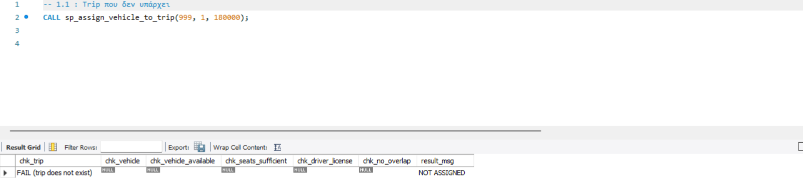
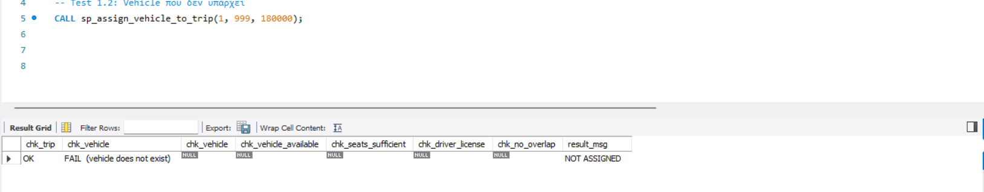
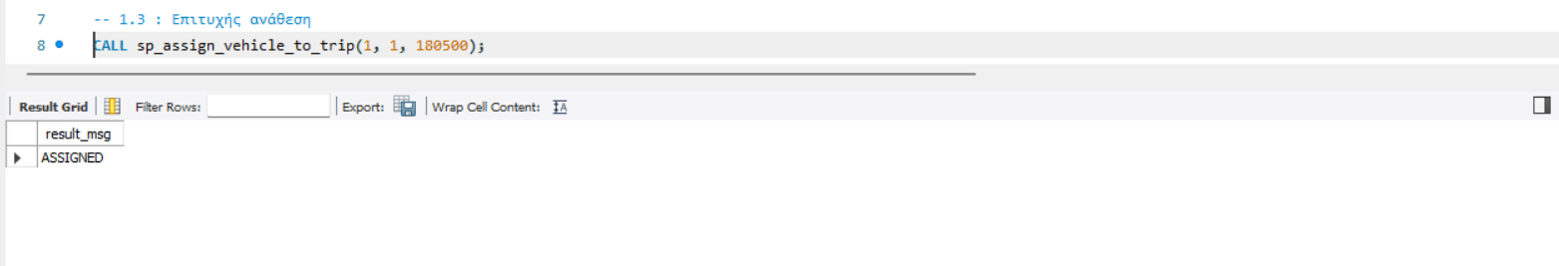
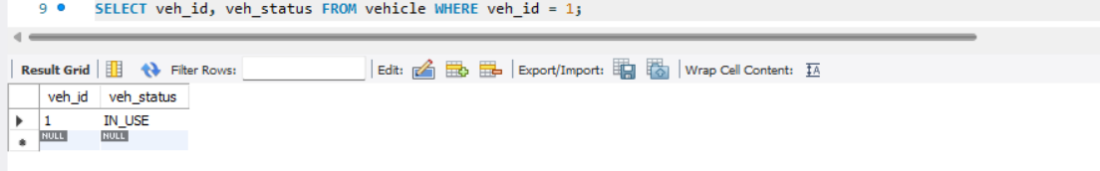
Κώδικας
DELIMITER $
DROP PROCEDURE IF EXISTS sp_assign_vehicle_to_trip $$
CREATE PROCEDURE sp_assign_vehicle_to_trip(
IN p_tr_id INT,
IN p_veh_id INT,
IN p_current_km INT
)
proc: BEGIN
DECLARE v_ok_vehicle_available TINYINT DEFAULT 0;
DECLARE v_ok_seats TINYINT DEFAULT 0;
DECLARE v_ok_license TINYINT DEFAULT 0;
DECLARE v_ok_overlap TINYINT DEFAULT 0;
DECLARE v_ok_km TINYINT DEFAULT 0;
DECLARE v_tr_departure DATETIME;
DECLARE v_tr_return DATETIME;
DECLARE v_tr_drv CHAR(10);
DECLARE v_veh_status VARCHAR(20);
DECLARE v_veh_capacity INT;
DECLARE v_veh_total_km INT;
DECLARE v_res_cnt INT DEFAULT 0;
DECLARE v_overlap_cnt INT DEFAULT 0;
DECLARE v_drv_license CHAR(1);
IF NOT EXISTS (SELECT 1 FROM trip WHERE tr_id = p_tr_id) THEN
SELECT
'FAIL (trip does not exist)' AS chk_trip,
NULL AS chk_vehicle,
NULL AS chk_vehicle_available,
NULL AS chk_seats_sufficient,
NULL AS chk_driver_license,
NULL AS chk_no_overlap,
'NOT ASSIGNED' AS result_msg;
LEAVE proc;
END IF;
IF NOT EXISTS (SELECT 1 FROM vehicle WHERE veh_id = p_veh_id) THEN
SELECT 'OK' AS chk_trip,
'FAIL (vehicle does not exist)' AS chk_vehicle,
NULL AS chk_vehicle,
NULL AS chk_vehicle_available,
NULL AS chk_seats_sufficient,
NULL AS chk_driver_license,
NULL AS chk_no_overlap,
'NOT ASSIGNED' AS result_msg;
LEAVE proc;
END IF;
SELECT tr_departure,tr_return , tr_drv_AT
INTO v_tr_departure,v_tr_return,v_tr_drv
FROM trip
WHERE tr_id = p_tr_id;
SELECT veh_status, veh_capacity
INTO v_veh_status , v_veh_capacity
FROM vehicle
WHERE veh_id = p_veh_id;
IF v_veh_status = 'AVAILABLE' THEN
SET v_ok_vehicle_available = 1;
END IF;
SELECT COUNT(*)
INTO v_res_cnt FROM reservation WHERE res_tr_id = p_tr_id
AND res_status <> 'CANCELLED';
IF v_res_cnt <= v_veh_capacity THEN SET v_ok_seats = 1;
END IF;
SELECT drv_license INTO v_drv_license FROM driver WHERE drv_AT = v_tr_drv;
IF v_veh_capacity > 9 THEN
IF v_drv_license IN ('C','D') THEN SET v_ok_license = 1;
END IF;
ELSE
IF v_drv_license IN ('B','C','D') THEN SET v_ok_license = 1;
END IF;
END IF;
SELECT COUNT(*)
INTO v_overlap_cnt FROM trip t2
WHERE t2.tr_id <> p_tr_id
AND t2.tr_veh_id = p_veh_id
AND t2.tr_departure < v_tr_return
AND t2.tr_return > v_tr_departure;
IF v_overlap_cnt = 0 THEN SET v_ok_overlap = 1;
END IF;
SELECT
'OK' AS chk_trip,
'OK' AS chk_vehicle,
IF(v_ok_vehicle_available = 1,'OK','FAIL') AS chk_vehicle_available,
CONCAT(IF(v_ok_seats = 1, 'OK','FAIL'),'(reservations=',v_res_cnt,'/ capacity=',v_veh_capacity,')')AS chk_seats_sufficient,
CONCAT(IF(v_ok_license=1,'OK','FAIL'),' (driver_license=',IFNULL(v_drv_license,'NULL'),')') AS chk_driver_license,
IF(v_ok_overlap=1,'OK','FAIL') AS chk_no_overlap;
IF v_ok_vehicle_available = 1
AND v_ok_seats = 1
AND v_ok_license = 1
AND v_ok_overlap = 1
THEN
UPDATE trip
SET tr_veh_id = p_veh_id,
tr_veh_km_assign = p_current_km
WHERE tr_id = p_tr_id;
UPDATE vehicle
SET veh_total_km = p_current_km,
veh_status = 'IN_USE'
WHERE veh_id = p_veh_id;
SELECT 'ASSIGNED' AS result_msg;
ELSE
SELECT 'NOT ASSIGNED' AS result_msg;
END IF;
END $
DELIMITER ;
3.1.3.2 Η stored procedure που φτιάξαμε ονομάστηκε procedure_search_accomodations και για την κλήση της χρησιμοποιήθηκαν τα παράκατω παραδείγματα :
-- 2.1 : Αναζήτηση στη Σαντορίνη (dst_id=1)
CALL procedure_search_accomodations(1, '2025-06-01 14:00:00', '2025-06-05 10:00:00', 5, @first_acc);
SELECT @first_acc AS first_accommodation_found;

-- 2.2 : Αναζήτηση με πολλά δωμάτια
CALL procedure_search_accomodations(1, '2025-06-01 14:00:00', '2025-06-05 10:00:00', 50, @first_acc);
-- SELECT @first_acc AS first_accommodation_found;

-- 2.3 : Αναζήτηση σε προορισμό χωρίς καταλύματα
CALL procedure_search_accomodations(14, '2025-08-01 14:00:00', '2025-08-05 10:00:00', 2, @first_acc);
SELECT @first_acc AS first_accommodation_found;
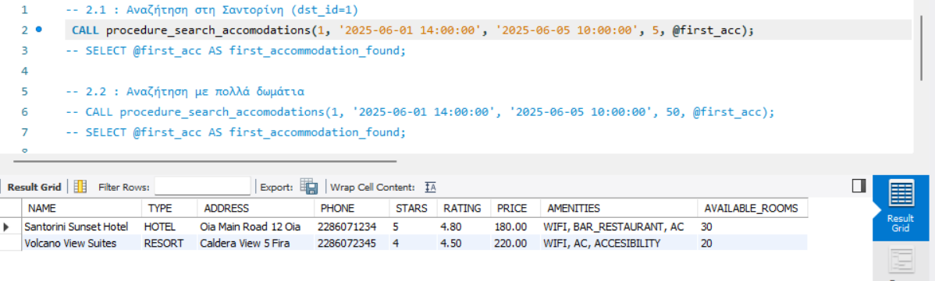

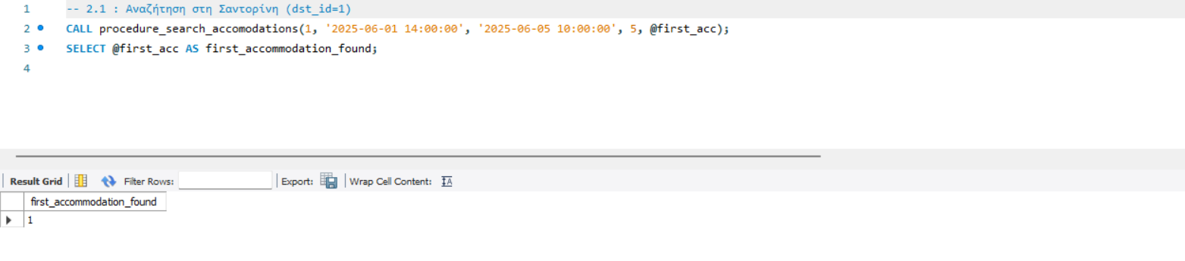
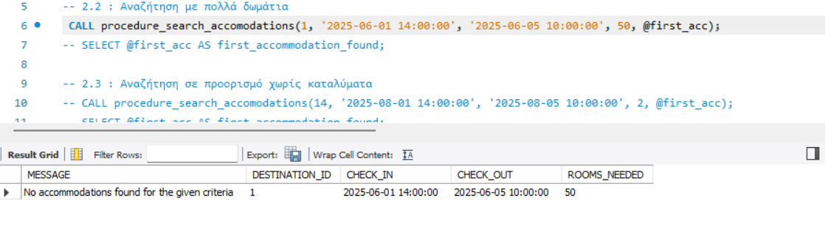
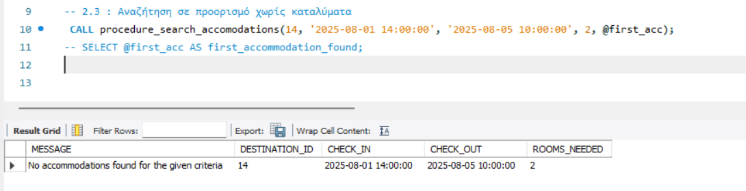
Κώδικας
DROP PROCEDURE IF EXISTS procedure_search_accomodations;
DELIMITER $
CREATE PROCEDURE procedure_search_accomodations(
IN p_DST_ID INT,
IN p_DATE_IN DATETIME,
IN p_DATE_OUT DATETIME,
IN p_ROOMS INT,
OUT p_FIRST_ACC_ID INT
)
BEGIN
DECLARE v_count INT DEFAULT 0;
SET p_FIRST_ACC_ID = NULL;
SELECT a.acc_ID INTO p_FIRST_ACC_ID
FROM accommodation a WHERE a.acc_DEST_ID = p_DST_ID
AND a.acc_STATUS = 'ACTIVE'
AND(a.acc_ROOMS - (
SELECT COALESCE(SUM(ta.ta_ROOMS),0)
FROM tripAccommodation ta WHERE ta.ta_ACC_ID = a.acc_ID
AND(ta.ta_CHECKIN < p_DATE_OUT AND ta.ta_CHECKOUT > p_DATE_IN)
)) >= p_ROOMS
ORDER BY a.acc_ROOM_PRICE ASC, a.acc_STARS DESC, a.acc_RATING DESC
LIMIT 1;
SELECT COUNT(*) INTO v_count
FROM accommodation a
WHERE a.acc_DEST_ID = p_DST_ID
AND a.acc_STATUS = 'ACTIVE'
AND (a.acc_ROOMS - (
SELECT COALESCE(SUM(ta.ta_ROOMS),0)
FROM tripAccommodation ta WHERE ta.ta_ACC_ID = a.acc_ID
AND (ta.ta_CHECKIN < p_DATE_OUT AND ta.ta_CHECKOUT > p_DATE_IN)
)) >= p_ROOMS;
IF v_count = 0 THEN
SELECT 'No accommodations found for the given criteria' AS MESSAGE,
p_DST_ID AS DESTINATION_ID,
p_DATE_IN AS CHECK_IN,
p_DATE_OUT AS CHECK_OUT,
p_ROOMS AS ROOMS_NEEDED;
ELSE
SELECT
a.acc_NAME AS 'NAME',
a.acc_TYPE AS 'TYPE',
CONCAT(a.acc_STREET, ' ', a.acc_NUMBER, ' ',a.acc_CITY) AS 'ADDRESS',
a.acc_PHONE AS 'PHONE',
a.acc_STARS AS 'STARS',
a.acc_RATING AS 'RATING',
a.acc_ROOM_PRICE AS 'PRICE',
GROUP_CONCAT(am.am_NAME SEPARATOR ', ') AS 'AMENITIES',
(a.acc_ROOMS -(
SELECT COALESCE(SUM(ta.ta_ROOMS),0)
FROM tripAccommodation ta WHERE ta.ta_ACC_ID = a.acc_ID
AND (ta.ta_CHECKIN < p_DATE_OUT and ta.ta_CHECKOUT > p_DATE_IN)
)) AS 'AVAILABLE_ROOMS'
FROM accommodation a
LEFT JOIN accommodationAmenities am ON a.acc_ID = am.am_ACC_ID
WHERE a.acc_DEST_ID = p_DST_ID
AND a.acc_STATUS = 'ACTIVE'
GROUP BY a.acc_ID HAVING AVAILABLE_ROOMS >= p_ROOMS
ORDER BY a.acc_ROOM_PRICE ASC, a.acc_STARS DESC, a.acc_RATING DESC;
END IF;
END $
DELIMITER ;
3.1.3.3 Η stored procedure που φτιάξαμε ονομάστηκε procedureBookTripAccomodation και για την κλήση της χρησιμοποιήθηκαν τα παράκατω παραδείγματα :
-- Test 3.1: Κράτηση για ένα trip
CALL procedureBookTripAccommodation(1);
-- Test 3.2: Κράτηση για trip με πολλούς προορισμούς
CALL procedureBookTripAccommodation(5);

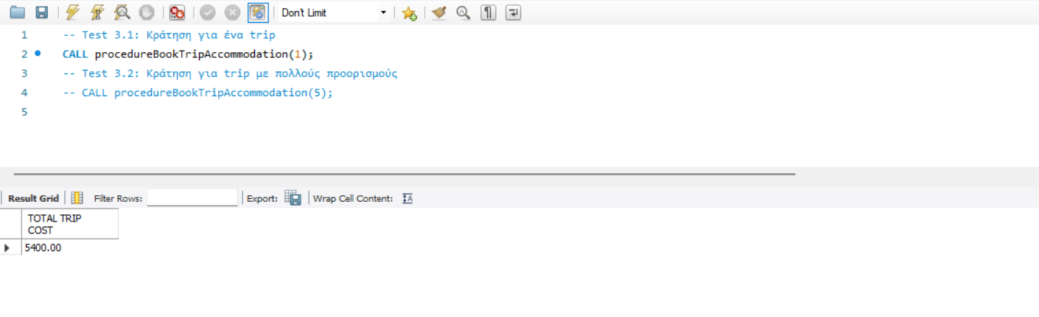
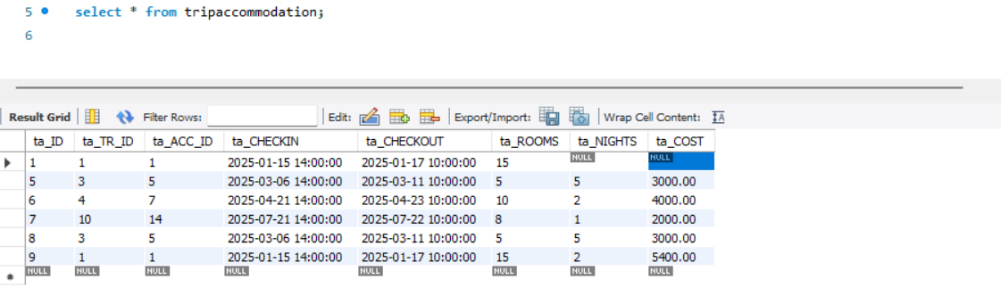
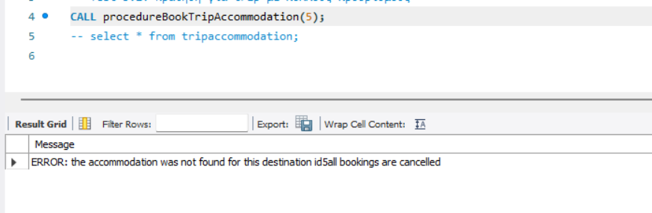

Κώδικας
DELIMITER $
CREATE PROCEDURE procedureBookTripAccommodation(
IN p_TR_ID INT
)
BEGIN
DECLARE v_FINISHED INT DEFAULT 0;
DECLARE v_DEST_ID INT;
DECLARE v_ARRIVAL DATETIME;
DECLARE v_DEPARTURE DATETIME;
DECLARE v_NEEDED_ROOMS INT;
DECLARE v_ACCID_FOUND INT;
DECLARE v_ERROR INT DEFAULT 0;
DECLARE DEST_CURSOR CURSOR FOR
SELECT to_dst_id, to_arrival, to_departure FROM travel_to
WHERE to_tr_id = p_TR_ID
ORDER BY to_sequence;
DECLARE CONTINUE HANDLER FOR NOT FOUND SET v_FINISHED = 1;
SELECT CEIL(tr_maxseats/2) INTO v_NEEDED_ROOMS
FROM trip WHERE tr_id = p_TR_ID;
OPEN DEST_CURSOR;
trip_LOOP: LOOP
FETCH DEST_CURSOR INTO v_DEST_ID,v_ARRIVAL,v_DEPARTURE;
IF v_FINISHED = 1 THEN
LEAVE trip_LOOP;
END IF;
CALL procedure_search_accomodations(v_DEST_ID,v_ARRIVAL,v_DEPARTURE,v_NEEDED_ROOMS,v_ACCID_FOUND);
IF v_ACCID_FOUND IS NULL THEN
SET v_ERROR = 1;
LEAVE trip_LOOP;
ELSE
INSERT INTO tripAccommodation(ta_TR_ID,ta_ACC_ID,ta_CHECKIN,ta_CHECKOUT,ta_ROOMS)
VALUES (p_TR_ID,v_ACCID_FOUND,v_ARRIVAL,v_DEPARTURE,v_NEEDED_ROOMS);
END IF;
END LOOP;
CLOSE DEST_CURSOR;
IF v_ERROR = 1 THEN
DELETE FROM tripAccommodation WHERE ta_TR_ID = p_TR_ID;
SELECT CONCAT('ERROR: the accommodation was not found for this destination id',v_DEST_ID,'all bookings are cancelled') AS Message;
ELSE
SELECT
a.acc_NAME AS 'ACCOMODATION',
ta.ta_CHECKIN AS 'CHECK IN',
ta.ta_CHECKOUT AS 'CHECK OUT',
ta.ta_NIGHTS AS 'NIGHTS',
ta.ta_COST AS 'COST'
FROM tripAccommodation ta
JOIN accommodation a ON ta.ta_ACC_ID = a.acc_ID
WHERE ta.ta_TR_ID = p_TR_ID;
SELECT SUM(ta_COST) AS 'TOTAL TRIP COST'
FROM tripAccommodation
WHERE ta_TR_ID = p_TR_ID;
END IF;
END $
DELIMITER ;
3.1.3.4
Α. Η stored procedure που φτιάξαμε ονόμαστηκε athroisma_esodon και για την κλήση της χρησιμοποιήθηκε το παράκατω παράδειγμα : call athroisma_esodon(‘2015-01-09’,’2015-05-16);
Κώδικας
-- sp 3.1.3.4a
DROP PROCEDURE IF EXISTS athroisma_esodon;
DELIMITER $
CREATE PROCEDURE athroisma_esodon(
IN imerominia_1 DATE,
IN imerominia_2 DATE
)
BEGIN
SELECT SUM(sinolo_esodon) AS sinolo_esodon_
FROM trip_history
WHERE tr_departure BETWEEN imerominia_1 AND imerominia_2;
END $
DELIMITER ;
Β. Η stored procedure που φτιάξαμε ονόμαστηκε plithos_proorismon και για την κλήση της χρησιμοποιήθηκε το παράκατω παράδειγμα : call plithos_proorismon(2);
Κώδικας
DROP PROCEDURE IF EXISTS plithos_proorismon;
DELIMITER $$
CREATE PROCEDURE plithos_proorismon(
IN p_plithos_dest INT
)
BEGIN
SELECT tr_departure, tr_return
FROM trip_history
WHERE plithos_dest = p_plithos_dest;
END $$
DELIMITER ;

Δημιουργήσαμε τα δύo παρακάτω indexes :
Α. -- index a
CREATE INDEX index_departure
ON trip_history (tr_departure);
Β. -- index b
CREATE INDEX index_plithos_dest
ON trip_history (plithos_dest);
Όπως βλέπουμε στα παρακάτω screenshots ο χρόνος κλήσης κάθε stored procedure μειώθηκε μετα την δημιουργία των indexes
Indexes
Τα indexes τα χρησιμοποιήσαμε καθώς βελτιώνουν την αποδόση ερωτημάτων αναζήτησης σε πίνακες με μεγάλο πλήθος εγγραφών (trip_history 90.000 εγγραφές). Επιτρέπουν στην βάση μας να εντοπίζει πιο γρήγορα τις εγγραφές που ικανοποιούν τις συνθήκες where αποφεύγοντας την πλήρη σάρωση του πίνακα.
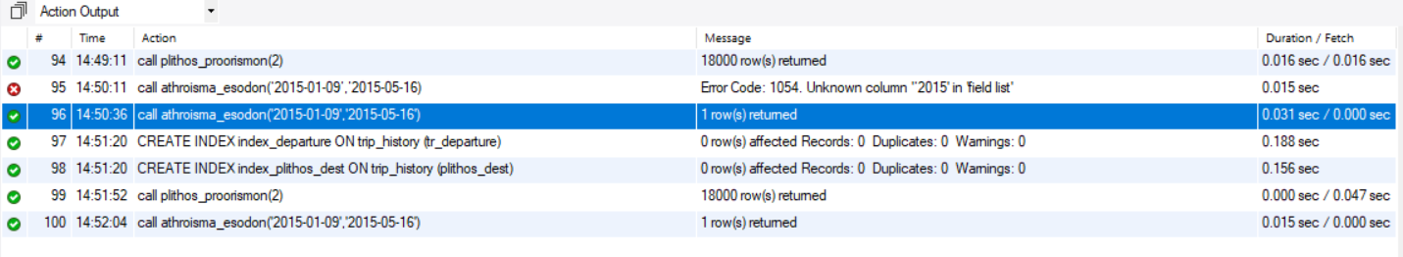
ΚΕΦΑΛΑΙΟ 3
3.1.4.1 Παρακάτω βλέπουμε την ενημέρωση του πίνακα log μετά από κάθε ενέργεια (εισαγωγή,ενημέρωση, διαγρφαφή) που εκτέλεσε ο dba.
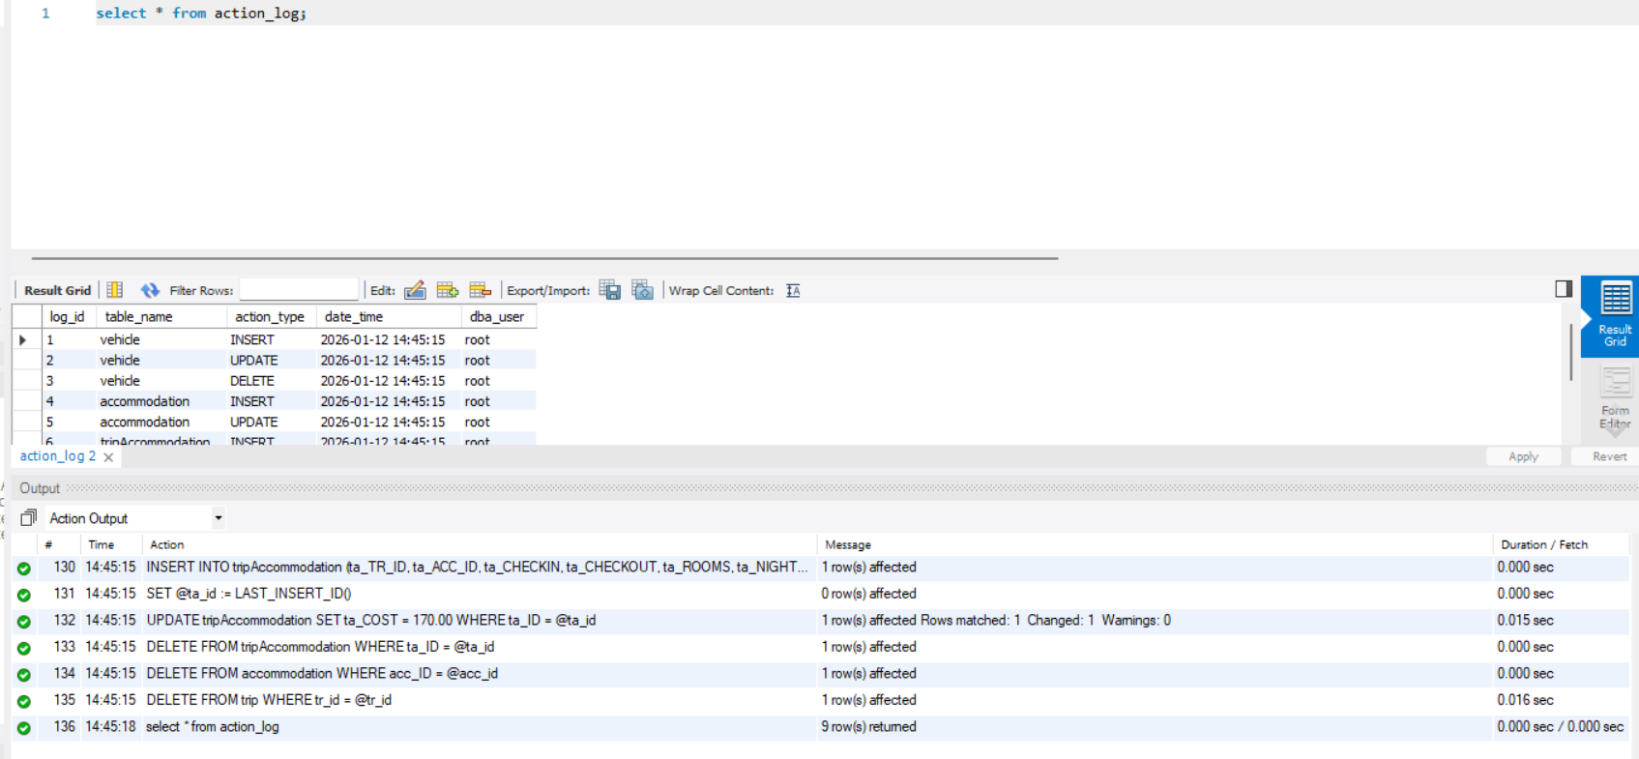
Παρακάτω είναι οι κώδικες για τα Triggers insert,update,delete για τους πίνακες reservation,trip,customer ,destination,vehicle,accommodation,tripAccomodation :
-- TRIP

DROP TRIGGER IF EXISTS trip_insert;
DELIMITER $
CREATE TRIGGER trip_insert
AFTER INSERT ON trip
FOR EACH ROW
BEGIN
INSERT INTO action_log (table_name, action_type, date_time, dba_user)
VALUES ('trip', 'INSERT', NOW(), SUBSTRING_INDEX(CURRENT_USER(),'@',1));
END$
DELIMITER ;

DROP TRIGGER IF EXISTS trip_update;
DELIMITER $
CREATE TRIGGER trip_update
AFTER UPDATE ON trip
FOR EACH ROW
BEGIN
INSERT INTO action_log (table_name, action_type, date_time, dba_user)
VALUES ('trip', 'UPDATE', NOW(), SUBSTRING_INDEX(CURRENT_USER(),'@',1));
END$
DELIMITER ;

DROP TRIGGER IF EXISTS trip_delete;
DELIMITER $
CREATE TRIGGER trip_delete
AFTER DELETE ON trip
FOR EACH ROW
BEGIN
INSERT INTO action_log (table_name, action_type, date_time, dba_user)
VALUES ('trip', 'DELETE', NOW(), SUBSTRING_INDEX(CURRENT_USER(),'@',1));
END$
DELIMITER ;

-- RESERVATION

DROP TRIGGER IF EXISTS reservation_insert;
DELIMITER $
CREATE TRIGGER reservation_insert
AFTER INSERT ON reservation
FOR EACH ROW
BEGIN
INSERT INTO action_log (table_name, action_type, date_time, dba_user)
VALUES ('reservation', 'INSERT', NOW(), SUBSTRING_INDEX(CURRENT_USER(),'@',1));
END$
DELIMITER ;

DROP TRIGGER IF EXISTS reservation_update;
DELIMITER $$
CREATE TRIGGER reservation_update
AFTER UPDATE ON reservation
FOR EACH ROW
BEGIN
INSERT INTO action_log (table_name, action_type, date_time, dba_user)
VALUES ('reservation', 'UPDATE', NOW(), SUBSTRING_INDEX(CURRENT_USER(),'@',1));
END$
DELIMITER ;

DROP TRIGGER IF EXISTS reservation_delete;
DELIMITER $$
CREATE TRIGGER reservation_delete
AFTER DELETE ON reservation
FOR EACH ROW
BEGIN
INSERT INTO action_log (table_name, action_type, date_time, dba_user)
VALUES ('reservation', 'DELETE', NOW(), SUBSTRING_INDEX(CURRENT_USER(),'@',1));
END$
DELIMITER ;

-- CUSTOMER

DROP TRIGGER IF EXISTS customer_insert;
DELIMITER $
CREATE TRIGGER customer_insert
AFTER INSERT ON customer
FOR EACH ROW
BEGIN
INSERT INTO action_log (table_name, action_type, date_time, dba_user)
VALUES ('customer', 'INSERT', NOW(), SUBSTRING_INDEX(CURRENT_USER(),'@',1));
END$
DELIMITER ;

DROP TRIGGER IF EXISTS customer_update;
DELIMITER $
CREATE TRIGGER customer_update
AFTER UPDATE ON customer
FOR EACH ROW
BEGIN
INSERT INTO action_log (table_name, action_type, date_time, dba_user)
VALUES ('customer', 'UPDATE', NOW(), SUBSTRING_INDEX(CURRENT_USER(),'@',1));
END$
DELIMITER ;

DROP TRIGGER IF EXISTS customer_delete;
DELIMITER $
CREATE TRIGGER customer_delete
AFTER DELETE ON customer
FOR EACH ROW
BEGIN
INSERT INTO action_log (table_name, action_type, date_time, dba_user)
VALUES ('customer', 'DELETE', NOW(), SUBSTRING_INDEX(CURRENT_USER(),'@',1));
END$
DELIMITER ;

-- DESTINATION

DROP TRIGGER IF EXISTS destination_insert;
DELIMITER $
CREATE TRIGGER destination_insert
AFTER INSERT ON destination
FOR EACH ROW
BEGIN
INSERT INTO action_log (table_name, action_type, date_time, dba_user)
VALUES ('destination', 'INSERT', NOW(), SUBSTRING_INDEX(CURRENT_USER(),'@',1));
END$
DELIMITER ;

DROP TRIGGER IF EXISTS destination_update;
DELIMITER $
CREATE TRIGGER destination_update
AFTER UPDATE ON destination
FOR EACH ROW
BEGIN
INSERT INTO action_log (table_name, action_type, date_time, dba_user)
VALUES ('destination', 'UPDATE', NOW(), SUBSTRING_INDEX(CURRENT_USER(),'@',1));
END$
DELIMITER ;

DROP TRIGGER IF EXISTS destination_delete;
DELIMITER $
CREATE TRIGGER destination_delete
AFTER DELETE ON destination
FOR EACH ROW
BEGIN
INSERT INTO action_log (table_name, action_type, date_time, dba_user)
VALUES ('destination', 'DELETE', NOW(), SUBSTRING_INDEX(CURRENT_USER(),'@',1));
END$
DELIMITER ;

-- VEHICLE

DROP TRIGGER IF EXISTS vehicle_insert;
DELIMITER $$
CREATE TRIGGER vehicle_insert
AFTER INSERT ON vehicle
FOR EACH ROW
BEGIN
INSERT INTO action_log (table_name, action_type, date_time, dba_user)
VALUES ('vehicle', 'INSERT', NOW(), SUBSTRING_INDEX(CURRENT_USER(),'@',1));
END$$
DELIMITER ;

DROP TRIGGER IF EXISTS vehicle_update;
DELIMITER $$
CREATE TRIGGER vehicle_update
AFTER UPDATE ON vehicle
FOR EACH ROW
BEGIN
INSERT INTO action_log (table_name, action_type, date_time, dba_user)
VALUES ('vehicle', 'UPDATE', NOW(), SUBSTRING_INDEX(CURRENT_USER(),'@',1));
END$$
DELIMITER ;

DROP TRIGGER IF EXISTS vehicle_delete;
DELIMITER $$
CREATE TRIGGER vehicle_delete
AFTER DELETE ON vehicle
FOR EACH ROW
BEGIN
INSERT INTO action_log (table_name, action_type, date_time, dba_user)
VALUES ('vehicle', 'DELETE', NOW(), SUBSTRING_INDEX(CURRENT_USER(),'@',1));
END$$
DELIMITER ;

-- ACCOMMODATION

DROP TRIGGER IF EXISTS accommodation_insert;
DELIMITER $$
CREATE TRIGGER accommodation_insert
AFTER INSERT ON accommodation
FOR EACH ROW
BEGIN
INSERT INTO action_log (table_name, action_type, date_time, dba_user)
VALUES ('accommodation', 'INSERT', NOW(), SUBSTRING_INDEX(CURRENT_USER(),'@',1));
END$$
DELIMITER ;

DROP TRIGGER IF EXISTS accommodation_update;
DELIMITER $$
CREATE TRIGGER accommodation_update
AFTER UPDATE ON accommodation
FOR EACH ROW
BEGIN
INSERT INTO action_log (table_name, action_type, date_time, dba_user)
VALUES ('accommodation', 'UPDATE', NOW(), SUBSTRING_INDEX(CURRENT_USER(),'@',1));
END$$
DELIMITER ;

DROP TRIGGER IF EXISTS accommodation_delete;
DELIMITER $$
CREATE TRIGGER accommodation_delete
AFTER DELETE ON accommodation
FOR EACH ROW
BEGIN
INSERT INTO action_log (table_name, action_type, date_time, dba_user)
VALUES ('accommodation', 'DELETE', NOW(), SUBSTRING_INDEX(CURRENT_USER(),'@',1));
END$$
DELIMITER ;

-- TRIP ACCOMMODATION (tripAccommodation)

DROP TRIGGER IF EXISTS tripAccommodation_insert;
DELIMITER $$
CREATE TRIGGER tripAccommodation_insert
AFTER INSERT ON tripAccommodation
FOR EACH ROW
BEGIN
INSERT INTO action_log (table_name, action_type, date_time, dba_user)
VALUES ('tripAccommodation', 'INSERT', NOW(), SUBSTRING_INDEX(CURRENT_USER(),'@',1));
END$$
DELIMITER ;

DROP TRIGGER IF EXISTS tripAccommodation_update;
DELIMITER $$
CREATE TRIGGER tripAccommodation_update
AFTER UPDATE ON tripAccommodation
FOR EACH ROW
BEGIN
INSERT INTO action_log (table_name, action_type, date_time, dba_user)
VALUES ('tripAccommodation', 'UPDATE', NOW(), SUBSTRING_INDEX(CURRENT_USER(),'@',1));
END$$
DELIMITER ;

DROP TRIGGER IF EXISTS tripAccommodation_delete;
DELIMITER $$
CREATE TRIGGER tripAccommodation_delete
AFTER DELETE ON tripAccommodation
FOR EACH ROW
BEGIN
INSERT INTO action_log (table_name, action_type, date_time, dba_user)
VALUES ('tripAccommodation', 'DELETE', NOW(), SUBSTRING_INDEX(CURRENT_USER(),'@',1));
END$$
DELIMITER ;

3.1.4.2
DELIMITER $
CREATE TRIGGER trg_CALCULATE_TRIP_ACC_COST
BEFORE INSERT ON tripAccommodation
FOR EACH ROW
BEGIN
DECLARE v_PRICE_PER_ROOM DECIMAL (10,2);
DECLARE v_NIGHTS INT;
SET v_NIGHTS = DATEDIFF(NEW.ta_CHECKOUT,NEW.ta_CHECKIN);
SELECT acc_ROOM_PRICE INTO v_PRICE_PER_ROOM
FROM accommodation WHERE acc_ID = NEW.ta_ACC_ID;
SET NEW.ta_NIGHTS = v_NIGHTS;
SET NEW.ta_COST = v_NIGHTS * NEW.ta_ROOMS * v_PRICE_PER_ROOM;
END $
DELIMITER ;
Στα παρακάτω screenshots βλέπουμε τις νέες τιμές που καταχωρήθηκαν στον πίνακα tripaccommodation μετά τα update που εκτελέσαμε οι οποίες προκλήθηκαν από την λειτουργία του trigger.
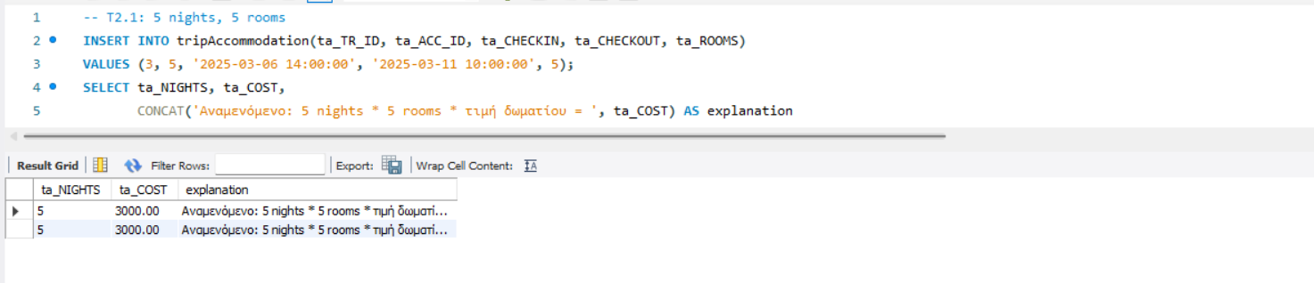
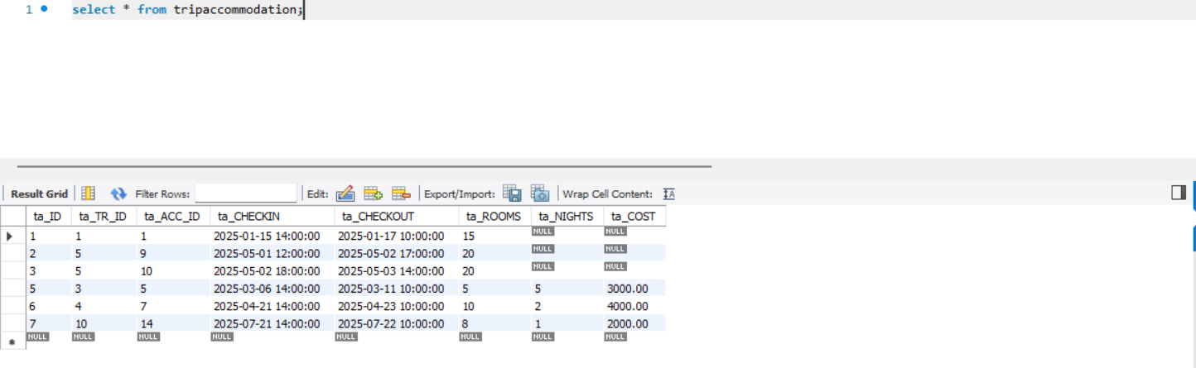
Nea screenshots
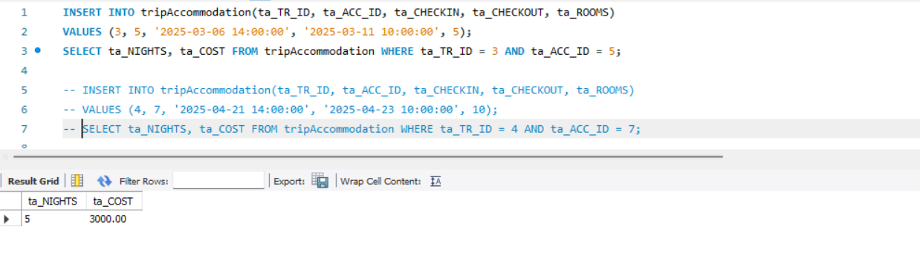
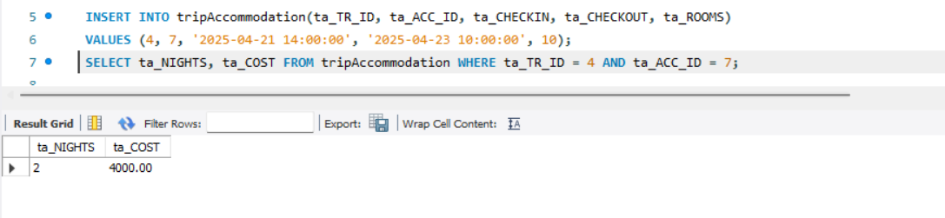
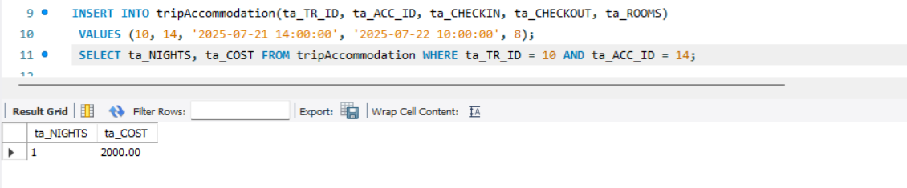
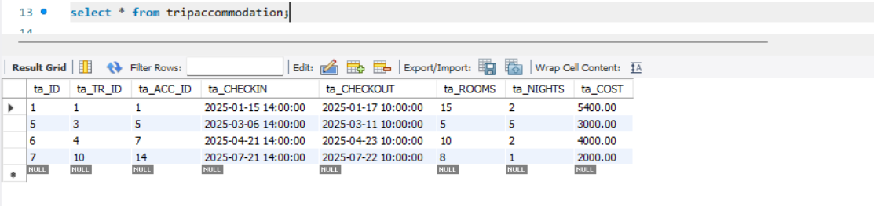
3.1.4.3
DELIMITER $
DROP TRIGGER IF EXISTS trg_trip_assign_vehicle $
CREATE TRIGGER trg_trip_assign_vehicle
BEFORE UPDATE ON trip
FOR EACH ROW
BEGIN
IF NEW.tr_veh_id IS NOT NULL
AND (OLD.tr_veh_id IS NULL OR OLD.tr_veh_id <> NEW.tr_veh_id) THEN
IF OLD.tr_veh_id IS NOT NULL AND OLD.tr_veh_id <> NEW.tr_veh_id THEN
UPDATE vehicle
SET veh_status = 'AVAILABLE'
WHERE veh_id = OLD.tr_veh_id;
END IF;
IF (SELECT veh_status FROM vehicle WHERE veh_id = NEW.tr_veh_id) <> 'AVAILABLE' THEN
SIGNAL SQLSTATE '45000'
SET MESSAGE_TEXT = 'Vehicle is not AVAILABLE for assignment.';
END IF;
UPDATE vehicle
SET veh_status = 'IN_USE'
WHERE veh_id = NEW.tr_veh_id;
END IF;
IF OLD.tr_veh_id IS NOT NULL AND NEW.tr_veh_id IS NULL THEN
UPDATE vehicle
SET veh_status = 'AVAILABLE'
WHERE veh_id = OLD.tr_veh_id;
END IF;
END $
DELIMITER ;
DELIMITER $
DROP TRIGGER IF EXISTS trg_trip_return_vehicle $
CREATE TRIGGER trg_trip_return_vehicle
AFTER UPDATE ON trip
FOR EACH ROW
BEGIN
IF NEW.tr_veh_id IS NOT NULL
AND NEW.tr_status = 'COMPLETED'
AND NEW.tr_veh_km_return IS NOT NULL
AND (OLD.tr_status <> 'COMPLETED' OR OLD.tr_veh_km_return IS NULL) THEN
IF NEW.tr_veh_km_assign IS NOT NULL AND NEW.tr_veh_km_return < NEW.tr_veh_km_assign THEN
SIGNAL SQLSTATE '45000'
SET MESSAGE_TEXT = 'Return km is less than assigned km. Update rejected.';
END IF;
IF NEW.tr_veh_km_return < (SELECT veh_total_km FROM vehicle WHERE veh_id = NEW.tr_veh_id) THEN
SIGNAL SQLSTATE '45000'
SET MESSAGE_TEXT = 'Return km is less than vehicle total km. Update rejected.';
END IF;
UPDATE vehicle
SET veh_total_km = NEW.tr_veh_km_return,veh_status = 'AVAILABLE'
WHERE veh_id = NEW.tr_veh_id;
END IF;
IF NEW.tr_veh_id IS NOT NULL
AND OLD.tr_status <> NEW.tr_status
AND NEW.tr_status = 'CANCELLED' THEN
UPDATE vehicle
SET veh_status = 'AVAILABLE'
WHERE veh_id = NEW.tr_veh_id;
END IF;
END $
DELIMITER ;
Στα παρακάτω screenshots βλέπουμε τις αλλαγές στους πίνακες trip και vehicle μετά τα update που εκτελέσαμε οι οποίες προκλήθηκαν από την λειτουργία του trigger.
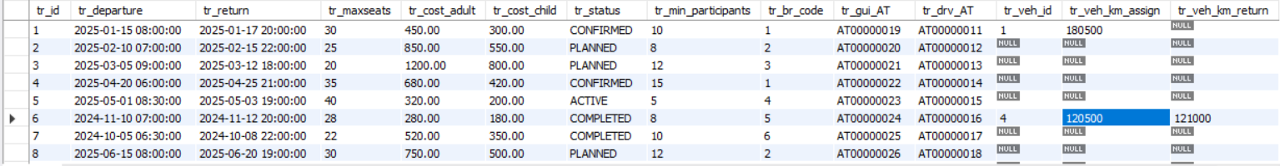
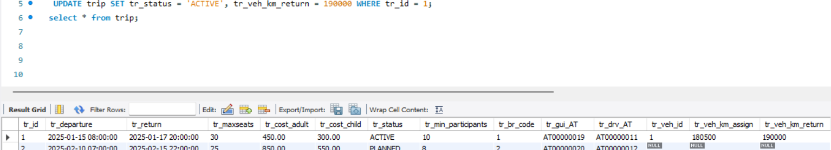

ΚΕΦΑΛΑΙΟ 4
GUI
Για υην διαχείρηση των δεδομένων της βάσης υλοποιήθηκε ενιαίο γραφικό περιβάλλον, το οποίο λειτουργεί ως γενικός διαχειριστής πινάκων.
Ο χρήστης μπορεί να επιλέξει τον επιθυμητό πίνακα από αναπτυσσόμενη λίστα και να φορτώσει τις αντίστοιχες εγγραφές. Τα δεδομένα εμφανίζονται σε μορφή πίνακα, διευκολύνοντας την επισκόπηση και την επιλογή συγκεκριμένων εγγραφών προς επεξεργασία.
Για κάθε πίνακα παρέχεται φόρμα επεξεργασίας εγγραφών( Row Editor) , η οποία περλαμβάνει ολα ταγνωρίσματα του αντίστοχου πίνακα. Τα πεδία απλής μορφής (ημερομηνίες,αριθμητικές τιμλες, κόστη) εισάγονται μέσω πεδίων κειμένου, ενώ τα γνωρίσματα τύπου ENUM και τα ξένα κλειδιά (foreign keys) υλοποιούνται μέσω αναπτυσσόμενων λιστών, με τιμές που αντλούνται δυναμικά από τους αντίστοιχους πίνακες της βάσης.
Μέσω των διαθέσιμων λειτουργίων Insert , Update και Delete είναι δυνατή η εισαγωγή νέων εγγραφών, η τροποποίηση υπαρχουσών και η διαγραφή τους. Κατά την εκτέλεση των ενεργειών αυτών εφαρμόζονται όλοι οι περιορισμοί ακεραιότητας της βάσης ( primary keys, foreign keys, CHECK constraints, ENUM), καθώς και τα triggers που έχουν οριστεί, διασφαλίζοντας την ορθότητα και τη συνέπεια των δεδομένων.
Update :
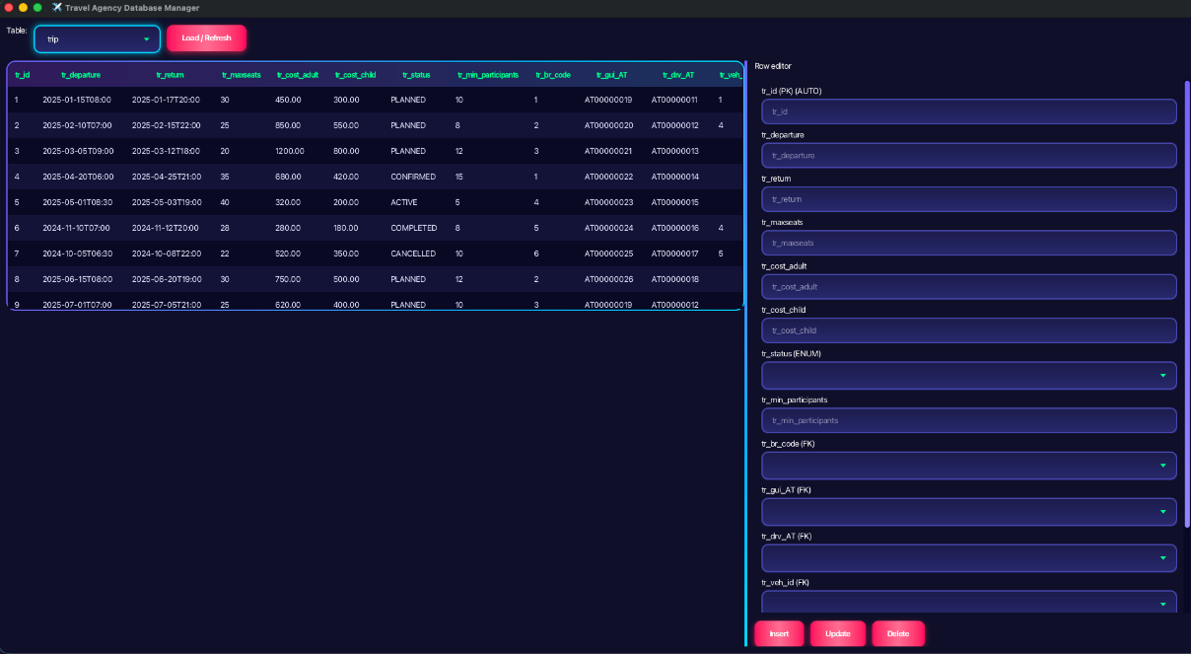
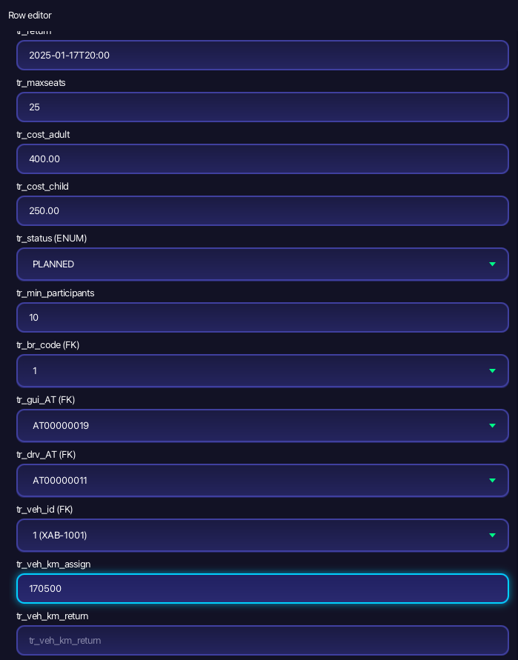
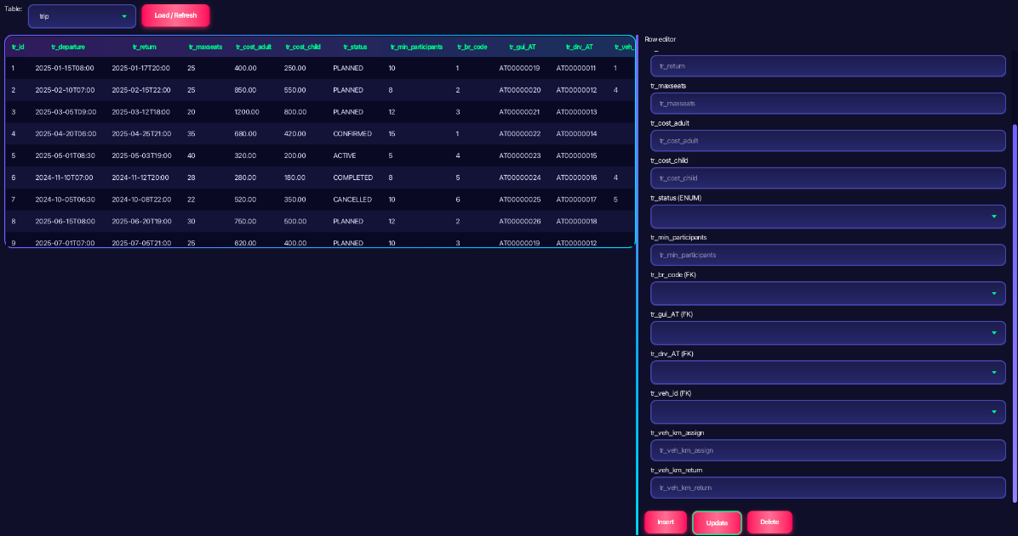
Insert :
