**Water survey results**

In the last four sampling rounds (July and October 2012 and March and May 2013) there were five *Cryptosporidium*-positive samples amongst the 80 samples taken. These were from the Waikato River (Hamilton and Tuakau). Numbers of oocysts ranged from 1-4/100 L. The Waikato River (Hamilton) site was *Giardia*-positive on three of the four sampling occasions while Waikato River (Tuakau) was *Giardia*-positive on all four occasions. All ground water sites were negative for *E. coli* except for Seadown Well which had 15 organisms/100 mL on a single occasion. Eleven of the surface water sites had 10 or fewer *E. coli*/100mL on at least single occasion: Big Huia Creek, Hutt River, Turitea Dam and Orongorongo River sites on all four occasions; Ashley River, Lower Huia Dam and Waitakere Dam on three occasions. Surface sites that had more than *E. coli*/100mL on all four occasions include Oroua River, Tautau Stream, Waikato River (Hamilton), Waikato River (Tuakau) and Waiorohi Stream. In total 34/80 samples had more than *E. coli*/100mL.

Fifteen samples were positive for *Campylobacter*;Waiorohi Stream was positive on all four occasions, Waikato River (Tuakau) on three occasions, Waikato River (Hamilton) and Oroua River on two occasions while Lake Karapiro, Waingawa River, Wainuiomata River and Waitakere Dam on single occasion.

**Table 2. Summary of positive and negative results from all 15 rounds of water sampling. Sites that were positive for a pathogen on 50% to 100% of sampling occasions are highlighted in red.**

|  |  |  |  |  |  |  |  |  |  |  |  |  |  |  |  |  |  |  |  |  |  |  |  |  |  |  |  |  |  |  |  |
| --- | --- | --- | --- | --- | --- | --- | --- | --- | --- | --- | --- | --- | --- | --- | --- | --- | --- | --- | --- | --- | --- | --- | --- | --- | --- | --- | --- | --- | --- | --- | --- |
|  | | ***Cryptosporidium*** | | | | | | | | ***Giardia*** | | | | | |  | | ***E. coli*** | | | | | |  | | ***Campylobacter*** | | | | | |
| **Site** | | **Neg** | | **Pos** | | **%Pos** | |  | | **Neg** | | **Pos** | | **%Pos** | |  | | **Neg** | | **Pos** | | **%Pos** | |  | | **Neg** | | **Pos** | | **%Pos** | |
| Ashley River | 14 | | 1 | | 6.7 | |  | | 15 | | 0 | | 0.0 | |  | | 11 | | 4 | | 26.7 | |  | | 15 | | 0 | | 0.0 | |
| Big Huia Creek | 15 | | 0 | | 0.0 | |  | | 15 | | 0 | | 0.0 | |  | | 13 | | 2 | | 13.3 | |  | | 15 | | 0 | | 0.0 | |
| Hicks Road Spring | 15 | | 0 | | 0.0 | |  | | 15 | | 0 | | 0.0 | |  | | 15 | | 0 | | 0.0 | |  | | 14 | | 1 | | 6.7 | |
| Hutt River | 15 | | 0 | | 0.0 | |  | | 15 | | 0 | | 0.0 | |  | | 14 | | 1 | | 6.7 | |  | | 14 | | 1 | | 6.7 | |
| Lake Karapiro | 15 | | 0 | | 0.0 | |  | | 15 | | 0 | | 0.0 | |  | | 8 | | 7 | | 46.7 | |  | | 13 | | 2 | | 13.3 | |
| Lower Huia Dam | 13 | | 2 | | 13.3 | |  | | 15 | | 0 | | 0.0 | |  | | 11 | | 4 | | 26.7 | |  | | 12 | | 3 | | 20.0 | |
| NW Christchurch Aquifer 1 | 15 | | 0 | | 0.0 | |  | | 15 | | 0 | | 0.0 | |  | | 15 | | 0 | | 0.0 | |  | | 15 | | 0 | | 0.0 | |
| Orongorongo River | 15 | | 0 | | 0.0 | |  | | 15 | | 0 | | 0.0 | |  | | 10 | | 5 | | 33.3 | |  | | 14 | | 1 | | 6.7 | |
| Oroua River | 12 | | 3 | | 20.0 | |  | | 12 | | 3 | | 20.0 | |  | | 0 | | 15 | | 100.0 | |  | | 7 | | 8 | | 53.3 | |
| Pareora River | 15 | | 0 | | 0.0 | |  | | 15 | | 0 | | 0.0 | |  | | 4 | | 11 | | 73.3 | |  | | 10 | | 5 | | 33.3 | |
| Seadown Well | 15 | | 0 | | 0.0 | |  | | 15 | | 0 | | 0.0 | |  | | 14 | | 1 | | 6.7 | |  | | 15 | | 0 | | 0.0 | |
| Tautau Stream | 15 | | 0 | | 0.0 | |  | | 14 | | 1 | | 6.7 | |  | | 1 | | 14 | | 93.3 | |  | | 14 | | 1 | | 6.7 | |
| Turitea Dam | 15 | | 0 | | 0.0 | |  | | 15 | | 0 | | 0.0 | |  | | 9 | | 6 | | 40.0 | |  | | 14 | | 1 | | 6.7 | |
| Waikato River - Hamilton | 8 | | 7 | | 46.7 | |  | | 4 | | 11 | | 73.3 | |  | | 0 | | 15 | | 100.0 | |  | | 6 | | 9 | | 60.0 | |
| Waikato River - Tuakau | 6 | | 9 | | 60.0 | |  | | 2 | | 13 | | 86.7 | |  | | 0 | | 15 | | 100.0 | |  | | 6 | | 9 | | 60.0 | |
| Waingawa River | 15 | | 0 | | 0.0 | |  | | 15 | | 0 | | 0.0 | |  | | 3 | | 12 | | 80.0 | |  | | 14 | | 1 | | 6.7 | |
| Wainuiomata River | 15 | | 0 | | 0.0 | |  | | 15 | | 0 | | 0.0 | |  | | 6 | | 9 | | 60.0 | |  | | 13 | | 2 | | 13.3 | |
| Waiorohi Stream | 11 | | 4 | | 26.7 | |  | | 12 | | 3 | | 20.0 | |  | | 0 | | 15 | | 100.0 | |  | | 2 | | 13 | | 86.7 | |
| Waitakere Dam | 15 | | 0 | | 0.0 | |  | | 14 | | 1 | | 6.7 | |  | | 12 | | 3 | | 20.0 | |  | | 13 | | 2 | | 13.3 | |
| Whakarewarewa Forest Spring | 15 | | 0 | | 0.0 | |  | | 15 | | 0 | | 0.0 | |  | | 15 | | 0 | | 0.0 | |  | | 15 | | 0 | | 0.0 | |
| **Total** | **274** | | **26** | | **8.7** | |  | | **268** | | **32** | | **10.7** | |  | | **161** | | **139** | | **46.3** | |  | | **241** | | **59** | | **19.7** | |

The following analyses include all water samples taken as part of the 20-site survey, from September 2009 to May 2013. Table 2 summarises the number of samples positive and negative for each pathogen and abstraction site. The Table also includes the percentage of samples for each pathogen and abstraction site. The most consistently contaminated sites remain the two Waikato River locations. Figure 2 illustrates the percentage of positive samples taken by month, with April and May being the most likely time to find samples contaminated with *Campylobacter,* September the most likely for *Cryptosporidium* with May and July the most likely for *Giardia*. Twenty-six of the 300 samples have been *Cryptosporidium*-positive, all from surface water sites. The two Waikato River sites have been positive on about half of the sampling occasions (Table 2, Figure 3). *Cryptosporidium* counts have been between one and 12 oocysts/100 L (Figure 4), with log credit removal requirements highlighted. There was a higher frequency of contamination of *Giardia* at the Waikato River sites, with at least 11 samples being positive at each site, and cyst counts ranging from 1-18/100 L (Figure 5). *Giardia* – positive samples were found at six sites on 40 occasions.

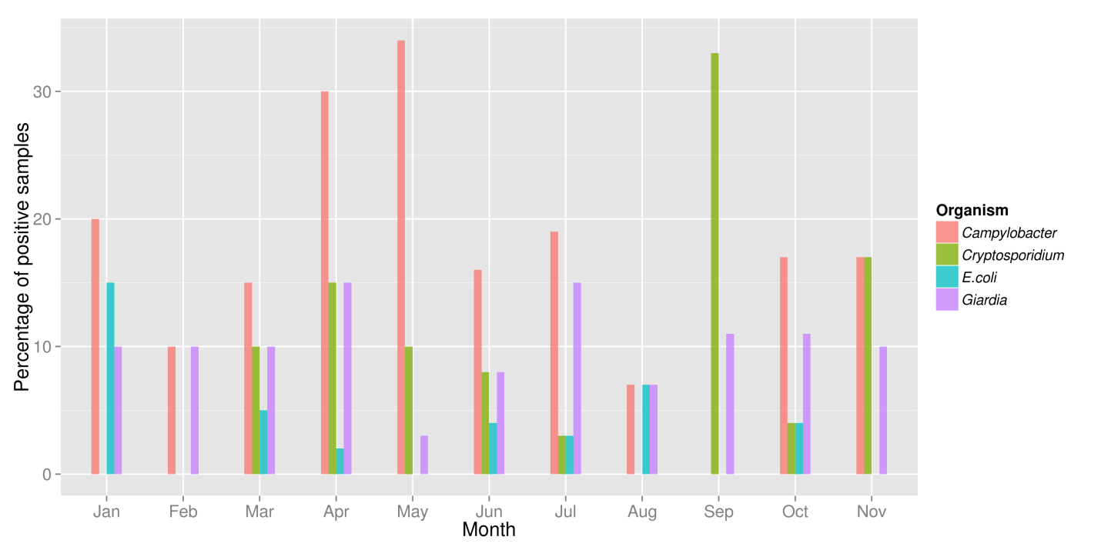

**Figure 2. Percent of samples taken in each month that were positive for each pathogen. For example, 20% of samples taken in January were positive for *Campylobacter*.**

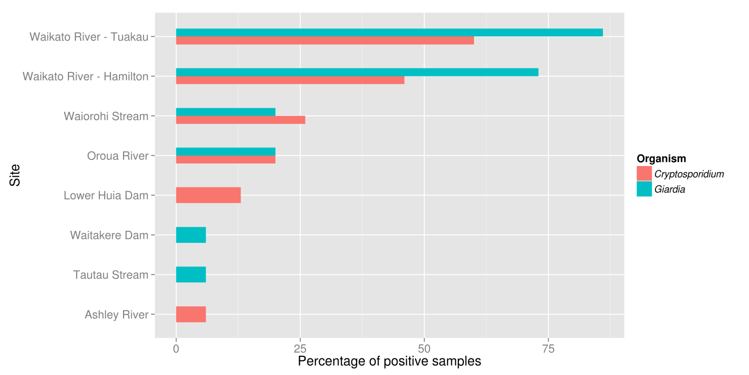

**Figure 3. Percent of positive samples from sites where *Cryptosporidium* or *Giardia* were found**

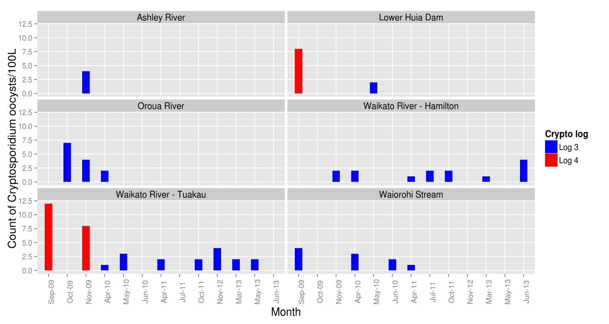

**Figure 4. Locations and dates of *Cryptosporidium*-positive samples taken from 2009 – 2013. Sites requiring 4 log credit removal are highlighted in red, with those requiring 3 log credit removal in blue.**

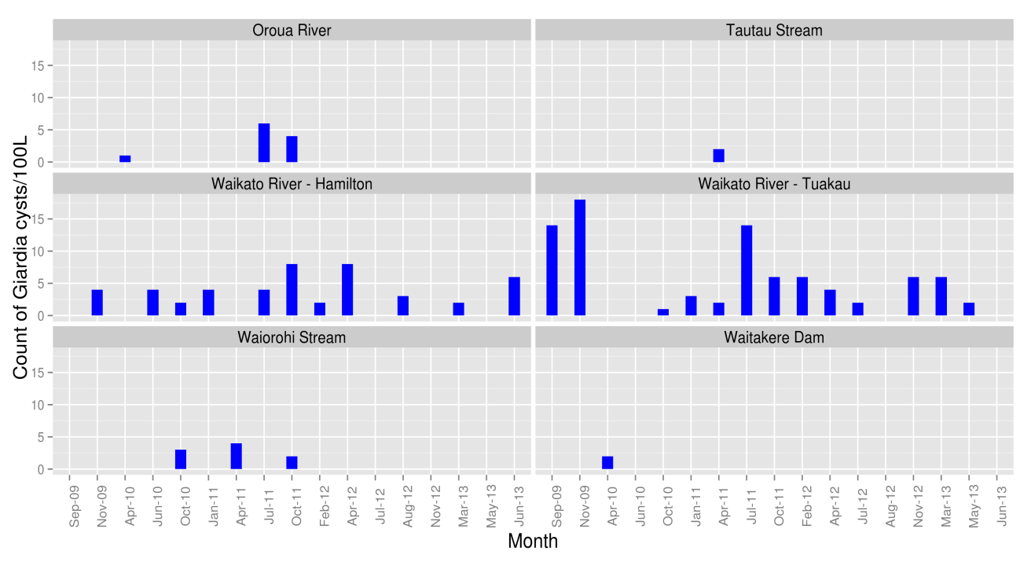

**Figure 5. Locations and dates of *Giardia-*positive samples taken from 2009 – 2013**

**3.3 Output C2.3.2: assay samples from the ongoing groundwater survey for *E. coli* and *Campylobacter***

Sub-samples from each survey site were analysed for *E. coli* presence/absence, and were cultured for *Campylobacter* in the Hopkirk Institute using techniques currently employed for testing recreational water.

**Methods**

***E. coli* enumeration**

100mL grab samples were sent to accredited regional laboratories and processed using standard procedures.

***Campylobacter* detection**

100mL samples were filtered through a 0.45μm cellulose nitrate filter which was then placed into Bolton’s broth and incubated for 48 hours at 42°C in microaerophilic conditions. A sample was then placed onto mCCDA (Fort Richard) plates, to select for *Campylobacter*, and grown under the same conditions. From this, a single colony was selected and grown on blood agar (Fort Richard) for another 48 hours. This culture was speciated using PCR to detect *C. jejuni*, and positive samples were then genetically typed using multi-locus sequencing typing (MLST) (Dingle et al. 2001).

**Results**

The Waorohi Stream has had *E. coli* counts of at least 100 organisms/100 mL on 11/15 sampling occasions. Nine surface water sites, including Ashley River, Lower Huia Dam, Oroua River, Pareora River, Tautau Stream, Waikato River, Wairorohi Stream and Waitakere Dam, have had *E. coli* counts of at least 300 organisms/100 mL on at least one occasion (Figure 6). Of the groundwater sites, the Seadown Well and Whakarewarewa Forest Spring have the highest maximum value of at least 8 *E. coli*/100 mL. Figure 6 shows sampling sites that have 300 or more *E. coli*/100 mL.

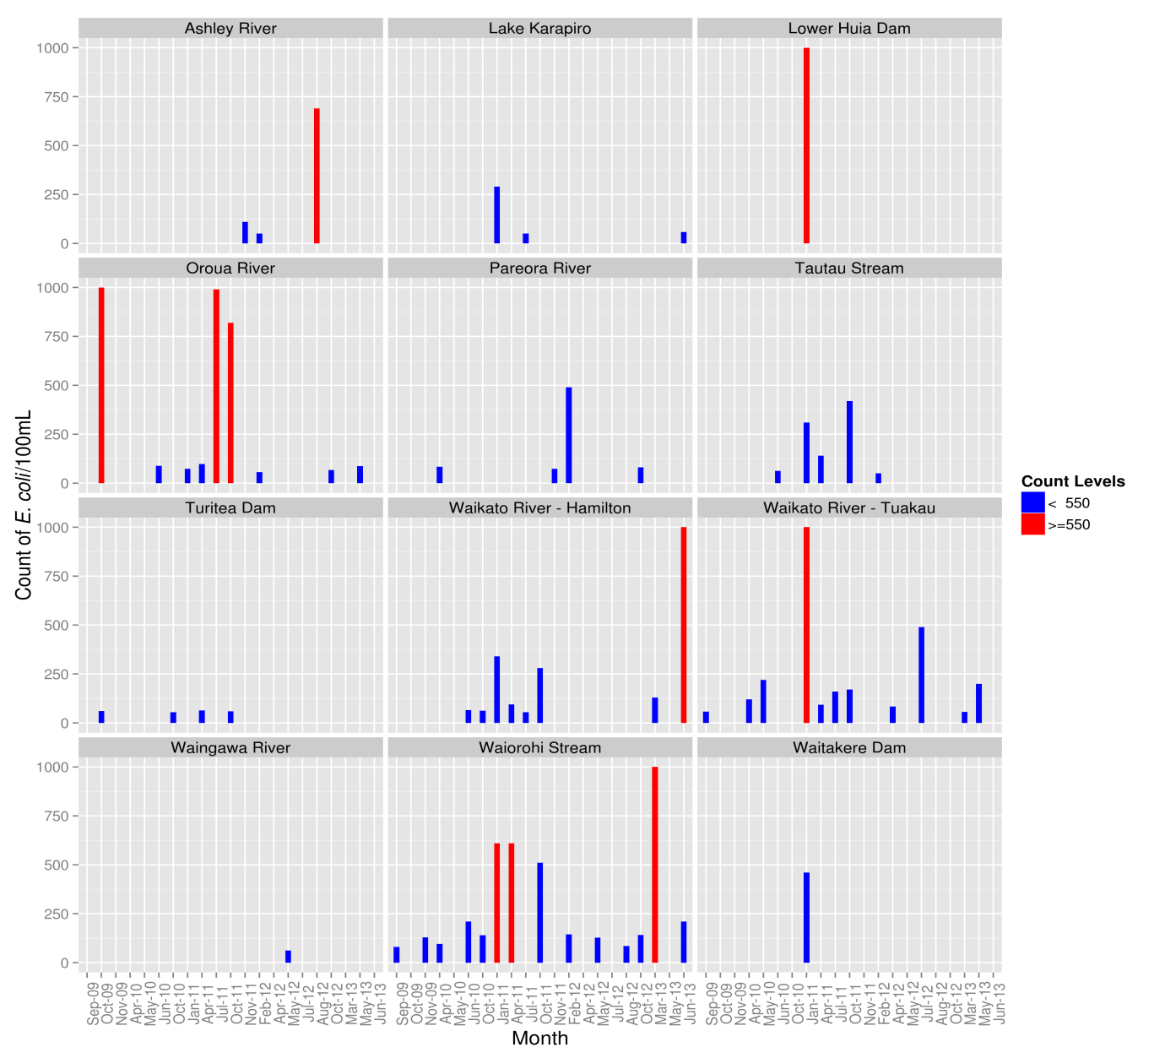

**Figure 6. Locations and dates for each location where water was contaminated by ≥50 E. coli/100 mL from 2009 – 2013. Sites having counts of *E*. *coli*/100mL more of 550 or more highlighted in red, with those with fewer in blue. The maximum count was limited to 1,000 i.e. counts more than 1,000 were equaled to 1,000.**

Of the 300 samples, 59 (19.7%) were positive for *Campylobacter*. Of the ground water sites only Hicks Road Spring had at least one *Campylobacter*-positive sample. The Waiorohi Stream has had *Campylobacter*-positive results on 13/15 (86.7%) occasions and each of the Waikato River sites 9/15 (60.0%).

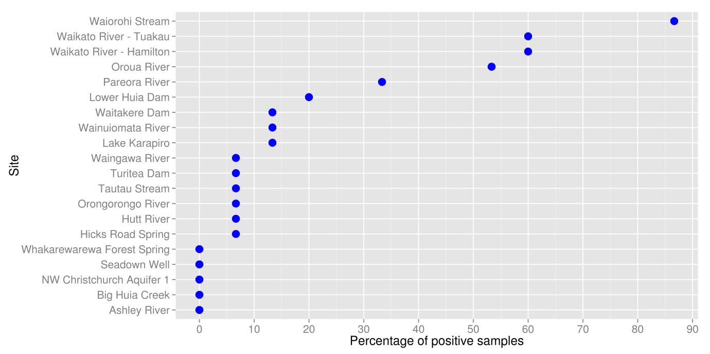

**Figure 7. Percent of *Campylobacter-*positive samples taken at each site from 2009 – 2013. For example, 60% samples taken at each of the Waikato River sites were positive for *Campylobacter.***

**Variable Importance for assay samples from the ongoing water survey**

Random forests is a statistical technique that constructs a large number of decision trees from a given dataset. The ensemble of decision trees is then used to produce various types of output, including ranking the importance of explanatory variables. Random forests was to predict which catchment was likely to have a given pathogen in their raw water on the basis of 10 explanatory variables (Table 2).

Figure 8 shows important variables for the prediction of the presence of each of the four organisms monitored in water samples collected between 2009 and 2013 The measure of importance has been ranked e.g. the four most important variables for predicting the presence of *Cryptosporidium* oocysts in water include the presence of *Giardia* cysts in water include the presence of beef cattle dairy cattle and sheep in the catchment Conversely presence of *Campylobacter* and *E coli* in water are irrelevant for the prediction of the presence of *Cryptosporidium*

**Table 2. Description of the variables used in the Random Forests analysis.**

|  |  |
| --- | --- |
| **Variable** | **Description** |
| **Animal Populations** | |
| Beef | Number of beef cattle in the catchment |
| Dairy | Number of dairy cattle in the catchment |
| Sheep | Number of sheep in the catchment |
|  |  |
| **Land Use** | |
| Catchment_area | Size of the catchment in km2 |
| Crop_prop | Proportion of catchment used for crop production |
| Farm_prop | Proportion of catchment used for farming |
| Forest_prop | Proportion of catchment covered by forest |
| Highprod_prop | Proportion of catchment classified as high production land |
| Lowprod_prop | Proportion of catchment classified as low production land |
| Other_prop | Proportion of unclassified land within the catchment |
| Settlement_prop | Proportion of catchment used for settlement |
| Wetland_prop | Proportion of catchment covered by wetlands |
|  |  |
| **Microorganisms** | |
| Campy | Presence of *Campylobacter* in 100mL of water |
| Crypto | Counts of *Cryptosporidium* oocysts in 100L of water |
| Ecoli | Counts of *E. coli* in 100mL of water |
| Giardia | Counts of *Giardia* cysts in 100L of water |

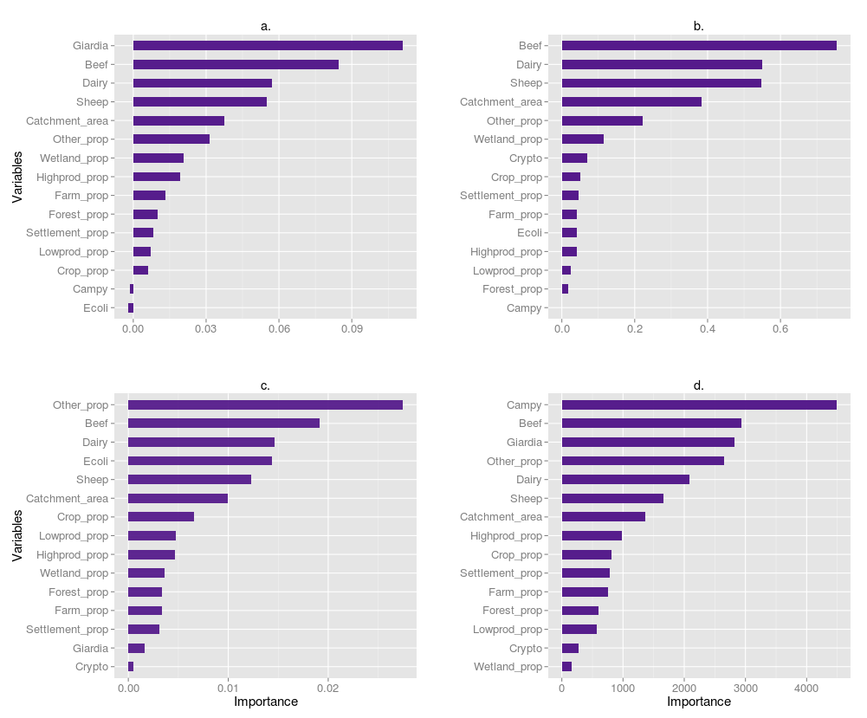

**Figure 8. Variable importance for the prediction of the presence of a. *Cryptosporidium*, b. *Giardia*, c. *Campylobacter* and d. *E*. *coli* in samples taken from 2009 – 2013. For example, plot b. shows that presence of beef and dairy cattle in the catchment were two most important variables for predicting a *Giardia***-**positive sample*.***