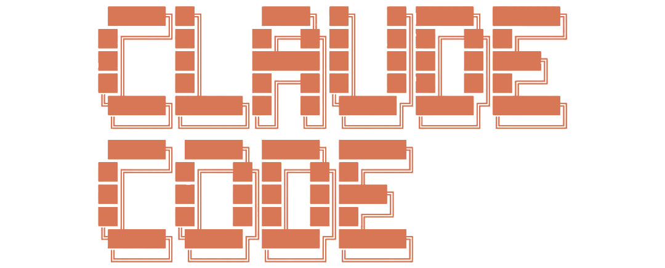
Custom Status Line Setup Guide
This guide explains how to set up a custom color-coded status line for Claude Code that displays:
- Working Directory (Cyan)
- Model Name (Yellow)
- Context Window Usage with visual meter + percentage (Green/Orange/Red)
- Current Git Repository and Branch (Magenta)

Windows Setup
Windows uses PowerShell (built-in, no additional dependencies required).

Step 1: Create the PowerShell Script
Create a file named statusline.ps1 in your .claude folder:
C:\Users\<YourUsername>\.claude\statusline.ps1

PowerShell Script (statusline.ps1):
# Claude Code Status Line - Windows PowerShell
# Color-coded KPIs with visual context meter
$esc = [char]27
# Color definitions (ANSI)
$cyan = "$esc[96m" # Working directory
$yellow = "$esc[93m" # Model
$magenta = "$esc[95m" # Git repo/branch
$green = "$esc[92m" # Context low
$orange = "$esc[38;5;208m" # Context medium
$red = "$esc[91m" # Context high
$dim = "$esc[90m" # Separators/labels
$reset = "$esc[0m"
# Read JSON input
$input_json = [Console]::In.ReadToEnd() | ConvertFrom-Json
# Working Directory
$full_dir = $input_json.workspace.current_dir
$dir = Split-Path -Leaf $full_dir
# Model
$model = $input_json.model.display_name
# Context Window with visual meter
$context_display = ''
$usage = $input_json.context_window.current_usage
if ($usage) {
$current = $usage.input_tokens + $usage.cache_creation_input_tokens + $usage.cache_read_input_tokens
$size = $input_json.context_window.context_window_size
if ($size -gt 0) {
$pct = [int](($current * 100) / $size)
# Choose color based on usage level
if ($pct -lt 50) {
$ctx_color = $green
} elseif ($pct -lt 80) {
$ctx_color = $orange
} else {
$ctx_color = $red
}
# Build visual meter [======== ] style
$meter_width = 10
$filled = [int](($pct * $meter_width) / 100)
if ($filled -gt $meter_width) { $filled = $meter_width }
$empty = $meter_width - $filled
$meter_bar = ('=' * $filled) + (' ' * $empty)
$context_display = "${dim}CTX ${ctx_color}[${meter_bar}] ${pct}%${reset}"
}
}
# Git Repo/Branch
$git_display = ''
try {
$branch = git -C $full_dir --no-optional-locks branch --show-current 2>$null
if ($branch) {
$repo_name = git -C $full_dir --no-optional-locks remote get-url origin 2>$null
if ($repo_name) {
$repo_name = [System.IO.Path]::GetFileNameWithoutExtension($repo_name.Split('/')[-1])
$git_display = "${magenta}${repo_name}:${branch}${reset}"
} else {
$git_display = "${magenta}${branch}${reset}"
}
}
} catch {}
# Build output with separators
$sep = "${dim} | ${reset}"
$parts = @()
$parts += "${cyan}${dir}${reset}"
$parts += "${yellow}${model}${reset}"
if ($context_display) { $parts += $context_display }
if ($git_display) { $parts += $git_display }
$output = $parts -join $sep
Write-Host $output -NoNewline

Step 2: Configure settings.json
Edit or create the file:
C:\Users\<YourUsername>\.claude\settings.json
Add the following configuration (replace <YourUsername> with your actual username):
{
"statusLine": {
"type": "command",
"command": "powershell -NoProfile -ExecutionPolicy Bypass -File C:\\Users\\<YourUsername>\\.claude\\statusline.ps1"
}
}

Mac / Linux Setup

Step 1: Install jq
jq is a command-line JSON processor required for parsing the status data.
Mac (using Homebrew):
brew install jq
Ubuntu/Debian:
sudo apt install jq
Fedora/RHEL:
sudo dnf install jq

Step 2: Create the Bash Script
Create a file named statusline.sh in your .claude folder:
~/.claude/statusline.sh

Bash Script (statusline.sh):
#!/bin/bash
# Claude Code Status Line - Mac/Linux
# Color-coded KPIs with visual context meter
# Color definitions (ANSI)
CYAN="\033[96m"
YELLOW="\033[93m"
MAGENTA="\033[95m"
GREEN="\033[92m"
ORANGE="\033[38;5;208m"
RED="\033[91m"
DIM="\033[90m"
RESET="\033[0m"
# Read JSON from stdin
INPUT=$(cat)
# Parse JSON with jq
DIR=$(echo "$INPUT" | jq -r '.workspace.current_dir' | xargs basename)
MODEL=$(echo "$INPUT" | jq -r '.model.display_name')
CURRENT_TOKENS=$(echo "$INPUT" | jq -r '
.context_window.current_usage |
if . then (.input_tokens + .cache_creation_input_tokens + .cache_read_input_tokens) else 0 end
')
CONTEXT_SIZE=$(echo "$INPUT" | jq -r '.context_window.context_window_size // 0')
FULL_DIR=$(echo "$INPUT" | jq -r '.workspace.current_dir')
# Build context meter
CTX_DISPLAY=""
if [ "$CONTEXT_SIZE" -gt 0 ] 2>/dev/null; then
PCT=$((CURRENT_TOKENS * 100 / CONTEXT_SIZE))
# Choose color based on usage
if [ "$PCT" -lt 50 ]; then
CTX_COLOR="$GREEN"
elif [ "$PCT" -lt 80 ]; then
CTX_COLOR="$ORANGE"
else
CTX_COLOR="$RED"
fi
# Build visual meter
FILLED=$((PCT / 10))
[ "$FILLED" -gt 10 ] && FILLED=10
EMPTY=$((10 - FILLED))
METER=$(printf '=%.0s' $(seq 1 $FILLED 2>/dev/null) | tr -d '\n')
SPACES=$(printf ' %.0s' $(seq 1 $EMPTY 2>/dev/null) | tr -d '\n')
CTX_DISPLAY="${DIM}CTX ${CTX_COLOR}[${METER}${SPACES}] ${PCT}%${RESET}"
fi
# Git repo/branch
GIT_DISPLAY=""
if [ -d "$FULL_DIR" ]; then
BRANCH=$(git -C "$FULL_DIR" --no-optional-locks branch --show-current 2>/dev/null)
if [ -n "$BRANCH" ]; then
REPO=$(git -C "$FULL_DIR" --no-optional-locks remote get-url origin 2>/dev/null | xargs basename 2>/dev/null | sed 's/.git$//')
if [ -n "$REPO" ]; then
GIT_DISPLAY="${MAGENTA}${REPO}:${BRANCH}${RESET}"
else
GIT_DISPLAY="${MAGENTA}${BRANCH}${RESET}"
fi
fi
fi
# Build output
SEP="${DIM} | ${RESET}"
OUTPUT="${CYAN}${DIR}${RESET}${SEP}${YELLOW}${MODEL}${RESET}"
[ -n "$CTX_DISPLAY" ] && OUTPUT="${OUTPUT}${SEP}${CTX_DISPLAY}"
[ -n "$GIT_DISPLAY" ] && OUTPUT="${OUTPUT}${SEP}${GIT_DISPLAY}"
printf "%b" "$OUTPUT"

Step 3: Make the Script Executable
chmod +x ~/.claude/statusline.sh

Step 4: Configure settings.json
Edit or create the file:
~/.claude/settings.json
{
"statusLine": {
"type": "command",
"command": "bash ~/.claude/statusline.sh"
}
}

Color Reference
KPI | Color | Description
Working Directory | Cyan | Current folder name
Model | Yellow | Claude model being used
Context Meter | Green/Orange/Red | Green <50%, Orange 50-80%, Red >80%
Git Repo:Branch | Magenta | Repository name and current branch

Example Output
REPO | Claude Opus 4.5 | CTX [====== ] 62% | my-project:main

Troubleshooting
1. If colors do not display, ensure your terminal supports ANSI colors
2. On Windows, use Windows Terminal (not legacy cmd.exe) for best results
3. On Mac/Linux, verify jq is installed by running: jq --version
4. Restart Claude Code after making changes to settings.json
5. Ensure the script path in settings.json matches your actual file location

