Wavendon Properties Specification http://hostliquid.com/bugs/view.php?id=12.

Login to system http://dev11.softreactor.com/index.php/admin/admin/login by login Admin@Wavendon.com p1a@3@wo7rd

- Peoples List (http://dev11.softreactor.com/index.php/admin/user/index/page/1):
1.1) Filter by name, type fields. Sorting by main fields. User(landlord) with related properties can not be deleted.
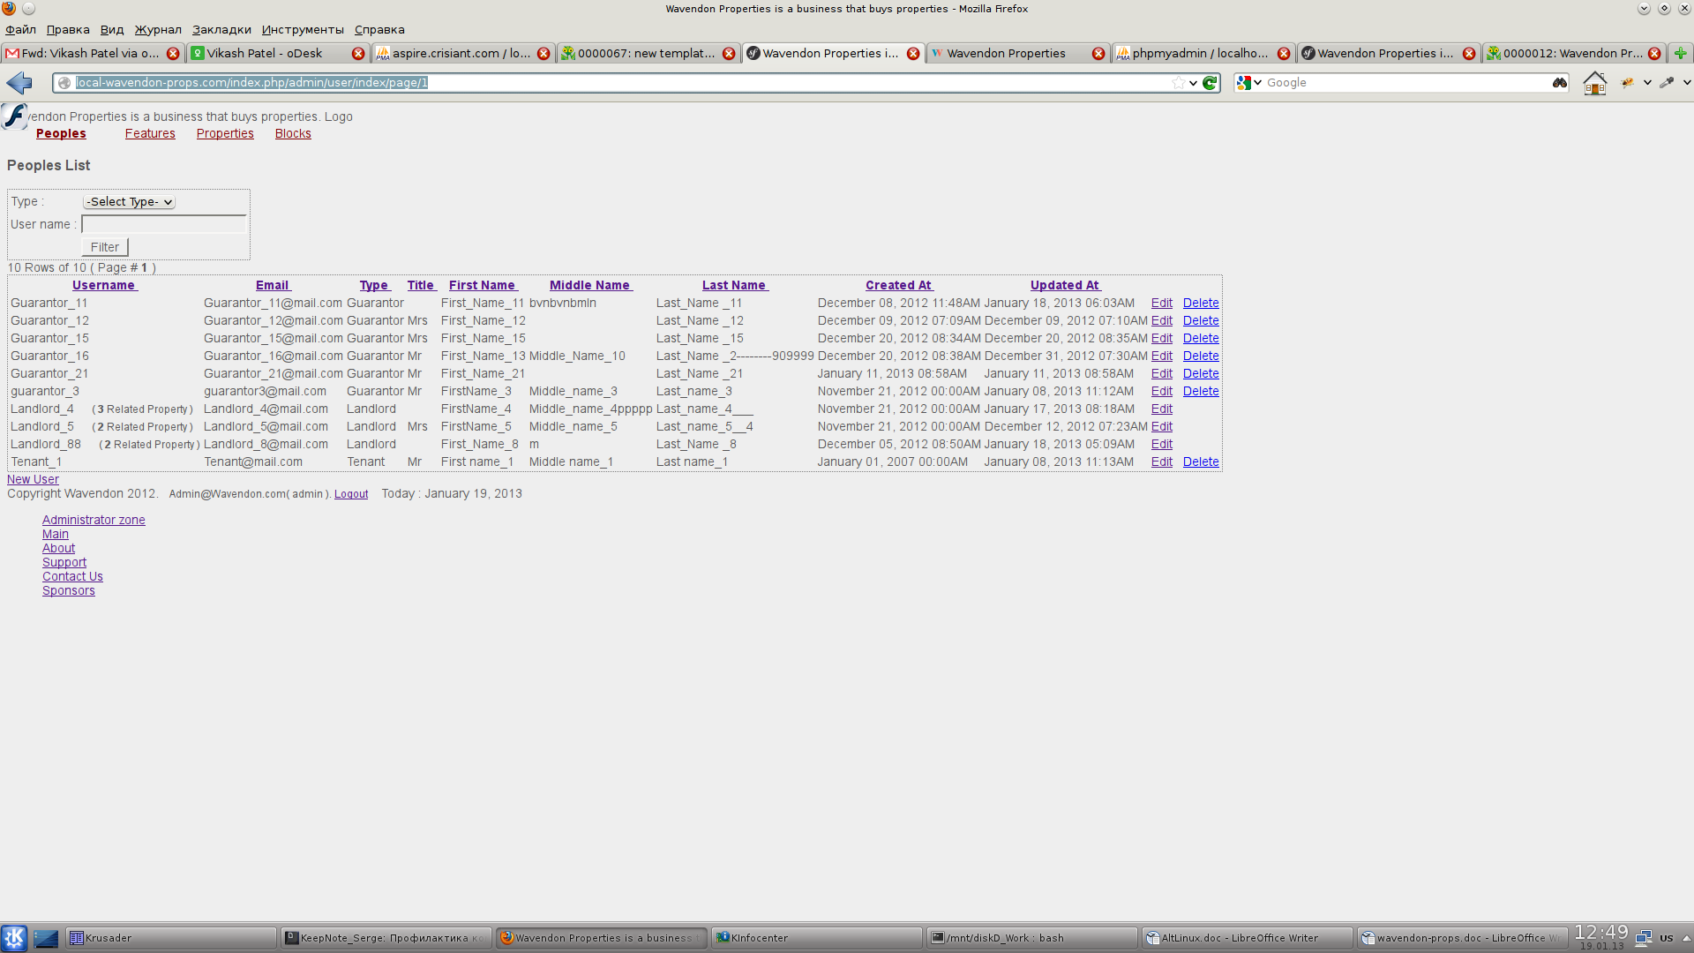
  - Users can be edited, deleted, added. Deleting user all related data(tenants, guarantors, User notes, Images with directory) are deleted too.
  - In editor of user :
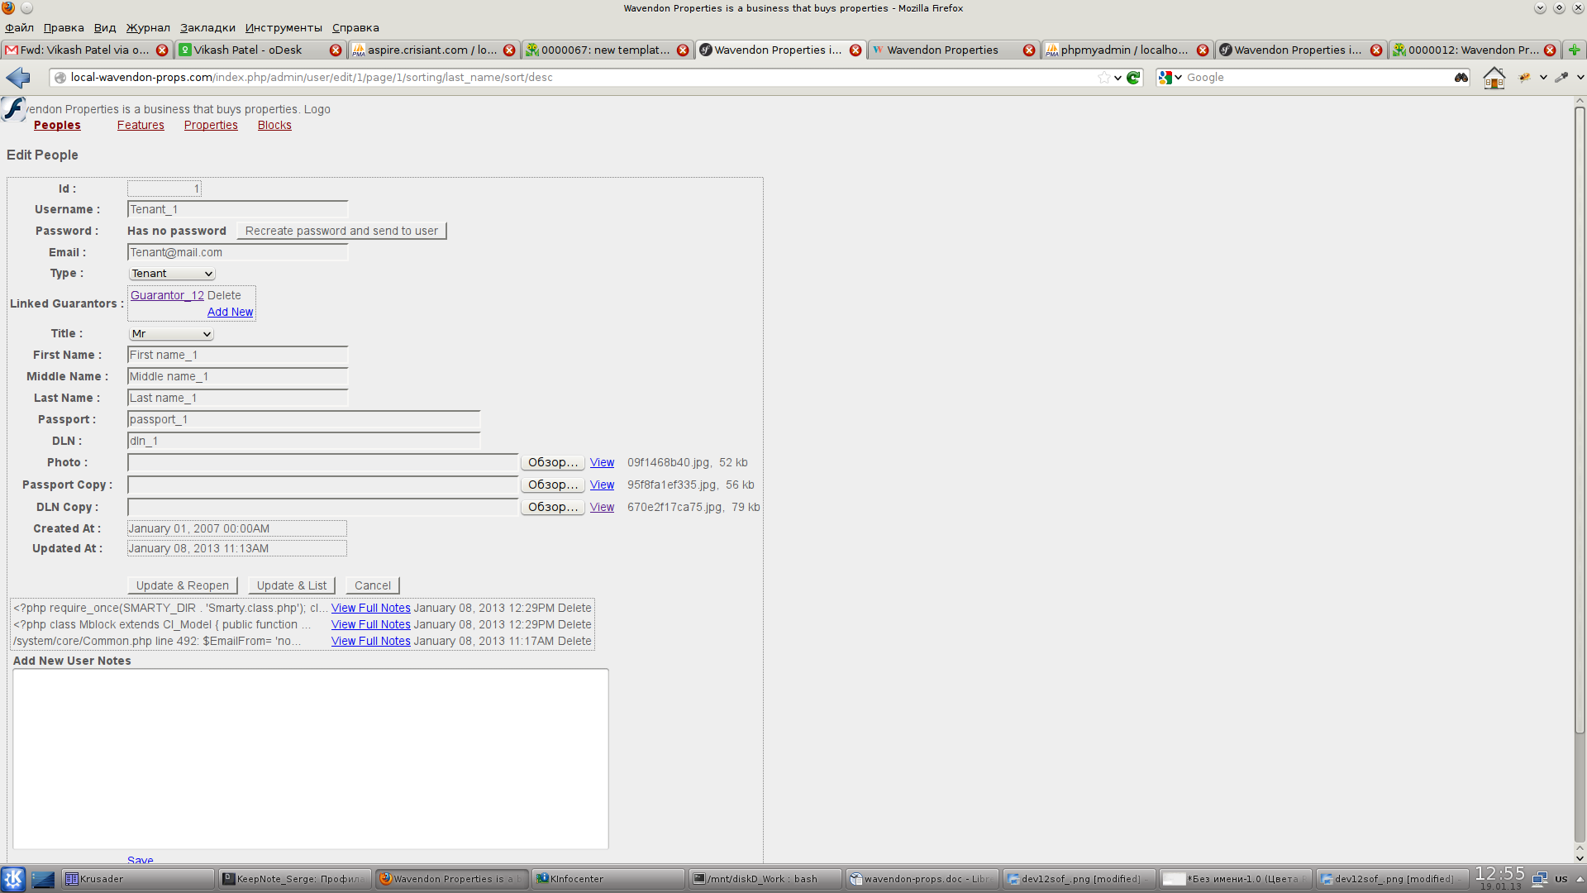
  - Fields username, email,passport, dln are unique
  - Depending on Type of user (Tenant/Guarantor) related list of Linked Guarantors/Tenants can be added/deleted.
  - In fields Photo,Passport Copy, DLN Copy images can be loaded and updated. There are preview links for these images and names/sizes of them are shown.
  - Admin can Add/delete/preview User Notes with datetime stamp at below of page.

    - Features list (http://dev11.softreactor.com/index.php/admin/feature/index/page/1)
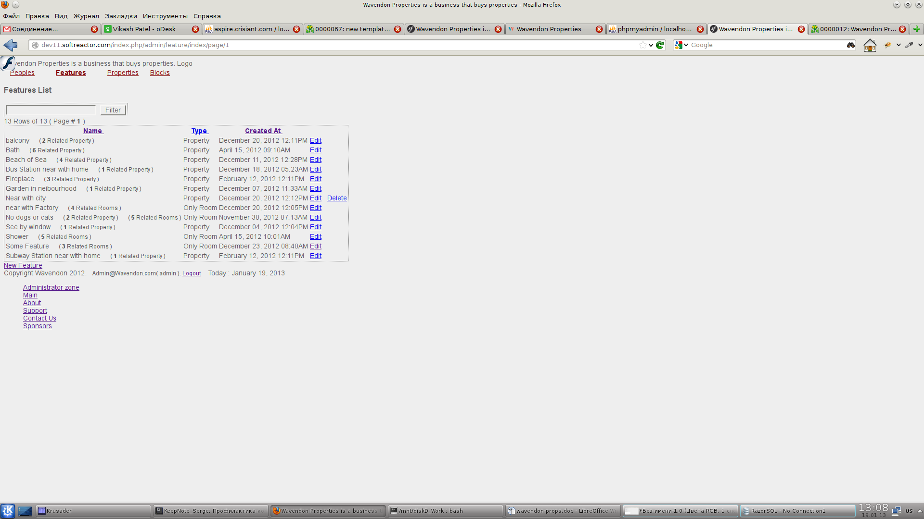
3.1) Filter by name field. Sorting by main fields. Feature can not be deleted deleted if has related rooms/properties.
3.2) Features can be edited, deleted, added.
4) In editor of feature :
4.1) Field name is unique in system

    - Properties List (http://dev11.softreactor.com/index.php/admin/property/index/page/1)
5.1) Filter by Landlord, type, address fields. Sorting by main fields.
5.2) Propertiess can be edited, deleted, added. Deleting property all related data(features, rooms, related data of rooms) are deleted too.
6) In editor of property :
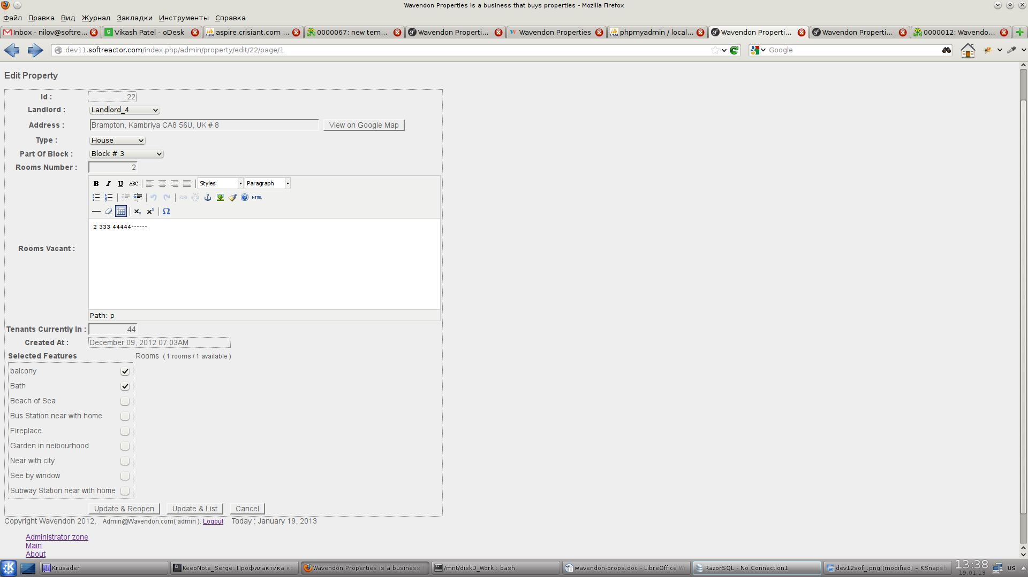
6.1) Clicking on «View on Google Map» button google map with Proiperty address is opened.
6.2) All fields excepting Rooms Vacant (which is rtf text) are required. Fields Rooms Number and Tenants Currently In are validated as valid integers.
  - Property editor has 2 tabs for selecting features and adding/deleting/modifing rooms of property.
  - Deleting rom of property all related data for room(tenants, features, history, directory of images) are deleted too.
    - In room Editor :
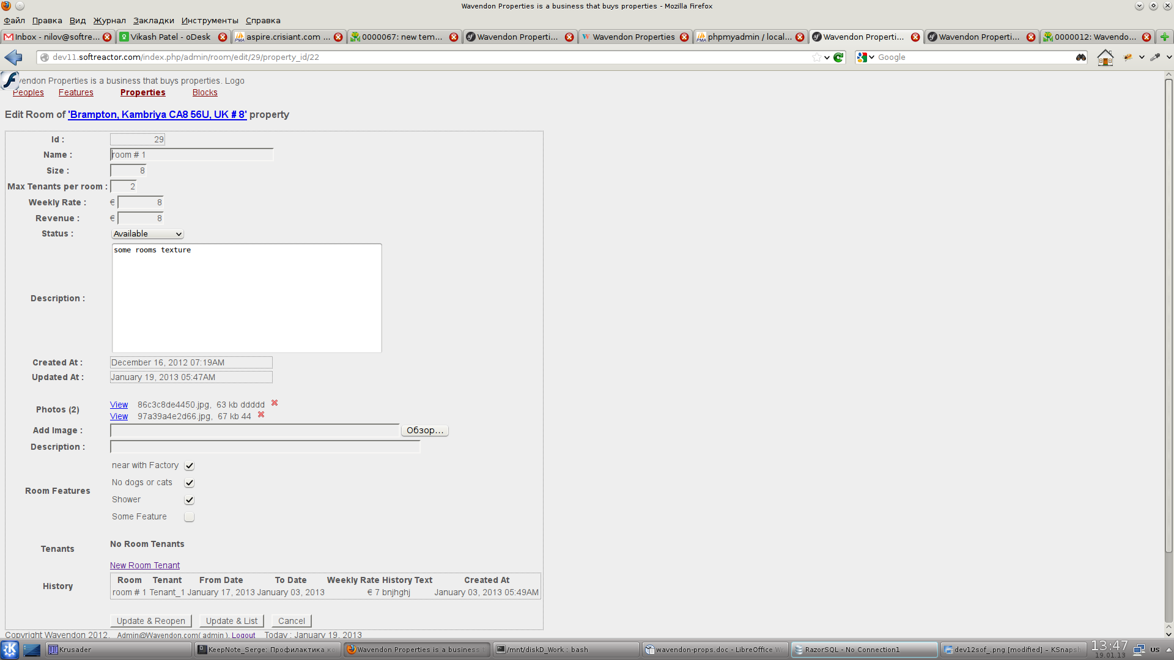
7.1) All fields exepting Description are required. Fields Size, Max Tenants per room, Weekly Rate, Revenue are validated as valid integer, money values. Name of room is unique for any property.
7.2) Any number of Images and description to images can be uploaded. These images can be previewd and deleted.
7.3) Room Features can be selected.
7.4) Any Room can have list of Tenants, but no more then Max Tenants per room value in room editor.
  - Room Tenants can be added, edited, deleted and moved to history.
  - Rooms history ( former Tenants ) only for preview list.
  - If status field has value «Unavailable» then text field «Status Description» is shown.
    - In tenant Editor :
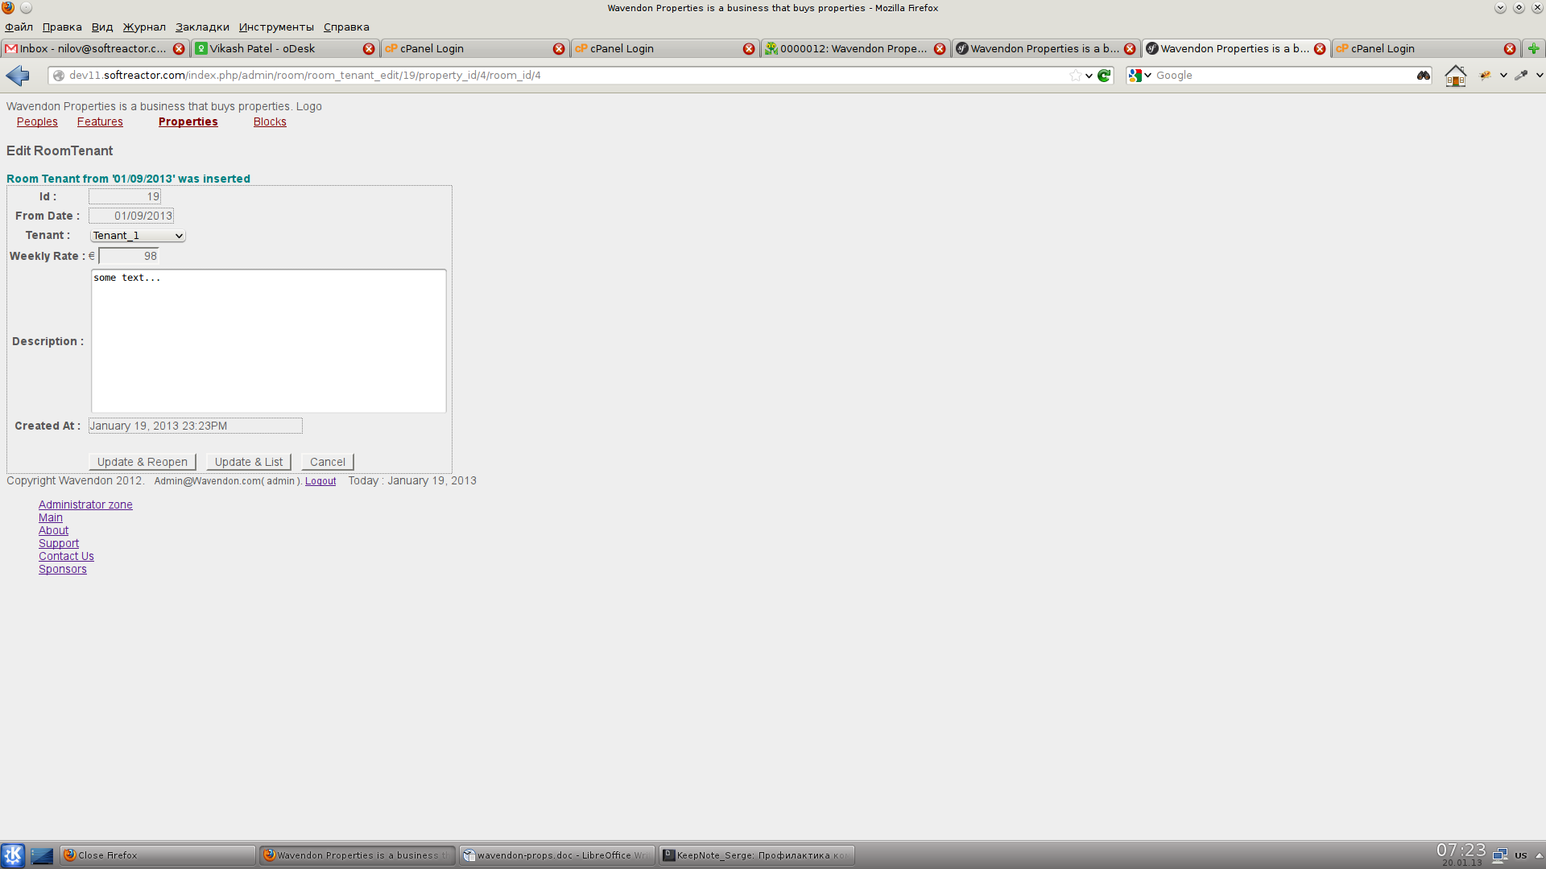
7.1) All fields exepting Description are required. FieldWeekly Rate is validated as valid money value.

In case of wrong data error message(s) are show at top of page (in red color). If data are added/modified/deleted succesfully then message at top of page is shown in color.

User must be logged as admin to enter any page of admins site.

Simplified main frontend page for any users http://dev11.softreactor.com/index.php/main/ with page of details of any property. In admin's menu there is link to this page «main»

